Q1
Compilateur croisé
cross compilation

Q2
buildroot ---- compilateur croisé
linux------
u-boot -----chargé d’exécuter le kernel
et est capable d’utiliser les fonctions matérielles de base

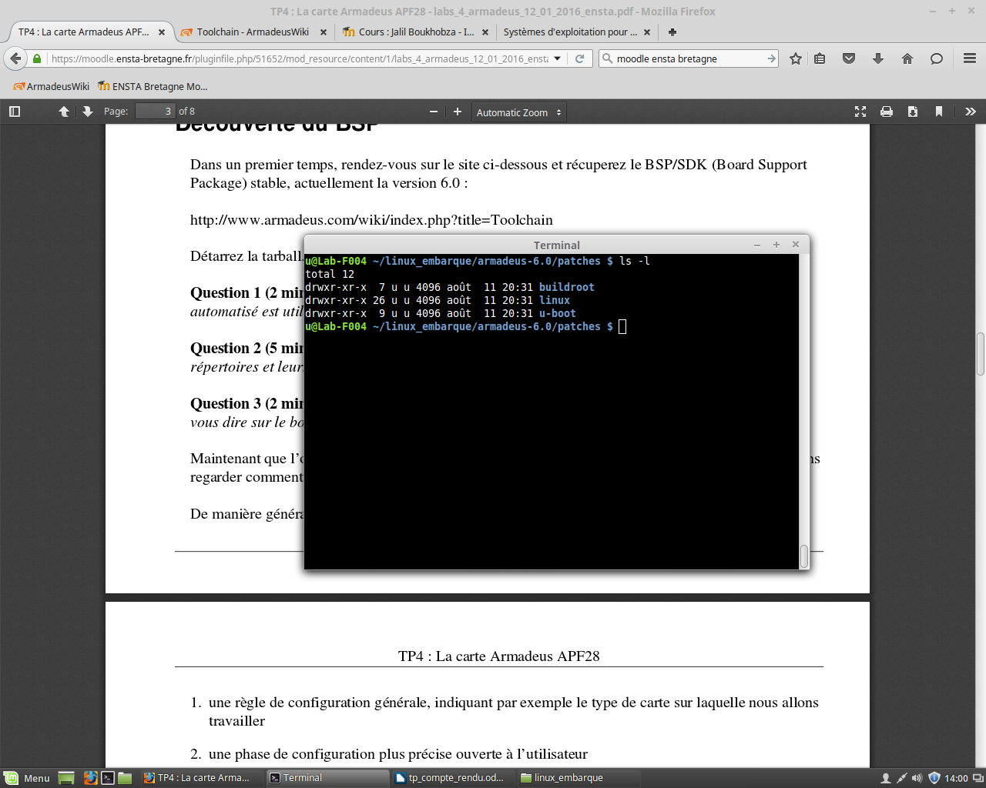
Q3
en dehors des cartes x86,
U-Boot est le bootloader le plus répandu

Q4

Q5
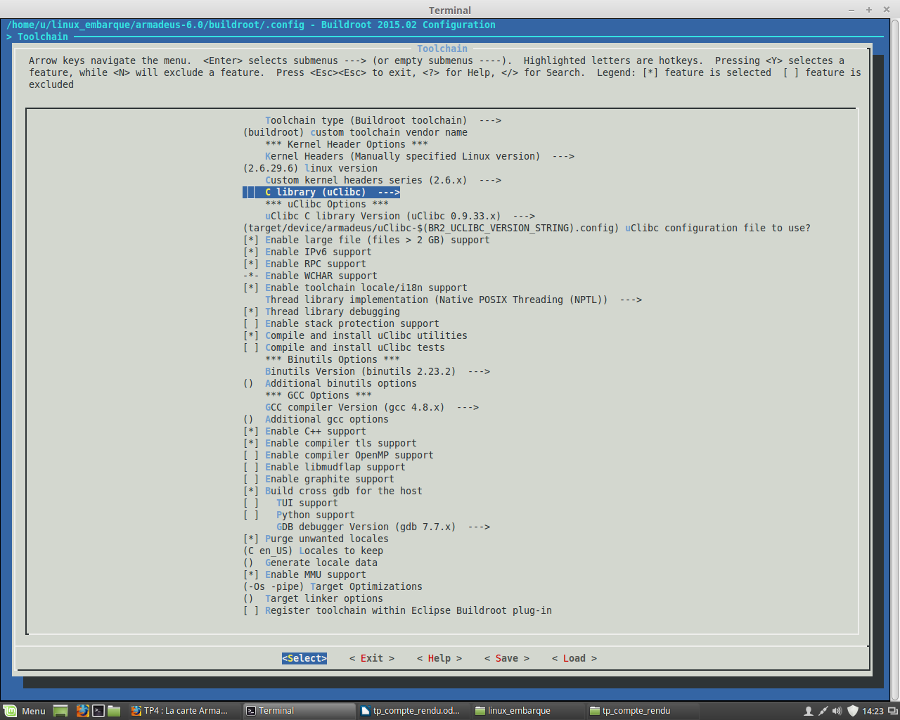
kernel version : 2.6.29.6
libc version : uclibc

Q6:
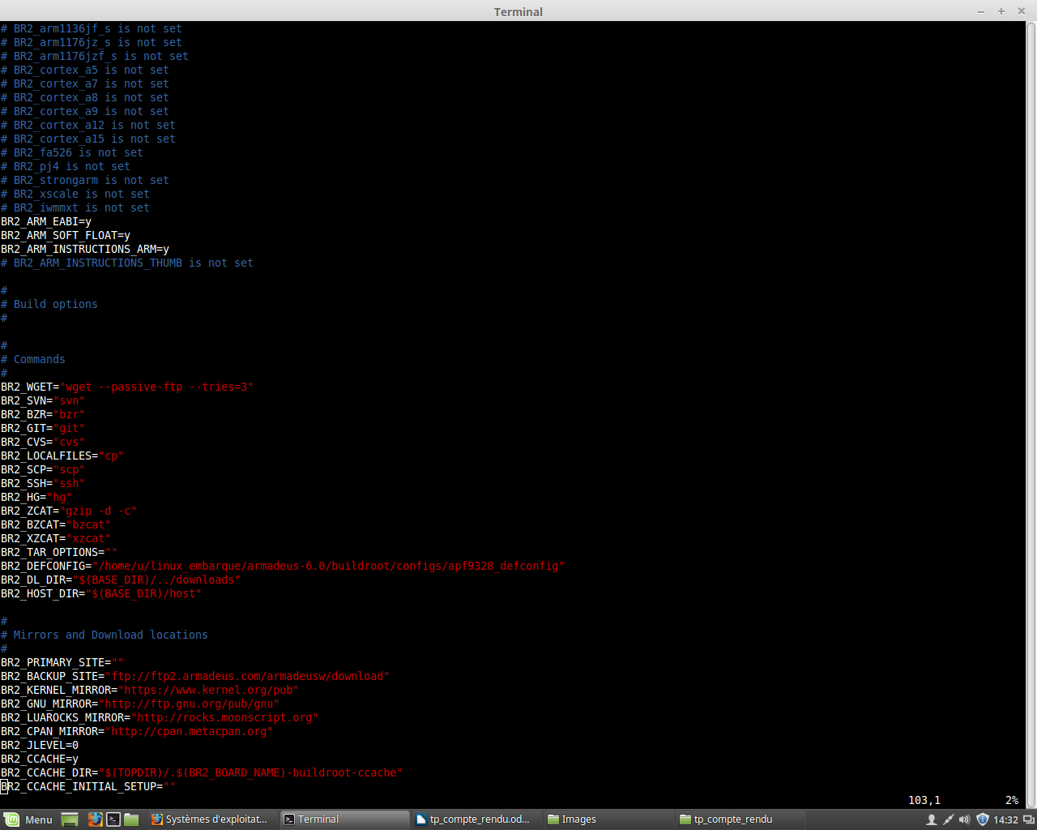
EABI : Embedded-ABI
C'est un bon choix, car l'autre OABI est une version ancienne.

Q7 :
busybox est un binaire unique fournissant les
commandes

Q8 :
make busybox-menuconfig

Q9 :
fdisk/ ping ok
ssh no

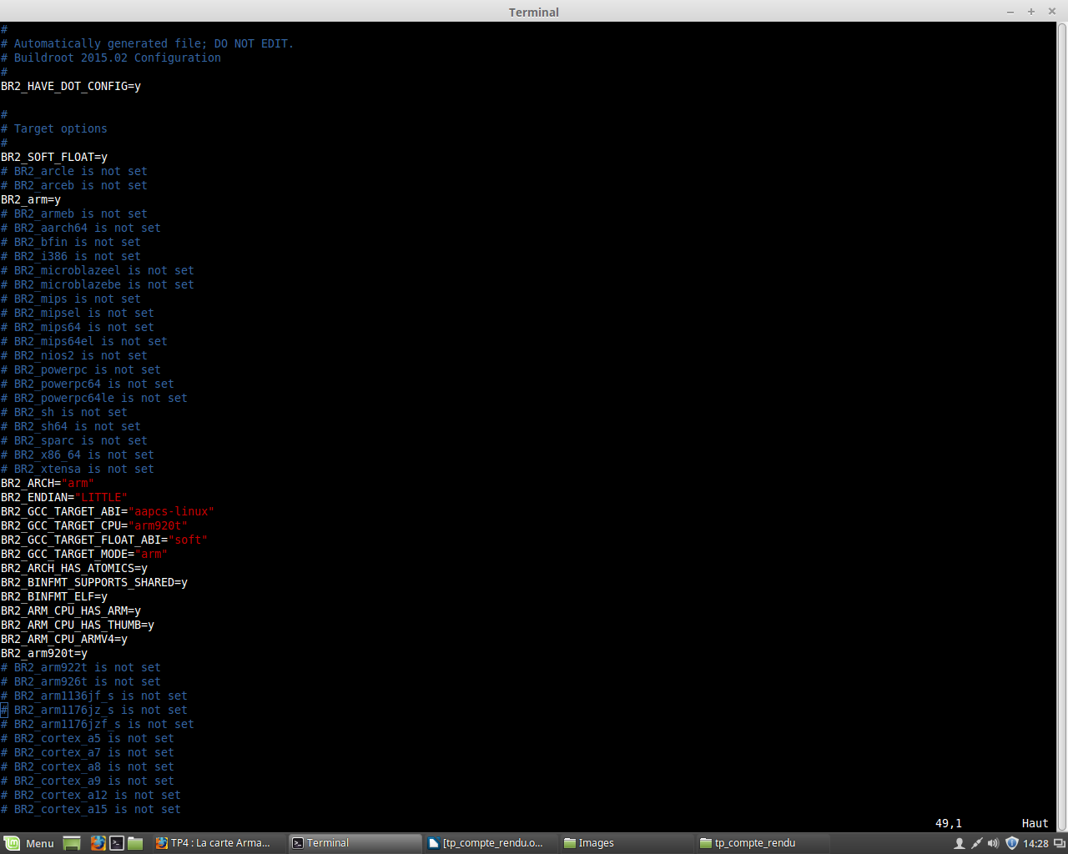

Q10
dmesg
ttyACM0

Q11
recharger le system et reinitialiser les configurations

Q12
télecharger enregistrer
download_kernel flash_kernel
download_rootfs flash_rootfs
download_uboot flash_uboot

Q13
kernel_addr=0x00500000
kernel_addr_r=40000000
rootfs_addr=0x00D00000
u-boot_addr=0x00100000
u-boot_len=0x00100000
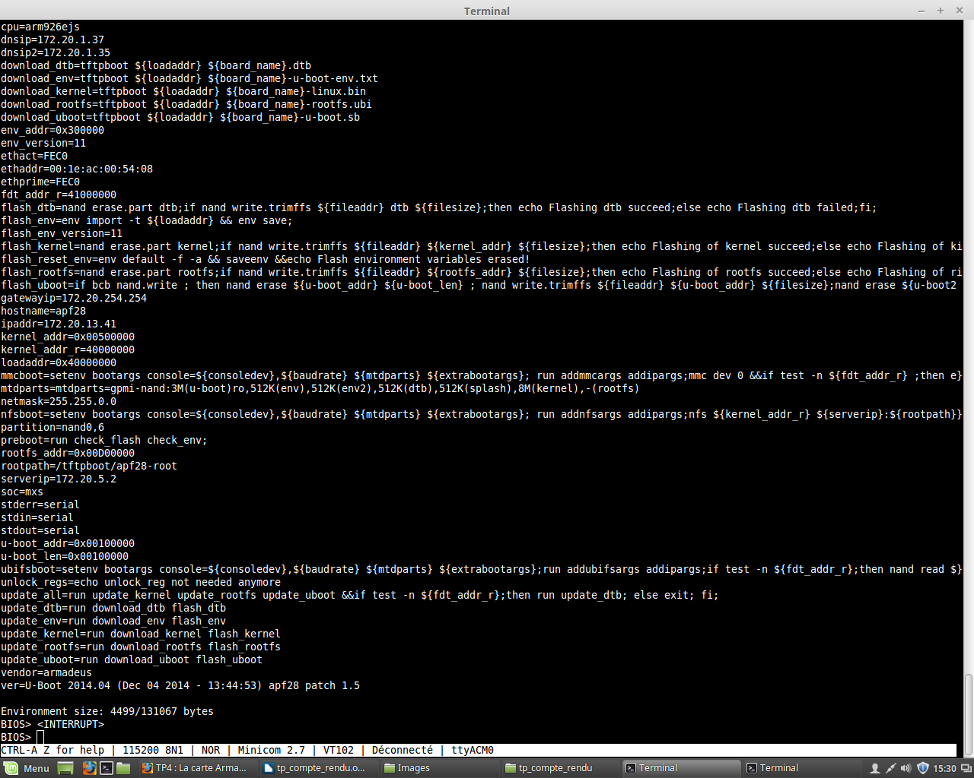
Q14
172.20.13.41

Q15
loadaddr=0x40000000

Q16
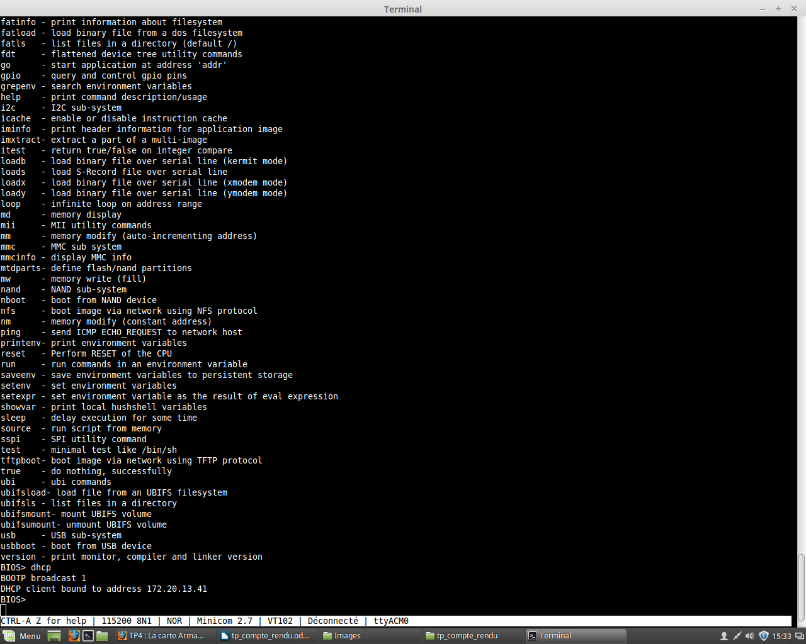
Q21 :
i.MX user LED. A high level on GPMI_RDY1 (GPIO bank 0 pin
21) of the i.MX will light the LED

gpio_linux= (32*bank_num)+pin_num ;
gpio_linux=21

Q23
Manage GPIO from command line or script
From the user level side this "operation" for reserve the GPIO is called "export" the GPIO. For make this export operation you simply need to echo the GPIO number you are interested to a special path as follow (change XX with the GPIO number you need):

echo XX > /sys/class/gpio/export

If operation successful (the possible case of operation failed is explained below) a new "folder" will show up in the GPIO interface path as example below:

/sys/class/gpio/gpioXX/

This new "folder" will allow you to work with the GPIO you just reserved. In particular if you want to set the in/out direction you simply need to execute the following echo commands:

echo "out" > /sys/class/gpio/gpioXX/direction
or
echo "in" > /sys/class/gpio/gpioXX/direction

In case you set out direction you can directly manage the value of GPIO. You can make this operation by executing additional echo commands like:

echo 1 > /sys/class/gpio/gpioXX/value
or
echo 0 > /sys/class/gpio/gpioXX/value

http://falsinsoft.blogspot.fr/2012/11/access-gpio-from-linux-user-space.html
Q24
sys/socket.h

Q26
Macro: AC_ENABLE_SHARED
Macro: AM_ENABLE_SHARED
Change the default behaviour for LT_INIT to enable shared libraries. This is the default on all systems where Libtool knows how to create shared libraries. The user may still override this default by specifying ‘--disable-shared’. The option ‘shared’ to LT_INIT is a shorthand for this. AM_ENABLE_SHARED is a deprecated alias for AC_ENABLE_SHARED.

