BLEENTR / BRAND SYSTEM 01
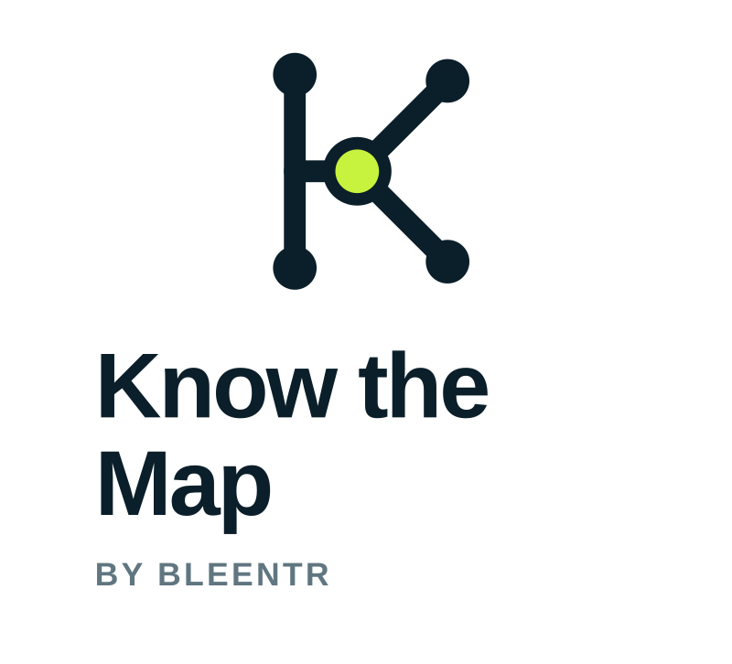
Brand manual
Repository & Change Intelligence
BRAND THESIS Deep understanding for the systems behind every change.
Version 1.0 · August 2026

01 / FOUNDATION
The map reviewers need
Know the Map gives engineers a durable mental model of a repository and makes change legible in that context.
CENTRAL PRINCIPLE Reduce the amount of system state the reviewer must reconstruct mentally.

What the product is
Repository & Change Intelligence: a persistent, temporal model of structure, dependencies, flows, intent, invariants, ownership, tests, and architectural history. A pull request is understood as a semantic transition between two repository states—not as isolated text.

What the product is not
- A generic AI code reviewer.
- A diff summarizer with a chat box.
- A static documentation generator.
- A promise to replace engineering judgment.

Brand promise
Give reviewers the mental map they need without making them reconstruct the whole system from scratch.

02 / POSITIONING
Own comprehension, not automation

Positioning statement
For engineers and technical teams reviewing complex, stacked, or agent-generated changes, Know the Map is the repository and change-intelligence layer that shows what the system was, what a change alters, and what the system becomes. Unlike diff summarizers and generic AI reviewers, it grounds review in a persistent, evidence-aware model of architecture and history.

Message hierarchy
- Understand the system, not just the diff.
- See architecture and history around every change.
- Review a semantic transition, not isolated hunks.
- Reduce the system state reviewers must reconstruct mentally.
- Bring the harness that fits your workflow; Know the Map remains the intelligence layer.

Category language
Lead with “Repository & Change Intelligence.” Use “AI” only when explaining how analysis is executed. The capability is intelligence; the customer outcome is comprehension.

03 / MESSAGING
A language system for understanding
Role | Line | Use
Primary | Understand the system behind the change. | Default product tagline
Campaign | Don’t just read the diff. Know the map. | Launch, README, social
Repository | See the system. Follow its history. | Repository intelligence
Change | Know what it was. See what it becomes. | PR and trajectory views
Agent era | Agents write the code. You still need to know the map. | Thought leadership

Claims to avoid
- “AI that reviews every PR.”
- “Instant codebase understanding.”
- “Never review code again.”
- “Catches every bug.”
RULE Never imply omniscience. Show the model, the evidence, and the boundary of the inference.

04 / PERSONALITY
Thoughtful technical authority
Deep — not dense. Reveal the underlying model without performing complexity.
Grounded — not magical. Point to code, history, tests, and evidence.
Calm — not alarmist. Surface risk in proportion to evidence.
Precise — not pedantic. Use the exact term, then make it legible.
Curious — not omniscient. Ask the review question that unlocks understanding.
Systemic — not reductive. Connect local edits to architecture and trajectory.

The emotional outcome
The reviewer should feel oriented—not dazzled. The product turns “I need to load this whole system into my head” into “I can see the shape, the history, and the consequence of this change.”

05 / VOICE
Write like a staff engineer orienting a peer

Voice principles
- Lead with the system-level consequence, then show evidence.
- Prefer active verbs and concrete nouns.
- Separate observation, inference, and question.
- Name the before state and after state when discussing change.
- Use confidence proportionate to the evidence.

Say / avoid
Say | Avoid
This introduces SessionStore between AuthService and persistence. | The AI detected a significant architectural modification.
Observed in code; inferred impact; question for review. | This is definitely a bug.
This route has no consumers in the current stack. | Unused code found.
What happens if persistence succeeds but invalidation fails? | Potential race condition issue.

06 / VISUAL IDEA
The living topology
Stable structure, traced history, and one semantic transition under examination.


The K-route
The vertical spine suggests repository history. The branches suggest architecture and affected flows. The center node is the change being understood. The geometry is intentionally compact: a map you can hold in your head.

The Signal rule
Signal Lime is semantic, never decorative. It marks exactly one of three things: the change, the current point in time, or the reviewer’s active focus. Highlighting everything means understanding nothing.

07 / COLOR
Depth, structure, and focus
Color | Hex | Role
Deep Ink | #0B1F2A | Primary field; authority and depth
Paper | #F5F1E8 | Warm reading surface
Mineral | #2F7F78 | Routes and secondary emphasis
Signal | #C7F23D | One change or focus only
Slate | #607680 | Secondary text and metadata
Fog | #DDE5E2 | Boundaries and diagram support

Usage ratio
60% Paper · 25% Deep Ink · 10% Fog/Mineral · ≤5% Signal
Never use Signal for paragraphs or large backgrounds. Pair Deep Ink text with Signal. Use Paper or white for long-form reading surfaces.

08 / TYPOGRAPHY
Clarity at product scale

Inter
Primary family for UI, web, documentation, and communications. Use 700–800 for major headlines, 600 for labels, and 400–500 for body copy. Keep sentence case by default.

JetBrains Mono
Use for commit IDs, symbols, file paths, evidence labels, and temporal coordinates. It is a technical annotation voice, not a body font.
FALLBACKS Inter, Arial, Helvetica, sans-serif / JetBrains Mono, ui-monospace, monospace

Type behavior
- Favor compact headlines with generous space around them.
- Use tabular alignment for before/after states and timestamps.
- Do not set long prose in monospace.
- Avoid all caps except short metadata and evidence labels.

09 / LOGO SYSTEM
One mark, deliberate variants


Default hierarchy
Use the horizontal lockup by default. Use the stacked lockup for square or narrow compositions. Use the symbol alone only when the product name is already present or the surface is constrained.

Bleentr endorsement
Bleentr is the umbrella brand. “by Bleentr” stays visibly secondary and travels with the product lockup. In copy, the first mention may be “Know the Map by Bleentr”; subsequent mentions use “Know the Map.”

Color variants
- Primary: Deep Ink + Signal on Paper or white.
- Reverse: Paper/white + Signal on Deep Ink.
- Monochrome: one-color reproduction, engraving, or constrained integrations.

10 / LOGO RULES
Protect recognition and meaning

Clear space and minimum size
Clear space equals one center-node diameter on every side. Minimum digital widths: horizontal 160 px; stacked 96 px; symbol 20 px. Use the dedicated favicon at 16 px. Minimum print widths: horizontal 42 mm; stacked 25 mm.

Never
- Redraw, rotate, stretch, crop, or rearrange the mark.
- Add shadows, gradients, glows, bevels, outlines, or animation effects.
- Recolor individual nodes or highlight more than one node.
- Place the primary mark on low-contrast or noisy imagery.
- Detach, enlarge, or restyle “by Bleentr.”
- Use the K-route as a generic bullet or decorative pattern.
MEANING CHECK If the accent does not answer “what changed?” or “where is focus?”, remove it.

11 / VISUAL LANGUAGE
Show systems, not AI theater

Use
- Architecture layers and repository boundaries.
- Dependency routes and affected flows.
- Commit trajectories and before/after states.
- Evidence paths linking claims to code, tests, and history.
- Generous negative space and restrained editorial grids.

Avoid
- Brains, robots, sparkles, chat bubbles, and magic wands.
- Circuit boards, glowing neural networks, and cyberpunk gradients.
- Literal folded maps, pins, globes, and compasses.
- Dense decorative node clouds with no semantic hierarchy.

Motion
Motion may trace a route, reveal a dependency, or transition from before state to after state. It should explain causality. Avoid idle pulsing, scanning, or perpetual “thinking” animations.

12 / APPLICATIONS
A consistent system across surfaces
Surface | Rule
Web | Horizontal lockup on Paper/white; reverse in dark hero or footer.
README | Use the 1200 × 300 banner or horizontal SVG. Keep product explanation immediately below.
Social card | Use the 1200 × 630 asset; replace only supporting editorial copy, not the lockup.
Social profile | Use the 1200 × 1200 tiled symbol with safe padding.
Favicon | Prefer SVG; provide 16/32/48 PNG and ICO fallbacks.
Product UI | Keep branding quiet. Use the topology grammar for diagrams, timelines, and change states.
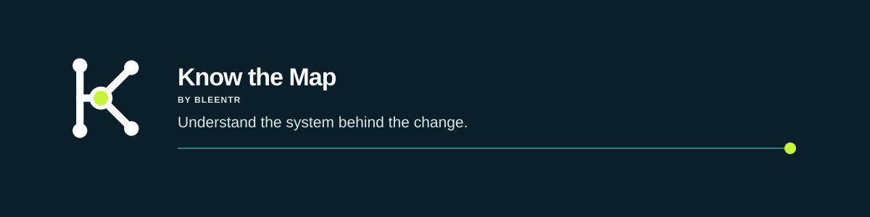

13 / GOVERNANCE
The five-minute brand check
- □ Does the message lead with comprehension rather than automation?
- □ Is every claim grounded in a system state, history, or evidence?
- □ Does Signal identify one meaningful focus?
- □ Is the mark legible at the intended size?
- □ Is “by Bleentr” secondary but intact?
- □ Does the design feel calm, technical, and editorial?
- □ Have generic AI clichés been removed?

Asset package
The accompanying folder includes editable SVG masters and production-ready PNG/ICO exports for web, README, social, and browser use. Start with the README in the asset folder.
NORTH STAR Don’t just read the diff. Know the map.

