Nícolas Maduro
The codes are appended at the end.

Exercise 1
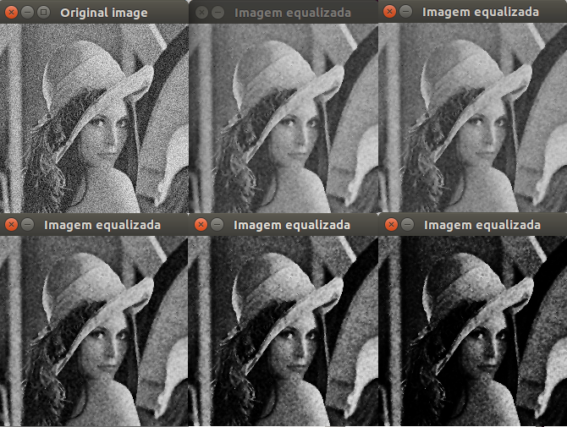

It was used in this example sigma equal to 80 and r is equal to 0, 0.5, 1 and 2 from left to right, respectivamente. As expected, when larger R, darker is the image.

Exercise 2

The edge detector work by tests using both first-order and second-order derivatives. The derivatives are calculated with the Sobel Operator.

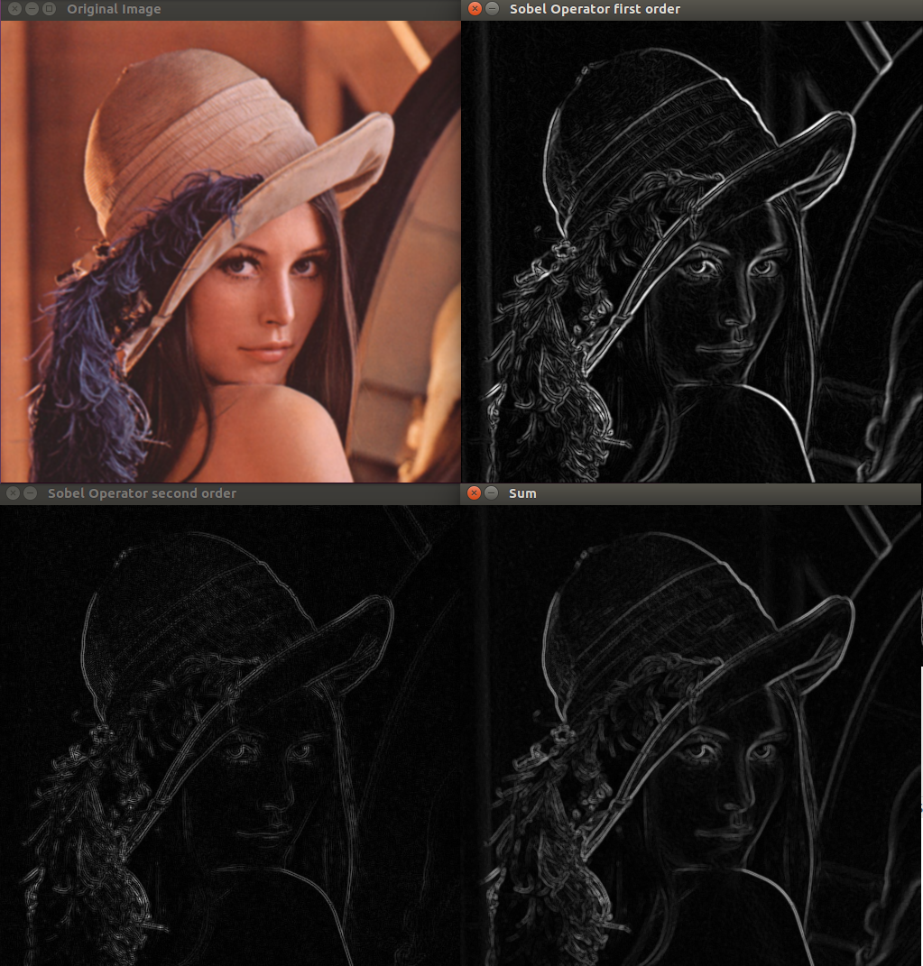

Exercise 3

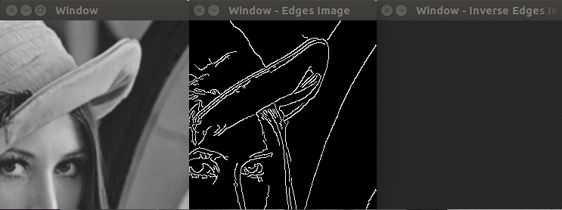
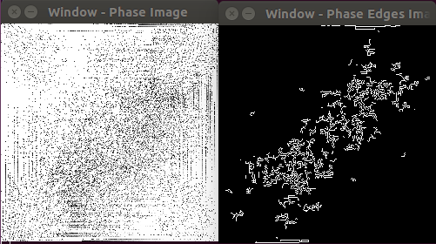
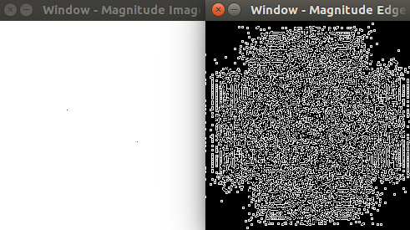

The edge detector applied in phase and magnitude windows creates uninterpretable images even when was apply inverse Fourier transform. It wasn't possible count the numbers of pixels being in the thresholding edge because the edge map thresholding was perform in Canny function from OpenCV.

