Client Portfolio Review & Investment Recommendation
Client N.A. (anonymised) · Valuation date 7 November 2026 · Base currency US$, real terms unless stated
MBA Asset Management & Global Markets, IE Business School · Prof. Andrea G. Angelone · Individual assignment

1. Executive summary
Your goal. US$5,000 a month in today's money from age 55. Your spouse covers US$1,500, so your investments must pay US$3,500, which needs about US$1.2 million.
Where you stand. You hold US$69k in eToro and your Skandia pension plan. With the Skandia funds' peso exposure, risk is 14.0%, above the agreed 13% ceiling; new savings bring it to 13.3% within five years. The mix leans on US technology, and 14% is cash.
Our recommendation. A diversified, value-tilted portfolio expected to earn 8.0% a year in US$ (nominal; 5.2% real after costs, 3.8% above the 4% US Treasury bill). A 2008-type crisis could cut it by about 45%, so risk falls from age 45.
Will it be enough? With today's savings the goal is met in 72 of 100 scenarios, short of our 80. A weaker peso is your plan's most specific risk: each extra point of yearly depreciation costs about 6 in 100.
Three decisions for you:
- Put new savings and the excess cash into value shares and gold, not more technology.
- Save US$1,700 a month and retire at 56: success rises to 82 in 100 (92 if you retire at 60).
- Skandia stays as it is: your decision, not our advice. Its 3% fee and peso hedge cut success from 90 to 72 in 100 for the same mix; we review an unhedged option every six months. Start reducing risk at 45.

2. Client profile & Investment Policy Statement
METHOD: INVESTMENT POLICY STATEMENT (IPS)
What it is: a written agreement on your goal, horizon, risk limits and investment rules.
Why we use it: every later choice in this report is tested against it.
What it tells us: you need about US$1.2m by 55; you can accept 12% risk until 45, falling to 8% by 55.

IPS item | Client N.A. | Implication
Objective | US$5,000/month household income in today's dollars, minus US$1,500 from the spouse = US$3,500/month from the portfolio from age 55 to 95. Sustainable withdrawal 3.5% → capital needed US$1.2m real (≈US$2.2m nominal in 2051 at 2.5% inflation). Protect purchasing power against a weaker Colombian peso (COP). | Equity-led, US$ core; success standard: ≥80% probability in the Monte Carlo (§8.1)
Return target (base currency US$) | 5.2% real in US$ after investment costs, before tax = 7.83% nominal (8.03% expected return − 0.2% costs, with 2.5% US inflation); ≈4.9% real net of a 0.5% fees-and-tax drag ("Client IPS" O33); ≈4.1% real at retirement (8% risk, after costs). Required premium 3.83% over the 4.0% US T-bill (table below) | The 12% frontier point, then the glide path
Horizon | Age 29 now; retirement at 55: 25 saving years to Dec-2051, income from the 55th birthday (May-2052); sensitivity 55–65; decumulation to 95. Tables show age during each calendar year, so 2051 appears as age 54 (last saving year) | Can hold through several equity cycles
Risk and glide path | Growth profile until 45: target volatility 12% (ceiling 13%), annual VaR99 ≤ −20%, tolerated loss ≈45% (2008 replay). From 45 to 55 volatility falls linearly to 8%: VaR99 −19.9% → −11.8%, 2008 replay −44.6% → −31% (Appendix C4) | A −45% year at 55 would cut the sustainable income almost in half
Liquidity and Skandia | Skandia voluntary pension plan (≈32% of modelled wealth): locked until ≈Dec-2035, reallocation between Skandia portfolios only. Held as-is: Acciones USA 74% / Europa 13% / Liquidez USA 13% (≈63% of the equity hedged to COP, a regression estimate, §6). No wedding reserve. eToro cash band 2–10% of the eToro account | Fixed-mix, illiquid sleeve; a Skandia switch is a future option, not assumed
Contributions | US$1,500/month to eToro (maximum US$1,700), indexed to US inflation; COP 60m a year to Skandia every December (constant in real COP), pro-rata into the as-is mix | New money is the main rebalancing tool
Constraints | No leverage. LC Growth ≤30%; LC Value ≤40%; small caps ≤5% each; Intl ≥5%; EM 5–20%; Gold 3–10%; High Yield ≤20%; Bonds ≥5%; non-US ≤40% of equities; position ≤8% of eToro; crypto ≤5% (outside the model) | Prevents a single-style portfolio (§4)
Rebalancing and review | Bands ±5 pp. Order: (1) reallocate inside Skandia (no tax); (2) eToro cash and new money to underweights; (3) eToro sales by tax lot (losses first, then lots held >2 years). Semi-annual review (next 15-Apr-2027) plus alerts from the monitoring app; Colombian tax resident (use the pension-plan tax allowance before 31-Dec) | Minimises tax; the glide path needs planned sales from 45

Return target and currency | US$ (base currency) | COP-equivalent (reference only)
Real target, after 0.2% costs, before tax | 5.20% | 5.20% (same real return)
Nominal target (inflation 2.5% US$ / 4.0% COP) | 7.83% = (1 + 5.2%)(1.025) − 1 | 9.41% = (1 + 7.83%)(1.04 / 1.025) − 1
Risk-free rate | 4.0% US T-bill (course rate, all Sharpe ratios) | 12.25% BanRep policy rate (30-Oct-2026)
Required premium = nominal target − risk-free | 3.83% | Depends on the peso assumption (§8.1 FX rows)
Recommended portfolio (§4), same risk-free | 8.03% − 0.2% = 7.83%; premium 3.83% net | —
Base currency US$: the goal and the model are in real US$; assets are US$ (eToro, Liquidez USA) or US$/EUR equity funds ≈63% hedged to pesos (Skandia). COP column: relative PPP with no real depreciation, for reference; the BanRep rate (12.25%, decided 30-Oct-2026 and in force on 7-Nov-2026; El País, 30-Oct-2026) embeds expected depreciation, so it is not the hurdle. Source: Excel "Client IPS" N48:Q60; results_v8.json "targetCurrency".
Why risk falls near retirement. A 45% loss is bearable at 29, while you still add money every month. It is not bearable at 55, when you start drawing US$42,000 a year. A 2008-type fall in the first year of retirement would push the withdrawal rate from 3.5% to about 6% of what is left. So the IPS moves from the 12% to the 8% frontier portfolio between 45 and 55. That cuts the 2008 replay loss to about −31%; a strict 25% cap would need about 7% risk.
One currency throughout. Every amount is in real US$ (today's dollars). Real return = (1 + nominal − costs)/(1 + 2.5%) − 1. Your Skandia contribution in pesos is converted at the USD/COP exchange rate, with a scenario for real peso depreciation.

3. Current portfolio assessment
METHOD: ASSET-CLASS MAPPING
What it is: every holding placed in one of nine asset classes, plus cash, to measure return and risk.
Why we use it: it shows the portfolio as the model sees it, not as a list of 42 positions.
What it tells us: risk is on target, but too much US growth, too little value and gold, and 14% in cash.

We placed every holding in one of the course's nine asset classes, plus a separate cash class: 42 eToro lines, the eToro cash and the three Skandia portfolios (sheet "Current 7-Nov"). Values are as of 7-Nov-2026: eToro at the Friday 6-Nov close, Skandia from your 7-Nov statement, and USD/COP at 3,228.26.
We treat cash as cash, not as bonds. Idle eToro cash (US$6,272) and Skandia Liquidez USA (US$2,767, 1.9% fee, no peso hedge) earn the course risk-free rate, like a US Treasury bill (4.0%, volatility 0.5%, no correlation with any class). The model covers US$66,712; your crypto (US$2.4k) sits outside it.
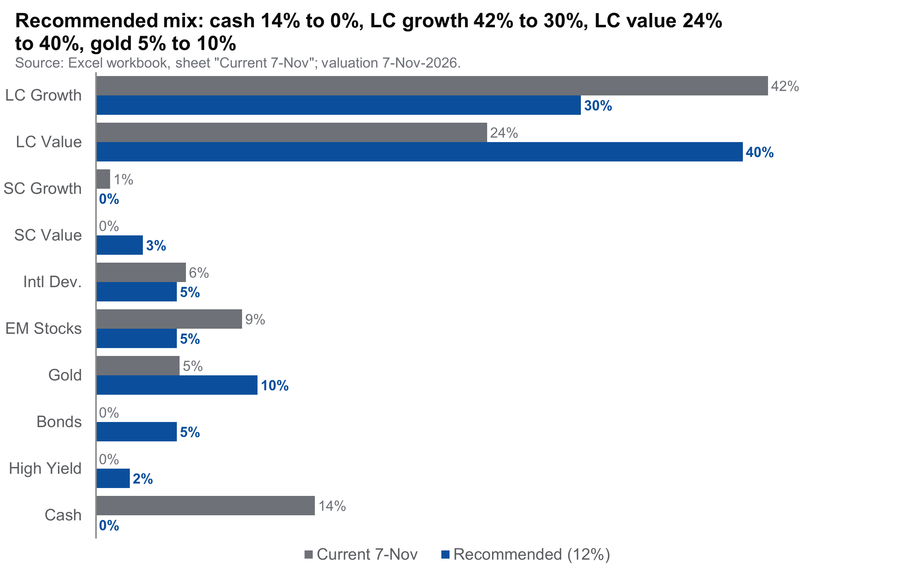
Figure 1. Allocation by asset class: current portfolio (grey; 7-Nov-2026, ex-crypto, cash as a cash class) vs the recommended 12%-risk portfolio (blue). Source: Excel workbook, sheet "Current 7-Nov"; valuation date 7-Nov-2026.
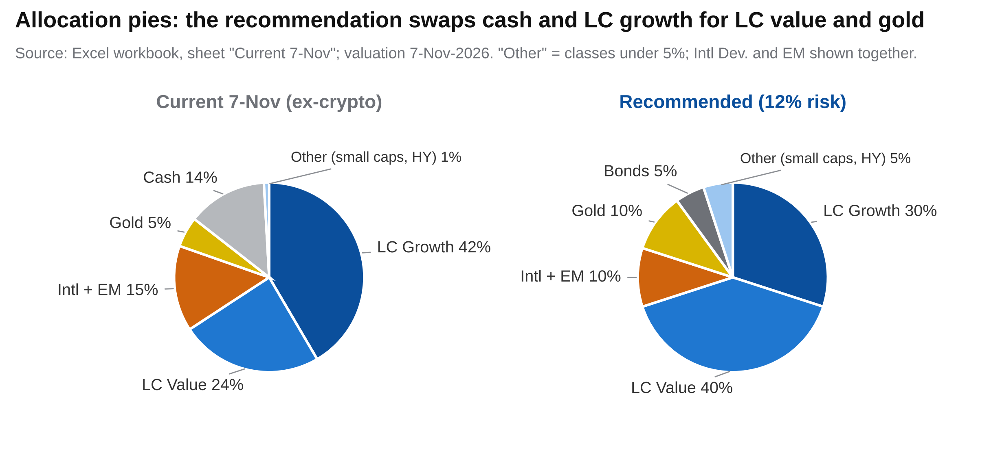
Figure 1b. Asset allocation pies: current portfolio at 7-Nov-2026 (ex-crypto, cash as a cash class) and the recommended 12%-risk portfolio; Figure 1 gives the exact class-by-class comparison. Intl Dev. and EM are shown together, and classes under 5% (small caps, high yield) are grouped as "Other". Workbook: sheet "Current 7-Nov", helper V13:X20 from R14:S23.
Portfolio (course assumptions) | Exp. return (nominal) | Exp. risk | Sharpe (rf 4%) | VaR 99%, 1 year | 2008 replay | LC Growth | LC Value | Cash
As-found at intake (cash and peso money market mapped to Bonds) | 6.62% | 7.97% | 0.33 | −11.9% | −27.1% | 31% | 11% | —
Current, 7-Nov-2026 (cash as cash) | 7.70% | 11.97% | 0.31 | −20.2% | −43.5% | 42% | 24% | 14%
Current, cash mapped to Bonds (method sensitivity) | 7.75% | 11.86% | 0.32 | −19.9% | −42.9% | 42% | 24% | 0%
Recommended (12% frontier) | 8.03% | 12.00% | 0.34 | −19.9% | −44.6% | 30% | 40% | 0%

What we found. Your overall risk is on target: 12.0% on the nine classes, or 14.0% once we add the peso exposure of the hedged Skandia funds (§8.2). The problem is the mix, which sits 33 basis points (bp) a year below the frontier. Growth outweighs value (42% against 24%): eToro leans on technology, and half of Skandia USA counts as growth. Gold is at half its target, and 14% sits in cash.
Why cash is not bonds. US Treasury bonds (the course Bonds class) cushion a stock-market fall; cash does not. Modelling the cash as a Treasury bill rather than as bonds lowers expected return by 5 bp and raises risk by 0.1 percentage points (pp). At intake, 42% sat in eToro cash and a peso money-market fund. Your October switch of Skandia into US$ and EUR equity funds (≈60% hedged back to pesos) removed most of it.

4. Efficient frontier analysis
METHOD: EFFICIENT FRONTIER
What it is: the highest expected return for each level of risk, found by Solver within the IPS limits.
Why we use it: to see whether you could earn more for the same risk.
What it tells us: yes: 33 bp a year more at 12% risk, moving from growth and cash to value and gold.

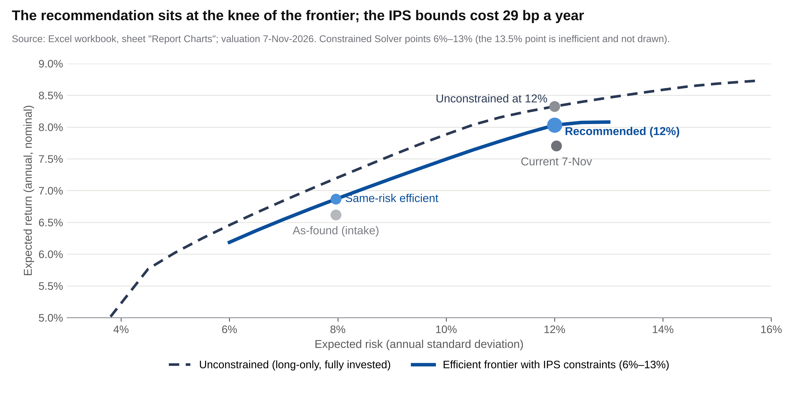
Figure 2. Efficient frontier with the IPS constraints (Solver, GRG Nonlinear; 6–13% risk) and without them (long-only, fully invested), with the portfolios. Only the efficient upper branch is drawn: the 13.5% Solver point (7.97%) lies below the 13% point and is therefore inefficient. Course assumptions: 50% 30-year history + 50% J.P. Morgan 2026 long-term capital market assumptions (LTCMA, as provided in the course workbook), median rolling 5-year volatility. Source: Excel, sheets "Report Charts" (block 4) and "EF Output"; 7-Nov-2026.
 | Exp. return (nominal) | Exp. risk | Sharpe | LC G | LC V | SC V | Intl | EM | Gold | Bonds | HY | Cash
Same-risk efficient (7.97%) | 6.87% | 7.97% | 0.36 | 6% | 31% | 0% | 5% | 5% | 10% | 23% | 20% | 0%
Current 7-Nov | 7.70% | 11.97% | 0.31 | 42% | 24% | 0% | 6% | 9% | 5% | 0% | 0% | 14%
Recommended (12%) | 8.03% | 12.00% | 0.34 | 30% | 40% | 3% | 5% | 5% | 10% | 5% | 2% | 0%
Unconstrained at 12% | 8.32% | 12.00% | 0.36 | 32% | 50% | 0% | 0% | 0% | 18% | 0% | 0% | 0%

Why we recommend it. The recommended portfolio is a corner solution: 7 of its 9 weights sit on an IPS limit. US large-cap growth (LC Growth), large-cap value (LC Value) and Gold are at their maximum. International (Intl), emerging markets (EM) and Bonds are at their minimum, and small-cap growth (SC Growth) is at zero.
Its Sharpe ratio, the return above the risk-free rate per unit of risk (0.34), is lower than that of the same-risk efficient portfolio (0.36). So its advantage is not efficiency. It earns more absolute return because it deliberately takes more risk (12% against 8%), which suits a 25-year goal funded by monthly savings. Above 12% the frontier is flat (8.08% at 13%) because the large-cap limits bind. So 12% is both the IPS target and the point where extra risk stops paying.
The cost of the limits. Without them, the optimiser holds only US large caps and gold and earns 8.32%. The limits therefore cost ≈29 bp a year: the price of diversification against estimation error.
Robustness: optimum at 12% risk with… | LC G | LC V | SC V | Intl | EM | Gold | HY | E[r] nominal, own set | At a bound | Moved vs rec.
Course blend (recommended) | 30% | 40% | 3% | 5% | 5% | 10% | 2% | 8.03% | 7 of 9 | 0%
100% 30-year history | 30% | 38% | 5% | 5% | 5% | 10% | 2% | 9.09% | 6 of 9 | 2%
100% J.P. Morgan 2026 LTCMA | 1% | 40% | 5% | 16% | 15% | 3% | 15% | 7.18% | 5 of 9 | 36%
100% 10-year history | 30% | 40% | 3% | 5% | 5% | 10% | 2% | 12.71% | 7 of 9 | 0%
Bonds stay at their 5% minimum in every case. Sheet "Robustness" (Python SLSQP = Solver GRG, same covariance). Reading: the weights barely move with 30- or 10-year history (≤2% of the portfolio); with J.P. Morgan's forward-looking returns alone the optimum shifts 36% toward value, international, EM and high yield. The bounds keep both answers diversified.
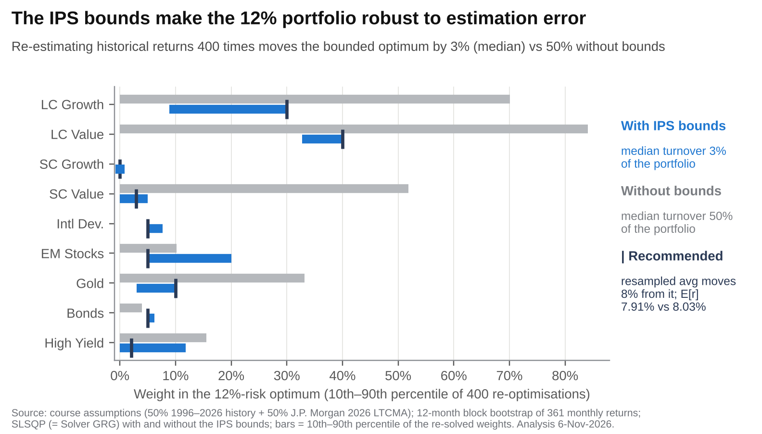
Figure 2b. Resampled efficient frontier: 10th–90th percentile of the 12%-risk optimal weights across 400 block-bootstrap re-estimations of the historical half of the course return blend, with (blue) and without (grey) the IPS bounds; tick = recommended weight. Source: course assumptions, 361 monthly returns 1996–2026; Excel sheet "Robustness Extras" (computed in Python); analysis 6-Nov-2026.
Is the answer stable? We re-estimated the returns 400 times within their statistical error (Michaud resampling, Figure 2b). Without the limits, the answer is unstable: half of the optimal 12%-risk portfolio changes each time (median turnover 50%), and US large-cap weights swing between 0% and 84%. The unconstrained 8.32% optimum is mostly estimation noise.
With the IPS limits, the optimum barely moves (median turnover 3%). The average resampled portfolio gives up only 12 bp of expected return (7.91% against 8.03%). That is why we accept the ≈29 bp cost of the limits. The least stable weight is LC Growth (9–30%). The resampled portfolio shifts ≈4 pp from LC Growth toward EM and high yield, a sensible direction for new money.

5. Risk analysis
METHOD: VALUE AT RISK (VAR), EXPECTED SHORTFALL (ES) AND STRESS TESTS
What it is: VaR is the loss not exceeded with 99% confidence; ES is the average loss beyond it.
Why we use it: to size bad outcomes from history, from a normal curve and from replays of past crises.
What it tells us: the normal curve understates crises; plan for a 2008 replay, about −45% for the recommendation.

Metric (99% confidence) | Horizon / method | As-found | Current 7-Nov | Recommended
Return / volatility / ES, 10 years | Historical, May-2016 to Apr-2026 | 9.4% / 9.2% / −6.7% | 13.4% / 12.6% / −9.3% | 13.1% / 13.0% / −10.2%
Return / volatility / ES, 20 years | Historical, May-2006 to Apr-2026 | 7.9% / 8.9% / −8.2% | 9.9% / 13.0% / −11.9% | 9.8% / 13.4% / −12.7%
Return / volatility / ES, 30 years | Historical, May-1996 to Apr-2026 | 7.8% / 9.0% / −8.3% | 9.2% / 13.1% / −12.3% | 9.6% / 13.2% / −12.9%
Historical VaR / ES | Monthly, 30 years (1st percentile; worst 1%) | −6.2% / −8.3% | −8.9% / −12.3% | −8.5% / −12.9%
(i) Parametric VaR / ES, normal fitted to history | Monthly, 30-year mean − 2.33 SD / normal ES | −5.4% / n.a. | −8.0% / −9.3% | −8.0% / −9.3%
(ii) Parametric VaR / ES, forward | Annual, E[r] − 2.33σ / E[r] − 2.67σ | −11.9% / −14.6% | −20.2% / −24.2% | −19.9% / −24.0%
Skewness / excess kurtosis | Monthly returns, 30 years | — | −0.67 / 1.36 | −0.70 / 1.71
Return, volatility and ES = annualised geometric return, annualised SD and monthly 99% expected shortfall. Row (i) is the like-for-like check on the historical VaR and ES (same months, monthly); row (ii) uses the forward course assumptions (annual) and is the basis of the IPS −20% limit. Cash replayed at 4.0% a year. Sources: "Historical VaR" (live), "Current 7-Nov" Q35:Q53 and "VaR Histogram" (Python, labelled).
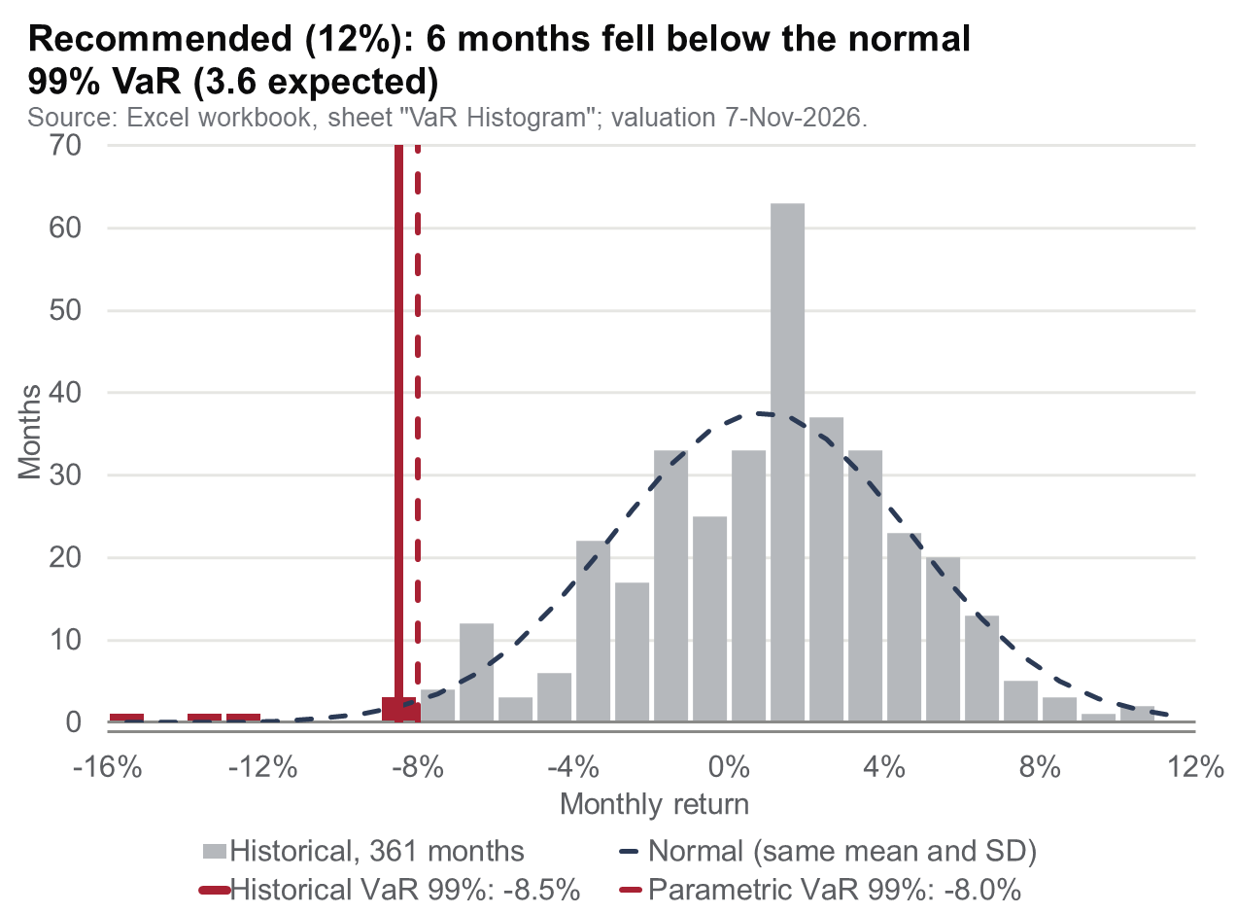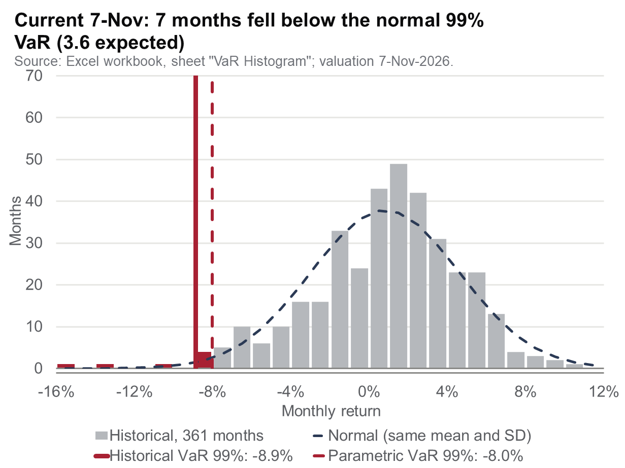
Figure 3. 361 monthly returns (Apr-1996 to Apr-2026) of the recommended and current portfolios vs a normal distribution with the same mean and SD; vertical lines: historical (red, solid) and parametric (red, dashed) 99% VaR; red bars = months at or beyond the historical VaR; dashed slate curve = normal. Source: Excel, sheet "VaR Histogram"; 7-Nov-2026.
History against the normal curve. Real returns bring more bad surprises than the normal curve allows. They lean to the loss side (skew −0.70) and have fat tails (excess kurtosis 1.7). The normal curve fits ordinary months well but gives almost no chance to a month below −10%. History has several, the worst at −17.3% in Oct-2008.
So the historical VaR (−8.5%) is deeper than the parametric one (−8.0%). History also breaks the normal 99% line more often: 6 months, against 3.6 expected. The historical ES is 4.4 pp beyond the VaR, against ≈1.3 pp under a normal curve. Each method has a weakness. The parametric one is transparent and forward-looking but understates crisis losses. The historical one assumes no shape but rests on only four tail months.
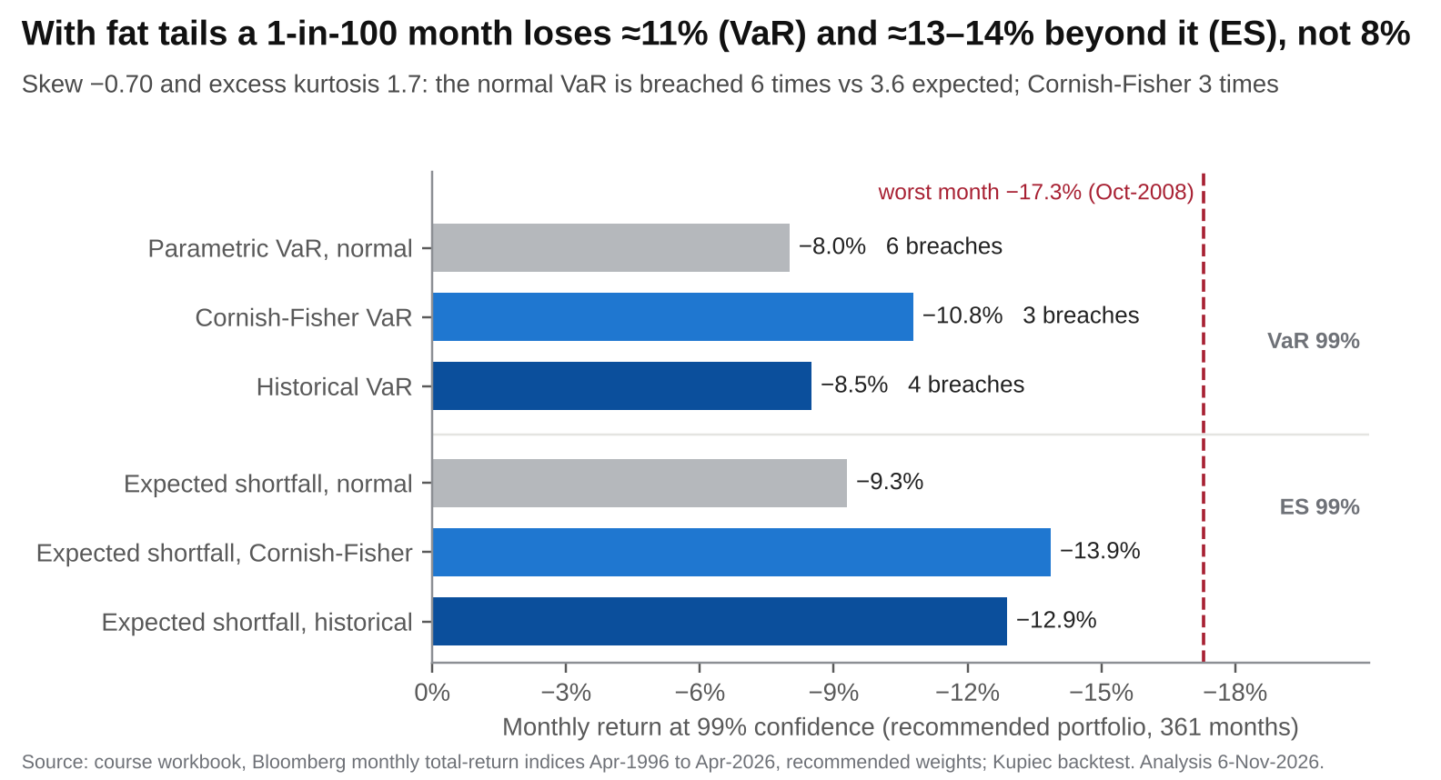
Figure 3b. Monthly 99% VaR and expected shortfall of the recommended portfolio under three methods: normal, Cornish-Fisher (adjusted for skew −0.70 and excess kurtosis 1.71) and historical; breaches = months below each VaR in 361 months (3.6 expected; Kupiec test). Source: course workbook, Bloomberg monthly total-return indices Apr-1996 to Apr-2026; Excel sheet "Robustness Extras" (computed in Python); analysis 6-Nov-2026.
Adjusting for fat tails. The Cornish-Fisher method corrects the normal VaR for the skew and fat tails we observe. It moves the monthly 99% VaR from −8.0% to −10.8%, and the ES from −9.3% to −13.9%, close to the historical −12.9%. In short, the normal model understates the tail by roughly a third.
Can we tell which model is right? Not with confidence. The normal VaR was breached 6 times and the Cornish-Fisher VaR 3 times, against 3.6 expected. With 361 months, the standard backtest (Kupiec test) cannot reject either model (p = 0.25 and 0.74). That is the honest limit of any 99% backtest.
On the annual forward view, the same adjustment moves the IPS limit from −19.9% to about −21.9% (ES −26.9%). The −20% VaR ceiling is therefore a normal-model figure. The number to discuss with you remains the 2008 replay (−45%).
Stress episode (weights replayed through history) | As-found | Same-risk eff. | Current 7-Nov | Recommended
Global Financial Crisis (Nov-07 → Feb-09), peak to trough | −27.1% | −30.9% | −43.5% | −44.6%
Dot-com bust (Sep-00 → Sep-02) | −22.6% | −12.3% | −39.5% | −33.1%
2022 inflation shock (calendar year) | −17.3% | −10.8% | −16.6% | −15.0%
COVID crash (Jan → Mar-2020) | −8.1% | −12.5% | −16.0% | −18.2%

STRESS TEST IN DOLLARS: WOULD YOU STAY INVESTED?
A repeat of 2008 would cost about US$29k on today's US$67k with the current mix. At 45, on the ≈US$0.87m we expect by then, the recommended mix would lose about US$390k. This is the number to plan for, not the −20% VaR. It is inside today's 45% tolerance, and the glide path cuts it to ≈−31% by 55.
Crises also break the frontier. The same-risk efficient portfolio looks safer on paper, yet it lost more than your as-found mix in 2008 (−30.9% against −27.1%), when high yield and value stocks fell like equities. For someone who earns in pesos, US$ assets are the natural hedge: the dollar tends to rise against the peso when the S&P 500 falls (correlation −0.45 between monthly USD/COP changes and S&P 500 returns, 2017–2026).

6. Style analysis
METHOD: RETURNS-BASED STYLE ANALYSIS
What it is: Solver finds the index mix that best tracks a fund (highest R², the share of its moves explained).
Why we use it: to see what a fund really is, and whether the manager adds value beyond that cheap mix.
What it tells us: Skandia Acciones Global acts as a global large-cap fund, but its cost-free copy beat it by 4.1 pp a year.

Which fund and why. We analyse Skandia Acciones Global, the global equity option inside your own Skandia pension plan. You do not hold it today (your balance is in Acciones USA, Acciones Europa and Liquidez USA), but it is the realistic fund you could switch into, and it shares their structure (3% fee, peso hedge). So it answers your real question, keep, switch or replace, which a supplied fund would not. To meet the brief, Appendix C applies the same method to a supplied multi-asset fund, Vanguard Wellington (VWELX): R² 93.9%, a 59/41 stock-bond balanced style.
How we fitted it. Solver maximised the R² of the fund's 111 monthly returns (Feb-2017 to Apr-2026, net of the 3% fee) against the nine classes. In pesos it is a global large-cap fund: 45% LC Growth, 27% LC Value and 28% International (R² 88.8%). In US$ the fit falls to 87.0%, because currency noise spills into other classes.
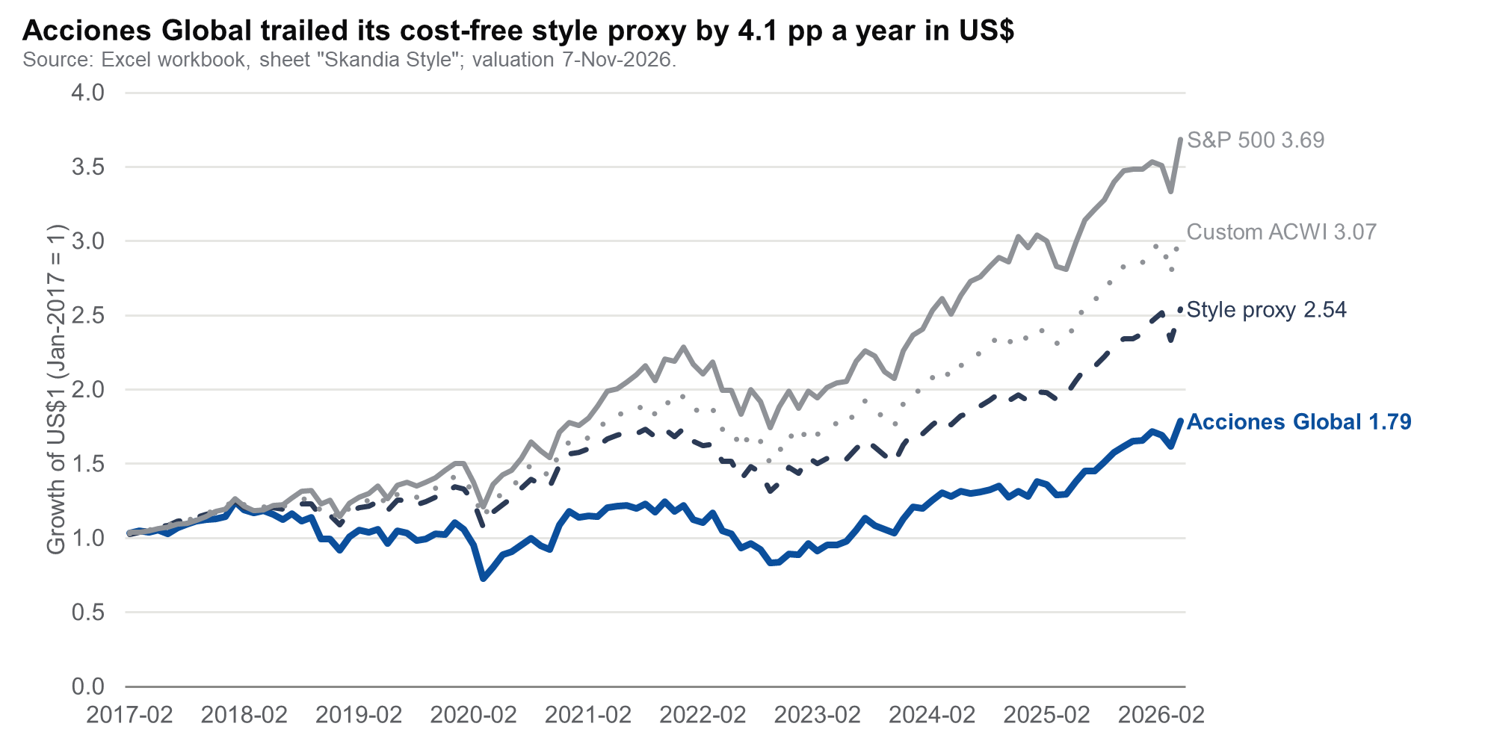
Figure 4. Growth of US$1, Feb-2017 to Apr-2026: Skandia Acciones Global (blue) vs its best-fit style portfolio (dark slate, dashed), the S&P 500 (grey) and the custom benchmark (grey, dotted). Source: Excel, sheet "Skandia Style" (gap table rows 150–153); 7-Nov-2026.
 | LC G | LC V | Intl | EM | Gold | Bonds | Other | Exp. return (nominal) | Risk | Fee | Net return (nominal) | Net Sharpe
Best-fit style (COP) | 45% | 27% | 28% | 0% | 0% | 0% | 0% | 8.19% | 14.4% | 3.0% | 5.19% | 0.08
Recommended (12%) | 30% | 40% | 5% | 5% | 10% | 5% | 5% | 8.03% | 12.0% | 0.2% | 7.83% | 0.32

Does it do what it says, and does allocation add value? It does behave as its mandate says: in pesos it is a global large-cap fund. But its cost-free style copy beat it by 4.1 pp a year in US$ (6.5% against 10.6%), and by 5.2 pp in pesos. US$1 grew to US$1.79 in the fund and to US$2.54 in the copy. The gap is the 3% fee plus the peso hedge, so the manager adds no value beyond cheap index exposure (§7).
Why the recommended portfolio beats holding the fund. There are three reasons:
- Cost. 3.0% against ≈0.2% a year. On a similar gross return, the recommendation keeps 2.6 pp a year more.
- Currency. The fund hedges an estimated ≈63% of its foreign exposure back to pesos (1 − FX beta of 0.37, from a regression of its US$ returns on the benchmark and USD/COP; not a published figure). This brings back the peso risk you want to diversify away: 19.7% volatility in US$, against 14.3% for its benchmark.
- Diversification. Its style holds no gold, bonds or high yield and almost no EM. The recommendation holds 17% in defensive diversifiers plus 5% EM. So the fund's expected risk is 14.4%, against 12.0%.

7. Manager attribution & skill assessment
METHOD: PERFORMANCE ATTRIBUTION
What it is: the fund against the S&P 500 and a matching global benchmark, with the gap (alpha) split into causes.
Why we use it: to separate skill from cost, currency and luck.
What it tells us: alpha is −6.4% a year, explained by the 3% fee and the peso hedge, not by poor stock-picking.

Feb-2017 → Apr-2026, US$, monthly (n = 111) | Fund | S&P 500 | Custom benchmark
Geometric annualised return | 6.5% | 15.1% | 12.9%
Monthly standard deviation | 5.69% | 4.55% | 4.12%
Annualised standard deviation · 99% VaR (annual, parametric) | 19.7% · −39.4% | 15.8% · −21.6% | 14.3% · −20.3%
Alpha (geometric) · tracking error · information ratio |  | −8.7% · 9.8% · −0.89 | −6.4% · 8.7% · −0.74
Batting average · upside / downside capture |  | 42% · 91% / 129% | 41% · 101% / 137%
Beta · Jensen's alpha · Sharpe, geometric (fund 0.13) |  | 1.09 · −9.7% · 0.71 | 1.27 · −8.8% · 0.62
Custom benchmark = a constructed proxy of the fund's official benchmark (95% MSCI ACWI + 5% Colombian interbank rate): 95% × (64% S&P 500 + 26% MSCI World ex-US + 10% MSCI EM) + 5% cash at 4% a year, in US$ (sheet "Skandia Attribution" A2). It is fairer than the S&P 500 because the fund is global; the S&P 500 is shown as the brief requires. Sharpe ratios in this table use geometric returns (rf 4%). Source: Excel, sheet "Skandia Attribution".
Decomposition of the −6.4% a year vs the custom benchmark | Return effect | How it is measured
1. Beta / style (beta to the benchmark, hedge removed = 0.99) | −0.11% | (β − 1) × benchmark return
2. Peso hedge (≈63% hedged, estimated; USD/COP 2,937 → 3,622: +2.3% a year geometric, +3.0% arithmetic mean) | −1.87% | − hedged share × arithmetic mean peso depreciation (0.63 × 2.97%)
3. Fee | −3.00% | Skandia equity portfolios, 3.0% a year
4. Selection (residual) | 0.06% | Arithmetic gap minus 1–3; regression selection alpha +0.03%, t = 0.0 (p = 0.97)
5. Compounding / volatility drag | −1.48% | Geometric minus arithmetic gap: the hedge's extra volatility
Total = geometric alpha | −6.40% | Risk: benchmark beta 52% of variance · hedge 15% · hedge losses in sell-offs 29%

Verdict. For a US$-based investor the fund destroyed value, but through its structure, not through stock-picking. The fee explains 3.0 pp a year. Hedging into a depreciating peso explains 1.9 pp, and the extra volatility of that hedge costs another 1.5 pp through compounding. Selection is ≈0.
The hedge is the hidden risk. Without it, the fund's volatility would fall from 19.7% to 14.5%, in line with its benchmark. The peso tends to fall when markets fall (correlation −0.52 between monthly USD/COP changes and the custom benchmark). Your Acciones USA and Europa portfolios share this structure. By the same regression they are ≈61–62% hedged, carry the same 3% fee and are not index trackers (beta 0.71/0.81, R² 0.82/0.79 in pesos; sheet "Skandia Managers Attribution"). This is why the realistic plan trails the frictionless target (§8.1–8.2), and why an unhedged Skandia option is the first lever to review.
Is the underperformance luck? No. The net alpha of −7.4% a year is statistically significant (Figure 4b; t = −3.1 with Newey-West errors, p < 0.01), so your loss against a cheap global index is real. Before the fee, alpha is −4.4% (p = 0.07). Before fee and hedge, the selection alpha is +0.03% (t = 0.0, p = 0.97). So the data show neither skill nor its absence: an information ratio (IR) as small as the selection IR (≈0.01) would need tens of thousands of years of data to prove.
Sharpe ratios tell the same story. With Lo's (2002) method, the Sharpe ratio is 0.24 for the fund [−0.47; 0.94] and 0.78 for the benchmark [−0.01; 1.57]. They use arithmetic monthly excess returns (annualised with Lo's autocorrelation factor); the table above uses geometric returns (0.13 and 0.62), so compare within one definition only. The difference is significant (Memmel test z = −3.1, p = 0.002) because the two series are highly correlated. The decision therefore rests on cost and currency.
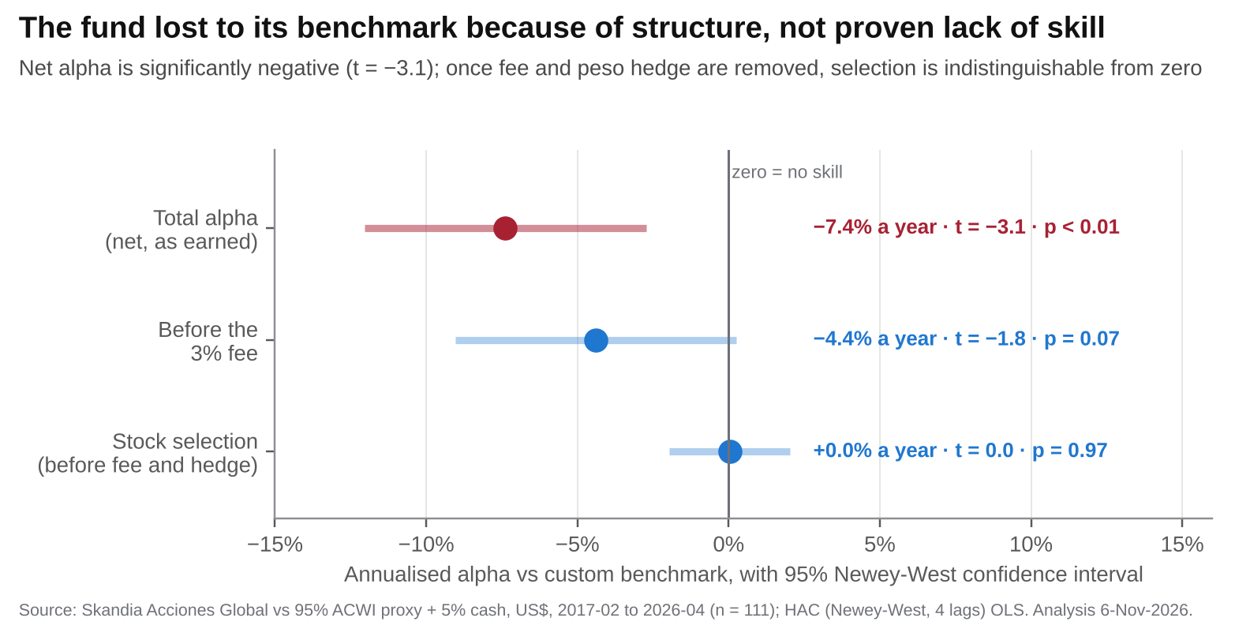
Figure 4b. Skandia Acciones Global vs its custom benchmark (95% ACWI proxy + 5% cash, US$, Feb-2017 to Apr-2026, n = 111): annualised regression alpha with 95% Newey-West (4 lags) confidence intervals, net, before the 3% fee, and before fee and peso hedge (selection). Regression alphas are arithmetic and therefore differ from the geometric figures above. Source: Excel "Skandia Attribution" and "Robustness Extras" (computed in Python); analysis 6-Nov-2026.

8. Recommendation
METHOD: MONTE CARLO SIMULATION
What it is: 10,000 simulated paths of markets and the peso, using your actual savings, fees and cash.
Why we use it: to estimate the chance of reaching US$1.2m by 55, and which levers close the gap.
What it tells us: 71.6% success, below the 80% target; US$1,700 a month and retiring at 56 lift it to 82%.

Target. The 12%-risk efficient portfolio: 30% US LC Growth, 40% LC Value, 3% SC Value, 5% International, 5% EM, 10% Gold, 5% Bonds and 2% High Yield. From 45 to 55 it glides to the 8% frontier portfolio.
How we get there. On eToro we use new money only: no sales, so no tax. eToro cash above the 10% band (US$1,505) is invested now, and US$4,767 stays as cash. Skandia stays as it is. That is your decision, not our advice; §8.1 shows what it costs.

8.1 Funding gap: will the plan reach US$1.2m?
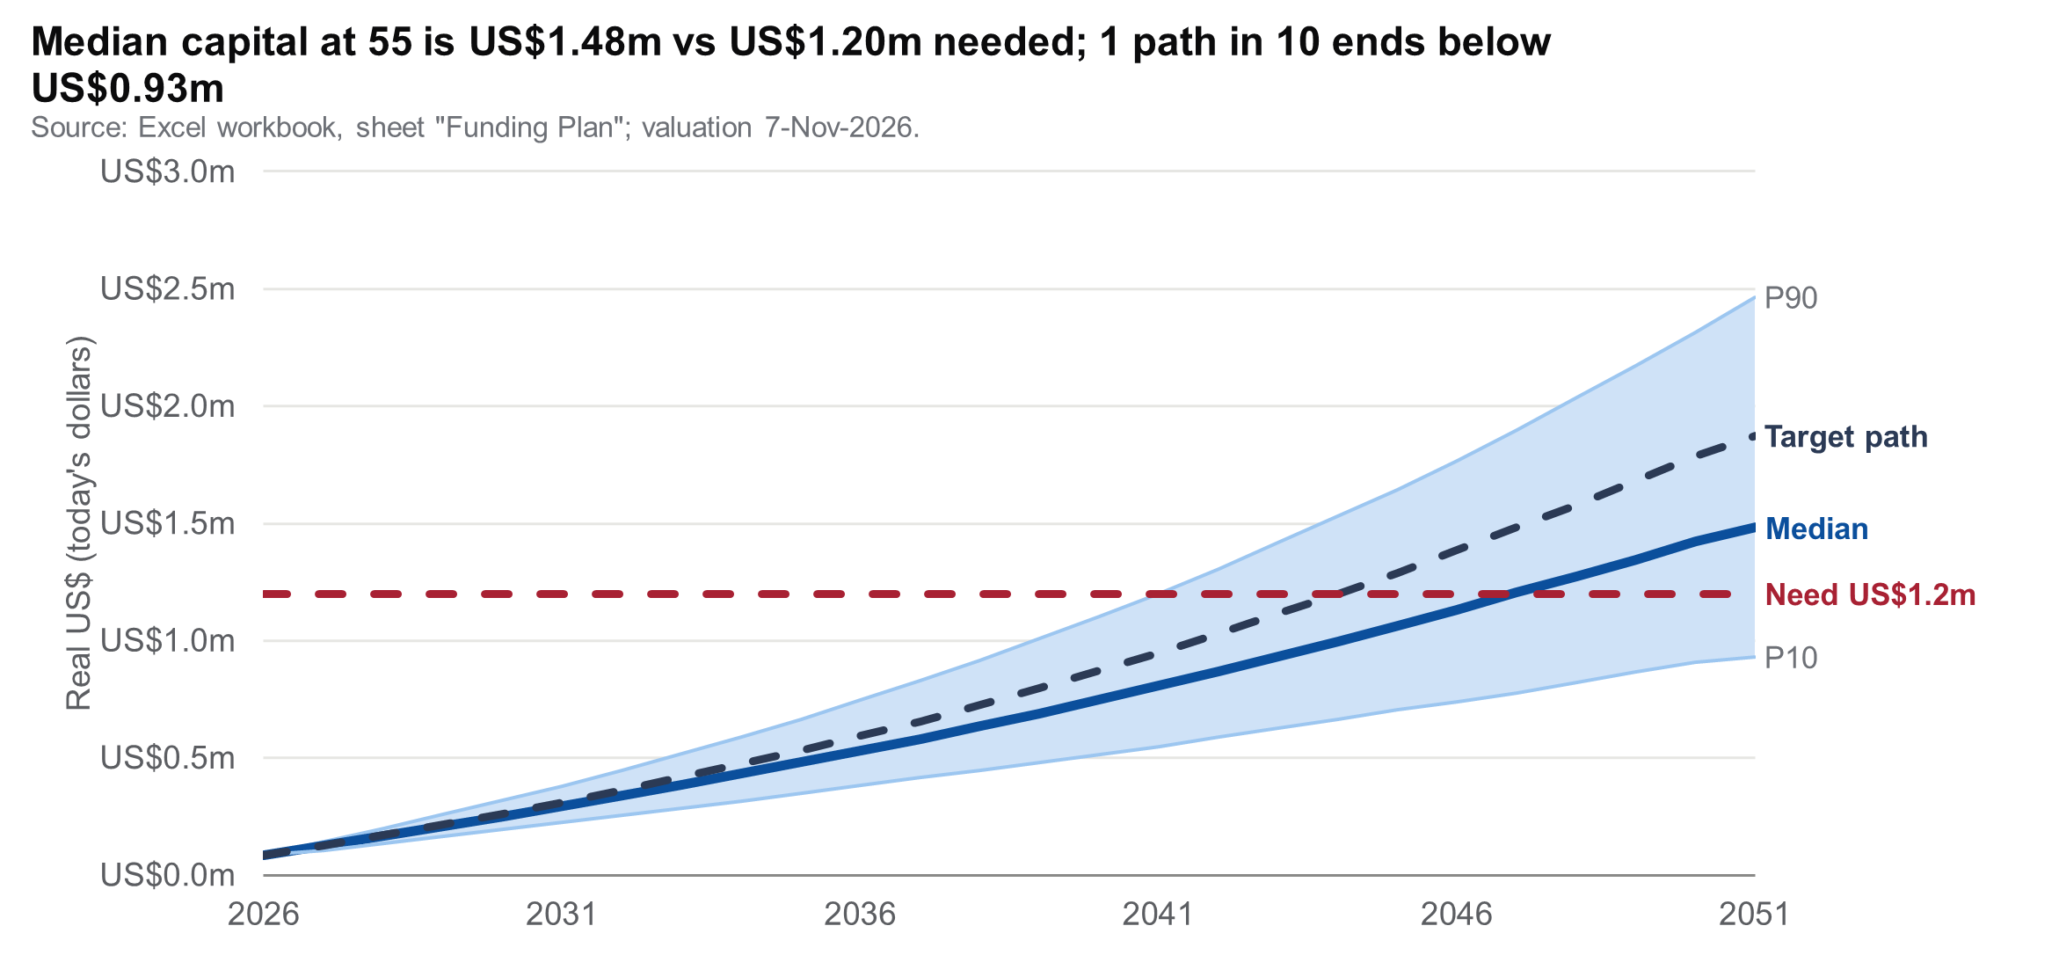
Figure 5. Real wealth percentiles to age 55: actual transition (blue line: median; light-blue band: 10th–90th percentiles), target glide path (dark slate, dashed) and the US$1.2m need (red, dashed). Source: Excel, sheet "Funding Plan" (deterministic projection live; Monte Carlo pasted from Python, 10,000 paths, labelled); 7-Nov-2026.
How we modelled it. We start from US$85,298: eToro including cash (US$45.3k), Skandia (US$21.4k at USD/COP 3,228.26) and the Dec-2026 contribution (US$18.6k). We then simulate 10,000 annual paths with the course returns, volatilities and correlations. We add a real US$/peso factor (volatility 12%, mean-reverting, correlated with the classes as in 2017–2026) and a separate shock for cash.
Costs are charged where you pay them: Skandia equity 3.0%, Liquidez USA 1.9%, eToro 0.2% plus 0.75% on deposits. Skandia equity is ≈63% hedged to pesos (regression estimate, §6), so it loses 0.63 × the real peso depreciation. From 55 to 95, the money sits in the 8%-risk portfolio.
At age 55, real US$ | P10 | Median | P90 | P(≥ US$1.2m) | Lasts to 95 | Income P50 / P10
Target, US$1,500/month only (no Skandia contributions) | US$653k | US$1,007k | US$1,584k | 31% | — | US$2,937 / US$1,904
Target glide path, low-cost vehicles (frictionless) | US$1,195k | US$1,874k | US$2,978k | 89.8% | 96% | US$5,466 / US$3,486
Target held through Skandia vehicles (fees + hedge) | US$950k | US$1,482k | US$2,353k | 72.4% | 88% | US$4,322 / US$2,771
Actual transition (realistic plan) | US$931k | US$1,482k | US$2,465k | 71.6% | 88% | US$4,321 / US$2,715
Gap (realistic plan): median surplus US$282k (+23%); 10th-percentile gap −US$269k (−22% of the need). Sustainable income = capital × 3.5% / 12. Deterministic check: target US$1.99m, transition US$1.69m.
Lever (actual transition model) | For 80% success | For 90% success
Current plan: US$1,500/month, retire at 55, US$3,500/month | 71.6% today | lasts to 95: 87.5%
(a) Spend less: affordable portfolio income | US$3,185/month (−315) | US$2,715/month (−785)
(b) Save more: eToro contribution | US$1,758/month (US$1,700 gives 78.3%) | US$2,246/month
(c) Retire later | age 58 (83.0%; 58: 83.0%) | age 61 (60: 88.4%; 65: 95.5%)
(d) Spouse contributes more | US$1,815/month (vs 1,500) | US$2,285/month
(e) Realistic combination: US$1,700/month and retire at… | 56 (82.0%) | 60 (91.8%)

Real peso depreciation per year | −2% | −1% | 0% (base) | +1% | +2%
P(≥ US$1.2m), actual transition | 84% | 78% | 72% | 65% | 59%
Median capital at 55, actual transition | US$1.73m | US$1.59m | US$1.48m | US$1.39m | US$1.31m
P(≥ US$1.2m), target (frictionless) | 94% | 92% | 90% | 87% | 85%
Skandia COP 60m contribution in year 10, real US$ | US$23k | US$21k | US$19k | US$17k | US$15k
Positive = the peso loses value in real terms. The realistic plan is more exposed than the target because ≈22–26% of wealth is peso-hedged Skandia equity and the Skandia contribution is fixed in pesos.
What it means. The goal is reachable, but below the 80% standard. At 72%, roughly one path in four falls short, most likely a weak peso combined with a poor decade for equities.
Which levers work. Saving the stated maximum (US$1,700) adds ≈7 pp. Retiring three years later adds ≈11 pp; it is the strongest lever available today. The Skandia structure costs more (90% → 72% for the target mix), but it is locked until 2035. Taking more risk is not a lever, because the frontier is flat above 12%. Each 1 pp a year of real peso depreciation costs ≈6 pp of success.
How precise is this? With 10,000 paths, the standard error √(p(1−p)/N) is 0.45 pp at 71.6% success (95% interval ±0.9 pp). US$1,700 with retirement at 60 reaches 91.8%, above 90% beyond Monte Carlo sampling error (95% interval ±0.5 pp).

8.2 Target portfolio vs the actual transition
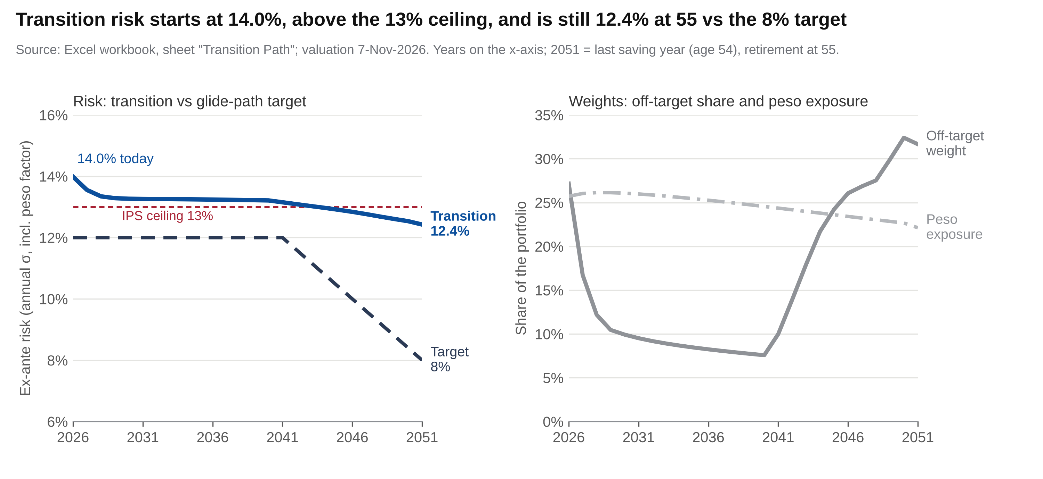
Figure 6. Left: ex-ante risk of the actual transition (blue; includes the peso factor of the hedged Skandia sleeve) vs the glide-path target (dark slate, dashed) and the 13% IPS ceiling (red, dashed). Right: share of the portfolio still off-target (grey; cash counts as off-target) and peso exposure (grey, dash-dot; hedged Skandia equity). Source: Excel, sheet "Transition Path" (Python values, labelled); 7-Nov-2026.
Year (age in year) | Target σ | Transition σ (incl. peso factor) | Off-target | of which cash | Peso exposure | Wealth: transition (deterministic) | Wealth: target (deterministic) | P10 transition / target (Monte Carlo)
2026 (29) | 12.0% | 14.0% | 27% | 12% | 26% | US$85k | US$85k | US$85k / US$85k
2031 (34) | 12.0% | 13.3% | 10% | 8% | 26% | US$301k | US$315k | US$225k / US$242k
2036 (39) | 12.0% | 13.2% | 8% | 7% | 25% | US$560k | US$610k | US$382k / US$427k
2041 (44) | 12.0% | 13.2% | 10% | 6% | 24% | US$874k | US$991k | US$548k / US$639k
2046 (49) | 10.0% | 12.8% | 26% | 6% | 23% | US$1,252k | US$1,462k | US$740k / US$901k
2051 (54, last saving year) | 8.0% | 12.4% | 32% | 6% | 22% | US$1,688k | US$1,987k | US$931k / US$1,195k

What the transition really delivers. This risk figure includes the peso exposure of the hedged Skandia funds, which the nine-class figure in §3 (11.97%) leaves out. It starts at 14.0%, above the 13% IPS ceiling. It falls to 13.3% by 2031 and stays slightly above the ceiling until 2044 (age 47).
New money works fast. 27% of the portfolio is off-target today, 10% after five years and 8% after ten. New money quickly dilutes the eToro growth overweight; what remains is mostly the cash kept in the band and Liquidez USA.
Skandia is the weak spot. It is ≈87% equity, 63% hedged to pesos, and it never de-risks. So from 45 the gap reopens (32% at 54), and at retirement the transition still carries ≈12.4% expected risk against the 8% target. Wealth at 55 is 15% lower than the frictionless target in the deterministic projection (21% at the Monte Carlo median), because of Skandia fees, the hedge and idle cash.

8.3 Implementation plan and behavioural risks
Done (October) | Amount | Model mapping | Effect
Skandia: peso money market → Acciones USA 75% / Europa 12.5% / Liquidez USA 12.5% as instructed (74.3/12.8/12.9 on the 7-Nov statement; kept as-is) | COP 69.1m ≈ US$21.4k (7-Nov value) | LC Growth/Value 50/50; Intl; Cash | Peso cash becomes US$ equity and US$ cash
eToro: buy Bank of America (BAC) | US$500 | LC Value | First step of the value rotation

- Invest the eToro cash above the 10% band (US$1.5k; keep US$4.8k) and the US$1,500 monthly contribution in LC Value (a broad value exchange-traded fund, ETF, such as VTV) and gold (GLD) until both reach target. Stop adding to growth and technology, and to NU, which is above the 8% position limit.
- Raise the contribution to US$1,700 and plan to retire at 56 (82% success; 60 for 90%). Check progress at each semi-annual review (April and October) against the "Funding Plan" sheet.
- Skandia: keep the as-is mix. This is your decision, not our recommendation; §8.1 shows its cost. Pay the December COP 60m pro rata into it. A switch to unhedged US$ exposure is an optional lever, not assumed. Use the remaining pension-plan tax allowance before 31-Dec.
- From age 45, follow the glide path: 12% → 8% risk over ten years, new money first, then sales by tax lot. After 2035, move the unlocked Skandia balance to US$ bonds.
RISKS AND BEHAVIOURAL BIASES
Model and market risks. One set of assumptions; normal returns understate tails (§5); correlations can break down in crises; frictions (FX spread, taxes, Skandia fees and unit-price lag); and regret if technology keeps rallying while you are underweight.
Biases to watch. Recency bias (the 30% LC Growth cap is the antidote). Home and familiarity bias (peso cash, NU). Overconfidence (42 self-picked lines on one theme). Disposition effect: reluctance to sell losing positions such as LAC and NKE. Loss aversion in a 2008-type fall: we agree now not to sell, and to rebalance into the fall. Monitoring: a semi-annual review plus alerts in the monitoring app (Appendix A).

9. Conclusion
You are a long-horizon investor. Your portfolio is close to the target risk on the nine asset classes (14.0% including the peso exposure of the Skandia funds), but the mix is wrong: too much US growth, too little value and gold, and 14% in cash. The 12%-risk efficient allocation adds about 33 bp a year.
Whether the goal is funded depends on saving, not on the portfolio. With US$1,500 a month alone it is not (31%). With the COP 60m Skandia contributions, the realistic plan reaches US$1.2m in 72% of scenarios, and 82% with US$1,700 and retirement at 56. Risk must come down from 45, and a weaker peso is the risk most specific to your plan. Keeping Skandia as it is was your decision: its 3% fee and peso hedge cost about 17 points of success for the target mix (§8.1).
Data: Bloomberg monthly total-return indices (course workbook, to Apr-2026); course assumptions (J.P. Morgan 2026 LTCMA blend); eToro connector (7-Nov-2026, Friday 6-Nov close) and the client's Skandia statement balances for the single 7-Nov-2026 valuation, USD/COP 3,228.26 (TRM vigente 6-Nov, last published, datos.gov.co); Skandia fact sheets and fee table. Model estimates, not forecasts. Educational exercise, not regulated advice.

Appendix A — AI & investment analytics tool (Part VI)
What it automates. Two tools take over steps an adviser would otherwise repeat by hand. Client Portfolio Risk Lab takes a client's weights and returns, in one step, the frontier position, Sharpe ratio, parametric and historical VaR/ES, stress losses and an efficient alternative, without running Solver by hand. The course assumptions and 30-year history are built in, and the optimiser runs in the browser.
Control Patrimonial is a read-only monitoring app that turns the IPS into a nightly rules-based check. It reads eToro positions via a connector, and Skandia unit values and the USD/COP rate from Superfinanciera. It raises alerts (bands, cash 2–10%, concentration), and its "Goal" tab runs the same funding model as §8.1 (cash class included) from the latest snapshot. It proposes orders and never executes them.
Public site (landing page and deliverables): https://nicolasarenasg07-maker.github.io/ie-am-client-na/
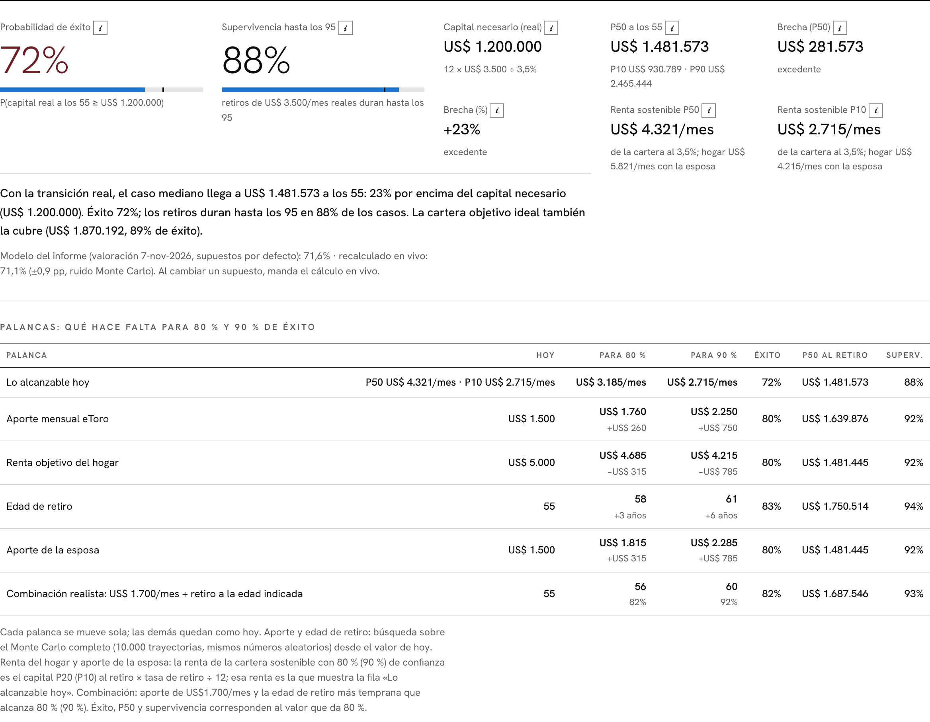
Figure A1. Monitoring app, "Goal" tab (Spanish view), valuation date 7-Nov-2026. The app now shows the frozen results of the report's 7-Nov model run: 71.6% success; US$1,758 and US$2,246 a month for 80% and 90% (rounded in the app); US$1,700 and age 60 for 90%. These come from the 10,000-path Python model run (seed 20261104) pasted in the Excel "Funding Plan" sheet. Live recalculation, with the app's own random draws, is shown as a secondary line and takes over when an assumption is changed.
Validation: tool / Python engine vs Excel workbook | Tool / Python | Excel | Difference
As-found / recommended expected return | 6.6182% / 8.0303% | 6.6180% / 8.0303% | <0.0001
Current 7-Nov expected return / risk (cash class) | 7.7034% / 11.9743% | 7.7034% / 11.9743% | <0.0001
Recommended historical VaR / ES 99% (monthly) | −8.5060% / −12.8884% | −8.5060% / −12.8884% | <0.0001
VWELX best-fit R² (Python vs live RSQ) | 93.879% | 93.879% | <0.0001
Skandia alpha / IR vs custom benchmark | −6.40% / −0.736 | −6.40% / −0.736 | <0.0001
Deterministic capital at 55, target (Funding Plan) | US$1,987,375 | US$1,987,377 | 0.0001%
Starting capital incl. Dec-2026 Skandia contribution (Funding Plan B24, live) | US$85,298 | US$85,298 | US$0

DISCLOSURE
AI-use disclosure. Claude (Anthropic) was used as an assistant throughout this assignment: to write and run the Python and JavaScript code (Monte Carlo, optimisation checks, resampling and statistical tests), to retrieve and organise market data, to build the Risk Lab and monitoring app, to produce the charts, and to help draft and edit the report text. The student defined the client case, objectives, constraints and assumptions, made the investment decisions, reviewed and edited the text, checked the results against the Excel model (validation table above) and is responsible for the final content.

Appendix B — Methodology notes and workbook map
Workbook tab | What was done
Client IPS · EF Model · EF Output | Questionnaire, IPS and intake holdings; goal block (US$3,500/month, US$1.2m, linked to Funding Plan); return target and currency table (N48:Q60); course blend for return, risk and correlation; client constraints; Solver frontier 6–13.5% (the 13.5% point is inefficient and is not plotted); row 16 recommended, row 20 current 7-Nov (live, cash in column M).
Current 7-Nov | 42 eToro lines + cash, three Skandia portfolios (statement balances / USD/COP), class mapping with a cash class (T-bill proxy, H13:I21), live E[r]/σ/Sharpe, risk figures (Python, labelled), cash-method bridge (cash as Bonds vs cash class), allocation bar chart (Figure 1) and allocation pie charts (Figure 1b, helper V13:X20).
Robustness · Robustness Extras (new) | Optimum at 12% under four return sets; corner-solution check (7 of 9 weights at a bound); Sharpe comparison. Extras (values computed in Python, extras_v8.py): resampled frontier, alpha significance, Cornish-Fisher VaR and Kupiec backtest (Figures 2b, 3b, 4b).
Funding Plan · Transition Path | 25-year deterministic projection with live formulas; funding gap; Monte Carlo, levers 80/90% and peso sensitivity (Python, labelled); transition year by year incl. cash share (Figures 5–6).
VaR Histogram · Historical VaR | 1% bins of 361 monthly returns vs the normal; VaR lines, skew, kurtosis (Figure 3); 10/20/30-year VaR/ES; note on which parametric row is official.
Skandia Style · Skandia Attribution · VWELX Style (new) | Max-R² style in US$ and pesos, fund-vs-proxy gap (rows 150–153), three reasons; attribution decomposition (live); VWELX best fit with live R² and cumulative chart.

- Monte Carlo (model_v8.py): annual steps; 9 classes + real US$/peso factor (Cholesky of the 10×10 covariance; AR(1) φ 0.8, σ 12%) + an independent cash shock (4.0%, σ 0.5%); Skandia equity US$ return = class return − 3% − 0.63 × real depreciation; Liquidez USA = cash − 1.9%, unhedged; eToro cash above 10% of the eToro account invested at the start, the rest kept as cash; contributions at year end with half a year of return; new eToro money to the underweights vs the glide target on total wealth; US$42,000 withdrawn at the start of each retirement year. Levers by bisection with common random numbers.
- Current portfolio (valuation 7-Nov-2026): eToro US$47,671 (connector 7-Nov, Friday 6-Nov close) incl. US$6,272 cash and US$2,359 crypto, plus Skandia COP 69,083,797 (client statement, 7-Nov-2026: Acciones USA 74.3% / Europa 12.8% / Liquidez USA 12.9%) at USD/COP 3,228.26 (US$21,400); modelled capital US$66,712. New symbol: BAC → LC Value.

Appendix C — Supporting analysis

C1. Style analysis of a supplied multi-asset fund: Vanguard Wellington (VWELX)
VWELX, Apr-1996 to Apr-2026 | LC G | LC V | Intl | EM | Gold | Bonds | HY | R² | Fund return | Style return | Tracking error
Best fit, 30 years (sheet "VWELX Style") | 9% | 45% | 4% | 1% | 0% | 33% | 8% | 93.9% | 9.0% | 7.7% | 2.5%
Course template, 1988–2026 (sheet "Style Analysis") | 10% | 47% | 2% | 0% | 1% | 34% | 7% | 93.8%
VWELX behaves as its balanced mandate says (≈59% equity, mostly US large-cap value, ≈41% bonds and high yield; R² 94%) and, unlike the Skandia fund, beat its cost-free style proxy by 1.4 pp a year.
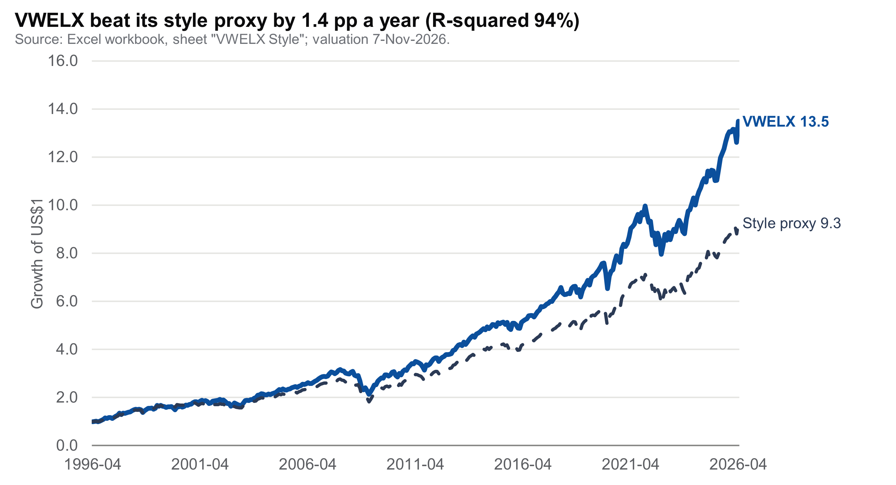
Figure C1. Growth of US$1: VWELX vs its best-fit style portfolio. Source: Excel, sheet "VWELX Style"; 7-Nov-2026.

C2. Other supporting figures
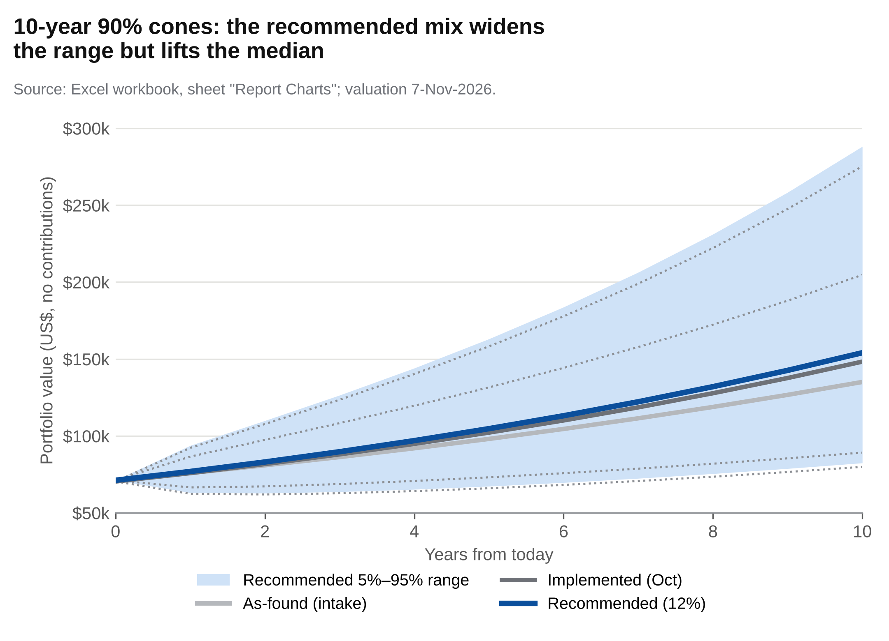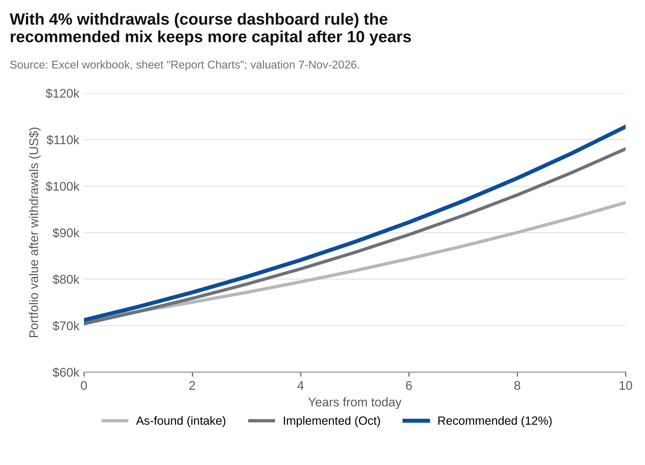
Figure C2. Course "Client Outcome dashboard": 10-year 90% cones (no contributions; recommended 5–95% range shaded light blue, as-found and implemented 5%/95% bounds dotted grey) and 4% withdrawals for the as-found (light grey), October-implemented (dark grey) and recommended (blue) portfolios, in US$ without contributions. The 4% withdrawal is the course dashboard's rule; the IPS uses 3.5% (§2, §8.1). Source: "Report Charts".
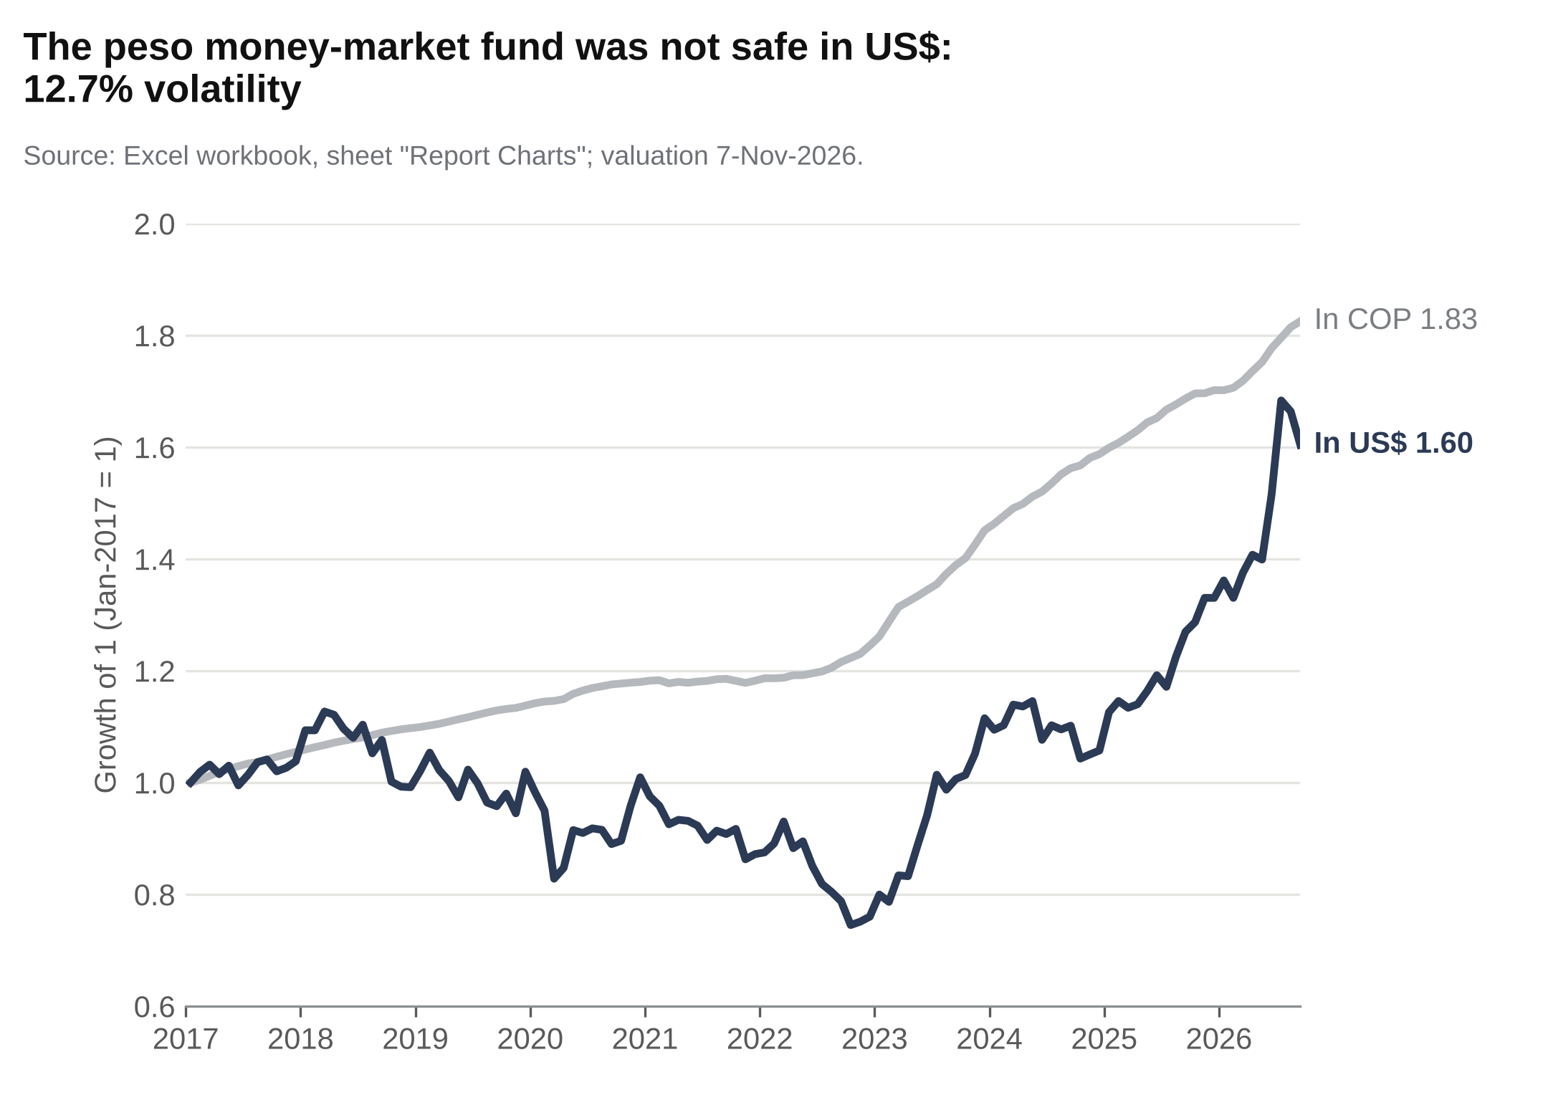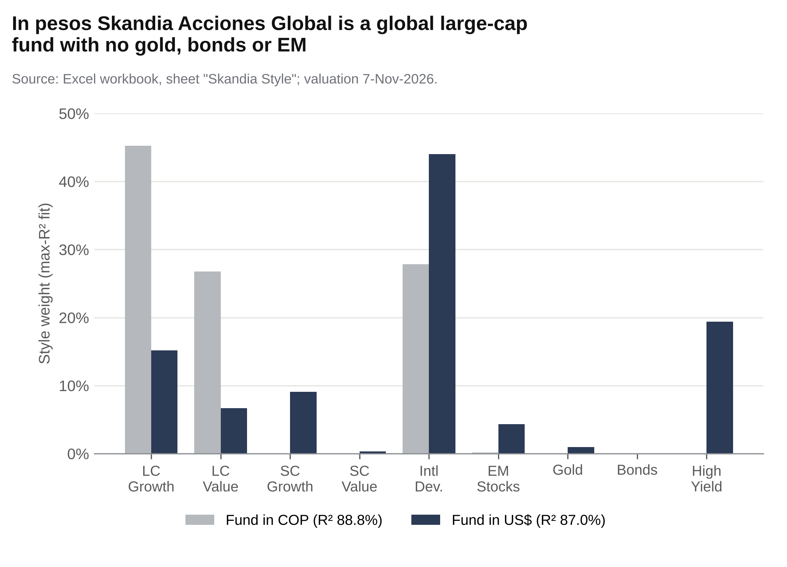
Figure C3. Left: the peso money-market fund held at intake, +6.4% a year in pesos but +5.0% in US$ with 12.7% volatility. Right: Skandia Acciones Global best-fit style weights in pesos (grey) and US$ (dark slate); in US$ the fit spreads currency noise into small caps, EM, gold and high yield. Source: "Report Charts" and "Skandia Style".

C4. Glide path (IPS)
Glide path (age during the year) | ≤44 | 45 | 47 | 49 | 51 | 53 | 54 (last saving year)
Target volatility | 12.0% | 11.6% | 10.8% | 10.0% | 9.2% | 8.4% | 8.0%
Expected nominal return | 8.03% | 7.93% | 7.72% | 7.49% | 7.25% | 7.00% | 6.88%
Equities (US + Intl + EM) | 83% | 78% | 69% | 62% | 56% | 51% | 48%
Bonds + High Yield | 7% | 12% | 21% | 28% | 34% | 39% | 42%
Annual VaR99 (parametric) | −19.9% | −19.1% | −17.4% | −15.8% | −14.2% | −12.6% | −11.8%
Glide-path weights interpolated on the IPS-constrained frontier; 2008 replay of the 8% portfolio −31%, of the 7% portfolio −26%.

