|  |  |
| --- | --- |
| **GPC JAPAN CARS EXPORT**  **Address: Edogawaku Komatsugawa 3 Chome, Minato-Ku,**  **City: Tokyo, Japan**  **Post code: 1320034**  **Email: jpangps@gmail.com , assanirahman07@gmail.com**  **Tel: +819083267671, 09063480459** |  |

|  |  |  |  |  |
| --- | --- | --- | --- | --- |
|  | **PROFORMA INVOICE** | |  | |
|  | | **Invoice Number** | | 000023421 | |
| ***Delivery port****:* | | **Date** | | 2025/01/31 | |

|  |  |  |  |  |
| --- | --- | --- | --- | --- |
| **INVOICE TO** | |  |  | **BANK ACCOUNT DETAILS** |
| **Full Name:** | **Foundation ETIENNE TSHISEKEDI** | **Account No** | 047-0176600 |
| **Address:** | CONGO DR | **Account Name** | ASSANI MUSUSA PATRICK |
| **Phone :** | +2439785655751 | **Bank Name** | MUFG LTD |
| **Email :** | contact@fondation-etiennetshisekedi.org | **Branch** | HIROO |
| **Country :** | DR Congo | **Address** | 4-1-1 Minami Azabu Minato- Ku Tokyo |
|  |  | **Country** | Japan |
|  |  | **Swift code** | BOTKJPT |

|  |  |  |  |  |
| --- | --- | --- | --- | --- |
| **DESCRIPTION** | | **Qty** | **Price (USD)** | **Amount (USD)** |
| **Minibus Toyota coaster 2021 model (neuf)** | | **15** | **70,000** | **1,050,000** |
| **2024 TOYOTA LAND CRUISER 70 3DA-GDJ76W 4WD (neuf)** | | **20** | **75,000** | **1,500,000** |
| **Remorque tête de marque Toyota ou Mitsubishi FUSO (neuf)** | | **15** | **95000** | **1,425,000** |
| **2024 Toyota Land Cruiser 300 (neuf)** | | **20** | **100,000** | **2,000,000** |
|  | |  |  |  |
|  | |  |  |  |
|  | | | TOTAL | $5,975,000 |
| **Amount in words**: five million nine hundred seventy-five thousand. | | | | |
| **TERMS AND CONDITIONS** |  | | | |
| Payment must be done within 10 days |  | | | |
| Please include our invoice number on the check |  | | | |

**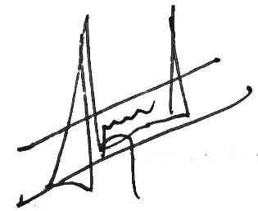*NB : Veuillez noter que le montant indiqué sur la facture proforma inclut uniquement le prix d'achat des marchandises. Les frais d'expédition ne sont pas inclus et seront facturés séparément.***

**MANAGER**

**THANKS FOR DOING BUSINESS WITH US.**