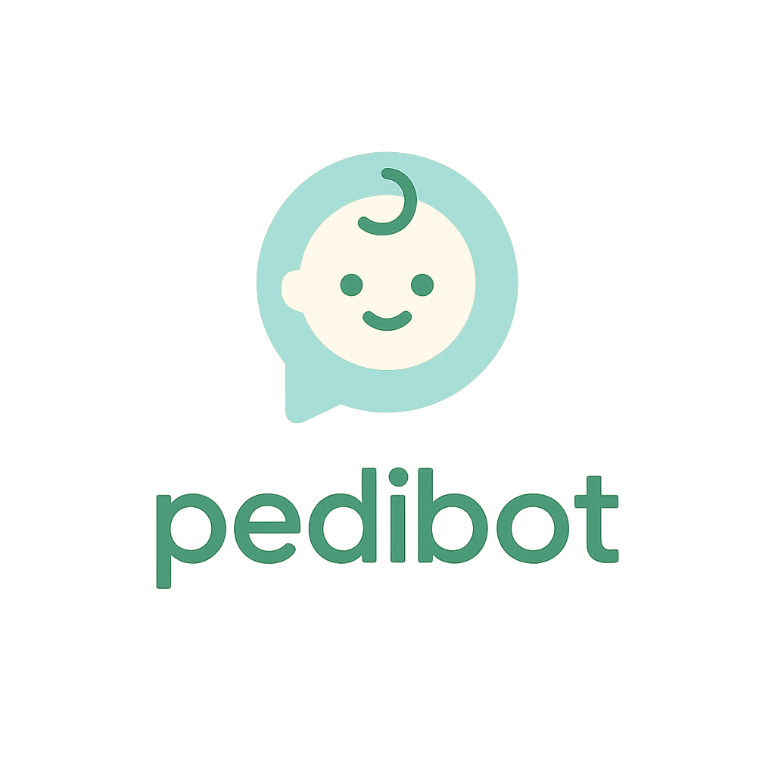
Project Presentation

Executive Summary
PediBot is an AI-powered pediatric assistant that helps parents and caregivers make confident, informed health decisions for their children.
With over 100+ daily active users and a 9.8% CTR from Meta Ads, PediBot has already demonstrated strong product-market fit.
The project integrates artificial intelligence, verified medical data, and Web3 tokenization to create a scalable, transparent, and community-driven ecosystem.
By enhancing the product experience, expanding monetization channels, and leveraging anonymized data insights, PediBot aims to become a global reference in digital pediatric assistance.

1. Project Vision
PediBot’s mission is to empower families by offering trusted, immediate pediatric guidance — anytime, anywhere.
The assistant provides clear and reliable information on symptoms, nutrition, medications, and first aid, all verified by recognized medical sources.
It is designed not to replace doctors, but to serve as a first point of reference, reducing uncertainty and unnecessary visits.

2. Problem & Opportunity
Parents often struggle to interpret symptoms, especially at night or during weekends, unsure whether professional care is urgently needed.
Online information can be overwhelming and unreliable, while medical attention is not always immediately accessible.
PediBot solves this gap by offering a trusted, AI-driven tool that delivers verified guidance and clear next steps.
The early traction — over 100 daily users and confirmed affiliate sales — demonstrates both need and monetization potential.

3. Current Status
- Functional live product with growing daily active users.
- Meta Ads campaign with ~9.8% CTR, confirming audience engagement.
- 50+ childcare products integrated through Amazon Affiliates.
- Implemented features: dose calculator, percentile growth tracking, and pediatric health protocols.
- Referral system under development for professional pediatric consultations.
- Tokenization model under implementation to support financing, community incentives, and liquidity.

4. Tokenomics
Funds raised will be used to strengthen the PediBot ecosystem and ensure long-term growth.
The following allocation represents the current model for capital use and distribution (linear unlock between $2M and $160M FDV):
- Reserve Wallet – 25% → Used for strategic buybacks to support token stability and the chart.
- Advisors – 15% → Web3, medical, legal, and strategic support.
- Project Scaling Wallet – 60% → Partnerships, development, and project expansion.
Funds are distributed in stablecoins or other tokens after automated limit sells of the main project token.
Transaction fees generated by token volume are divided 50% to the team and 50% to the Reserve and Project Scaling Wallets.

5. Mechanism
The capital distribution follows a linear unlock model between $2M and $160M FDV.
The Reserve Wallet supports token stability through strategic buybacks, while the Project Scaling Wallet funds partnerships, product growth, and ecosystem development.
This structure ensures controlled liquidity, continuous reinvestment, and market confidence.

6. Use of Funds
Funds will be strategically deployed to strengthen PediBot’s position, accelerate user growth, and enhance the product experience:
- Website Upgrade: Redesign to create a modern, user-friendly, and visually appealing interface.
- AI Enhancement: Enable responses that include images and graphs for better understanding.
- Brand Development: Build a strong identity with professional illustrations and cohesive design.
- Data & Analytics: Record and analyze all user queries to monitor system performance and trends.
- Data Monetization: Explore partnerships to sell anonymized datasets to research and statistical institutions.
- Marketing & Partnerships: Expand outreach, scale campaigns, and secure collaborations that drive adoption.

7. Roadmap / Key Milestones
Period | Key Objectives
Q4 2025 | Public launch of the stable chatbot version in Spain. Initiate token model: issuance, reserves, buybacks, liquidity. Optimize metrics (users, retention, satisfaction). Expand affiliate catalog and pilot medical referrals.
Q1 2026 | Full website redesign and UX upgrade. Introduce AI responses including images and graphs. Launch medical consultation service and refine billing process.
Q2 2026 | Implement animated illustrations for pediatric guidance (e.g., how to handle common conditions). Integrate data analytics dashboard to study user behavior and performance.
Q3 2026 | Begin anonymized data monetization with selected institutions. Scale token utility programs and partnerships for user rewards and engagement.
Q4 2026 | International expansion to new Spanish-speaking markets. Strengthen brand ecosystem, partnerships, and sustainable revenue channels.

8. Future Vision
PediBot aims to become the leading digital reference for pediatric health guidance worldwide.
The combination of AI precision, medical credibility, and Web3 incentives creates a scalable model that can expand to multiple markets and languages.
As user data grows, anonymized insights may evolve into a valuable resource for healthcare and research institutions — adding a new vertical for long-term growth.

9. Team
Nicolás Bk – Founder / Product & AI Lead
Architect by training and new father, inspired by real parenting needs to develop a trusted AI companion for child health.
Oversees AI development, product strategy, UX, and marketing.
Works with advisors across Web3, medical, and legal sectors to ensure sustainable and compliant project growth.

10. Key Risks & Mitigation
- Medical reliability: Verified sources, clear disclaimers, and professional referrals.
- Regulation & data privacy: Legal advisory, compliance, and privacy-by-design.
- Token adoption: Real-world utility (discounts, access, rewards).
- User acquisition cost: Optimize campaigns, monitor CAC vs LTV, and improve retention.
- Scalability: Lean operation and controlled expansion.

11. Conclusion
PediBot integrates artificial intelligence, medical expertise, and tokenized incentives into one comprehensive ecosystem.
With verified guidance, growing traction, and a roadmap focused on innovation and global scalability, PediBot stands out as a pioneering project redefining digital pediatric care.

Contact
Thank you for your attention.
For partnership or investment inquiries, contact us at pedibot.ai@gmail.com

