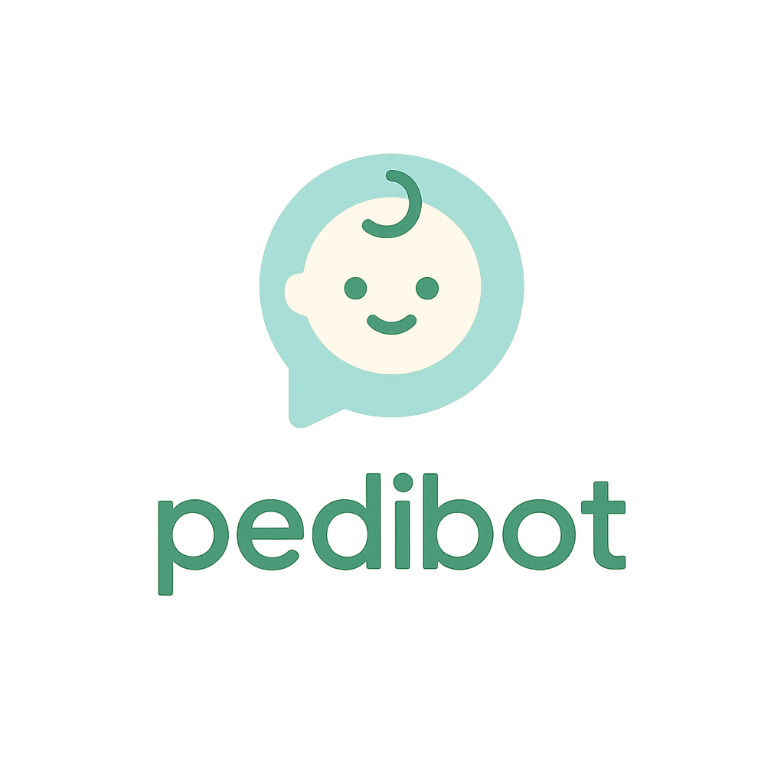
Project Presentation

1. Project Vision
PediBot is an AI‑based conversational assistant designed to support mothers, fathers and caregivers in everyday pediatric care. It offers immediate and reliable orientation on common child health concerns — symptoms, fever, nutrition, medications, first aid, etc. — aiming to reduce uncertainty and enable informed decision‑making.
PediBot operates 24/7 on any device. It does not replace professional medical consultation but serves as a useful first‑step guide.
All responses are backed by verified medical sources and recognized clinical protocols, and delivered in clear, accessible language suitable for family users.

2. Problem & Opportunity
- Many families face uncertainty when interpreting children’s symptoms, especially at unusual hours, and worry about whether medical attention is urgent or not.
- Online health information is abundant but varies in quality; parents may distrust sources that are not clearly referenced or verified.
- A specialized chatbot with medical backing can function as a first filter, reducing unnecessary medical visits, alleviating anxiety, and improving decision confidence.
- Initial uptake (over 100 active daily users with minimal advertising) demonstrates real demand.
- The Meta Ads campaign produced a CTR of ~9.8%, indicating strong resonance with the target audience.
- Early revenue via product affiliation confirms that monetization is viable at early stages.

3. Current Status
- A functional product is in real‑use stage; daily active users exceed 100.
- Advertising campaigns are live and delivering high click‑through performance.
- 50 childcare‑related products integrated via Amazon Affiliates; some confirmed sales.
- Medical functionalities implemented: dose calculator, child growth percentiles, pediatric health protocols.
- System in design to refer users to rated pediatric professionals when needed.
- Tokenization is being launched as a core financing and incentive mechanism for the ecosystem.

4. Business Model & Monetization
PediBot combines multiple revenue streams and integrates tokenization from the outset.

4.1 Tokenization / Web3
- Tokens are issued as part of the ecosystem to enable participation, incentives and direct financing.
- Funds raised via tokens or crypto (e.g. USDC) are used to develop, market, and maintain liquidity in the ecosystem.
- Mechanisms for reserve, token repurchases, liquidity support, and token‑based benefits are built in from the beginning.
- Token benefits may include priority access, discounts on consultations, community participation, referral rewards, etc.
- Advisors from the Web3 space assist in designing a token model that is valuable, legal, sustainable and meaningful for users.
- Proposed allocation of incoming capital: ≈45% to reserve (buybacks/liquidity), ≈20% to advisors, ≈35% to project growth.

4.2 Product Affiliate Revenue
- Recommending selected childcare products; earning commissions from sales via affiliate links.
- Using Amazon’s API to improve the real‑time relevance and personalization of product suggestions.

4.3 Premium Medical Consultation Service
- When the chatbot alone is insufficient, users can consult pediatricians via WhatsApp or video calls.
- Professionals charge consultation fees; PediBot earns a commission as referral facilitator.
- This service adds credibility, utility and recurring income potential.

4.4 Digital Marketing & User Acquisition
- Campaigns (Meta Ads, social media, content marketing), A/B testing, optimized messaging, segmentation.
- Focus on converting new users, retaining them, increasing engagement, and maximizing user lifetime value.

5. Future Vision
- Position PediBot as the go‑to digital platform for urgent pediatric health questions, offering backed and verified guidance, with referral options when needed.
- Begin rollout in Spain, then expand to other Spanish‑speaking markets and later to other languages/regions as appropriate.
- Build a comprehensive ecosystem: chatbot + medical referrals + curated products + engaged community + tokenized incentives.
- Maintain full transparency of medical sources; allow users to verify or review the origin of guidance.
- Encourage user loyalty, repeat usage, and word‑of‑mouth growth based on trust and utility.

6. Roadmap / Key Milestones
Period | Key Objectives
Q4 2025 | Public launch in Spain of the stable chatbot version. Initiate the token model: issuance, reserves, buybacks, liquidity. Intensive metrics monitoring (active users, retention, satisfaction, conversion). Optimize acquisition campaigns; expand affiliate catalog; pilot referrals to pediatric professionals.
Q1 2026 | Improve AI engine (precision, speed, language understanding). Launch medical consultation service; refine process and billing. Integrate Amazon API for dynamic recommendations. Enhance UX/UI. Scale marketing and optimize CAC/retention. Monitor token behaviour and adjust incentives.
Q2 2026 | Scale token usage (referral bonuses, rewards, special access). Validate revenues (affiliates, consultations, token perks). Measure CAC vs. LTV. Prepare legal/compliance for expansion; design localized versions for Spanish‑speaking regions.
Q3 2026 | Launch in at least one international Spanish‑speaking market (if favorable). Add advanced features (health tracking, reminders, growth history, alerts). Build community content and tokenized loyalty programs. Review business economics and adjust token model.
Q4 2026 | Consolidate market presence; assess growth, retention, revenue, satisfaction. Plan expansion to additional markets/languages. Establish partnerships with clinics/institutions. Evaluate impact and consider further funding/token extensions.

7. Team
Nicolás Bk— Founder / Product & AI Lead
Licensed architect by training, with strong passion for applying artificial intelligence in real‑life use cases.
As a new father, he personally experienced the frequent doubts surrounding infant health; he created the agent for his own use and recognized its potential to save unnecessary medical visits.
Directs product design, AI development, UX, monetization strategy and marketing direction.
Collaborates with Web3 advisors to build a token model that is meaningful, compliant and supportive of growth — not speculative for its own sake.

8. Funding Request & Use of Funds
Purpose: Rapid growth of users, community engagement, product functionality, medical referral service, marketing outreach, token launch and liquidity management, compliance, expansion, and maintenance of operational quality and trust.
Proposed allocation of received capital (crypto or equivalent):
- ≈45% → Project reserve for liquidity support, token buybacks, price stability and incentives.
- ≈20% → Advisors’ compensation (Web3, medical, legal, marketing, strategic).
- ≈35% → Growth (product development, marketing, partnerships, expansion, compliance, support, staffing, etc.).

9. Competitive Differentiators
- Medically‑backed guidance; transparent references; referral to specialists when needed.
- Multi‑channel monetization (token, affiliates, consultations).
- Early evidence of demand and engagement (active users, CTR, initial purchases).
- Structured token ecosystem from day one (reserves, incentives, liquidity).
- Local advantage in Spain with scalable international potential.
- Relentless focus on user value, trust and retention.

10. Key Risks & Mitigation
- Medical inaccuracies or misinterpretation → verified medical sources, clear disclaimers, referral to professionals, iterative improvements.
- Regulation of health advice and personal data → legal/compliance advisory, privacy‑by‑design, clear communication that this is guidance, not diagnosis.
- Token adoption → real utilities (discounts, access, rewards), community engagement; adjust model based on usage/feedback.
- High customer acquisition cost → optimize campaigns, monitor CAC vs LTV, improve retention and conversion.
- Medical content updates → maintain updatable knowledge base, collaborate with professionals, monitor guideline changes.
- Scalability and staffing → start lean, expand with revenue, safe automation while preserving quality.

11. Conclusion
PediBot offers a compelling, real‑world solution combining artificial intelligence, medical credibility, user trust, marketing potential, product monetization and a token economy. Launching the token from the start accelerates financing, community development, incentives and liquidity support. With the right execution, feedback loop, marketing, compliance and user focus, PediBot is well positioned to become a trusted digital reference in pediatric health guidance, starting in Spain and scaling internationally.

