**Moduldokumentation**  
(MOD)

(TINF18C, SWE I Praxisprojekt 2019/2020)

Modul

**ChangeRequest**

Project: Profinet DCP Client als WEB-Applikation

Customer: Rentschler & Ewertz

Rotebühlplatz 41

70178 Stuttgart

Supplier: Team 2 (Jannik Schwarz, Sinan Yurttadur, Noah Broß, Nicolas Breuninger, Marvin Sonntag, Rene Scholz)

Rotebühlplatz 41

70178 Stuttgart

|  |  |  |  |
| --- | --- | --- | --- |
| **Version** | **Date** | **Author** | **Comment** |
| 0.1 | 28.04.2020 | Noah Broß | Created the document |
| 1.0 | 06.05.2020 | Noah Broß | Added all the information |
| 1.1 | 13.05.2020 | Noah Broß | Added test information |
|  |  |  |  |
|  |  |  |  |
|  |  |  |  |
|  |  |  |  |
|  |  |  |  |

# Content

1. Content 2

2. History 3

3. Scope 3

4. Definitions 3

5. Module Requirements 4

5.1. User View 4

5.2. Module Context 4

6. Analysis 5

7. Design 5

7.1. Risks 5

8. Implementation 6

9. Module Test 7

9.1. Module Testreport 7

10. Summary 8

# History

|  |  |  |  |
| --- | --- | --- | --- |
| **Version** | **Datum** | **Autor(en)** | **Kommentare** |
| 0.1 | 28.04.2020 | Noah Broß | First draft |
| 1.0 | 06.05.2020 | Noah Broß | Added all the information |
| 1.1 | 13.05.2020 | Noah Broß | Added Test information |
|  |  |  |  |
|  |  |  |  |
|  |  |  |  |

# Scope

The Module Documentation (MOD) describes the architecture, the interfaces and the main features of the module. It also describes the module/component test including the results. It can also serve as a programming or integration manual for the module. If there are some risks related to the module itself, they shall be noted and commented within this document.

Die Moduldokumentation beschreibt die Architektur, die Schnittstellen und die Hauptmerkmale des Moduls. Außerdem werden die Modul bzw. Komponententests einschließlich der Ergebnisse beschrieben und dokumentiert. Die MOD dient bei Bedarf auch als Programmier- oder Integrationshandbuch für das Modul. Wenn bestimmte Risiken direkt mit der Verwendung des Moduls verknüpft sind, so sind sie in diesem Dokument zu benennen und zu kommentieren.

# Definitions

<Wichtige Abkürzungen, Terminologien, Begriffe und Worte hier erklären>

# Module Requirements

## User View

This module will be used when the frontend makes changes to a profinet device and makes a request to save the changes.

## Module Context

This module works with the frontend and the backend API module.

# Analysis

This module is dependent on a connection to the network as well as the correct IP sent by the frontend.

# Design

Module architecture:

This module was divided into smaller sub-modules.

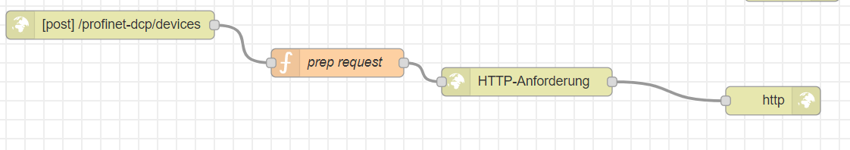

APIs:

As an API this module offers a http-post-request.

[Source Dateien]

## Risks

What happens when this component fails?

The application will not be able to save changes to an profinet-device.

If the profinet-API-specification changes this module must be updated.

Measures to reduce risk:

The module was kept simple. It also tries to find mistakes or false requests sent to it and will not act on those.

# Implementation

This module was implemented with Node.JS and a framework “Node-red”.

Node-red allows this module to be developed visually based on flow-charts. This is used to make quick progress for the most, rough parts of the application. The finer code is implemented using JavaScript.

With Node-red the module was divided into multiple small modules that could be quickly generated using the UI. Details like how functions work were then directly coded by hand.

# Module Test

## Module Testreport

|  |  |  |  |  |  |
| --- | --- | --- | --- | --- | --- |
| **Test-ID** | **Pass/Fail** | **If failed: Test Observation** | | **Date** | **Tester** |
| **13** | **Pass** |  | **14.05.2020** | | **Rene Scholz** |

# Summary

Strenghts:

Specialized for device made by Balluff.

Weaknesses:

Cannot handle changes to device API

Possible improvements:

Should add support for more Profinet-Device-Manufactures.

Possible extensions:

A switch could be implemented allowing for the installation of a submodule which would allow for the compatibility for non-Balluff-devices.