**Customer Requirements Specification**

**(Lastenheft)**

(TINF18C, SWE I Praxisprojekt 2018/2019)

Project: Profinet DCP Client als WEB-Applikation

Customer: Rentschler & Ewertz

Rotebühlplatz 41

70178 Stuttgart

Supplier: Team 2 *(Jannik Schwarz, Sinan Yurttadur, Noah Broß, Marvin Sonntag, Nicholas Breuninger, Rene Scholz)*

Rotebühlplatz 41

70178 Stuttgart

|  |  |  |  |
| --- | --- | --- | --- |
| **Version** | **Date** | **Author** | **Comment** |
| 0.1 | 23.09.2019 | Jannik Schwarz | Created the document |
| 0.2 | 4.10.2019 | Jannik Schwarz | New open questions and ideas for use-cases and functionality |
| 0.3 | 7.10.2019 | Jannik Schwarz | Added the use-cases |
| 0.4 | 18.10.2019 | Jannik Schwarz | Mostly everything was added, fine tuning will still be needed |
| 1.0 | 21.10.2019 | Jannik Schwarz | Added the figures for use-cases and the product environment |
| 1.1 | 31.10.2019 | Jannik Schwarz | Added Product Data |
|  |  |  |  |
|  |  |  |  |

CONTENTS

1. Goal 3

2. Product Environment 4

3. Product Usage 5

3.1. Business Processes 5

3.2. Use Cases 5

3.2.1. <UC.001> Search Devices 5

3.2.2. <UC.002> Display Data of Device 5

3.2.3. <UC.003> Save Changes to Device 6

3.3. Features 7

3.3.1. /LF10/ Device discovery 7

3.3.2. /LF20/ Device configuration 7

4. Product Data 8

4.1. /LD10/ The local network 8

5. Other Product Characteristics 9

5.1. /NF10/ Easy looking up of IP-addresses 9

5.2. /NF20/ Easy use of application 9

5.3. /NF30/ Reliability 9

5.4. /NF40/ Modularity 9

5.5. System Environment 9

6. References 10

# Goal

**What is has to do**

The application is used to ease the management of Profinet-Devices, by displaying them for the user. All devices connected to the network of the user must be displayed. Because the program is used to help with configuration of the network and finding configuration errors it must display the device descriptor and the IP-address.

Optionally a function to reconfigure the IP-addresses from within the Application would be of great use. With this optional feature, an easy reconfiguration of the entire network would be possible from within this one application.

# Product Environment

**Data structure and environments**

The main goal is to create a Profinet-DCP-Client, which is able to scan and display all the Profinet-Devices in the network. Furthermore, it should handle the display and management the IP-addresses and the DNS names of each device.

An additional graphical interface has to be created in Angular. The backend for the DCP-Client shall be programmed in C, C++ or NodeJS with the usage of an open-source-stack.

The communication between front- and backend must be realized with a JSON-based REST-API.

**Setup and installation**

The installation of the program should be handled easily, preferably by using an installer, which guides the user through the installation process. Options such as the installation path must beincluded. Additionally, a manual is required, explaining how to use the program and its limitations.

**The operating systems and installation**

The Product will be used on Windows and or Linux Systems.

Program will be installed over an installer, which will guide you through everything.

**Rough Diagram of the Environment**

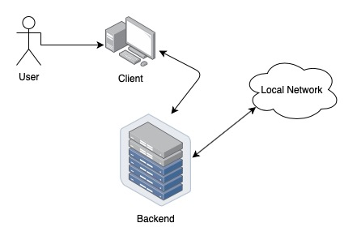

Figure 1 of the environment

# Product Usage

**Using the Application**

The Backend is started locally on a computer. After the Backend started it is possible to retrieve data and display it on the frontend, which is going to be accessible through the browser, by browsing for the localhost on a specific port.

## Business Processes

Since this is a Project by students of the DHBW the processes behind this project are to learn about different tools, project management and problem solving. The tools which will be used are GitHub, the DCP-Protocol, how to implement a REST-API, document that API with Swagger and use Postman to test it.

## Use Cases

The use cases of the application are the searching of devices in the local network and returning a list of them to the user ( <UC.001> ) and also displaying detailed information about a chosen device out of the list ( <UC.002> ).

Optional use cases are the configuration of devices from within the client ( <UC.003> ).

### <UC.001> Search Devices

|  |  |
| --- | --- |
| **Use Cases Objective:** | The server handles the frontend request over an API-request. The server will start to listen for all Profinet-devices in the network.  Then all found devices will be send back to the frontend in form of a list or array. |
| **System Boundary:** | The system is bound to the local network of the server |
| **Precondition:** | The connection to the network is required |
| **Postcondition on success:** | The backend must find all devices |
| **Beteiligte Nutzer:** | Frontend  Server  All Profinet-devices in the network |
| **Triggering Event:** | When the user clicks on “Search Devices” |

### <UC.002> Display detailed data of Device

|  |  |
| --- | --- |
| **Use Cases Objective:** | The frontend displays the information of one of the found devices. Information like the IP-address and name of the device are shown. |
| **System Boundary:** | The frontend is limited to the list of devices it received by the server. |
| **Precondition:** | A list of devices must have been sent back to the frontend |
| **Beteiligte Nutzer:** | Frontend  Server |
| **Triggering Event:** | Selecting a device out of the list |

### <UC.003> Save changes to device configuration

|  |  |
| --- | --- |
| **Use Cases Objective:** | The objective is to save the new configuration of a selected device. Changes like a different IP-address or name are to be used by the device from that point on. |
| **System Boundary:** | The operation is limited to the selected device. |
| **Precondition:** | A user must have selected a device.  A connection to the device is needed. |
| **Postcondition on success:** | The device is visible on new IP-address. |
| **Beteiligte Nutzer:** | Frontend  Backend (Server)  A single device in the network |
| **Triggering Event:** | When the user saves changes in the configuration of a device |

Use-Case-Diagram:

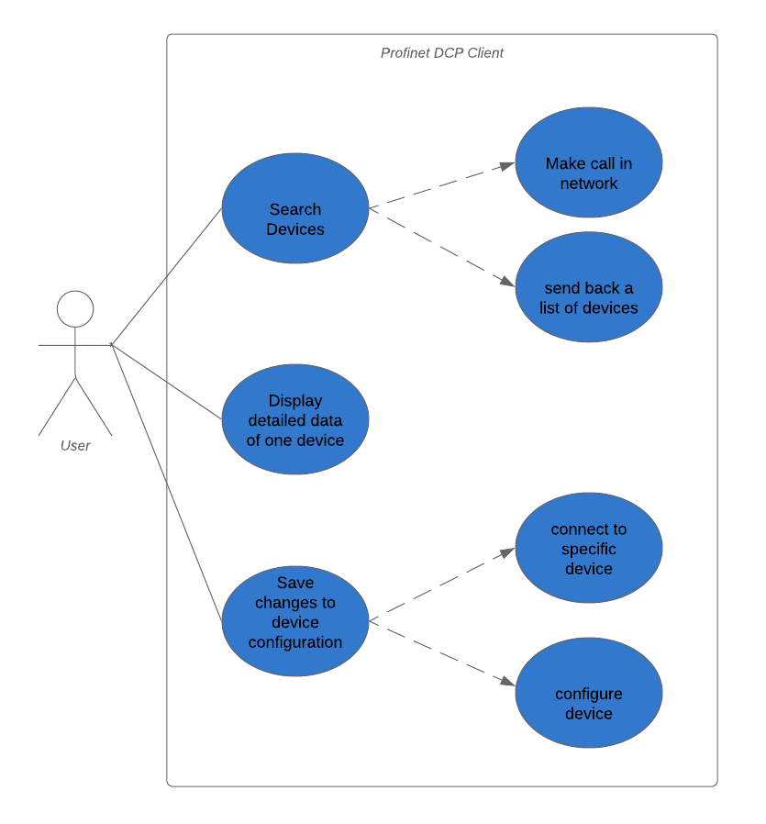

## Features

### /LF10/ Device discovery

When making a search request for all devices the server must use the DCP-protocol to find the devices in the local network so, the server can return a list of them to the client.

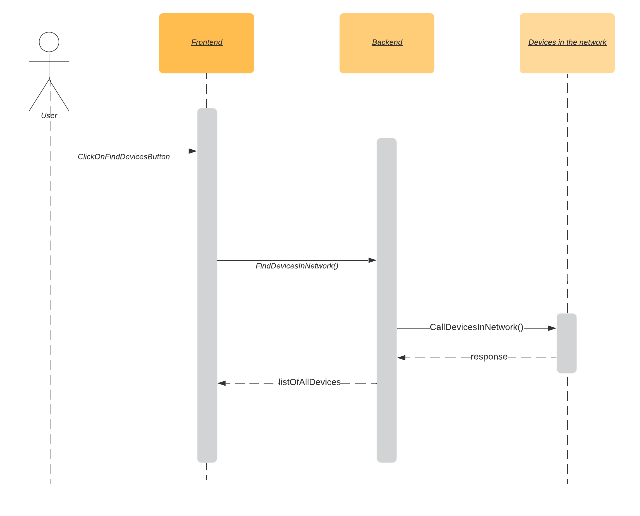

### /LF20/ Device configuration

When saving a new configuration of a device the server must reconfigure the selected device and set the new IP-address or name of the device.

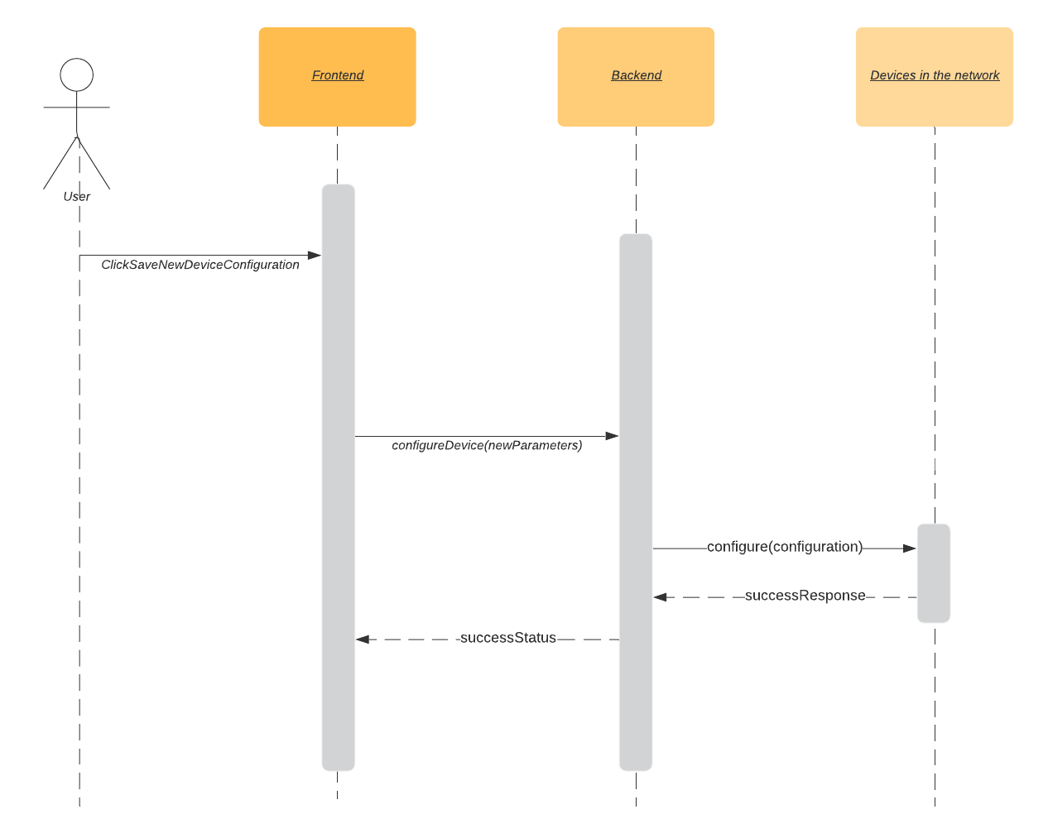

# Product Data

## /LD10/ Data topology

Devices are connected via Ethernet cables.

The Information flow will occur in two directions. Data about the devices will be called from the client. The client will make a call to all Profinet-devices in the local network and will listen to the answers. A list of these answers will be stores in the backend of the application.

The backend will then continue to forward the information gathered to the frontend, where it will be displayed to the user.

## /LD10/ Device data

The data of the device will be everything that can be gathered. It must include the IP-address of the device, the name of the device and, if possible, the port it is connected to.

# Other Product Characteristics

## /NF20/ Easy use of the application

Intuitive design should be implemented by guiding the user through the application. This should be achieved by making certain options or steps accessible only after certain conditions are met. E.g., you can only click on “Show Details of Device” after you already selected a device. This may be achieved by either hiding these actions or clearly disabling them.

## /NF30/ Reliability

The system should display all connected devices reliably. A scan for devices in the network must return all devices.

## /NF40/ Modularity

The program should be created with modularity in mind to make it easy to continue the project. Future teams may pick up the works and continue developing it. To make it easy on them the project shall oblige the modularity idea to create an easier entry in project.

# References

[1] https://github.com/Eiwanger/profinet_scanner_prototype/blob/master/SendPacket/ReadMe.txt

[2] https://www.feldbusse.de/Profinet/grundlagen.shtml

[3]

https://www.beckhoff.de/default.asp?fieldbus_components/system_profinet.htm?pk_campaign=AdWords-AdWordsSearch-Profinet_DE&pk_kwd=%2Bprofinet%20%2Bdevice