## Introduction

In this report there will be presented the methodology used to find a location for a new Barbershop in the USA. To do so, a market study will be made to better understand and select the most profitable areas in the country. The main target of this study is people interested in opening their own business, but do not know where to place it. Therefore, it will present information and a list of the top 5 places to open such business, in the author’s opinion.

According to a Forbes article from mid 2017, barbershops are back in trend:

"While soft goods retailers are shuttering stores in record numbers, a cultural resurgence of men's grooming, estimated to reach $26B by 2020, has barbers, brokers and landlords lining up to get their cut."

In addition, an article from 2017 by US Census Bureau claims that there is an opportunity in this kind of business, according to de article

"While more than half of US counties (2,400) have no barber shops, there are only 802 with no beauty salon. Men in these counties probably go to the local beauty salon to get their hair cut".

This shows that even with a growing trend, the country still has a major lack of stores available for their customers. This statement will be tested and analyzed in the following discussions.

## Data

All data will be obtain from the US Census Bureau, DataUSA, FRED and Foursquare. Since there is very little information, many assumptions will be justified later.

The plot below shows the total revenue for barbershops between the year 1999 to 2018 (data extracted from fred.stlouisfed.org).

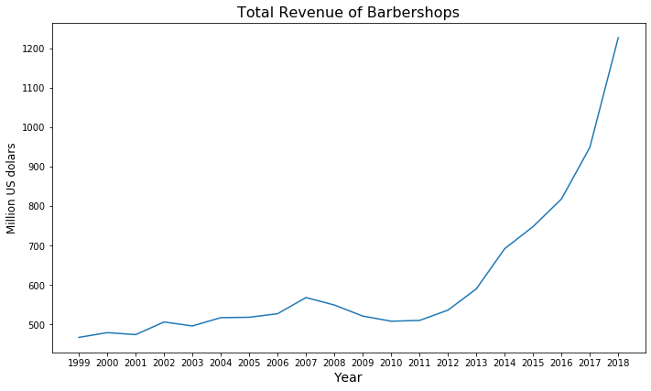

From the Revenue Graph above, a clear revenue increase can be observed starting in the year 2013. This is the main argument for starting a new barbershop.

The population distribution, the number of independents barbers or nonemployer establishments and the annual revenue for those establishments for each state (as shown in the Table 1 below) will be used to find the best location based. All this data was obtained from the US Census Bureau.

Table 1 - First 5 rows of the Census Bureau Data

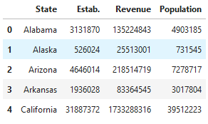

Foursquare will be used to find the competition near the area selected, using the API call to retrieve the venues of the same category: Barbershop.