Content of the Artificial Intelligence program in Osnabrück:

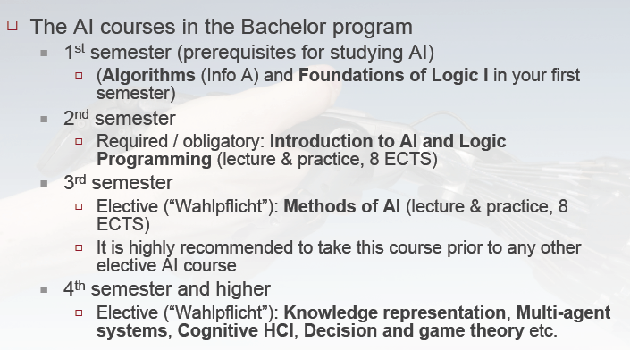

Beyond the theory (First Order Logic, Horn clauses…), we learned and practiced Prolog. The book I found most useful was Prolog Programming for Artificial Intelligence, by Ivan Bratko.

Here an example of exercice we did: using the GDL (Game Description Language) platform from Stanford, we had to implement a player strategy for a game like Tic Tac Toe or another game of our own conception.
We implemented a mini-max strategy and to reduce search time and search deeper in the state space, we additionally implemented alpha beta pruning. But because mini-max, even with alpha-beta pruning, is not practical in most games (it would take to long to go down to each terminal state for all branches), we implemented the classical idea (already in Shannon’s 1950 paper ‘Programming a computer for playing chess’, as quoted by Russell-Norvig) : ‘cut off the search and apply a heuristic evaluation function’ (Russell-Norvig).
So, we set have set up a certain limit for the depth of exploration, from which (if no terminal state has been reached), an evaluation function is called (as mini-max requires an outcome at any leave or pseudo-leave in the search tree).
We first tested our alpha-pruning mini-max on the simple example (ply game) in the Russell-Norvig book, and then on a bigger and irregular tree (with different depth levels on different branches), and then adapted it to the Game environment.

We found it practical to build and test our algorithm on simpler case, as the book-keeping of the alpha-beta values was not straightforward.
We use the ‘assert/retract’ mechanism to simplify the task (basically using the predicate database as a stack). A alpha (or beta) value regarding a certain depth downward in the tree is eliminated when we quit this depth-level and go back upward (it would lead to wrong pruning if we kept up this value).
For this, we found it convenient to associate the alpha and beta values to the associated depth-level.
Moreover, depth book-keeping is necessary for the cut-off strategy.

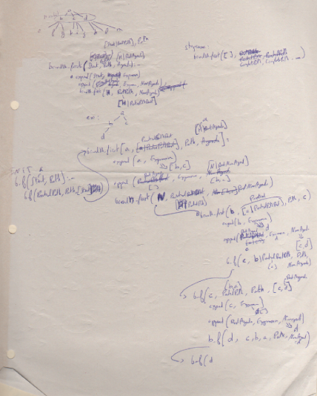
Sketching the program principle.

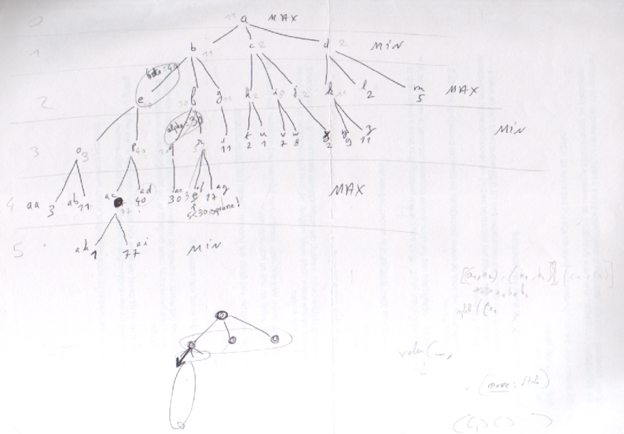
Tree for testing the program.

