JM Smuckers - Term Set Configuration Guide

Creating a New Term Set "OurPeople"

Overview
This guide provides step-by-step instructions for creating a new term set called "OurPeople" in SharePoint's Term Store and updating the Site Column to use the new term set in the Dev environment. This configuration will allow content to be properly categorized under the Our People section.

Part 1: Create New Term Set in SharePoint Term Store

Step 1: Navigate to Central Site Settings
Example:
Dev : https://jmscollabdev.sharepoint.com/sites/NeighborhoodCentralDev/_layouts/15/settings.aspx
Prod : https://jmsmucker.sharepoint.com/sites/NeighborhoodCentral/_layouts/15/settings.aspx

Step 2: Access Term Store Management
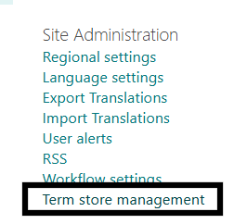

Step 3: Locate and Expand Global Term Groups for Each environment, below example from DEV
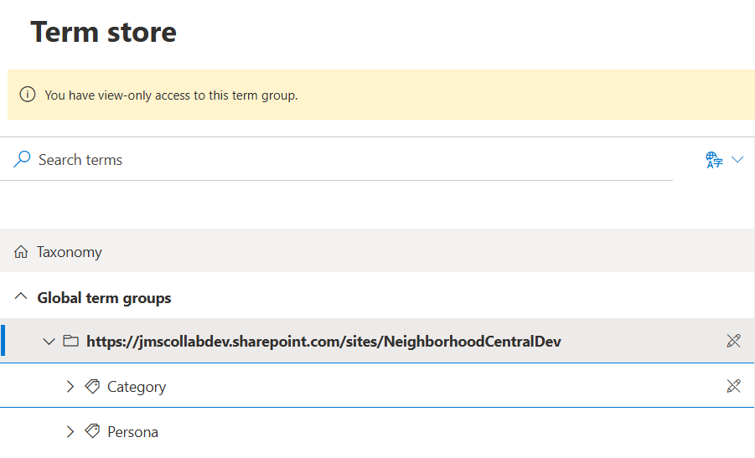

Step 4: Create New Term Set "OurPeople"
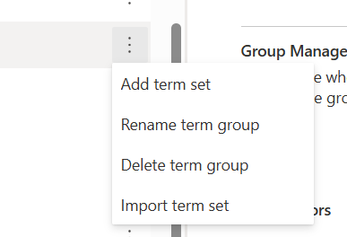
Important: Make sure the term set is created at the correct level in the hierarchy. It should be visible alongside other term sets like "Category" and "Persona".

Step 5: Add Terms to the OurPeople Term Set

Now you need to add individual terms that will be used to categorize Our People content.

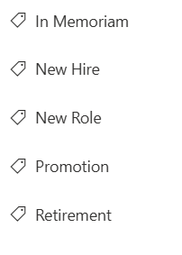

Part 2: Update Site Column to Use New Term Set

Now that the OurPeople term set has been created, you need to configure the SpotlightCategory site column to use this new term set instead of the previous one.

Step 1: Navigate to SpotlightCategory Field Edit Page

DEV: https://jmscollabdev.sharepoint.com/sites/NeighborhoodDeliveryDev/_layouts/15/FldEditEx.aspx?List=%7BD865EEBE%2DAB9C%2D4FC3%2DBB37%2D91BFC1437E1C%7D&Field=SpotlightCategory

PROD: https://jmsmucker.sharepoint.com/sites/NeighborhoodDelivery/_layouts/15/FldEditEx.aspx?List=%7B88B4B25E%2DC4FF%2D48CA%2D9F3C%2DFF2139526F42%7D&Field=SpotlightCategory

What you're viewing: This is the field configuration page for the SpotlightCategory managed metadata column used in the list/library.

Step 2: Locate the Term Set Settings Section
  - Use a managed term set

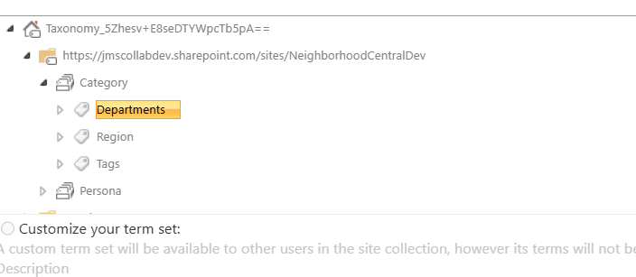

Step 3: Select the OurPeople Term Set
  - You should see all the terms you created (In Memoriam, New Hire, New Role, Promotion, Retirement)

Step 5: Save the Column Configuration

Confirmation: You should be redirected back to the list settings page. The SpotlightCategory column now uses the OurPeople term set.
Important: The column is now pointed to the OurPeople term set. Any existing items with old category values will need to be updated manually

Part 3: Clear System Caches
After making changes to the term set and column configuration, you must clear the Akumina caches to ensure the new configuration is loaded throughout the system.

Why Clear Caches?
- List Cache: Stores cached list data including column configurations
- Taxonomy Cache: Stores cached term set and term information
- Clearing these ensures the system fetches the latest configuration from SharePoint

Step 1: Navigate to Admin Debug Panel in App Manager
Dev: https://cloud-dev-jmsmucker.onakumina.com/admin/debug
Prod: https://neighborhoodcentral.jmsmucker.com/Admin/debug

Step 2: Clear List Cache

What this does: Removes cached list schema information, forcing the system to reload the SpotlightCategory column configuration with the new OurPeople term set.
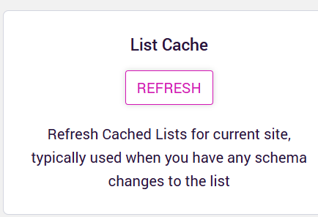

Step 3: Clear Taxonomy Cache
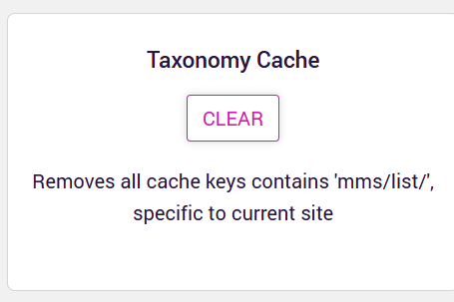
What this does: Removes cached term set and term information, forcing the system to reload the OurPeople term set with all its terms (In Memoriam, New Hire, New Role, Promotion, Retirement).

Part 4: Verify Configuration on Delivery Site

Now that everything is configured and caches are cleared, you need to verify that the Our People component is working correctly with the new term set.

Step 1: Navigate to the Delivery Site

Step 2: Access the Our People Component Location
Navigate through the site structure to reach the Our People component:

Step 3: Review Existing Items

Step 4: Verify SpotlightCategory Field is Working
For each item in the list:

  - 🏷️ In Memoriam
  - 🏷️ New Hire
  - 🏷️ New Role
  - 🏷️ Promotion
  - 🏷️ Retirement

Step 5: Update All Items with Correct Categories
Go through each Our People item and ensure they have the correct SpotlightCategory assigned:

Step 6: Test on the Front-End Site
  - Items are displaying correctly

Step 7: Final Verification Checklist
Review the following before concluding:

- ✅ All Our People items have a SpotlightCategory assigned
- ✅ Categories match the new OurPeople term set terms
- ✅ No items are using old/invalid category values
- ✅ The SpotlightCategory field shows only the OurPeople terms when editing

