LA Courts (LASC)

Production Deployment

Release Notes - January 16, 2026

Deployment Information
Date | January 16, 2026
Environment | Production (LASC)
Branch | 1.26.01.14.01
Build | 2601.1401 (Build ID 107996)
Pipeline | LASC PROD - Headless Pipeline

Summary
This production deployment includes 5 enhancements with 44 commits, delivering a new Court Resources Widget with advanced search and filtering capabilities, PeopleSync improvements, and performance optimizations. The Court Resources Widget provides staff with an easy-to-use tool to find and access court resources, forms, and documents in multiple languages.

Features & Enhancements

LAC-213: Court Resources Widget
Priority: Medium | Status: Deployed
What It Does:
The Court Resources Widget is a powerful search tool that helps staff quickly find and access court resources, forms, documents, and information. It provides an intuitive interface with multiple viewing options and filtering capabilities to make finding the right resource fast and easy.
Key Features:
- Two View Modes - Switch between Grid (visual cards) and List (table) views based on your preference
- Quick Search - Type keywords to instantly find relevant resources
- Smart Filters - Narrow results by Litigation Type, Resource Type, or Department
- Multi-Language Support - Available in English, Spanish, and French
- Save Favorites - Bookmark frequently used resources for quick access
- Share Links - Send filtered searches to colleagues via URL
Grid View (Visual Cards)
This view displays resources as visual cards with icons, making it easy to scan and recognize resources at a glance. Perfect for browsing and discovering new resources.
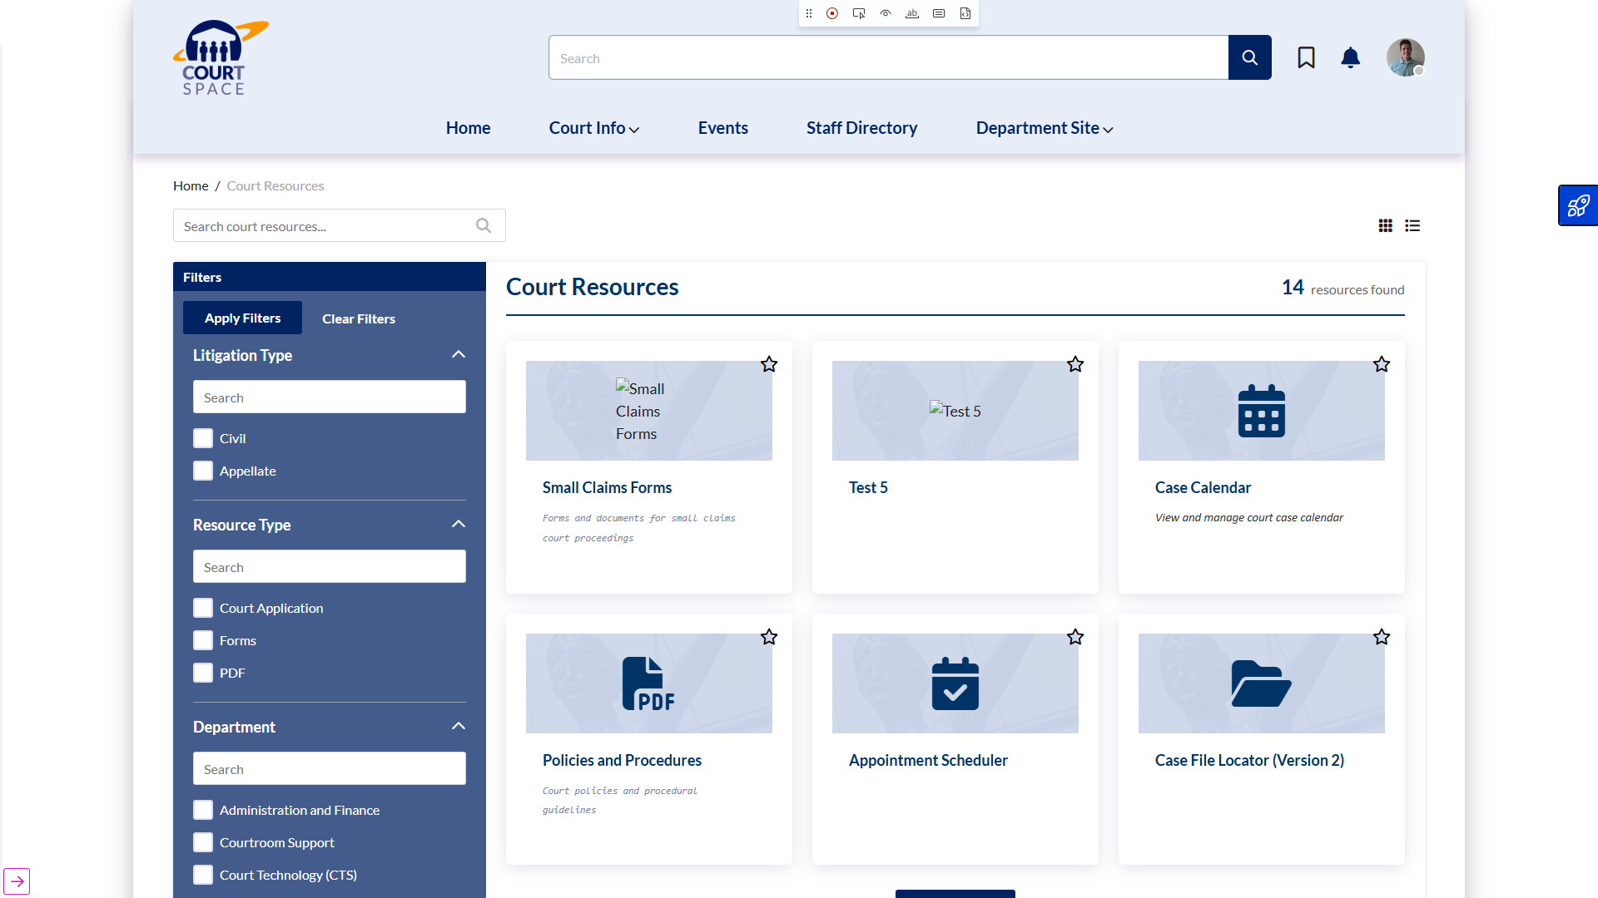

List View (Compact Table)
This view shows resources in a compact table format, ideal for quickly scanning titles and descriptions. Great when you know what you're looking for and want to see more items at once.
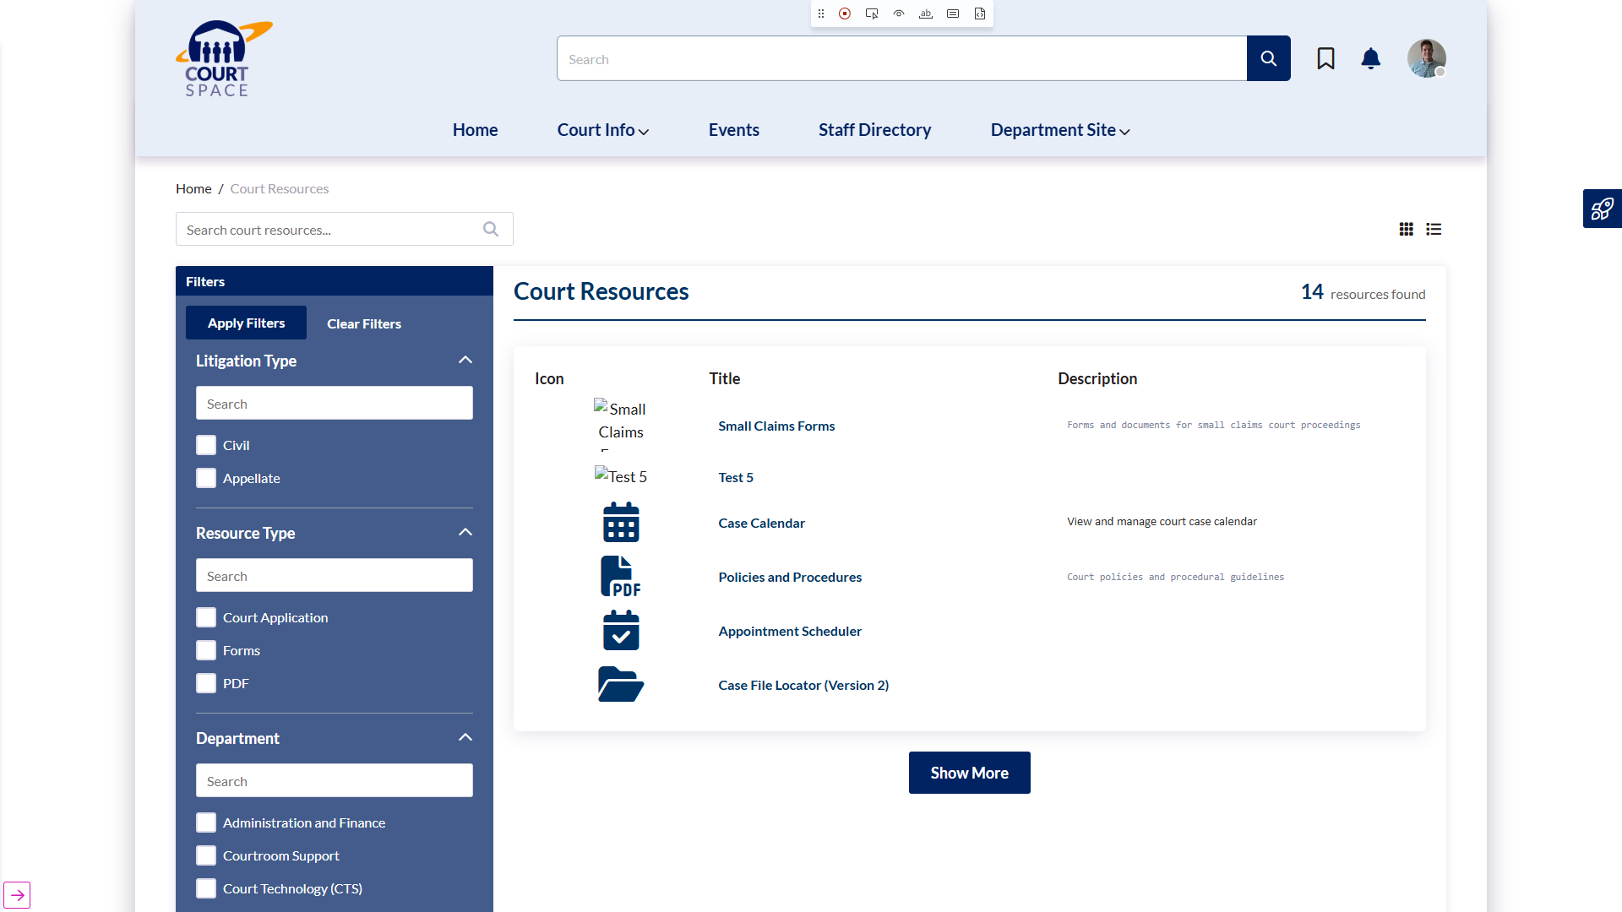

Search Functionality
Type keywords into the search box to instantly filter resources. The search looks through titles, descriptions, and keywords to find the most relevant matches.
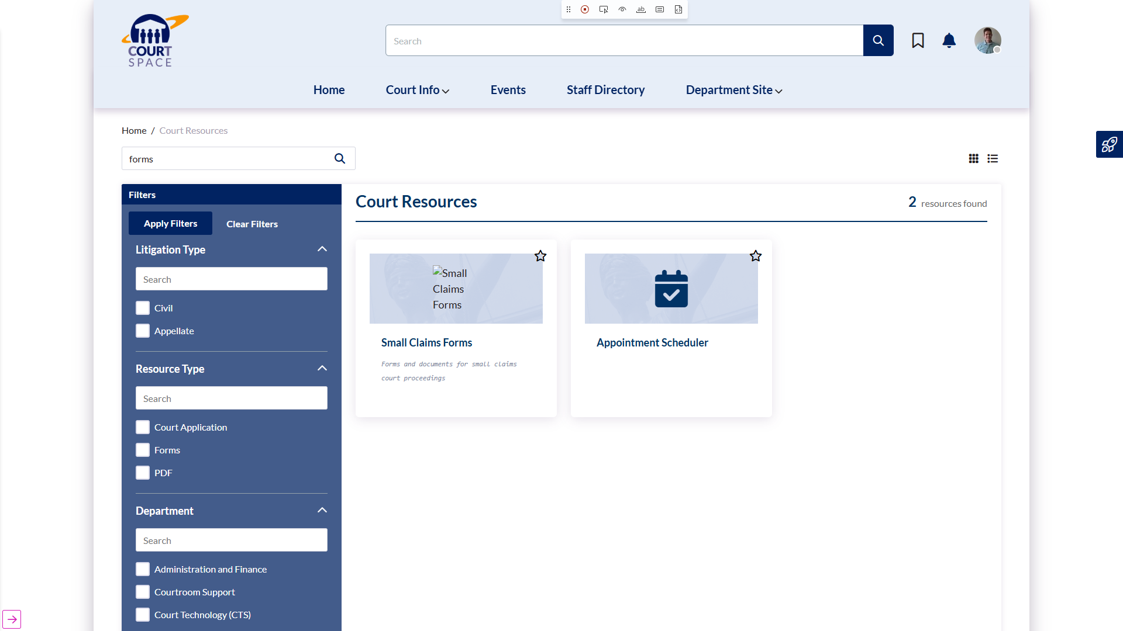

Filter Panel
Use the filter panel on the left to refine your search by specific categories. Select one or more filters, then click 'Apply Filters' to see matching resources. You can combine search and filters for precise results.
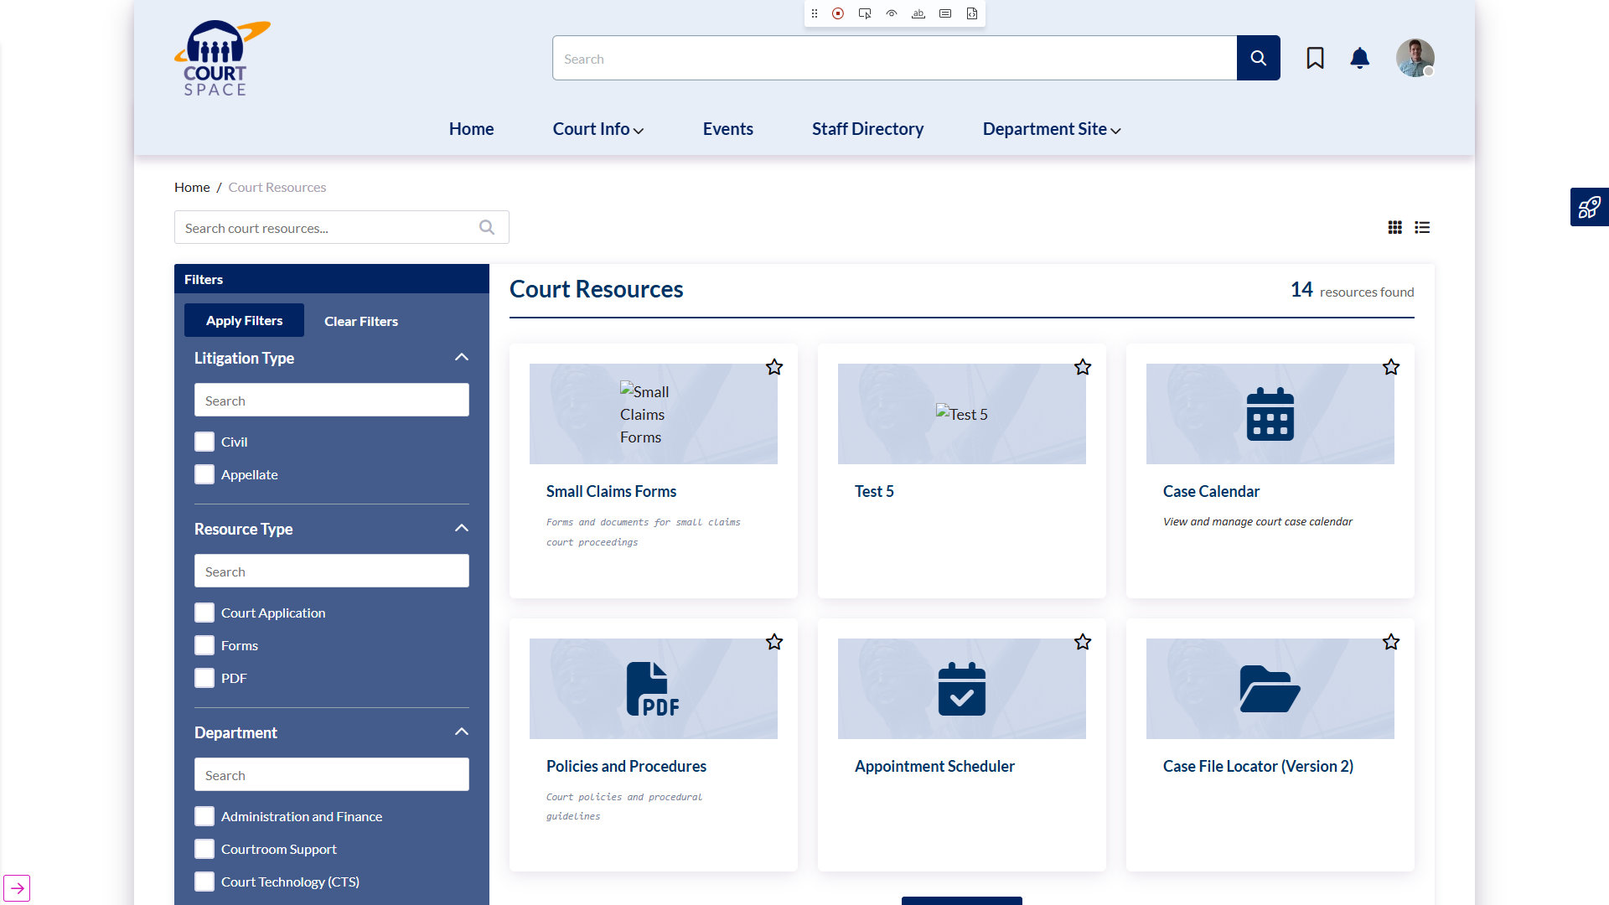

How to Use the Court Resources Widget:
1. Finding Resources
- Type keywords in the search box (e.g., 'civil forms', 'mediation', 'small claims')
- Or browse all available resources by scrolling through the list
- Click 'Search' or press Enter to see results
2. Using Filters
- Select one or more filter options from the left panel
- Click 'Apply Filters' to see only matching resources
- Use 'Clear Filters' to remove all selections and start over
3. Switching Views
- Click the Grid icon (squares) for visual card view
- Click the List icon (lines) for compact table view
- Your preference is remembered for next time
4. Saving Favorites
- Click the star icon on any resource card
- The bookmark modal will open to save it to your Quick Links
- Access your saved resources anytime from your Quick Links widget
5. Sharing Searches
- After applying filters or search, copy the URL from your browser
- Share the URL with colleagues - they'll see the same filtered results
- Great for directing others to specific resource sets

Additional Improvements
LAC-219: PeopleSync Filter Improvements
What It Does:
Fixed an issue where the People Directory filters were showing incorrect employee types. Filters now display the correct options, making it easier to find specific staff members.
LAC-207: Enhanced Employee Filtering
What It Does:
Improved how employee types are categorized in the system, providing more accurate filtering when searching for people. This ensures you see the right staff members when using filters.
LAC-193: Faster Page Loading
What It Does:
Implemented smart image loading that loads images as you scroll down the page instead of all at once. This makes pages load faster, especially on slower connections, providing a better browsing experience.
LAC-194: Improved Page Layout
What It Does:
Adjusted header and footer heights for more consistent spacing and better visual balance across all pages. Pages now have a cleaner, more professional appearance.

Support & Questions
If you have questions about these new features or need assistance:
- Contact your IT Help Desk for technical support
- Reach out to your department's SharePoint administrator
- Email: Akumina Support for system issues
Document generated: January 22, 2026

