AMI-CIM Microservice Design Document

1. Overview

1.1 Glossary
Term | Full Name | Description
AMI | Advanced Metering Infrastructure | Smart metering system architecture.
CIM | Common Information Model | IEC 61968/61970 model; used here as the external interface standard.
CIS | Customer Information System | Manages customer files, accounts, and billing relationships.
MDC/MDM | Meter Data Collection / Management | Collects and manages metering data and device communication.
DCU | Data Concentrator Unit | Aggregates meter data and uploads it to the head-end system.
POC | Point of Connection | Physical installation or connection point for a meter.
STS | Standard Transfer Specification | Token encryption standard for prepaid meters.
UDIL | - | Meter communication protocol used by specific projects or vendors.
VEE | Validation, Estimation, Editing | Validation, estimation, and editing for metering data.
DLMS | Device Language Message Specification | Meter device communication protocol, IEC 62056.
FND | Field Network Director | Cisco field network controller.
RocketMQ | - | Distributed message queue used for asynchronous integration.

1.2 Service Positioning
ami-cim is the CIM interface service in the AMI platform. It acts as the unified integration layer for external systems, field platforms, and downstream AMI services.
- Receives meter data and business requests from different countries and project sites.
- Integrates with CIS, SAP, SMS platforms, STS encryption services, Huawei IoT, FND, and other external systems.
- Adapts external protocols into internal service models and task commands.
- Distributes data to downstream collection, analytics, archive, prepaid, and monitoring services through Feign and RocketMQ.

1.3 Technology Stack
Category | Technology | Version / Notes
Core framework | Spring Boot | 2.0.3.RELEASE; Spring Boot Loader 2.1.3
Runtime | Java | JDK 1.8
Build | Maven | 3.5.0
Web | Spring MVC + Tomcat | Spring 5.0.7 / Tomcat 8.5.31
Persistence | Hibernate JPA + MyBatis | Hibernate 5.2.17 / MyBatis 3.4.0
Databases | MySQL + SQL Server + MongoDB + Redis | Primary DB, secondary DB, document store, cache
Service discovery | Eureka | Spring Cloud Netflix 2.0.0
Service calls | Feign + Ribbon + Hystrix | Feign 9.5.1 / Ribbon 2.2.5 / Hystrix 1.5.12
Messaging | RocketMQ | 4.3.0
SOAP | Apache CXF | 3.2.9
Device connectivity | Netty + Eclipse Paho MQTT | Netty 4.1.25 / Paho 1.2.5
Scheduling | xxl-job | 2.0.1
API documentation | Swagger Bootstrap UI | Swagger 2.6.1
JSON | FastJSON + Jackson | FastJSON 1.2.53 / Jackson 2.9.6
Security | JWT + Jasypt | jjwt 0.9.0 / Jasypt Spring Boot 2.1.1

1.4 Relationship with Other Microservices
Traffic typically enters through ami-zuul or external gateways, reaches ami-cim, and is then routed to collection, archive, analysis, prepaid, operations, and monitoring services.
Service | Role
ami-zuul | API gateway and external traffic entry.
ami-cim | External interface and protocol adaptation service.
ami-collect / ami-collection | Front-end collection and collection platform services.
ami-analysis | Analytics and metering data analysis.
ami-archives | Archive and master data service.
ami-ops | Operations and maintenance service.
ami-prepay | Prepaid business service.
ami-monitor | Monitoring service.

2. Project Structure

2.1 Module Breakdown
Module | Responsibility
ami-cim-interface | Web interface layer and application startup module.
ami-cim-client | Feign client module exposed for other services.
ami-cim-application | Application services, task scheduling, MQ consumers, job handlers, and caches.
ami-cim-domain | Domain entities, DTOs, repositories, value objects, constants, and enums.
ami-cim-infrastructure | Infrastructure configuration, data sources, STS service, SMS service, and technical adapters.

2.2 Key Package Map
Package / Area | Purpose
com.sxg.ami.cim.controller | REST controllers grouped by country, protocol, or business domain.
com.sxg.ami.cim.service | SOAP WebService interfaces and service implementations.
com.sxg.ami.cim.interceptor | Authorization interceptor and web request controls.
com.sxg.ami.cim.application.service | Application-level business orchestration.
com.sxg.ami.cim.application.task | Task scheduling framework, task adapters, and response handlers.
com.sxg.ami.cim.application.mq | RocketMQ producers and consumers.
com.sxg.ami.cim.application.jobHandler | xxl-job task handlers for scheduled jobs.
com.sxg.ami.cim.application.client | HTTP, MQTT, FTP/SFTP, Feign, and generated SOAP clients.
com.sxg.ami.cim.domain.entity | JPA business entities such as Meter, Customer, Dcu, Poc, Event, Token, and Transaction.
com.sxg.ami.cim.domain.repository | Spring Data repositories for primary database access.
com.sxg.ami.cim.domain.repositorySecondary | Repositories for secondary SQL Server / UDIL data access.
com.sxg.ami.cim.infrastructure | Data source, job, logging, parameter, SMS, and STS infrastructure classes.

3. Core Architecture Design

3.1 Layered Architecture
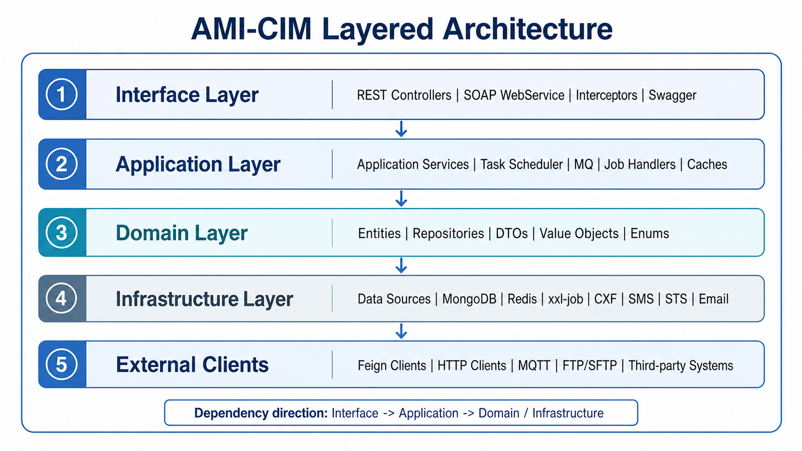
Figure 1. AMI-CIM layered architecture.
Layer | Main Responsibility | Typical Code Areas | Dependency Direction
Interface | Accept REST/SOAP requests, adapt entry protocols, wrap responses, expose Swagger, and apply interceptors. | controller/, service/impl/, swagger/, interceptor/ | Calls Application only.
Application | Orchestrate business flows, validate parameters, convert DTOs, create tasks, refresh caches, and process MQ/job events. | application/service/, task/, mq/, jobHandler/, caches/ | Calls Domain, Infrastructure, and external clients.
Domain | Model core business objects, data access, DTOs, value objects, constants, and enums. | domain/entity/, domain/repository/, domain/DTO/, domain/valobj/ | Does not depend on Interface.
Infrastructure | Provide data sources, MongoDB, Redis, xxl-job, CXF, SMS, STS, logging, and parameter configuration. | infrastructure/config/, infrastructure/stsservice/, infrastructure/huawei/sms/ | Used by Application.
External Clients | Integrate internal microservices and third-party systems. | application/client/, application/client/feign/ | Called by Application.

- Controllers should stay thin and avoid long-running retries, protocol framing, or transactional loops.
- Application services are the main orchestration boundary and decide whether to use synchronous queries, tasks, MQ, or Feign calls.
- Task adapters translate business commands into protocol-specific or system-specific operations.
- Repositories should expose business-oriented data access and keep SQL/query details out of upper layers.
- Infrastructure should encapsulate technical details and avoid embedding business decisions.

3.2 Runtime Component View
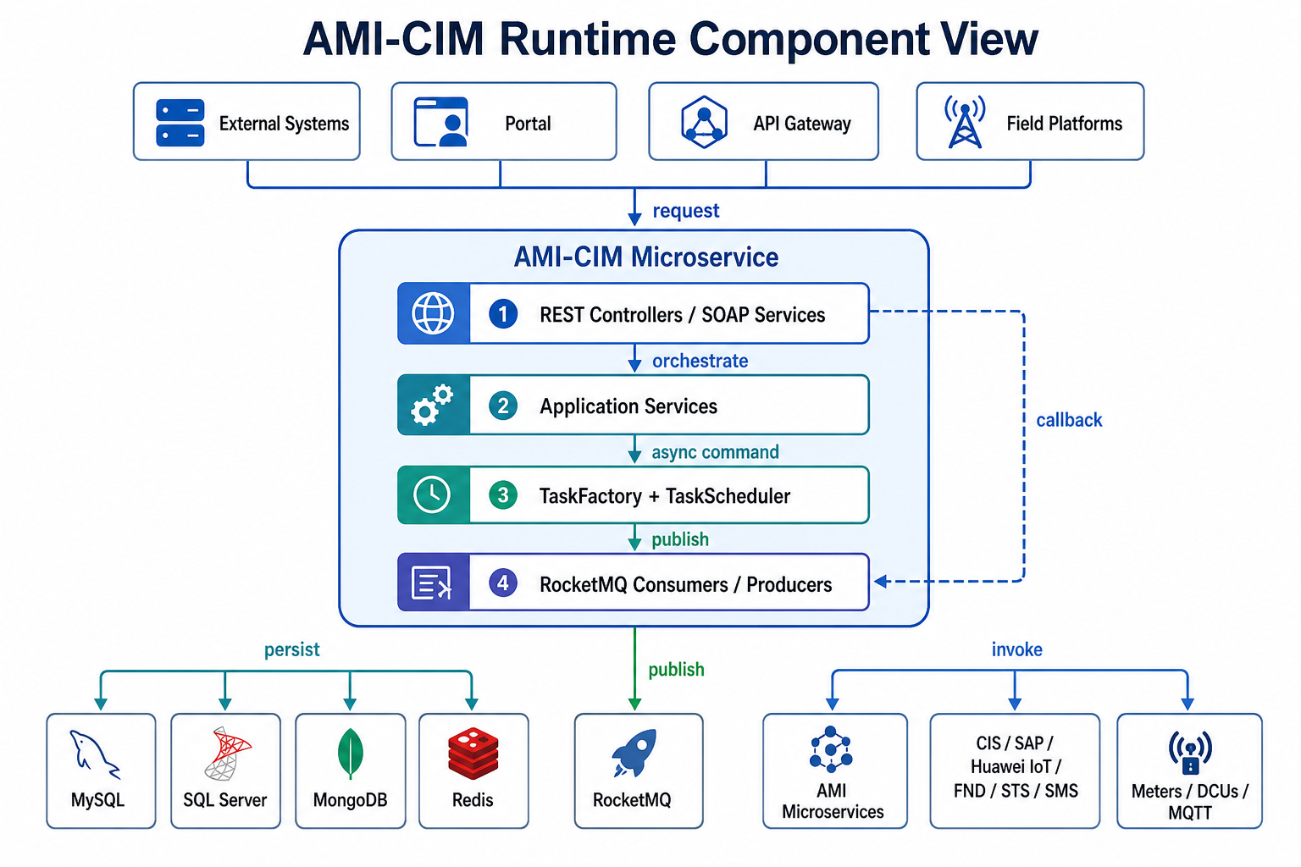
Figure 2. AMI-CIM runtime component view.
Traffic Type | Source | Processing Characteristics | Typical Modules
Northbound business requests | CIS, SAP, Portal, third-party systems, API gateway | Stable interface contracts and controlled response formats. | Controllers, SOAP services
Southbound device interaction | Meters, DCUs, IoT platforms, collection links | Asynchronous, timeout-prone, callback-based, and protocol-specific. | TaskScheduler, TaskAdapter, MQTT/HTTP clients
Internal microservice collaboration | Archive, collection, analysis, prepaid, monitoring services | Mixed Feign and MQ integration, with decoupling and fault tolerance. | Feign clients, RocketMQ consumers/producers

3.3 Request Processing Flow
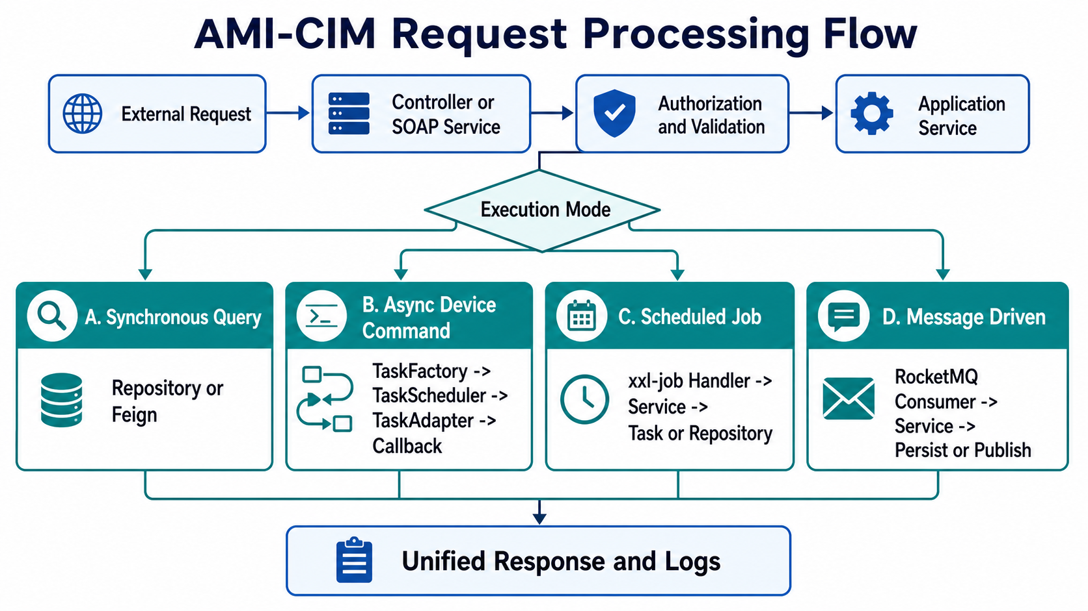
Figure 3. AMI-CIM request processing flow.
Mode | When to Use | Main Path | Key Concerns
Synchronous REST query | Logs, status, archive, portal data, and lightweight reads. | Controller -> ApplicationService -> Repository/Feign -> Response | Validation, pagination, authorization, response contract.
Async device command | Meter reading, remote control, parameter write, and device operations. | Controller -> ApplicationService -> TaskFactory -> TaskScheduler -> TaskAdapter -> Callback | taskId, batchId, timeout, idempotency, offline devices.
Scheduled job | Daily/monthly billing, compensation, export, and synchronization jobs. | xxl-job -> JobHandler -> ApplicationService -> Repository/MQ/Task | Job parameters, duplicate execution, retry strategy.
Message driven | Archive sync, event push, communication history, and real-time command return. | RocketMQ Consumer -> ApplicationService/TaskFactory/Repository | Topic, Group, Tag, message schema, idempotent consumption.

3.4 Task Scheduler
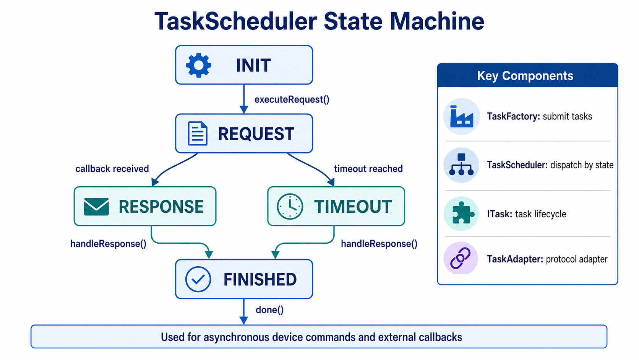
Figure 4. TaskScheduler state machine.
TaskScheduler is the core asynchronous execution framework. It uses a finite-state model to manage device commands and external callbacks.
Component | Responsibility
TaskScheduler | Pulls tasks from a LinkedBlockingQueue and dispatches execution according to task state.
ITask | Defines the lifecycle methods: request(), getResult(), handleResponse(), and done().
TaskFactory | Submits tasks, tracks callback state, and coordinates the scheduler.
TaskAdapter | Adapts business operations such as reads, controls, parameter writes, and events to a specific protocol.

- ApplicationService validates the request and prepares the task context.
- A concrete TaskAdapter is created with task type, parameters, timeout, taskId, and batchId.
- TaskFactory submits the task to TaskScheduler.
- TaskScheduler invokes request() to start external communication.
- The callback entry writes the response back through insertCallBack().
- TaskScheduler invokes handleResponse() to parse, persist, and publish the result.
- The task calls done() to clean up callback state and finalize the result.
Region / Protocol | Approx. Task Count | Typical Tasks
UDIL | 22 | OnDemandRead, ParamWrite, SyncDevice
Huawei | 20 | SyncDevice, SendData, EventSubscribe, HeartBeat
Brazil | 17 | MeterRead, MeterControl, MeterInstall, MeterEvent
CIM standard | 16 | EndDeviceControls, GetMeterReadings, MeterConfig
SMS | 8 | Balance, Vending, CheckToken, ProductToken
SAP | 7 | Install, Disconnect, Remove, Reconnect
Turkey | 8 | MeterConfig, MeterReadings, Billing, EndDeviceControls
Argentina | 5 | ConnectMeter, DisconnectMeter, PingMeter
Angola | 4 | Archive, DeviceControl, MeterRead
Copel | 5 | CreateConfiguration, EndDeviceControls, MeterReadings
Egypt | 3 | OnDemand, HistoryRead, UpdateParameter
Nepal | 2 | MeterConfig

3.5 Data Storage Architecture
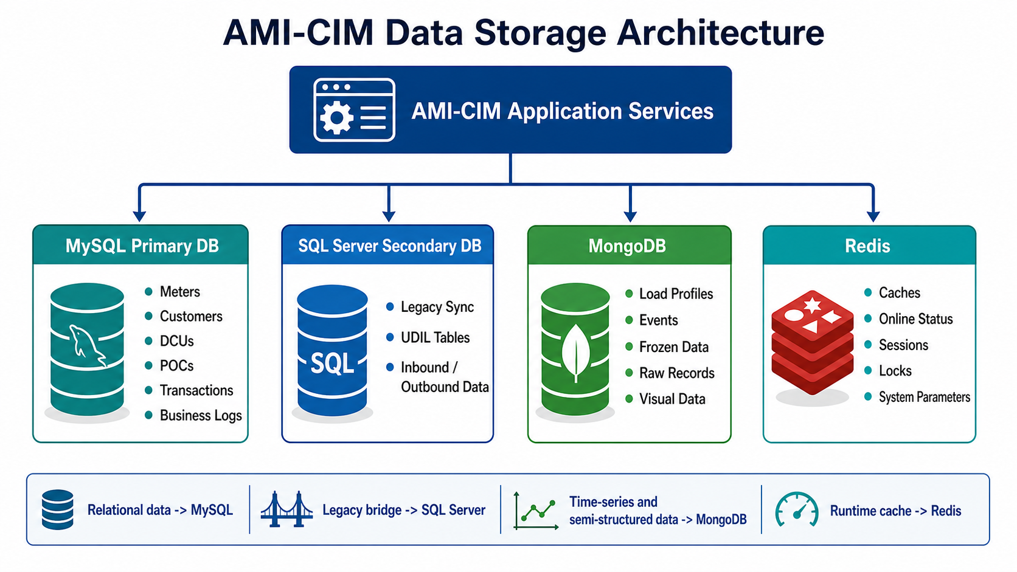
Figure 5. AMI-CIM data storage architecture.
Storage | Primary Purpose | Typical Data | Design Concerns
MySQL primary DB | Core AMI business and configuration data. | Meters, customers, organizations, POCs, event definitions, tokens, transactions, log indexes. | Transactions, indexes, status enums.
SQL Server secondary DB | Legacy or external-system bridge data. | SAN/UDIL sync tables, communication history, inbound/outbound data. | Synchronization boundaries, field mapping, compatibility.
MongoDB | Large semi-structured and time-series data. | Load profiles, frozen data, events, raw records, visual data. | Write throughput, time-range queries, retention.
Redis | Cache and runtime state. | Meter/DCU/POC cache, parameters, online state, sessions, locks. | Expiration policy, cache refresh, concurrency.

3.6 Messaging Design
Consumer | Topic | Consumer Group | Purpose
ArchiveSyncConsumer | archive-synchronization-topic | archive-synchronization-cim | Archive synchronization and cache refresh.
AutoReSendFailedUdilConsumer | wareup-event | cim-resend-failed-udil | Automatic retry for failed UDIL tasks.
CommunicationHistoryConsumer | meter-pdu-message | meter-pdu-message-cim | Communication history persistence.
MeterPushConsumer | report-event | cim-report-event-group | Meter push data processing.
PushAlarmConsumer | report-event | cim-report-event-group | Alarm event push.
PushEventConsumer | cim_event | cim_event_group | Recharge, low-balance, and emergency-credit events.
RealTimeCmdConsumer | realtime_cmd_return_topic | realtime_cmd_return_cim | Real-time command callback and Task state transition.
SysParamConsumer | SYSTEM_PARAM_TOPIC | INTEGRATION_SYSTEM_TOPIC | System and project parameter refresh.

- Use MQ for cross-service notifications, cache refreshes, asynchronous callbacks, and batch event fan-out.
- Consumers should separate business meaning by Topic and Tag rather than accumulating too many branches in one handler.
- Consumption logic must tolerate duplicate messages. Critical writes need idempotency keys.
- Device callback messages must preserve taskId and batchId to support TaskScheduler correlation.

3.7 External Integration
Type | Representative Systems | Main Responsibility | Design Concerns
REST/HTTP | Huawei IoT, Tencent Cloud SMS, Portal | Device management, SMS, portal queries. | Timeouts, signatures, error-code conversion, rate limits.
SOAP/CXF | CIS, SAP, FND, STS | Enterprise integration, work orders, encryption tokens. | WSDL contracts, namespaces, XML encoding.
Feign | Internal AMI services | Archive, collection, analysis, prepaid calls. | Hystrix, Ribbon timeout, fallback return.
MQTT/TCP/WebSocket | Field devices and site systems | Command delivery, event subscription, device reporting. | Keepalive, reconnect, message tracing.
FTP/SFTP/File | Reports, batch import/export | Offline file exchange. | Naming, idempotent import, failure archive.

3.8 Cache and Parameter Refresh
Source | Trigger | Impact
Service startup | Initialization listener loads base caches. | Full baseline cache.
Manual API | Parameter reload endpoint. | System parameters, project parameters, code mapping.
MQ notification | Archive sync and system parameter messages. | Meters, DCUs, POCs, system parameters.
Scheduled task | Periodic sync or compensation. | Site-specific data and historical data.

- Read-heavy archive and parameter data may use cache, but writes and sync operations must define a refresh strategy.
- Cache keys should align with business identifiers such as meterNo, dcuNo, and pocNo.
- Strong-consistency domains such as transactions, recharge, and control results should not rely only on cache state.

3.9 Error Handling and Observability
Failure Area | Common Symptoms | Primary Evidence
Entry parameters | 400 responses, validation failure, missing fields. | Controller input logs and interface logs.
Internal data | Meter/customer/POC not found, invalid state. | Repository queries, cache content, business logs.
External system | Feign/SOAP/HTTP timeout or external error code. | Feign logs, CXF logs, third-party response body.
Device link | Task timeout, no callback, protocol parsing failure. | Task logs, communication logs, MQ callback messages.

- taskId tracks a single asynchronous task.
- batchId tracks a batch task or real-time callback group.
- meterNo and dcuNo locate the device archive and communication link.
- Topic and Tag locate the MQ message source and consumption path.
- Interface logs and communication logs should be read together during incidents.

4. External System Integration
External System | Communication | Function | Key Code Area
CIS | SOAP / CXF | Customer, meter, and gateway configuration synchronization. | taskAdapter/cis/CimTask/
SAP | SOAP / CXF | Work orders and portal indexes. | service/sap/, taskAdapter/sap/
Huawei IoT | HTTPS REST | Device management, event subscription, profile reads. | controller/huawei/, service/huawei/, taskAdapter/huawei/
Cisco FND | SOAP / CXF | Event search, subscription, and cancellation. | client/cisco/, controller/cisco/
Colombia ECA | SOAP | Meter readings and consumption reporting. | client/columbia/
Langxin | Netty WebSocket | Event push and subscription. | service/netty/langxin/
STS encryption service | SOAP / CXF | Token generation, verification, and encryption. | infrastructure/stsservice/
Huawei SMS | SOAP | SMS sending and status callbacks. | infrastructure/huawei/sms/
Tencent Cloud SMS | HTTPS REST | Verification code, alarm, and recharge SMS. | taskAdapter/smsTencent/
Sparrow SMS | HTTPS REST | Nepal SMS integration. | taskAdapter/sms/
Email | SMTP | Alarms and notifications. | util/email/
MQTT | Eclipse Paho | Device command delivery. | client/MqttProviderConfig.java
FTP/SFTP | FTP/SFTP | File transfer. | client/FtpClientManger.java, client/SftpClientManger.java

5. Key Business Flows

5.1 Meter Read Flow - Brazil Example
- An external system submits a meter read request.
- MeterReadController receives the request DTO.
- MeterReadApplicationService validates parameters and resolves meter information.
- TaskFactory creates a BrazilMeterReadTask.
- TaskScheduler accepts the task.
- The task builds the protocol command and sends it through the communication layer.
- The system waits asynchronously for a device response.
- The response is parsed, converted, and persisted.
- The result is written to MongoDB/MySQL and downstream notification messages are published.
- The controller or callback path returns the final business result.

5.2 STS Prepaid Token Generation Flow
- The customer or upstream system initiates a recharge request.
- PrepayService calls OrderNoService to generate an order number.
- StsTokenGenerateService prepares token request parameters.
- The EncryptionEngine SOAP service generates the STS token.
- The token and transaction details are persisted.
- The token is returned to the customer through SMS, Portal, or another channel.
- The customer enters the token into the meter to complete recharge.

5.3 UDIL Data Processing Flow
- UdilReadDbController receives a data query request.
- UdilReadDbService builds a UDIL protocol query command.
- UdilTask adapts the business command to UDIL format.
- The command is sent to the device through MQTT, serial, or network communication.
- The device response is parsed by a ResponseConverter.
- Load profile, billing, instantaneous, and event data are stored in MongoDB or the secondary database.
- RocketMQ messages notify downstream services.

6. Configuration and Deployment

6.1 Profiles
Profile | Purpose
dev | Development environment.
demo | Demonstration environment.
brazil | Brazil project site.
bangladesh | Bangladesh project site.
saudi | Saudi project site.
mongolia | Mongolia project site.
columbia_cpu | Colombia CPU project site.
template | Configuration template.

6.2 Key Configuration Items
Group | Key Variables | Description
Database | mysql-host, mysql-port, mysql-db, mysql-user, mysql-pwd | MySQL primary database connection.
Secondary DB | sqlserver-host, sqlserver-db, sqlserver-user, sqlserver-pwd | SQL Server secondary database connection.
MongoDB | mongo-host, mongo-port, mongo-db, mongo-user, mongo-pwd | MongoDB connection.
Redis | redis-host, redis-port, redis-auth | Redis cache connection.
MQ | mq-host, mq-port | RocketMQ NameServer.
Discovery | eureka-host, eureka-port | Eureka service registry.
Scheduling | xxljob-host, xxljob-port | xxl-job Admin.
SMS | sms_secretId, sms_secretKey, sms_sdkAppId, sms_templateId_* | Tencent Cloud SMS parameters.
SSL | ssl-path, ssl-password, ssl-type | HTTPS certificate.
Encryption | ami.password.key | Jasypt master key.
Logging | log-base-dir, log-level | Log path and log level.

Security note: environment-specific configuration files may contain real addresses, accounts, SMS, email, KMS, or SSL values. New developers should use sanitized local configuration and should not copy site configuration into documentation or source repositories.

6.3 Port Allocation
Service | Port
ami-cim | 18084
ami-zuul | 18088
ami-collection | 18083
ami-ops | 18086
ami-analysis | 18087
ami-monitor | 18082
ami-prepay | 18089
ami-archives | 18081
xxl-job-admin | 9000
Eureka | 9001

7. New Developer Onboarding Guide

7.1 Environment Setup
- Install JDK 1.8.
- Use IntelliJ IDEA and import the project as a Maven multi-module project.
- Use Maven 3.5+ and ensure internal dependencies are available through the private repository or local repository.
- Prepare MySQL 5.7+, MongoDB 3.6+, Redis 5.0+, RocketMQ NameServer and Broker, xxl-job-admin 2.0.1, and optional SQL Server where required.
- Startup class: com.sxg.ami.cim.CimApplication.
java -jar ami-cim.jar --mysql-host=127.0.0.1 --mysql-port=3306 --mysql-db=amibase --mysql-user=root --mysql-pwd=yourpwd --mongo-host=127.0.0.1 --mongo-port=27017 --mongo-db=amibase --mongo-user=ami --mongo-pwd=yourpwd --redis-host=127.0.0.1 --redis-port=6379 --redis-auth=yourpwd --mq-host=127.0.0.1 --mq-port=9876 --eureka-host=127.0.0.1 --eureka-port=9001 --xxljob-host=127.0.0.1 --xxljob-port=9000 --log-base-dir=./logs --log-level=INFO --date-format="yyyy-MM-dd HH:mm:ss" --time-zone=Asia/Shanghai --cim-port=18084 --cim-job-handler=9997

7.2 Recommended Reading Path
- Configuration: application.yml, bootstrap.yml, and local profile files.
- Startup and web entry: CimApplication and InterceptorConfig.
- Simple controller example: MeterReadController.
- Business orchestration: MeterReadApplicationService.
- Task execution: BrazilMeterReadTask and TaskScheduler.
- Domain model: entity and repository packages.

7.3 Adding a New Country or Region
- Create DTO classes under domain/DTO/<country>/.
- Create Controller classes under controller/<country>/.
- Create ApplicationService interfaces and implementations.
- Create TaskAdapter classes under task/taskAdapter/<country>/.
- Create response handlers or converters where needed.
- Register task types through TaskFactory or the related creation path.
- Add local configuration under application-<country>.properties.

7.4 Common Development Patterns
Pattern | Flow
Synchronous REST API | Controller -> ApplicationService -> Repository -> DB -> Response
Async device interaction | Controller -> ApplicationService -> TaskFactory -> TaskScheduler -> TaskAdapter -> Communication -> Callback -> Response handling -> Persistence
Scheduled job | xxl-job -> JobHandler -> ApplicationService -> TaskScheduler or Repository
Message driven | RocketMQ Consumer -> Message parsing -> ApplicationService -> Business processing -> Persistence

7.5 Key Design Decisions
Decision | Reason
Custom TaskScheduler instead of only xxl-job | Device communication needs async callbacks, timeout handling, retries, and batch tracking. xxl-job is better suited for scheduled triggers.
DTOs grouped by country | Country and vendor protocols differ significantly. Separate packages reduce coupling and change risk.
Dual SQL data sources | MySQL stores core AMI data; SQL Server bridges legacy or external systems.
MongoDB for time-series and semi-structured data | Meter profiles, events, and raw readings are high-volume and vary by protocol.
CXF WebService | Enterprise customers and utility systems often expose SOAP contracts.
Jasypt encrypted configuration | Sensitive values can be stored encrypted and resolved through the configured master key.
Feign + Hystrix for internal calls | Declarative service calls with timeout, isolation, and fallback support.

7.6 Troubleshooting
Problem | Checks
Database connection failure | Check MySQL/MongoDB startup and host, port, user, and password values.
xxl-job registration failure | Check xxl-job-admin startup and xxljob-host / xxljob-port values.
UDIL API returns 401 | Check Authorization header and JWT validity. Non-UDIL APIs may rely on gateway or caller-side authentication.
MongoDB error | Check mongo-host and replica-set or authentication configuration.
RocketMQ send or consume failure | Check mq-host, mq-port, NameServer reachability, and consumer group conflicts.
Task timeout without callback | Check device communication path, MQTT/TCP connection state, and communication logs.

7.7 Logging
- Application log: ${log.path}/app/ami-cim.log
- xxl-job log: ${log.path}/xxljob/cim-jobhandler/
- Tomcat access log: ${log.path}/tomcat/ami-cim/
- Log level is controlled by log.level.
- Console and file output are both supported.

7.8 Authorization
Path Scope | Authorization Behavior
/ami/cim/udil/authorization_service | Allowed as the authorization endpoint.
/ami/cim/udil/** | Handled by AuthorizationInterceptor.
Other REST paths | Not uniformly handled by this interceptor; check gateway, caller, or endpoint logic.
/doc.html | Protected by Swagger basic authentication.

7.9 Developer Startup Checklist
Item | What to Confirm
Scope | New API, existing API change, compensation job, message consumer, or external-system adapter.
Interface contract | URL, request DTO, response structure, error code, authorization, and caller.
Data model | Entities, tables, collections, indexes, and migration scripts.
Task path | Whether TaskScheduler, taskId, batchId, timeout, and callbacks are involved.
Message path | RocketMQ Topic, Group, Tag, and message payload.
External dependency | Feign, SOAP, HTTP, MQTT, SMS, STS, or field devices.
Idempotency and retry | Duplicate requests, duplicate messages, device timeouts, and external failures.
Verification | Local startup, API sample, MQ sample, database assertion, and log keywords.

7.10 Main REST API Index
Business Domain | Controller | Base Path | Main APIs
Common code | CimCodeController | ami/cim/V1/code | /findCimCodeById, /findCimCodeByCim
System parameter | SysParamReloadController | ami/cim/V1 | /reload
Voltage sag | VoltageSagController | ami/cim/V1 | /voltage
Angola | AngolaMeterEventController | ami/cim/V1 | /documentSync, /manualCall, /deviceControl
Brazil meter read | MeterReadController | ami/cim/V2 | /meterread
Brazil control | MeterControlController | ami/cim/V2 | /remote
Brazil install | MeterInstallController | ami/cim/V2 | /install
Brazil events | MeterEventController | ami/cim/V2 | /readevents, /meterevents, /eventpush, /cpueventpush
Brazil settings/tariff | MeterSetController, TariffSetController | ami/cim/V2 | /meterset, /tariffset
Brazil status | MeterStatusController | ami/cim/V2 | /installstatus, /meteronline, /meterinfo
UDIL authorization | UdilAuthController | ami/cim/udil | /authorization_service
UDIL device | UdilDeviceController | ami/cim/udil | /device_creation, /update_meter_status, /update_device_metadata
UDIL read | UdilOnDemandController, UdilReadDbController | ami/cim/udil | /on_demand_data_read, /instantaneous_data, /billing_data, /load_profile_data
UDIL transaction | UdilTransactionController | ami/cim/udil | /transaction_status, /transaction_cancel
UDIL write | UdilWriteController | ami/cim/udil | /aux_relay_operations, /time_synchronization, /sanctioned_load_control

8. Appendix

8.1 Key Dependencies
Dependency | Purpose
ami-cim-domain | Domain entities, DTOs, and repositories.
ami-cim-application | Application services, task scheduling, and MQ consumers.
ami-cim-infrastructure | Database configuration, STS, SMS, and external services.
ami-cim-client | Feign interfaces for other microservices.
common-cim | Common CIM protocol model.
common-base | Base utility library.
ami-archives-client | Archive service Feign client.
ami-collect-client / ami-collection-client | Collection service clients.
ami-monitor-client / ami-ops-client / ami-prepay-client | Monitoring, operations, and prepaid service clients.
gsm-client / sr-client | SMS modem and SR clients.
mdc-common / mdc-core | Core MDC metering data collection libraries.

8.2 Internationalization
- i18n/messages.properties: default messages.
- i18n/messages_en_US.properties: English messages.
- i18n/messages_zh_CN.properties: Chinese messages.
- i18n/validation/: validation message bundles.

8.3 Swagger API Documentation
Access path: http://{host}:{port}/doc.html

Document version: v1.0 | Source date: 2026-06-29 | Service package: ami-cim.jar

