MDM-Integration Microservice Design Document

Field | Value
Service package | mdm-integration.jar
Runtime service name | mdm-integration
Primary reader | New backend developer or integration engineer
Design preset | compact_reference_guide
Document scope | Architecture, integration interfaces, runtime flows, deployment configuration, and onboarding checklist

Document Map
- Overview: terminology, service positioning, technology stack, and upstream/downstream relationships.
- Project Structure: modules, package map, and key class index.
- Core Architecture Design: layered model, runtime entries, task scheduler, MQ, data storage, cache, and observability.
- External System Integration: SAP, DME, SAS, Legacy, Nepal, Kyrgyzstan, CEMIG, CIM, and internal services.
- Key Business Flows: SAP control, DME, SR_REQUEST, archive synchronization, SAS reports, parameters, Kyrgyzstan, and Nepal.
- Configuration and Deployment: base configuration, data sources, service governance, RocketMQ, XXL-JOB, and startup.
- New Developer Onboarding Guide: reading path, extension patterns, troubleshooting, and review checklist.
- Interface Index: REST APIs, SOAP endpoints, MQ topics, and job handlers.
- Appendix: design decisions, later additions, and minimum integration checklist.

1. Overview

1.1 Glossary
Term | Meaning
MDM | Meter Data Management. The metering data management domain, including VEE data, channel mapping, and report data capabilities.
Integration | This service. It converts data, orchestrates tasks, adapts external interfaces, and handles compensation or resend flows between MDM/AMI and external systems.
AMI | Advanced Metering Infrastructure. The overall smart metering head-end system.
VEE | Validation, Estimation, Editing for metering data.
SR | Service Request. Remote control, parameter read/write, supplementary reading, event query, and similar request tasks.
SAP | External business system integration covering billing, archives, relay control, GDIs, and SAS reports.
DME | External business system integration covering billing, control, indicators, and register interfaces.
SAS | Report and file-output integration, including mass data, events, power quality, tax, totalizer, and provisioning reports.
CIM | Common Information Model. This service includes CIM SOAP endpoints and CIM request conversion capabilities.
CXF | Apache CXF, used to publish SOAP WebService endpoints.
RocketMQ | Message queue used for archive synchronization, SR requests, interface resend, and system parameter refresh.
XXL-JOB | Distributed scheduler used for compensation resend, scheduled reports, FTP download, and archive synchronization jobs.
POC | Point of Connection or Point of Consumption. Often used as a metering point, supply point, or customer-side measurement point.
DCU | Data Concentrator Unit.
Legacy | Legacy platform or legacy-format integration domain, including gateway, meter command, FK7 data, event, and angle data interfaces.
FDM | Field Device Management related integration domain.

1.2 Service Positioning
mdm-integration is an integration adapter microservice. It does not own the core MDM calculation logic. Its primary responsibility is to connect internal AMI/MDM capabilities with external system contracts.
Problem Type | Service Responsibility
External interface access | Receive SAP, DME, Legacy, Nepal, Kyrgyzstan, CEMIG, and similar system requests through REST and SOAP.
Data model conversion | Convert external DTOs, XML, SOAP messages, and Legacy DTOs into internal tasks, archive objects, VEE data, or report structures.
Asynchronous task orchestration | Use TaskScheduler, RocketMQ, and XXL-JOB to organize remote control, billing requests, compensation resend, and batch reports.
Integration state closure | Record interface logs, task results, exceptions, and synchronization details, then use MQ or scheduled tasks for retry and compensation.

- External boundary: exposes REST, SOAP, project-specific APIs, report exports, and compensation task entries.
- Internal boundary: calls archive, MDM/VEE, SR, and prepay microservice capabilities.
- Data boundary: writes MySQL business tables, stores or queries VEE and push records in MongoDB, and uses Redis or local caches for archive and parameter reads.
- Runtime boundary: depends on Eureka, Feign/Ribbon/Hystrix, RocketMQ, XXL-JOB, rolling logs, and thread pools.

1.3 Technology Stack
Category | Technology / Component | Use
Language and runtime | Java 8 | Runtime foundation.
Web framework | Spring Boot, Spring MVC | REST APIs, application startup, and configuration assembly.
Service governance | Spring Cloud Eureka, OpenFeign, Ribbon, Hystrix | Service discovery, internal service calls, timeout control, and circuit breaking.
SOAP | Apache CXF, JAX-WS | Publish SOAP WebService endpoints under /mdm/integration/services/*.
Data access | Spring Data JPA, MyBatis, Druid, MySQL | Relational business data, logs, archive mapping, and status records.
API docs | Swagger2, swagger-bootstrap-ui | REST API browsing and debugging.
Messaging | RocketMQ | Archive synchronization, SR requests, interface resend, and system parameter refresh.
Scheduling | XXL-JOB | Compensation resend, periodic reports, FTP download, and archive synchronization.
Cache | Spring Cache, Redis, local caches | System parameters, meters, DCUs, factories, POCs, channel mapping, and related hot data.
Files | Apache POI, CSV utilities, FTP utilities | Report generation, file download, export, and upload.
Logging | Logback, RocketMQ client log appender | Application logs and MQ client rolling logs.
Database migration | Flyway | Script capability is configured, but disabled by default.
Security and encryption | Jasypt, BouncyCastle, JWT-related dependencies | Password, certificate, authorization, and encryption support.

1.4 Relationship with Other Microservices
Dependency | Interaction | Main Use
ami-archives | Feign | Archives, organization, meters, DCUs, remote modules, dictionaries, and data items.
mdm / MDM VEE | Feign | VEE data, channel mapping, event definitions, and metering data required by reports.
ami-sr / mdm SR | Feign + RocketMQ | Query, create, and update service requests and tasks for remote control, supplementary reading, and parameter operations.
ami-prepay | Feign | Prepay auxiliary data such as SGC drop lists.
RocketMQ | Subscribe / publish | Archive synchronization, SR requests, interface resend, and parameter refresh.
XXL-JOB Admin | HTTP/RPC | Executor registration and scheduled task orchestration.
MySQL | JDBC/JPA/MyBatis | Business tables, log tables, mapping tables, archive mirrors, and monitoring status.
MongoDB | Spring Data MongoDB | VEE data, push records, and part of report data.
Redis | Spring Data Redis | Cache and shared state.
SAP/DME/SAS/Legacy/Nepal/Kyrgyzstan/CEMIG/FDM | REST/SOAP/file/FTP | Site-specific external integration.

2. Project Structure

2.1 Module Breakdown
Module | Main Package Prefix | Responsibility
Startup layer | com.sxg.ami.integration | IntegrationApplication starts Spring Boot, Eureka, Swagger, Feign, and Cache, and scans com.sxg.ami.*.
Interface layer | com.sxg.ami.integration.controller / service | REST controllers, SOAP services, interceptors, Swagger configuration, and CXF endpoint publishing.
Application layer | com.sxg.ami.integration.application | Business orchestration, cache initialization, MQ consumers/producers, XXL-JOB handlers, TaskScheduler, converters, external clients, file, mail, and FTP utilities.
Domain layer | com.sxg.ami.integration.domain | DTOs, entities, enums, queries, value objects, and repositories.
Infrastructure layer | com.sxg.ami.integration.infrastructure | Thread pools, XXL-JOB, Mongo, RestTemplate, and CIM parameter configuration.
Archive client | com.sxg.ami.archives.client | Archive service Feign contracts and DTOs.
MDM client | com.sxg.ami.business.mdmm.client | MDM/VEE Feign contracts and DTOs.
SR client | com.sxg.ami.sr.client | SR task and service-request Feign contracts and DTOs.
Legacy client | com.sxg.ami.legacy.client | Legacy DTOs, command objects, and enums.

2.2 Package Map
Package / Area | Content | What New Developers Should Check
controller | REST API entries grouped by project or external system. | Find where an external REST request enters.
controller.dme | DME billing, control, indicators, and register APIs. | Start here for DME integration changes.
controller.kyrgyzstan | Kyrgyzstan /Api interfaces. | Start here for Kyrgyzstan project APIs.
interceptor | Authorization interceptor and MVC interceptor configuration. | Check authorization, headers, and login validation.
service.config.CxfConfig | CXF servlet and SOAP endpoint publishing. | Check SOAP URL, WSDL, and endpoint mapping.
service.impl | SOAP service implementations. | Trace SAP billing/provision and CIM SOAP requests.
application.caches | DcuCache, MeterCache, FactoryCache, PocCache, ProgramDefMappingCache, SysParamCache. | Check local cache and parameter refresh logic.
application.client | ArchiveRemoteService, PrepayClientService, ClientManager. | Find outbound calls from this service to other microservices.
application.dataProcess | File, data, event, register, online-state, and organization sync processing. | Check batch data and asynchronous file processing.
application.initial | Startup initialization listener and cache initialization. | Check which baseline data is loaded after startup.
application.jobHandler | XXL-JOB handlers. | Check scheduled and compensation tasks.
application.mq | MQ constants, consumers, and producers. | Check topic, group, and message processing paths.
application.service | Application service interfaces and implementations. | Most business orchestration is concentrated here.
application.service.legacy | Legacy adapter services. | Check legacy system data and command adaptation.
application.task | Task model, converters, processors, and scheduler threads. | Check remote control, supplementary reading, and parameter task orchestration.
application.util | Date, file, CSV, FTP, Mongo upsert, XML, Zip, and mail utilities. | Check report files and common utilities.
domain.dto | External interface DTOs and internal transfer objects. | Check request and response fields.
domain.entity | JPA and Mongo entities. | Check persistent objects and table relationships.
domain.repository | Spring Data repositories and Mongo repositories. | Check database access entry points.
domain.enums | Business enums. | Check status codes, task types, project types, and interface states.
infrastructure.config | Thread pool, XXL-JOB, Mongo, RestTemplate, and CIM parameter config. | Check runtime infrastructure configuration.

2.3 Key Class Index
Class / Interface | Layer | Description
IntegrationApplication | Startup | Application entry point. Enables service discovery, Feign, Swagger, and cache.
CxfConfig | Interface | Publishes the CXF servlet and SOAP endpoints.
AuthorizationInterceptor | Interface | REST request authorization interceptor.
TaskScheduler | Application | Asynchronous task scheduling center. Manages request queue, processing tasks, response queue, timeouts, and task completion.
TaskProcess | Application | Unified task processor interface for request, response processing, and callback methods.
AbstractTaskProcess | Application | Common task validation logic, including meter and remote-module validation.
ProjectProcessService | Application | Project-specific task process dispatch.
DataProcessCenter | Application | Data processing center.
EventProcessCenter | Application | Event processing center.
MqConstants | Application | RocketMQ topic and group constants.
MqGroupConfig | Application | Generates archive-sync consumer group suffixes from instance information to avoid group conflicts.
VEEDataRepository | Domain | VEE data query repository implementation.
SysParameterItemRepository | Domain | System parameter JPA repository.
ThreadConfiguration | Infrastructure | TaskExecutor and FileExecutor thread pools.
XxlJobConfig | Infrastructure | XXL-JOB executor registration configuration.

3. Core Architecture Design

3.1 Layered Architecture
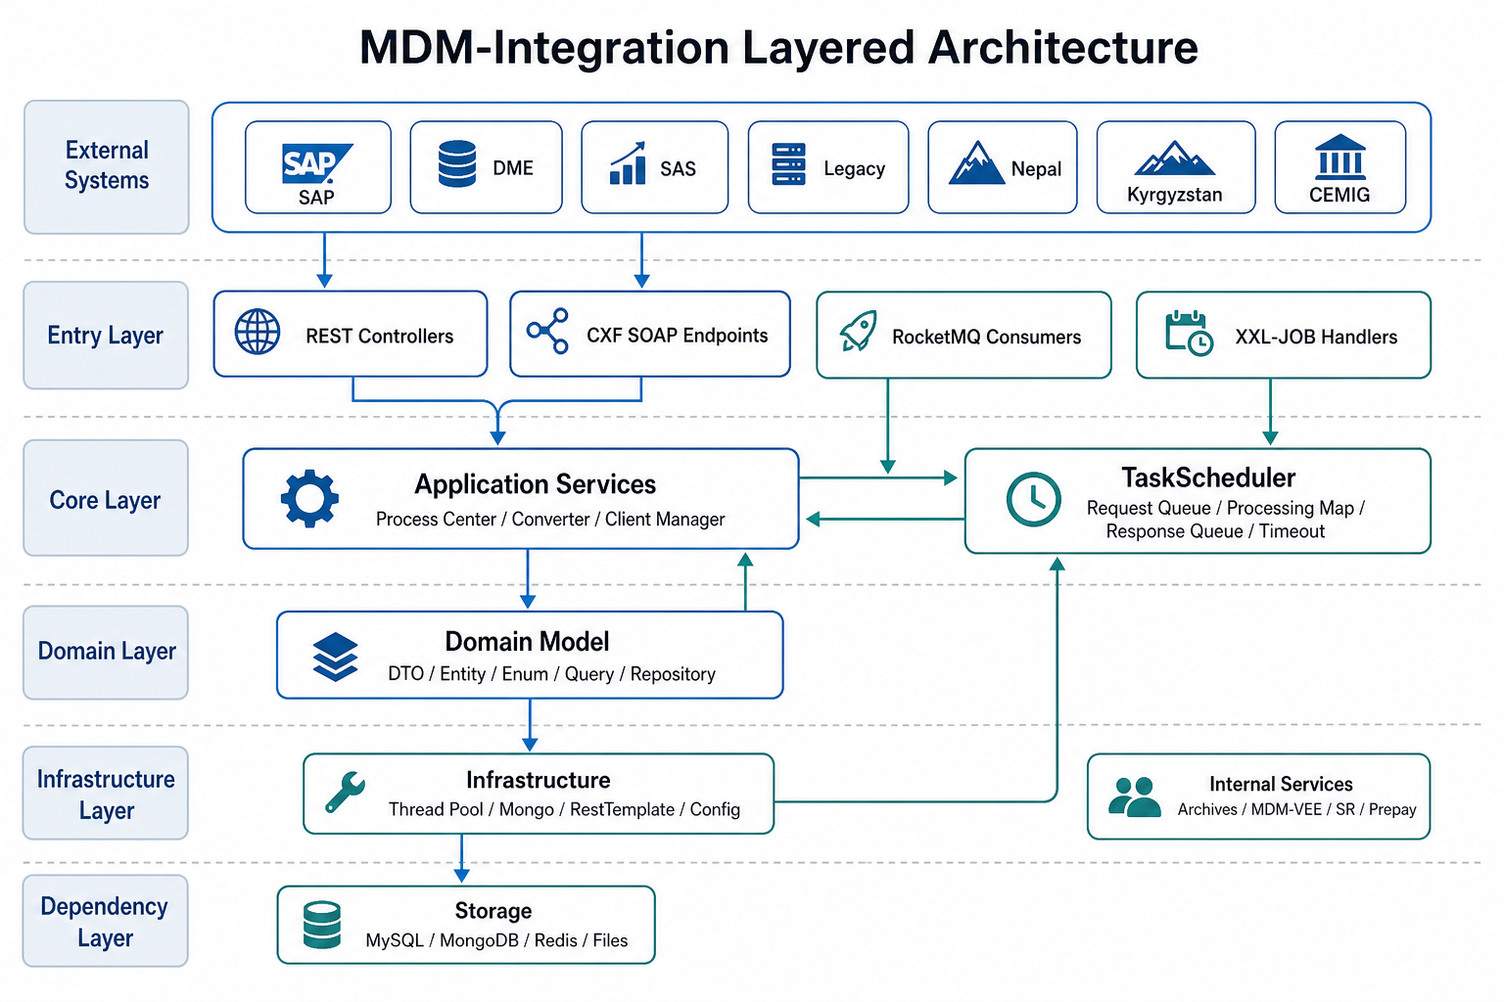
Figure 1. MDM-Integration layered architecture.
The architecture has two important characteristics. First, the service has many entry points, but the core business eventually converges in the application layer and task scheduling layer. REST, SOAP, MQ, and XXL-JOB are trigger sources; conversion, outbound calls, compensation, and state recording are completed in the application and domain layers. Second, the service is an integration adapter rather than a single business module. Different site projects may use different controllers, DTOs, task processes, and job handlers, but they share cache, logs, MQ, task scheduling, and persistence capabilities.

3.2 Runtime Entry Model
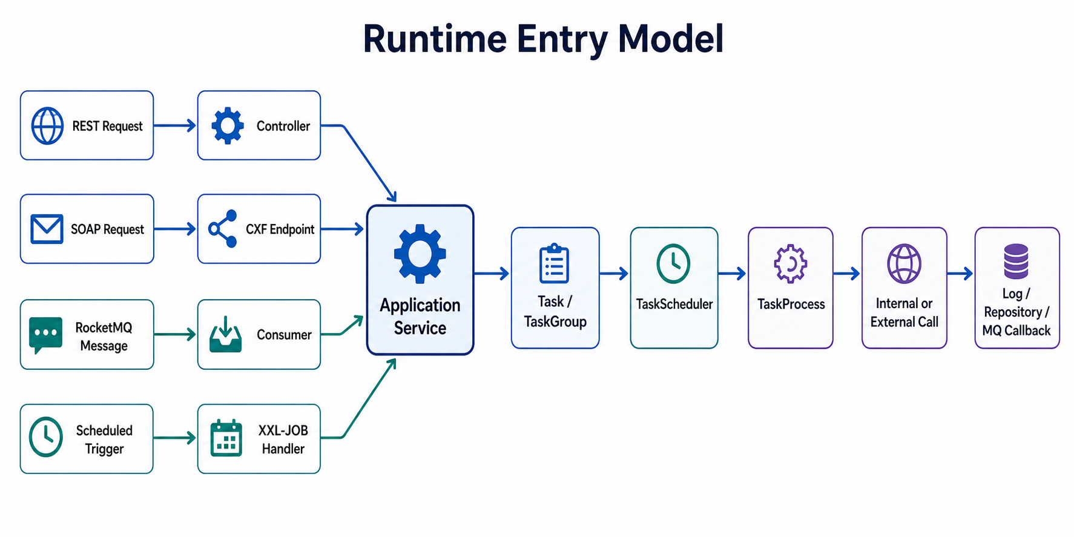
Figure 2. Runtime entry model.
Entry Type | Typical Classes | Applicable Scenario
REST | SapControlController, DmeControlController, LegacyController, SasExportController | External systems call actively, query reports, trigger synchronization manually, or call project-specific APIs.
SOAP | CxfConfig, CimServicesImpl, BillingInputMIServiceImpl, ProvisionInputMIServiceImpl | SAP/CIM style interfaces that require WSDL contracts.
RocketMQ | ArchiveSyncConsumer, CommandConsumer, InterfaceResendConsumer, SysParamConsumer | Asynchronous archive synchronization, SR requests, interface resend, and system parameter refresh.
XXL-JOB | *Handler | Compensation retry, periodic reports, scheduled file download, and periodic synchronization.

3.3 REST Interface Architecture
The REST layer is organized by project or external business system.
Controller | Base Path | Main Responsibility
ArchiveSyncMdcController | mdm/integration/V2 | Manually trigger MDC archive synchronization by time range or meter number.
DmeBilingController | mdm/integration/V2/dme | DME billing request entry.
DmeControlController | mdm/integration/V2/dme | DME relay/control request entry.
DmeIndicatorsController | mdm/integration/V2/dme | DME indicator query entry.
DmeRegisterController | mdm/integration/V2/dme | DME register/archive request entry.
KyrgyzstanController | /Api | Kyrgyzstan login, meter readings, switch, relay status, events, and archive APIs.
LegacyController | mdm/integration/V2 | Legacy gateway sync, command return, FK7 data, event, and angle data sync.
MeterConfigController | mdm/integration/V2 | FDM meter archive add and replacement records.
NepalBillController | mdm/integration/V1 | Nepal bill, SPT notification, and heartbeat.
NepalConsDetailController | mdm/integration/V1 | Nepal Cons Details report data synchronization.
SapControlController | mdm/integration/V2 | SAP control request.
SapGdisController | mdm/integration/V2 | SAP GDIs request.
SasExportController | mdm/integration/V2 | SAS report export, query, and delete.
VoltageSagController | mdm/integration/V1 | CEMIG voltage sag query.

- Controllers should only receive parameters, perform basic validation, and dispatch to services. Business conversion details belong in application services, converters, processes, or tasks.
- Project-specific business should enter application services before selecting converters, task processes, or task implementations.
- External callbacks must record interface logs and business identifiers so compensation tasks can locate failures later.
- New APIs should update Swagger annotations, authorization or interceptor rules, error codes, and interface log fields.

3.4 SOAP Interface Architecture
Servlet / Endpoint | Path | Implementation | Description
CXF Servlet | /mdm/integration/services/* | CxfConfig.disServlet() | Unified SOAP entry.
CIM Service | /mdm/integration/services/cis | CimServicesImpl | doCommand and getResponse.
Billing Input | /mdm/integration/services/leiturabilling | BillingInputMIServiceImpl | SAP billing request input.
Provision Input | /mdm/integration/services/provision | ProvisionInputMIServiceImpl | SAP archive or customer data input.

- Receive the external request through WSDL DTOs.
- Convert it into an internal Task or application-layer DTO.
- Submit it to TaskScheduler or an application service, then update log status during response or callback processing.

3.5 TaskScheduler Asynchronous Task Framework
TaskScheduler is one of the core runtime components. It turns external requests into trackable tasks that can time out, be resent, and be completed by callbacks.
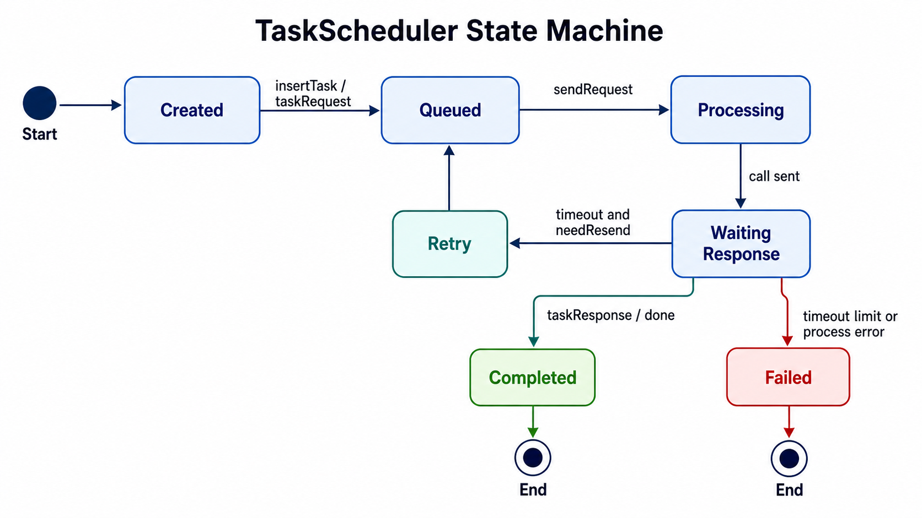
Figure 3. TaskScheduler state machine.
Member | Type | Purpose
requestQueue | PriorityBlockingQueue<Task> | Pending task queue. Tasks support priority ordering.
processing | ConcurrentHashMap<String, Task> | Tasks currently being processed, tracked by task ID.
queueRecv | LinkedBlockingQueue<CimReplyModule> | Response receiving queue.
mapParentGroup | ConcurrentHashMap<String, TaskGroup> | Batch task groups, tracking total count, completed count, and final state.
taskExecutor | Executor | Executes task send, response handling, and timeout scanning asynchronously.

Method | Description
sendRequest() | Takes tasks from the request queue and sends them.
handleResponse() | Processes returned results in the response queue.
timeOutThread() | Scans timed-out tasks and decides whether to resend or fail.
taskRequest(Task) | Submits a single task.
taskResponse(Task, CimReplyModule) | Processes a task response.
insertGroup(TaskGroup) | Registers a batch task group.
checkTask(String) | Checks whether a task is still in processing.
done(Task, String) | Completes a task and calls back the business result.

Task Subclass | Usage Scenario
SapBillingTask | SAP billing request.
SapControlTask | SAP control request.
SapProvisionTask | SAP archive or customer data request.
DmeBillingTask | DME billing.
DmeControlTask | DME control.
DmeIndicatorsTask | DME indicators.
DmeProvisionTask | DME register/provision.
SanplatTask | Sanplat project service request.
UdilControlTask | UDIL control service request.
VoltageSagTask | Voltage sag query task.

3.6 TaskProcess and Converter Design
Method | Semantics
request(Task) | Converts a task into an external or internal call request and sends it.
handleResponse(Task, CimReplyModule) | Converts response messages into business results.
response(Task, String) | Single-task callback.
response(TaskGroup, String) | Batch task group callback.

Package | Representative Classes | Description
task.process.sap | SapBillingTaskProcessImpl, SapControlTaskProcessImpl, SapGdisTaskProcessImpl, SapProvisionTaskProcessImpl | SAP billing, control, GDIs, and archive request processing.
task.process.dme | DmeBillingTaskProcessImpl, DmeControlTaskProcessImpl, DmeIndicatorsTaskProcessImpl, DmeProvisionTaskProcessImpl | DME request processing.
task.process.sanplat | SanplatTaskProcessImpl, LegacyRemoteTaskProcessImpl, VoltageSagTaskProcessImpl | Sanplat, Legacy, and voltage sag processing.
task.process.udil | UdilTaskProcessImpl | UDIL task processing.

Converter / Package | Description
CimReadsConverter, CimHistoryConverter, CimParamReadsConverter, CimSetConverter | CIM reads, history, parameter reads, and parameter setting conversion.
CimDisconnectConverter, CimReconnectConverter | CIM disconnect and reconnect conversion.
CimCustomerSyncConverter, CimMeterSyncConverter, CimOrganizationConverter, CimPocSyncConverter | CIM archive synchronization conversion.
dme.*Converter | DME control, register, reconnect, and disconnect conversion.
sap.*Converter | SAP control, archive, reconnect, and disconnect conversion.
legacy.*Converter | Legacy read and setting conversion.

3.7 RocketMQ Design
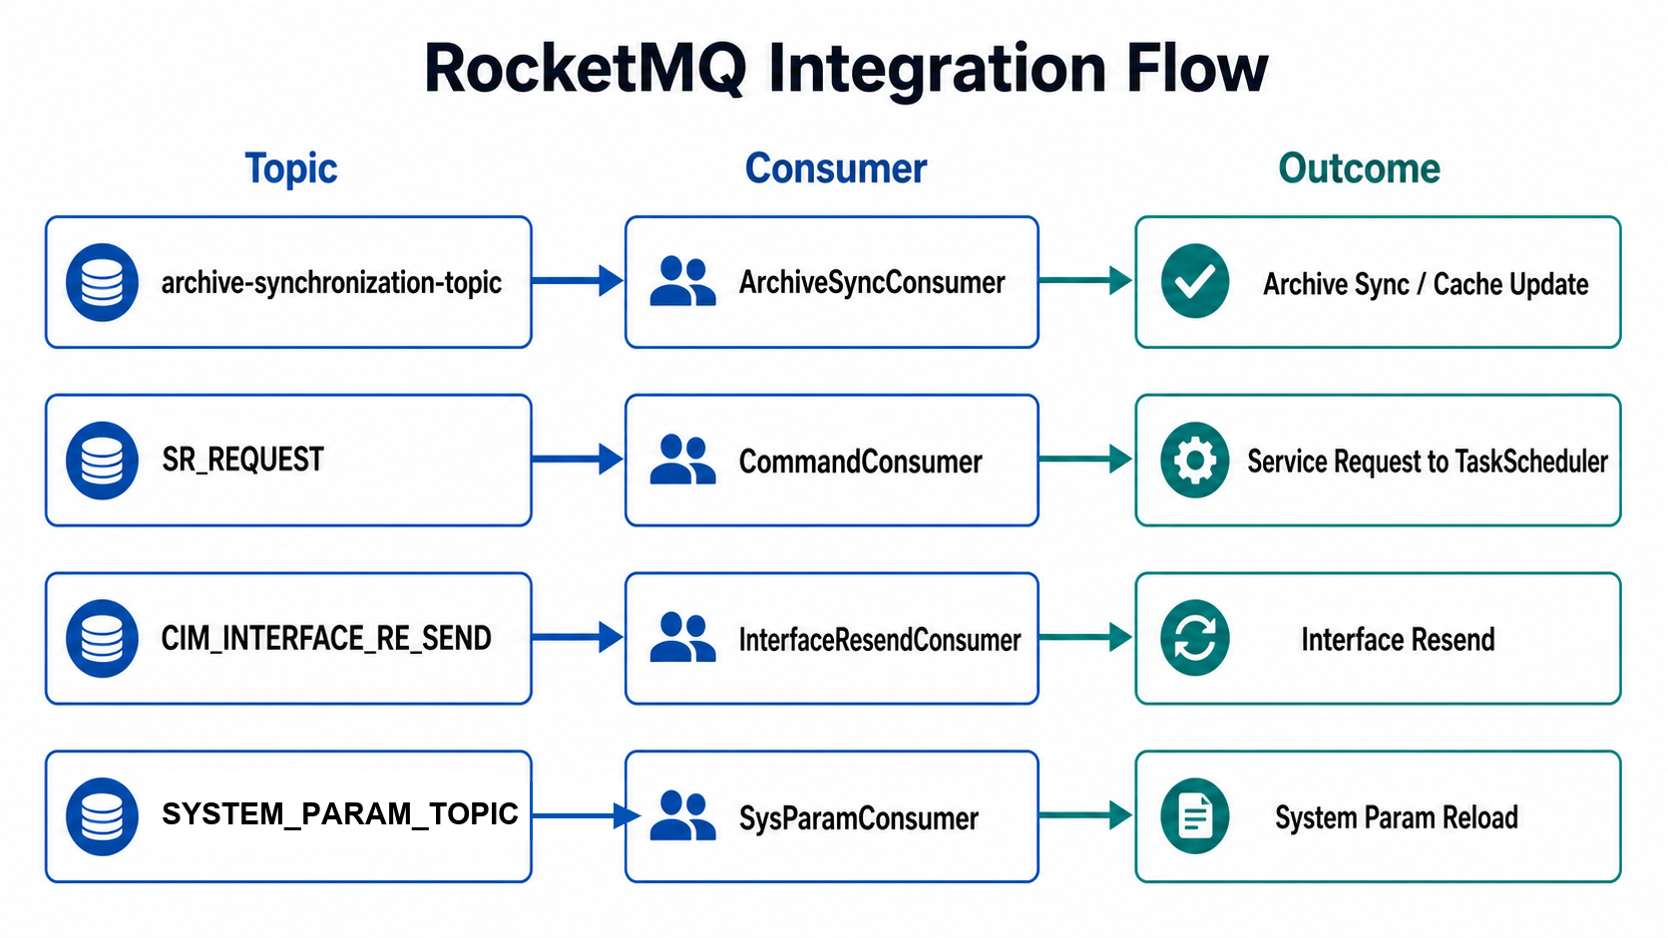
Figure 4. RocketMQ integration flow.
Topic | Consumer Group | Consumer | Purpose
archive-synchronization-topic | archive-synchronization-integration, dynamic instance group | ArchiveSyncConsumer | Receives archive synchronization events and updates local archive mirror, cache, and sync status.
SR_REQUEST | SR_REQUEST_GROUP | CommandConsumer | Receives MDM/SR service requests, constructs tasks, and submits them to scheduling.
CIM_INTERFACE_RE_SEND | CIM_INTERFACE_RE_SEND_GROUP | InterfaceResendConsumer | Interface resend and compensation processing.
SYSTEM_PARAM_TOPIC | INTEGRATION_SYSTEM_PARAM | SysParamConsumer | System parameter refresh and local cache reload.

Constant | Use
SR_RESPONSE / SR_RESPONSE_GROUP | SR response message grouping.
MDM_PARAM_VERIFICATION_DATA | Parameter verification data message.
MDM_PARAM_RECOVERY_DATA | Parameter recovery data message.
/cim/param/updata | CIM parameter update path constant.

- Consumers should parse messages into explicit DTOs before business processing.
- Message handling must be idempotent because MQ retry and duplicate delivery are normal failure modes.
- Failure logs should include message ID, topic, tag, business key, and exception detail.

3.8 XXL-JOB Scheduling Design
Handler | Class | Responsibility
archiveReSyncHandler | ArchiveReSyncHandler | Compensation synchronization for archives not yet synced.
cimOrganizationSyncHandler | CimOrganizationSyncHandler | Periodic CIM organization archive synchronization.
dmeBillingRequestHandler | DmeBillingRequestHandler | DME billing request compensation.
dmeLastGaspHandler | DmeLastGaspHandler | DME Last Gasp related processing.
dmeRelayControlRequestHandler | DmeRelayControlRequestHandler | DME control request compensation.
e241CollectHandler | E241CollectHandler | E241 collection task.
ftpFileDownloadHandler | FtpFileDownloadHandler | FTP file download task.
sapBillingRequestHandler | SapBillingRequestHandler | SAP billing request compensation.
sapProvisionRequestHandler | SapProvisionRequestHandler | SAP archive/customer-data request compensation.
sapRelayControlRequestHandler | SapRelayControlRequestHandler | SAP control request compensation.
sasEventsReport | SasEventsReport | Legacy SAS events report.
sasEventsSanplatReport | SasEventsReportV2 | Sanplat SAS events report.
sasMassDataReport | SasMassDataReport | Legacy SAS mass data report.
sasMassSanplatDataReport | SasMassDataReportV2 | Sanplat SAS mass data report.
sasPowerQuality | SasPowerQualityReport | Legacy power quality report.
sasPowerQualitySanplat | SasPowerQualityReportV2 | Sanplat power quality report.
sasProvisioningReport | SasProvisioningReport | Legacy provisioning report.
sasProvisioningSanplatReport | SasProvisioningReportV2 | Sanplat provisioning report.
sasTaxReport | SasTaxReport | Tax report.
sasTotalizerReport | SasTotalizerReport | Legacy totalizer report.
sasTotalizerSanplatReport | SasTotalizerReportV2 | Sanplat totalizer report.

3.9 Data Storage Architecture
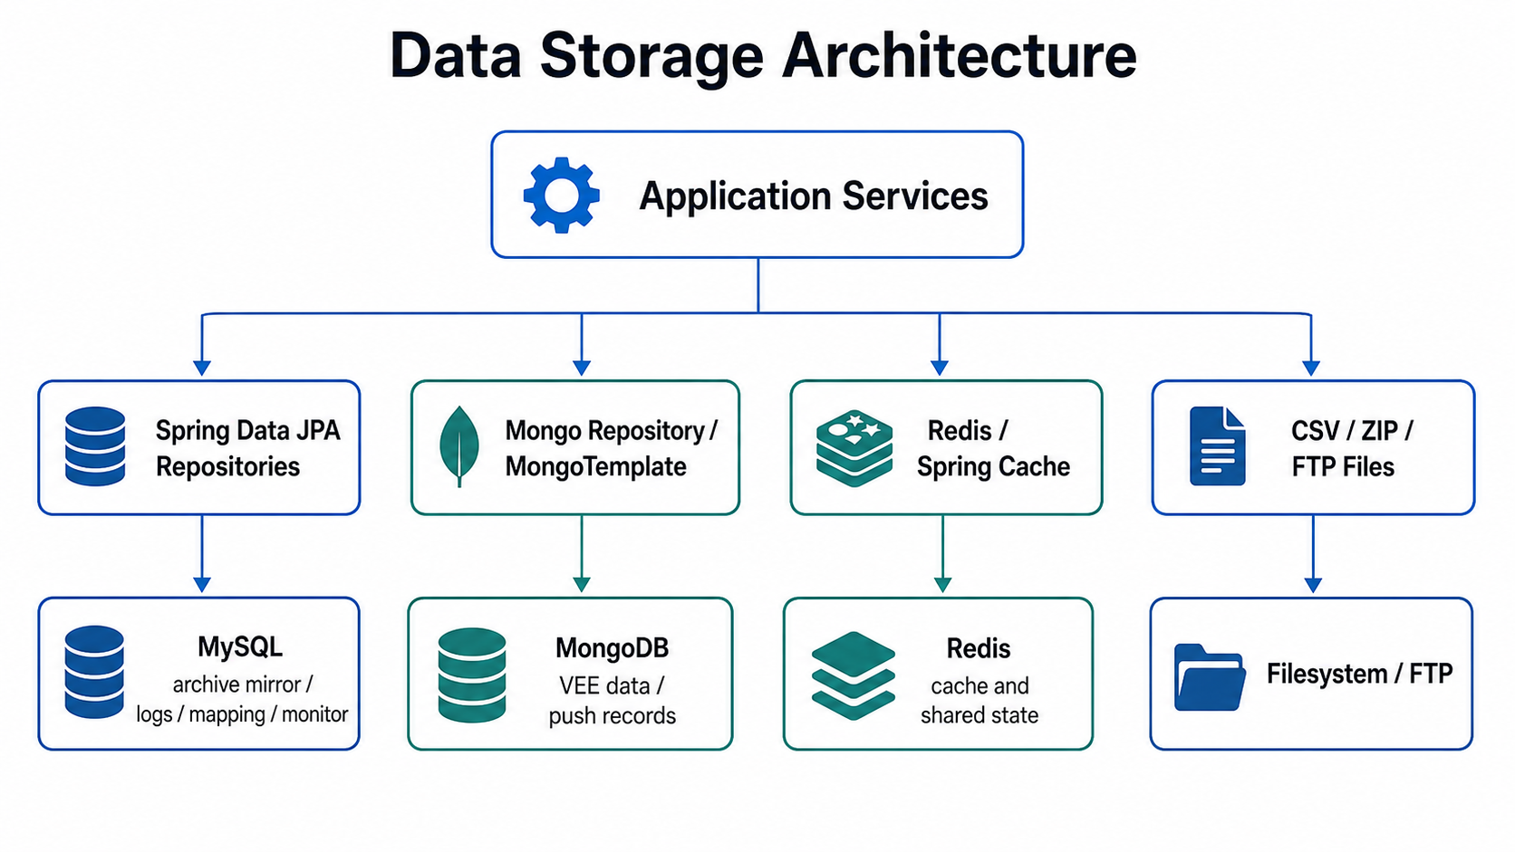
Figure 5. Data storage architecture.
Group | Entities
Archive mirror | Meter, Dcu, Poc, Organization, Factory, Sim, MeterType, DcuType, RemoteModule, ArchiveSyncDetail
Interface logs | CimLog, CimLogDetail, GdisRequestInfo, ServerExceptionLog
Monitoring | OnlineInfo, OnlineInfoVO, MonitorBillingInterfaceStatus
Nepal | BilledData, BilledDataPK, ConsDetails, ConsDetailsPK, SptTaskReportDetail
Mapping configuration | ChannelMapping, MappingDetail, MappingProgram, MDMEventDefinition
Last Gasp | PocEvents, ChannelValue
Authorization | AuthUser

Repository | Description
MeterRepository, ArchiveChangeMeterListRepository, and related archive repositories | Maintain archive mirrors and archive synchronization records used by this service.
OrganizationRepository, PocRepository, FactoryRepository | Organization, metering point, and factory base data.
SysParameterItemRepository | System parameter read and cache refresh.
ChannelMappingRepository, MappingDetailRepository, MappingProgramDefRepository | Channel mapping and program definitions.
MDMEventDefinitionRepository | MDM event definitions.
GdisRequestRepository | GDIs request logs and status.
MonitorBillingInterfaceStatusRepository | Billing interface monitoring status.
OnlineInfoRepository | Online status.
VEEDataRepo / VEEDataRepository | VEE data queries.

3.10 Cache and Parameter Refresh
Cache Class | Data Type | Trigger / Refresh Source
MeterCache | Meter archive | Startup initialization, archive-sync MQ, manual sync.
DcuCache | DCU archive | Startup initialization and archive-sync MQ.
PocCache | POC / metering point | Startup initialization and archive-sync MQ.
FactoryCache | Factory information | Startup initialization and organization/factory sync.
ProgramDefMappingCache | Channel/program mapping | Startup initialization and configuration refresh.
SysParamCache | System parameters | Startup initialization and SYSTEM_PARAM_TOPIC.

- Cache is mainly used for archive and parameter data that is queried frequently by external interfaces.
- Any archive or parameter write path must define how local cache and Redis state are refreshed.
- Task result, billing, control, and compensation state should not rely only on cache state.

3.11 Error Handling and Observability
Capability | Current Design
Application log | logging.file writes to ${log.path}/app/${spring.application.name}.log.
Log rotation | Daily rotation, 10 MB per file, 10 GB total retained size, 60 days history.
MQ log | RocketMQ client writes to ${log.path}/rocketmqlogs/ami-integration-rocketmq-client.log.
XXL-JOB log | Writes to ${log.path}/xxljob/integration-jobhandler.log.
Interface log | CimLog, CimLogDetail, GdisRequestInfo, ServerExceptionLog, and related entities support interface tracing.
Thread-pool monitoring | ThreadConfiguration registers monitor-related entries under /monitor/*.
Swagger | Swagger2 is enabled for REST interface debugging.

- Troubleshooting should combine request ID, external system, business key, task ID, SR ID, and log ID.
- For long-running flows, check both interface logs and TaskScheduler processing state.
- For MQ-driven failures, the topic, consumer group, tag, and message body are as important as the application exception.

4. External System Integration

4.1 Integration System Overview
System | Direction | Mode | Main Business
SAP | Bidirectional | REST/SOAP/task callback | Billing, archive, relay control, GDIs, and SAS reports.
DME | Bidirectional | REST/task callback/compensation task | billing, control, indicators, and register.
SAS | Output | REST/XXL-JOB/file | mass data, events, power quality, tax, totalizer, and provisioning reports.
Legacy | Bidirectional | REST/DTO/report task | Gateway sync, command return, FK7 data, events, angle data, and Legacy reports.
Nepal | Input | REST | Bills, SPT notification, heartbeat, and Cons Details data.
Kyrgyzstan | Input/query | REST /Api | Login, readings, switch, relay status, events, and archives.
CEMIG | Query | REST/Task | Voltage sag.
CIM peer | Bidirectional | SOAP | doCommand, getResponse, and CIM XML requests.
AMI Archives | Internal call | Feign | Archives, organization, remote modules, and base data.
MDM/VEE | Internal call | Feign | VEE data, channel mapping, and event definitions.
AMI SR | Internal call | Feign/MQ | Service requests and tasks.
Prepay | Internal call | Feign | Prepay auxiliary data.

4.2 Feign Clients
Client | Service Name | Key Path | Use
ArchiveRemoteService | ami-archives | ami/archives/V1/* | Remote modules, organizations, and archive synchronization.
ArchivesService | ami-archives | ami/archives/V1/archives/* | Archive query and license information.
PrepayClientService | ami-prepay | ami/prepay/V1/sgcs/droplist | SGC drop list.
SrRequestService | mdm | ami/sr/V1/serviceRequest/* | Service request query, creation, and status update.
ServiceRequestService | ami-sr | ami/sr/V1/serviceRequest/* | Standard SR client interface.
TaskService | ami-sr | ami/sr/V1/task/* | Task query, creation, update, and XXL-JOB task configuration.
VeeDataService | mdm | mdm/vee/V1/veeData/* | POC and meter VEE data, mass data.
ChannelMappingService | mdm | mdm/vee/V1/channelMapping/* | Channel mapping, program definitions, and event definitions.

4.3 SOAP Integration
Type | Description
SOAP published by this service | Endpoints include /cis, /leiturabilling, and /provision.
External SOAP called by this service | integration.url points to the external CIS WSDL. SendRequest sends CIM XML/SOAP requests.

5. Key Business Flows

5.1 SAP Control Request Flow
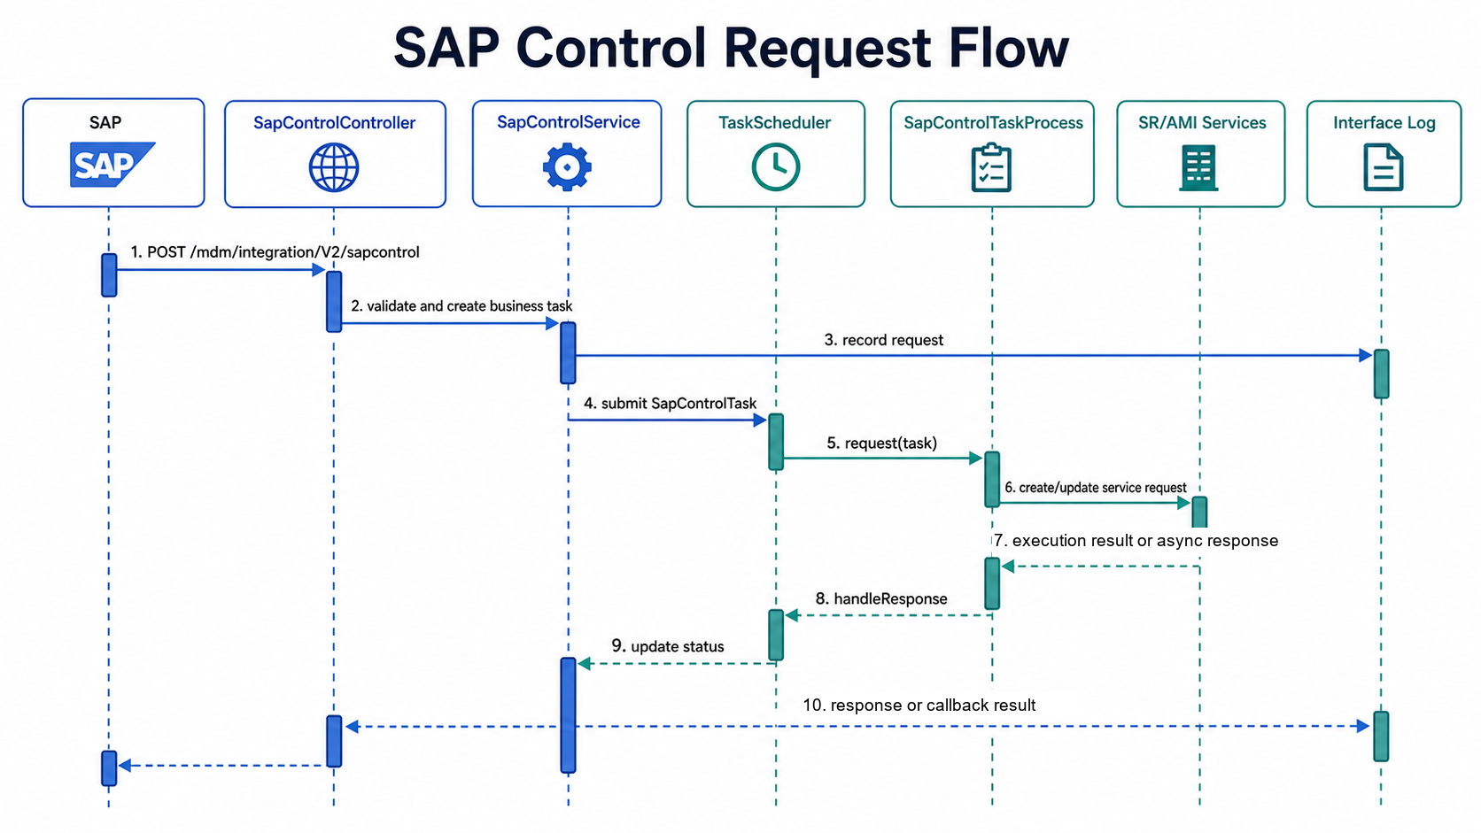
Figure 6. SAP control request flow.
- The external SAP-side request enters SapControlController.
- The application layer creates a SapControlTask and submits it to TaskScheduler.
- TaskProcess converts the task into an SR or downstream service request.
- The callback or response path updates task state, interface logs, and final result.

5.2 DME Request Flow
Interface | Controller | Task | Process
/billing | DmeBilingController | DmeBillingTask | DmeBillingTaskProcessImpl
/control | DmeControlController | DmeControlTask | DmeControlTaskProcessImpl
/indicators | DmeIndicatorsController | DmeIndicatorsTask | DmeIndicatorsTaskProcessImpl
/register | DmeRegisterController | DmeProvisionTask | DmeProvisionTaskProcessImpl

- DME calls the REST endpoint.
- The controller validates and dispatches the request.
- The application layer creates the matching DME task.
- TaskScheduler sends the task to the correct TaskProcess.
- The response or compensation path updates logs and status.

5.3 SR_REQUEST Message Processing Flow
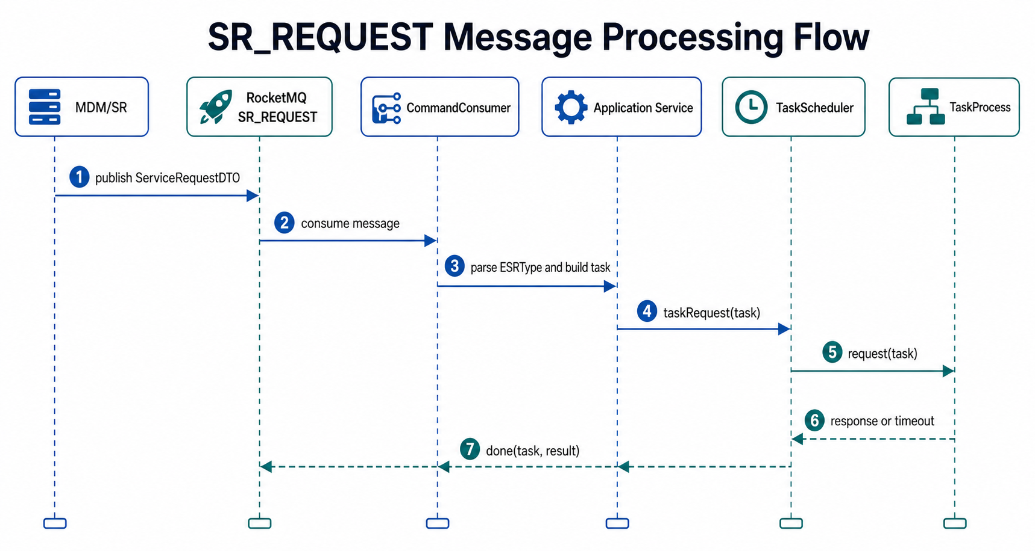
Figure 7. SR_REQUEST message processing flow.
- CommandConsumer receives SR_REQUEST messages from RocketMQ.
- The message body is converted into an internal request model.
- The service identifies project, task type, meter, POC, and remote module information.
- A task is submitted to TaskScheduler or a related process service.
- Task result and response messages are written back to the SR-related path.

5.4 Archive Synchronization Flow
Entry | Description
archive-synchronization-topic | The archive service publishes archive change events, and ArchiveSyncConsumer consumes them.
/syncMdc and /syncMdcbyMeter | Manually trigger MDC archive synchronization for compensation or site troubleshooting.

- Receive archive change information from MQ or manual REST entry.
- Read archive details from ami-archives or local mapping tables.
- Update local archive mirror tables such as meter, DCU, POC, organization, and factory data.
- Refresh relevant caches.
- Record synchronization detail and failure reason for retry.

5.5 SAS Report Flow
Report | Legacy Handler | Sanplat Handler
Events | sasEventsReport | sasEventsSanplatReport
Mass Data | sasMassDataReport | sasMassSanplatDataReport
Power Quality | sasPowerQuality | sasPowerQualitySanplat
Provisioning | sasProvisioningReport | sasProvisioningSanplatReport
Totalizer | sasTotalizerReport | sasTotalizerSanplatReport
Tax | sasTaxReport | -

- Report generation usually has a clear time window, POC scope, and file output path.
- Empty reports should be checked against time range, POC coverage, VEE/Legacy source data, channel mapping, and file permissions.
- Large reports should be controlled by batch size and job timeout.

5.6 System Parameter Refresh Flow
- A parameter update is published to SYSTEM_PARAM_TOPIC or triggered during startup.
- SysParamConsumer receives the refresh message.
- SysParamCache reloads the parameter data.
- Business paths that read parameters use the refreshed local cache.

5.7 Kyrgyzstan API Flow
API | Description
/login | Log in and obtain session information.
/meterReadings | Query meter readings.
/switch | Switch or relay control.
getRelayStatus | Query relay status.
getMeterEvent | Query meter events.
meterArchive | Meter archive synchronization or query.

5.8 Nepal Data Synchronization Flow
API | Description
/mdm/integration/V1/billedData | Bill data synchronization.
/mdm/integration/V1/notifySpt | SPT task detail notification.
/mdm/integration/V1/heartBeat | Heartbeat.
/mdm/integration/V1/consDetailsReport/saveData | Cons Details Report save.
/mdm/integration/V1/consDetails/sync | Cons Details synchronization.

- Pay attention to the consistency of composite primary key fields in BilledDataPK and ConsDetailsPK.
- For repeated pushes, confirm whether the business key is treated idempotently.
- Keep request logs and persistence status synchronized for site troubleshooting.

6. Configuration and Deployment

6.1 Base Application Configuration
Configuration Item | Description
spring.application.name | Service name: mdm-integration.
server.port | HTTP service port, supplied by mdm-interface-port.
spring.jackson.date-format | Date format.
spring.jackson.time-zone | Time zone.
log.path | Log root path.
log.level | Log level.
sys-language | Default language, affecting i18n and part of response text.

6.2 Data Source Configuration
Configuration Item | Description
spring.datasource.* | MySQL primary database connection using the Druid connection pool.
spring.data.mongodb.uri | MongoDB connection.
spring.redis.* | Redis connection and Lettuce connection pool.
spring.flyway.* | Flyway script location and switch, disabled by default.
spring.jpa.database-platform | MySQL InnoDB dialect.

- MySQL, MongoDB, and Redis must be reachable before startup.
- Druid monitoring credentials should not use weak default values.
- If Flyway is enabled, customized-path must match the deployed site version.

6.3 Service Governance Configuration
Configuration Item | Description
eureka.client.serviceUrl.defaultZone | Eureka registry address.
eureka.instance.instance-id | Instance identifier, including IP, service name, and port.
feign.hystrix.enabled | Feign circuit-breaker switch.
ribbon.ConnectTimeout | Connection timeout.
ribbon.ReadTimeout | Read timeout.
hystrix.command.default.execution.* | Hystrix isolation and timeout configuration.

Timeout note: External SOAP, report, and batch tasks often take longer than normal REST requests. Do not tune only Ribbon timeouts. Hystrix timeout and task business timeout must be reviewed together.

6.4 RocketMQ Configuration
Configuration Item | Description
rocketmq.nameServer | NameServer address.
rocketmq.mdc-client.instanceId | Local instance ID used for dynamic consumer-group suffixes.
rocketmq.producer.group | Producer group: integration-producer.
rocketmq.producer.send-message-timeout | Message send timeout.
rocketmq.producer.retry-times-when-send-failed | Retry count when send fails.

- Confirm that topics have been created.
- Confirm consumer group planning against deployment instances.
- Confirm that message body format matches consumer parsing logic.
- Decide whether failed messages require manual republish or dead-letter handling.

6.5 XXL-JOB Configuration
Configuration Item | Description
xxl.job.admin.addresses | XXL-JOB Admin address.
xxl.job.executor.appname | Executor name.
xxl.job.executor.port | Executor port, supplied by mdm-interface-job-port.
xxl.job.executor.logpath | Job execution log path.
xxl.job.executor.logretentiondays | Job log retention days.
job.* | Default configuration used when tasks are created or registered automatically.

- mdm-interface-port is the HTTP service port.
- mdm-interface-job-port is the XXL-JOB executor port.
- The two ports must not conflict with other microservices.

6.6 External Interface Configuration
Configuration Item | Description
integration.url | External CIS/SOAP WSDL address.
integration-user / integration-pwd | External interface account configuration.
sap-url | SAP or mock service address.
ftp-* | FTP download/upload configuration.
mail-* | Mail sending configuration.
ssl-* | HTTPS/certificate configuration.
datetime.format | External data time format.
data-report-path | Report generation path.

Security note: Documentation, logs, screenshots, and tickets must not expose passwords, tokens, certificate passphrases, or production intranet addresses. Site configuration should be managed through environment variables, a configuration center, or controlled configuration files.

6.7 Startup Mode
java -jar mdm-integration.jar --spring.profiles.active=dev
java -Xms512m -Xmx2g \
-Dspring.profiles.active=<profile> \
-jar mdm-integration.jar

- Confirm Eureka, MySQL, MongoDB, Redis, RocketMQ, and XXL-JOB are reachable.
- Confirm mdm-interface-port and mdm-interface-job-port are free.
- Confirm log-base-dir, data-report-path, and FTP download directories have read/write permissions.
- Confirm the external SOAP WSDL is accessible.
- Confirm system time zone, date format, and database time zone are consistent.

7. New Developer Onboarding Guide

7.1 Recommended Reading Path
Order | Reading Target | Focus
1 | IntegrationApplication | Startup annotations, scan scope, Feign, Swagger, and Cache.
2 | application.yml and target profile | Ports, data sources, MQ, XXL-JOB, and external interfaces.
3 | controller and service.config.CxfConfig | Find all external entries.
4 | application.service.impl | Find business orchestration logic.
5 | application.task | Understand how remote control, supplementary reading, and parameter tasks are scheduled.
6 | application.mq.consumer | Understand asynchronous message trigger paths.
7 | application.jobHandler | Understand compensation and periodic jobs.
8 | domain.dto/entity/repository | Understand data contracts and persistence objects.
9 | application.caches | Understand archive, parameter, and channel mapping caches.

7.2 Adding a REST API
- Add a method under the correct Controller. Create a separate Controller when adding a new system or project.
- Define request and response DTOs under domain.dto.<system>.
- Add the service interface and implementation under application.service.
- If asynchronous processing is required, add a Task subclass or reuse an existing Task.
- If external request conversion is required, add a Converter or TaskProcess.
- Record interface logs with clear success, failure, and processing states.
- Update Swagger, authorization configuration, error codes, and integration examples.
- Verify normal requests, missing parameters, external timeout, duplicate requests, and compensation retry.

7.3 Adding a SOAP API
- Clarify the WSDL contract, targetNamespace, serviceName, and portName.
- Maintain request/response objects and the JAX-WS interface under the domain DTO area.
- Add the implementation class under service.impl.
- Publish the endpoint in CxfConfig.
- Connect to TaskScheduler when asynchronous execution is required.
- Verify WSDL access, SOAP request parsing, and exception responses against the peer system requirement.

7.4 Adding a RocketMQ Consumer Path
- Add topic and group constants in MqConstants.
- Create a consumer and annotate topic, group, and consumer thread settings.
- Convert the message body into an explicit DTO. Avoid repeated string parsing in the business layer.
- Keep consumption idempotent. Duplicate messages must not produce duplicate billing, commands, or reports.
- Log message ID, topic, tag, business key, and failure reason.
- Submit downstream asynchronous work to TaskScheduler or the proper thread pool when needed.

7.5 Adding an XXL-JOB Task
- Create an IJobHandler subclass and define a unique handler name.
- Document input parameters. Use JSON for complex parameters.
- Limit query range and batch size.
- Reuse existing application services instead of placing complex business logic in the handler.
- Configure executor, cron, routing strategy, blocking strategy, and failure alarm in XXL-JOB Admin.
- Verify empty data, partial failure, repeated execution, timeout interruption, and traceable logs.

7.6 Adding a Project-Specific External Integration
- Confirm the entry type first: REST, SOAP, MQ, file, FTP, or scheduled task.
- Define project-specific DTOs and enums. Do not pollute common DTOs.
- Put project differences in converter, process, or service classes. Avoid changing unrelated project flows.
- Reuse TaskScheduler for long-running requests.
- Prefix configuration keys with the project or system name to avoid conflicts.
- Add interface logs and compensation jobs so site support can diagnose and recover failures.

7.7 Common Troubleshooting Paths
Problem | Where to Check
REST API returns 404 | Base path, HTTP method, server.port, and gateway forwarding path.
SOAP WSDL cannot be accessed | /mdm/integration/services/*, CXF servlet, port, and firewall.
Feign call fails | Eureka, service name, Ribbon/Hystrix timeout, and fallback logs.
MQ is not consumed | Topic, Group, NameServer, consumer instance, consumer threads, and logs.
Job does not execute | XXL-JOB executor registration, handler name, port, and routing strategy.
Task stays in processing | TaskScheduler.processing entry, response queue, timeout configuration, and TaskProcess.
Report is empty | Time window, POC scope, VEE/Legacy source data, channel mapping, and file path permissions.
Parameter does not take effect | SYSTEM_PARAM_TOPIC, SysParamConsumer, and SysParamCache.
Archive does not sync | archive-synchronization-topic, ArchiveSyncDetail, and manual synchronization APIs.

7.8 Pre-Development Review Checklist
Check Item | Description
Entry is clear | Confirm whether the request is REST, SOAP, MQ, Job, file, or internal call.
Business key is clear | Meter number, asset number, POC, task ID, SR ID, and log ID must be traceable.
Timeout strategy is clear | External interface timeout, Task timeout, and Feign/Hystrix timeout should be aligned.
Retry strategy is clear | Define which failures can be retried and which require manual handling.
Idempotency strategy is clear | Duplicate requests, duplicate messages, and repeated jobs must not produce duplicate business impact.
Log fields are clear | Request ID, external system, business key, status, error code, and error message.
Configuration is clear | New configuration items need defaults, descriptions, and site override approach.
Data impact is clear | Estimate impact on relational tables, Mongo documents, Redis keys, and file paths.
Rollback plan is clear | External interface changes should be disableable, degradable, or rollbackable to the previous path.

8. Interface Index

8.1 REST APIs
Method | Path | Controller | Description
POST | /mdm/integration/V2/syncMdc | ArchiveSyncMdcController | Synchronize MDC archives by time range.
POST | /mdm/integration/V2/syncMdcbyMeter | ArchiveSyncMdcController | Synchronize MDC archives by meter number.
POST | /mdm/integration/V2/dme/billing | DmeBilingController | DME billing.
POST | /mdm/integration/V2/dme/control | DmeControlController | DME control.
POST | /mdm/integration/V2/dme/indicators | DmeIndicatorsController | DME indicators.
POST | /mdm/integration/V2/dme/register | DmeRegisterController | DME register/archive.
POST | /mdm/integration/V2/gateway/sync | LegacyController | Legacy gateway synchronization.
POST | /mdm/integration/V2/gateway/cmd/return | LegacyController | Legacy gateway command return.
POST | /mdm/integration/V2/meter/cmd/return | LegacyController | Legacy meter command return.
POST | /mdm/integration/V2/data/sync | LegacyController | Legacy FK7 data synchronization.
POST | /mdm/integration/V2/event/sync | LegacyController | Legacy event synchronization.
POST | /mdm/integration/V2/angle/sync | LegacyController | Legacy angle data synchronization.
POST | /mdm/integration/V2/addmeter | MeterConfigController | FDM meter archive add.
POST | /mdm/integration/V2/record | MeterConfigController | Replacement record.
POST | /mdm/integration/V2/sapcontrol | SapControlController | SAP control request.
POST | /mdm/integration/V2/gdis | SapGdisController | SAP GDIs request.
POST | /mdm/integration/V2/sas/export | SasExportController | SAS report export.
GET | /mdm/integration/V2/sas/findFiles | SasExportController | Query SAS export files.
DELETE | /mdm/integration/V2/sas/deleteFile | SasExportController | Delete SAS export files.
GET | /mdm/integration/V2/priority/test | TestController | Priority test.
POST | /mdm/integration/V1/billedData | NepalBillController | Nepal bill data.
POST | /mdm/integration/V1/notifySpt | NepalBillController | Nepal SPT notification.
POST | /mdm/integration/V1/heartBeat | NepalBillController | Nepal heartbeat.
POST | /mdm/integration/V1/consDetailsReport/saveData | NepalConsDetailController | Cons Details Report save.
POST | /mdm/integration/V1/consDetails/sync | NepalConsDetailController | Cons Details synchronization.
POST | /mdm/integration/V1/voltage | VoltageSagController | CEMIG voltage sag.
ANY | /Api/login | KyrgyzstanController | Kyrgyzstan login.
ANY | /Api/meterReadings | KyrgyzstanController | Kyrgyzstan readings.
ANY | /Api/switch | KyrgyzstanController | Kyrgyzstan switch.
ANY | /Api/getRelayStatus | KyrgyzstanController | Kyrgyzstan relay status.
ANY | /Api/getMeterEvent | KyrgyzstanController | Kyrgyzstan event.
ANY | /Api/meterArchive | KyrgyzstanController | Kyrgyzstan meter archive.

8.2 SOAP APIs
Path | Implementation | Method | Description
/mdm/integration/services/cis | CimServicesImpl | doCommand, getResponse | CIM request and response.
/mdm/integration/services/leiturabilling | BillingInputMIServiceImpl | downloadLeituraBTSanplatInputMI | SAP billing input.
/mdm/integration/services/provision | ProvisionInputMIServiceImpl | dadosCadastraisResponseMI | SAP provision input.

8.3 MQ Topic Index
Topic | Group | Consumer | Description
archive-synchronization-topic | archive-synchronization-integration | ArchiveSyncConsumer | Archive synchronization.
SR_REQUEST | SR_REQUEST_GROUP | CommandConsumer | Convert SR requests into tasks.
CIM_INTERFACE_RE_SEND | CIM_INTERFACE_RE_SEND_GROUP | InterfaceResendConsumer | Interface resend.
SYSTEM_PARAM_TOPIC | INTEGRATION_SYSTEM_PARAM | SysParamConsumer | Parameter refresh.

8.4 XXL-JOB Handler Index
See section 3.8. When troubleshooting scheduled tasks, new developers should search by handler name in XXL-JOB Admin first.

9. Appendix

9.1 Design Decisions New Developers Should Understand First
Decision | Reason
Keep controllers thin | There are many entries and many projects. Business logic must be centralized in service/process classes to avoid duplication and hard-to-diagnose flows.
Send long-running requests to TaskScheduler | External systems, SR, CIM, and reports have unpredictable latency and need unified timeout, resend, and state tracking.
Use MQ to decouple archive and parameter refresh | Archive and parameter changes come from other services. Asynchronous messages are better suited than synchronous calls for multi-instance deployment.
Use XXL-JOB for compensation and reports | Compensation, report generation, and FTP download have clear time windows and batch characteristics.
Cache archive and system parameters | External interfaces frequently query base data by meter number, POC, factory, or channel. Cache reduces database and remote-call pressure.
Isolate project-specific capabilities | SAP, DME, Legacy, Nepal, Kyrgyzstan, and similar contracts differ significantly. Isolation reduces cross-project impact.

9.2 Recommended Future Additions
Content | How to Add It
Data dictionary | Organize table names, fields, and indexes from database scripts or entity annotations.
Interface samples | Add one successful request, one failed request, and one compensation request for each external system.
Error code dictionary | Consolidate RetCode, external error codes, and SAP/DME status enums.
Site deployment topology | Add Eureka, MQ, XXL-JOB, database, and external-system network topology.
Performance boundaries | Use load testing to confirm per-instance limits for REST, MQ, reports, and TaskScheduler concurrency.
Task state-machine details | Add state, retry count, timeout, and callback strategy for each task type.

9.3 Minimum Integration Checklist
Scenario | Verification Point
Service startup | Eureka registration succeeds, and HTTP and XXL-JOB ports are listening.
Swagger | REST APIs are browsable, and base APIs can be requested.
SOAP | /mdm/integration/services/cis?wsdl, leiturabilling?wsdl, and provision?wsdl are accessible.
Feign | ami-archives, mdm, ami-sr, and ami-prepay services can be called.
MQ | The four core topics can produce and consume messages, and consumer failures are logged.
XXL-JOB | The executor is online, and at least one test handler can be triggered.
Data sources | MySQL, MongoDB, and Redis connections are healthy.
Archive cache | Meter, DCU, POC, and parameter caches can be read after startup.
Reports | The report path is writable, and export records can be queried.
Compensation | Failure logs can be scanned and retried by the corresponding handler.

Document version: v1.0 | Source document: mdm-integration-design-doc.md | Service package: mdm-integration.jar

