NewLab air



www.newlab-plugins.com

plugin version: 7.0.0
DESCRIPTION
The Air plugin separates the harmonic content and the noise content from a
sound and remix them. The harmonic content consists in pure frequencies,
which define for example the pitch of a sound. The noise content is for example
the breath in a singing voice or the transients.

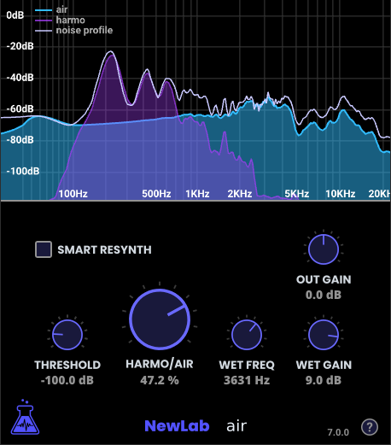

EXAMPLES OF USE
Adjust the amount of breath sound in a singing voice
The Air plugin can be used to separate the musical sound, from the breath
sound in a sound of a singing voice. Then it enables the possibility to adjust,
from almost 100% of musical sound, to almost 100% of breath sound.

Adjust the amount of air sound in a wind musical instrument
The Air plugin can be used to separate the musical sound, from the air sound
of a wind musical instrument. Then it enables the possibility to adjust, from
almost 100% of musical sound, to almost 100% of air sound.

Adjust the amount of string noises in a guitar
The Air plugin can be used to separate the musical sound, from the strings
noises of a guitar track. Then it enables the possibility to adjust, from almost
100% of musical sound, to almost of 100% string noises.

Adjust the amount of noise in any instrument or other sounds
More generally, the Air plugin can be used to extract noise parts (air,
transients, other noises…) and the harmonic parts, and remix these two parts.

DISCLAIMER
The Air plugin is designed to increase the harmonic part or the noise part
from a given sound. But the sound quality won’t be optimal when keeping
almost 100% of harmonic part, or almost 100% of noise, i.e. when extracting
totally one of the parts.

USAGE

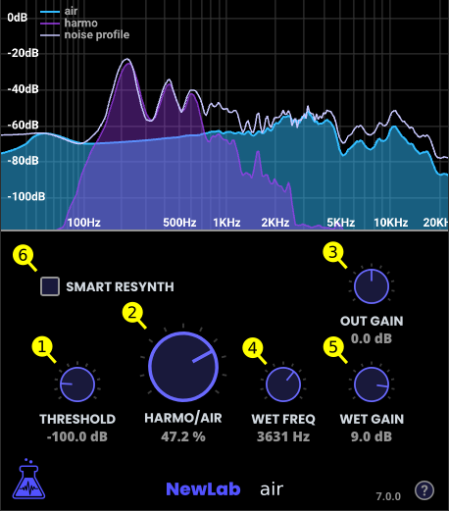

It can be helpful to use the Air plugin with a spectrogram viewer plugin
inserted just after, in order to understand exactly the harmonic part and the
noise part.

The THRESHOLD (1) parameter sets the separation threshold
between the harmonic part and the noise part. Typical good values will be
around -100 dB.

The HARMO/AIR (2) parameter defines the amount of harmonic sound and
noise sound in the result. With a value of 0% we will get 50% of harmonic
sound and 50% of noise sound (the result sound will be close to the original sound). With a value of -100% we will get 100% of harmonic sound. With a
value of 100% we will get 100% of noise sound.

The quality of the sound is not guaranteed for extreme low or high values of
the HARMO/AIR (2) parameter.

The OUT GAIN (3) parameter changes the output gain of the mixed signal. It is
particularly useful to increase the gain to compensate when the HARMO/AIR
(3) parameter is high and we keep much noise and few harmonic sound.

The WET FREQ (4) parameter chooses at which frequency the processing
starts. In order to process the air only after 5000Hz for example, set the wet
frequency to 5000Hz.

The WET GAIN (5) parameter applies a gain to the wet signal only. It can be
used for example to increase the air even more.

The SMART RESYNTH (6) option processes in order to get a better result sound quality (but it takes more CPU resource).

The graph on the upper part of the plugins shows the air signal, the harmonic
signal, and the result signal.

