NewLab denoiser



www.newlab-plugins.com

plugin version: 7.0.0
DESCRIPTION
Denoiser is a plugin which can be used to attenuate or suppress the
background noise on a track. The noise and the interesting signal are separated
in the spectral domain, then the noise is attenuated or suppressed on all the
track.

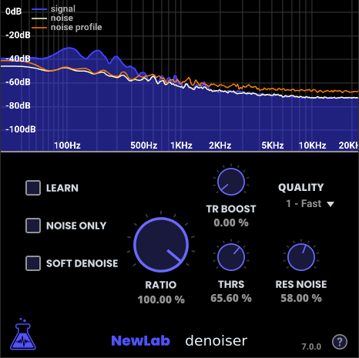
PRINCIPLE
The track must contain at least a small part, even very brief, containing only
noise. This part can be for example the beginning or the end of the recording.
The plugin learns the characteristics of the noise. Then this noise can be
attenuated or suppressed on the whole recording.

USAGE

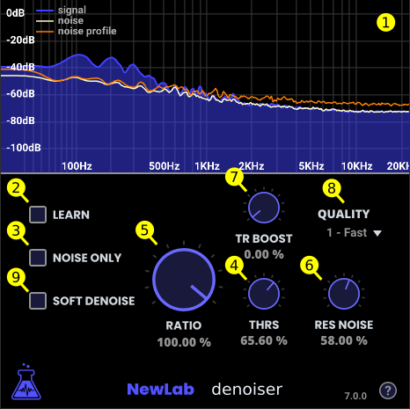
To begin, it is necessary to capture the noise profile. To do that, it is
recommended to create a play loop in the DAW, on a part of the track
containing only noise.

Check the LEARN (2) checkbox and start the playback. The plugin will then
learn the characteristics of the noise on the track. The NOISE PROFILE curve gets up to date progressively with the characteristics of the noise to suppress. The noise profile is ready when the NOISE PROFILE curve becomes stable.
Then uncheck the LEARN (2) option.
The noise suppressing is now available, with the default parameters. The NOISE curve depicts the suppressed noise.

The THRS. (4) parameter adjusts the noise suppression threshold. By moving
slightly the noise profile curve, this parameter defines more precisely what the
noise is and what the signal to keep is.

To adjust this parameter, the NOISE ONLY (3) option will help, by enabling the
possibility to listen only what we want to suppress.

The THRS. (4) parameter will be adjusted this way, by verifying that we don’t
remove too many interesting elements from the signal.

The RATIO (5) parameter defines the proportion of the noise to be suppressed.
When setup to the value 0%, the result will be identical to the original signal.
When setup to the value 100%, all the noise will be suppressed. In some cases,
it is desirable to keep a light background noise, so not to suppress all the noise.

RESIDUAL NOISE
At this step of noise suppression, there can remain residual noise also called musical noise, that sounds like some many brief frequencies.
The RES. NOISE (6) parameter attenuates this phenomenon or even suppresses it.

Note: When the RES. NOISE (6) parameter is set to 0, the residual noise processing is not made, to save some processor resources.

Note: A technique for masking the residual noise can be used without having
to use the RES. NOISE (6) parameter. For that, the RATIO (5) parameter can be
used with a value of about 80%, in order to keep a few original noise in the
result signal. The residual noise will no longer be audible, but the result will still
contain some few background noise.

Note: By keeping a slight background noise, in addition to avoid residual noise,
we will avoid to “smother” the sound too much.

Note: The more we increase the THRS. (4) parameter, the more we suppress
the residual noise. We can process this way in some cases to suppress the
residual noise without using the RES. NOISE (6) parameter, where it is possible
to do that without suppressing interesting elements of the signal.
SOFT DENOISE
The SOFT DENOISE (9) option has several effects when activated :

- The residual noise (musical noise) is automatically attenuated. No need to
take time to adjust the RES. NOISE (6) parameter.

- Better sound quality after residual noise removal. The sound is less
gated, more clear compared to manual residual noise removal. The result
sound contains more air from the original sound, while still removing the
hiss.

Note: In all cases, the noise threshold parameter, THRS. (4) , still has to be
setup carefully.

TRANSIENT BOOST
The TR. BOOST (7) parameter recovers the transients (attacks) which could
have been attenuated after processing. When set to 0%, the transients remain
unchanged, whereas when set to 100% the transients are amplified at a
maximum.

QUALITY
The QUALITY (8) parameter defines the quality of the processing. This
parameter goes from 1 (fast processing) to 4 (best quality).
When set to the value 1, the plugin processes using a minimum of resources, to
avoid overloading too much the DAW if for example the project is using many
plugins.
At the contrary when set to the value 4, the quality of the processing is at the
maximum. The signal is analyzed with a maximum of accuracy and the processing is done on the most detailed data.
It is advised to adjust the noise suppression parameters with an intermediate quality, and then to make an offline processing (bounce) with the maximum quality.
However pay attention that the result can be slightly different when modifying
the QUALITY (8) parameter. Indeed, by increasing this parameter, the plugin
make a more accurate analysis of the signal, and processes some signal details
that were not there with a lower quality.

SUMMARY
- create a playback loop on a part of the track containing only noise
- check the LEARN (2) option, start the playback, uncheck the LEARN (2) option
- start the playback
- adjust the THRS. (4) parameter
- if necessary, adjust the RES. NOISE (6) and RATIO (5) parameters

FAQ
When the RES. NOISE (6) parameter is set to a too big value, sometimes
the higher frequencies, or even all the signal totally disappear.
Indeed, if the RES. NOISE (6) parameter is set to a value that is too big, the whole signal will be considered as residual noise and all will be suppressed!
The RES. NOISE (6) parameter is to use additionally, after having suppress the
background noise using the THRS. (4) parameter.

