BlueLab STN



www.bluelab-plugins.com

plugin version: 7.0.2
DESCRIPTION
The BlueLab STN plugin separates Sines, Transients and Noise from a
sound and remixes them. Sines, transients and noise separation is also called Harmonic (tonal), Percussive and remainder Separation (HPS).
The plugin uses a state of the art method to separate the different parts in the spectral domain while limiting the result sound artifacts.

The sines extracted from the sound are pure frequencies that define the tonal part of the sound. The extracted transients are brief and percussive sound components. The noise part is the remainder, consisting in equalized noise (or shaped noise).

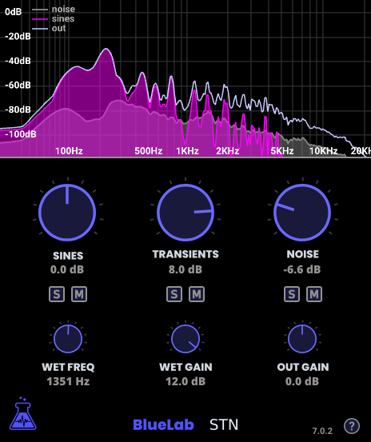

EXAMPLES OF USE
Adjust the amount of breath sound in a singing voice
The STN plugin can be used to separate the tonal part from the breath
sound in a sound of a singing voice. Then it enables the possibility to remix the tonal part and the breath part differently, for example to increase the breath and the highest frequencies to gain more clarity.

Adjust the amount of air sound in a wind musical instrument
The STN plugin can be used to separate the musical sound from the air sound
of a wind musical instrument. The air sound consists in transients for brief air sounds, and noise for long air sounds.

Adjust the amount of string noises in a guitar
The STN plugin can be used to separate the musical sound from the strings
noises of a guitar track. This can be used to decrease the strings noise in order to have a smoother sound, or on the contrary to increase the strings noise and the high frequencies to have more clarity.

Adjust the amount of noise of any instrument or other sounds
More generally, the STN plugin can be used to extract the tonal, transient and noise parts of any sound and remix these three parts.

DISCLAIMER
The STN plugin works with many types of sound, but it is not designed to handle very rapid and strong frequency changes such as in a strong vibrato or in a rapid glissando. In this cases some sines parts can be detected as transient parts instead of sines.

USAGE

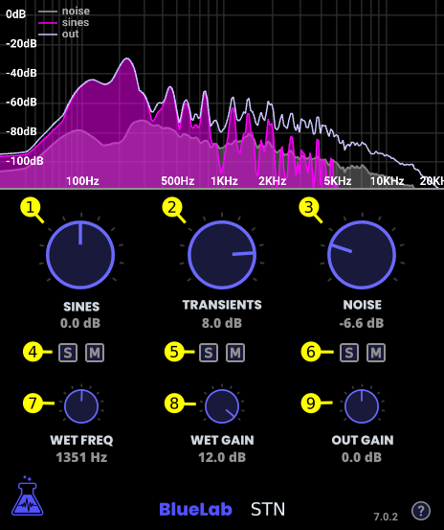

It can be helpful to use the STN plugin with a spectrogram viewer plugin
inserted just after, in order to understand exactly the sines, transients and noise parts.

The MIX (1)(2)(3) parameters are used to increase or decrease the gain of the sines, transients and noise parts.

The SOLO and MUTE (4)(5)(6) parameters are used to solo or mute each part individually.

The WET FREQ (7) parameter chooses at which frequency the processing
starts. In order to process the separation and remix only after 1000Hz for example, set the wet frequency to 1000Hz.

The WET GAIN (8) parameter applies a gain to the wet signal only. It can be
used for example to increase the transients and noise (air) in a vocal sound even more.

The OUT GAIN (9) parameter changes the output gain of the mixed signal. It is
particularly useful to decrease the gain to compensate when the MIX(1)(2)(3) parameters are used to increase one or more parts.

The graph on the upper part of the plugins shows the noise signal, the sines signal, and the result signal.

