Neural networks for coherence detection
Université de Franche-Comté
Centre Tesniere, CRIT
Master 2 LLCER
Parcours Traitement Automatique des Langues
Sous la direction d’Iana Atanassova
Brooke Stephenson

Table of Contents
1 Introduction 5
1.1 Student Evaluation 5
1.2 Aims 5
1.3 Outline 6
2 Coherence 7
2.1 Cohesion 7
2.2 Centering Theory 8
2.3 Temporal Centering 11
2.4 Rhetorical Structure Theory 12
2.5 Thematic Progression 14
3 Deep Learning 15
3.1 Training a neural network 17
3.1.1 Backpropagation 18
3.1.2 Activation Functions 18
3.2 Hyperparameters 19
3.2.1 Batch Size 19
3.2.2 Learning Rate 20
3.3 Preventing Overfitting 20
3.3.1 L1 and L2 Regularization 21
3.3.2 Dropout 21
3.3.3 Batch Normalization 22
3.4 Architectures 22
3.4.1 Recurrent Neural Networks 22
3.4.2 Recursive Neural Networks 25
3.4.3 Convolutional Neural Networks 26
3.4.4 Comparison of Architecture types 27
4 Text Representation 29
4.1 One Hot Encoding 29
4.2 Dense Word Vectors 30
4.2.1 Predictive Methods 30
4.2.2 Count-based Methods 31
4.2.3 GloVe 32
4.2.4 Dependency Embeddings 33
4.2.5 Retrofitted Vectors 34
4.2.6 Polysemy 35
4.2.7 Task-specific Embeddings 36
4.3 Character Embeddings 36
4.4 Sentence Embeddings 37
4.4.1 Skip-Thought Vectors 37
4.4.2 Contextualized Vectors (CoVe) 38
4.5 Comparing Nearest Neighbours of word embeddings 38
5 Natural Language Processing Techniques for Coherence Detection 42
5.1 Semantic Relatedness 42
5.2 Entity Transition Grid 43
5.3 Content Models 44
5.4 Syntactic Model of Coherence 46
5.5 Neural Networks 47
6 Experiment 49
6.1 Evaluation 49
6.2 Corpus 50
6.2.1 Corpus Statistics 51
6.2.2 Topic Model 51
6.2.3 Preprocessing 53
6.3 Word Embeddings 54
6.4 Neural Network Models 54
6.4.1 Convolutional Models 55
6.4.2 LSTM Models 56
7 Results and Discussion 59
7.1 Accuracy and Loss 59
7.1.1 Ensembling and Vector Concatenation 64
7.2 Sensitivity to Sentence Ordering 65
7.3 Sensitivity to Pronoun Coreference 68
7.4 Sensitivity to Temporal Coherence 71
7.5 Intermediary Layers 73
7.5.1 Sentence Representations 74
7.5.2 Sequence Representation 77
7.6 Topical Clustering and False Negatives/Borderline Cases 81
7.7 Topics in Training vs. Test Corpus 82
7.8 Visualizations 83
8 Future Research 91
9 Conclusion 93
10 Works Cited 95

Introduction

Student Evaluation
The evaluation of student writing is a problematic task for teachers. Apart from the tedious nature of the exercise, the subjective aspect of assessment and the myriad of influencing factors that play a role in determining a grade (the order in which the papers are seen, the teacher’s mood at the time of grading, unconscious biases) all contribute to an incoherent and at times unfair evaluation system. A computer algorithm, capable of assessing written work based on objective criteria would be an ideal solution to remedy the inconsistencies and prejudices of human evaluators and it could help to lessen the workload of busy teachers.
However, while natural language processing has advanced considerably in the last decade, it is not yet at the point where it can comprehend all the complexities of human language; to successfully appraise a piece of writing, a computer not only has to understand the grammar and vocabulary of a language, but also the organization of the text, the validity of the arguments, the stylistic properties, as well as the coherence and the transitions between different sections.

Aims
In this work, we hope to contribute to the advancement of machine knowledge regarding textual coherence and cohesion. This will be done by training neural networks to distinguish between coherent and incoherent sequences of text.
The aim of this thesis is to compare different neural network architectures and different language representation methods for the task of coherence detection. Previous work [ CITATION li2014model \l 3084 ] has explored the use of neural networks on evaluating coherence and has achieved good results. In this thesis, we will expand on the work of Li and Hovy by investigated the suitability of different word embeddings for this specific task and also by evaluating the use of a convolutional architecture.
While various other methods of coherence detection have been explored in the past, we are interested in studying neural networks because of their ability to learn complex functions with minimal feature engineering. Another interesting characteristic of neural networks is their ability to map words/sentences/sequences into a latent semantic space; if we can define in a latent semantic space where the boundaries are between coherent and incoherent texts, then we can construct tools that can identify breaks in coherence and potentially offer suggestions on how to better express ideas.

Outline
This thesis is organised in the following manner:
In the first section, we will define the concept of coherence from the perspective of linguistic theory.
In the second section we will delve into the topic of deep learning.
In the third section, we will explore the different options for text representation in natural language processing.
In the fourth section, we will review previous research in natural language processing involving coherence detection.
In the fifth section, we will discuss the experimental procedure used for our research into neural networks for coherence detection.
In the sixth section, we will discuss the results of the experiment.
In the final section, we will discuss possibilities for further research.

Coherence
In this section, we will examine some of the work done in linguistic theory to define the concept of coherence and the mechanisms used to build coherent texts.
The topic of coherence can be divided into two categories: global coherence or the macrostructure of a text and local coherence or the microstructure of a text. In this work, we will focus our attention mainly on local coherence.

Cohesion
In Cohesion in English [ CITATION halliday2014cohesion \l 3084 ], Halliday and Hasan investigate the properties that distinguish unified, coherent texts from random assortment of sentences; they study the cohesive features which help to establish meaningful connection across sentence boundaries. They define cohesion as a semantic relationship where “[i]nterpretation of some element in the discourse is dependent on that of another. The one presupposes the other, in the sense that it cannot be effectively decoded except by recourse to it.” (pg. 4)
Cohesive features are broken down into five categories: reference, substitution, ellipsis, conjunction and lexical cohesion. Reference, substitution and ellipsis are categories that function on the grammatical level, lexical cohesion functions on the lexical level and conjunction straddles the two. While these devices are used to create ties between sentences, they can also be found within individual sentences.
Reference refers to items that share an identity with or whose identity is directly dependent on another item in the text, such as pronouns, demonstratives and adjectives and adverbs of comparison (e.g. Would you like more cards?).
Substitutions are linguistic items (words or phrases) that allow a speaker to avoid the repetition of words while referring to the same general concept which has appeared earlier in the text. For example, You think Joan already knows? – I think everybody does. In English, substitutions come in three forms: Nominal (one, ones; same), Verbal (do) and Clausal (so, not).
Substitution and ellipsis are almost identical concepts, except where substitution replaces one linguistic item with an equivalent substitute, ellipsis leaves a gap. e.g. They haven’t got my usual morning paper. Can I borrow yours? (instead of Can I borrow your morning paper?)
Conjunction refers to elements that “express meaning that presupposes the presence of other components in discourse.” (pg. 226). Conjunctions fall into four different categories: additive, adversative, causal and temporal. An example of each category can be seen in the sentences below:
For the whole day he climbed up the steep mountainside, almost without stopping.
a. And in all this time he met no one. (additive)
b. Yet he was hardly aware of being tired. (adversative)
c. So by night time the valley was far below him. (causal)
d. Then, as dusk fell, he sat down to rest. (temporal)

Lexical Cohesion refers to the cohesive effect that is created through the use of semantically related words. Halliday and Hasan present this manner of linking sentences together as a continuum. At one end of the scale, you have the simple repetition of words. At the other end, you have the use of general nouns. And in the center, you have synonyms and superordinates. For example:
I turned to the ascent of the peak.
The ascent/The climb/The task/The thing is perfectly easy.

Centering Theory
Centering theory [ CITATION grosz1995centering \l 3084 ] explains the concept of coherence through the role nouns and pronouns play in the way a speaker/writer orients their interlocutor. Every utterance is characterized in terms of the current center of focus and the connections between previous and future centers of focus.
Grosz et al. acknowledge that coherence is not an all or nothing prospect; there are different degrees of coherence. Their focus of interest is in explaining why some sequences of text are more coherent than others. Take for example the two sets of sequences below (from Grosz et al., 1995):
Sequence 1
a. John went to his favorite music store to buy a piano.
b. He had frequented the store for many years.
c. He was excited that he could finally buy a piano.
d. He arrived just as the store was closing for the day.

Sequence 2

a. John went to his favorite music store to buy a piano.
b. It was a store John has frequented for many years.
c. He was excited that he could finally buy a piano.
d. It was closing just as John arrived.

Most would agree that Sequence 1 is easier to process than Sequence 2 even though the two sequences contain essentially the same factual information. This can be explained by the fact that Sequence 1 has a constant focus (John) while Sequence 2 switches its focus back and forth (John - > the store -> John -> the store).
In centering theory, every utterance has three types of centers:
Forward-looking centers – C_{F} | A list of candidates for the focus of the next utterance.
Preferred center - C_{P} | The most prominent member of the forward-looking centers. Prominence is based on features such as syntactic role (subjects are more prominent than direct objects; direct objects are more prominent than indirect objects, etc.), order of appearance, clausal subordination and semantic roles.
Backward-looking center - C_{B} | The center which links the current utterance to the previous utterance (The first utterance of a text does not possess this type of center). The highest ranked C_{F} that is realized in the current utterance is the C_{B} for that utterance.
Figure 2.1 Types of centers in centering theory
Centering theory also defines four types of relationships between utterance. A summary of these relationships can be found in Table 2.2 (U_{i} represents an Utterance at position i):
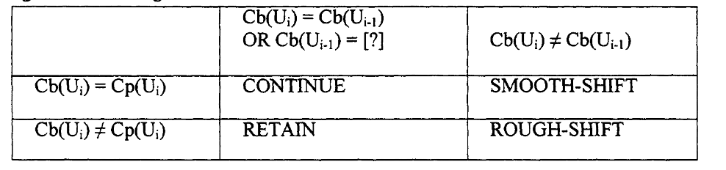
Figure 2.2: Relationships between utterances in Centering theory. (Grosz et al., 1995)
Centering theory posits two rules about the maintenance of coherence:

Rule 1: If any element of () is realized by a pronoun in , then the () must be realized by a pronoun also.
Rule 2 : Sequences of continuation are preferred over sequences of retaining; and sequences of retaining are to be preferred over sequences of shifting.

Rule 1 explains why 7b and 7c are preferable to 7a in Figure 2.3. We expect the most prominent entity from 6 (Tony) to be represented by the only pronoun in 7a and so we must recalculate the situation when we get conflicting information.

Utterance
1. Terry really goofs sometimes | Terry | Terry | n/a
2. Yesterday was a beautiful day and he was excited about trying out his new sailboat. | Terry, sailboat, yesterday | Terry | Terry
3. He wanted Tony to join him on a sailing expedition. | Terry, Tony, sailing expedition | Terry | Terry
4. He called him at 6 AM. | Terry, Tony | Terry | Terry
5. Tony was sick and furious at being woken up so early. | Tony | Tony | Tony
6. He told Terry to get lost and hung up. | Tony, Terry | Tony | Tony
7a. Of course, he hadn’t intended to upset Tony. | Terry, Tony | Terry | Tony
7b. Of course, Terry hadn’t intended to upset Tony. | Terry, Tony | Terry | Tony
7c. Of course, he hadn’t intended to upset him. | Terry, Tony | Terry | Tony
Figure 2.3: A centering theory analysis of centers over a sequence of utterances. Grosz et al. (2014)
Rule 2 does not mean that shifts in focus are not possible in coherent texts (they are necessary for a text to be developed); it simply says that the default for processing a text is continuation. If a writer wishes to pivot, then they must first introduce a new possible subject in the C_{F}s before making the change to avoid breaks in coherence.
Note that the C_{B} of an utterance can be realized either by one of the C_{F}s or by an indirect realization of one of the C_{F}s. For example, The house appeared to have been burgled. The door was ajar. In the second sentence, the backwards center (the house) is realized by a part of the house (the door).

Temporal Centering
Temporal Centering [ CITATION kameyama1993temporal \l 3084 ] was inspired by the precursor to centering theory [ CITATION sidner1983focusing \l 3084 ], but rather than explaining the transitions between entities, it strives to explain shifts between discourse reference times and the maintenance of temporal coherence.
Kameyama et al. advance that “each temporal operator in a sentence introduces a discourse reference time into the discourse context.” Like the forward-looking centers in centering theory, these reference times represent possible anchors for integrating the time of action of the next utterance into the mental scene the reader is constructing.
For example, in the sequence below (from Kameyama et al., 1993), both c and c’ can be integrated into discourse without difficulty, despite their different reference times, because b introduces two possible jumping off points with its use of the past perfect tense (t2 and t3).
a. John went over (t1) to Mary’s house.
b. On the way, he had (t2) stopped (t3) by the flower shop for some roses. (t3 < t2 (=t1))
c. Unfortunately, they failed (t4) to cheer her up. (t3 < t1 < t4)
c’. He picked out (t4’) 5 red ones, 3 white ones and 1 pale pink. (t3 < t4’ < t1)

Rhetorical Structure Theory
Rhetorical structure theory (RST) (Thompson & Mann, 1987, Mann & Thompson, 1988) is a framework for understanding coherence that looks at how individual text segments fit into the global structure of a discourse. For a text to be considered coherent, every part (clause, sentence or groups of paragraphs) must have a definable relationship with another section of the text.
RST has identified 25 different types of relationships between spans of text. Each is defined in terms of the writer’s assumptions about their reader and the intended effect they would like their text to have on the reader.
Most of these relationships take the form of a nucleus + satellite. This is an asymmetrical relationship where one argument is seen to be supporting the other (see Figure 2.4 for a list of nucleus-satellite relationships). The two sentences that follow are an example of a solutionhood relationship:
1. What if you’re having to clean floppy drive heads too often?
2. Ask for Syncom diskettes, with burnished Ectype coating and dust-absorbing jacket liners.
Sentence 2 functions as the nucleus (the solution) and Sentence 1 functions as the satellite (the question or need).
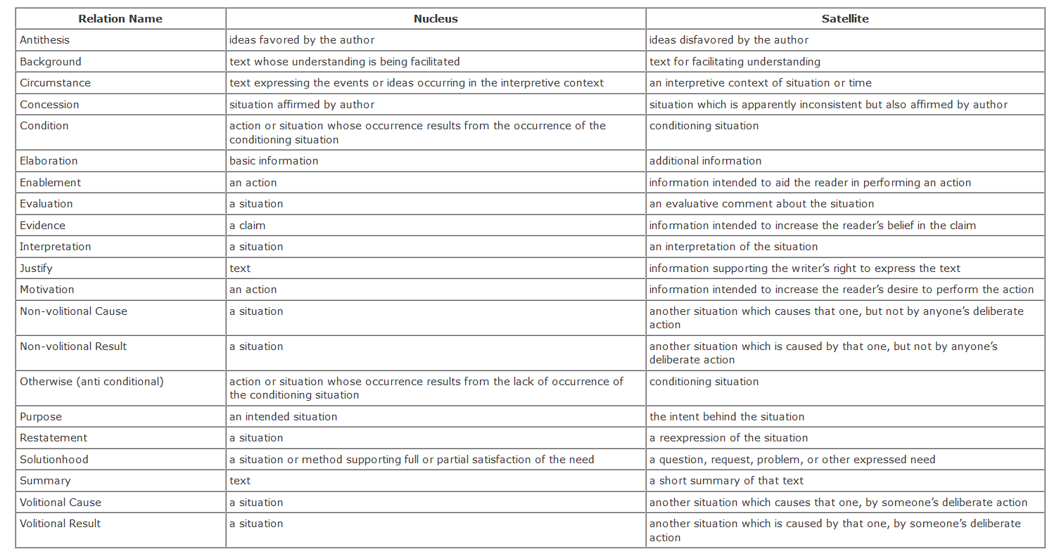
Figure 2.4 – Rhetorical Structure Theory Nucleus-Satellite relationships. [ CITATION mann1988rhetorical \l 3084 ]
The units formed by these relationships can then be combined with other spans of the text to create larger units. This process continues until the whole text is accounted for.
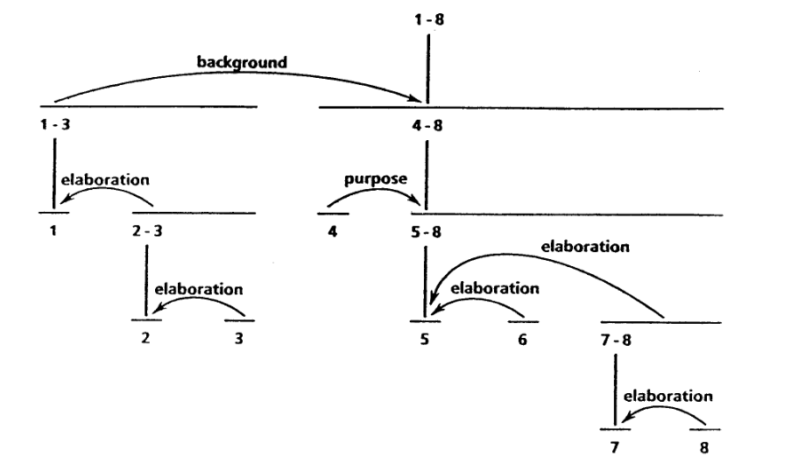
Figure 2.5: An example of rhetorical structure theory text structure [ CITATION mann1988rhetorical \l 3084 ].

Thematic Progression
Coherence is not only built through cohesive devices and discourse relations over adjoining units of text. It is also established through the presentation of information within sentences; a reader expects to be presented with known or retrievable information first before learning new information. The known information is usually presented in the theme of the utterance (the beginning of the sentence/clause where the topic is established) and the new information is typically given in the rheme (the remainder of the sentence where the topic is commented upon or developed).
The organization of information extends to larger units of text in what [ CITATION danes1974functional \l 3084 ] refers to as thematic progression.
Danes identified three types of thematic progression:
1. Constant: The theme from one sentence is carried over to the next sentence.
2. Linear: The rheme from the first sentence becomes the theme of the second sentence.
3. Derived: The theme of successive sentences can be derived from a macrotheme.
Different types of thematic progressions have been found to be preponderant in different genres of text [ CITATION bloor1991thematic \l 3084 ]; texts whose aim is to introduce a topic to the general public usually contain more linear patterns and texts targeted towards experts in a field often have more constant patterns. So thematic progression should be considered in order to make a text coherent for one’s intended audience.

Deep Learning
Deep learning is a branch of machine learning which uses artificial neural networks inspired by the human brain. First proposed in 1958 (the perceptron – Rosenblatt, 1958), these models have enjoyed great popularity in recent years thanks in part to technological developments (Graphical processor units) and the availability of big data. When provided with sufficient amounts of data, these models are particularly adept at finding the underlying patterns present in the data.

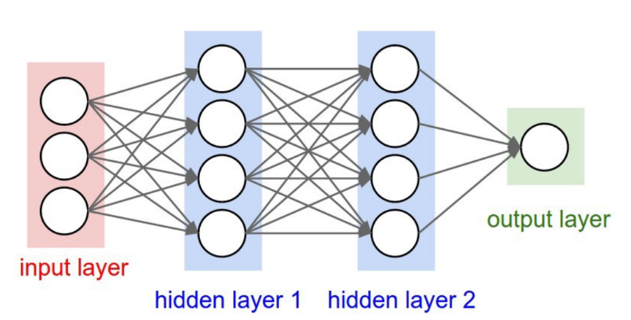
Figure 3.6: A neural network. (Image: Fei-Fei Li, 2018)

In deep learning models, a set of inputs are fed into a network. Each input is multiplied by a series of weights, each connected to a separate neuron in the first layer of the network. If the input multiplied by the weights for a particular neuron is greater than a certain threshold, then the neuron is activated (i.e. the feature that neuron has been trained to look for is deemed present), and that activation (after passing through an activation function e.g. tanh) is passed on as the input to the next layer of the network.
In this way, neural networks can build intricate representations of data, detecting increasingly complex features as the data is passed through the successive layers. This concept is clearly demonstrated if we look at representations of visual input data when processed by a computer vision networks (see Figure 3.2). In the lower levels, the network learns to detect basic features like vertical and horizontal lines. At higher levels the network starts to recognize combinations of these lower level features, like eyes and noses. And finally, the combination of higher level features can be used to classify images (e.g. Does this picture contain the image of a dog?)

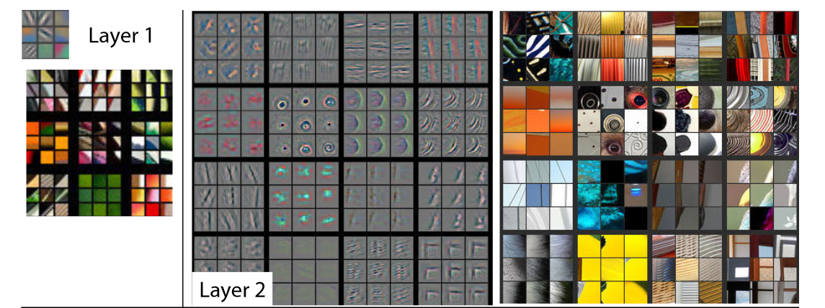
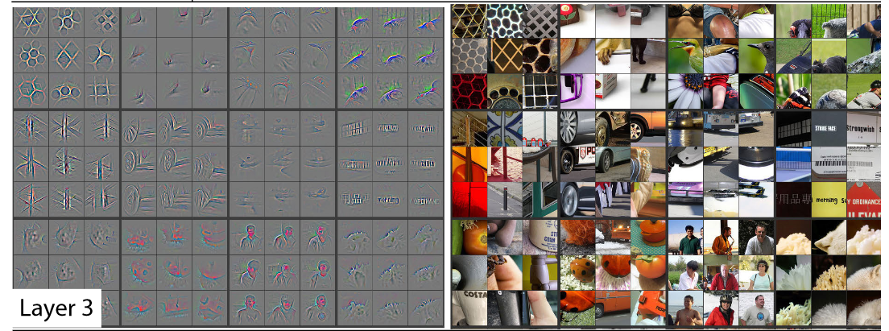
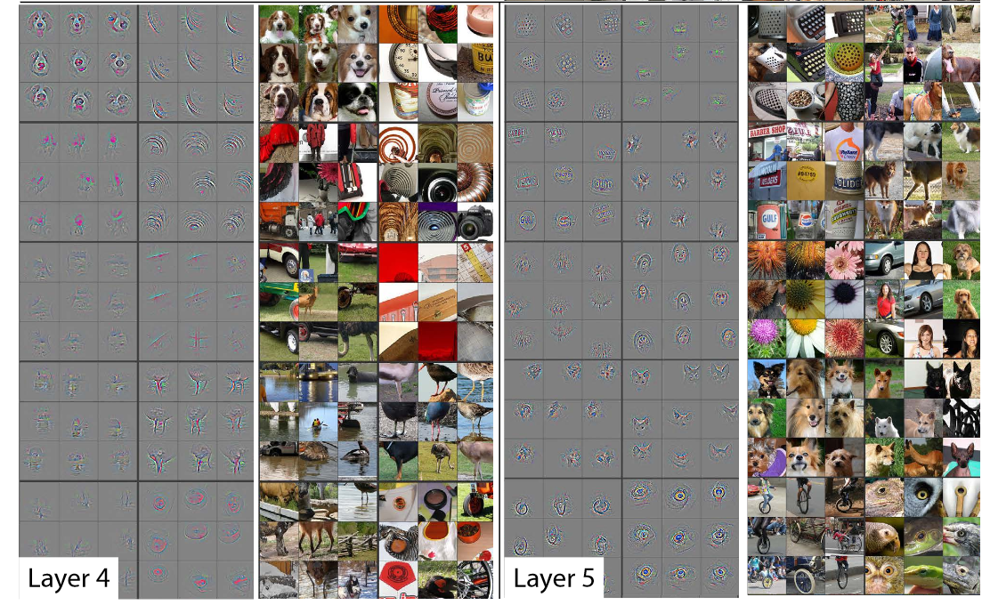
Figure 3.7: Neural Network feature detection at different layers. (Zeiler & Fergus, 2014)

Training a neural network
To train a neural network, one must first define a loss function (i.e. a function that calculates the difference between the expected outputs and the actual outputs generated by a model. The loss will be large when the model offers poor classifications/predictions and it will be small when a model is more precise. Thus, the training process involves trying to minimize the function as much as possible.

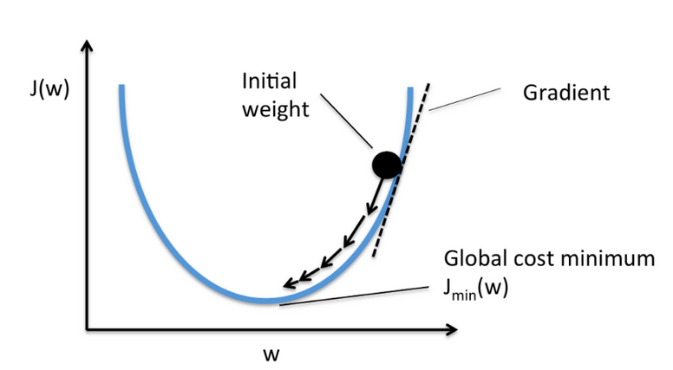
Figure 3.8: A mean-squared error loss function J(w) for a linear equation. (Image: Raschka, 2014)

This is done using an algorithm called gradient decent. Figure 3.3 shows an example of gradient decent being applied to a simple model with only one trainable weight (w). The loss function (also known as the cost or objective function), J(w), is the mean squared error. We begin by randomly initializing the weight. Then, to determine which direction the weight should be moved to minimize the loss function, we look at the gradient of the function at the initial weight (the tangent to the curve at that particular point). If the gradient is positive, then we know the weight needs to be decreased (moved to the left) and if the gradient is negative, the weight needs to be increased (moved to the right).
Once the direction of the desired change is known, we make a slight update to the weight and then check the gradient again to make sure we are still on the right path. This process is continued until we eventually converge at a global (or local) cost minimum.

Backpropagation
The weight updates for the entire network are determined based on an algorithm known as backpropagation [ CITATION linnainmaa1976taylor \l 3084 ]. Backpropagation employs the chain rule of calculus to discover how much each of the parameters in the network contributed to the final outcome. In this way, the gradients for each weight can be calculated.

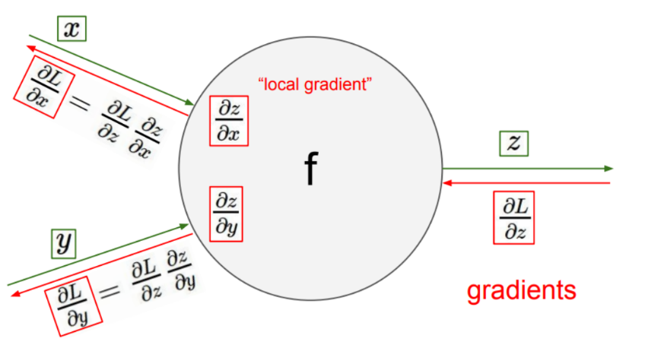
Figure 3.9: Backpropagation – L=Loss from the final layer; x,y and z = weights within the neural network. (Image: Fei-Fei Li, 2018)

Activation Functions
Neural networks are universal function approximators [ CITATION cybenko1989approximation \l 3084 ]; that is to say they can eventually, provided they have sufficient neurons, model any continuous function, no matter how complex. They are able to do this by combining multiple non-linear functions (see Figure 3.5 as an example), where each non-linear function (neuron of the neural network) approximates a section of the function.
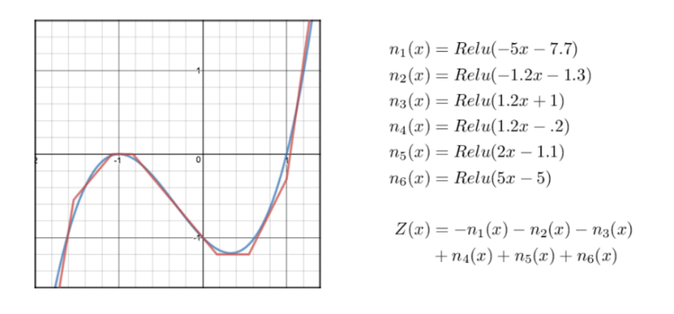
Figure 3.10: The function f(x) (the blue curve) can be approximated using the sum of non-linear functions Z(x) (the red curve)[ CITATION Bre17 \l 3084 ]
Three common non-linear equations commonly utilized in deep learning are the hyperbolic tangent (Tanh), the sigmoid and the rectified linear unit functions.
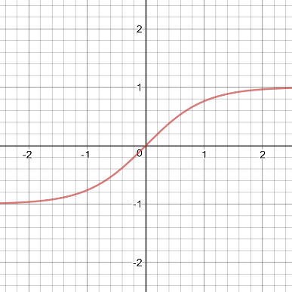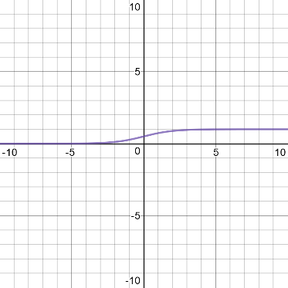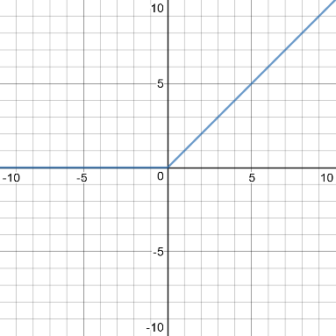
Figure 3.11: LEFT: Hyperbolic Tangent (Tanh), CENTER: sigmoid, RIGHT: Rectified Linear Unit (ReLU)

Hyperparameters

Batch Size
To make the most accurate updates to a neural network’s weights (with the objective of minimizing the loss on a training set), one must calculate the loss function and the gradients with respect to the entire training dataset. However, with a large amount of data, this process could take an extremely long time and could potentially exceed the memory limits of the computer. Furthermore, there is a high risk of overfitting the model to the training set (Keskar et al., 2016). That is why most neural nets are trained using successive portions (mini-batches) of the dataset; a forward pass is carried out on a batch, the average loss for the samples in the batch is determined and then updates are made to the network before moving on to the next batch.
The batch size is thus one of the hyperparameters that can be tweaked. No definitive rules have been discovered for choosing the optimal batch size but there are some general guiding principals: we want to find a batch size that is small enough to allow fast training and will find a model capable of generalizing to new data, but large enough to capture recurrent patterns in the data. Commonly a batch-size that is a power of 2 (e.g. 128, 256, 512) is chosen to make the data processing more efficient for the computer’s GPU or CPU.

Learning Rate
The learning rate of a neural network refers to the size of the updates to the weights after each training batch. If the learning rate is too small, the model will take too long to find the optimal settings; if the learning rate is too large, then the model might jump over the weights that would minimize the loss.
Several optimizers have been proposed to speed up the training process by adjusting the learning rate based on the history of updates to the model. For example, the Adaptive Gradient algorithm (Adagrad – Duchi, Hazan, & Singer, 2011) calculates different learning rates for the different parameters of a network on the basis of how frequently those parameters are used; it calculates larger updates for parameters that are infrequently used and smaller updates for frequently used parameters. Root Mean Square Propagation (RMSProp – [ CITATION tieleman2012lecture \l 3084 ]) also provides per-parameter learning rates, but rather than keeping a record of all previous gradients as Adagrad does, it keeps a diminishing average. Adaptive Moment Estimation (Adam - [ CITATION kingma2014adam \l 3084 ]) does the same thing with the added feature of momentum (a method for accelerating the search for the global minimum along dimensions that are comparatively shallow to other dimensions).

Preventing Overfitting

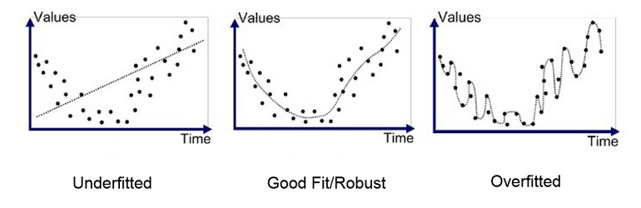
Figure 3.12: LEFT: a function which does not represent the data well. CENTER: a function that represents the data well and can generalize to new data. RIGHT: a function that fits the data too well and will not generalize to new data. [ CITATION Anu18 \l 3084 ]

A common problem encountered when training neural networks is overfitting. Overfitting is when a model learns how to make accurate predictions for the data it has been trained on, but it is unable to generalize to new input data. Aside from increasing the amount of training data (which is not always feasible), several methods have been proposed to reduce this phenomenon:

L1 and L2 Regularization
L1 and L2 regularization are techniques that encourage the model to find the least complex weights that will still fit the training data. They involve adding an additional parameter to the loss function which penalizes complexity.

Dropout
Dropout ( (Hinton et al., 2012), (Srivastava et al., 2014)) is a technique that prevents neural networks from becoming over dependent on the co-occurrence of features found in the training data. It does this by deleting a percentage of the neurons at each step of the training process, so some features are blocked out. This makes models more robust because they need to find alternative paths to produce the desired outcome.
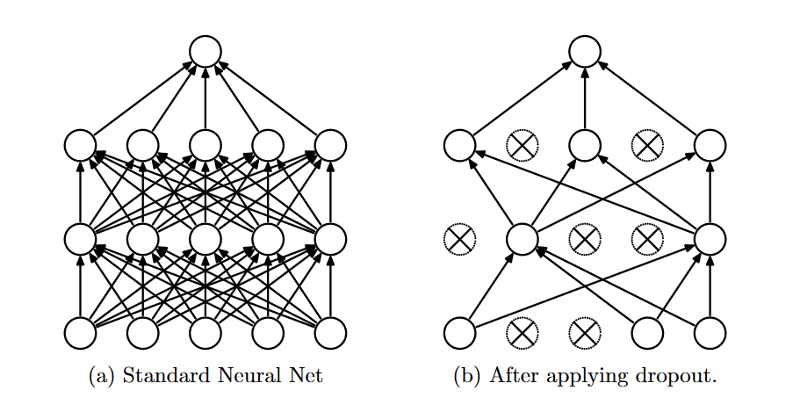
Figure 3.13: An example of dropout (Srivastava et al., 2014)

Batch Normalization
Batch Normalization [ CITATION ioffe2015batch \l 3084 ] is a method for reducing the effects of large activation outputs which can destabilize a network. It handles this problem by normalizing all the outputs for a given layer on each training batch. That is to say, it subtracts the mean and divides by the standard deviation for each activation. It then multiplies the normalized output by an arbitrary parameter and then adds another arbitrary parameter to the resulting product. The arbitrary parameters are optimized during the neural network’s training process.

Architectures
Positive results from the use of neural networks have been obtained from a variety of different architectures. In this section, we will examine three of the most popular classes of neural nets in the field of natural language processing.

Recurrent Neural Networks
A recurrent neural network is a type of network designed to deal with sequential information. This is useful for language processing, since the interpretation of words is dependent on the words that came before.
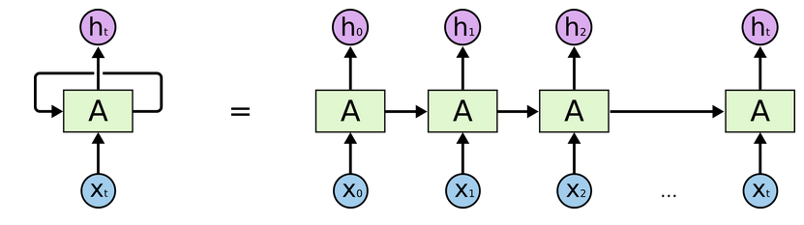
Figure 3.14: Recurrent neural network structure. (Image: Olah, 2015)
At each timestep, a recurrent network computes an output as well as a hidden state value that will be passed on to the subsequent timestep. This can be thought of as either a network containing a loop or as several copies of the same network where each copy is responsible for processing one part of the input data and for passing a message on to the next copy.
To illustrate, let’s look at Karpathy’s (2015) toy language model example (Figure3.10). Here we have a recurrent model that tries to predict the next letter in the sequence given the one-word training example of hello. At the initial timestep, the model is fed the input h in the form of a one-hot encoding (see section 4.1 for more details). By multiplying the input with the model’s weights (W) the network produces an output that scores the probability of seeing each of the four possible letters as the next letter in the sequence (h: 1.0, e:2.2, l: -3.0, o:4.1). Given our particular training data (hello), we would hope that the letter e would have the highest score, but since it does not, this model requires more training. The model also produces a hidden vector (0.3, -0.1, 0.9) which will be used to determine the output at the next timestep (Note that the initial hidden state, the one used to calculate the first output, is a parameter of the network that must be learnt).
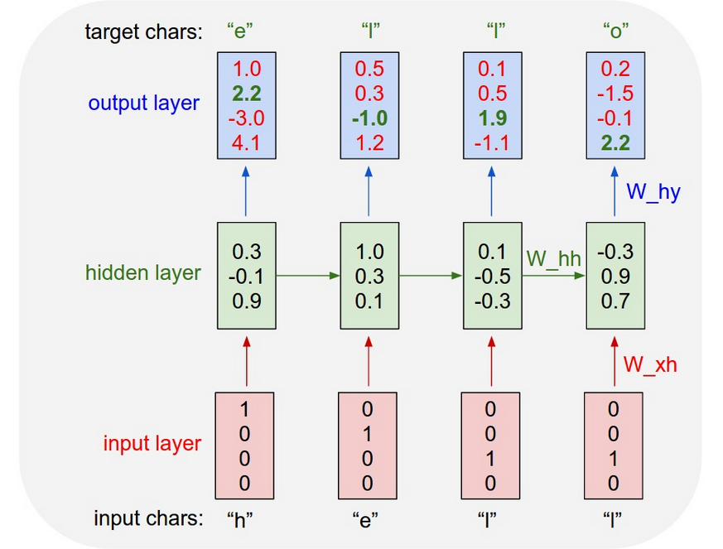
Figure 3.15: Example of an LSTM language model. [ CITATION And15 \l 3084 ]
The hidden state, which captures information about the previous letters in the sequence, allows us to obtain different outputs for the same input value. If you look at the last two inputs (both the letter l), the second last output predicts an l as the next letter and the last output predicts an o. This fits perfectly with our training data because we are most likely to see an l after h + e + l and most likely to see an o after h + e + l + l.
One problem with basic recurrent networks is the issue of vanishing gradients. This refers to the difficulty these models have learning long-range dependencies: the error signal gets lost as it travels backwards through time. To overcome this problem, gated networks containing multiple neural nets have been introduced.
The most popular of these gated networks is known as a Long Short-Term memory cell (LSTM – [ CITATION hochreiter1997long \l 3084 ]). This network contains four types of neural cells which determine which updates should be made to the two information highways passing through the network, the cell state (the black arrows passing through the top of the cells in Figure 3.11) and the hidden state (the black errors passing through the bottom of the cells in Figure 3.11). The four gates within an LSTM cell which control the updates are: the forget gate, the input gate, the output gate and the memory cell. These cells are optimized during training to effectively learn what information to remember and what information can be discarded in accordance with the incoming input.
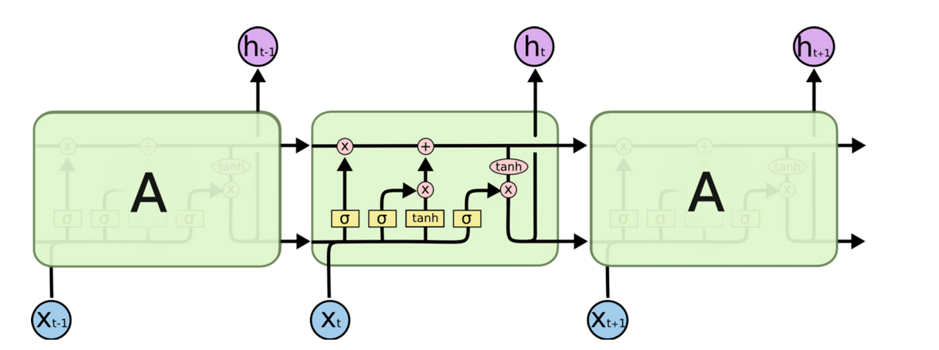
Figure 3.16: Long Short-Term Memory Network. (Image : Olah, 2015)

Bidirectional Recurrent Models
The interpretation of language does not only depend on what has come before, but also on what is to come in the future. For example, we cannot fully understand the role a word plays in a sentence unless we see both its left and its right contexts.
To improve the results of recurrent neural networks on NLP tasks, we can employ bidirectional recurrent models [ CITATION schuster1997bidirectional \l 3084 ]. This simply involves running one network over the data in the forward direction and running another in the backwards direction. The resulting vectors from the two networks can then be concatenated or added together to give representations of the full context.

Recursive Neural Networks
Recursive neural networks (Socher et al., 2011) are networks that incorporate hierarchical structure into their design. This mirrors the hierarchy of human syntax, where smaller units recursively combine into larger units until they form sentences.
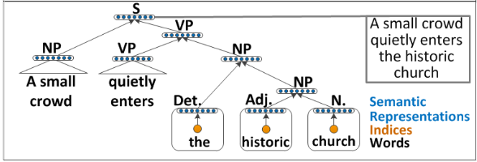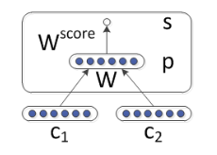
Figure 3.17: An example recursive neural network from Socher et al., 2011.
In Socher et al.’s implementation of a recursive net (Figure 3.12), the objective of which was to score potential syntactic parses of a sentence, the vector representations of the words on the lowest connected subbranches of the possible tree were merged together into a new combined representation. The combined representations were then merged with the children of their parent node. This procedure is repeated until you have a representation of the entire sentence. At each merger, the pairing of two words/phrases is given a score and the sum of these scores can be used to evaluate the parse.
For other NLP tasks using a recursive network, a preliminary parse of the syntax tree is required before training.

Convolutional Neural Networks
Convolutional neural networks (LeCun et al., 1999) are a type of architecture which have had great success in computer vision tasks and are increasingly being used in NLP.
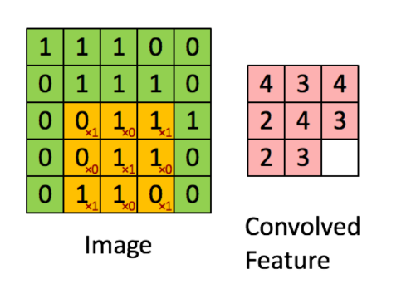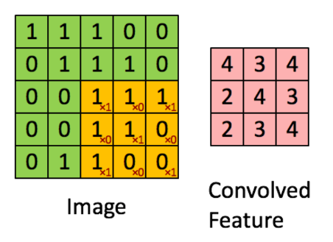
Figure 3.18: Two convolutional passes in the convolution of an image. (Image: Stanford Deep Learning, 2013)
These models work by passing a filter over each section of the input data to try and detect characteristics that are helpful for accomplishing a given task. The illustration above (Figure 3.13) shows a filter with a kernel size of 3x3 (the orange box) passing over a two-dimensional image (the green box). In each 3x3 section of the image, the filter multiplies its feature weights (the red digits) by the pixel values in that section and then records the sum of those products in a feature map (the pink square). When a feature that a filter has been trained to look for is spotted, a large value will be returned to the feature map. Most convolutional networks use multiple filters and feature maps to gain a rich representation of the input data.
In NLP, the filters pass over word embeddings (see section 4). The kernel size/filter width will determine how many words are encapsulated in each dimension of the feature map. In the model below (Figure 3.14, [ CITATION kim2014convolutional \l 3084 ]), feature maps for bigrams and trigrams (a filter width of 2 and 3 respectively) are calculated; so for the example sentence, the bigram filter will build representations for wait for, for the, the video, video and, and do, do n’t, n’t rent, rent it and the trigram filter will build representations for wait for the, for the video, etc.
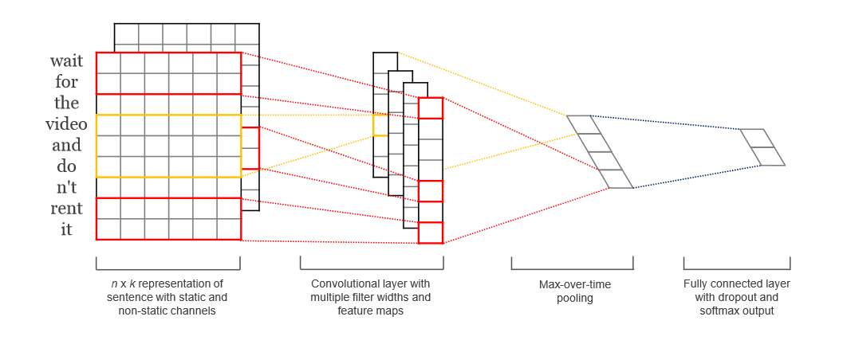
Figure 3.19: Convolutional Network Architecture [ CITATION kim2014convolutional \l 3084 ].
In order to reduce the number of trainable parameters and to focus the model’s attention on the most salient features of a text, a technique known as max-pooling is often applied in convolutional networks. This involves passing the largest value from a feature map onto the next layer of the network and disregarding the other values.

Comparison of Architecture types
Each of these architectures have their strengths and weaknesses with regards to NLP.
Convolutional neural networks have the significant advantage of being fast to train. It is possible to train a convolutional model on a large corpus of data in a matter of hours whereas recurrent and recursive models can take days/weeks. This is possible because convolutional models can pass their filters over all sections of a text in parallel while recurrent and recursive need to compute hidden layer representations for each timestep/subtree before moving on to the next.
Recursive and recurrent networks are better able to capture word order and the context of words than convolutional models. However, Convolutional Nets are capable of learning longer range dependencies (Kalchbrenner et al., 2014).
Recursive models most resemble the syntactic structure of natural language, but to achieve this, they are dependent on the upstream task of dependency parsing. So any errors in the dependency parsing will introduce errors into the model.

Text Representation
In order to make language understandable to a deep learning model, it is necessary to convert text into a machine-readable numeric representation. Several methods have been developed to derive such representations and, in this section, we will summarize the available options which can be used to train a neural network to detect coherence (or any other natural language processing task).

One Hot Encoding
The simplest way to represent text is by assigning the value of one in a sparse matrix for each item in the vocabulary, i.e. one hot encoding.
'dog' = [1,0,0,0]
'cat' = [0,1,0,0]
'violin' = [0,0,1,0]
'guitar' = [0,0,0,1]
Figure 4.20: Example of one-hot encoding vectors for a 4-word vocabulary.
One problem with this type of representation is that it does not effectively capture the semantic similarities shared between certain words; it is not possible to know that the word dog is more closely related to the word cat than it is to the word violin because each word is depicted by an all or nothing vector.
Furthermore, because one hot encoding cannot harness word similarity, data sparsity is an issue. Rare words that seldom appear in a corpus will not have very rich/accurate representations.
Another issue with one-hot encodings is that the size of the word vectors can very quickly become unmanageably large because the size of the matrix grows linearly.

Dense Word Vectors
An alternative to one-hot encodings are dense vectors. These vectors are much smaller; they usually contain between 30 and 300 dimensions. These dimensions represent semantic and syntactic features of words.
Since words that appear in similar contexts usually have similar meanings, these properties can be learnt through the cooccurrence of words in large corpora of texts. Training methods for dense vectors fall into two categories: predictive methods and count-based methods.

Predictive Methods
Predictive models are trained to predict which words are likely to appear together. Word2vec (Mikolov et al., 2013), the most well-known of these models, derives its embeddings by means of a simple three-layered neural network. Word2vec comes in two varieties, skip-gram and continuous bag of words (CBOW). In the skip-gram version, a word is fed into the network and using this input, the model has to learn vector representations that will predict what the surrounding context words are. The CBOW version takes the opposite approach; it takes the surrounding context words as input and tries to predict the target word.
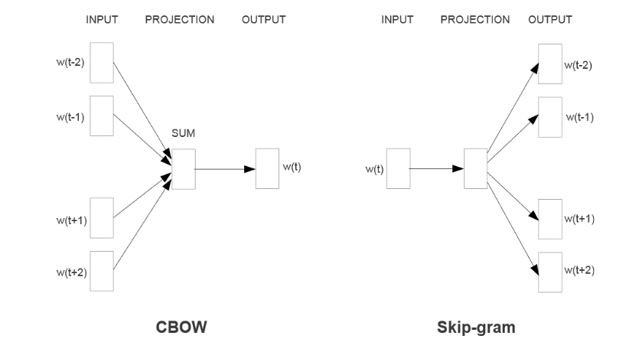
Figure 4.21 Continuous bag of words and skip-gram models (Mikolov et al., 2013)
In their original form, the training process for both skipgram and CBOW involved working through an entire training corpus, predicting one context window/target word at a time and then modifying the vectors to reduce the prediction error. However, updating all of the word vectors at every step is very computationally expensive, so Mikolov et al. (2013) introduced a method called negative sampling which speeds up training considerably. Instead of decreasing the probability that all non-target words will be in the context under consideration, a chosen number of random sample words are updated.
One of the remarkable properties of Word2Vec embeddings is their ability to capture analogies between words. For example, if you take the vector for man and subtract the vector for woman and then add the vector for king, the resulting vector is queen. Other relationships between words such as countries and their capital cities and verbs in the past tense and their corresponding verb in the present tense have also been observed in the Word2vec vector space.

Count-based Methods
Count-based methods are techniques that use cooccurrence matrices and matrix factorization to derive embeddings. Some examples include latent semantic analysis (Deerwester et al., 1990), COALS (Rohde et al., 2006) and Hellinger-PCA [ CITATION lebret2013word \l 3084 ].
 | Document 1 | Document 2 | Document 3 | Document 4
Word 1 | 3 | 1 | 0 | 0
Word 2 | 0 | 0 | 3 | 1
Word 3 | 2 | 1 | 0 | 0
Word 4 | 0 | 0 | 4 | 2
Figure 4.22 – Example Term-Document Matrix
A cooccurrence matrix is a table where each row represents a word in a corpus, each column represents a context in that corpus (e.g. a sentence/a paragraph/a document) and each of the cells represent the number of times a word appears in a context. Words that appear in the same types of contexts are more closely related than those that don’t. For example, words 1 and 3 in Figure 4.3 are more similar to one another than to word 2 because they both appear in Documents 1 and 2 and they do not appear in documents 3 or 4, while word 2 does.
Each row from a cooccurrence matrix could be considered a word vector, but since they are quite large, mathematical techniques such as Principal Component Analysis (PCA – Joliffe, 2011) are performed on these matrices to reduce the number of dimensions.

GloVe
Global Vectors (Pennington et al. (2014)) are embeddings that try to overcome the shortcomings of the predictive and count-based models by forming a hybrid. Predictive models, while learning which words are more likely to appear together, do not make effective use of the cooccurrence statistics of the corpus since they train on one context window at a time. Count-based embeddings on the other hand begin their training process with complete cooccurrence statistics, but they do not capture the same analogies as word2vec and they tend to overvalue frequent words.
GloVe embeddings make use of a cooccurrence matrix in their training input and they use a loss objective that captures discriminative aspects of word meaning which results in a semantic space containing word analogies.
The discriminative properties of words can be gleaned from the ratios of cooccurrence derived from the matrix. For example, if we want to find the features that separate the words ice and steam, we can do this by investigating the ratios of the cooccurrence counts of these two words with other words in the corpus. The word ice is more likely to appear with the word solid than is the word steam and the opposite is true for the word gas. For other words, such as water and fashion the ratio of cooccurrence with ice and steam will be roughly equal to 1 because they appear in approximately the same frequency, either because they are equally related to both terms (water) or equally unconnected to both terms (fashion). Using this knowledge, GloVe will learn the meaning of chemical state and encode this dimension into its vectors.
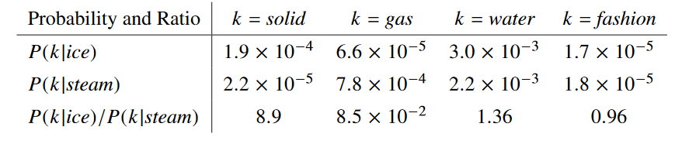
Figure 4.23: The probability and ratio of word co-occurrence. [ CITATION pennington2014glove \l 3084 ]
GloVe also implements constraints during training to regulate the effects of word frequency on the resultant word embeddings. This is done by including a function in the objective function that sets a maximum cooccurrence weight at a certain threshold.

Dependency Embeddings
Most techniques for training word embeddings use linear context as the main feature for discovering word similarities; in other words, the words directly before and after the target word within a variable window length. Levy and Goldberg (2014), using the same technique as Word2Vec, experimented with an alternative context and discovered they could extract embeddings which better reflect functional similarity between words, whereas Word2Vec vectors better reflects domain similarity.
This work was motivated by the fact that some linear context windows lump together words that do not significantly contribute to the target word’s meaning. They use the sentence Australian scientist discovers star with telescope to illustrate. In a linear context with a window size of two words, the verb discovers would have Australian, scientist, star and with as its context. The word telescope, an instrument used for discovery is more informative than the word Australian for learning the meaning of discovers, but since telescope is a longer-range dependency, it would be missed by this model. Moreover, because no distinction is made between the types of relationships between target words and their context, vectors for words such as scientist and star might end up with a similar representation simply because they are in the same window as discovers.
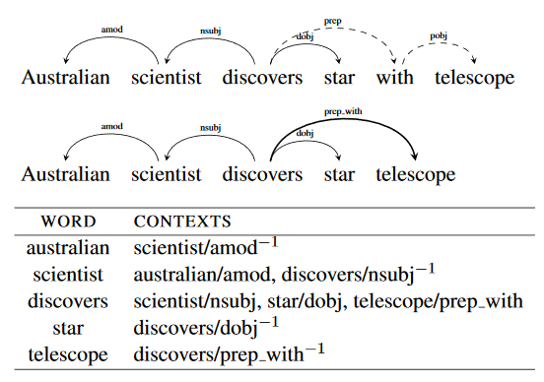
Figure 4.24: An example of Word/Context pairs used for training dependency embeddings. [ CITATION levy2014dependency \l 3084 ]
To remedy these issues, Levy and Goldberg used syntactic structure to determine context words. They preprocessed a corpus with a dependency parser and then, for every word, took its dependents as well as its head as the context. See Figure 4.5.
The context vectors were typed by dependency relationship. That is to say, the word scientist which functions as the nominal subject (nsubj) would be considered a separate context from the same word functioning as a direct object (dobj). Prepositional dependencies and their prepositional objects were merged into a single dependency.
The resulting word vectors display distinctive patterns relative to Word2vec in terms of their nearest neighbours in vector space. For example, with the word Florida, the closest vectors given by Word2vec were all cities and counties within the state, whereas the dependency embedding for Florida clustered around other states.

Retrofitted Vectors
Retrofitted Vectors are a class of embeddings that combine distributional methods with other sources of structured, human curated information. The idea was first introduced by Faruqui et al. (2015). In their experiments, they took matrices of embeddings that were pretrained using common techniques (Word2vec, GloVe) and graphs of words from the following linguistic resources:
-The paraphrase database (Ganitkevitch et al., 2013) (PPDB), a database of over 220 million paraphrase pairs obtained from the analysis of parallel texts (two words/phrases in one language that are both translated to the same word/phrase in a foreign language are considered paraphrases.).
-FrameNet (Baker et al., 1998; Fillmore et al., 2003), a semantic network that links words to the contextual frames that they evoke.
-WordNet (Miller, 1995) is an ontology of word relationships. Words are connected to their synonyms, hypernyms and hyponyms.
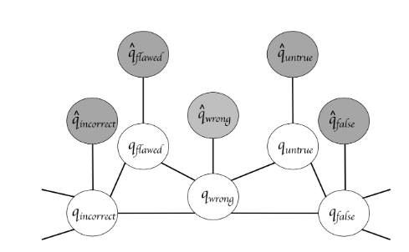
Figure 4.25 Retrofitting vectors (Faruqui et al., 2015). The words in grey represent neural network trained vectors and the words in white represent connected words in a semantic graph.
Faruqui et al. designed a learning technique which refined the word embeddings so that the vectors are close to both their neighbours from the original embedding training and to the words each word is linked to in the semantic graphs.
Numberbatch embeddings (Speer et al., 2017) used the retrofitting technique described above, with the addition of one other resource, Concept Net (Speer & Havasi, 2012). Concept Net is semantic network that contains information about common sense relationships between different concepts.

Polysemy
One of the drawbacks of Word2vec and GloVe embeddings is the fact that they collapse all the word senses represented by the same group of characters into a single vector.
One proposal for dealing with this issue is Adagram (Bartunov et al., 2016). Adagram is an extension of the skipgram model which creates multiple prototypes to represent the word senses in the corpus. The number of protypes can be tuned to give different degrees of “semantic resolution.”

Task-specific Embeddings
The word embeddings we have seen up until now are vectors that are pretrained before being integrated into a neural network. It is however possible to train a set of word embeddings at the same time a neural network is being trained on an nlp task, such as classification. It is simply a question of extending the backpropagation process used in deep learning to the initial layer of the word embeddings.
The drawback of this way of producing embeddings is that they are very likely to overfit the training data.

Character Embeddings
An alternative to representing text at the word level, is to represent it at the character level. Character embeddings have been applied successfully to many tasks in NLP such as language modelling (Sutskever et al., 2011) and part-of-speech tagging (Ling et al., 2015).
A significant advantage to this approach is the reduction in the vocabulary size required to train a model; instead of learning a separate embedding for each word item of a large vocabulary, a model can learn a representation for a few hundred characters. These character embeddings can then be applied to new words not seen within the training corpus. This method does however come with the trade-off of much slower training times.
Character embeddings are particularly interesting for morphological rich languages like German that have many rare words due to their word-compounding system. They could also be useful for models designed to evaluate student work because they could still interpret misspelt words.
Fasttext (Bojanowski et al., 2016) is a type of word embedding that shares many of the benefits of character embeddings. It is yet another variation on Word2vec that builds word vectors by summing all of the character n-grams that the word contains. For example, for the word where, with n=3, Fasttext will learn representations for <wh, whe, her, ere, re> (< and > are characters representing the beginning and the end of a word) and then it will add these vectors together to obtain the final word embedding.

Sentence Embeddings
It is also possible to represent larger stretches of text, such as sentences or paragraphs as dense vectors. This is a more difficult task than learning word or character embeddings because of the increased complexity of these units, but neural network architectures have succeeded in encoding some of the semantic content of sentences.

Skip-Thought Vectors
Skip-thought (Kiros et al., 2015) is a method for encoding sentences that involves an encoder-decoder architecture. To train this model, groups of three sentences are taken from natural texts. First, the middle sentence is fed into the encoder (a recurrent neural network). Then, the vector that results from this network is passed on to two decoders (also recurrent networks) which must learn to reconstruct the first and the third sentence, using only the information contained within the input vector.
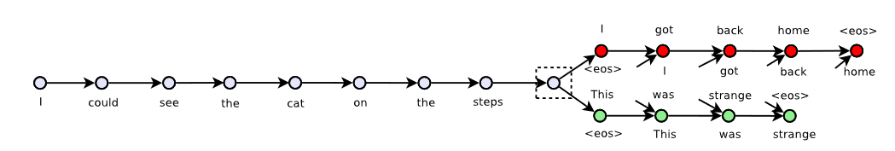Figure 4.26: The encoder-decoder architecture of the skip-thought model. [ CITATION kiros2015skip \l 3084 ]
Once the model is trained, the decoders are discarded and the encoder can be used to devise vector representations for new sentences.
By examining the nearest neighbors of the sentence vectors created by the skip-thought encoder, we can see that both semantic and syntactic information has been encoded.
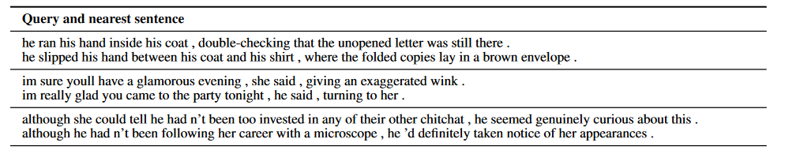Figure 4.27: Query sentences (the first sentence in each row) and the nearest neighbor of the query sentence (the second sentence of each row) for sentences encoded using a skip-thought model. [ CITATION kiros2015skip \l 3084 ]

Contextualized Vectors (CoVe)
Contextualized vectors (McCann et al. (2017)), like skip-thoughts, are trained on an encoder-decoder architecture. But unlike skip-thoughts, the training task of the model is machine translation. The output vector from an encoded sentence is used to reconstruct that same sentence in another language.
McCann et al. compared CoVe with skip-thoughts on a classification task and found that CoVe gave superior results.

Comparing Nearest Neighbours of word embeddings
To make more concrete the word representations captured by the various embeddings, in this section we will look at the ten nearest neighbours within the vector spaces for a selection of vocabulary taken from the corpus used for this thesis. We have randomly selected a noun (whale - Figure 4.9), an adjective (genetic – Figure 4.10), a verb (investigate – Figure 4.11) and an adverb (unfortunately – Figure 4.12).

Whale
word2vec | FastText | GloVe | Dependency | Numberbatch
'whales'  0.79856  'humpback' 0.77014  'sharks'  0.72595  'bowhead'  0.71833  'shark'  0.69512  'dolphin'  0.68669  'minke'  0.68376  'balaenoptera' 0.65812  'fish'  0.65738  'baleen'  0.64780 | 'whaler'  0.84591  'whalebone' 0.84319  'whales'  0.79345  'whalecopter' 0.79176  'whalers'  0.75774  'dolphin'  0.74352,  'shark'  0.72986  'fish'  0.68590  'catbird'  0.67816,  'dolphins'  0.67523 | 'whales'  0.80388  'shark'  0.78401,  'dolphin'  0.74711,  'humpback' 0.72765,  'fish'  0.65906  'tuna'  0.65009,  'hunts'  0.63628  'whaling'  0.63339,  'minke'  0.63207,  'beached'  0.62873 | 'whales'  0.74314  'dolphin'  0.73661  'orca'  0.68459  'shark'  0.68376  'wildebeest' 0.67819,  'crocodile'  0.67603  'turtle'  0.67272  'koala'  0.67128  'walrus'  0.66873  'dugong'  0.66823 | 'whale_calf'  0.95834  'whales'  0.89415  'marine_mammals' 0.87515  'large_whale' 0.86681  'balaenoptera_musculus'  0.84992  'humpback_whale' 0.84738  'marine_mammal' 0.84183  'blue_whale'  0.83887  'fin_whale'  0.83600  'sperm_whale_family'  0.82911

Figure 4.28 : Nearest Neighbours for the noun Whale

Genetic
Word2Vec | FastText | GloVe | Dependency | Numberbatch
'mitochondrial' 0.77099  'dna'  0.74942  'inherited'  0.73185  'gene'  0.72140  'mutation'  0.71498  'genome'  0.69631  'genomes'  0.67205,  'recessive'  0.66780  'genomic'  0.65825 'sequencing' 0.65501 | 'nongenetic' 0.90148  'epigenetic'  0.84473  'morphogenetic'  0.84304  'phylogenetic'  0.81198  'genetics'  0.78263  'genomic'  0.75929  'genetesis'  0.74934  'gene'  0.74829,  'frenetic'  0.73378  'genial'  0.72340 | 'dna'  0.74656  'genes'  0.71034  'biological'  0.69489  'mutations'  0.68293  'mutation'  0.68051  'genetics'  0.67395  'gene'  0.66970  'molecular'  0.66933  'behavioral'  0.64912  'evolutionary'  0.64323 | 'morphological' 0.75236  'genomic'  0.74946  'epigenetic'  0.74136  'mendelian'  0.73180  'neurobiological'  0.73154  'immunological' 0.72961  'biochemical' 0.72615  'sociocultural' 0.72603  'phonological' 0.72589  'geochemical' 0.72576 | 'nullisomic'  0.94464  'intralocus'  0.90872,  'interlocus'  0.90872  'extragenomic' 0.90844,  'cisgenic'  0.90662,  'genetical'  0.90515  'tetramutant' 0.88565  'epimutation' 0.88077,  'aneupolyploid'  0.87782  'genetics'  0.87753

Figure 4.29 Nearest Neighbours for the adjective Genetic.

Investigate
Word2Vec | FastText | GloVe | Dependency | Numberbatch
'examine'  0.61316  'determine'  0.60069  'investigated'  0.58750,  'conduct'  0.58416  'captivate'  0.58363  'understand' 0.58306  'explore'  0.55693  'bryn'  0.55617  'philipp'  0.54606,  'probing'  0.54591 | 'instigate'  0.82586  'investigates' 0.82366  'investigating'  0.75849  'examine'  0.75418  'investigative'  0.75087  'investigated' 0.73683  'reexamine'  0.72235  'investigational' 0.71984  'reevaluate'  0.71679  'evaluate'  0.71658 | 'investigating'  0.83224  'examine'  0.81258  'investigation' 0.77635  'investigated' 0.77135  'inquiry'  0.74596  'investigations' 0.73508  'probe'  0.72110  'prosecute'  0.71766  'investigators'  0.71474  'probing'  0.69915 | 'examine'  0.80950 'interrogate' 0.72890,  'inspect'  0.72423  'reexamine'  0.71803  'apprehend' 0.71104  'adjudicate'  0.70691  'evaluate'  0.70616  'investigated' 0.70456  'scrutinize'  0.70223  'litigate'  0.70023 | underseek'  0.95917  'vestigate'  0.94948  'evestigate'  0.92796  'uninvestigable' 0.92792  'overexplored' 0.90859  'investigates' 0.90385  'investigable' 0.86916  'indagative'  0.84518  'indagate'  0.81093  'investigating' 0.79996
Figure 4.30 Nearest Neighbours for the verb Investigate

Unfortunately
Word2Vec | FastText | GloVe | Dependency | Numberbatch
'but'  0.61034  'saviors'  0.60023  'however'  0.56658  'though'  0.54661  'because'  0.54367  'assuredly'  0.52934  'think'  0.51992  'reforest'  0.51837  'stressed'  0.51643  'so' 0.51608 | 'unfortunate' 0.78206  'fortunately' 0.78111  'exceptionally'  0.62747  'indefinitely' 0.62528  'improbably' 0.62292  'unforgettable'  0.61049  'fortunate'  0.60687  'definitely'  0.60663  'obviously'  0.60533  'surely'  0.59792 | 'indeed'  0.84780  'fortunately' 0.84381  'certainly'  0.81819,  'nothing'  0.80458  'obviously'  0.80217  'really'  0.80208  'though'  0.79348  'thing' 0.79155  'fact'  0.79053  'sure'  0.79049 | 'fortunately' 0.86001  'sadly'  0.85938  'regrettably' 0.83763  'thankfully'  0.83086  'doubtlessly' 0.81835  'luckily'  0.81804  'absolutly'  0.81753  'apparantly' 0.81714  'predictably' 0.81524  'understandably' 0.81509 | 'sad_to_say' 0.89444  'regrettably' 0.87691,  'unluckily' 0.86063  'sadly'  0.83876  'unfelicitously' 0.80054,  'fortunately' 0.79029,  'i_regret_that' 0.76068,  'luckily'  0.74967  "i'm_afraid_so" 0.74320  "i'm_afraid_not" 0.74215
Figure 4.31 Nearest Neighbours for the adverb Unfortunately.

Examining these nearest neighbours, we notice certain characteristics about the various embedding. FastText embeddings do a good job at recognizing word families (e.g. investigate, investigates, investigation, investigative, investigating) as well as compound words and portmanteaus (e.g. whalebone, whalecopter) which are clearly semantically related, but the emphasis on character n-gram similarity does occasionally bring together words that seemingly share few characteristics apart from their spelling (e.g. genetic – frenetic, investigate - instigate ).
The dependency embeddings reach beyond specific domains to find other functionally similar words. For example, the nearest neighbours for whale are not only other marine animals like dolphin and shark, they also include land animals like wildebeest and koala. Likewise for the neighbours of genetic, we see other scientific fields and not just words in the genetics domain (e.g. sociocultural, geochemical).
Word2vec, GloVe and Numberbatch all cluster thematically (and sometimes functionally) related words. Numberbatch seems to do the best job at capturing the meaning of unfortunately, while Word2vec and GloVe lump this word together with other words that might share the same syntactic position in a sentence despite their different meanings.
The Word2vec and Fasttext embeddings shown here were trained on the training corpus used in this thesis, which is comparatively small relative to the training corpus for the GloVe, Numberbatch and the Dependency embeddings (Wikipedia), which probably explains why Word2vec produces some unexpectedly close word vectors (e.g. unfortunately – saviors, reforest; investigate – bryn, phillip).

Natural Language Processing Techniques for Coherence Detection

Previous work in NLP in the subject of Coherence detection can be broken down into the following categories: Semantic relatedness, entity transition, syntax based, content models and the application of neural networks.

Semantic Relatedness
The simplest way to measure coherence is to count word overlap between adjacent sentences. This method however fails to detect a wide range of lexical connections. It cannot for example capture synonymy, antonyms, hyponyms or collocation.
A better alternative is to measure the semantic relatedness using word embeddings. That is what Foltz et al. (1998) did using Latent Semantic Analysis (LSA). They performed Singular Value Decomposition (SVD – see De Lathauwer et al., 2000 for more details) on a word-document matrix which results in a high dimensional semantic space in which words and sentences can be embedded. The SVD outputs vector representations for the words in the corpus and sentence representations can be derived by a weighted average of the vectors for its constituent words. The weighting takes into account the relative importance of the words in the sentence as well as the degree to which a word evokes a given topic.
Foltz et al. measured the semantic relatedness of two text segments using the cosine distance between their vector representations. Overall coherence was measured by averaging the cosine distances for all segments in the text. The coherence scores were compared to reader comprehension scores and a high correlation was found.
A major advantage of this method is the ability to quickly and easily analyze a large number of texts. However, one of the major shortcomings of this coherence measure is its inability to detect when the same information is repeated multiple times in a row, as might happen in imperfect computer-generated summaries of multiple texts that use extractive methods or by students who do not progress in their argumentation.

Entity Transition Grid
In a method that quantifies the shifts in focus described in Centering theory, Barzilay and Lapata (2008) proposed the Entity-Grid Model that learns the probabilities of seeing different types of entity transitions in coherent and incoherent texts.
In this model, a grid is created where the columns represent each entity/noun phrase present in a passage of text and the rows represent each sentence (figure 5.1). The cells of the grid record the mentions of a particular entity in each sentence and the syntactic role played by the entity (S:Subject, O:Object, X:Other, -:No mention).
These grids are able to capture the relative saliency of the various entities discussed in a text, since the most salient entities are usually mentioned more frequently and they take on important syntactic roles such as subject or object. This is a common characteristic of coherent texts; if a grid were to show several mentions of an entity across sentences that never took on a significant syntactic role or if there was little overlap between adjoining sentences, these would be signs of an incoherent text.
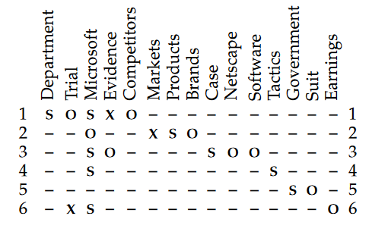
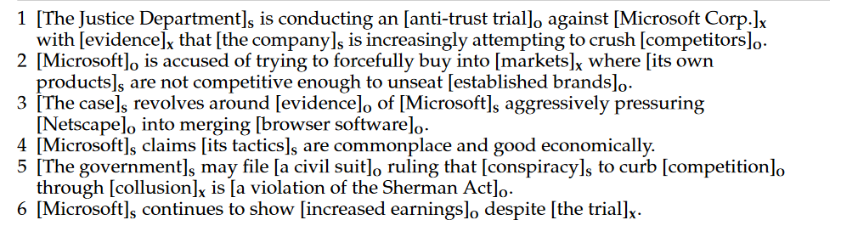
Figure 5.32- Example of an entity-grid model (Barzilay and Lapata, 2008))

These grids are then transformed into feature vectors where the features are the probabilities of different transition types (e.g. S -> -, S -> O, etc. ) within the grid. To learn the properties of coherent texts, Barzilay and Lapata trained a weight vector to rank feature vectors for natural texts higher than feature vectors for random permutations of those same texts.
They tested their model on three tasks: text ordering, summary evaluations and readability assessment. The model performed significantly better than LSA methods.

Content Models
Barzilay and Lee (2014) proposed a model that is capable of learning the distribution of topics in coherent texts within a specific domain. Building on the work of Harris (1982) who had observed that word recurrence patterns were defining elements of different types of discourse, they designed an algorithm for discovering topics within a training corpus and they implemented a hidden markov model [ CITATION baum1966statistical \l 3084 ] to model the patterns in topic shifts in thematically related texts.
For example, news articles reporting on earthquakes typically cover topics such as the strength of the quake, the location and the casualties. The transitions between these topics will often occur in the same order; a description of the casualties will commonly come before a description of rescue efforts.
The Athens seismological institute said the temblor’s epicenter was located 380 kilometers (238 miles) south of the capital.
Seismologists in Pakistan’s Northwest Frontier Province said the temblor’s epicenter was about 250 kilometers (155 miles) north of the provincial capital Peshawar.
The temblor was centered 60 kilometers (35 miles) north-west of the provincial capital of Kumming, about 2,200 kilometers (1,300 miles) southwest of Beijing, a bureau seismologist said.
Figure 5.33: Example of a topical cluster from Brazilay and Lee (2014).
Using bigrams as features, they clustered sentences based on their lexical similarity; these clusters represent the topics in the corpus (example in Figure 5.2). The probability of one topic following another is determined based on the number of documents in the corpus containing such a transition divided by the number of documents containing a sentence of the initial topic type.
Barzilay and Lee’s tested their models for five different subjects on an information ordering task. They ranked the probability of producing the original sentence order of texts in their test corpus against the probability of producing all other permutations of the same text (sometimes numbering over 3 million variations). The model performed well overall on this task with the original sentence order ranking in the top 5 percent for 95% of the texts from one test corpus. There was however some variability across test corpora, with the worst performing model ranking higher than 10th position in over 45% of the texts.
One problem with content models is that they must be trained for each specific domain; a model trained on one domain is not portable to another. The style of the texts must also be highly formulaic for representative transitions to be learned.

Syntactic Model of Coherence

Louis and Nenkova (2009) developed two models designed to learn the distributions of syntactic patterns in coherent texts. They made the observation that sentences with similar communicative goals often share syntactic features; this is also true for sequences of sentences. For example, when an author is defining a subject, they will frequently utilize the following pattern: Noun phrase (the subject) + copular verb + noun phrase (the class to which the subject belongs) + a relative clause that provides details about the subject. The next sentence in the sequence will often begin with a prepositional phrase that describes a context in which the subject is found (see Figure 5.3 for two examples of this pattern).
1 a) An aqueduct is a water supply or navigable channel
constructed to convey water.
b) In modern engineering, the term is used for any system
of pipes, canals, tunnels, and other structures used for
this purpose.

2 a) Cytokine receptors are receptors that binds cytokines.
b) In recent years, the cytokine receptors have come to
demand more attention because their deficiency has now been
directly linked to certain debilitating immunodeficiency states

Figure 5.34: Two examples of the syntactic pattern for the communicative goal of providing a definition. [ CITATION louis2009automatically \l 3084 ]
Their first coherence model evaluated local coherence based on the probability of seeing pairs of syntactic items across adjacent sentences (the probabilities having been determined from the distribution in a training corpus).
Their second coherence model looked at the global structure of texts. They clustered sentences using their syntactic components as features and then they trained a hidden markov model (HMM) to model the relationships between communicative goals and syntactic items. The transition probabilities between the hidden states of the model represent the common patterns in intentional structure of the training data.
The syntax-HMM outperformed the local coherence model on the task of comparing original and randomly permutated texts. Accuracy on this task was further improved when the syntax-HMM was combined with the entity grid method and/or content model methods.

Neural Networks
Li and Hovy (2014) model local coherence using distributed sentence representations which are learnt from neural networks. To learn these representations, they used human produced sequences as positive coherent examples and they used sequences with a random replacement sentence as a negative coherence example (the methodology in the present work was inspired by this research).
Li and Hovy tested two methods for encoding their sentences: recurrent (see section 3.4.1) and recursive (see section 3.4.2) neural networks.
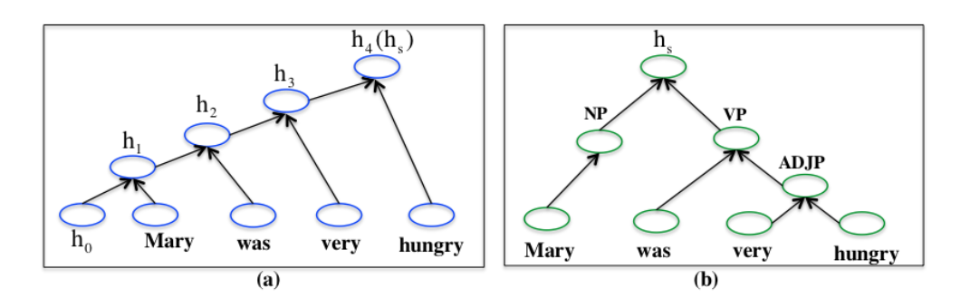
Figure 5.35: Two methods for encoding sentence embeddings. (a) a recurrent neural network; (b) a recursive neural network. (Li and Hovy, 2014)
The vector representations for the three sentences in the sample sequences were fed into a second network (see Figure 5.5). The three vectors were concatenated and then passed through a linear function that produces a scalar value and then finally passed through a sigmoid layer that outputs the probability that the sequence is coherent.
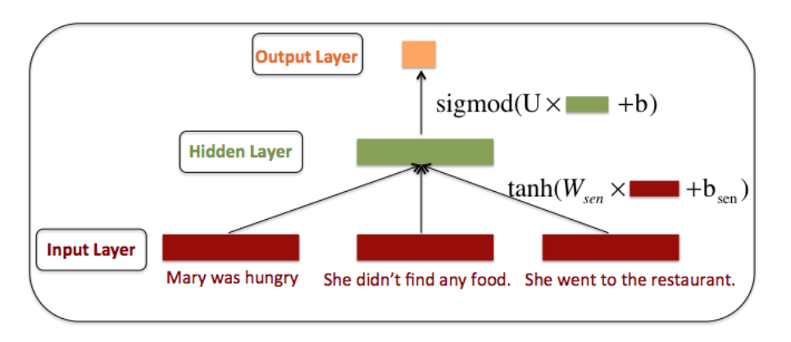
Figure 5.36: Neural network architecture used by Li and Hovy to evaluate coherence. [ CITATION li2014model \l 3084 ]
The recursive sentence embeddings gave superior results on a sentence ordering task. Both the recursive and recurrent sentence embeddings performed better than the entity-grid and the syntax-based model on the same task.

Experiment
In this work, we compared different neural network architectures as well as different word embedding types to see which are best suited to the task of coherence detection. More specifically, we tested convolutional and recurrent networks using Word2vec, Fasttext, GloVe, Dependency and Numberbatch embeddings.
The neural networks were trained on a binary classification task using binary cross entropy as the objective function. The models had to decide whether a sequence of three sentences was coherent or incoherent.
Coherent Sequence
Sentence 1 | But UW’s pig-rearing facility is kept free of disease-causing microbes, so the team can’t just implant their pigs with commercially sourced embryos.
Sentence 2 | Instead, they have to artificially inseminate their own sows, collect the embryos, inject them with CRISPR ingredients, and put them back into other pigs.
Sentence 3 | The embryos themselves are hard to work with, because they’re not translucent like those of many other animals.
Figure 6.37: An example of a coherent sequence taken from our training corpus.
Incoherent Sequence
Sentence 1 | But UW’s pig-rearing facility is kept free of disease-causing microbes, so the team can’t just implant their pigs with commercially sourced embryos.
Sentence 2 | Bell says she doubts Zika would fan out across the U.S. in the way that West Nile virus has spread.
Sentence 3 | The embryos themselves are hard to work with, because they’re not translucent like those of many other animals.
Figure 6.38: An example of an incoherent sequence taken from our training corpus.

Evaluation
Our trained models were evaluated on four different metrics: their accuracy at identifying coherent and incoherent sequences in a test corpus and their sensitivity to different coherence features, namely pronoun coreference, temporal coherence and sequence order (more details will be provided in the Results section).

Corpus
To guarantee a large, extendable supply of coherent and incoherent sample sequences, we choose to compile a corpus of professionally written English texts from which artificial incoherent sequences were created.
Sequences of three sentences were extracted from the original texts to serve as positive examples. The negative examples were compiled by taking the positive examples and replacing the second sentence from the sequence with a random sentence taken from another document in the corpus. This method was inspired by the skipgram technique used by Mikolov et al (2013*) which trains word embeddings on positive and negative examples of a word in a particular context, as well as the work of Li and Hovy (2014).
A length of three sentences was chosen, as opposed to two sentences because it seems more likely that cohesive links will be present in at least one of the adjacent sentence pairs (either between Sentence 1 and Sentence 2 or between Sentence 2 and Sentence 3), whereas with a sequence of two sentences there might not be any obvious connections where the text switches topics over paragraph breaks. Similarly, breaks in coherence are more likely to be evident over longer passages.
Two corpora were compiled using the same methodology; one to be used for training the models and one to test the models.
One potential issue with this method for deriving incoherent texts is that, sometimes by chance, the random insert will form a coherent sequence. This can happen when you have pronouns or common nouns which can fit into many different contexts (e.g. It was real.; Things get more confusing.). Examination of the corpus shows that, while this does happen occasionally, it is rare enough to be unlikely to confuse the models.

The genre chosen for this experiment consisted of journalistic articles about science and technology. Articles were taken exclusively from American publications to reduce the number of spelling variations.

Corpus Statistics

The training corpus consisted of 34,624,891 individual tokens. Before preprocessing, the training corpus contained 80,384 unique tokens. The training corpus was made up of 450,740 three-sentence sequences, half of which were positive examples of coherence and the other half negative. The average length of a sentence in the corpus was 25.52 tokens. The test corpus contained 11012 sequences.

Topic Model
We performed non-negative matrix factorization (NMF - Lee and Seung, 2001) to get an idea of the distribution of topics within the training and testing corpora. Figure 6.3 and Figure 6.4 summarize the topics found within the training corpus. Figure 6.5 shows the topic vectors for the articles in the test corpus. Darker colors in the heatmap indicate the presence of a topic covered in the training corpus.
NMF Topics | Key Words
Topic 0 | people, researchers, study, data, new, university, time, team, work, used
Topic 1 | space, nasa, earth, mission, spacecraft, mars, moon, planet, orbit, station
Topic 2 | research, science, government, nih, funding, budget, national, president, agency
Topic 3 | star, stars, light, astronomers, galaxy, black, galaxies, universe, planets, telescope
Topic 4 | water, fish, ocean, river, surface, lake, plastic, earth, marine, sea
Topic 5 | spacex, rocket, falcon, launch, musk, company, heavy, flight, orbit, space
Topic 6 | cells, cell, cancer, gene, mice, genes, immune, crispr, dna, stem
Topic 7 | virus, vaccine, disease, health, infected, hiv, people, cases, infection, patients
Topic 8 | species, animals, birds, fish, conservation, animal, wild, bird, predators, mammals
Topic 9 | energy, power, solar, nuclear, electricity, wind, plants, carbon, plant, fuel
Topic 10 | climate, carbon, change, emissions, warming, global, co2, temperatures, dioxide, atmosphere
Topic 11 | dna, ancient, years, modern, ago, fossils, bones, humans, genetic, africa
Topic 12 | ice, sea, arctic, ocean, waters, surface, north, meters, rise, island
Topic 13 | brain, brains, neurons, activity, mice, pain, study, patients, sleep, tissue
Topic 14 | dogs, humans, animal, animals, food, wild, behavior, study, scientists
Figure 6.39 : NMF topic model of our training corpus.
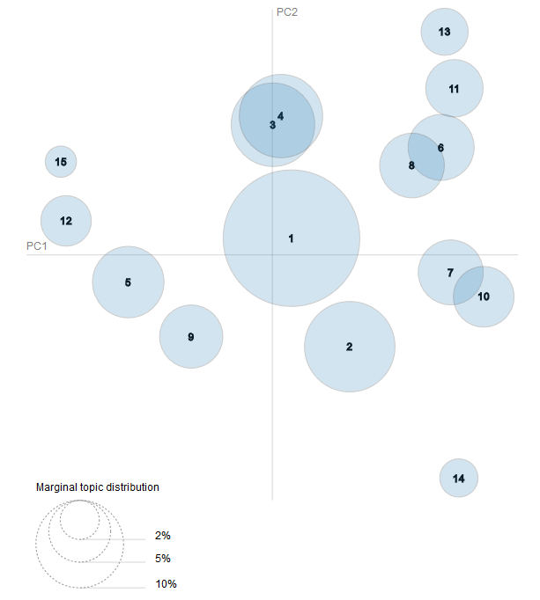
Figure 6.40 Visualization of topic distribution for the training corpus.
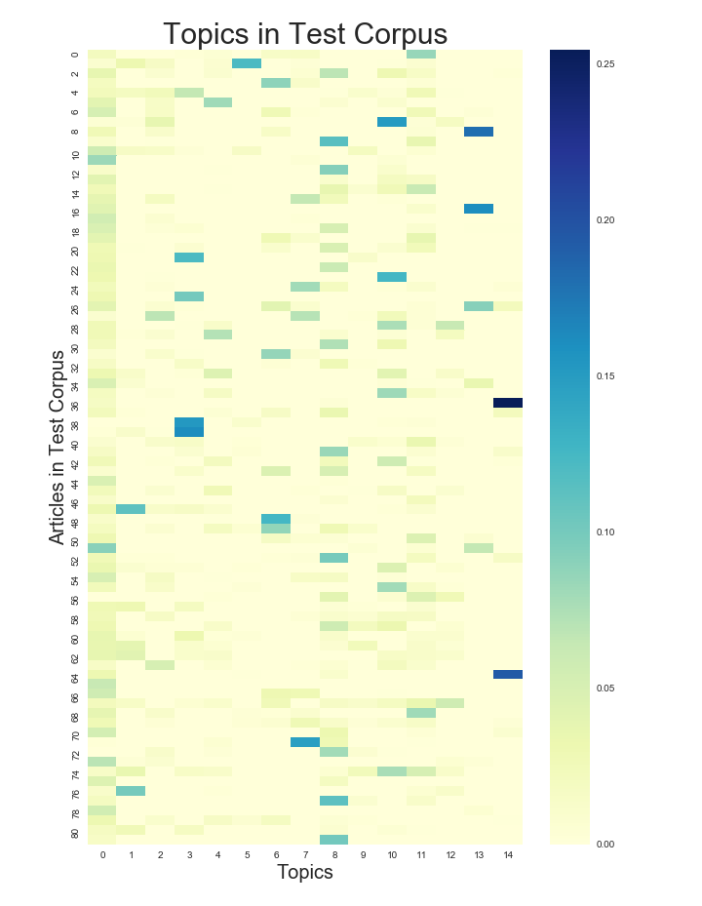
Figure 6.41: Topic distribution in test corpus.

Preprocessing

Vocabulary Size
The size of the vocabulary was reduced in order to limit some of the noise caused by rare words. Different vocabulary sizes were experimented with in order to find the right balance between limiting the complexity of the models and providing a sufficiently rich representations of the sentence topics. With a smaller vocabulary, the neural network has fewer parameters to learn and hence trained slightly faster, but our tests revealed less overfitting when a larger vocabulary size was used. A larger vocabulary seems to make the models more adaptable to new topics. We limited the vocabulary to the top 40,000 most frequent words.

Stopwords
Although the removal of stopwords (i.e. function words that bring little semantic information to the text) has proven useful in many NLP tasks such as text classification, we decided not to filter out these words because of the coherence signalling characteristics that would be lost. For example, the definite determiner the in English often signals that the noun it is modifying has been previously mentioned in the discourse. Furthermore, work in the related task of discourse relation detection showed that stopword filtering had a negative effect. Pitler et al. (2009) showed that the word pairs that provided the most information gain when trying to distinguish between the discourse relations comparison and contingency vs. other were all stopwords.
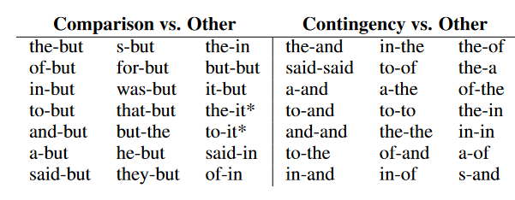
Figure 6.42: Word pairs used to identify discourse relations (Pitler et al., 2009)

Word Embeddings
In addition to differences in their training algorithms (see section 4 for more details), the word embeddings used in these experiments differed in other ways due to their varied sources. The contribution of these differences to the neural networks’ final results will have to be sussed out in future research.
The Word2vec and Fasttext vectors were trained on the vocabulary in our training corpus; we trained them using the Gensim library (Rehurek and Sojka (2010)). The GloVe and Dependency Vectors were trained on Wikipedia and the Numberbatch embeddings were retrofitted using multiple resources (WordNet, PPDB, FrameNet).
The Dependency and Numberbatch vectors contained 300 dimensions, while the other three contained 100.
 | Word2vec | Fasttext | GloVe | Dependency | Numberbatch
Training Corpus | Science News Stories | Science News Stories | Wikipedia | Wikipedia | Word2Vec, GloVe, Concept Net, WordNet, PPDB, FrameNet
Vector Dimensions | 100 | 100 | 100 | 300 | 300
Absent words | 1004 | 257 | 2837 | 5491 | 6627
Figure 6.43 – Word Embedding types used in this experiment.
Not all words in the corpus had a trained vector representation, either because they were not in the original training data, or because they contained foreign or unusual characters which were filtered out before training. Those words were represented using normally distributed vectors.

Neural Network Models
In this section, we will present the neural network architectures used in our experiments. The models were implemented using the Keras Python library (Chollet, 2015). For both models, we used Binary Cross Entropy as the loss function, Adam as an optimizer and a batch size of 128.
The maximum length for the input sentences was set to 90 words. Sentences under 90 words were padded and sentences over 90 words were cropped. The initial embedding size depends on the type of embedding being used for the particular model (either 100 or 300 dimensions).
We trained each of the models until the training no longer yielded increases in accuracy on the training set.
The final layer of both models outputs a coherence score (between 0 and 1) representing the probability that a sequence is coherent and a complementary score with the probability of incoherence.

Convolutional Models
The convolutional model used for these experiments (see Figure 6.8) contained three convolutional layers; the first layer had 100 filters and a kernel size of 2 (i.e. the filters looked at two word embeddings at a time), the second layer had 100 filters and a kernel size of 3 and the third layer had 50 filters and a kernel size of 4. The first two convolution layers are followed by a max pooling layer.
The regularization techniques used were Dropout and Batch normalization. The first dropout layer was set at 30% and the subsequent dropout layers were set at 40%.
To further prevent overfitting, we trained part-of-speech embeddings as part of the model to reduce the influence of specific vocabulary items. Part of speech tags were derived using Stanford’s CoreNLP (Manning et al. 2014). The POS embeddings were concatenated together with the word embeddings.

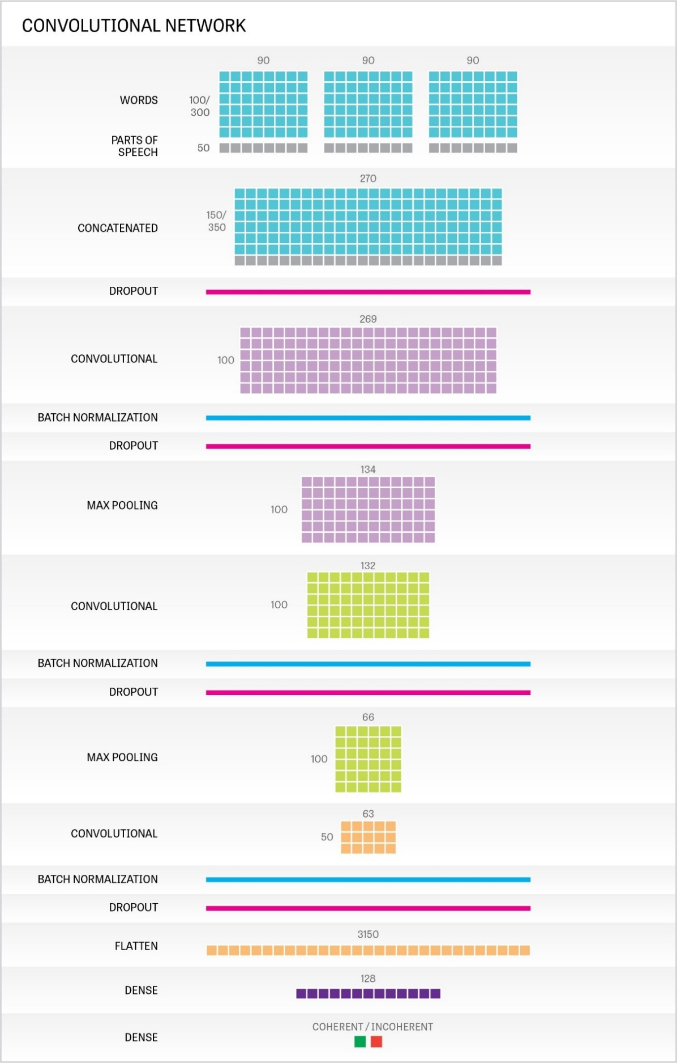
Figure 6.44: The Convolutional Model’s Architecture.

LSTM Models
The LSTM model (see Figure 6.9) builds sentence representations with a shared bidirectional LSTM cell. The cell outputs the hidden state with 30 dimensions at each time step (i.e. for each word). The representations for the three sentences are concatenated together and then fed into a separate bidirectional LSTM which builds a sequence representation. The final hidden state vector (as opposed to the entire hidden state sequence) is then used to determine whether or not the sequence is coherent.
This model uses dropout after the initial layer (30% of the words + padding from each sentence are dropped). We also use batch normalization before the final layer.

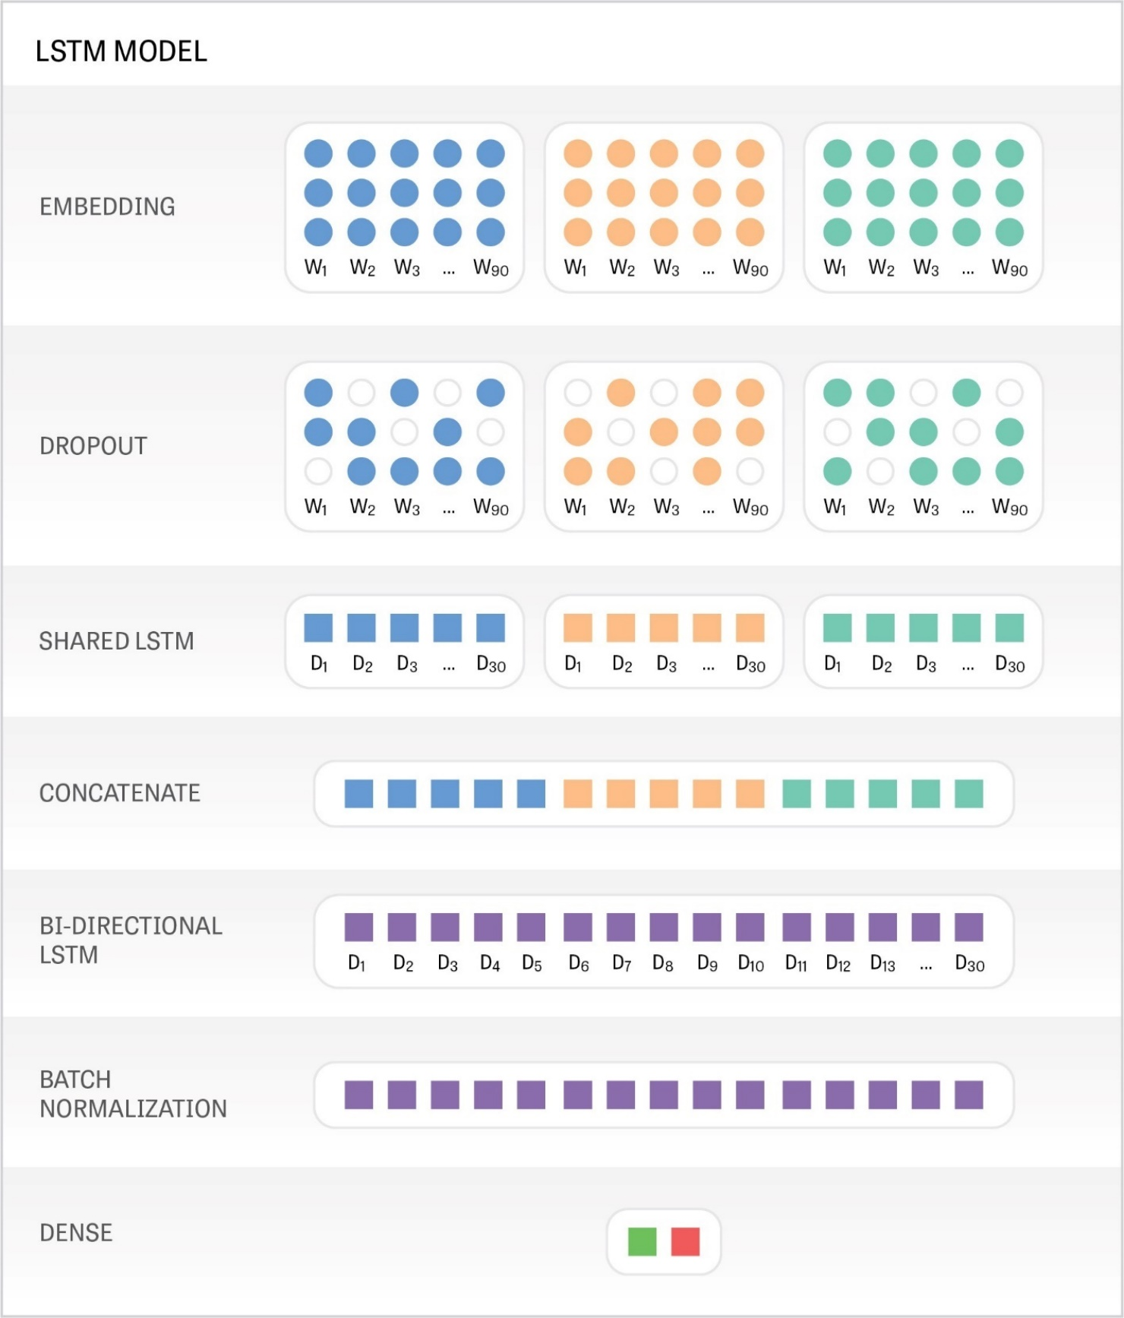
Figure 6.45 The Recurrent (LSTM) Model’s Architecture

Results and Discussion

Accuracy and Loss
The figure below (7.1) shows accuracy scores for the LSTM and the Convolutional Models. The top performing model was the Word2vec LSTM model, closely followed by the Numberbatch LSTM model. All of the LSTM models outperformed the convolutional models. The top performing convolution model used dependency embeddings. The weakest models from both sets were the ones that employed the Fasttext embeddings.
Embedding Type | LSTM model |  | Convolutional Model with Parts of Speech
 | Loss | Accuracy | Loss | Accuracy
Word2vec | 0.3366 | 85.44% | 0.3909 | 82.47%
Fasttext | 0.3757 | 83.20% | 0.4094 | 81.17%
GloVe | 0.3573 | 83.95% | 0.3914 | 82.56%
Dependency | 0.3621 | 83.94% | 0.3833 | 82.74%
Numberbatch | 0.3399 | 85.23% | 0.3847 | 82.31%
Figure 7.46 : Accuracy and loss for LSTM and Convolutional Models on the test corpus.
Figure 7.2 and Figure 7.3 show the confusion matrix figures for each of the models. All of the models present a bias towards evaluating sequences as coherent, with false positives greatly outnumbering false negatives.
Embedding Type | True Positives | True Negatives | False Positives | False Negatives
Word2vec LSTM | 5001 | 4408 | 1098 | 505
Fasttext LSTM | 4797 | 4365 | 1141 | 709
GloVe LSTM | 4968 | 4277 | 1229 | 538
Dependency LSTM | 4886 | 4358 | 1148 | 620
Numberbatch LSTM | 4972 | 4414 | 1092 | 534
Word2vec Convolutional | 5088 | 3994 | 1512 | 418
Fasttext Convolutional | 5017 | 3922 | 1584 | 489
GloVe Convolutional | 5129 | 3963 | 1543 | 377
Dependency Convolutional | 4935 | 4176 | 1330 | 571
Numberbatch Convolutional | 4889 | 4175 | 1331 | 617
Figure 7.47: Confusion Matrix figures for the LSTM and Convolutional models on 11012 sequences from the test corpus. The bolded numbers show the best scores on each of these measures.

Figure 7.48 Confusion matrix figures for our 10 neural network models on the tests corpus.
False Positive Example
Sentence 1 | Kantha Shelke, food scientist and one of the heads of the company Corvus Blue, a food science and research firm, told Gastropod that "we’ve got a few wonder proteins in nature, and casein is definitely one of them."
Sentence 2 | In the room next door, 22 more kiwi eggs are incubating in an artificial chamber.
Sentence 3 | But if you add the enzyme chymosin to milk, it cuts the tails off those casein molecules, allowing the protein to all clump together in curds.
False Negative Example
Sentence 1 | In 2009, China began construction on its fourth launch site, the Wenchang Space Launch Center.
Sentence 2 | Wenchang is located on the island province of Hainan — right off the coast of the South China Sea.
Sentence 3 | Officials chose the site because it sits just 19 degrees north of the equator, a prime spot for launches because rockets traveling in the same direction of the Earth’s spin get a boost in velocity there.
Figure 7.49 An example of a false positive and a false negative from the test corpus. All of our models classified these sequences incorrectly.
Figures 7.5 and 7.6 summarize the coherence scores given by each of the models for each of the test sequences. Figure 7.5 shows the coherent sequences from the test corpus; lighter colours represent correct answers and darker colours represent incorrect answers. Figure 7.6 shows the incoherent sequences from the test corpus; here darker colours represent correct answers and lighter colours represent incorrect answers.
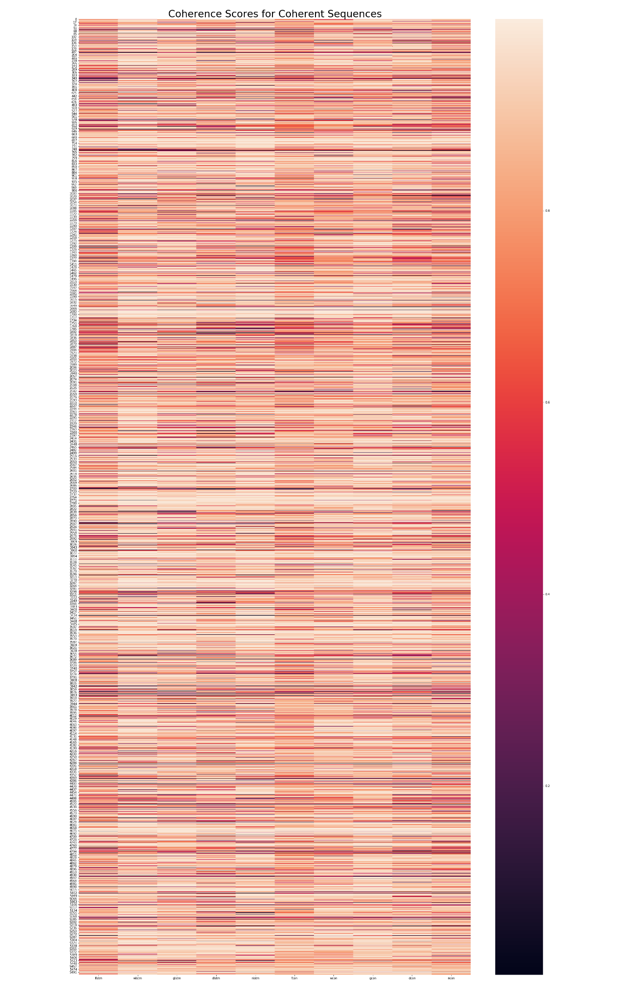
Figure 7.50: Coherence scores for the positive examples in the test corpus. The rows represent the sample sequences and the columns represent the different models (from left to right: LSTM – Fasttext, Word2vec, GloVe, Dependency, Numberbatch; Convolutional- Fasttext, Word2vec, GloVe, Dependency, Numberbatch)

Figure 7.51: Coherence Scores for the incoherent sequences in the test corpus. The rows represent the sample sequences and the columns represent the different models (from left to right: LSTM – Fasttext, Word2vec, GloVe, Dependency, Numberbatch; Convolutional- Fasttext, Word2vec, GloVe, Dependency, Numberbatch)
Table 7.7 shows the Pearson correlations scores for each of the models. This measure shows us how similar the models are to one another in terms of their coherence predictions. We can see that there is a fair amount of variability between models.
 | Word2vec  LSTM | Fasttext LSTM | GloVe LSTM | Dependency LSTM | Numberbatch LSTM | Word2vec Convolutional | Fasttext Convolutional | GloVe Convolutional | Dependency Convolutional | Numberbatch Convolutional
Word2vec LSTM | 1 | 0.746 | 0.773 | 0.753 | 0.771 | 0.776 | 0.713 | 0.743 | 0.742 | 0.736
Fasttext LSTM | 0.746 | 1 | 0.742 | 0.723 | 0.732 | 0.714 | 0.727 | 0.708 | 0.714 | 0.709
GloVe LSTM | 0.773 | 0.742 | 1 | 0.763 | 0.765 | 0.722 | 0.703 | 0.769 | 0.749 | 0.731
Dependency LSTM | 0.753 | 0.723 | 0.763 | 1 | 0.763 | 0.707 | 0.696 | 0.735 | 0.775 | 0.73
Numberbatch LSTM | 0.771 | 0.732 | 0.765 | 0.763 | 1 | 0.716 | 0.701 | 0.734 | 0.734 | 0.753
Word2vec Convolution | 0.776 | 0.714 | 0.722 | 0.707 | 0.716 | 1 | 0.75 | 0.76 | 0.739 | 0.74
Fasttext Convolution | 0.713 | 0.727 | 0.703 | 0.696 | 0.701 | 0.75 | 1 | 0.734 | 0.743 | 0.723
GloVe Convolution | 0.743 | 0.708 | 0.769 | 0.735 | 0.734 | 0.76 | 0.734 | 1 | 0.777 | 0.763
Dependency Convolution | 0.742 | 0.714 | 0.749 | 0.775 | 0.734 | 0.739 | 0.743 | 0.777 | 1 | 0.768
Numberbatch Convolution | 0.736 | 0.709 | 0.731 | 0.73 | 0.753 | 0.74 | 0.723 | 0.763 | 0.768 | 1
Figure 7.52: Pearson correlation coefficients for LSTM and Convolutional Models

Ensembling and Vector Concatenation
Given the variability between models, we thought it may be possible to obtain higher accuracy results by combining the different models. We experimented with two methods for blending the divergent representations: Ensembling (see Dietterich, 2000) and vector concatenation plus a support vector machine.
The form of ensembling we tried involved taking the average of the coherence predictions from all models. To balance out the bias towards evaluating sequences as positive, we required the average coherence score to be greater than 60% to obtain a positive prediction. This technique resulted in an accuracy score of 86.94% for all models and a score of 87.10% when we combined only the top three performing models.
Our other approach involved extracting sequence vector representations from an intermediary layer of our LSTM models. We concatenated these vectors and then used them as input to a support vector machine that had to classify the vectors as coherent or incoherent. This technique boosted the accuracy score to 87.2% when we merged the top four models, but decreased accuracy when we combined all of the models.

Sensitivity to Sentence Ordering
To improve on systems that simply measure the semantic similarity between adjacent sentences (e.g. Foltz et al., 1998), we require a model that is sensitive to the ordering of sentences (patterns in the presentation of topics, the ways in which focus shifts between entities in the discourse). To test the sensitivity of our models with regards to these features, we compared the models’ predictions for coherent sequences with their predictions for those same sequences rearranged in their reverse order (see Figures 7.8 and 7.9 for an example of sequence inversion).
True Order
Sentence 1 | “It was peculiar, but we needed more data.”
Sentence 2 | He later mentioned this peculiarity while giving a talk at a conference, where both Meijaard and Nowak happened to be in the audience.
Sentence 3 | The three talked, and, suspecting that these orangutans might belong to their own distinct species, they team up to test that idea.
Figure 7.53: A sequence from the test corpus in its original ordering.
Reverse Order
Sentence 1 | The three talked, and, suspecting that these orangutans might belong to their own distinct species, they team up to test that idea.
Sentence 2 | He later mentioned this peculiarity while giving a talk at a conference, where both Meijaard and Nowak happened to be in the audience.
Sentence 3 | “It was peculiar, but we needed more data.”
Figure 7.54: A sequence from the test corpus with its ordering reversed.
If we look at both the properly ordered sequence in Figure 7.8 and the improperly ordered sequence in Table 7.9, the lexical cohesion achieved by peculiar/peculiarity is present in both and if the model has only learnt to search for related words, it would judge both of these sequences coherent. But if it has learnt to identify other cohesive devices like the anaphoric this, then it should score the reversed sequence lower.
It is true that reversing the order of a sequence can sometimes produce coherent sequences if there are no overt ties across sentence boundaries, but on average we expect to see a drop in coherence scores for the reversed sequences.
Figures 7.10 (LSTM models) and 7.12 (Convolutional models) show the change in coherence scores for a subsample of 500 sequences from the test corpus. By change in coherence score, we mean the difference between the coherence score for the original sequence and the coherence score for the reversed sequence. So if for example, a model judged a sequence to be 70% coherent (Coherence score = 0.7) and it judged the reverse sequence to be 60% coherent (Coherence score = 0.6), the change in coherence score would be -0.1 for that sample.
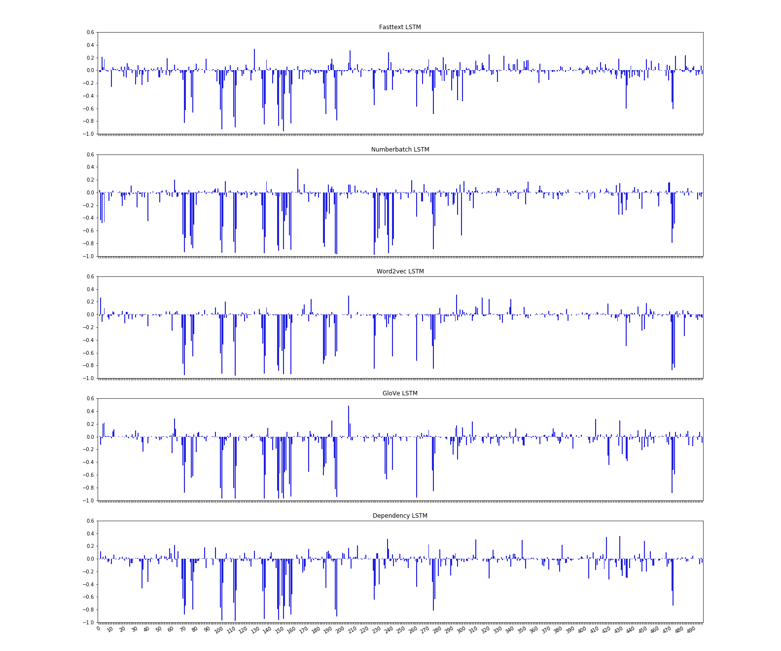
Figure 7.55: The change in coherence scores for a subsample of 500 sequences from the test corpus. The graphs show the change between the coherence score for the original sequence and the reversed sequences.
The average coherence scores for all the models decreased with the reversed sequences, but for a substantial number of the samples, the score actually increased. The best performing model on this particular task was the Numberbatch LSTM model which had the greatest average decrease and the fewest number of samples with an increased coherence score.
Embedding Type | Average Change in Coherence Score | # samples where score increased
Word2vec LSTM | -0.074 | 2174
Fasttext LSTM | -0.063 | 2200
GloVe LSTM | -0.079 | 2166
Dependency LSTM | -0.078 | 2192
Numberbatch LSTM | -0.096 | 2104
Word2vec Convolutional | -0.039 | 2322
Fasttext Convolutional | -0.009 | 2510
GloVe Convolutional | -0.052 | 2240
Dependency Convolutional | -0.055 | 2258
Numberbatch Convolutional | -0.047 | 2314
Figure 7.56 Average change in coherence scores for 5506 sequence + reverse sequence pairs and the number of pairs where the coherence score was higher for the reversed sequence.

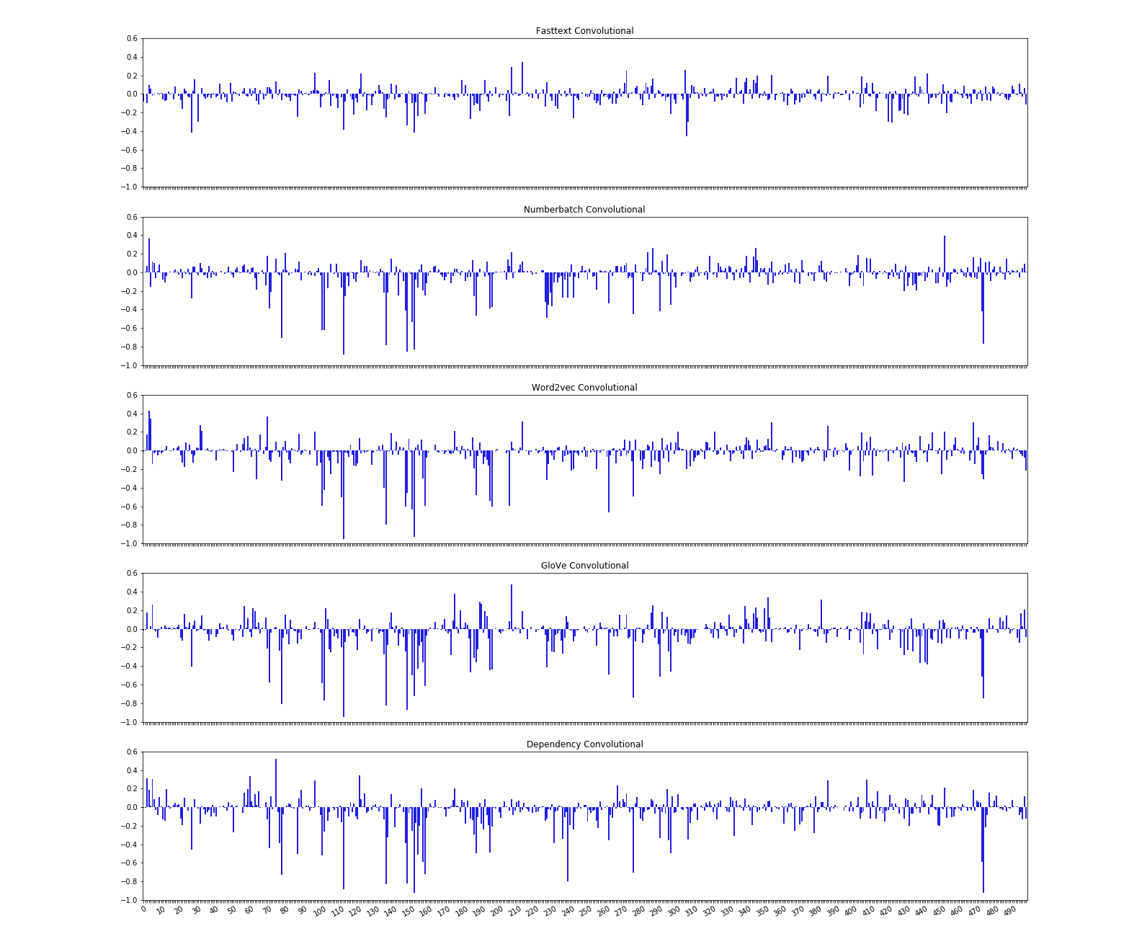
Figure 7.57: The change in coherence scores for a subsample of 500 sequences from the test corpus. The graphs show the change between the coherence score for the original sequence and the reversed sequences.

Sensitivity to Pronoun Coreference
We also measured the change in coherence scores to evaluate the models’ sensitivity to pronoun coreference. We wanted to know what effect substituting one pronoun for another would have since we presume that this change will make the sequence less coherent.
Pronoun change
Sentence 1 | McLaughlin grew to love golf, he says, but passion was never the project’s animating principle.
Sentence 2 | “I was very serious about it/he, but it/he never became an obsession.
Sentence 3 | At the end of the day, I could always walk away and say, ‘what’s next?’”
Figure 7.58 An example of a sequence with pronoun substitution.
We took all the sequences from the coherent samples in the test corpus that contained the pronoun it in its second sentence (for a total of 1065 sequences). We then replaced it with the pronoun he. This sometimes made the sequence ungrammatical as well as breaking the connection with the antecedent (like in Figure 7.13).
On this task, the Dependency LSTM model had the best results. This is perhaps due to the functional information encoded into its word embeddings. Figures 7.15 and 7.16 show the changes for subsample of 500 sequences from the corpus.
Embedding Type | Average Change in Coherence Score | # samples where score increased
Word2vec LSTM | -0.018 | 418
Fasttext LSTM | -0.012 | 475
GloVe LSTM | -0.025 | 457
Dependency LSTM | -0.090 | 277
Numberbatch LSTM | -0.046 | 392
Word2vec Convolutional | -0.010 | 502
Fasttext Convolutional | 0.010 | 572
GloVe Convolutional | -0.018 | 444
Dependency Convolutional | -0.016 | 458
Numberbatch Convolutional | -0.011 | 471
Figure 7.59 Average change in coherence scores for 1065 sequence + reverse sequence pairs and the number of pairs where the coherence score was higher for the reversed sequence.

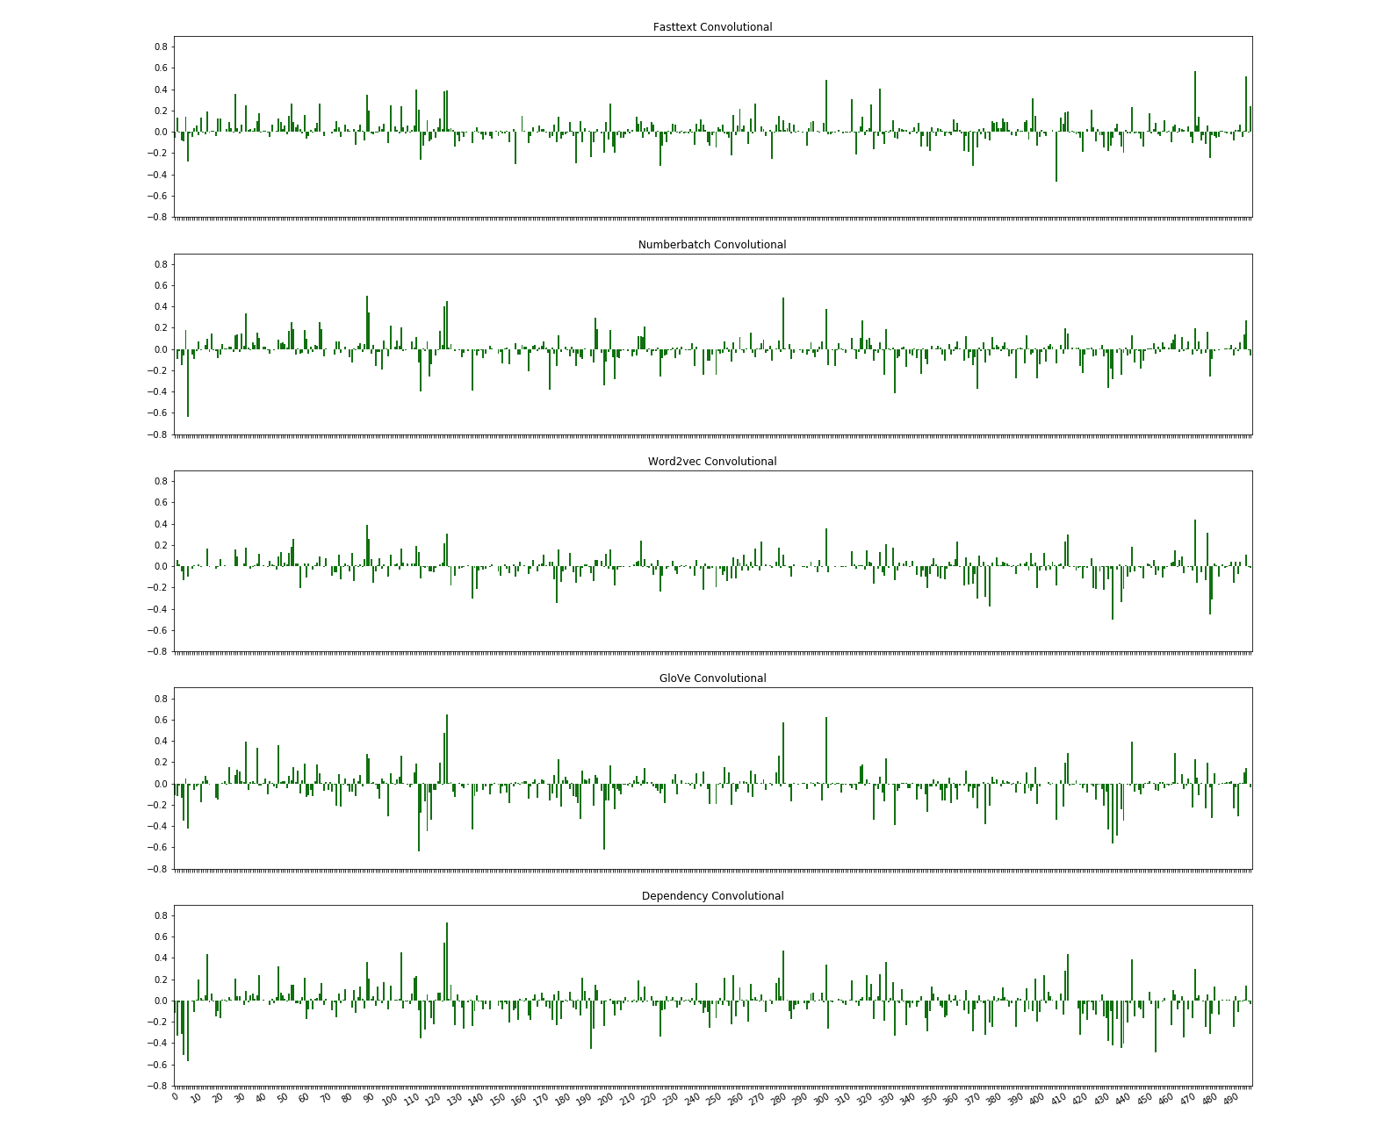
Figure 7.60: Change in coherence with pronoun substitution for convolutional models for a subsample of 500 sequences from the test corpus.

When examining the sequences for which the coherence score increased, in spite of the illogical /ungrammatical sentence, we noticed that the first sentence often contained the pronoun he. This suggests that the models are learning statistics about which words are likely to appear in a subsequent sentence, regardless of whether or not that sentence is grammatical or logical. In the future, we must add constraints that prevent our models from favouring ungrammatical sentences over grammatical ones.

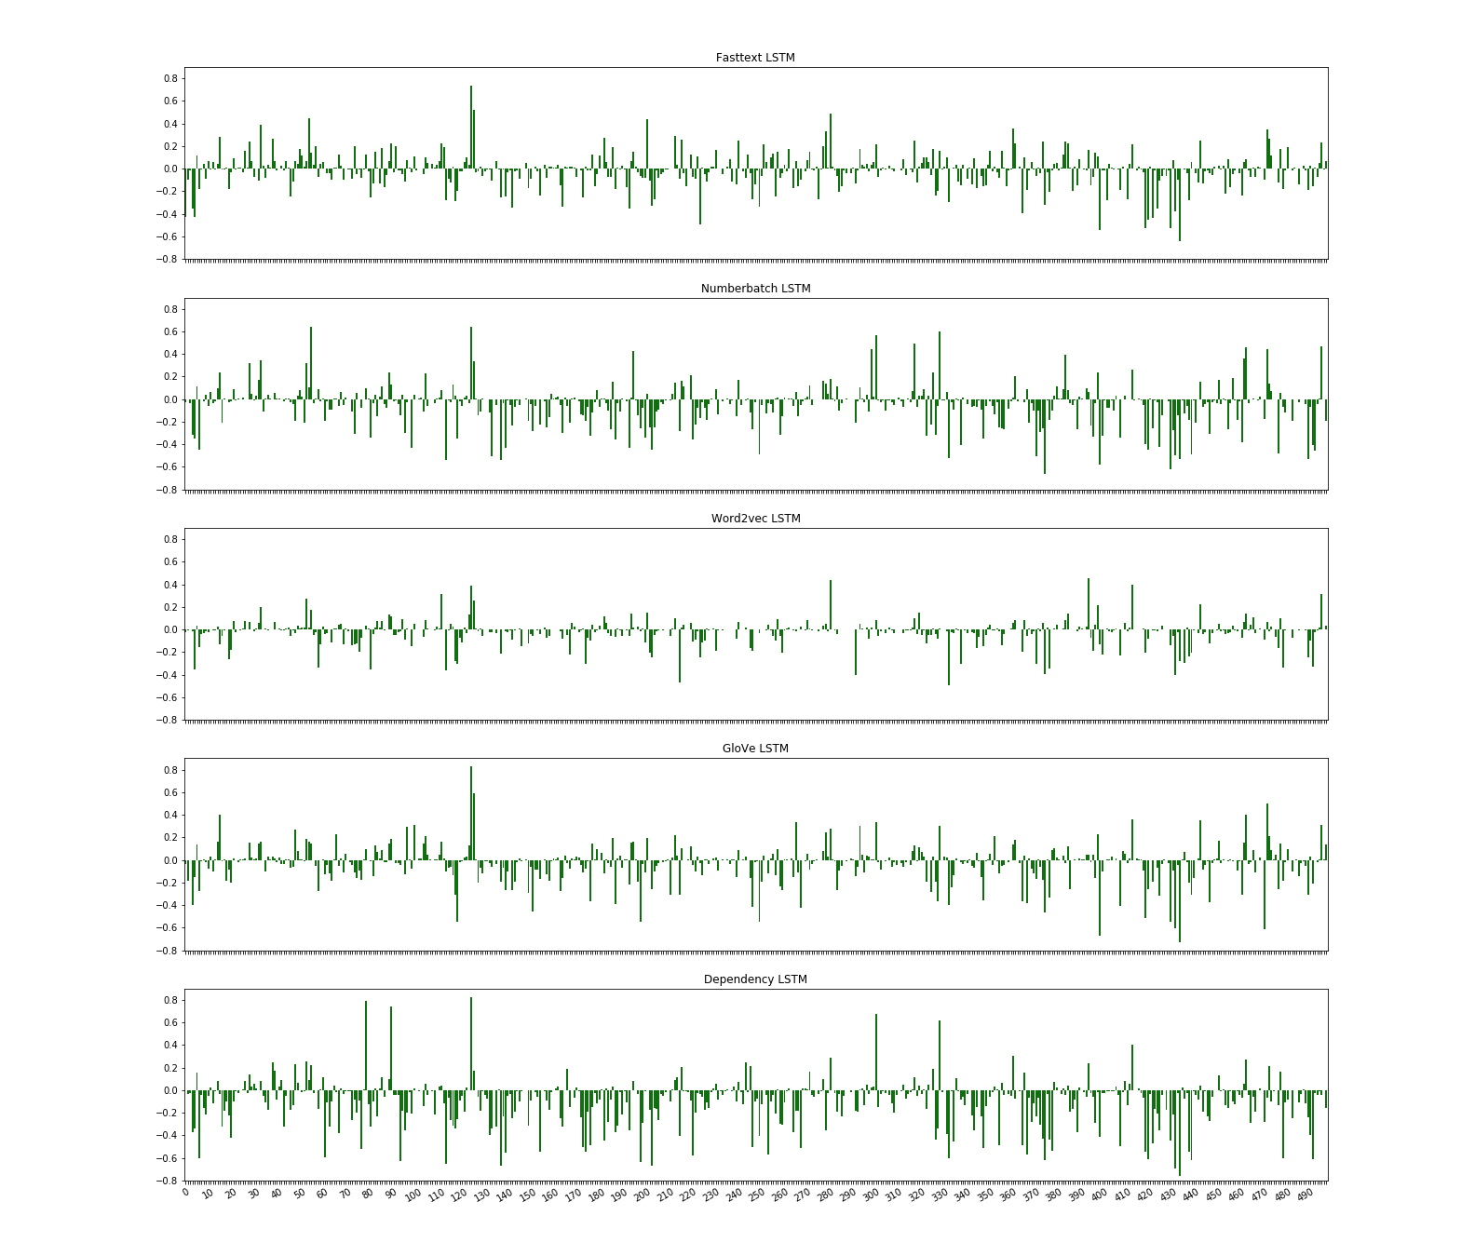
Figure 7.61: Change in coherence with pronoun substitution for LSTM models for a subsample of 500 sequences from the test corpus.

Sensitivity to Temporal Coherence
Our final coherence score test involved temporal coherence. We substituted a tensed verb for that same verb in another tense. Our sample size (20 sequences) is quite small due to the fact that the sample sequences had to be hand-selected to assure an incongruence with respect to time. Systematically changing the tense for a large number of sequences did not reliably produce incoherence, as a large number of those sequences were still plausible.
Tense change
Sentence 1 | Last summer, Donihue, a researcher from Harvard University, traveled to the Caribbean islands of Turks and Caicos to study a local species of anole lizard.
Sentence 2 | Conservationists were/are set to exterminate rats that had been introduced to the two islands to preserve their native wildlife, and Donihue wanted to see how the lizards might evolve once the rodents were gone.
Sentence 3 | He and his colleagues captured dozens, and measured their bodies, legs and toes.
Figure 7.62 An example of a sequence with verb tense substitution.
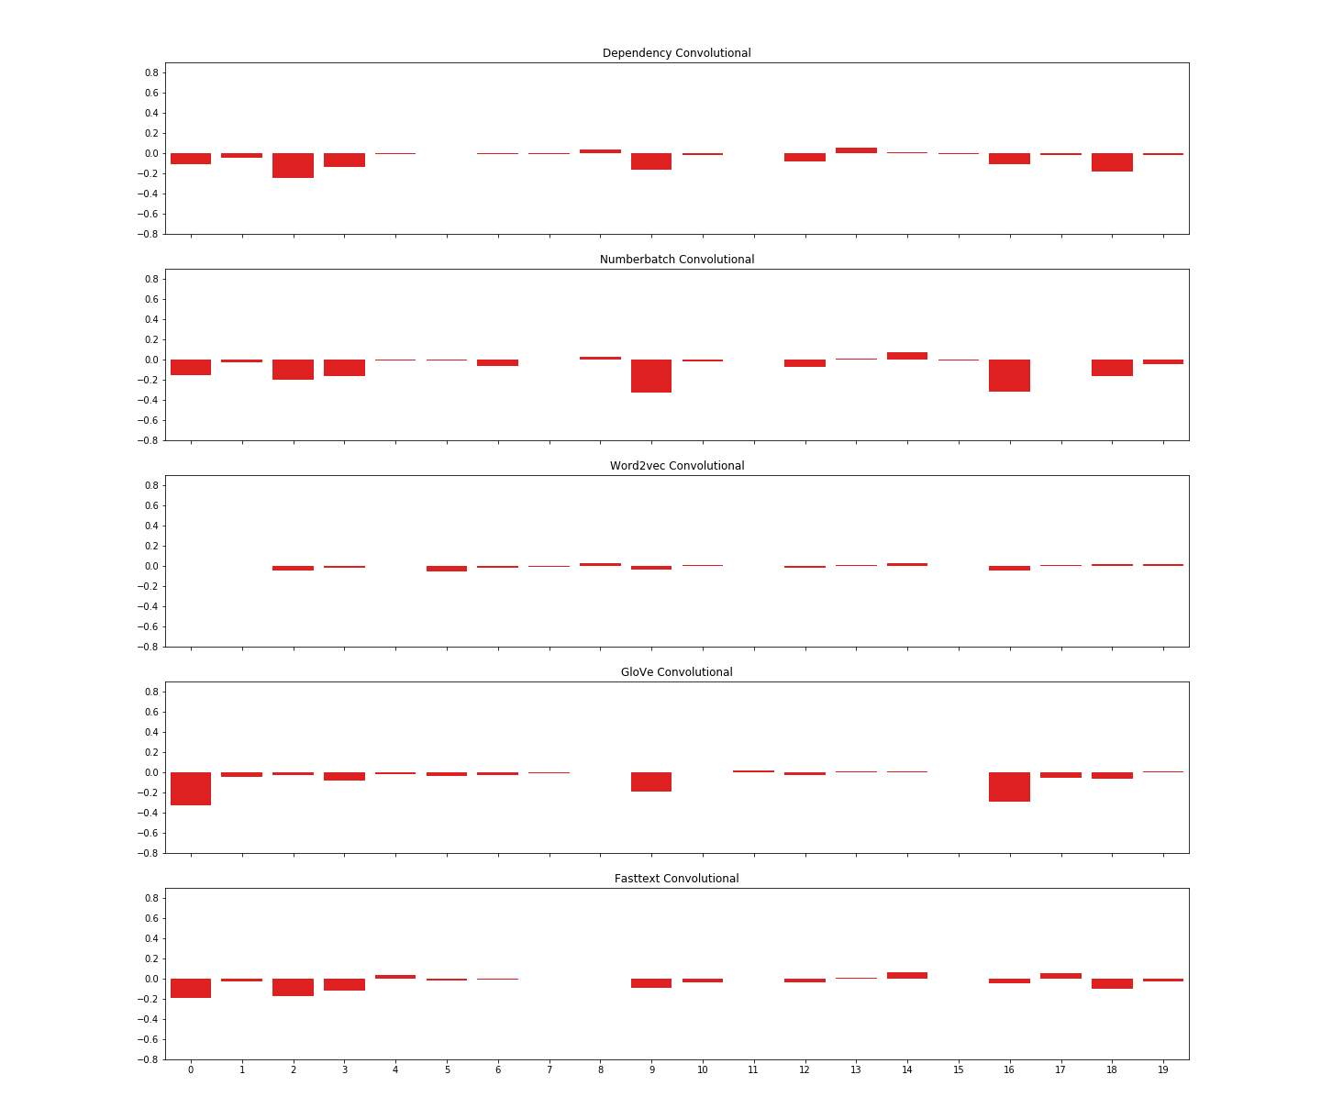
Figure 7.63: Change in coherence scores for the convolutional models.

Embedding Type | Average Change in Coherence Prediction Score | Score Increased
Word2vec LSTM | -0.032 | 3
Fasttext LSTM | -0.061 | 5
GloVe LSTM | -0.037 | 4
Dependency LSTM | -0.103 | 1
Numberbatch LSTM | -0.074 | 5
Word2vec Convolutional | -0.007 | 11
Fasttext Convolutional | -0.038 | 6
GloVe Convolutional | -0.059 | 7
Dependency Convolutional | -0.051 | 4
Numberbatch Convolutional | -0.074 | 6
Figure 7.64 Average change in coherence scores for 20 sequences with substituted verb tenses.
The strongest performing model for this task was the dependency LSTM model. Figures 7.18-7.20 summarize the results.
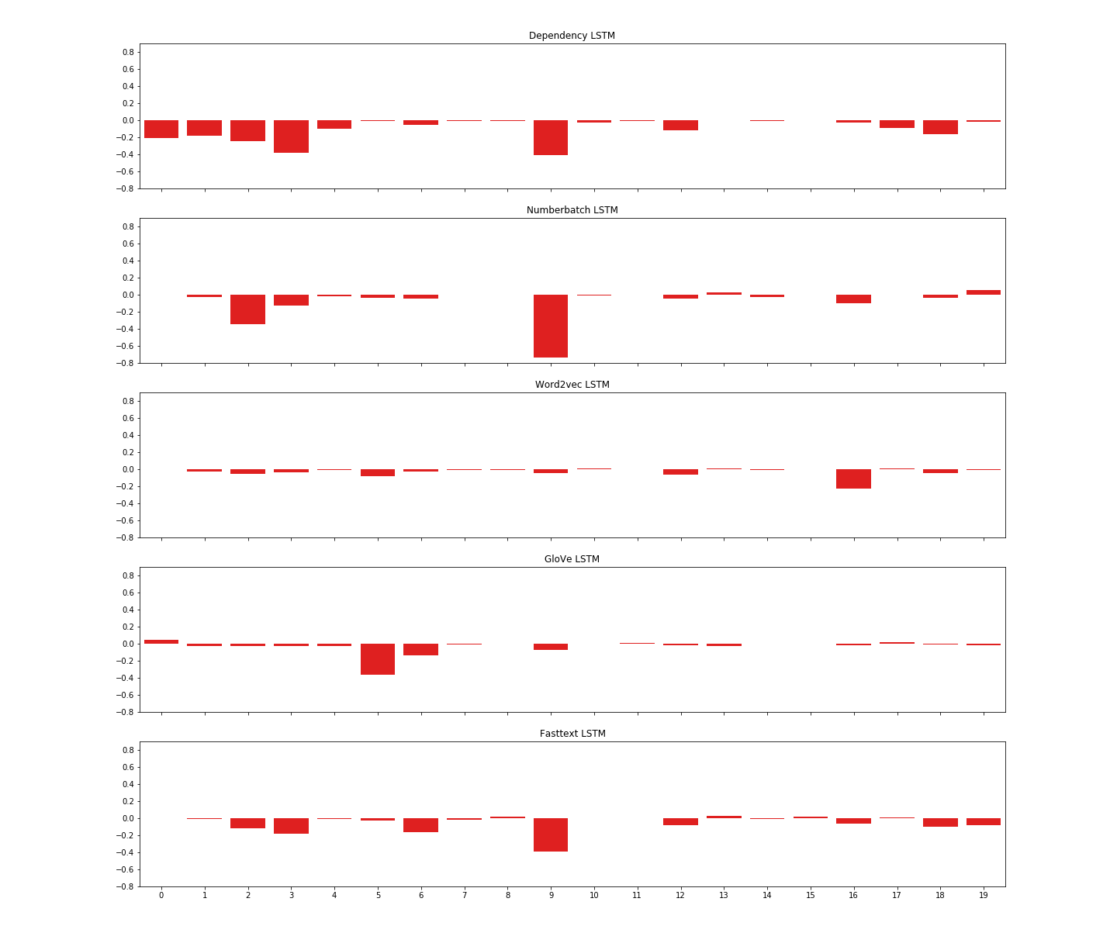
Figure 7.65: Change in coherence scores for the LSTM models.

Intermediary Layers
In order to gain a better understanding of the way our models were organizing sentences and sequences, we extracted the models’ activation outputs for the layers that encode these units, giving us vector representations for sentences and sequences. We then performed T-SNE (Maaten & Hinton, 2008) to reduce the number of dimensions down to three and then visualized the result in Tensorboard’s embeddings projector.
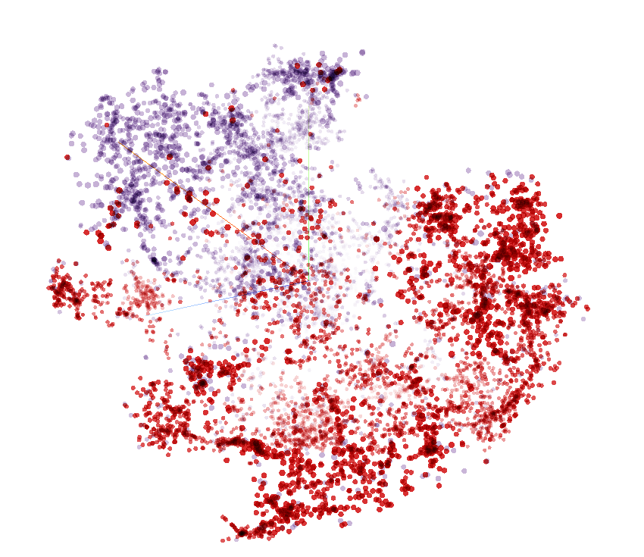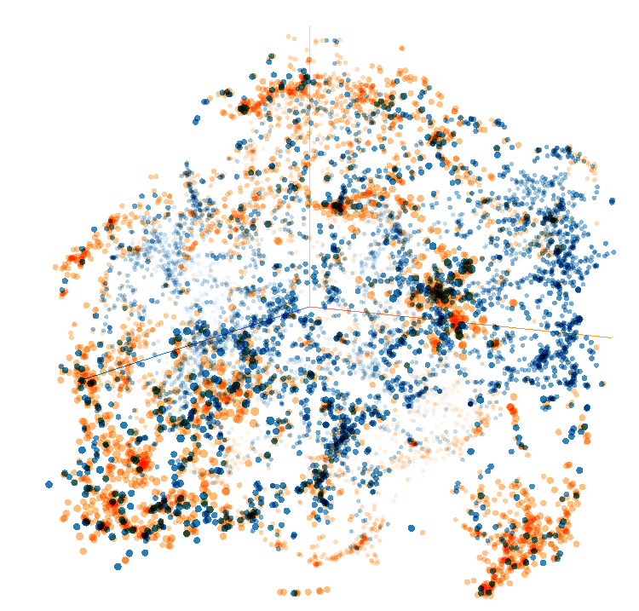
Figure 7.66 : T-SNE representations of the test corpus sequences from the Word2vec LSTM model (LEFT) and the Dependency Convolutional model (RIGHT). Each point in space represents a sequence and the colours represent coherence (purple, orange) or incoherence (red, blue).
The t-sne representations of sequences show that the LSTM models are much better at separating the coherent from the incoherent; the coherent and incoherent sequences in the convolutional latent semantic space are intermingled, whereas the LSTM has a relatively distinct line of separation. In both sets of models, at both the sentence and the sequence level, we see topical clusters that form in these latent semantic spaces.

Sentence Representations
In this section, we will examine some of the sentence clusters from the LSTM models. After the embedding layer, the convolutional models process the entire sequence together, so there are no intermediary-layer sentence representations from these models.
Figures 7.22 to 7.24 show the nearest neighbours in the vector spaces for three different sentences from the test corpus. If we look at the first example (Figure 7.22), we see the different word embedding models grouping sentences according to different themes: the Word2vec model groups this sentence with others relating to the theme of sleep; the dependency model groups the sentence with a cluster on babies and antibiotics; GloVe clusters around motherhood; Fasttext groups around a family theme (e.g. father and grandmother, siblings); it is more difficult to see a commonality among the Numberbatch sentences (perhaps mental states, but that is probably a stretch).
In some clusters, Numberbatch in Table 7.23 for example, there appears to be a theme (nations and military conflict), but it is difficult to see how the target sentence fits in with those neighbours. Other clusters are not human interpretable at all. We can see though that each embedding model views sentences from a different angle, and the complementarity of these views contributes to increased accuracy with our ensemble methods.

Sentence 1: She found a way to write still, fighting through extreme fatigue and finishing her book in the spurts when her baby slept.
Word2vec | For too long, sleep has been undervalued, seen as an inconvenient distraction from wakefulness.
Word2vec | She will hunt during the day now, even though it is more dangerous – because her babies need her at night.
Word2vec | It is implicated in mind-wandering, spontaneous free thought, and the kind of mental stimulation that sparks glimmers of ideas, still unfocused and undetermined.
Word2vec | Investing in sleep research is not just about the few with demonstrable sleep disorders.
Dependency | Two earlier trials tested off-the-shelf probiotics on 1,099 and 1,315 premature infants respectively.
Dependency | Beyond protecting infants, Panigrahi says that this approach would also reduce the use of antibiotics.
Dependency | Since 2008, Panigraphi’s team has been running a large clinical trial in rural India, where they gave a probiotic of their own devising to thousands of randomly selected newborn babies.
Dependency | “Those that looked at sepsis, for example, usually involved just 100 to 200 babies, making it hard to know whether any beneficial effects were the result of random chance.
Numberbatch | The executive-control network is involved in decision-making, directed attention, planning, self- control.
Numberbatch | In another recent fMRI study, poets were asked to generate new poetry, and then revise those poems.
Numberbatch | Leslie began writing her second novel while she was pregnant with her first (and only) child.
Numberbatch | This mystery is one of 725 open cases of unidentified deceased children in the United States that the National Center for Missing and Exploited Children, or NCMEC, is helping to investigate.
Fasttext | I Skyped with her from Mexico, knowing she was well cared for by both her father and grandmother.
Fasttext | For example, early studies showed that a male named Gulliver has versions of immune genes that are completely missing in all other kakapo — even his siblings.
Fasttext | If a female hasn’t mated, or has mated with a dud male who’s known to have poor quality sperm, the team artificially inseminates her with sperm from a stud.
Fasttext | Still, when she saw my face on the screen, she cried so hard her nose bled.
GloVe | In a mother, there also resides an equally, if not more powerfully, intoxicating drive to adore and tend to her child.
GloVe | I was sprawled out on an examination table as my obstetrician adjusted an overhead monitor so my husband and I could get a better look at the sonogram.
GloVe | These are the images that Koh sketched in 2015 while nursing her twins, or while they slept.
GloVe | Leslie began writing her second novel while she was pregnant with her first (and only) child.
Figure 7.67 Nearest Neighbours for sentence in vector space.
Sentence 2: In that chapter, which previous National Climate Assessments did not include, the authors warn of “compound extremes,” the risk of multiple unusual weather conditions coming to pass at the same time.
Word2vec | No matter how the doom loop churns, global warming will very likely increase the foreign-born population of the northern and richer democracies all by itself.
Word2vec | Climate change isn’t a simple trajectory toward warmer weather and longer growing seasons.
Word2vec | Outside of California, there’s widespread evidence that global warming has already made the West’s wildfires more intense and more expansive.
Word2vec | While climate change does not cause hurricanes or wildfires, it has a role in worsening the effects of both.
Dependency | The authors caution that current climate models are more likely to underestimate future warming than overestimate it.
Dependency | The climate Science Special Report comes at an auspicious time in the history of global warming and the United States.
Dependency | The report includes forecasts of how much the sea level will rise around the world.
Dependency | A draft version of the second volume, on the human impacts of climate change, was also released Friday.
Numberbatch | Her Majesty’s Navy responded with the full force of its futuristic technology, running ironclad steamships straight up the Yangtze, sinking Chinese junk boats, until the emperor had no choice but to sign the first of the "unequal treaties" that ceded Hong Kong, along with five other ports, to British jurisdiction.
Numberbatch | A large landmass ruled by long dynasties may have encouraged less technical dynamism than did Europe, where more than 10 polities were crammed into a small area, triggering constant conflict.
Numberbatch | Now, the United States sets many more extreme heat records than extreme cold records; it sees more intense heat waves and weaker, briefer cold snaps.
Numberbatch | This lack of curiosity is said to explain why China pressed pause on naval innovation during the late Middle Ages, right at the dawn of Europe’s age of exploration, when the Western imperial powers were looking fondly back through the medieval fog to seafaring Athens.
Fasttext | Meanwhile, the blisters were getting bigger.
Fasttext | It is motivated by deep human desires for connection and transcendence.
Fasttext | This grim cosmic outlook is called "dark - forest theory," because it conceives of every civilization in the universe as a hunter hiding in a moonless woodland, listening for the first rustlings of a rival.
Fasttext | Scientists already suspected that the Black Death was caused by the bacteria Yersinia pestis, but no one is as certain about the exact cause of cocolitzli.
GloVe | The authors caution that current climate models are more likely to underestimate future warming than overestimate it.
GloVe | Presenting a false balance, as is often seen with climate-change reporting, is problematic.
GloVe | "This is the most comprehensive assessment of climate science currently available in the world, and it reaffirms what we’ve already known," said Robert Kopp, one of the lead authors of the report and a professor of climate science at Rutgers University.
GloVe | The two-degree limit is a rough target used by the United Nations to signal the point where dangerous climate change could begin.
Figure 7.68 Nearest Neighbours for sentence in vector space.
Sentence 3: But evolution did not stop when the first modern humans emerged.
Word2vec | Homo sapiens didn’t make their appearance on the planet until just 300,000 years or so ago.
Word2vec | But this particular ape has a significance that will transcend his death.
Word2vec | There actually are modern odontocetes that don’t really use their teeth either.
Word2vec | Around 3.4 million years ago, these ancestral apes split into two populations, one which gave rise to the current Batang Toru lineage.
Dependency | “The full genomes of every kakapo will probably reveal similar differences.”
Dependency | “And it was divers looking for megalodon teeth who initially found the fossilized skull, loose on the bottom of the Wando River.
Dependency | The girl’s bones were unearthed the following year.
Dependency | The ones with teeth grasp and tear like reptiles and then swallow the chunks whole.
Numberbatch | The team catches the males and collects samples of their sperm.
Numberbatch | Roth pivoted, offering an unusual gift in the face of rejection: peacock feathers.
Numberbatch | Thus was born the mirror test — one of the most famous techniques in the study of animal intelligence, and one of the most controversial.
Numberbatch | What’s more, the mirror test is a visual test, designed by visual animals (us) for other visual animals.
Fasttext | "You can look at the entire spectrum of consequence of variants.
Fasttext | * Erich Jarvis thinks that those genomes have interesting evolutionary stories to tell.
Fasttext | In both these cases, they found genetic variants associated with dying younger.
Fasttext | When we talk about human evolution, we usually talk about how we evolved into humans: how we lost body hair, gained brain mass, started to walk on two feet — in short, things that happened millions of years ago.
GloVe | DNA will only tell you so much about an animal, but it becomes especially powerful when combined with all the other kakapo data around.
GloVe | They wanted to know how these traits are related to lifespan.
GloVe | That is a pretty big shift in how we can do evolutionary genetics," says McVean.
GloVe | The full genomes of every kakapo will probably reveal similar differences.
Figure 7.69 Nearest Neighbours for sentence in vector space.

Sequence Representation
The sequence representations, like the sentences, cluster around different topics. There is no obvious indication that patterns of entity transitions, syntactic features or discourse relations play any role in these groupings, although a corpus annotated with these features would be necessary to know for sure.
Figures 7.25 to 7.34 show examples of the top three nearest neighbours for each of our models for the following sequence:
Sentence 1: But evolution did not stop when the first modern humans emerged.

Sentence 2: A new study of two massive genetic databases — one in the United Kingdom and one in California — suggests genetic mutations that shorten lifespans have been weeded out since, and are possibly still in the process of being weeded out today.

Sentence 3: The idea for the study, says Molly Przeworski, a geneticist at Columbia, came when the health - care company Kaiser Permanente decided to make available a massive genetic database of certain patients in California.

Most of the neighbours are related to the broad theme of genetics/evolution, but other patterns are not evident.
Word2vec LSTM
When the team got the sequencing data back, they noticed that the same networks of genes appear to be active in both the fungus’s rhizomorphs and its mushrooms. It suggests one potential evolutionary origin for rhizomorphs in this genus: Armillaria could have gained its rhizomorphs — and consequently its ability to spread so wide — by co-opting genes originally used to grow mushrooms. Nagy speculates the rhizomorphs may be akin to mushroom stems that failed to sprout and grow a cap, instead growing long and thin underground.
Many scientists, Reed included, have addressed that second question. By carrying out painstaking cross-breeding experiments, and by working out where in the wings various genes are active, they identified a handful of pattern-defining genes, with colorful names like optix, doublesex, and cortex. "It was convincing but we didn’t know exactly what these genes were doing," says Reed.
But there’s also the genetic data, and the unique behaviors. Besides, other primates have been billed as distinctive species on the basis of much less. Bonobos, for example, were proposed as a distinct species from chimpanzees based on a single female specimen and five skulls — without any supporting genetic information to begin with.
Figure 7.70 Nearest sequence neighbours – Word2vec LSTM
Dependency LSTM
The most obvious effects from APOE and CHRNA3 emerge late in life, after most people have already had children. In that case, you would expect there to be no selection pressure on mutations affecting longevity. And without selection pressure, a lot of such mutations would have accumulated by chance somewhere in the 6 billion letters of human DNA.
A 2006 study by Amaral and Schumann that looked at 9 autism brains and 10 control brains revealed a decrease in neurons in the amygdalae of people with autism. But subsequent analyses with 31 more brains have painted a more complex picture: Adults with autism have a dearth of neurons in the amygdala, but children with the condition have a surplus. The findings have yet to be published, but they reinforce the need for more postmortem brains.
In a separate study, they showed that the brains of people with classic autism and those with dup15q syndrome bear a similar pattern of chemical tags that affect gene expression. Together, the studies hint at a common molecular signature across multiple forms of autism, regardless of the cause or clinical features. "I don’t think we would have been able to find that result without looking at gene expression in autistic brains," says Dan Arking, an associate professor of medicine at Johns Hopkins University in Baltimore, who led the 2014 study.
Figure 7.71 Nearest sequence neighbours – Dependency LSTM
Numberbatch LSTM
Journalist and author Maryn McKenna weaves these two intertwined tales together in her new book, Big Chicken: The Incredible Story of How Antibiotics Created Modern Agriculture and Changed the Way the World Eats. In this episode of Gastropod, she describes the consequences of decades spent feeding chicken antibiotics, in terms of chicken flavor, poultry well-being, and, most significantly, human health. In the 1920s, chickens were not only pricey, they were also only seasonally available and not necessarily very tasty, either.
The team behind the first study later discovered that people with classic autism share patterns of brain-gene expression with those who have dup15q duplication syndrome — a rare genetic condition associated with autism. In a separate study, they showed that the brains of people with classic autism and those with dup15q syndrome bear a similar pattern of chemical tags that affect gene expression. Together, the studies hint at a common molecular signature across multiple forms of autism, regardless of the cause or clinical features.
Casein’s unique structure also contributes to the stretchiness of cheeses such as mozzarella and the smoothness of cheeses such as brie, and it is the secret to cheese’s sensuous meltability. Like many vegans, Miyoko Schinner, the founder of the vegan cheese company Miyoko’s Kitchen and the author of Artisan Vegan Cheese, found that cheese was the one thing she really missed when she gave up dairy. She was such a cheese fan that she’d even traveled Europe sampling the continent’s thousands of small - batch, artisanal cheeses, before she realized that her constant stomachaches might have been due to a dairy intolerance.
Figure 7.72 Nearest sequence neighbours – Numberbatch LSTM
GloVe LSTM
“The method does not rule them out. In particular, the team can only detect DNA, but some viruses carry RNA instead.” “If all these people died from RNA viruses, we will never know, at least not with these techniques,” says Nicolas Rascovan, a microbiologist at Aix-Marseille Université, who also studies dental-pulp DNA among people in the Americas.
But having tried this approach themselves, Geoghegan and Holmes argue it’s not very useful. Partly, that’s because the results of such studies are too broad to narrow down the list of suspicious viruses in a helpful way. Partly, it’s because such work is based on past epidemics – events that are relatively rare, and so difficult to draw reliable patterns from.
The most obvious effects from APOE and CHRNA3 emerge late in life, after most people have already had children. In that case, you would expect there to be no selection pressure on mutations affecting longevity. And without selection pressure, a lot of such mutations would have accumulated by chance somewhere in the 6 billion letters of human DNA.
Figure 7.73 Nearest sequence neighbours – GloVe LSTM
Fasttext LSTM
This spring, 11 years after the first volunteer gave up a tube of blood, U.K. Biobank announced it would release its full genetic data set to registered scientists in July. This huge amount of genetic information, combined with the thousands of other characteristics tracked by U.K. Biobank, allows scientists to look for the genetic determinants of virtually any disease. Geneticists marked their calendars.
Their lungs fill with fluid and they start bleeding uncontrollably. These immune - suppressing strains might have emerged as early as the 1970s, and they’re circulating broadly now. Still, their effects are hard to spot in wild rabbits, which still die from the same kinds of symptoms as they used to.
Two genes immediately popped up: APOE, a mutation in which is associated with late - onset Alzheimer’s disease, and CHRNA3, a gene for a nicotine receptor where a variant is associated with more smoking. In both these cases, they found genetic variants associated with dying younger. What was truly intriguing, though, is that the team only found two such genes.
Figure 7.74 Nearest sequence neighbours – Fasttext LSTM
Word2vec Convolutional
This spring, 11 years after the first volunteer gave up a tube of blood, U.K. Biobank announced it would release its full genetic data set to registered scientists in July. This huge amount of genetic information, combined with the thousands of other characteristics tracked by U.K. Biobank, allows scientists to look for the genetic determinants of virtually any disease. Geneticists marked their calendars.
Prior archaeological work had linked the burials to the 1545 cocolitzli epidemic, and the city was likely abandoned after the disease killed so many of its inhabitants. "Teeth are an excellent source of DNA," says Kirsten Bos, an anthropologist at the Max Planck Institute for the Science of Human History who worked on the new study. Dental pulp — the soft, living tissue inside teeth — is full of blood vessels and thus any pathogens that once circulated in the blood.
And it was divers looking for megalodon teeth who initially found the fossilized skull, loose on the bottom of the Wando River. The skull — unusually wide and unusually squat — made its way to a collector who gave it to the College of Charleston’s Mace Brown Museum of Natural History. By the time the paleontologist Robert Boessenecker came to it, he says "It was already known as something new and very strange."
Figure 7.75 Nearest sequence neighbours – Word2vec Convolutional
Numberbatch Convolutional
Mutations that appear in 10 percent of the population are still relatively common. Przeworski and Pickrell have already done another calculation, this time more rigorous than their initial back - of - the - envelope calculation: With 500,000 samples, the team could study mutations that appear in only 2 percent of population. And that will provide even more detail about recent human evolution.
But the fact there are only two such variants suggest others have indeed been actively weeded out. The method from Przeworski and her colleagues is indirect but clever: They’re using genetic signatures (or lack thereof) from people in the present to infer evolution that happened in the past. But why would mutations that affect longevity get selected out?
These low oxygen levels (called ocean anoxia) help trigger the conditions needed for making fossil fuels like oil and coal in the first place. In this way, a civilization and its demise might sow the seed for new civilizations in the future. By asking about civilizations lost in deep time, we’re also asking about the possibility for universal rules guiding the evolution of all biospheres in all their creative potential, including the emergence of civilizations.
Figure 7.76 Nearest sequence neighbours – Numberbatch Convolutional
Dependency Convolutional
But the fact there are only two such variants suggest others have indeed been actively weeded out. The method from Przeworski and her colleagues is indirect but clever: They’re using genetic signatures (or lack thereof) from people in the present to infer evolution that happened in the past. But why would mutations that affect longevity get selected out?
It’s just a matter of finding the right strains, and helping them to establish themselves. That suggests any trait may have trade - offs, and this big genetic database is one way to study these trade-offs. Since 2008, Panigrahi’s team has been running a large clinical trial in rural India, where they gave a probiotic of their own devising to thousands of randomly selected newborn babies.
In that case, you would expect there to be no selection pressure on mutations affecting longevity. And without selection pressure, a lot of such mutations would have accumulated by chance somewhere in the 6 billion letters of human DNA. But the fact there are only two such variants suggest others have indeed been actively weeded out.
Figure 7.77 Nearest sequence neighbours – Dependency Convolutional
Fasttext Convolutional
With more people, they can look for the effects of even rarer mutations than the ones in this study. Mutations that appear in 10 percent of the population are still relatively common. Przeworski and Pickrell have already done another calculation, this time more rigorous than their initial back-of-the- envelope calculation: With 500,000 samples, the team could study mutations that appear in only 2 percent of population.
One study of 13,000 fraternal twins (like Koh’s, who share half of each other’s genes) and identical twins (like mine, who share all of each other’s genes) from six countries showed that motivation levels of identical twins were more alike than fraternal twins. The researchers estimated that 40 percent of differences in motivation appear to stem from genetics — while shared environments like home life, parents, classrooms, and teachers mattered little. There is still much that scientists do not understand about why motivation varies from person to person, said Abraham, but we do know that within our species there is a strong need to express ourselves.
Two genes immediately popped up: APOE, a mutation in which is associated with late - onset Alzheimer’s disease, and CHRNA3, a gene for a nicotine receptor where a variant is associated with more smoking. In both these cases, they found genetic variants associated with dying younger. What was truly intriguing, though, is that the team only found two such genes.
Figure 7.78 Nearest sequence neighbours – Fasttext Convolutional

GloVe Convolutional
With more people, they can look for the effects of even rarer mutations than the ones in this study. Mutations that appear in 10 percent of the population are still relatively common. Przeworski and Pickrell have already done another calculation, this time more rigorous than their initial back-of-the- envelope calculation: With 500,000 samples, the team could study mutations that appear in only 2 percent of population.
It’s just a matter of finding the right strains, and helping them to establish themselves. That suggests any trait may have trade-offs, and this big genetic database is one way to study these trade-offs. Since 2008, Panigrahi’s team has been running a large clinical trial in rural India, where they gave a probiotic of their own devising to thousands of randomly selected newborn babies.
The process wasn’t easy to observe in organisms, but it was easier to see in words." But natural selection is just one force of evolutionary change. Under its influence, genes become more (or less) common because their owners are more (or less) likely to survive and reproduce.
Figure 7.79 Nearest sequence neighbours – GloVe Convolutional

Topical Clustering and False Negatives/Borderline Cases
The topical clustering we observed in the vector space help explain why some of the coherent sequences with seemingly obvious lexical connections across sentences are missclassified or at least difficult for the model to classify. The example in Figure 7.35 shows one such sequence where the semantically related words travel and journey bind the first and the second sentence together, but the GloVe LSTM model is unable to judge the coherence with any confidence (the coherence score given is 0.501). By looking at this sequence’s two nearest neighbours, both or which are incoherent, the model’s confusion becomes more comprehensible.
Sequence: Many of these creatures have free-living stages, where they travel through the world in search of hosts. On these journeys, they’re vulnerable to the same changes in temperature and rainfall that are affecting the entire planet. Global climate change is also forcing animals to move into new areas; that could be a problem for the parasites that depend on those animals, especially if they have complex life cycles that involve several hosts.
Nearest Neighbour 1: Conservationists do already think about edge effects, Haddad says, but typically on the scale of tens of meters – not hundreds. That heat is shrinking the ice sheets at the planet’s north and south poles and causing the oceans to expand. Only half world’s forests lie more than 500 meters from an edge, and conservationists should focus on the species that persist in this invisible corral.
Nearest Neighbour 2: They’ve done this for millions of mosquitos, creating an unprecedented trove of information – easily one of the biggest long-term attempts to monitor any group of animals, if not the very biggest. Sea-level rise will make every tropical cyclone that hits New York more likely to release damaging floods. The rest is inaccessible, hoarded by local mosquito-control agencies around the country.
Figure 7.80: A topical cluster from the GloVe LSTM model.
The first and third sentences in the nearest neighbours are about ecology and the second sentence discusses meteorological issues. We can thus deduce that the words temperature and rainfall are a source of confusion for this model.
In future research, we could perhaps add an additional input to our models that makes lexical cohesion more explicit, but this feature is not always indicative of coherence. For example, in the sequence below, we have the repetition of the word bird, but the sequence is still not very coherent because of the shift in focus from a specific topic out to a general topic and back to the original specific topic.
Sentence 1: A critically endangered species found nowhere else in the world, those chatty green birds had never known life outside of captivity.
Sentence 2: Is what we're doing good or bad for birds?
Sentence 3: “We wanted an experience that would instill in those birds a very real fear and recognition of a red - tailed hawk as a deadly predator,” says Tom White, a wildlife biologist with the U.S.

Topics in Training vs. Test Corpus
By looking at the coherence scores given by all the models in Figures 7.5 and 7.6, we notice patches where several sequences in a row (sequences originating from the same text) are evaluated incorrectly. Perhaps this is an indication that some of the topics covered in the test corpus were not well represented in the training corpus and so the models are not well equipped to deal with those topics.
To explore this theory further, we used our topic model (section 6.2.2) to create a topic vector for each of the sentences in the corpus. We then summed the dimensions of the topic vectors for all three sentences in each sequence to be used as a proxy for how much overlap there was between the topics in the sequence and the topics in the training corpus. We then compared the distributions (Figure 7.36) of sequences that were identified correctly by the majority of the models with the sequences that were identified incorrectly by the majority of the models with respect to their topic vector sums.
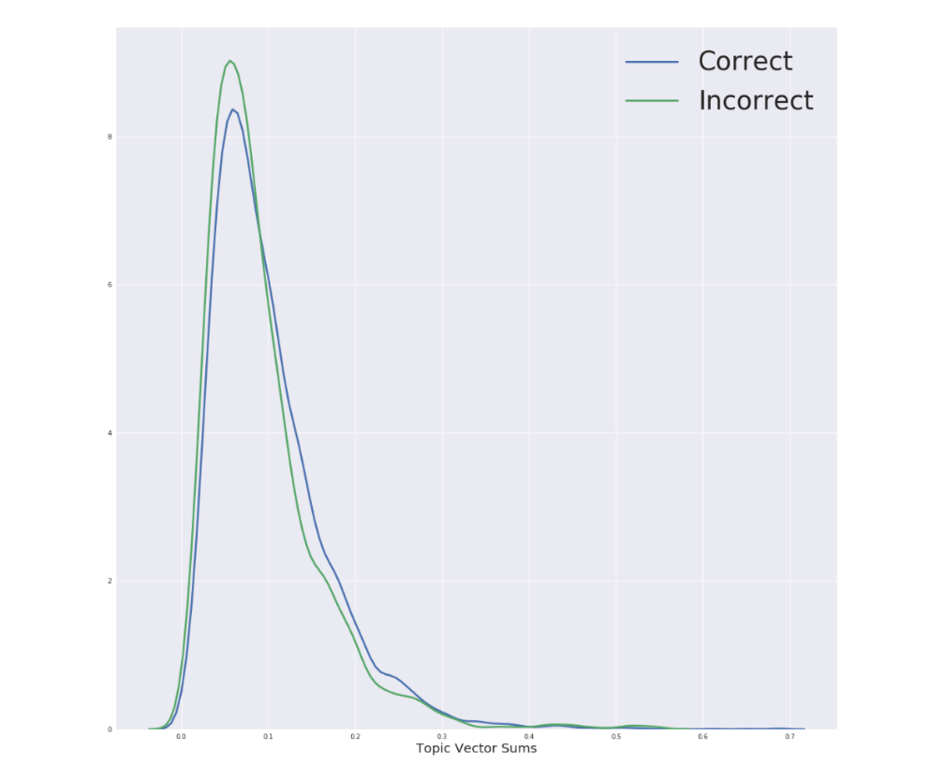
Figure 7.81: The distribution of sequences that were evaluated correctly and incorrectly with regards to their topic vector sums.
The results show that sequences with less overlap with the training corpus are slightly more likely to be judged incorrectly by our models. This suggests that higher accuracy could be achieved if the training corpus was expanded to get a broader coverage of topics.

Visualizations
To try and understand how our models are deciding which sequences are coherent, we experimented with a visualization technique which allows you to see the relative importance of each word embedding to the final decision. This technique is the same as back propagation, but the gradients are applied to the input rather than to the weights (for more information, see Li et al., 2015). In the heatmaps in this section, the rows represent the words in a sequence and the columns represent the dimensions of the word embeddings. Darker and lighter cells contribute a lot to the coherence score and mid-range colours contribute a little.
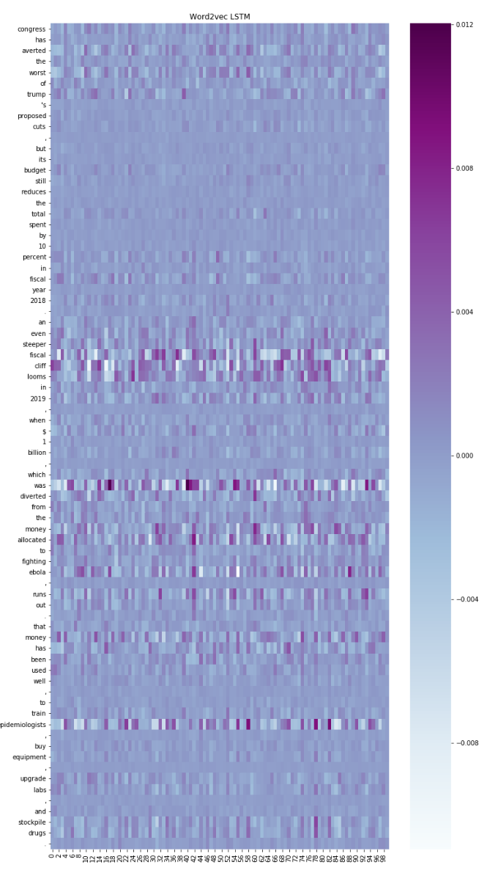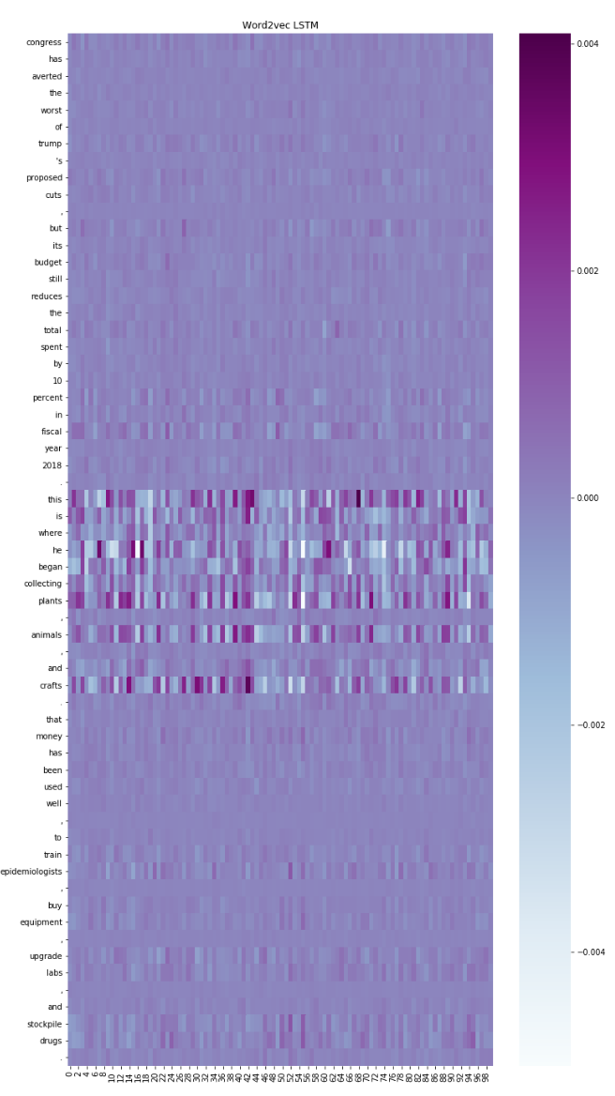
Figure 7.82 Visualization of the relative importance of each word embedding and dimension to the final coherence score for the Word2vec LSTM model: LEFT – a coherent sequence and RIGHT – an incoherent sequence.
These visualizations were ultimately not very helpful for interpreting the differences in the models’ representations of sequences. While one might think that different models would focus in on different words, this did not seem to be the case. Often, when the models gave coherence scores with high confidence levels (for either coherence or incoherence) all the models’ paid most attention to the same key words, whether the models were in agreement or not. Disagreements in coherence scores may be due to the combined force of the weakly contributing words, but we cannot say for sure.
When the confidence levels for the coherence scores are not very high, we do see differences in the representations of the different models, but it is difficult to decipher any kinds of patterns in these representations. Figure 7.38 gives an example of sequence with mixed coherence scores. Figure 7.39 shows the coherence scores for each of our models and 7.40 to 7.44 show the visualizations of this sequence for each of our models.
Sentence 1 | Then, hard and painful nodules appeared behind one or both ears along with headache, chest pain, abdominal pain, tremor, great anxiety and dysentery.
Sentence 2 | The study authors acknowledge that S. enterica may have interacted with other circulating pathogens.
Sentence 3 | The method does not rule them out.
Figure 7.83 A sequence from the test corpus that results in a wide range of coherence scores.
LSTM Models | Coherence Score | Convolutional Models | Coherence score
Word2vec | 0.156 | Word2vec | 0.426
Dependency | 0.790 | Dependency | 0.829
Numberbatch | 0.711 | Numberbatch | 0.551
GloVe | 0.442 | GloVe | 0.435
Fasttext | 0.551 | Fasttext | 0.250
Figure 7.84 The coherence scores for the sequence in Table *.
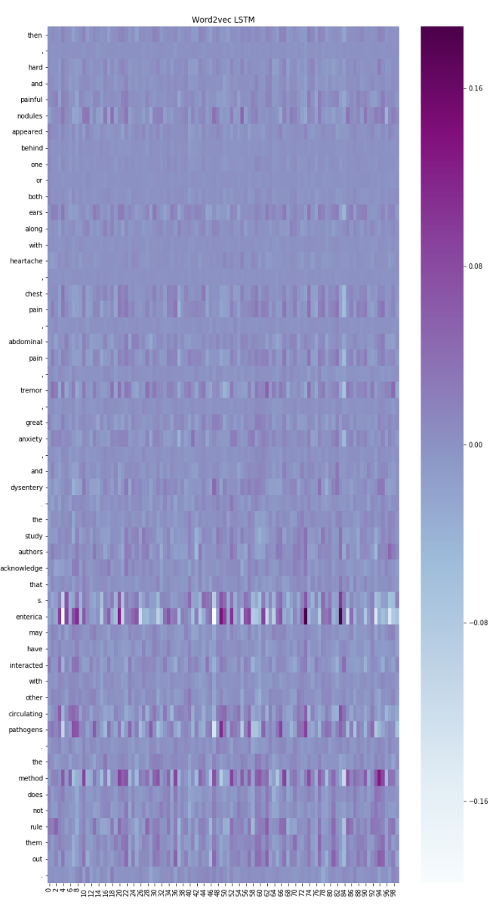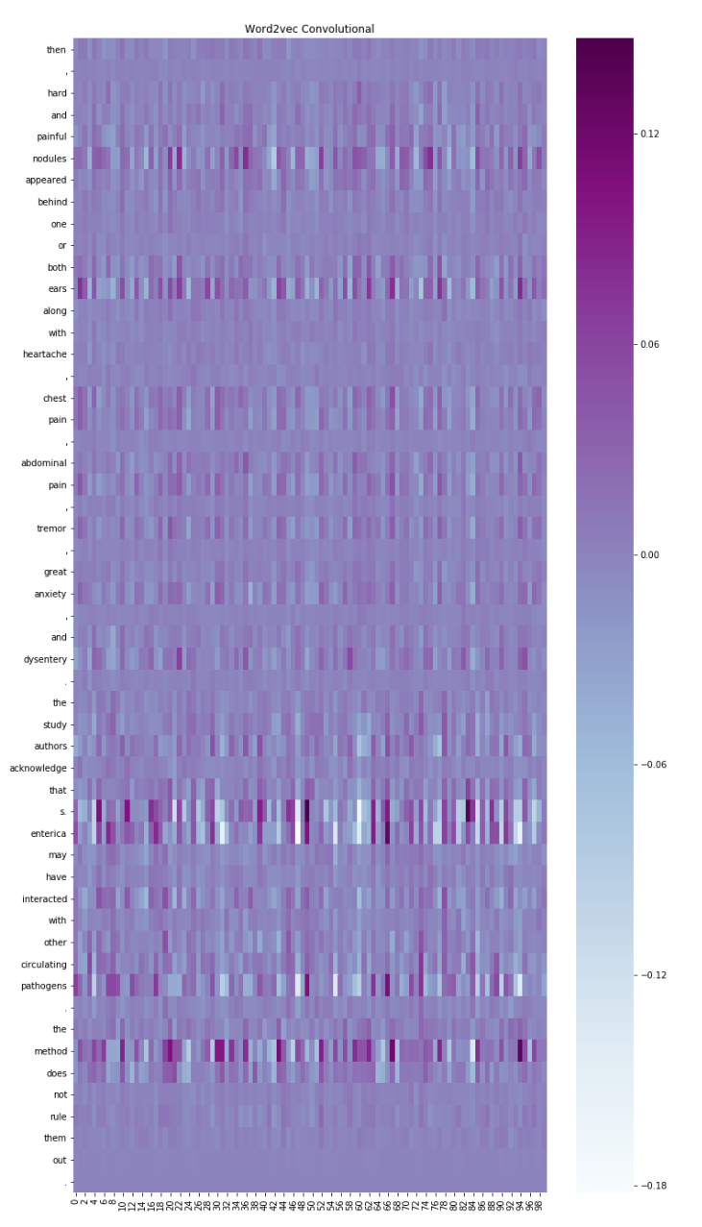
Figure 7.85 Visualization of the relative importance of each word embedding and dimension to the final coherence score for the Word2vec LSTM (LEFT) and Convolutional (RIGHT) models.

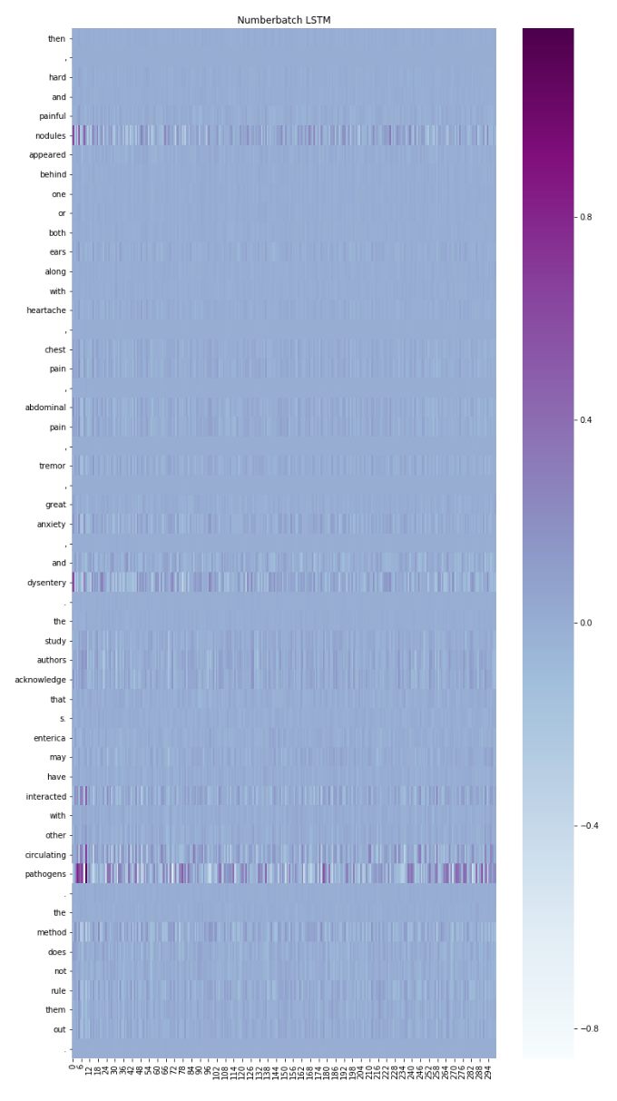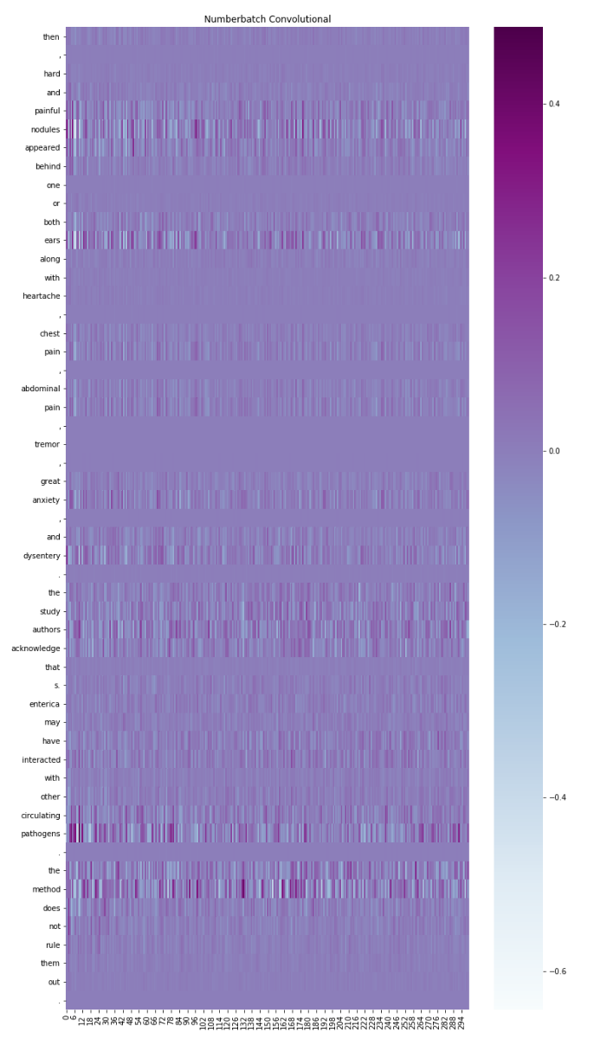
Figure 7.86 Visualization of the relative importance of each word embedding and dimension to the final coherence score for the Numberbatch LSTM (LEFT) and Convolutional (RIGHT) models.
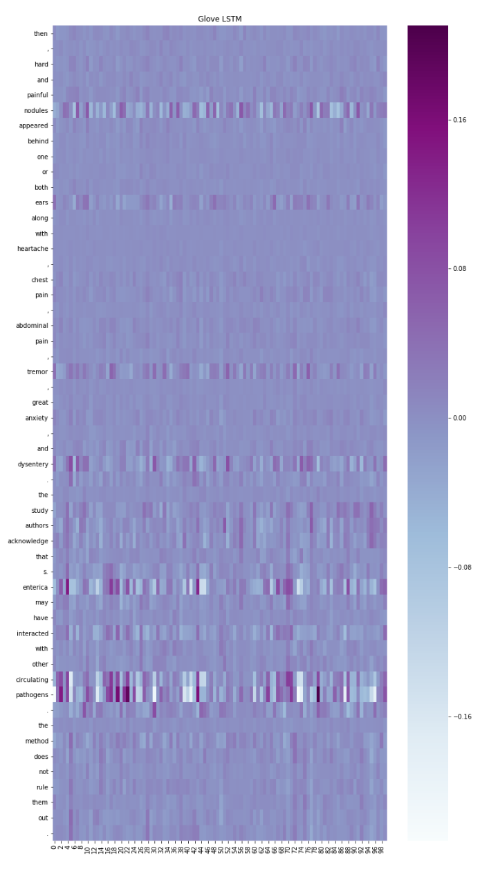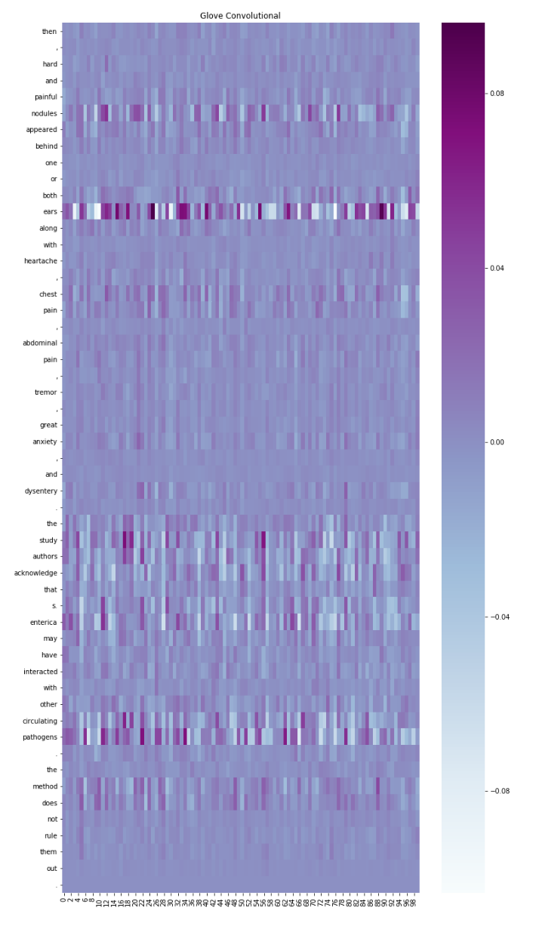
Figure7.87 Visualization of the relative importance of each word embedding and dimension to the final coherence score for the GloVe LSTM (LEFT) and Convolutional (RIGHT) models.

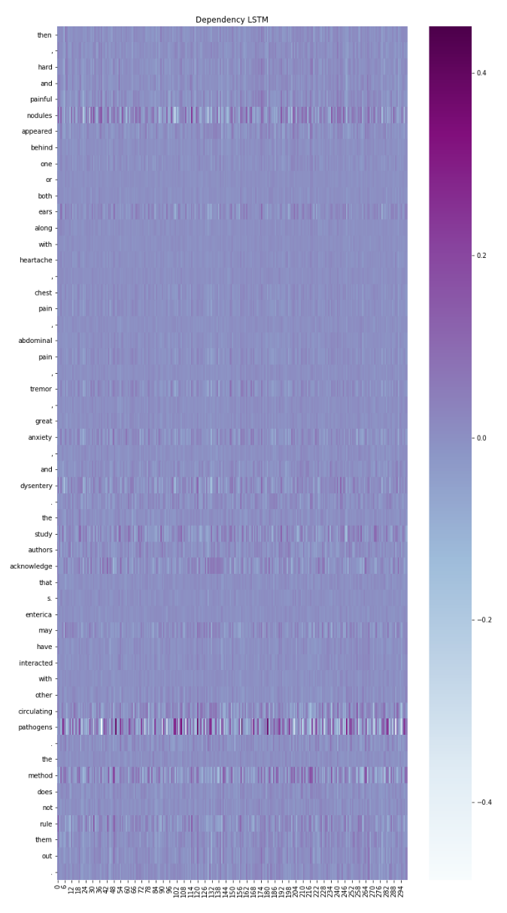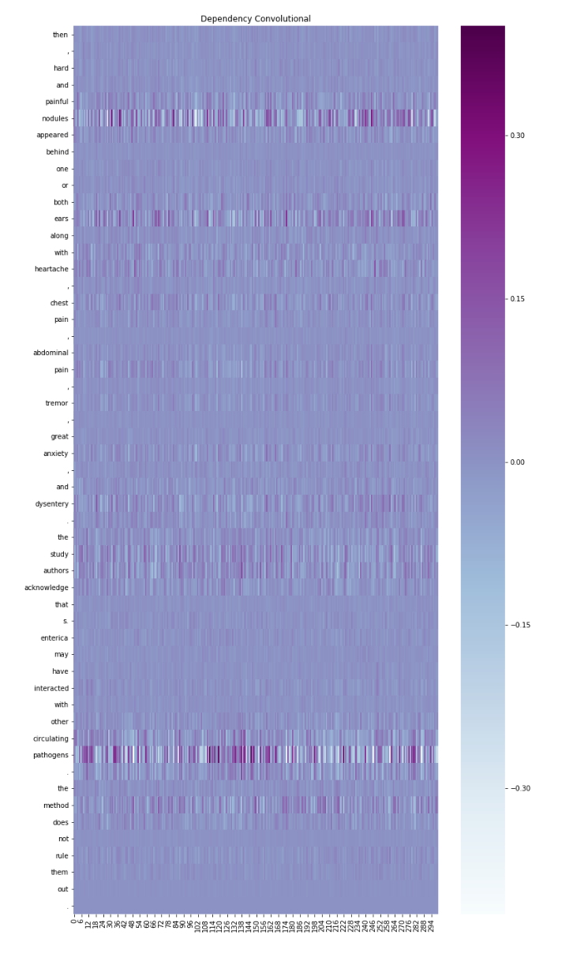
Figure7.88 Visualization of the relative importance of each word embedding and dimension to the final coherence score for the Dependency LSTM (LEFT) and Convolutional (RIGHT) models.

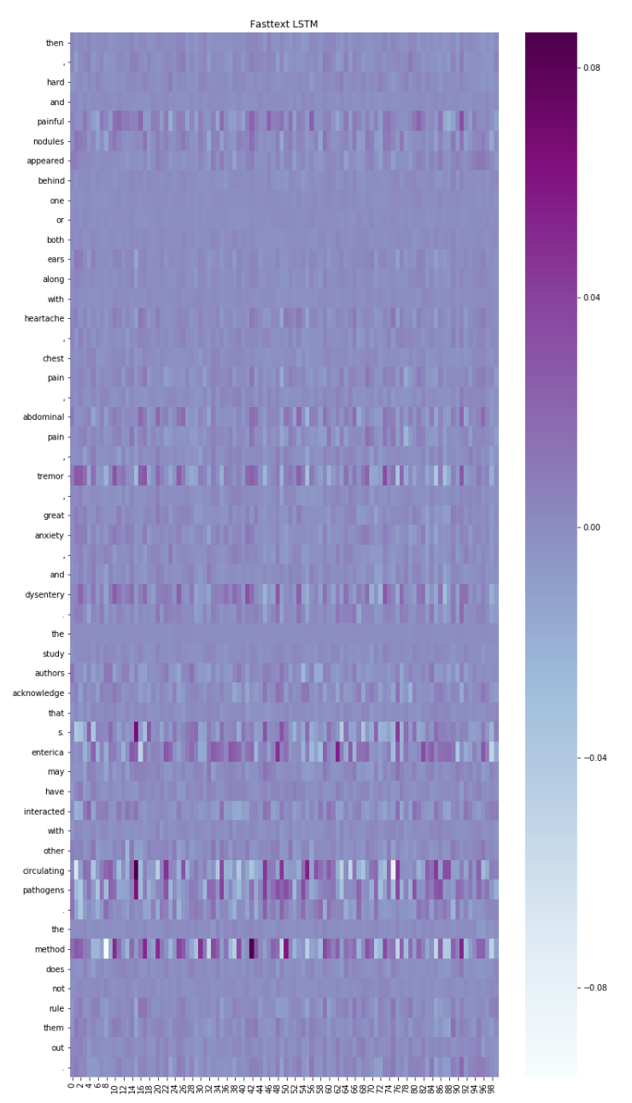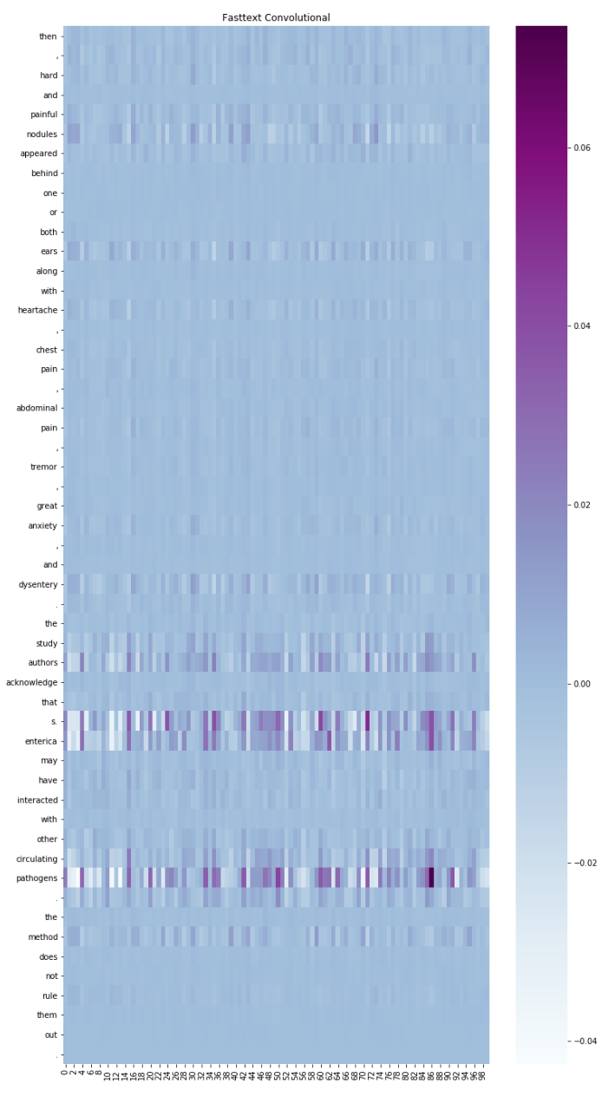
Figure7.89 Visualization of the relative importance of each word embedding and dimension to the final coherence score for the Fasttext LSTM (LEFT) and Convolutional (RIGHT) models.

Future Research
To build on the work done in this thesis, we envisage two main categories for future research: improving accuracy and evaluating performance on the work of students.
While our combined models did achieve fairly high accuracy, they are not yet at a level that could replace human evaluators reliably. To further improve accuracy, there are several things we could try. The simplest would be to expand the size of the training corpus so that the models can build a richer, more nuanced representation of English sequences. We could also train more models using the top performing word embeddings; the new models will not be exactly the same as the models we have trained here because of the random shuffling of the training examples and the randomness introduced by dropout. Averaging a larger group of models would probably improve accuracy.
We could also experiment with some of the latest techniques being introduced in the field of deep learning. For example, Sabour et al. (2017) have proposed an architecture called a capsule network. These networks improve on traditional convolutional networks by forcing them to pay more attention to word order in NLP tasks. Generative Adversarial models (GANs – Goodfellow et al., 2014) may also yield interesting results. GANs have two competing components, a generator and a discriminator. The discriminator has to learn how to distinguish between real input examples and input examples generated by the generator (the generator gets better at fooling the discriminator over time and the discriminator in turn, gets better at detecting the fakes). We could use the generator’s input instead of random replacement for coherence detection.
Applying our models to student evaluation will require a lot more testing. We cannot be sure if they will actually detect the types of errors students make because unlike our training examples, where the incoherent sequences often jump to completely different topics, students lose coherence when they fail to introduce new entities or when they do not make relationships between entities or sections of the discourse explicit.
We would also have to determine to what degree grammatical errors distort the results. If the student, for example, makes a verb tense error, we would hope there would be a slight drop in the coherence score but since a person familiar with the text’s context can usually make the necessary adjustments to maintain coherence in their mental representation, we would hope the sequence would still be judged coherent if there were no other coherence violations.

Conclusion
In this thesis, we explored the suitability of different neural network architectures and different word embeddings to the task of coherence detection.
We used sequences extracted from natural texts as positive examples of coherence and we used sequences with a randomly substituted sentence as negative examples to train the models. The objective of the neural networks was to provide a binary classification for each sequence.
We tested the classification accuracy of these models using a test corpus with sequences not seen during training. We also evaluated the models’ sensitivity to features such as pronoun coreference, temporal coherence and sentence ordering. We did this by comparing the coherence scores given by our models for coherent sequences and for those same sequences with minor modifications that should make them less coherent. Pronoun coreference and temporal coherence were tested by substituting a pronoun or a tensed verb in the sequence. For sentence ordering, we reversed the sentences in the sequences.
We compared recurrent and convolutional networks on coherence detection and found that recurrent networks outperformed convolutional networks. In addition, recurrent networks required less preprocessing (POS-tagging) to achieve superior accuracy.
Using both recurrent and convolutional networks, we evaluated five different types of word embeddings (for a total of ten different models): Word2vec, Fasttext, GloVe, Dependency and Numberbatch. In terms of classification accuracy, word2vec was the highest performing word embedding amongst the recurrent models and the dependency vectors gave the highest performance from amongst the convolutional models. All the models performed fairly well on coherence classification with scores between 81.2% and 82.7% for the convolutional models and between 83.2% and 85.44% for the recurrent models.
As for the sensitivity tests, the Numberbatch LSTM model had the best results for sequence ordering and the Dependency LSTM model had the best scores for both pronoun and tense substitution.
We also did some qualitative analysis of the models to gain insights into the way our models were representing sequences and how they were deciding whether a sequence was coherent or not. We examined the nearest neighbors of vectors extracted from intermediary layers of our models; these layers represented either sentences or sequences. Clusters in the semantic vector space suggest that the models are dividing sentences and sequences up based on topic rather than other criteria such as entity transition patterns.
To increase accuracy even further, we experimented with additional techniques using the output from our neural network models. One such technique was an ensembling method where we took the average of the coherence scores given by all models; this boosted the accuracy to 86.94% on the test corpus. When we only used the top performing models, this achieved an accuracy score of 87.1%
Another technique we tried involved concatenating the vectors from the penultimate layer from the recurrent networks and then feeding the combined embeddings into a support vector machine. This technique yielded an accuracy score of 87.2%.

Bibliography
- Baker, C. F., Fillmore, C. J., & Lowe, J. B. (1998). The berkeley framenet project. Proceedings of the 17th international conference on Computational linguistics-Volume 1, (pp. 86-90).
Bartunov, S., Kondrashkin, D., Osokin, A., & Vetrov, D. (2016). Breaking sticks and ambiguities with adaptive skip-gram. Artificial Intelligence and Statistics, (pp. 130-138).
Barzilay, R., & Lapata, M. (2008). Modeling local coherence: An entity-based approach. Computational Linguistics, 34, 1-34.
Barzilay, R., & Lee, L. (2004). Catching the drift: Probabilistic content models, with applications to generation and summarization. arXiv preprint cs/0405039.
Baum, L. E., & Petrie, T. (1966). Statistical inference for probabilistic functions of finite state Markov chains. The annals of mathematical statistics, 37, 1554-1563.
Bhande, A. (2018, March 11). What is underfitting and overfitting in machine learning and how to deal with it. Retrieved from Medium: https://medium.com/greyatom/what-is-underfitting-and-overfitting-in-machine-learning-and-how-to-deal-with-it-6803a989c76
Bloor, K. N.—T. (1991). Thematic progression in professional and popular medical texts. Functional and systemic linguistics: Approaches and uses, 55, 369.
Bojanowski, P., Grave, E., Joulin, A., & Mikolov, T. (2016). Enriching word vectors with subword information. arXiv preprint arXiv:1607.04606.
Cybenko, G. (1989). Approximation by superpositions of a sigmoidal function. Mathematics of control, signals and systems, 2, 303-314.
Danes, F. (1974). Functional sentence perspective and the organization of the text. Papers on functional sentence perspective, 106-128.
De Lathauwer, L., De Moor, B., & Vandewalle, J. (2000). A multilinear singular value decomposition. SIAM journal on Matrix Analysis and Applications, 21, 1253-1278.
Deerwester, S., Dumais, S. T., Furnas, G. W., Landauer, T. K., & Harshman, R. (1990). Indexing by latent semantic analysis. Journal of the American society for information science, 41, 391-407.
Dietterich, T. G. (2000). Ensemble methods in machine learning. International workshop on multiple classifier systems, (pp. 1-15).
Duchi, J., Hazan, E., & Singer, Y. (2011). Adaptive subgradient methods for online learning and stochastic optimization. Journal of Machine Learning Research, 12, 2121-2159.
Faruqui, M., Dodge, J., Jauhar, S. K., Dyer, C., Hovy, E., & Smith, N. A. (2014). Retrofitting word vectors to semantic lexicons. arXiv preprint arXiv:1411.4166.
Fei-Fei Li, J. J. (2018, April 12). Stanford cs231. Retrieved from Stanford.edu: http://cs231n.stanford.edu/slides/2018/cs231n_2018_lecture04.pdf
Fillmore, C. J., Johnson, C. R., & Petruck, M. R. (2003). Background to framenet. International journal of lexicography, 16, 235-250.
Foltz, P. W., Kintsch, W., & Landauer, T. K. (1998). The measurement of textual coherence with latent semantic analysis. Discourse processes, 25, 285-307.
Fortuner, B. (2017, March 7). Can networks really learn any functions? Retrieved from Towards Data Science: https://towardsdatascience.com/can-neural-networks-really-learn-any-function-65e106617fc6
Ganitkevitch, J., Van Durme, B., & Callison-Burch, C. (2013). PPDB: The paraphrase database. Proceedings of the 2013 Conference of the North American Chapter of the Association for Computational Linguistics: Human Language Technologies, (pp. 758-764).
Goodfellow, I., Pouget-Abadie, J., Mirza, M., Xu, B., Warde-Farley, D., Ozair, S., . . . Bengio, Y. (2014). Generative adversarial nets. Advances in neural information processing systems, (pp. 2672-2680).
Grosz, B. J., Weinstein, S., & Joshi, A. K. (1995). Centering: A framework for modeling the local coherence of discourse. Computational linguistics, 21, 203-225.
Halliday, M. A., & Hasan, R. (1976). Cohesion in English. Routledge.
Harris, Z. (1982). Discourse and sublanguage. Sublanguage: studies of language in restricted semantic domains, 231-236.
Hinton, G. E., Srivastava, N., Krizhevsky, A., Sutskever, I., & Salakhutdinov, R. R. (2012). Improving neural networks by preventing co-adaptation of feature detectors. arXiv preprint arXiv:1207.0580.
Hochreiter, S., & Schmidhuber, J. (1997). Long short-term memory. Neural computation, 9, 1735-1780.
Ioffe, S., & Szegedy, C. (2015). Batch normalization: Accelerating deep network training by reducing internal covariate shift. arXiv preprint arXiv:1502.03167.
Jolliffe, I. (2011). Principal component analysis. In International encyclopedia of statistical science (pp. 1094-1096). Springer.
Kalchbrenner, N., Grefenstette, E., & Blunsom, P. (2014). A convolutional neural network for modelling sentences. arXiv preprint arXiv:1404.2188.
Kameyama, M., Passonneau, R., & Poesio, M. (1993). Temporal centering. Proceedings of the 31st annual meeting on Association for Computational Linguistics, (pp. 70-77).
Karpathy, A. (2015, 05 21). The Unreasonable Effectiveness of Recurrent Neural Networks. Retrieved from Hacker's guide to neural networks: http://karpathy.github.io/2015/05/21/rnn-effectiveness/
Keskar, N. S., Mudigere, D., Nocedal, J., Smelyanskiy, M., & Tang, P. T. (2016). On large-batch training for deep learning: Generalization gap and sharp minima. arXiv preprint arXiv:1609.04836.
Kim, Y. (2014). Convolutional neural networks for sentence classification. arXiv preprint arXiv:1408.5882.
Kingma, D. P., & Ba, J. (2014). Adam: A method for stochastic optimization. arXiv preprint arXiv:1412.6980.
Kiros, R., Zhu, Y., Salakhutdinov, R. R., Zemel, R., Urtasun, R., Torralba, A., & Fidler, S. (2015). Skip-thought vectors. Advances in neural information processing systems, (pp. 3294-3302).
Lebret, R., & Collobert, R. (2013). Word emdeddings through hellinger PCA. arXiv preprint arXiv:1312.5542.
LeCun, Y., Haffner, P., Bottou, L., & Bengio, Y. (1999). Object recognition with gradient-based learning. In Shape, contour and grouping in computer vision (pp. 319-345). Springer.
Lee, D. D., & Seung, H. S. (2001). Algorithms for non-negative matrix factorization. Advances in neural information processing systems, (pp. 556-562).
Levy, O., & Goldberg, Y. (2014). Dependency-based word embeddings. Proceedings of the 52nd Annual Meeting of the Association for Computational Linguistics (Volume 2: Short Papers), 2, pp. 302-308.
Li, J., & Hovy, E. (2014). A model of coherence based on distributed sentence representation. Proceedings of the 2014 Conference on Empirical Methods in Natural Language Processing (EMNLP), (pp. 2039-2048).
Li, J., Chen, X., Hovy, E., & Jurafsky, D. (2015). Visualizing and understanding neural models in NLP. arXiv preprint arXiv:1506.01066.
Ling, W., Lu{\'\i}s, T., Marujo, L., Astudillo, R. F., Amir, S., Dyer, C., . . . Trancoso, I. (2015). Finding function in form: Compositional character models for open vocabulary word representation. arXiv preprint arXiv:1508.02096.
Linnainmaa, S. (1976). Taylor expansion of the accumulated rounding error. BIT Numerical Mathematics, 16, 146-160.
Louis, A., & Nenkova, A. (2009). Automatically evaluating content selection in summarization without human models. Proceedings of the 2009 Conference on Empirical Methods in Natural Language Processing: Volume 1-Volume 1, (pp. 306-314).
Maaten, L. v., & Hinton, G. (2008). Visualizing data using t-SNE. Journal of machine learning research, 9, 2579-2605.
Mann, W. C., & Thompson, S. A. (1988). Rhetorical structure theory: Toward a functional theory of text organization. Text-Interdisciplinary Journal for the Study of Discourse, 8, 243-281.
Manning, C. D., Surdeanu, M., Bauer, J., Finkel, J., Bethard, S. J., & McClosky, D. (2014). The Stanford CoreNLP Natural Language Processing Toolkit. Association for Computational Linguistics (ACL) System Demonstrations, (pp. 55-60). Retrieved from http://www.aclweb.org/anthology/P/P14/P14-5010
McCann, B., Bradbury, J., Xiong, C., & Socher, R. (2017). Learned in translation: Contextualized word vectors. Advances in Neural Information Processing Systems, (pp. 6294-6305).
Mikolov, T., Chen, K., Corrado, G., & Dean, J. (2013). Efficient estimation of word representations in vector space. arXiv preprint arXiv:1301.3781.
Mikolov, T., Sutskever, I., Chen, K., Corrado, G. S., & Dean, J. (2013). Distributed representations of words and phrases and their compositionality. Advances in neural information processing systems, (pp. 3111-3119).
Mikolov, T., Yih, W.-t., & Zweig, G. (2013). Linguistic regularities in continuous space word representations. Proceedings of the 2013 Conference of the North American Chapter of the Association for Computational Linguistics: Human Language Technologies, (pp. 746-751).
Miller, G. A. (1995). WordNet: a lexical database for English. Communications of the ACM, 38, 39-41.
Olah, C. (2015, August 27). Understanding LSTM Networks. Retrieved from Colah: http://colah.github.io/posts/2015-08-Understanding-LSTMs/
Pennington, J., Socher, R., & Manning, C. (2014). Glove: Global vectors for word representation. Proceedings of the 2014 conference on empirical methods in natural language processing (EMNLP), (pp. 1532-1543).
Pitler, E., Louis, A., & Nenkova, A. (2009). Automatic sense prediction for implicit discourse relations in text. Proceedings of the Joint Conference of the 47th Annual Meeting of the ACL and the 4th International Joint Conference on Natural Language Processing of the AFNLP: Volume 2-Volume 2, (pp. 683-691).
Raschka, S. (2014). Gradient Descent and Stochastic Gradient Descent. Retrieved from Github: https://rasbt.github.io/mlxtend/user_guide/general_concepts/gradient-optimization/
Rehurek, R., & Sojka, P. (2010, 5 22). Software Framework for Topic Modelling with Large Corpora. {Proceedings of the LREC 2010 Workshop on New Challenges for NLP Frameworks} (pp. 45-50). Valletta: ELRA.
Rohde, D. L., Gonnerman, L. M., & Plaut, D. C. (2006). An improved model of semantic similarity based on lexical co-occurrence. Communications of the ACM, 8, 116.
Rosenblatt, F. (1958). The perceptron: a probabilistic model for information storage and organization in the brain. Psychological review, 65, 386.
Sabour, S., Frosst, N., & Hinton, G. E. (2017). Dynamic routing between capsules. Advances in Neural Information Processing Systems, (pp. 3856-3866).
Schuster, M., & Paliwal, K. K. (1997). Bidirectional recurrent neural networks. IEEE Transactions on Signal Processing, 45, 2673-2681.
Sidner, C. (1983). Focusing in the comprehension of definite anaphora. Computational models of discourse, 267-330.
Socher, R., Lin, C. C., Manning, C., & Ng, A. Y. (2011). Parsing natural scenes and natural language with recursive neural networks. Proceedings of the 28th international conference on machine learning (ICML-11), (pp. 129-136).
Speer, R., & Havasi, C. (2012). Representing General Relational Knowledge in ConceptNet 5. LREC, (pp. 3679-3686).
Speer, R., Chin, J., & Havasi, C. (2017). ConceptNet 5.5: An Open Multilingual Graph of General Knowledge. AAAI, (pp. 4444-4451).
Srivastava, N., Hinton, G., Krizhevsky, A., Sutskever, I., & Salakhutdinov, R. (2014). Dropout: a simple way to prevent neural networks from overfitting. The Journal of Machine Learning Research, 15, 1929-1958.
Stanford, D. L. (2013). Feature extraction using convolution. Retrieved from Deeplearning.stanford.edu: http://deeplearning.stanford.edu/wiki/index.php/Feature_extraction_using_convolution
Sutskever, I., Martens, J., & Hinton, G. E. (2011). Generating text with recurrent neural networks. Proceedings of the 28th International Conference on Machine Learning (ICML-11), (pp. 1017-1024).
Thompson, S. A., & Mann, W. C. (1987). Rhetorical structure theory. IPRA Papers in Pragmatics, 1, 79-105.
Tieleman, T., & Hinton, G. (2012). Lecture 6.5-rmsprop: Divide the gradient by a running average of its recent magnitude. COURSERA: Neural networks for machine learning, 4, 26-31.
Zeiler, M. D., & Fergus, R. (2014). Visualizing and understanding convolutional networks. European conference on computer vision, (pp. 818-833).

Our expectation was that these texts, written by professional authors and having undergone the copywriting process, will be coherent.
This technique had a significant effect on the convolutional model during early tests when we were working with a smaller corpus and the effect was insignificant on the LSTM model. Tests on our final larger corpus show that the reduction in overfitting due to part of speech embeddings was much smaller for the convolution model than it had originally been, but they also showed a slight improvement to the LSTM model. Time constraints did not allow for us to retrain all LSTM models with POS embeddings, but this could help boost accuracy.
Generating random permutations, that is to say rearranging sentences from the same text, is commonly used to train and evaluate coherence detection models (e.g. Brazilay and Lapata, 2008). This usually involves taking random sentences from anywhere in the text, but here we chose to limit the permutations to consecutive sentences to increase the probability of seeing semantic overlap.
https://projector.tensorflow.org/

