**MODELOS Y BASES DE DATOS**

**LABORATORIO 2**

**PARTE UNO. Refactorización**

1. **MODELO CONCEPTUAL**
2. **Se corrigieron las multiplicidades y se añadieron los nombres de las relaciones.**

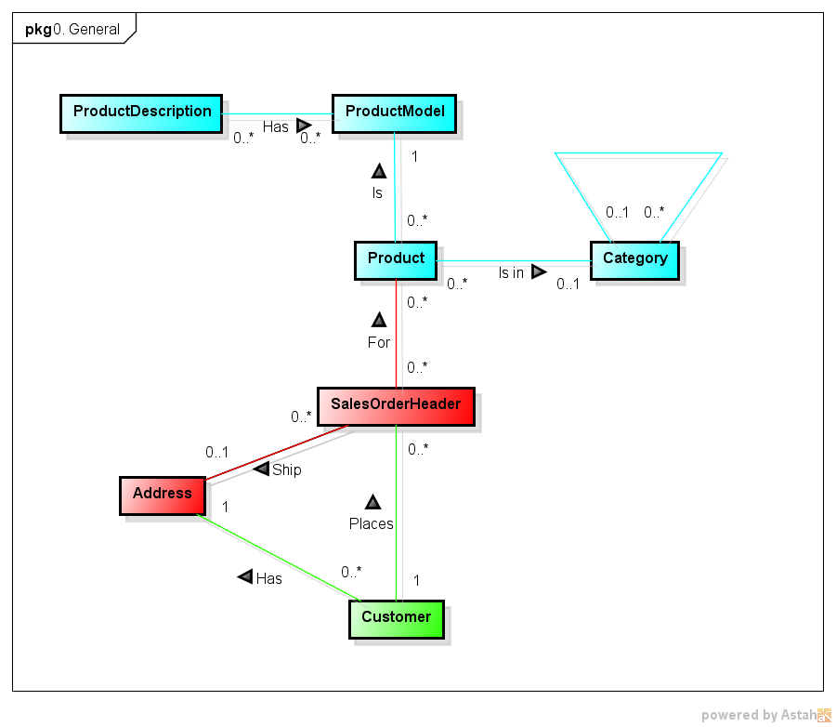

1. **MODELO LOGICO**
2. Se diferenciaron las PK´s y FK´s

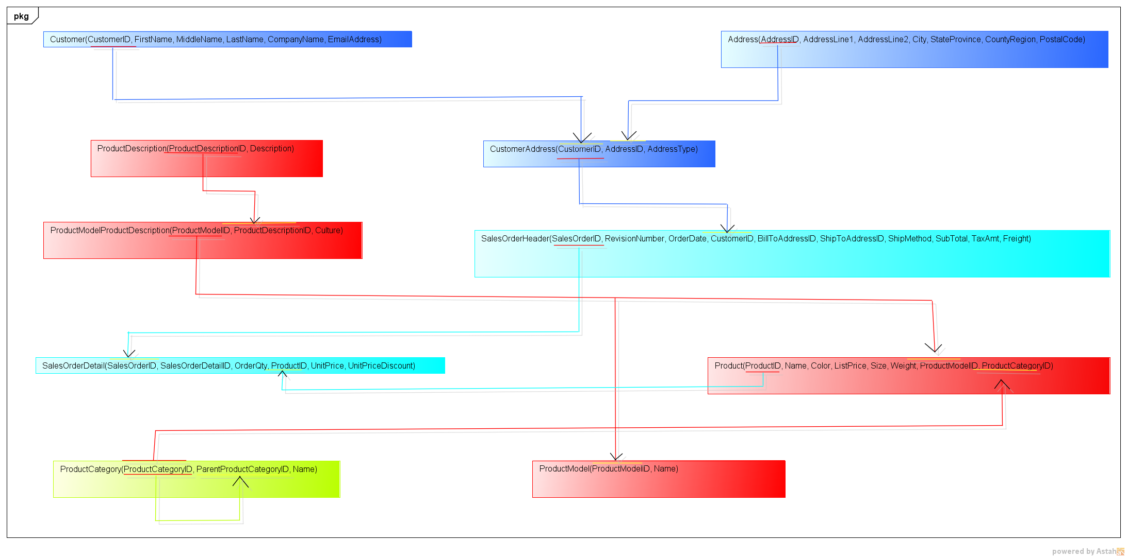**PARTE CUATRO**

**1**

|  |
| --- |
| **SELECT** |
|  | **Customer.CompanyName,** |
|  | **SalesOrderHeader.SubTotal,** |
|  | **SUM(SalesOrderDetail.OrderQty * Product.weight)** |
|  | **FROM** |
|  | **Product** |
|  | **JOIN** |
|  | **SalesOrderDetail** |
|  | **ON Product.ProductID = SalesOrderDetail.ProductID** |
|  | **JOIN** |
|  | **SalesOrderHeader** |
|  | **ON SalesOrderDetail.SalesOrderID = SalesOrderHeader.SalesorderID** |
|  | **JOIN** |
|  | **Customer** |
|  | **ON SalesOrderHeader.CustomerID = Customer.CustomerID** |
|  | **GROUP BY** |
|  | **SalesOrderHeader.SalesOrderID, SalesOrderHeader.SubTotal, Customer.CompanyName** |
|  | **ORDER BY** |
|  | **SalesOrderHeader.SubTotal DESC** |

**2**

|  |
| --- |
|  |
| **SELECT** |
|  | **Address.CountyRegion,** |
|  | **SUM(SubTotal)** |
|  | **FROM** |
|  | **SalesOrderHeader** |
|  | **JOIN** |
|  | **Address** |
|  | **ON SalesOrderHeader.ShipToAddressID = Address.AddressID** |
|  | **GROUP BY** |
|  | **Address.CountyRegion** |
|  | **ORDER BY** |
|  | **SUM(SubTotal) DESC;** |
|  |  |