# DAFTAR LAMPIRAN

DAFTAR LAMPIRAN ix

LAMPIRAN A ACTIVITY DIAGRAM A-1

LAMPIRAN B SEQUENCE DIAGRAM B-1

LAMPIRAN C DATA PENILAIAN PENGGUNA C-1

LAMPIRAN D DATA PENGUJIAN D-1

# ACTIVITY DIAGRAM

Rincian tiap *activity diagram* tersebut adalah sebagai berikut :

1. *Activity diagram* menambahkan produk baru

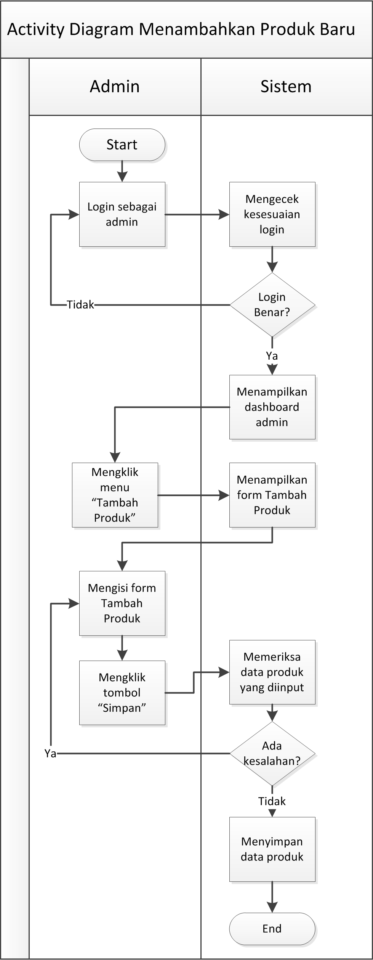

1. *Activity diagram* menambahkan resep baru

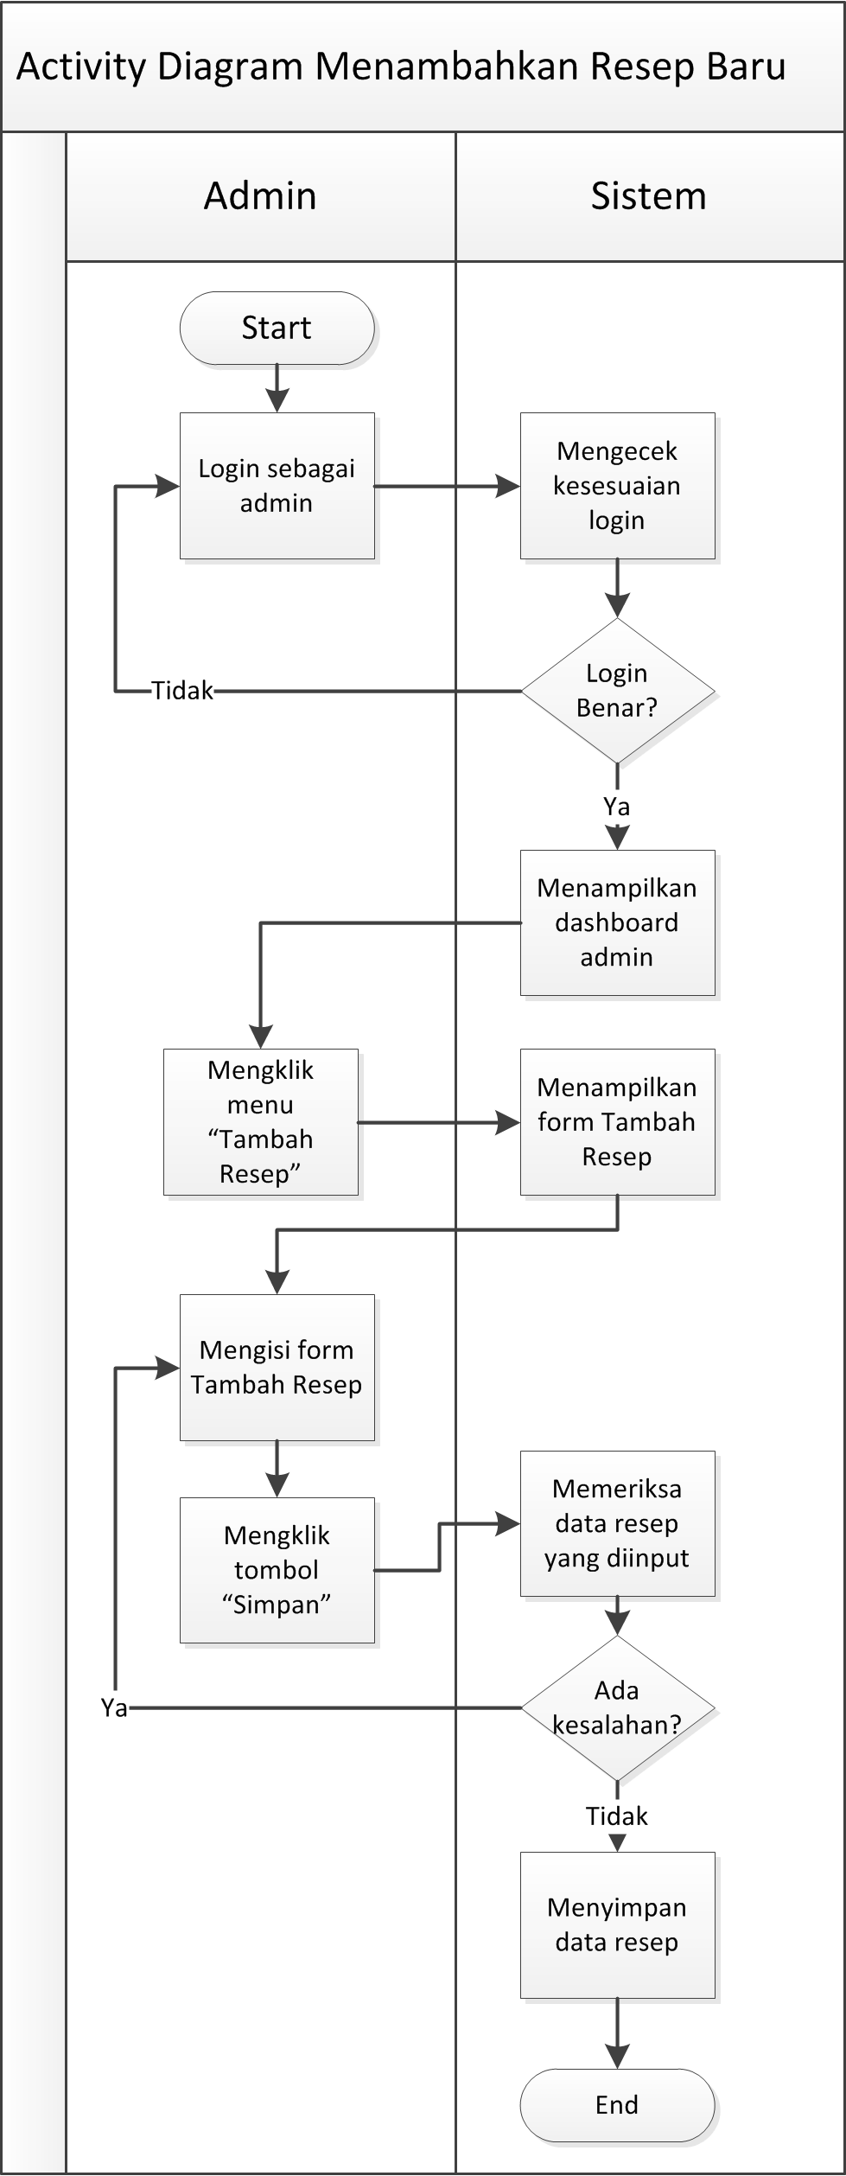

1. *Activity diagram* mengubah data produk

**

1. *Activity diagram* mengubah data resep

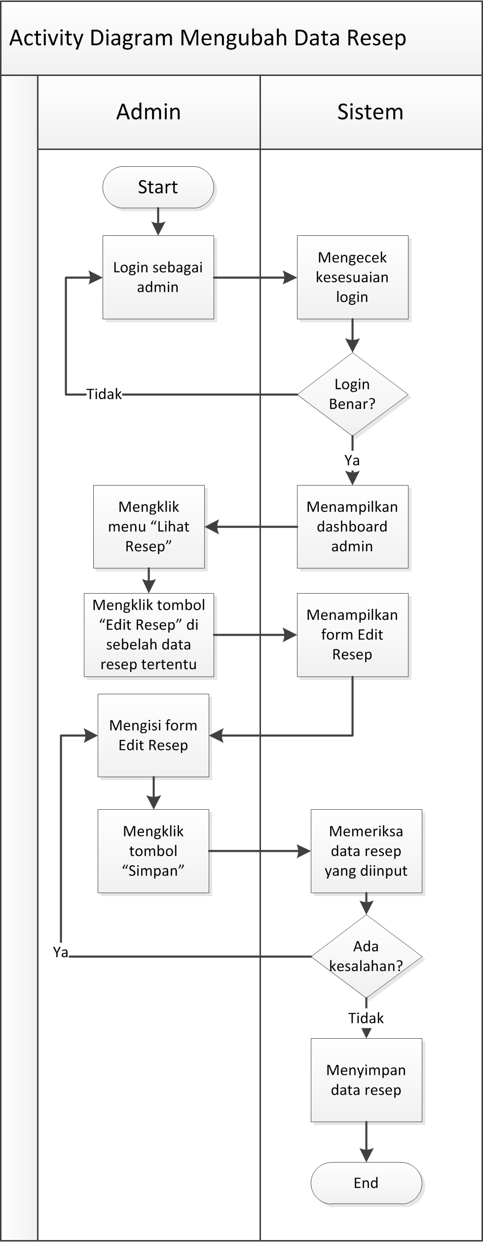

1. *Activity diagram* pendaftaran pengguna

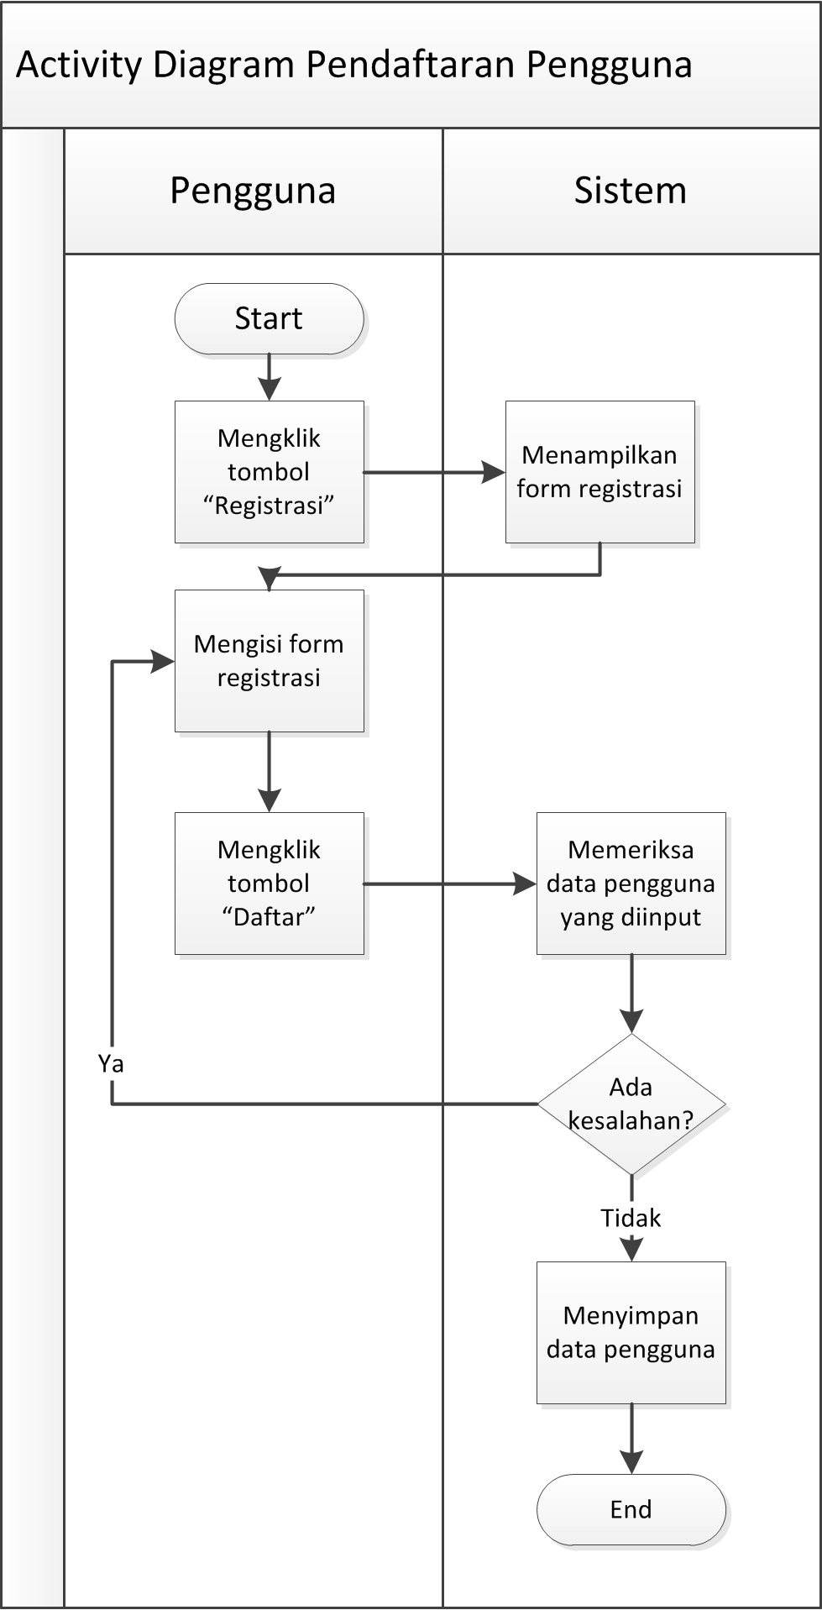

1. *Activity diagram* pembelian produk

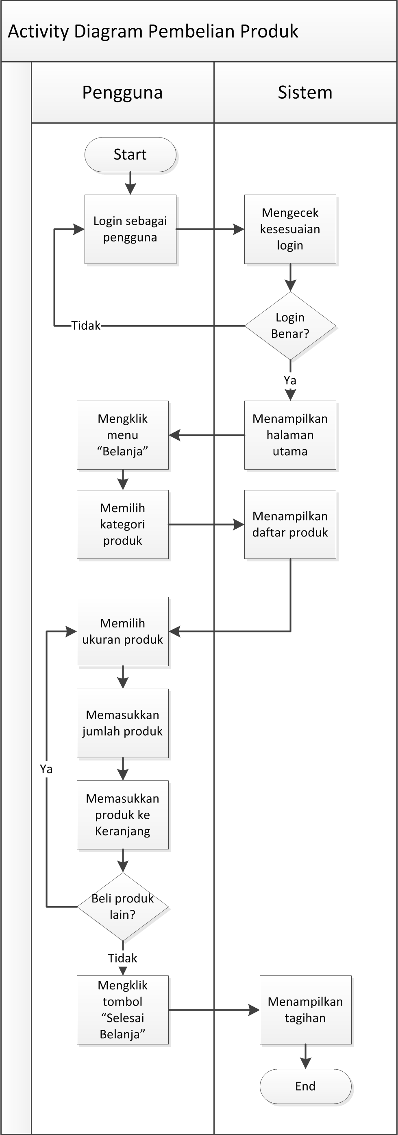

1. *Activity diagram* pencarian resep

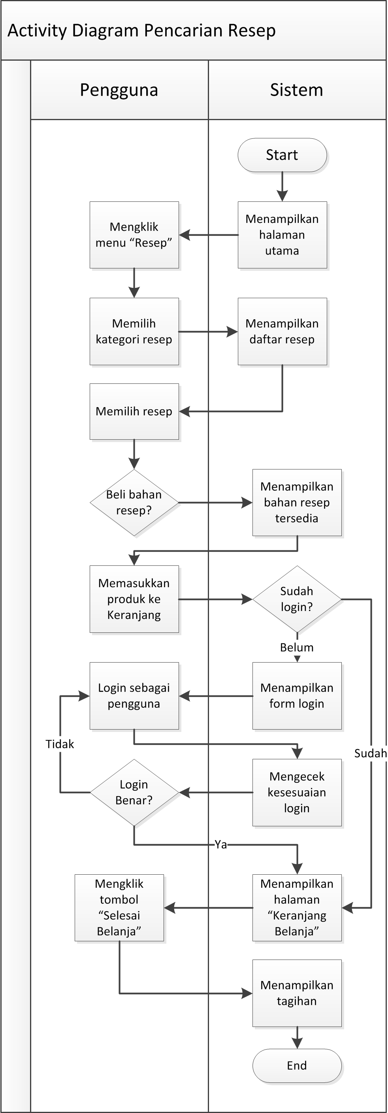

1. *Activity diagram* pemberian *rating*

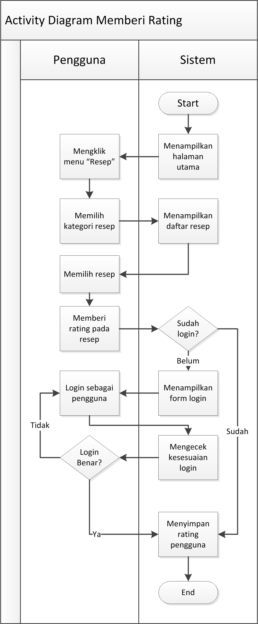

1. *Activity diagram* *generate similarity* resep

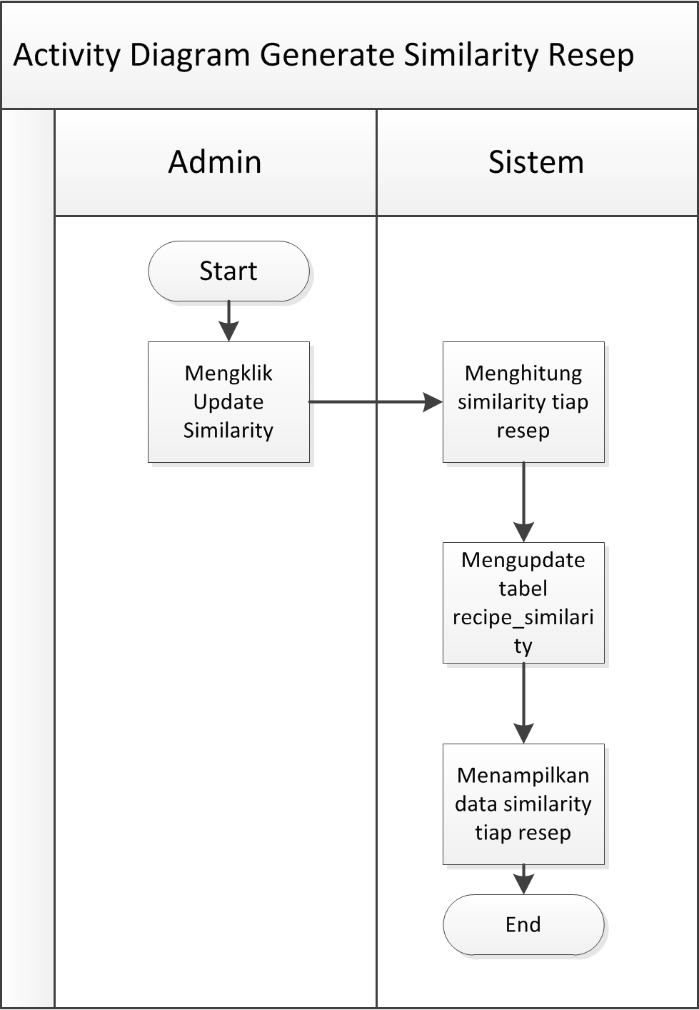

1. *Activity diagram* penentuan rekomendasi

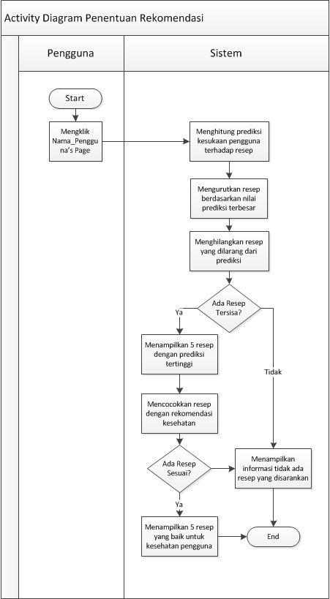

# SEQUENCE DIAGRAM

Rincian tiap *sequence diagram* tersebut adalah sebagai berikut :

1. *Sequence diagram* login admin

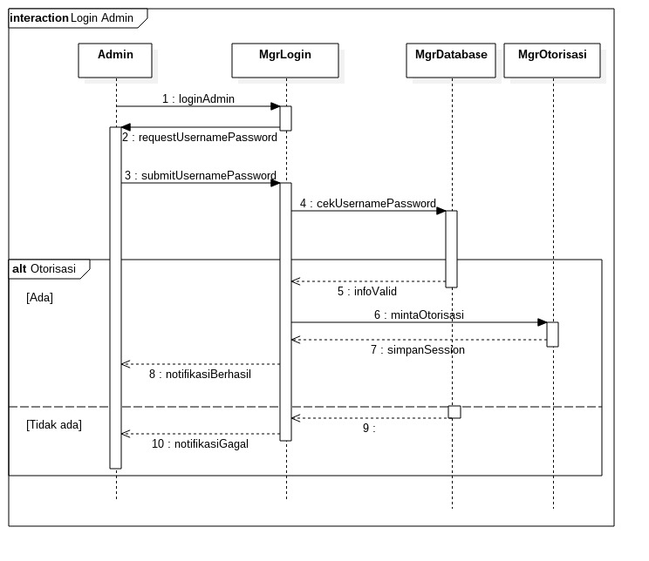

1. *Sequence diagram* menambahkan produk baru

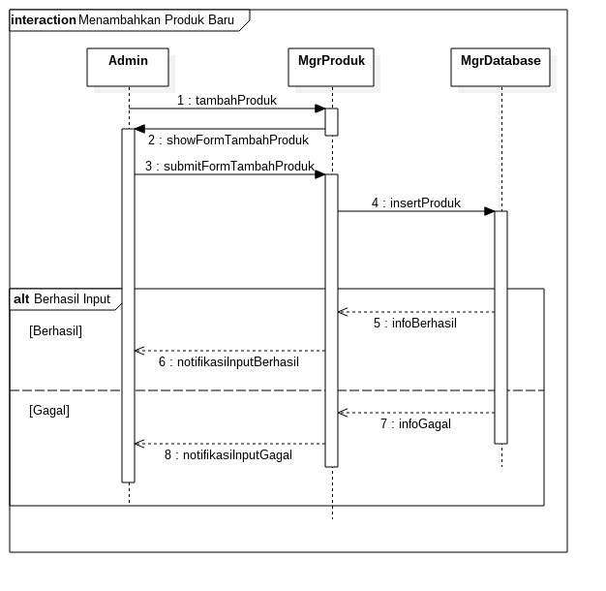

1. *Sequence diagram* menambakan resep baru

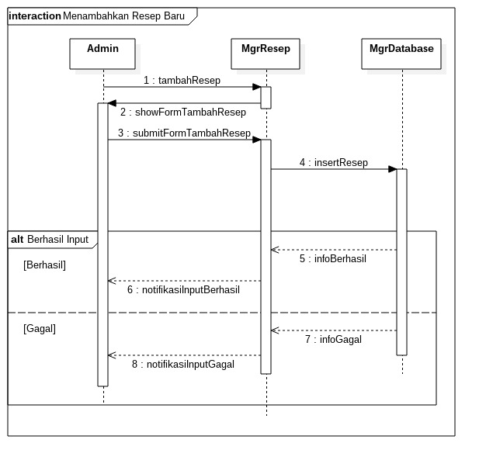

1. *Sequence diagram* mengubah data produk

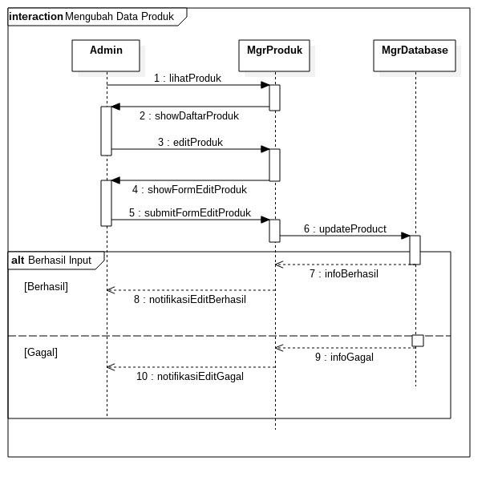

1. *Sequence diagram* mengubah data resep

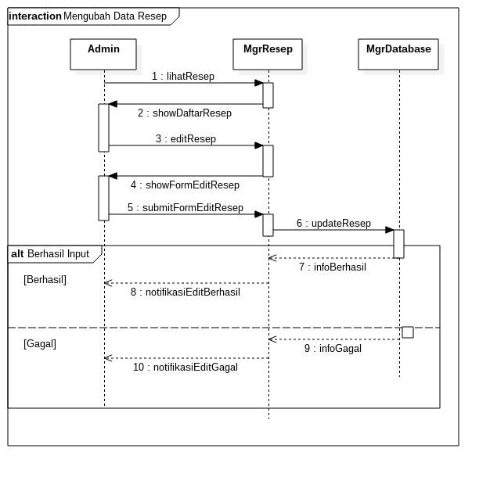

1. *Sequence diagram* pendaftaran pengguna

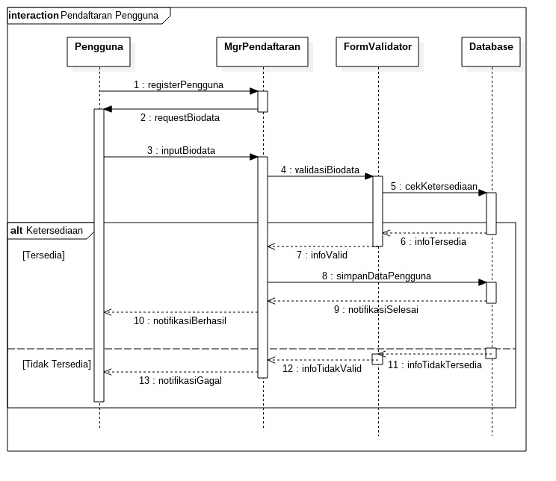

1. *Sequence diagram* pembelian produk

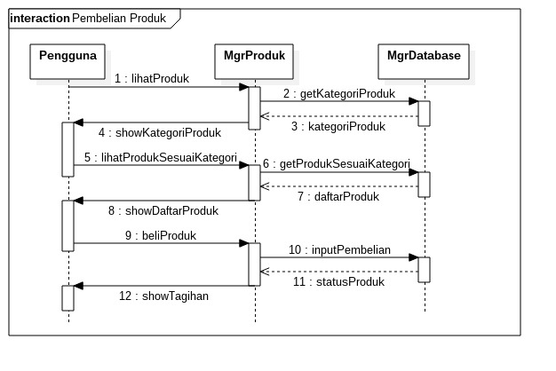

1. *Sequence diagram* pencarian resep

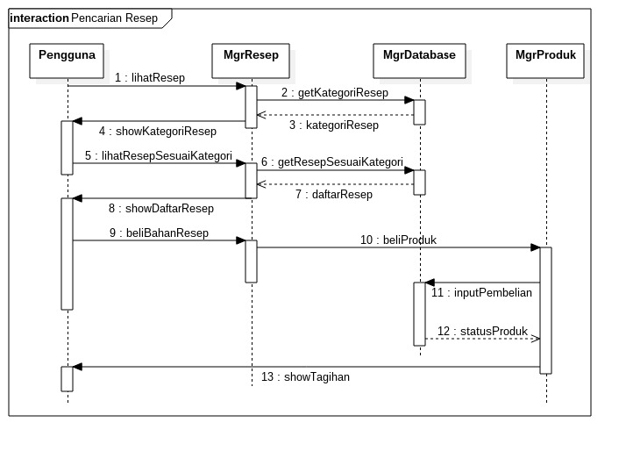

1. *Sequence diagram* memberi *rating*

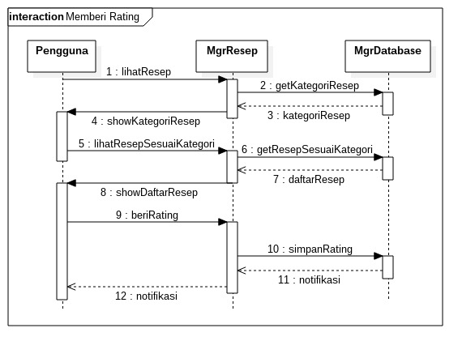

1. *Sequence diagram generate similarity*

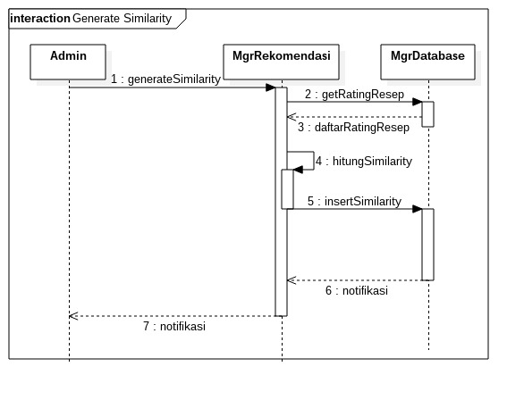

1. *Sequence diagram* penentuan rekomendasi

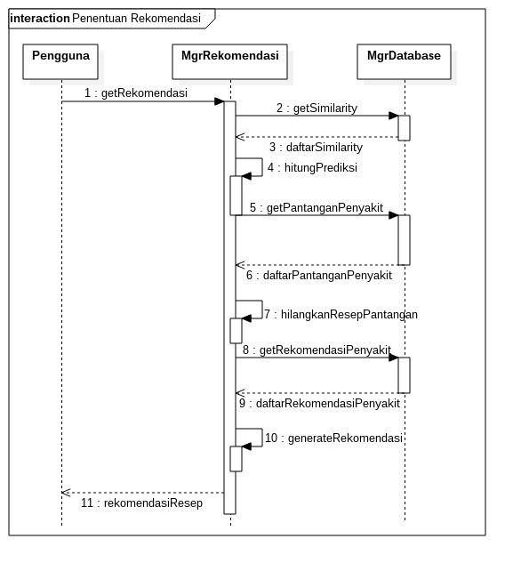

# DATA PENILAIAN PENGGUNA

Data penilaian pengguna merupakan data penilaian yang diberikan oleh penguna terhadap resep yang ada. Data penilaian pengguna dibagi atas data untuk pembelajaran sistem rekomendasi serta data untuk pengetesan sistem rekomendasi.

1. Data pembelajaran sistem rekomendasi

Data ini digunakan untuk menghasilkan nilai *similarity* antar resep serta prediksi terhadap penilaian resep yang ada pada set data pengetesan.

| Rating_id | Customer_Id | Recipe_id | Rating |
| --- | --- | --- | --- |
| 1 | 1 | 31 | 3 |
| 2 | 1 | 32 | 1 |
| 3 | 1 | 33 | 2 |
| 4 | 1 | 34 | 2 |
| 5 | 1 | 35 | 3 |
| 6 | 1 | 36 | 2 |
| 7 | 1 | 37 | 2 |
| 8 | 1 | 38 | 1 |
| 9 | 1 | 39 | 1 |
| 10 | 1 | 40 | 4 |
| 11 | 1 | 41 | 4 |
| 12 | 1 | 42 | 4 |
| 13 | 1 | 43 | 5 |
| 14 | 2 | 31 | 4 |
| 15 | 2 | 32 | 3 |
| 16 | 2 | 33 | 2 |
| 17 | 2 | 34 | 2 |
| 18 | 2 | 35 | 2 |
| 19 | 2 | 36 | 3 |
| 20 | 2 | 37 | 2 |
| 21 | 2 | 38 | 2 |
| 22 | 2 | 39 | 4 |
| 23 | 2 | 40 | 2 |
| 24 | 3 | 15 | 1 |
| 25 | 3 | 16 | 1 |
| 26 | 3 | 17 | 1 |
| 27 | 3 | 18 | 1 |
| 28 | 3 | 19 | 2 |
| 29 | 3 | 20 | 1 |
| 30 | 3 | 21 | 2 |
| 31 | 3 | 22 | 2 |
| 32 | 3 | 23 | 1 |
| 33 | 3 | 24 | 1 |
| 34 | 4 | 6 | 5 |
| 35 | 4 | 7 | 5 |
| 36 | 4 | 8 | 4 |
| 37 | 4 | 9 | 3 |
| 38 | 4 | 10 | 4 |
| 39 | 4 | 11 | 5 |
| 40 | 4 | 12 | 3 |
| 41 | 4 | 13 | 2 |
| 42 | 5 | 1 | 4 |
| 43 | 5 | 2 | 5 |
| 44 | 5 | 3 | 5 |
| 45 | 5 | 4 | 3 |
| 46 | 5 | 5 | 3 |
| 47 | 5 | 6 | 3 |
| 48 | 5 | 7 | 4 |
| 49 | 5 | 8 | 2 |
| 50 | 5 | 9 | 3 |
| 51 | 5 | 10 | 5 |
| 52 | 5 | 11 | 1 |
| 53 | 5 | 12 | 3 |
| 54 | 5 | 13 | 3 |
| 55 | 5 | 14 | 4 |
| 56 | 5 | 15 | 3 |
| 57 | 5 | 16 | 4 |
| 58 | 5 | 17 | 4 |
| 59 | 5 | 18 | 3 |
| 60 | 5 | 19 | 5 |
| 61 | 5 | 20 | 2 |
| 62 | 5 | 21 | 2 |
| 63 | 5 | 22 | 5 |
| 64 | 5 | 23 | 4 |
| 65 | 5 | 24 | 5 |
| 66 | 5 | 25 | 3 |
| 67 | 5 | 26 | 4 |
| 68 | 5 | 27 | 4 |
| 69 | 5 | 28 | 4 |
| 70 | 5 | 29 | 3 |
| 71 | 5 | 30 | 3 |
| 72 | 5 | 31 | 5 |
| 73 | 5 | 32 | 2 |
| 74 | 5 | 33 | 3 |
| 75 | 5 | 34 | 4 |
| 76 | 5 | 35 | 5 |
| 77 | 5 | 36 | 5 |
| 78 | 5 | 37 | 4 |
| 79 | 5 | 38 | 3 |
| 80 | 5 | 39 | 4 |
| 81 | 5 | 40 | 4 |
| 82 | 5 | 41 | 2 |
| 83 | 5 | 42 | 4 |
| 84 | 5 | 43 | 5 |
| 85 | 5 | 29 | 3 |
| 86 | 6 | 1 | 3 |
| 87 | 6 | 2 | 2 |
| 88 | 6 | 3 | 4 |
| 89 | 6 | 4 | 4 |
| 90 | 6 | 5 | 3 |
| 91 | 6 | 6 | 5 |
| 92 | 6 | 7 | 4 |
| 93 | 6 | 8 | 5 |
| 94 | 6 | 9 | 3 |
| 95 | 6 | 10 | 2 |
| 96 | 6 | 11 | 5 |
| 97 | 6 | 12 | 1 |
| 98 | 6 | 13 | 2 |
| 99 | 6 | 14 | 2 |
| 100 | 6 | 15 | 1 |
| 101 | 6 | 16 | 1 |
| 102 | 6 | 17 | 4 |
| 103 | 6 | 18 | 5 |
| 104 | 6 | 19 | 5 |
| 105 | 6 | 20 | 2 |
| 106 | 6 | 21 | 5 |
| 107 | 6 | 22 | 5 |
| 108 | 6 | 23 | 3 |
| 109 | 6 | 24 | 5 |
| 110 | 6 | 25 | 2 |
| 111 | 6 | 26 | 4 |
| 112 | 6 | 27 | 5 |
| 113 | 6 | 28 | 5 |
| 114 | 6 | 29 | 4 |
| 115 | 6 | 30 | 2 |
| 116 | 6 | 31 | 4 |
| 117 | 6 | 32 | 2 |
| 118 | 6 | 33 | 3 |
| 119 | 6 | 34 | 3 |
| 120 | 6 | 35 | 4 |
| 121 | 6 | 36 | 4 |
| 122 | 6 | 37 | 1 |
| 123 | 6 | 38 | 1 |
| 124 | 6 | 39 | 1 |
| 125 | 6 | 40 | 5 |
| 126 | 6 | 41 | 3 |
| 127 | 6 | 42 | 4 |
| 128 | 6 | 43 | 4 |
| 129 | 7 | 1 | 5 |
| 130 | 7 | 2 | 4 |
| 131 | 7 | 3 | 4 |
| 132 | 7 | 4 | 4 |
| 133 | 7 | 5 | 3 |
| 134 | 7 | 6 | 5 |
| 135 | 7 | 7 | 3 |
| 136 | 7 | 8 | 4 |
| 137 | 7 | 9 | 4 |
| 138 | 7 | 10 | 3 |
| 139 | 7 | 11 | 5 |
| 140 | 7 | 12 | 4 |
| 141 | 7 | 13 | 4 |
| 142 | 7 | 14 | 3 |
| 143 | 7 | 15 | 4 |
| 144 | 7 | 16 | 4 |
| 145 | 7 | 17 | 3 |
| 146 | 7 | 18 | 4 |
| 147 | 7 | 19 | 4 |
| 148 | 7 | 20 | 3 |
| 149 | 7 | 21 | 3 |
| 150 | 7 | 22 | 4 |
| 151 | 7 | 23 | 4 |
| 152 | 7 | 24 | 4 |
| 153 | 7 | 25 | 5 |
| 154 | 7 | 26 | 4 |
| 155 | 7 | 27 | 5 |
| 156 | 7 | 28 | 5 |
| 157 | 7 | 29 | 5 |
| 158 | 7 | 30 | 3 |
| 159 | 7 | 31 | 5 |
| 160 | 7 | 32 | 3 |
| 161 | 7 | 33 | 4 |
| 162 | 7 | 34 | 4 |
| 163 | 7 | 35 | 4 |
| 164 | 7 | 36 | 5 |
| 165 | 7 | 37 | 4 |
| 166 | 7 | 38 | 4 |
| 167 | 7 | 39 | 4 |
| 168 | 7 | 40 | 5 |
| 169 | 7 | 41 | 5 |
| 170 | 7 | 42 | 5 |
| 171 | 7 | 43 | 5 |
| 172 | 8 | 1 | 4 |
| 173 | 8 | 2 | 4 |
| 174 | 8 | 3 | 4 |
| 175 | 8 | 4 | 3 |
| 176 | 8 | 5 | 3 |
| 177 | 8 | 6 | 3 |
| 178 | 8 | 7 | 3 |
| 179 | 8 | 8 | 4 |
| 180 | 8 | 9 | 5 |
| 181 | 8 | 10 | 2 |
| 182 | 8 | 11 | 3 |
| 183 | 8 | 12 | 3 |
| 184 | 8 | 13 | 3 |
| 185 | 8 | 14 | 2 |
| 186 | 8 | 15 | 2 |
| 187 | 8 | 16 | 2 |
| 188 | 8 | 17 | 2 |
| 189 | 8 | 18 | 3 |
| 190 | 8 | 19 | 4 |
| 191 | 8 | 20 | 3 |
| 192 | 8 | 21 | 3 |
| 193 | 8 | 22 | 4 |
| 194 | 8 | 23 | 3 |
| 195 | 8 | 24 | 4 |
| 196 | 8 | 25 | 3 |
| 197 | 8 | 26 | 3 |
| 198 | 8 | 27 | 4 |
| 199 | 8 | 28 | 3 |
| 200 | 8 | 29 | 3 |
| 201 | 8 | 30 | 2 |
| 202 | 8 | 31 | 2 |
| 203 | 8 | 32 | 2 |
| 204 | 8 | 33 | 3 |
| 205 | 8 | 34 | 2 |
| 206 | 8 | 35 | 2 |
| 207 | 8 | 36 | 3 |
| 208 | 8 | 37 | 3 |
| 209 | 8 | 38 | 3 |
| 210 | 8 | 39 | 3 |
| 211 | 8 | 40 | 3 |
| 212 | 8 | 41 | 3 |
| 213 | 8 | 42 | 3 |
| 214 | 8 | 43 | 5 |
| 215 | 10 | 1 | 3 |
| 216 | 10 | 2 | 4 |
| 217 | 10 | 3 | 4 |
| 218 | 10 | 4 | 3 |
| 219 | 10 | 5 | 3 |
| 220 | 10 | 6 | 5 |
| 221 | 10 | 7 | 4 |
| 222 | 10 | 8 | 4 |
| 223 | 10 | 9 | 4 |
| 224 | 10 | 10 | 3 |
| 225 | 10 | 11 | 4 |
| 226 | 10 | 12 | 3 |
| 227 | 10 | 13 | 3 |
| 228 | 10 | 14 | 3 |
| 229 | 10 | 15 | 4 |
| 230 | 10 | 16 | 3 |
| 231 | 10 | 17 | 3 |
| 232 | 10 | 18 | 4 |
| 233 | 10 | 19 | 4 |
| 234 | 10 | 20 | 4 |
| 235 | 10 | 21 | 5 |
| 236 | 10 | 22 | 4 |
| 237 | 10 | 23 | 4 |
| 238 | 10 | 24 | 3 |
| 239 | 10 | 25 | 3 |
| 240 | 10 | 26 | 3 |
| 241 | 10 | 27 | 4 |
| 242 | 10 | 28 | 5 |
| 243 | 10 | 29 | 4 |
| 244 | 10 | 30 | 4 |
| 245 | 10 | 31 | 3 |
| 246 | 10 | 32 | 3 |
| 247 | 10 | 33 | 4 |
| 248 | 10 | 34 | 5 |
| 249 | 10 | 35 | 3 |
| 250 | 10 | 36 | 3 |
| 251 | 10 | 37 | 3 |
| 252 | 10 | 38 | 3 |
| 253 | 10 | 39 | 3 |
| 254 | 10 | 40 | 5 |
| 255 | 10 | 41 | 5 |
| 256 | 10 | 42 | 5 |
| 257 | 10 | 43 | 5 |
| 258 | 12 | 1 | 4 |
| 259 | 12 | 2 | 2 |
| 260 | 12 | 3 | 5 |
| 261 | 12 | 4 | 4 |
| 262 | 12 | 5 | 3 |
| 263 | 12 | 6 | 5 |
| 264 | 12 | 7 | 3 |
| 265 | 12 | 8 | 4 |
| 266 | 12 | 9 | 4 |
| 267 | 12 | 10 | 4 |
| 268 | 12 | 11 | 3 |
| 269 | 12 | 12 | 5 |
| 270 | 12 | 13 | 5 |
| 271 | 12 | 14 | 5 |
| 272 | 12 | 15 | 3 |
| 273 | 12 | 16 | 3 |
| 274 | 12 | 17 | 3 |
| 275 | 12 | 18 | 3 |
| 276 | 12 | 19 | 3 |
| 277 | 12 | 20 | 3 |
| 278 | 12 | 21 | 3 |
| 279 | 12 | 22 | 4 |
| 280 | 12 | 23 | 4 |
| 281 | 12 | 24 | 4 |
| 282 | 12 | 25 | 3 |
| 283 | 12 | 26 | 3 |
| 284 | 12 | 27 | 3 |
| 285 | 12 | 28 | 3 |
| 286 | 12 | 29 | 3 |
| 287 | 12 | 30 | 3 |
| 288 | 12 | 31 | 4 |
| 289 | 12 | 32 | 4 |
| 290 | 12 | 33 | 3 |
| 291 | 12 | 34 | 3 |
| 292 | 12 | 35 | 4 |
| 293 | 12 | 36 | 4 |
| 294 | 12 | 37 | 3 |
| 295 | 12 | 38 | 3 |
| 296 | 12 | 39 | 3 |
| 297 | 12 | 40 | 3 |
| 298 | 12 | 41 | 3 |
| 299 | 12 | 42 | 4 |
| 300 | 12 | 43 | 5 |
| 301 | 14 | 23 | 2 |
| 302 | 14 | 24 | 4 |
| 303 | 14 | 25 | 1 |
| 304 | 15 | 21 | 4 |
| 305 | 15 | 22 | 4 |
| 306 | 15 | 23 | 4 |
| 307 | 15 | 24 | 3 |
| 308 | 15 | 25 | 2 |
| 309 | 15 | 26 | 3 |
| 310 | 15 | 27 | 5 |
| 311 | 15 | 28 | 3 |
| 312 | 15 | 30 | 2 |
| 313 | 15 | 26 | 3 |
| 314 | 17 | 1 | 3 |
| 315 | 17 | 2 | 4 |
| 316 | 17 | 3 | 4 |
| 317 | 17 | 4 | 5 |
| 318 | 17 | 5 | 4 |
| 319 | 17 | 6 | 5 |
| 320 | 17 | 7 | 3 |
| 321 | 17 | 8 | 4 |
| 322 | 17 | 9 | 4 |
| 323 | 17 | 10 | 2 |
| 324 | 17 | 11 | 3 |
| 325 | 17 | 12 | 4 |
| 326 | 17 | 13 | 3 |
| 327 | 17 | 14 | 4 |
| 328 | 17 | 15 | 2 |
| 329 | 17 | 16 | 4 |
| 330 | 17 | 17 | 2 |
| 331 | 17 | 18 | 2 |
| 332 | 17 | 19 | 5 |
| 333 | 17 | 20 | 2 |
| 334 | 17 | 21 | 4 |
| 335 | 17 | 22 | 5 |
| 336 | 17 | 23 | 5 |
| 337 | 17 | 24 | 3 |
| 338 | 17 | 25 | 3 |
| 339 | 17 | 26 | 3 |
| 340 | 17 | 27 | 4 |
| 341 | 17 | 28 | 5 |
| 342 | 17 | 29 | 5 |
| 343 | 17 | 30 | 4 |
| 344 | 17 | 31 | 4 |
| 345 | 17 | 32 | 3 |
| 346 | 17 | 33 | 4 |
| 347 | 17 | 34 | 3 |
| 348 | 17 | 35 | 3 |
| 349 | 17 | 36 | 5 |
| 350 | 17 | 37 | 3 |
| 351 | 17 | 38 | 3 |
| 352 | 17 | 39 | 3 |
| 353 | 17 | 40 | 4 |
| 354 | 17 | 41 | 5 |
| 355 | 17 | 42 | 5 |
| 356 | 17 | 43 | 4 |
| 357 | 20 | 1 | 3 |
| 358 | 20 | 2 | 3 |
| 359 | 20 | 3 | 4 |
| 360 | 20 | 4 | 4 |
| 361 | 20 | 5 | 4 |
| 362 | 20 | 6 | 5 |
| 363 | 20 | 7 | 3 |
| 364 | 20 | 8 | 4 |
| 365 | 20 | 9 | 4 |
| 366 | 20 | 10 | 3 |
| 367 | 20 | 11 | 3 |
| 368 | 20 | 12 | 2 |
| 369 | 20 | 13 | 3 |
| 370 | 20 | 14 | 2 |
| 371 | 20 | 15 | 2 |
| 372 | 20 | 16 | 4 |
| 373 | 20 | 17 | 2 |
| 374 | 20 | 18 | 2 |
| 375 | 20 | 19 | 3 |
| 376 | 20 | 20 | 3 |
| 377 | 20 | 21 | 3 |
| 378 | 20 | 22 | 3 |
| 379 | 20 | 23 | 3 |
| 380 | 20 | 24 | 3 |
| 381 | 20 | 25 | 2 |
| 382 | 20 | 26 | 4 |
| 383 | 20 | 27 | 3 |
| 384 | 20 | 28 | 3 |
| 385 | 20 | 29 | 3 |
| 386 | 20 | 30 | 2 |
| 387 | 20 | 31 | 3 |
| 388 | 20 | 32 | 2 |
| 389 | 20 | 33 | 3 |
| 390 | 20 | 34 | 2 |
| 391 | 20 | 35 | 2 |
| 392 | 20 | 36 | 3 |
| 393 | 20 | 37 | 2 |
| 394 | 20 | 38 | 2 |
| 395 | 20 | 39 | 3 |
| 396 | 20 | 40 | 3 |
| 397 | 20 | 41 | 4 |
| 398 | 20 | 42 | 4 |
| 399 | 20 | 43 | 5 |
| 400 | 21 | 43 | 5 |
| 401 | 22 | 1 | 2 |
| 402 | 22 | 2 | 4 |
| 403 | 22 | 3 | 5 |
| 404 | 22 | 4 | 5 |
| 405 | 22 | 5 | 3 |
| 406 | 22 | 6 | 3 |
| 407 | 22 | 7 | 4 |
| 408 | 22 | 8 | 5 |
| 409 | 22 | 9 | 4 |
| 410 | 22 | 10 | 4 |
| 411 | 22 | 11 | 2 |
| 412 | 22 | 12 | 4 |
| 413 | 22 | 13 | 3 |
| 414 | 22 | 14 | 4 |
| 415 | 22 | 15 | 5 |
| 416 | 22 | 16 | 4 |
| 417 | 22 | 17 | 3 |
| 418 | 22 | 18 | 2 |
| 419 | 22 | 19 | 3 |
| 420 | 22 | 20 | 2 |
| 421 | 22 | 21 | 4 |
| 422 | 22 | 22 | 3 |
| 423 | 22 | 23 | 2 |
| 424 | 22 | 24 | 5 |
| 425 | 22 | 25 | 4 |
| 426 | 22 | 26 | 2 |
| 427 | 22 | 27 | 3 |
| 428 | 22 | 28 | 2 |
| 429 | 22 | 29 | 4 |
| 430 | 22 | 30 | 3 |
| 431 | 22 | 31 | 4 |
| 432 | 22 | 32 | 5 |
| 433 | 22 | 33 | 4 |
| 434 | 22 | 34 | 5 |
| 435 | 22 | 35 | 3 |
| 436 | 22 | 36 | 3 |
| 437 | 22 | 37 | 4 |
| 438 | 22 | 38 | 3 |
| 439 | 22 | 39 | 3 |
| 440 | 22 | 40 | 3 |
| 441 | 22 | 41 | 5 |
| 442 | 22 | 42 | 5 |
| 443 | 24 | 1 | 4 |
| 444 | 24 | 2 | 2 |
| 445 | 24 | 3 | 4 |
| 446 | 24 | 4 | 3 |
| 447 | 24 | 5 | 3 |
| 448 | 24 | 6 | 2 |
| 449 | 24 | 7 | 2 |
| 450 | 24 | 8 | 4 |
| 451 | 24 | 9 | 4 |
| 452 | 24 | 10 | 3 |
| 453 | 24 | 11 | 5 |
| 454 | 24 | 12 | 2 |
| 455 | 24 | 13 | 2 |
| 456 | 24 | 14 | 2 |
| 457 | 24 | 15 | 3 |
| 458 | 24 | 16 | 3 |
| 459 | 24 | 17 | 3 |
| 460 | 24 | 18 | 4 |
| 461 | 24 | 19 | 4 |
| 462 | 24 | 20 | 4 |
| 463 | 24 | 21 | 4 |
| 464 | 24 | 22 | 4 |
| 465 | 24 | 23 | 3 |
| 466 | 24 | 24 | 4 |
| 467 | 24 | 25 | 2 |
| 468 | 24 | 26 | 5 |
| 469 | 24 | 27 | 4 |
| 470 | 24 | 28 | 3 |
| 471 | 24 | 29 | 2 |
| 472 | 24 | 30 | 3 |
| 473 | 24 | 31 | 4 |
| 474 | 24 | 32 | 2 |
| 475 | 24 | 33 | 2 |
| 476 | 24 | 34 | 3 |
| 477 | 24 | 35 | 2 |
| 478 | 24 | 36 | 3 |
| 479 | 24 | 37 | 3 |
| 480 | 24 | 38 | 3 |
| 481 | 24 | 39 | 3 |
| 482 | 24 | 40 | 5 |
| 483 | 24 | 41 | 3 |
| 484 | 24 | 42 | 5 |
| 485 | 24 | 43 | 5 |
| 486 | 26 | 1 | 4 |
| 487 | 26 | 2 | 2 |
| 488 | 26 | 3 | 4 |
| 489 | 26 | 4 | 4 |
| 490 | 26 | 5 | 3 |
| 491 | 26 | 6 | 4 |
| 492 | 26 | 7 | 2 |
| 493 | 26 | 8 | 3 |
| 494 | 26 | 9 | 2 |
| 495 | 26 | 10 | 3 |
| 496 | 26 | 11 | 4 |
| 497 | 26 | 12 | 4 |
| 498 | 26 | 13 | 2 |
| 499 | 26 | 14 | 3 |
| 500 | 26 | 15 | 1 |
| 501 | 26 | 16 | 1 |
| 502 | 26 | 17 | 1 |
| 503 | 26 | 18 | 2 |
| 504 | 26 | 19 | 3 |
| 505 | 26 | 20 | 2 |
| 506 | 26 | 21 | 2 |
| 507 | 26 | 22 | 3 |
| 508 | 26 | 31 | 3 |
| 509 | 26 | 32 | 3 |
| 510 | 26 | 33 | 2 |
| 511 | 26 | 34 | 2 |
| 512 | 26 | 35 | 2 |
| 513 | 26 | 36 | 3 |
| 514 | 26 | 37 | 1 |
| 515 | 26 | 38 | 2 |
| 516 | 26 | 39 | 3 |
| 517 | 26 | 40 | 4 |
| 518 | 26 | 41 | 2 |
| 519 | 26 | 42 | 3 |
| 520 | 26 | 43 | 4 |
| 521 | 28 | 1 | 4 |
| 522 | 28 | 2 | 3 |
| 523 | 28 | 3 | 3 |
| 524 | 28 | 4 | 3 |
| 525 | 28 | 5 | 3 |
| 526 | 28 | 6 | 3 |
| 527 | 28 | 7 | 3 |
| 528 | 28 | 8 | 3 |
| 529 | 28 | 9 | 3 |
| 530 | 28 | 10 | 3 |
| 531 | 28 | 11 | 3 |
| 532 | 28 | 12 | 3 |
| 533 | 28 | 13 | 3 |
| 534 | 28 | 14 | 3 |
| 535 | 28 | 15 | 3 |
| 536 | 28 | 16 | 3 |
| 537 | 28 | 17 | 3 |
| 538 | 28 | 18 | 4 |
| 539 | 28 | 19 | 4 |
| 540 | 28 | 20 | 3 |
| 541 | 28 | 21 | 4 |
| 542 | 28 | 22 | 5 |
| 543 | 28 | 23 | 4 |
| 544 | 28 | 24 | 5 |
| 545 | 28 | 25 | 4 |
| 546 | 28 | 26 | 4 |
| 547 | 28 | 27 | 4 |
| 548 | 28 | 28 | 4 |
| 549 | 28 | 29 | 4 |
| 550 | 28 | 30 | 3 |
| 551 | 28 | 31 | 3 |
| 552 | 28 | 32 | 3 |
| 553 | 28 | 33 | 3 |
| 554 | 28 | 34 | 3 |
| 555 | 28 | 35 | 3 |
| 556 | 28 | 36 | 3 |
| 557 | 28 | 37 | 3 |
| 558 | 28 | 38 | 3 |
| 559 | 28 | 39 | 3 |
| 560 | 28 | 40 | 4 |
| 561 | 28 | 41 | 3 |
| 562 | 28 | 42 | 3 |
| 563 | 28 | 43 | 4 |
| 564 | 29 | 1 | 4 |
| 565 | 29 | 2 | 4 |
| 566 | 29 | 3 | 3 |
| 567 | 29 | 4 | 4 |
| 568 | 29 | 5 | 4 |
| 569 | 29 | 6 | 5 |
| 570 | 29 | 7 | 3 |
| 571 | 29 | 8 | 4 |
| 572 | 29 | 9 | 4 |
| 573 | 29 | 10 | 3 |
| 574 | 29 | 11 | 4 |
| 575 | 29 | 12 | 4 |
| 576 | 29 | 13 | 3 |
| 577 | 29 | 14 | 3 |
| 578 | 29 | 15 | 4 |
| 579 | 29 | 16 | 3 |
| 580 | 29 | 17 | 3 |
| 581 | 29 | 18 | 5 |
| 582 | 29 | 19 | 4 |
| 583 | 29 | 20 | 3 |
| 584 | 29 | 21 | 4 |
| 585 | 29 | 22 | 3 |
| 586 | 29 | 23 | 4 |
| 587 | 29 | 24 | 3 |
| 588 | 29 | 25 | 3 |
| 589 | 29 | 26 | 5 |
| 590 | 29 | 27 | 4 |
| 591 | 29 | 28 | 5 |
| 592 | 29 | 29 | 5 |
| 593 | 29 | 30 | 3 |
| 594 | 29 | 31 | 3 |
| 595 | 29 | 32 | 3 |
| 596 | 29 | 33 | 3 |
| 597 | 29 | 34 | 4 |
| 598 | 29 | 35 | 3 |
| 599 | 29 | 36 | 3 |
| 600 | 29 | 37 | 3 |
| 601 | 29 | 38 | 3 |
| 602 | 29 | 39 | 4 |
| 603 | 29 | 40 | 4 |
| 604 | 29 | 41 | 4 |
| 605 | 29 | 42 | 4 |
| 606 | 29 | 43 | 5 |
| 607 | 30 | 1 | 3 |
| 608 | 30 | 2 | 2 |
| 609 | 30 | 3 | 4 |
| 610 | 30 | 4 | 4 |
| 611 | 30 | 5 | 4 |
| 612 | 30 | 6 | 4 |
| 613 | 30 | 7 | 3 |
| 614 | 30 | 8 | 3 |
| 615 | 30 | 9 | 5 |
| 616 | 30 | 10 | 2 |
| 617 | 30 | 11 | 2 |
| 618 | 30 | 12 | 2 |
| 619 | 30 | 20 | 2 |
| 620 | 30 | 13 | 3 |
| 621 | 30 | 14 | 3 |
| 622 | 30 | 15 | 1 |
| 623 | 30 | 16 | 3 |
| 624 | 30 | 17 | 3 |
| 625 | 30 | 18 | 5 |
| 626 | 30 | 19 | 5 |
| 627 | 30 | 21 | 4 |
| 628 | 30 | 22 | 4 |
| 629 | 30 | 23 | 4 |
| 630 | 30 | 24 | 4 |
| 631 | 30 | 25 | 2 |
| 632 | 30 | 26 | 2 |
| 633 | 30 | 27 | 5 |
| 634 | 30 | 28 | 5 |
| 635 | 30 | 29 | 3 |
| 636 | 30 | 30 | 5 |
| 637 | 30 | 31 | 4 |
| 638 | 30 | 32 | 5 |
| 639 | 30 | 33 | 5 |
| 640 | 30 | 34 | 3 |
| 641 | 30 | 35 | 5 |
| 642 | 30 | 36 | 4 |
| 643 | 30 | 37 | 2 |
| 644 | 30 | 38 | 1 |
| 645 | 30 | 39 | 2 |
| 646 | 30 | 40 | 3 |
| 647 | 30 | 41 | 3 |
| 648 | 30 | 42 | 5 |
| 649 | 30 | 43 | 5 |
| 650 | 31 | 1 | 2 |
| 651 | 31 | 2 | 3 |
| 652 | 31 | 3 | 4 |
| 653 | 31 | 4 | 1 |
| 654 | 31 | 5 | 1 |
| 655 | 31 | 6 | 5 |
| 656 | 31 | 7 | 3 |
| 657 | 31 | 8 | 3 |
| 658 | 31 | 9 | 5 |
| 659 | 31 | 10 | 2 |
| 660 | 31 | 11 | 3 |
| 661 | 31 | 12 | 2 |
| 662 | 31 | 13 | 3 |
| 663 | 31 | 14 | 4 |
| 664 | 31 | 15 | 3 |
| 665 | 31 | 16 | 2 |
| 666 | 31 | 17 | 3 |
| 667 | 31 | 18 | 4 |
| 668 | 31 | 19 | 5 |
| 669 | 31 | 20 | 3 |
| 670 | 31 | 21 | 5 |
| 671 | 31 | 22 | 3 |
| 672 | 31 | 23 | 5 |
| 673 | 31 | 24 | 3 |
| 674 | 31 | 25 | 2 |
| 675 | 31 | 26 | 3 |
| 676 | 31 | 27 | 5 |
| 677 | 31 | 28 | 5 |
| 678 | 31 | 29 | 5 |
| 679 | 31 | 30 | 2 |
| 680 | 31 | 31 | 4 |
| 681 | 31 | 32 | 1 |
| 682 | 31 | 33 | 5 |
| 683 | 31 | 34 | 3 |
| 684 | 31 | 35 | 5 |
| 685 | 31 | 36 | 4 |
| 686 | 31 | 37 | 3 |
| 687 | 31 | 38 | 3 |
| 688 | 31 | 39 | 5 |
| 689 | 31 | 40 | 5 |
| 690 | 31 | 41 | 3 |
| 691 | 31 | 42 | 4 |
| 692 | 31 | 43 | 5 |
| 693 | 33 | 11 | 5 |
| 694 | 33 | 12 | 1 |
| 695 | 33 | 13 | 2 |
| 696 | 33 | 14 | 4 |
| 697 | 33 | 15 | 3 |
| 698 | 33 | 16 | 2 |
| 699 | 33 | 17 | 3 |
| 700 | 33 | 18 | 3 |
| 701 | 33 | 19 | 4 |
| 702 | 33 | 20 | 1 |
| 703 | 33 | 1 | 1 |
| 704 | 33 | 2 | 5 |
| 705 | 33 | 3 | 5 |
| 706 | 33 | 4 | 2 |
| 707 | 33 | 5 | 5 |
| 708 | 33 | 6 | 5 |
| 709 | 33 | 7 | 5 |
| 710 | 33 | 8 | 5 |
| 711 | 33 | 9 | 5 |
| 712 | 33 | 10 | 5 |
| 713 | 33 | 21 | 4 |
| 714 | 33 | 22 | 4 |
| 715 | 33 | 23 | 4 |
| 716 | 33 | 24 | 3 |
| 717 | 33 | 25 | 3 |
| 718 | 33 | 26 | 4 |
| 719 | 33 | 27 | 5 |
| 720 | 33 | 28 | 5 |
| 721 | 33 | 29 | 4 |
| 722 | 33 | 30 | 2 |
| 723 | 33 | 31 | 3 |
| 724 | 33 | 32 | 2 |
| 725 | 33 | 33 | 4 |
| 726 | 33 | 34 | 1 |
| 727 | 33 | 35 | 2 |
| 728 | 33 | 36 | 1 |
| 729 | 33 | 37 | 1 |
| 730 | 33 | 38 | 1 |
| 731 | 33 | 39 | 1 |
| 732 | 33 | 40 | 5 |
| 733 | 33 | 41 | 3 |
| 734 | 33 | 42 | 4 |
| 735 | 33 | 43 | 4 |

1. Data pengetesan sistem rekomendasi

Data ini digunakan untuk mengevaluasi prediksi penilaian resep yang dihasilkan oleh sistem rekomendasi.

| Rating_id | Recipe_id | Customer_id | Rating |
| --- | --- | --- | --- |
| 1 | 1 | 1 | 4 |
| 2 | 2 | 1 | 3 |
| 3 | 3 | 1 | 2 |
| 4 | 4 | 1 | 2 |
| 5 | 5 | 1 | 2 |
| 6 | 6 | 1 | 5 |
| 7 | 7 | 1 | 3 |
| 8 | 8 | 1 | 5 |
| 9 | 9 | 1 | 3 |
| 10 | 10 | 1 | 3 |
| 11 | 11 | 1 | 2 |
| 12 | 12 | 1 | 1 |
| 13 | 13 | 1 | 1 |
| 14 | 14 | 1 | 1 |
| 15 | 15 | 1 | 1 |
| 16 | 16 | 1 | 3 |
| 17 | 17 | 1 | 1 |
| 18 | 18 | 1 | 3 |
| 19 | 19 | 1 | 4 |
| 20 | 20 | 1 | 1 |
| 21 | 1 | 2 | 1 |
| 22 | 2 | 2 | 2 |
| 23 | 3 | 2 | 3 |
| 24 | 4 | 2 | 3 |
| 25 | 5 | 2 | 3 |
| 26 | 6 | 2 | 2 |
| 27 | 7 | 2 | 2 |
| 28 | 8 | 2 | 1 |
| 29 | 9 | 2 | 3 |
| 30 | 10 | 2 | 2 |
| 31 | 11 | 2 | 2 |
| 32 | 12 | 2 | 3 |
| 33 | 13 | 2 | 3 |
| 34 | 14 | 2 | 3 |
| 35 | 15 | 2 | 2 |
| 36 | 16 | 2 | 2 |
| 37 | 17 | 2 | 3 |
| 38 | 18 | 2 | 3 |
| 39 | 19 | 2 | 4 |
| 40 | 20 | 2 | 1 |
| 41 | 21 | 2 | 4 |
| 42 | 22 | 2 | 5 |
| 43 | 23 | 2 | 5 |
| 44 | 24 | 2 | 3 |
| 45 | 25 | 2 | 2 |
| 46 | 26 | 2 | 3 |
| 47 | 27 | 2 | 5 |
| 48 | 28 | 2 | 3 |
| 49 | 29 | 2 | 2 |
| 50 | 30 | 2 | 3 |
| 51 | 41 | 2 | 2 |
| 52 | 42 | 2 | 3 |
| 53 | 43 | 2 | 5 |
| 54 | 1 | 3 | 1 |
| 55 | 2 | 3 | 1 |
| 56 | 3 | 3 | 3 |
| 57 | 4 | 3 | 2 |
| 58 | 5 | 3 | 3 |
| 59 | 6 | 3 | 4 |
| 60 | 7 | 3 | 2 |
| 61 | 8 | 3 | 2 |
| 62 | 9 | 3 | 5 |
| 63 | 10 | 3 | 1 |
| 64 | 11 | 3 | 2 |
| 65 | 12 | 3 | 1 |
|  |  |  |  |
| 66 | 13 | 3 | 1 |
| 67 | 14 | 3 | 1 |
| 68 | 25 | 3 | 1 |
| 69 | 26 | 3 | 1 |
| 70 | 27 | 3 | 2 |
| 71 | 28 | 3 | 2 |
| 72 | 29 | 3 | 2 |
| 73 | 30 | 3 | 2 |
| 74 | 31 | 3 | 2 |
| 75 | 32 | 3 | 2 |
| 76 | 33 | 3 | 3 |
| 77 | 34 | 3 | 2 |
| 78 | 35 | 3 | 2 |
| 79 | 36 | 3 | 2 |
| 80 | 37 | 3 | 1 |
| 81 | 38 | 3 | 1 |
| 82 | 39 | 3 | 1 |
| 83 | 40 | 3 | 2 |
| 84 | 41 | 3 | 3 |
| 85 | 42 | 3 | 3 |
| 86 | 43 | 3 | 5 |
| 87 | 1 | 4 | 3 |
| 88 | 2 | 4 | 3 |
| 89 | 3 | 4 | 5 |
| 90 | 4 | 4 | 4 |
| 91 | 5 | 4 | 2 |
| 92 | 14 | 4 | 2 |
| 93 | 15 | 4 | 1 |
| 94 | 16 | 4 | 1 |
| 95 | 17 | 4 | 2 |
| 96 | 18 | 4 | 2 |
| 97 | 19 | 4 | 2 |
| 98 | 20 | 4 | 2 |
| 99 | 21 | 4 | 2 |
| 100 | 22 | 4 | 2 |
| 101 | 23 | 4 | 3 |
| 102 | 24 | 4 | 3 |
| 103 | 25 | 4 | 4 |
| 104 | 26 | 4 | 3 |
| 105 | 27 | 4 | 4 |
| 106 | 28 | 4 | 4 |
| 107 | 29 | 4 | 3 |
| 108 | 30 | 4 | 2 |
| 109 | 31 | 4 | 3 |
| 110 | 32 | 4 | 2 |
| 111 | 33 | 4 | 2 |
| 112 | 34 | 4 | 2 |
| 113 | 35 | 4 | 2 |
| 114 | 36 | 4 | 2 |
| 115 | 37 | 4 | 2 |
| 116 | 38 | 4 | 2 |
| 117 | 39 | 4 | 2 |
| 118 | 40 | 4 | 4 |
| 119 | 41 | 4 | 5 |
| 120 | 42 | 4 | 4 |
| 121 | 43 | 4 | 5 |

# DATA PENGUJIAN

### Pengujian Mean Absolute Error (MAE)

#### Tabel Pengujian MAE

Pengujian MAE yang dilakukan terhadap rekomendasi yang dihasilkan dapat dilihat pada tabel berikut.

| Perlakuan 1 (sehat, 5 produk yang paling serupa) | | | | |
| --- | --- | --- | --- | --- |
| Pengguna | Recipe_id | Prediksi | Rating | MAE |
| C1 - 23 rating | 3 | 4.498 | 2 | 2.664 |
| 13 | 4.494 | 1 |
| 14 | 4.329 | 1 |
| 4 | 4 | 2 |
| 5 | 4 | 2 |
| C2 – 10 rating | 11 | 2 | 2 | 1 |
| 25 | 2 | 2 |
| 26 | 2 | 3 |
| 27 | 2 | 5 |
| 28 | 2 | 3 |
| C3 – 10 rating | 7 | 2 | 2 | 0.699 |
| 8 | 2 | 2 |
| 9 | 1.501 | 5 |
| 1 | 1 | 1 |
| 2 | 1 | 1 |
| C4 – 8 rating | 2 | 5 | 3 | 1 |
| 3 | 5 | 5 |
| 5 | 5 | 2 |
| 4 | 4.0028 | 4 |
| 1 | 3 | 3 |

| Perlakuan 2 (sehat, 10 produk yang paling serupa) | | | | |
| --- | --- | --- | --- | --- |
| Pengguna | Recipe_id | Prediksi | Rating | MAE |
| C1 - 23 rating | 3 | 4.201 | 2 | 1.679 |
| 9 | 4.199 | 3 |
| 16 | 4 | 3 |
| 20 | 4 | 1 |
| 2 | 3.997 | 3 |
| C2 – 10 rating | 13 | 3 | 3 | 0.599 |
| 1 | 2.999 | 1 |
| 12 | 2.994 | 3 |
| 29 | 2.993 | 2 |
| 2 | 2 | 2 |
| C3 – 10 rating | 7 | 1.504 | 2 | 1.532 |
| 8 | 1.504 | 2 |
| 6 | 1.499 | 4 |
| 11 | 1.495 | 2 |
| 9 | 1.335 | 5 |
| C4 – 8 rating | 3 | 4.503 | 5 | 0.868 |
| 5 | 4.502 | 2 |
| 2 | 4.339 | 3 |
| 4 | 4.001 | 4 |
| 1 | 3 | 3 |

| Perlakuan 3 (sehat, 15 produk yang paling serupa) | | | | |
| --- | --- | --- | --- | --- |
| Pengguna | Recipe_id | Prediksi | Rating | MAE |
| C1 - 23 rating | 3 | 4.002 | 2 | 1.346 |
| 8 | 3.998 | 5 |
| 10 | 3.997 | 3 |
| 7 | 3.875 | 3 |
| 5 | 3.856 | 2 |
| C2 – 10 rating | 13 | 3 | 3 | 0.467 |
| 4 | 3 | 3 |
| 1 | 2.669 | 1 |
| 12 | 2.667 | 3 |
| 14 | 2.666 | 3 |
| C3 – 10 rating | 7 | 1.504 | 2 | 1.331 |
| 8 | 1.504 | 2 |
| 5 | 1.5 | 3 |
| 11 | 1.495 | 2 |
| 9 | 1.335 | 5 |
| C4 – 8 rating | 2 | 4.255 | 3 | 1.001 |
| 3 | 4.252 | 5 |
| 5 | 4.01 | 2 |
| 4 | 4.001 | 4 |
| 1 | 3.991 | 3 |

|  |  |  |  |  |
| --- | --- | --- | --- | --- |
| **Perlakuan 4 (sehat, 20 produk yang paling serupa)** | | | | |
| Pengguna | Recipe_id | Prediksi | Rating | MAE |
| C1 | 20 | 3.998 | 1 | 1.732 |
| 10 | 3.997 | 3 |
| 8 | 3.877 | 5 |
| 11 | 3.87 | 2 |
| 3 | 3.675 | 2 |
| C2 | 13 | 2.67 | 3 | 0.529 |
| 12 | 2.667 | 3 |
| 16 | 2.664 | 2 |
| 2 | 2.662 | 2 |
| 15 | 2.658 | 2 |
| C3 | 6 | 1.334 | 4 | 1.645 |
| 14 | 1.328 | 1 |
| 8 | 1.257 | 2 |
| 7 | 1.256 | 2 |
| 9 | 1.254 | 5 |
| C4 | 5 | 4.253 | 2 | 1.116 |
| 2 | 4.205 | 3 |
| 3 | 4.202 | 5 |
| 1 | 3.745 | 3 |
| 4 | 3.416 | 4 |

| **Perlakuan 5 (sehat, 25 produk yang paling serupa)** | | | | | | | | | |
| --- | --- | --- | --- | --- | --- | --- | --- | --- | --- |
| Pengguna | Recipe_id | | Prediksi | | Rating | | MAE | | |
| C1 | 11 | | 3.991 | | 2 | | 1.225 | | |
| 8 | | 3.82 | | 5 | |
| 7 | | 3.816 | | 3 | |
| 10 | | 3.78 | | 3 | |
| 6 | | 3.64 | | 5 | |
| C2 | 27 | | 2.775 | | 5 | | 1.199 | | |
| 12 | | 2.748 | | 3 | |
| 20 | | 2.669 | | 1 | |
| 17 | | 2.655 | | 3 | |
| 1 | | 2.504 | | 1 | |
| C3 | 7 | | 1.499 | | 2 | | 1.331 | | |
| 5 | | 1.496 | | 3 | |
| 6 | | 1.494 | | 4 | |
| 3 | | 1.425 | | 3 | |
| 11 | | 1.425 | | 2 | |
| C4 | 5 | | 4.335 | | 2 | | 1.214 | | |
| 2 | | 4.205 | | 3 | |
| 3 | | 3.845 | | 5 | |
| 1 | | 3.795 | | 3 | |
| 4 | | 3.416 | | 4 | |
|  |  | |  | |  | |  | | |
| **Perlakuan 6 (sehat, 30 produk yang paling serupa)** | | | | | | | | |
| Pengguna | | Recipe_id | | Prediksi | | Rating | | MAE |
| C1 (Hipertensi) | | 8 | | 3.549 | | 5 | | 1.071 |
| 6 | | 3.472 | | 5 | |
| 9 | | 3.47 | | 3 | |
| 5 | | 3.468 | | 2 | |
| 7 | | 3.438 | | 3 | |
| C2 (Jantung) | | 28 | | 2.774 | | 3 | | 0.572 |
| 14 | | 2.708 | | 3 | |
| 19 | | 2.657 | | 4 | |
| 10 | | 2.657 | | 2 | |
| 9 | | 2.652 | | 3 | |
| C3 (Diabetes) | | 2 | | 1.493 | | 1 | | 1.356 |
| 8 | | 1.428 | | 2 | |
| 5 | | 1.427 | | 3 | |
| 6 | | 1.427 | | 4 | |
| 3 | | 1.425 | | 3 | |
| C4 (Hipertensi) | | 5 | | 4.015 | | 2 | | 0.99 |
| 2 | | 4.011 | | 3 | |
| 3 | | 3.882 | | 5 | |
| 4 | | 3.856 | | 4 | |
| 1 | | 3.665 | | 3 | |

| **Perlakuan 7 (sehat, 35 produk yang paling serupa)** | | | | |
| --- | --- | --- | --- | --- |
| Pengguna | Recipe_id | Prediksi | Rating | MAE |
| C1 (Hipertensi) | 7 | 3.285 | 3 | 1.285 |
| 5 | 3.281 | 2 |
| 11 | 3.159 | 2 |
| 8 | 3.15 | 5 |
| 6 | 3.149 | 5 |
| C2 (Jantung) | 4 | 2.707 | 3 | 0.496 |
| 3 | 2.706 | 3 |
| 19 | 2.705 | 4 |
| 18 | 2.7 | 3 |
| 28 | 2.697 | 3 |
| C3 (Diabetes) | 2 | 1.425 | 1 | 0.724 |
| 3 | 1.425 | 3 |
| 4 | 1.424 | 2 |
| 14 | 1.421 | 1 |
| 8 | 1.376 | 2 |
| C4 (Hipertensi) | 5 | 3.893 | 2 | 0.937 |
| 2 | 3.886 | 3 |
| 3 | 3.882 | 5 |
| 4 | 3.873 | 4 |
| 1 | 3.665 | 3 |

| **Perlakuan 8 (sehat, 42 produk yang paling serupa)** | | | | |
| --- | --- | --- | --- | --- |
| Pengguna | Recipe_id | Prediksi | Rating | MAE |
| C1 | 11 | 2.951 | 2 | 1.038 |
| 18 | 2.939 | 3 |
| 8 | 2.939 | 5 |
| 7 | 2.939 | 3 |
| 6 | 2.939 | 5 |
| C2 | 12 | 2.604 | 3 | 0.679 |
| 1 | 2.603 | 1 |
| 4 | 2.602 | 3 |
| 13 | 2.6 | 3 |
| 16 | 2.6 | 2 |
| C3 | 6 | 1.305 | 4 | 1.295 |
| 11 | 1.304 | 2 |
| 7 | 1.304 | 2 |
| 8 | 1.304 | 2 |
| 5 | 1.304 | 3 |
| C4 | 5 | 3.893 | 2 | 0.977 |
| 2 | 3.886 | 3 |
| 3 | 3.882 | 5 |
| 4 | 3.873 | 4 |
| 1 | 3.865 | 3 |

| **Perlakuan 9 (sakit, 5 produk yang paling serupa)** | | | | |
| --- | --- | --- | --- | --- |
| Pengguna | Recipe_id | Prediksi | Rating | MAE |
| C1 | 7 | 4 | 3 | 1.599 |
| 12 | 4 | 1 |
| 16 | 4 | 3 |
| 19 | 3.668 | 4 |
| 17 | 3.663 | 1 |
| C2 | 11 | 2 | 2 | 1.2 |
| 25 | 2 | 2 |
| 28 | 2 | 3 |
| 7 | 0 | 2 |
| 12 | 0 | 3 |
| C3 | 7 | 2 | 2 | 0.899 |
| 9 | 1.501 | 5 |
| 1 | 1 | 1 |
| 2 | 1 | 1 |
| 11 | 1 | 2 |
| C4 | 15 | 0 | 1 | 1.6 |
| 16 | 0 | 1 |
| 17 | 0 | 2 |
| 19 | 0 | 2 |
| 20 | 0 | 2 |

| **Perlakuan 10 (sakit, 10 produk yang paling serupa)** | | | | |
| --- | --- | --- | --- | --- |
| Pengguna | Recipe_id | Prediksi | Rating | MAE |
| C1 (Hipertensi) | 16 | 4 | 3 | 1.56 |
| 20 | 4 | 1 |
| 19 | 3.874 | 4 |
| 17 | 3.873 | 1 |
| 7 | 3.801 | 3 |
| C2 (Jantung) | 12 | 2.994 | 3 | 0.201 |
| 7 | 2 | 2 |
| 11 | 2 | 2 |
| 15 | 2 | 2 |
| 17 | 2 | 3 |
| C3 (Diabetes) | 7 | 1.505 | 2 | 1.316 |
| 11 | 1.495 | 2 |
| 9 | 1.335 | 5 |
| 3 | 1.333 | 3 |
| 14 | 1.248 | 1 |
| C4 (Hipertensi) | 15 | 0 | 1 | 1.6 |
| 16 | 0 | 1 |
| 17 | 0 | 2 |
| 19 | 0 | 2 |
| 20 | 0 | 2 |

| **Perlakuan 11 (sakit, 15 produk yang paling serupa)** | | | | |
| --- | --- | --- | --- | --- |
| Pengguna | Recipe_id | Prediksi | Rating | MAE |
| C1 (Hipertensi) | 7 | 3.875 | 3 | 1.237 |
| 11 | 3.828 | 2 |
| 19 | 3.669 | 4 |
| 16 | 3.603 | 3 |
| 17 | 3.549 | 1 |
| C2 (Jantung) | 12 | 2.667 | 3 | 0.266 |
| 7 | 2 | 2 |
| 11 | 2 | 2 |
| 15 | 2 | 2 |
| 17 | 2 | 3 |
| C3 (Diabetes) | 7 | 1.505 | 2 | 1.566 |
| 5 | 1.5 | 3 |
| 11 | 1.495 | 2 |
| 9 | 1.335 | 5 |
| 3 | 1.333 | 3 |
| C4 (Hipertensi) | 15 | 0 | 1 | 1.6 |
| 16 | 0 | 1 |
| 17 | 0 | 2 |
| 19 | 0 | 2 |
| 20 | 0 | 2 |

| **Perlakuan 12 (sakit, 20 produk yang paling serupa)** | | | | |
| --- | --- | --- | --- | --- |
| Pengguna | Recipe_id | Prediksi | Rating | MAE |
| C1 (Hipertensi) | 20 | 3.998 | 1 | 1.687 |
| 11 | 3.87 | 2 |
| 7 | 3.67 | 3 |
| 19 | 3.47 | 4 |
| 17 | 3.368 | 1 |
| C2 (Jantung) | 12 | 2.667 | 3 | 0.702 |
| 16 | 2.664 | 2 |
| 15 | 2.658 | 2 |
| 19 | 2.655 | 4 |
| 17 | 2.487 | 3 |
| C3 (Diabetes) | 14 | 1.328 | 1 | 1.417 |
| 7 | 1.256 | 2 |
| 9 | 1.254 | 5 |
| 11 | 1.254 | 2 |
| 5 | 1.251 | 3 |
| C4 (Hipertensi) | 15 | 0 | 1 | 1.6 |
| 16 | 0 | 1 |
| 17 | 0 | 2 |
| 19 | 0 | 2 |
| 20 | 0 | 2 |

| **Perlakuan 13 (sakit, 25 produk yang paling serupa)** | | | | |
| --- | --- | --- | --- | --- |
| Pengguna | Recipe_id | Prediksi | Rating | MAE |
| C1 | 11 | 3.991 | 2 | 1.564 |
| 7 | 3.816 | 3 |
| 19 | 3.369 | 4 |
| 20 | 3.252 | 1 |
| 17 | 3.128 | 1 |
| C2 | 12 | 2.748 | 3 | 0.854 |
| 20 | 2.669 | 1 |
| 17 | 2.665 | 3 |
| 16 | 2.499 | 2 |
| 19 | 2.493 | 4 |
| C3 | 7 | 1.499 | 2 | 0.914 |
| 5 | 1.496 | 3 |
| 3 | 1.425 | 3 |
| 11 | 1.425 | 2 |
| 14 | 1.421 | 1 |
| C4 | 15 | 0 | 1 | 1.6 |
| 16 | 0 | 1 |
| 17 | 0 | 2 |
| 19 | 0 | 2 |
| 20 | 0 | 2 |

| **Perlakuan 14 (sakit, 30 produk yang paling serupa)** | | | | |
| --- | --- | --- | --- | --- |
| Pengguna | Recipe_id | Prediksi | Rating | MAE |
| C1 (Hipertensi) | 7 | 3.438 | 3 | 1.378 |
| 11 | 3.382 | 2 |
| 19 | 3.205 | 4 |
| 20 | 3.203 | 1 |
| 17 | 3.072 | 1 |
| C2 (Jantung) | 28 | 2.774 | 3 | 0.8 |
| 19 | 2.657 | 4 |
| 17 | 2.564 | 3 |
| 12 | 2.506 | 3 |
| 20 | 2.503 | 1 |
| C3 (Diabetes) | 2 | 1.493 | 1 | 0.927 |
| 5 | 1.427 | 3 |
| 3 | 1.425 | 3 |
| 11 | 1.425 | 2 |
| 14 | 1.421 | 1 |
| C4 (Hipertensi) | 15 | 0 | 1 | 1.6 |
| 16 | 0 | 1 |
| 17 | 0 | 2 |
| 19 | 0 | 2 |
| 20 | 0 | 2 |

| **Perlakuan 15 (sakit, 35 produk yang paling serupa)** | | | | |
| --- | --- | --- | --- | --- |
| Pengguna | Recipe_id | Prediksi | Rating | MAE |
| C1 (Hipertensi) | 7 | 3.285 | 3 | 1.28 |
| 11 | 3.159 | 2 |
| 19 | 3.074 | 4 |
| 17 | 3.021 | 1 |
| 20 | 3.008 | 1 |
| C2 (Jantung) | 19 | 2.705 | 4 | 0.642 |
| 28 | 2.697 | 3 |
| 16 | 2.619 | 2 |
| 17 | 2.617 | 3 |
| 25 | 2.611 | 2 |
| C3 (Diabetes) | 2 | 1.425 | 1 | 1.334 |
| 3 | 1.425 | 3 |
| 14 | 1.421 | 1 |
| 11 | 1.375 | 2 |
| 9 | 1.373 | 5 |
| C4 (Hipertensi) | 15 | 0 | 1 | 1.6 |
| 16 | 0 | 1 |
| 17 | 0 | 2 |
| 19 | 0 | 2 |
| 20 | 0 | 2 |

| **Perlakuan 16 (sakit, 42 produk yang paling serupa)** | | | | |
| --- | --- | --- | --- | --- |
| Pengguna | Recipe_id | Prediksi | Rating | MAE |
| C1 (Hipertensi) | 11 | 2.951 | 2 | 1.186 |
| 7 | 2.939 | 3 |
| 19 | 2.937 | 4 |
| 17 | 2.935 | 1 |
| 20 | 2.593 | 1 |
| C2 (Jantung) | 12 | 2.604 | 3 | 0.918 |
| 16 | 2.6 | 2 |
| 19 | 2.597 | 4 |
| 20 | 2.597 | 1 |
| 11 | 2.596 | 2 |
| C3 (Diabetes) | 11 | 1.305 | 2 | 1.417 |
| 7 | 1.305 | 2 |
| 5 | 1.304 | 3 |
| 2 | 1.303 | 1 |
| 9 | 1.303 | 5 |
| C4 (Hipertensi) | 15 | 0 | 1 | 1.6 |
| 16 | 0 | 1 |
| 17 | 0 | 2 |
| 19 | 0 | 2 |
| 20 | 0 | 2 |

### Grafik Pengujian MAE

Berikut ini adalah grafik yang diolah dari data pada tabel MAE.

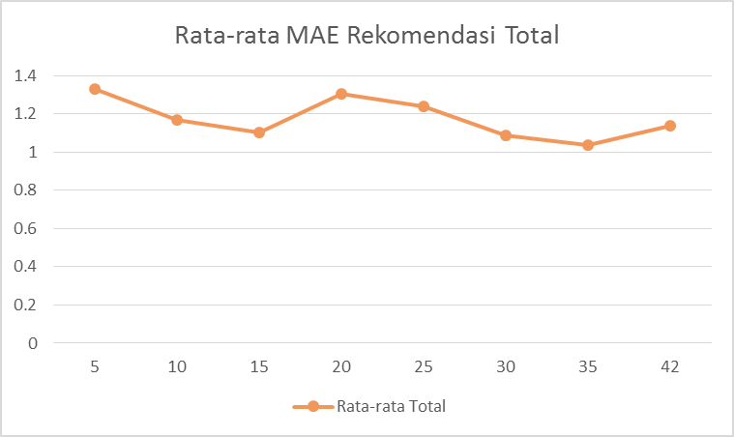

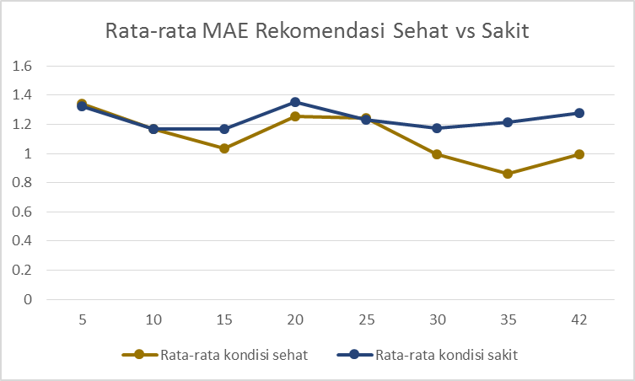

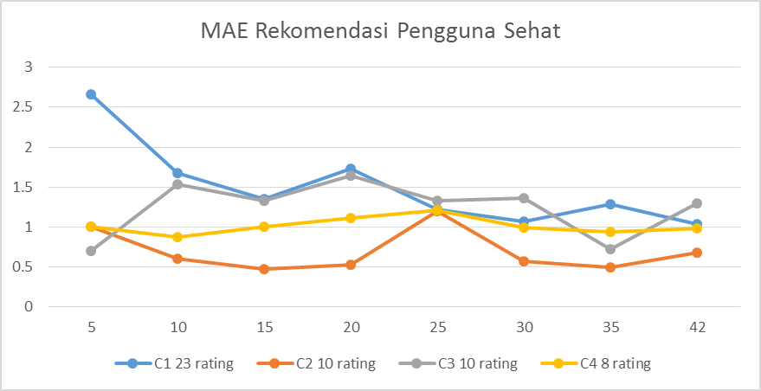

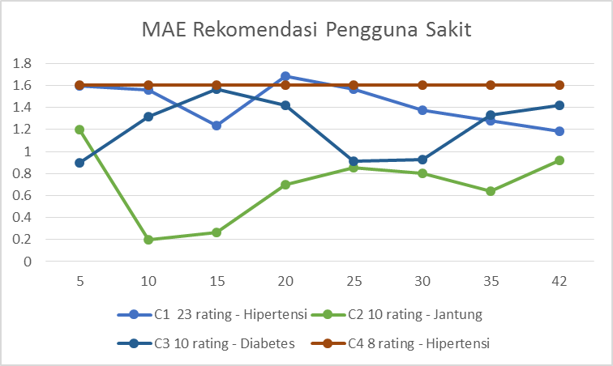

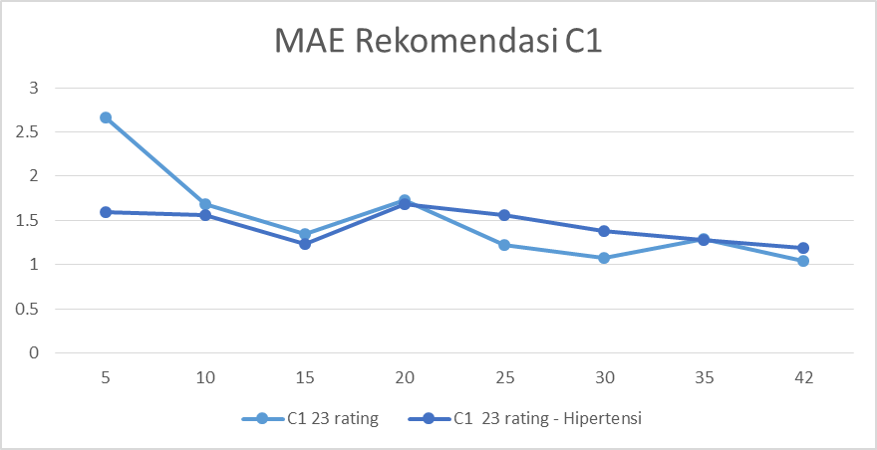

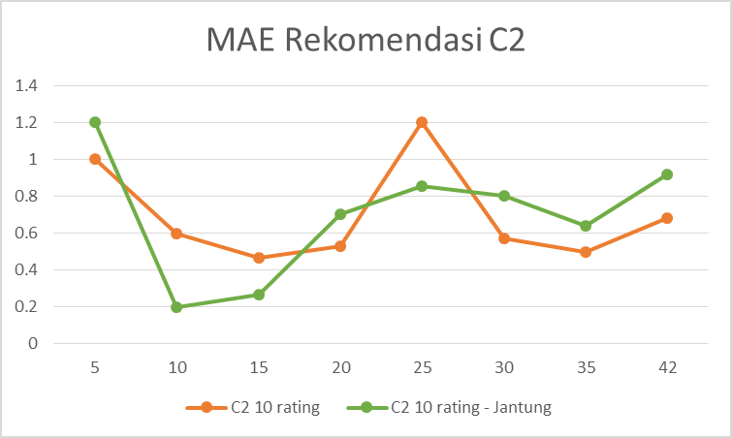

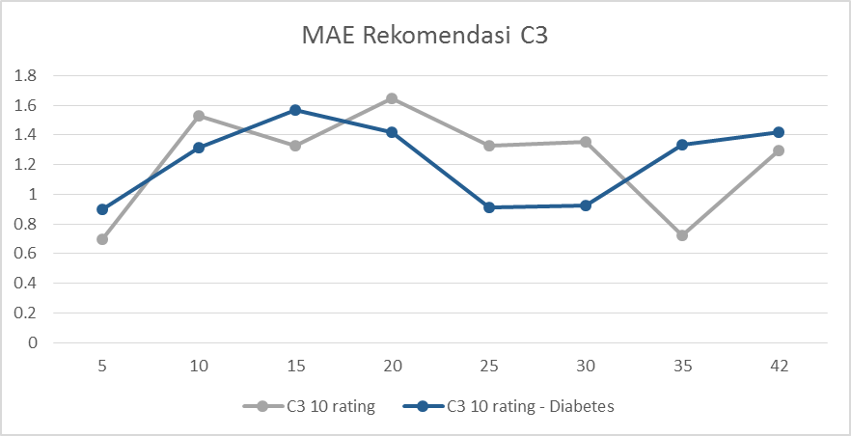

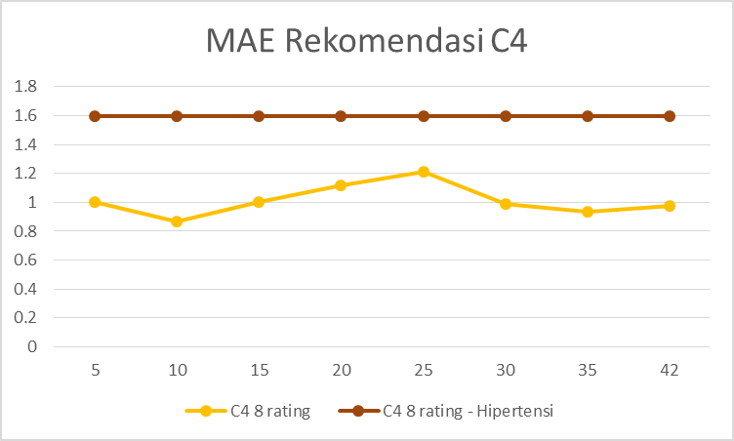

## Kesesuaian Rekomendasi Terhadap Selera Pengguna

### Tabel Pengujian Kesesuaian Rekomendasi

Pengujian kesesuaian rekomendasi terhadap selera pengguna yang dilakukan terhadap rekomendasi yang dihasilkan dapat dilihat pada tabel berikut.

| Perlakuan 1 (sehat, 5 produk yang paling serupa) | | | |
| --- | --- | --- | --- |
| Pengguna | Recipe_id | Rating | Kesesuaian |
| C1 - 23 rating | 3 | 2 | 0 |
| 13 | 1 |
| 14 | 1 |
| 4 | 2 |
| 5 | 2 |
| C2 - 10 rating | 11 | 2 | 0.6 |
| 25 | 2 |
| 26 | 3 |
| 27 | 5 |
| 28 | 3 |
| C3 - 10 rating | 7 | 2 | 0.2 |
| 8 | 2 |
| 9 | 5 |
| 1 | 1 |
| 2 | 1 |
| C4 - 8 rating | 2 | 3 | 0.8 |
| 3 | 5 |
| 5 | 2 |
| 4 | 4 |
| 1 | 3 |

| Perlakuan 2 (sehat, 10 produk yang paling serupa) | | | |
| --- | --- | --- | --- |
| Pengguna | Recipe_id | Rating | Kesesuaian |
| C1 - 23 rating | 3 | 2 | 0.6 |
| 9 | 3 |
| 16 | 3 |
| 20 | 1 |
| 2 | 3 |
| C2 - 10 rating | 13 | 3 | 0.4 |
| 1 | 1 |
| 12 | 3 |
| 29 | 2 |
| 2 | 2 |
| C3 - 10 rating | 7 | 2 | 0.4 |
| 8 | 2 |
| 6 | 4 |
| 11 | 2 |
| 9 | 5 |
| C4 - 8 rating | 3 | 5 | 0.8 |
| 5 | 2 |
| 2 | 3 |
| 4 | 4 |
| 1 | 3 |

| Perlakuan 3 (sehat, 15 produk yang paling serupa) | | | |
| --- | --- | --- | --- |
| Pengguna | Recipe_id | Rating | Kesesuaian |
| C1 - 23 rating | 3 | 2 | 0.6 |
| 8 | 5 |
| 10 | 3 |
| 7 | 3 |
| 5 | 2 |
| C2 - 10 rating | 13 | 3 | 0.8 |
| 4 | 3 |
| 1 | 1 |
| 12 | 3 |
| 14 | 3 |
| C3 - 10 rating | 7 | 2 | 0.4 |
| 8 | 2 |
| 5 | 3 |
| 11 | 2 |
| 9 | 5 |
| C4 - 8 rating | 2 | 3 | 0.8 |
| 3 | 5 |
| 5 | 2 |
| 4 | 4 |
| 1 | 3 |

| **Perlakuan 4 (sehat, 20 produk yang paling serupa)** | | | |
| --- | --- | --- | --- |
| Pengguna | Recipe_id | Rating | Kesesuaian |
| C1 - 23 rating | 20 | 1 | 0.4 |
| 10 | 3 |
| 8 | 5 |
| 11 | 2 |
| 3 | 2 |
| C2 - 10 rating | 13 | 3 | 0.4 |
| 12 | 3 |
| 16 | 2 |
| 2 | 2 |
| 15 | 2 |
| C3 - 10 rating | 6 | 4 | 0.4 |
| 14 | 1 |
| 8 | 2 |
| 7 | 2 |
| 9 | 5 |
| C4 - 8 rating | 5 | 2 | 0.8 |
| 2 | 3 |
| 3 | 5 |
| 1 | 3 |
| 4 | 4 |

| **Perlakuan 5 (sehat, 25 produk yang paling serupa)** | | | |
| --- | --- | --- | --- |
| Pengguna | Recipe_id | Rating | Kesesuaian |
| C1 - 23 rating | 11 | 2 | 0.8 |
| 8 | 5 |
| 7 | 3 |
| 10 | 3 |
| 6 | 5 |
| C2 - 10 rating | 27 | 5 | 0.6 |
| 12 | 3 |
| 20 | 1 |
| 17 | 3 |
| 1 | 1 |
| C3 - 10 rating | 7 | 2 | 0.6 |
| 5 | 3 |
| 6 | 4 |
| 3 | 3 |
| 11 | 2 |
| C4 - 8 rating | 5 | 2 | 0.8 |
| 2 | 3 |
| 3 | 5 |
| 1 | 3 |
| 4 | 4 |

| **Perlakuan 6 (sehat, 30 produk yang paling serupa)** | | | |
| --- | --- | --- | --- |
| Pengguna | Recipe_id | Rating | Kesesuaian |
| C1 - 23 rating | 8 | 5 | 0.8 |
| 6 | 5 |
| 9 | 3 |
| 5 | 2 |
| 7 | 3 |
| C2 - 10 rating | 28 | 3 | 0.8 |
| 14 | 3 |
| 19 | 4 |
| 10 | 2 |
| 9 | 3 |
| C3 - 10 rating | 2 | 1 | 0.6 |
| 8 | 2 |
| 5 | 3 |
| 6 | 4 |
| 3 | 3 |
| C4 - 8 rating | 5 | 2 | 0.8 |
| 2 | 3 |
| 3 | 5 |
| 4 | 4 |
| 1 | 3 |

| **Perlakuan 7 (sehat, 35 produk yang paling serupa)** | | | |
| --- | --- | --- | --- |
| Pengguna | Recipe_id | Rating | Kesesuaian |
| C1 - 23 rating | 7 | 3 | 0.6 |
| 5 | 2 |
| 11 | 2 |
| 8 | 5 |
| 6 | 5 |
| C2 - 10 rating | 4 | 3 | 1 |
| 3 | 3 |
| 19 | 4 |
| 18 | 3 |
| 28 | 3 |
| C3 - 10 rating | 2 | 1 | 0.2 |
| 3 | 3 |
| 4 | 2 |
| 14 | 1 |
| 8 | 2 |
| C4 - 8 rating | 5 | 2 | 0.8 |
| 2 | 3 |
| 3 | 5 |
| 4 | 4 |
| 1 | 3 |

| **Perlakuan 8 (sehat, 42 produk yang paling serupa)** | | | |
| --- | --- | --- | --- |
| Pengguna | Recipe_id | Rating | Kesesuaian |
| C1 - 23 rating | 11 | 2 | 0.8 |
| 18 | 3 |
| 8 | 5 |
| 7 | 3 |
| 6 | 5 |
| C2 - 10 rating | 12 | 3 | 0.6 |
| 1 | 1 |
| 4 | 3 |
| 13 | 3 |
| 16 | 2 |
| C3 - 10 rating | 6 | 4 | 0.4 |
| 11 | 2 |
| 7 | 2 |
| 8 | 2 |
| 5 | 3 |
| C4 - 8 rating | 5 | 2 | 0.8 |
| 2 | 3 |
| 3 | 5 |
| 4 | 4 |
| 1 | 3 |

| **Perlakuan 9 (sakit, 5 produk yang paling serupa)** | | | |
| --- | --- | --- | --- |
| Pengguna | Recipe_id | Rating | Kesesuaian |
| C1 - 23 rating - Hipertensi | 7 | 3 | 0.6 |
| 12 | 1 |
| 16 | 3 |
| 19 | 4 |
| 17 | 1 |
| C2 - 10 rating- Jantung | 11 | 2 | 0.4 |
| 25 | 2 |
| 28 | 3 |
| 7 | 2 |
| 12 | 3 |
| C3 - 10 rating - Diabetes | 7 | 2 | 0.2 |
| 9 | 5 |
| 1 | 1 |
| 2 | 1 |
| 11 | 2 |
| C4 - 8 rating - Hipertensi | 15 | 1 | 0 |
| 16 | 1 |
| 17 | 2 |
| 19 | 2 |
| 20 | 2 |

| **Perlakuan 10 (sakit, 10 produk yang paling serupa)** | | | |
| --- | --- | --- | --- |
| Pengguna | Recipe_id | Rating | Kesesuaian |
| C1 - 23 rating - Hipertensi | 16 | 3 | 0.6 |
| 20 | 1 |
| 19 | 4 |
| 17 | 1 |
| 7 | 3 |
| C2 - 10 rating- Jantung | 12 | 3 | 0.4 |
| 7 | 2 |
| 11 | 2 |
| 15 | 2 |
| 17 | 3 |
| C3 - 10 rating - Diabetes | 7 | 2 | 0.4 |
| 11 | 2 |
| 9 | 5 |
| 3 | 3 |
| 14 | 1 |
| C4 - 8 rating - Hipertensi | 15 | 1 | 0 |
| 16 | 1 |
| 17 | 2 |
| 19 | 2 |
| 20 | 2 |

| **Perlakuan 11 (sakit, 15 produk yang paling serupa)** | | | |
| --- | --- | --- | --- |
| Pengguna | Recipe_id | Rating | Kesesuaian |
| C1 - 23 rating - Hipertensi | 7 | 3 | 0.6 |
| 11 | 2 |
| 19 | 4 |
| 16 | 3 |
| 17 | 1 |
| C2 - 10 rating- Jantung | 12 | 3 | 0.4 |
| 7 | 2 |
| 11 | 2 |
| 15 | 2 |
| 17 | 3 |
| C3 - 10 rating - Diabetes | 7 | 2 | 0.6 |
| 5 | 3 |
| 11 | 2 |
| 9 | 5 |
| 3 | 3 |
| C4 - 8 rating - Hipertensi | 15 | 1 | 0 |
| 16 | 1 |
| 17 | 2 |
| 19 | 2 |
| 20 | 2 |

| **Perlakuan 12 (sakit, 20 produk yang paling serupa)** | | | |
| --- | --- | --- | --- |
| Pengguna | Recipe_id | Rating | Kesesuaian |
| C1 - 23 rating - Hipertensi | 20 | 1 | 0.4 |
| 11 | 2 |
| 7 | 3 |
| 19 | 4 |
| 17 | 1 |
| C2 - 10 rating- Jantung | 12 | 3 | 0.6 |
| 16 | 2 |
| 15 | 2 |
| 19 | 4 |
| 17 | 3 |
| C3 - 10 rating - Diabetes | 14 | 1 | 0.4 |
| 7 | 2 |
| 9 | 5 |
| 11 | 2 |
| 5 | 3 |
| C4 - 8 rating - Hipertensi | 15 | 1 | 0 |
| 16 | 1 |
| 17 | 2 |
| 19 | 2 |
| 20 | 2 |

| **Perlakuan 13 (sakit, 25 produk yang paling serupa)** | | | |
| --- | --- | --- | --- |
| Pengguna | Recipe_id | Rating | Kesesuaian |
| C1 - 23 rating - Hipertensi | 11 | 2 | 0.4 |
| 7 | 3 |
| 19 | 4 |
| 20 | 1 |
| 17 | 1 |
| C2 - 10 rating- Jantung | 12 | 3 | 0.6 |
| 20 | 1 |
| 17 | 3 |
| 16 | 2 |
| 19 | 4 |
| C3 - 10 rating - Diabetes | 7 | 2 | 0.4 |
| 5 | 3 |
| 3 | 3 |
| 11 | 2 |
| 14 | 1 |
| C4 - 8 rating - Hipertensi | 15 | 1 | 0 |
| 16 | 1 |
| 17 | 2 |
| 19 | 2 |
| 20 | 2 |

| **Perlakuan 14 (sakit, 30 produk yang paling serupa)** | | | |
| --- | --- | --- | --- |
| Pengguna | Recipe_id | Rating | Kesesuaian |
| C1 - 23 rating - Hipertensi | 7 | 3 | 0.4 |
| 11 | 2 |
| 19 | 4 |
| 20 | 1 |
| 17 | 1 |
| C2 - 10 rating- Jantung | 28 | 3 | 0.8 |
| 19 | 4 |
| 17 | 3 |
| 12 | 3 |
| 20 | 1 |
| C3 - 10 rating - Diabetes | 2 | 1 | 0.4 |
| 5 | 3 |
| 3 | 3 |
| 11 | 2 |
| 14 | 1 |
| C4 - 8 rating - Hipertensi | 15 | 1 | 0 |
| 16 | 1 |
| 17 | 2 |
| 19 | 2 |
| 20 | 2 |

| **Perlakuan 15 (sakit, 35 produk yang paling serupa)** | | | |
| --- | --- | --- | --- |
| Pengguna | Recipe_id | Rating | Kesesuaian |
| C1 - 23 rating - Hipertensi | 7 | 3 | 0.4 |
| 11 | 2 |
| 19 | 4 |
| 17 | 1 |
| 20 | 1 |
| C2 - 10 rating- Jantung | 19 | 4 | 0.6 |
| 28 | 3 |
| 16 | 2 |
| 17 | 3 |
| 25 | 2 |
| C3 - 10 rating - Diabetes | 2 | 1 | 0.4 |
| 3 | 3 |
| 14 | 1 |
| 11 | 2 |
| 9 | 5 |
| C4 - 8 rating - Hipertensi | 15 | 1 | 0 |
| 16 | 1 |
| 17 | 2 |
| 19 | 2 |
| 20 | 2 |

| **Perlakuan 16 (sakit, 42 produk yang paling serupa)** | | | |
| --- | --- | --- | --- |
| Pengguna | Recipe_id | Rating | Kesesuaian |
| C1 - 23 rating - Hipertensi | 11 | 2 | 0.4 |
| 7 | 3 |
| 19 | 4 |
| 17 | 1 |
| 20 | 1 |
| C2 - 10 rating- Jantung | 12 | 3 | 0.4 |
| 16 | 2 |
| 19 | 4 |
| 20 | 1 |
| 11 | 2 |
| C3 - 10 rating - Diabetes | 11 | 2 | 0.4 |
| 7 | 2 |
| 5 | 3 |
| 2 | 1 |
| 9 | 5 |
| C4 - 8 rating - Hipertensi | 15 | 1 | 0 |
| 16 | 1 |
| 17 | 2 |
| 19 | 2 |
| 20 | 2 |

### Grafik Pengujian Kesesuaian Rekomendasi

Berikut ini adalah grafik yang diolah dari data pada tabel kesesuaian rekomendasi dengan selera pengguna.

