PROJECT TITLE:
MEMBERS:
- Johnpaul Avelino – Programmer / Documentation

Project Scope: The project is for a daily time record keeper for the employees. It captures the time-ins and time-outs of employees for timekeeping purposes as these kinds of records are crucial to the computation of salaries and monitoring of lates, absences and undertimes for reference of the Human Resource Department.
Non-Functional Requirements:
- Usability – The system is easy to use as there are only a few buttons needed in order to record an employee’s time-ins and time-outs.
- Access Security – Access to the system is limited to the Admin so breach of access would be easily traced within the workplace.
- Availability – So far, no bugs have been encountered when using the system.
- Confidentiality – Since only the admin has access to the system, protection of data would be easily monitored.
- Efficiency – Since the system only has a few functions, the timekeeping is fast and efficient.
- Survivability – In case problems arise, it would be easily fixed as the admin has the sole access to the system.
- Flexibility – As of this stage, the system has a search function to filter out the individual employees. The system can be upgraded to have additional features to further filter the information of each employee. For example, using the current system, searching for Employee A would turn up results of their entire time-ins and time-outs but, upgrades can be made in order to further filter out the time-ins and time-outs by week, month, and year.

Functional Requirements:
Inputs:
- Employee Information - Collect employee details such as Employee ID, Name, Department
- Time In/Out - Capture the time when an employee starts and ends their workday.
- Data Validation
  - Validate Employee ID to ensure accuracy.
  - Check the validity of date and time entries.
  - Implement rules for overtime limits.
  - Include an approval process for leave requests.

Outputs:
- Daily Attendance Report -Generate a daily report showing employee attendance, including time in/out, breaks, and total hours worked.
- Employee Attendance Record - Maintain a historical record of each employee's daily attendance and work hours.
- User Notifications -
  - Notify employees and supervisors of successfully recorded time entries.
  - Send notifications for pending leave requests.

ERD Diagrams:
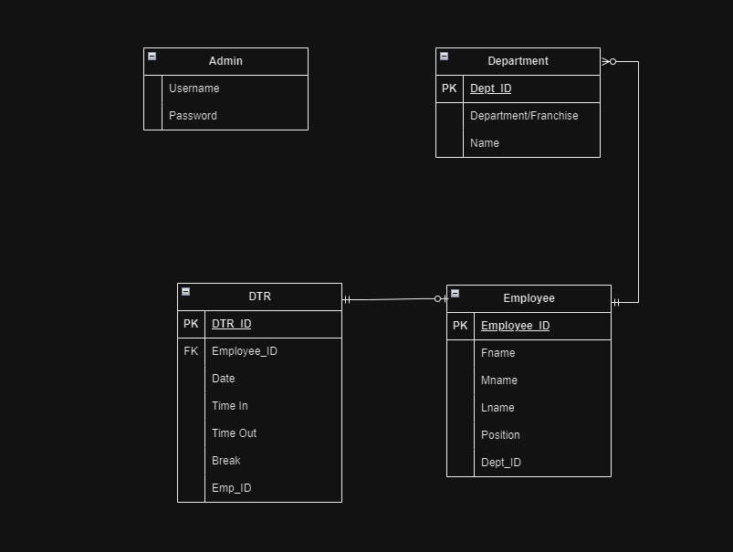

Use Case Diagrams:

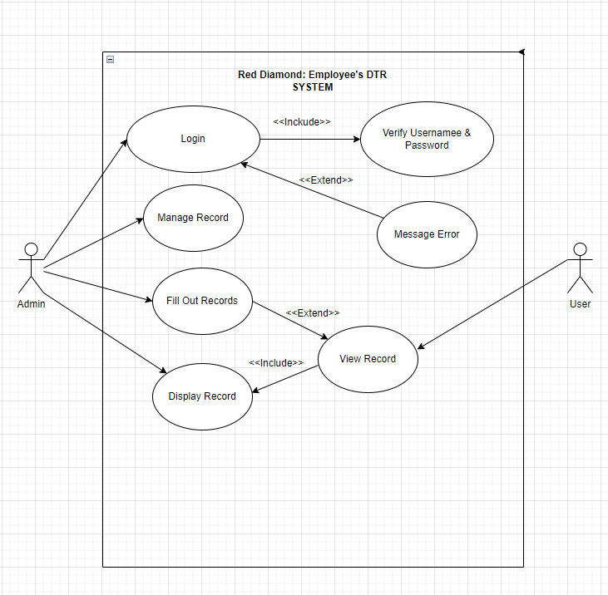

User Controls:
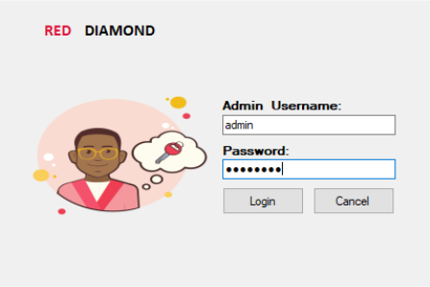
Figure 1 – This is the welcome screen/log-in module screen of the system. It requires the admin to enter their username and password in order to gain access to the system.

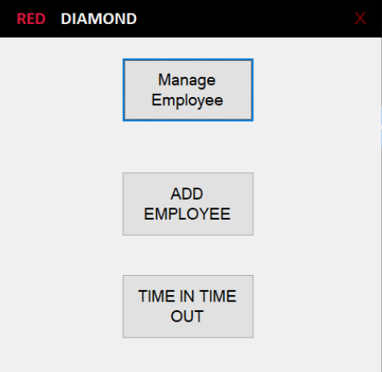

Figure 2 – Upon gaining access to the system, the admin may perform 3 different functions namely:
A .Manage Employee – This is where the admin may edit or delete employee information. This is also where their time-ins and time-outs may be viewed but not edited.
B.Add Employee – This is where the admin may add new employees to the system.
C. Time In, Time Out – this is where the admin may enter the time-ins and time-outs of the employees.
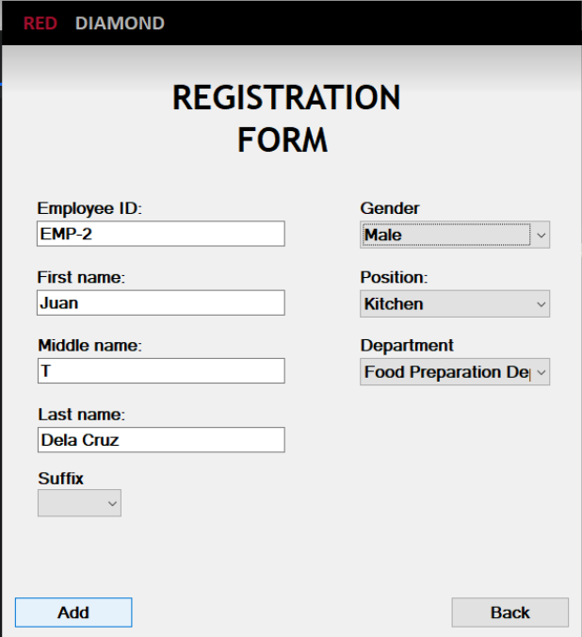
Figure 3 – This is the screen when the add employee button is clicked. Each employee is given a unique Employee ID in order to avoid repetition.
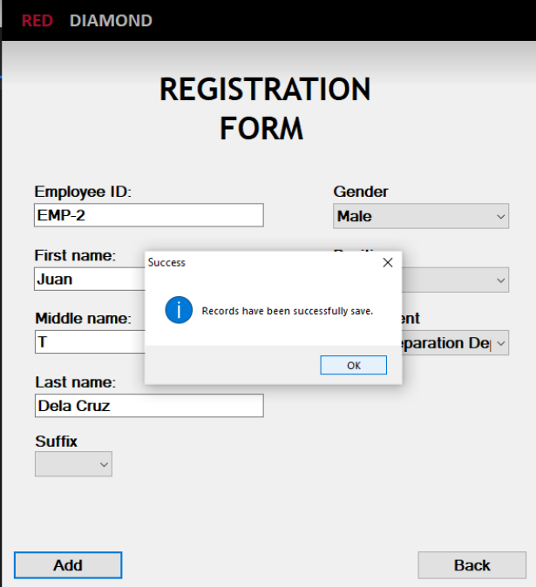
Figure 4 – When a new employee has been added, the Success Prompt will show to let the admin know that the employee information has now been added to the system.

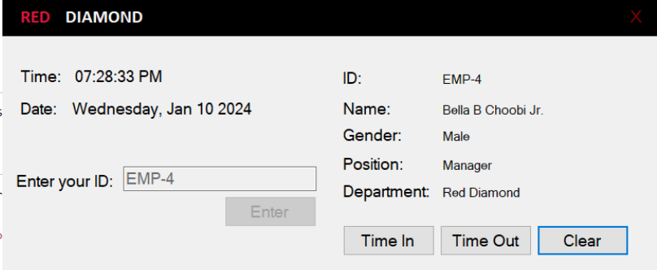
Figure 5 – When the Time In, Time Out button has been clicked, this is what the screen would look like. The information entered in the Add Employee button would show on the right side and the time and date is shown on the left. When the admin clicks the time in button, a success prompt will show up (Figure 6) and the admin may click the Clear button so that another employee time-in would be recorded.

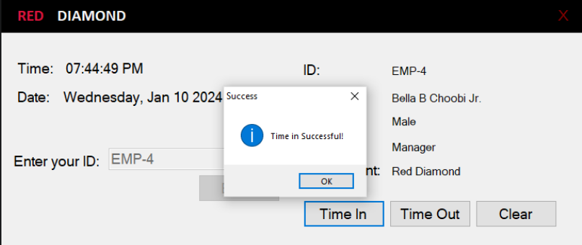
Figure 6

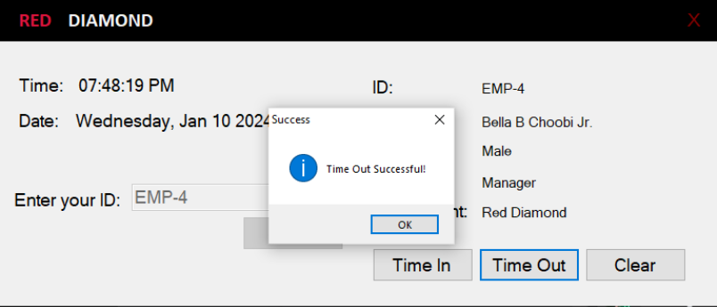
Figure 7 – When the time-out button is clicked, a success prompt will pop up in order to indicate that the time out has been recorded.

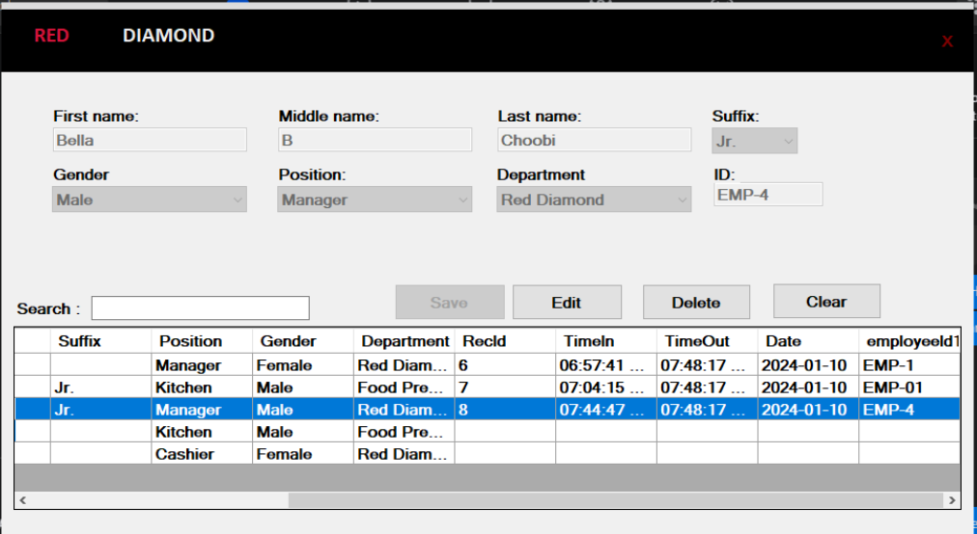
Figure 8 – This is what the Manage Employee screen looks like. This is where the admin can see the time-ins and time-out made for each employee. The search button may be used by entering the employee’s last name in order for their records to show. This is also the part of the system where the information of the employees may be edited or deleted. The clear button is used in order to clear out the text boxes.

