Discusión confianza, conocimiento y transparencia
¿Qué es la confianza calibrada? Tensiones que surgen
Trustwothiness no lo tenemos porque no estamos midiendo si nuestra IA tiene buen rendimiento. Es más, esto no cabe bien en este sistema. En SAE no hay una decisión correcta. En FONASA si (ahí una diferencia).
Ahora, nosotros estamos levantando un trustworthiness que va más allá de la perfomance: No tiene que ver con el rendimiento solamente, sino que se debe entender como funcionar, que la confianza esté alineada con la operación del algoritmo.

Las formas de transaparencia

Diferencias entre sistemas SAE y Fonasa
Diferencia en que SAE existe trustworthiness, mientras que en Fonasa no. Aunque igual puede entrar en tensión… porque las personas pueden tener valores distintos a los del fin del servicio de aprobar licencias reales. Pero sí en Fonasa hay una idea de performance más clara que en SAE.

Actitudes y literacidad hacia la IA

La comprensión subjetiva y su mediación de la transparencia
FRAN

------------------------------------------------------------------------------------------------------------------------
Do interface-level transparency interventions in AI-assisted public services generate trust that is grounded in users' objective knowledge of the system — or do they produce uninformed trust, in which increased confidence is decoupled from, or even substituted for, actual understanding?

H1: In both SAE and FONASA, algorithmic and AI disclosure (respectively) will increase the probability of belonging to the informed trusters profile relative to the distrusting baseline, but will not significantly increase the probability of belonging to the uninformed trusters profile.
H2a: In SAE, exposure to situational information will increase the probability of belonging to the informed trusters profile relative to the distrusting baseline, but will not significantly increase the probability of belonging to the uninformed trusters profile.
H2b: In FONASA, exposure to system performance information will increase the probability of belonging to the informed trusters profile relative to the distrusting baseline, but will not significantly increase the probability of belonging to the uninformed trusters profile.
H3: In both SAE and FONASA, human control information will increase the probability of belonging to the informed trusters profile relative to the distrusting baseline, but will not significantly increase the probability of belonging to the uninformed trusters profile.
H4: In both SAE and FONASA, higher levels of subjective comprehension will increase the probability of belonging to both the informed and uninformed trusters profiles relative to the distrusting baseline, reflecting a generalized trust-enhancing effect of perceived understanding regardless of its alignment with objective knowledge.
H5: In both SAE and FONASA, higher AI literacy will increase the probability of belonging to the informed trusters profile relative to the distrusting baseline, but will not significantly increase the probability of belonging to the uninformed trusters profile.
H6: In both SAE and FONASA, more positive AI attitudes will increase the probability of belonging to both the informed and uninformed trusters profiles relative to the distrusting baseline, reflecting a generalized dispositional effect on trust that operates independently of objective knowledge.

Method

Study Design
This study reports the results of a pre-registered online survey experiment examining the effects of interface-level transparency interventions on users' trust and objective knowledge across two Chilean public service systems: SAE, the school allocation algorithm, and FONASA, the public health insurance system. Both experiments were administered as part of a single online survey, in which each participant was exposed to experimental simulations of both systems in sequence. Random assignment to experimental conditions was performed independently for each system, such that a given participant's condition in the SAE experiment did not constrain their condition in the FONASA experiment.
Each experiment follows a 2×2×2 between-subjects factorial design, with three binary experimental factors yielding eight possible combinations of transparency conditions. In the SAE experiment, the three factors are: algorithmic disclosure (presence or absence of an explanation of how the allocation algorithm operates), situational information (presence or absence of a step-by-step timeline of the enrollment process), and human control (presence or absence of information emphasizing the user's agency within the allocation). In the FONASA experiment, the three factors are: AI disclosure (presence or absence of explicit information indicating that an AI system participates in the medical leave review process), system performance information (presence or absence of a message reporting the system's accuracy rate), and human control (presence or absence of a message indicating that a medical professional reviewed the AI recommendation and retained final decision-making authority). In the FONASA experiment, a baseline representation of the medical leave process as a step-by-step sequence was provided to all participants as a constant interface layer and was not manipulated experimentally.
The temporal structure of each experiment follows two moments of interaction. In the ex-ante phase, participants are exposed to information about the system before receiving a simulated outcome. In the ex-post phase, participants interact with the outcome screen, which may or may not include additional transparency elements depending on their assigned condition. In SAE, algorithmic disclosure and situational information are introduced at the ex-ante stage, while human control is introduced at the ex-post stage. In FONASA, AI disclosure is introduced at the ex-ante stage, while system performance information and human control are both introduced at the ex-post stage. This temporal arrangement follows the theoretical logic that transparency should be designed across the user journey rather than concentrated at a single point of interaction.
Neither experiment used the official interfaces of SAE or FONASA (see CITAS A LOS OTROS PAPERS). Both were implemented as research prototypes that simulate the relevant institutional processes and embed the experimental manipulations within them. The prototypes were designed to be intelligible to non-expert users and to reflect the actual institutional logic of each system, grounded in publicly available documentation.
Participants were recruited via [platform to be specified] and were eligible to participate if they were potential users of the respective systems — that is, individuals who could plausibly interact with a school enrollment process or a public health insurance service. No additional eligibility restrictions were applied.
A total of 600 participants were recruited. Respondents were excluded from the final analytical sample on the basis of a multi-criterion quality control procedure. Six attention check items were embedded throughout the survey — two in a common section and two specific to each system. Participants who failed two or more attention checks were automatically excluded. For the remaining participants, two additional quality indicators were assessed: response time (participants were excluded if they completed the survey in under 20 minutes or over 90 minutes) and intra-subject response variance (participants were excluded if the variance of their Likert-scale responses fell below 0.15 in any of the four measurement blocks, indicating near-uniform or straight-line responding). Participants who accumulated two or more of these quality strikes were also excluded. After applying this procedure, the final analytical sample comprised 514 participants. Descriptive characteristics of the final sample are reported in Table 1.

Variables

Demographics
The first block of predictors entered into the models comprises three demographic variables: gender (dummy-coded), age (entered as a continuous numerical variable), and maximum educational level attained, coded as an ordinal three-category variable (primary education, secondary education, and tertiary education).

AI Background
The second block captures participants' general orientation toward artificial intelligence prior to the experimental interaction. It includes two conceptually distinct variables, each tapping a different dimension of how users relate to AI systems. AI literacy, adapted from Carolus et al. (2023), covers four dimensions: use and application of AI systems, ability to detect AI-based systems, ethical reasoning about AI, and AI self-efficacy. This variable reflects the functional competencies a user brings to an interaction with an automated system. AI attitudes, by contrast, were measured using a nine-item scale assessing both positive orientations (e.g., perceived benefits of AI for everyday life and societal wellbeing) and negative orientations (e.g., perceived danger, loss of human control, and unethical use by organizations). Rather than competencies, this variable captures the normative and dispositional stance users hold toward AI — their underlying moral beliefs and affective predispositions that shape how they approach and evaluate automated decision-making systems. Including both variables allows the models to disentangle the effects of what users are capable of doing with AI from what users believe about AI, two dimensions that may have independent and potentially divergent effects on trust and knowledge outcomes.

Independent experimental variables
The experimental interventions were incorporated as dummy variables (0 = control group, 1 = treatment group). For SAE, the three interventions were: algorithmic disclosure (information about how the matching algorithm works), situational information (information about the stages and timeline of the process), and human control (information emphasizing the user's agency within the allocation process). For FONASA, the three interventions were: AI disclosure (information about the use of artificial intelligence in the review process), performance (information about the system's accuracy rate), and human control (information emphasizing that a human professional retains final decision-making authority).

Subjective comprehension
Subjective comprehension captures participants' self-perceived understanding of each system, independently of whether that understanding is factually accurate. It was measured with 9 items for SAE and 10 items for FONASA, all on a 5-point Likert scale. Items were designed to reflect general perceived understanding, self-assessed ability to explain the system to a third party, and perceived comprehension of each intervention-specific dimension (user control, algorithmic functioning, and situational information for SAE; AI disclosure, human control, and system performance for FONASA). The index was constructed as the arithmetic mean of the corresponding items and entered the multinomial models as a predictor variable.
Table 1.
Sample distribution
Variable |  | Value / Scale | Freq (%) / M (SD) | Cronbach’ alpha
Gender |  | Hombre | 255 (49.6%)
 |  | Mujer | 259 (50.4%)
Age |  |  | 38.10 (9.83)
Educational level |  | Media incompleta | 13 (2.5%)
 |  | Media completa | 148 (28.8%)
 |  | Educación superior | 353 (68.7%)
Attitudes toward AI |  | 1-5 | 3.04 (0.63)
AI skills |  | 1-5 | 3.22 (0.87)
AI disclosure |  | Control (0) | 266 (51.8%)
 |  | Experimental (1) | 248 (48.2%)
System performance |  | Control (0) | 268 (52.1%)
 |  | Experimental (1) | 246 (47.9%)
Human control |  | Control (0) | 263 (51.2%)
 |  | Experimental (1) | 251 (48.8%)
Algorithmic disclosure |  | Control (0) | 265 (51.6%)
 |  | Experimental (1) | 249 (48.4%)
Situational information |  | Control (0) | 264 (51.4%)
 |  | Experimental (1) | 250 (48.6%)
Human control |  | Control (0) | 254 (49.4%)
 |  | Experimental (1) | 260 (50.6%)
SAE |  | 1 – 5 | 3.24 (0.94)
FONASA |  | 1- 5 | 2.95 (0.94)

Dependent variable

Trust
Trust toward each system was operationalized using two established and theoretically distinct scales, applied separately rather than aggregated, in order to assess the robustness of the findings across different conceptualizations of trust.
The first measure was adapted from McKnight (2011) and captures trusting beliefs along three dimensions: reliability (the perceived dependability of the system), functionality (the perceived capacity of the system to fulfill its purpose), and helpfulness (the perceived usefulness of the information the system provides to support decision-making). This last dimension was only included in the post-experimental measurement. The scale comprises 10 items for SAE and 10 items for FONASA, all measured on a 5-point Likert scale (1 = Strongly disagree, 5 = Strongly agree).
The second measure was adapted from the Multidimensional Digital Trust Measure (MDMT) and captures two higher-order dimensions: functional trust, composed of reliability and capability subdimensions, and moral trust, composed of ethical integrity and sincerity subdimensions. This scale includes 12 items for both SAE and FONASA, also on a 5-point Likert scale.
Each trust index was constructed as the arithmetic mean of its corresponding items, with higher values indicating greater trust. Both indices were then standardized using z-scores. Participants scoring below zero were classified as distrusting, and those scoring zero or above zero as trusting. This classification was performed independently for each scale, yielding two parallel trust indicators per system.

Objective knowledge
Objective knowledge about each system's functioning was measured through multiple-choice questions, each offering two substantive answer options and a "I don't know" option. Items were coded dichotomously: correct answer = 1, incorrect answer or "I don't know" = 0. The objective knowledge index was constructed as the arithmetic mean of all items, yielding a score ranging from 0 to 1, where higher values reflect greater factual understanding of the system.
For SAE, the scale comprises 6 items organized around the three experimental intervention dimensions: user control (2 items), algorithmic functioning (2 items), and situational information (2 items). For FONASA, the scale comprises 11 items distributed across AI disclosure (2 items), human control over the decision (3 items), system performance (3 items), and general process understanding (3 items).
The index was standardized using z-scores. Participants scoring equal or above zero were classified as knowledgeable and those scoring below zero as non-knowledgeable.

Table 2. Variables for Informed trust
Variable |  | Value / Type |  | Freq (%) / M (SD) | Scale |  | Cronbach’ alpha
System Trust | Mcknight – SAE |  |  |  |  | 1 - 5
 | MDMT - SAE |  |  |  |  | 1 – 5
 | Mcknight – FONASA |  |  |  |  | 1 – 5
 | MDMT - FONASA |  |  |  |  | 1 - 5
Objective knowledge | Obj. Know. - SAE |  |  |  |  | 0 – 6
 | Obj. Know. - FONASA |  |  |  |  | 0 - 11

Informed trust typology
A three-category mutually exclusive typology was constructed by crossing the standardized trust and objective knowledge indices. Participants scoring below zero on either trust measure were classified as distrusting, regardless of their level of objective knowledge. This collapsing of knowledge variation within the distrusting group reflects a deliberate theoretical decision: the study's central concern lies in understanding the conditions under which trust, once present, is or is not accompanied by factual understanding.
Among trusting participants, two types were distinguished: informed trusters, who combine above-zero trust with above-zero objective knowledge, and uninformed trusters, who display above-zero trust alongside below-zero objective knowledge. This latter profile represents the core risk motivating the study — users who place confidence in a system without adequately understanding how it works, rendering them potentially vulnerable to decisions that directly affect their lives.
Since the typology was constructed independently for each trust measure (McKnight and MDMT), two parallel typologies were produced per system, each used as the dependent variable in a separate multinomial model.
Table 3.
Informed trust values
System | Trust Measure | Trust Category | n (%)
FONASA | McKnight | Skeptical informed / mistrust uninformed | 268 (52.0%)
 |  | Uninformed trust | 100 (19.0%)
 |  | Informed trust | 146 (28.0%)
 | MDMT | Skeptical informed / mistrust uninformed | 261 (51.0%)
 |  | Uninformed trust | 102 (20.0%)
 |  | Informed trust | 151 (29.0%)
SAE | McKnight | Skeptical informed / mistrust uninformed | 242 (47.0%)
 |  | Uninformed trust | 93 (18.0%)
 |  | Informed trust | 179 (35.0%)
 | MDMT | Uninformed trust | 266 (52.0%)
 |  | Ignorant trust | 80 (16.0%)
 |  | Informed trust | 168 (33.0%)

Analytical strategy
To examine the predictors of informed trust, we estimated multinomial logistic regression models using the nnet package in R. The dependent variable in all models is the three-category informed trust typology described in section 2.4, with the distrusting profile as the reference category. Accordingly, the model coefficients are interpreted as the change in the log-odds of belonging to the informed trusters or uninformed trusters profiles relative to the distrusting baseline. This framing is theoretically motivated: given that the study's central concern is understanding the conditions under which users move toward trust — and whether that trust is or is not accompanied by objective knowledge — the distrusting group constitutes the natural point of comparison.
Given that trust was operationalized through two conceptually distinct scales (McKnight and MDMT), two parallel models were estimated for each system, one for each trust measure. This yields four models in total: two for SAE and two for FONASA. Estimating separate models for each scale rather than combining them serves a validation purpose, allowing us to assess whether the observed patterns hold across different conceptualizations of trust. Analyses for SAE and FONASA were conducted independently, as the two systems differ in their institutional nature, the type of algorithmic decision-making involved, and the specific experimental interventions applied.
In each model, predictors were entered hierarchically in four sequential blocks. The first block includes demographic variables (gender, age, and educational level), establishing the baseline sociodemographic profile associated with each trust-knowledge outcome. The second block adds AI background variables (AI literacy and AI attitudes), allowing us to assess the contribution of users' pre-existing cognitive capacities and normative dispositions toward AI over and above demographic characteristics. The third block introduces the experimental intervention dummies, enabling an evaluation of the effect of each interface-level manipulation on the probability of belonging to each profile. The fourth and final block incorporates subjective comprehension, testing whether perceived understanding contributes independently to trust-knowledge outcomes after accounting for all prior predictors.
Model fit was evaluated using Nagelkerke's pseudo R², adjusted R², and the Akaike Information Criterion (AIC). The sequential entry of predictor blocks allows for an assessment of the incremental explanatory contribution of each set of variables.

Results

SAE Multinomial models
Table 4 presents the hierarchical multinomial logistic regression models for SAE using both trust measures (McKnight and MDMT). Across both, the overall pattern of results is highly consistent, suggesting that the findings are robust to alternative conceptualizations of informed trust.
Table 4.
SAE Multinomial models
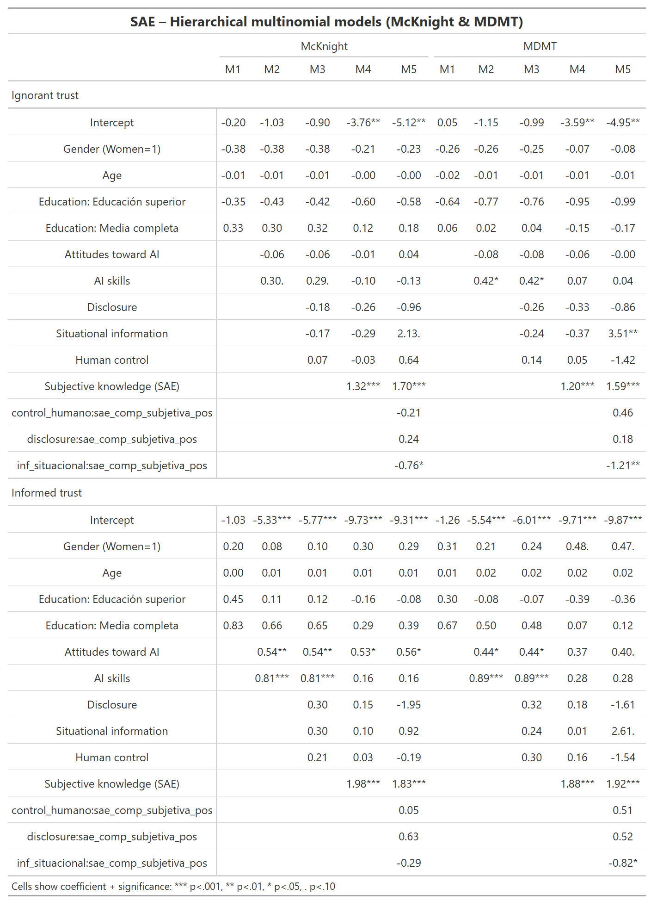
Demographic characteristics exhibit limited explanatory power. Gender, age, and educational attainment are not significantly associated with either informed or uninformed trust in most model specifications. Trust–knowledge profiles are not primarily structured by sociodemographic differences, but rather by cognitive and attitudinal factors associated with the interaction itself.
Consistent with H6, positive attitudes toward AI significantly increase the likelihood of belonging to the informed trust profile. This effect is remarkably stable across both trust measures and across all model specifications. Participants who hold more favorable views of AI are systematically more likely to trust SAE while simultaneously demonstrating higher levels of objective understanding.
However, AI attitudes do not significantly predict uninformed trust. Rather than producing generalized confidence irrespective of knowledge, positive attitudes appear to facilitate a form of trust that remains connected to factual understanding.
AI literacy exhibits a similarly differentiated pattern. Higher levels of AI skills significantly increase the probability of informed trust in the earlier model specifications, particularly under both the McKnight and MDMT measures. Yet these effects largely disappear after subjective comprehension is introduced into the model. This suggests that part of the influence of AI literacy may operate through users' perceptions of understanding the system. Importantly, AI literacy does not significantly increase uninformed trust, providing support for H5.
The experimental transparency interventions produce limited direct effects. Algorithmic disclosure does not significantly predict either informed or uninformed trust. Similarly, human control information fails to significantly affect either trust profile.
Situational information displays a more nuanced pattern. While its direct effect is not statistically significant in most models, an interaction emerges between situational information and subjective comprehension. Under both trust measures, the interaction term is negative and statistically significant for uninformed trust. This indicates that subjective comprehension is less likely to translate into uninformed trust when users are provided with contextual information about how the allocation process unfolds.
This finding provides partial support for H2a. Situational information does not directly create informed trust, but it appears to moderate the relationship between perceived understanding and misplaced confidence.
The strongest and most consistent predictor across all SAE models is subjective comprehension. Higher levels of perceived understanding substantially increase the probability of belonging to both informed and uninformed trust categories. The coefficients are large and highly significant across all specifications. This finding strongly supports H4. Individuals who believe they understand the system are more likely to trust it regardless of whether their objective knowledge is actually high. In other words, subjective comprehension functions as a generalized trust-enhancing mechanism.
At the same time, the negative interaction between subjective comprehension and situational information suggests that contextual transparency can partially prevent this subjective confidence from becoming detached from factual understanding.
Overall, the SAE results suggest that informed trust is primarily driven by AI attitudes, AI literacy, and subjective comprehension. Transparency interventions have comparatively weak direct effects. The only notable transparency effect is the moderating role of situational information, which appears to reduce the risk that subjective understanding translates into uninformed trust.

Fonasa Multinomial models
Table 5 reports the multinomial models for FONASA. As in SAE, the patterns are highly consistent across the McKnight and MDMT trust measures.
Table 5.
FONASA Multinomial models
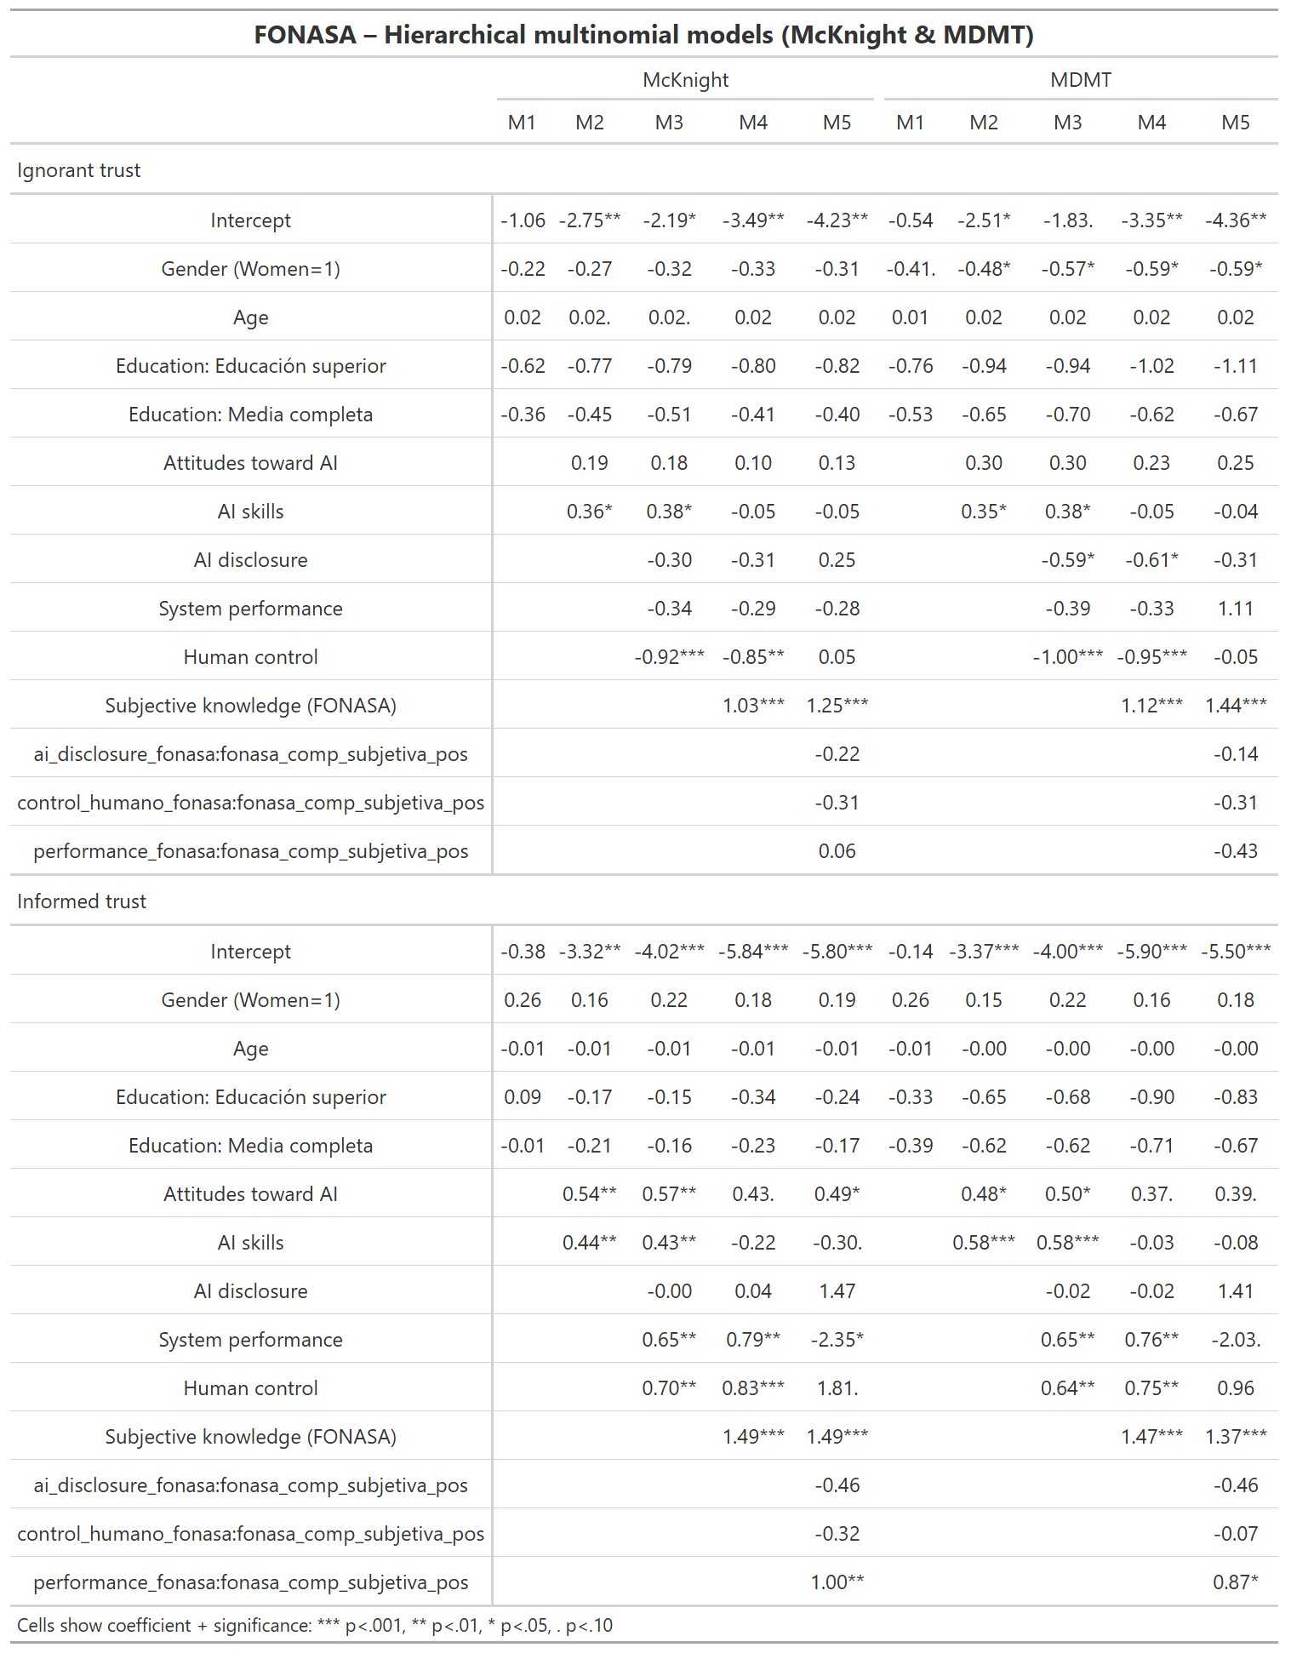
Demographic variables again exhibit little explanatory power. The only recurring effect concerns gender: women are somewhat less likely to belong to the uninformed trust category under the MDMT operationalization. However, these effects are modest and not consistently observed across all specifications.
Positive attitudes toward AI significantly increase the likelihood of informed trust across both trust measures. This effect remains significant even after the inclusion of transparency interventions and subjective comprehension. As in SAE, AI attitudes do not significantly increase uninformed trust. Consequently, H6 receives only partial support: Positive attitudes toward AI foster trust, but that trust tends to be associated with greater objective understanding rather than ignorance.
AI literacy also increases the likelihood of informed trust in intermediate model specifications. Yet these effects become weaker once subjective comprehension is introduced, suggesting a degree of overlap between objective competencies and perceived understanding. No evidence indicates that AI literacy promotes uninformed trust, supporting H5.
The experimental manipulations again produce limited direct effects. AI disclosure does not significantly affect either informed or uninformed trust. This finding directly contradicts H1 and aligns with recent literature suggesting that merely informing users about the presence of AI is insufficient to shape trust outcomes. Similarly, system performance information does not significantly increase informed trust, providing no support for H2b.
Human control and system performance information , however, displays a distinctive pattern. Both variables increase the probability of belonging to informed trust user, and human control significantly reduces the likelihood of belonging to the uninformed trust category. This effects are substantial and highly consistent across model specifications.
Rather than increasing trust indiscriminately, human oversight appears to act as the best safeguard against misplaced trust. Information emphasizing that a human professional retains decision-making authority may encourage a more calibrated interpretation of the system and discourage confidence unsupported by knowledge.
As in SAE, subjective comprehension emerges as the strongest predictor in the model. Higher perceived understanding strongly increases the probability of both informed and uninformed trust. The magnitude of these effects is among the largest observed in the analysis and remains highly significant across all specifications. This result provides strong support for H4 and represents the most robust finding across both systems.
A notable interaction emerges between subjective comprehension and system performance information in the informed trust models. The interaction is positive and statistically significant under both trust measures, while the direct effect of performance become highly negative. This suggests that performance information becomes effective only when users already perceive themselves as understanding the system. Performance metrics do not independently generate informed trust, but they can reinforce trust when users possess a strong sense of comprehension.
No comparable interaction is observed for AI disclosure or human control.

Discussion
PREGUNTAS QUE QUEDAN ABIERTAS QUE SON IMPORTANTES DE DISCUTIR
¿Por qué la transparencia no mueve nada en SAE, pero las medidas más accionables sí mueven en Fonasa?
¿Por qué las actitudes positivas hacia la IA refuerzar solo la confianza informada (no se cumple hipótesis de que mueve ambas confianzas)? En cambio, ¿Por qué la literacidad en la IA, que se supone que es la capaz de activar la sospecha, mueve ambas confianzas?
¿Por qué en SAE situational ifnormation ayuda a que el refuerzo de la confianza ciega que hace la percepción de saber se atenúe?
Para generar una confianza informada, necesitamos sofisticar la transparencia para que sea más accionable. Como se vio en Fonasa, Human control es la que más aumenta la probabilidad de confiar informadamente, y de mantener la desconfianza cuando uno no sabe Se genera la vigilancia algorítmica que sugiere la literatura.

IDEAS

DIFERENCIAS SAE FONASSA
Agarrarse de la discusión de los escenarios high stakes, y demostrar que SAE y Fonasa son los high stake pero resulta que tienen comportamientos distintos. Los ejes de transparencia pueden tener relaciones distintas para dos sistemas high stkaes que se suelen homogeneizar.
¿Qué es la diferencia exacta entre SAE y Fonasa? No lo sabemos.
Se eligió SAE porque el usuario toma decisiones, mientras que en FONASA te mandan una decisión. De hecho se pueden categorizar por grados de accionabilidad.

plataforma en que se hizo la muestra: Conjointly
¿cómo se garantizó que fueran usuarios potenciales de ambos sistemas?: Se usó un servicio de reclutamiento a los que se les pidió que fueran 1. Usuarios de Fonasa y 2. Que tuvieran hijos o sean cuidadores que estuvieran en colegios públicos y/o que declaran que han usado el SAE explícitamente. Potencial del servicio publico más que del software mismo.
Se intentó que una persona hubiera pedido una licencia en Fonasa, pero eso era demasiado estricto y se sacó.
¿cálculo de poder estadístico para justificar n = 600? En el pre-registro se señala esto. Además que el n es parecido en papers de HCI. Hay un meta análisis de experimentos que s epreguntan confianza-transparencia que exige aprox 35 usuarios por condición. Nosotros lo inflamos para evitar missigns.
ITEMS EXTRA EN CONOCIMIENTO OBJETIVO FONASA: Sí están incluidas. Se hicieron para hacer una comparativa con el exante. En el pso finalmente es más completamente porque el usuario se encuentra con información que no estaba en el pre.

Para publicar
Government Information Quarterly: están publicados los estudios más directamente relacionados con tu paper: Grimmelikhuijsen (2023) sobre transparencia algorítmica, Horvath et al. (2023) sobre aceptación de IA en servicios públicos, Kleizen et al. (2023) sobre límites de la IA ética en gobierno, y de Bruijn et al. (2022) sobre XAI en decisiones gubernamentales. Centrado en la politica publica.
AI & Society: Debate STS, Implicancias para la democracia de las tecnologías, mayor profundidad teórica. Más afin a lo que hago.
Buscar WOS Q1 EN SOCIOLOGIA Y/O GOVERNMENT:
DATA AND POLICY
Social sciences and computers review
Big data and society

Sobre el argumento
Los servicios públicos requieren cada vez de mayor automatización para enfrentar un contexto complejo y masivo. Por eso generar confianza en como toman decisiones sus sistemas automatizados es algo importante para la legitimidad de los gobierno.
Las primeras premisas de XAI sugirieron que para mejorar la confianza en los sistemas había que hacerlos transparentes; diseñar explicaciones para la toma de decisiones automática
La evidencia empieza a complicarse a medida que los algoritmos se hacen más complejos. Demasiada información confunde al usuario. Kizilcec (2023) paper clave: Nivel optimo/balanceado de transparencia para generar confianza
Trabajos empíricos más recientes encuentran automation complacency (harbarht, 2023): Saturar de información hace que los usuarios dependan de los algoritmos porque no logran entender. Lo ideal es generar una actitud de vigilancia algorítmica – punto medio entre oponerse y complacerse.
Automation bias/ Reliance son conceptos típicos en HCI, ya que se fijan más en comportamientos (hacer caso o no a la IA).
Con la revolución de la IA, ha comenzado a haber una sospecha humana sobre la máquina. Schilke y Reiman (2025) muestran que ya no es solo saturar de información el problema, sino que derechamente advertir que hay una IA en el sistema le quita el componente humano y erosiona la confianza.
Al final, estos problemas revelan que confianza y comprensión se trataban como una sola cadena causal dentro de la interacción humano-sistema, y que es debido separarlos: la transparencia puede llevar a confiar en el sistema porque se comprende o porque no se comprende. Pero en general las investigaciones los estudian como variables dependientes por separado.
Lo que la literatura aún no ha resuelto bien es si las intervenciones de transparencia generan confianza anclada en conocimiento real, o confianza desacoplada de ese conocimiento. Para eso se debe testear si confianza y comprensión se mueven juntas o en direcciones divergentes. Se justifica la tipología.
LÍMITE: No podemos medir automation complacency (no sabemos si la confianza ciega se produce por delegar al algorito) ni vigilancia algorítmica (no sabemos si los que desconfían tienen una actitud vigilante, y si los que confían con comprensión no están vigilando tambien), pero si hacer un primer acercamiento a estos conceptos.
La literatura también ha empezado a revisar qué tipos de transparencia son las que mueven conocimiento y confianza. Nos sumamos a esa tendencia con disclosure, performance, situational information y human control. Siguiendo a Schilke y Reiman, pareciera que a medida que el sistema se hace más accionable, el usuario tiende a entender mejor el funcionamiento y por ende a confiar.
Por último, también se requiere contribuir con evidencia de sistemas distintos. SAE y FONASA son servicios con diferentes tipos de algoritmos (uno con IA otro sin), que corresponden a diferentes áreas (salud y educación), y donde uno es de un uso más cotidiano y directo que el otro.

PENSAR EN UN MODELO TEORICO QUE JUSTIFIQUE
DEMOGRAFICAS
AI BACKGROUND
INDEPENDIENTE
SUBJETIVA

