Universal principles for a fair and prosperous society

Wealth creation, Universal Income, and Transparent Governance

Nicolas VIEL

The goal is to show how to create a fair, transparent society with opportunities for wealth creation and poverty alleviation. Global wealth inequality will always exist but poverty problem can be solved.

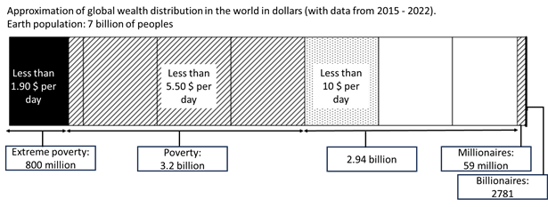

Summary

A modern society protects the rights of privacy, property, and wealth. It also protects citizen from poverty by providing a Universal Income to ensure a Minimum Acceptable Lifestyle. Employment for participate to society production effort and earning additional incomes is optional, with salaries supplementing the Universal Income, and the help of robotization and artificial intelligence. A modern society also calls for equal taxation by the use of flat taxes, transparency in government spending, and an educational system focused on skills that helps for a long-term societal growth.

Scope of application

The 8 Universal Principles are generics in order to be applicable by each government of each kind of modern societies.

The 8 Universal Principles

1. Privacy and property rights are fundamental

Privacy and Property are fundamental principles that could not be altered.

2. Everyone have the ability to secure their wealth

Gold and bitcoin are protection against fiat money inflation. Everyone can own, transport or exchange them.

* Each legal entity and citizens are free to hold gold and bitcoin in the way they want: Custody, personal vaults or wallets.
* Gold and bitcoin can be owned, transported and exchanged without any restrictions everywhere in the world, by using exchanges or OTC deals.

3. Governments have a high control on the usage of money

The use of a Central Bank Digital Currency (CBDC) with smart contracts allows the implementation of a smart Universal Income.

* An official CBDC wallet is provisioned for each citizen and it is managed by Central Bank and governments.
* Each citizen can create and manage additional CBDC wallets for their own purpose.
* Governments can fix usage on money sent to citizens: financial assistance for health care can only be spent for this purpose.
* Governments can send the Universal Income to each citizen in their official CBDC wallet with fixed usages: expiration delay, allowed only for consuming.

4. Every citizen have, at least, a Minimum Acceptable Lifestyle

Universal income remove poverty by giving a Minimum Acceptable Lifestyle to each citizen. For rent a place to live, a transportation system, pay food, clothes, goods and services.

* Universal Income amount corresponds to the Minimum Acceptable Lifestyle. Its amount is specific to a society. It is slightly lower than the total amount of charges of the median citizen. It allows citizens to have a decent lifestyle in the society where they are living.
* At the beginning of each month, Governments send the Universal Income to each adult citizen, in their official CBDC wallet. The income expiry date is 3 months and it can be used only for consuming.
* At the end of the 3 months, the Universal Income is completely spent by citizens or the remaining is returned to the Government.
* After a while, the Universal Income amount spent by citizens is returned to Government in the form of VAT.

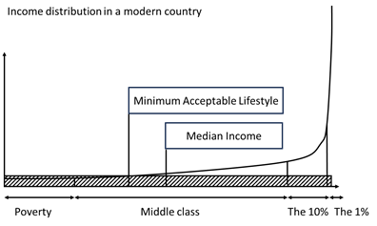

5. Every citizen have the choice to work or not

Jobs give the abilities to citizen to earn money and increase their wealth above the Minimum Acceptable Lifestyle.

* Each citizen is free to find a job, for earning extra money. Or not, and enjoy a life of leisure.
* When you have a job in a legal entity, the salary is delivered at the end of the month by the legal entity.
* Due to the Universal Income, minimum salary will be largely reduced, but high enough for citizens want to apply for the job.
* As opposite of the Universal Income, the Salary Income has no expiry date and can be used on all legal ways: saving, consuming, investing.
* A lot of citizens will choose to not work. This loss of work force will be compensated by a large use of automation, robotization and Artificial Intelligence.

6. Taxes equality for everyone

Each fiat money usage is charged by a flat tax. Taxes are equals for every citizen, and not block wealth creation and business development.

* VAT is applied for each consuming act, for each citizen and legal entities. For example, 20%
* Flat taxes on citizen and legal entity for everything: income, real estate, capital. For example, 10% on income, 20% on real estate, 30% on capital.

7. Government budget and expenses are public and detailed

Make governments budget and expenses public prevent fraud, misusage and create better and continuously improved financial management

* Government budget and expenses are be exposed in Open Data and accessible for each citizen without restriction. Its updated frequently, on a monthly basis.
* Only expenses concerning national security are not detailed.
* Citizen can have the ability to allocate a part of their taxes to specific government expenses.

8. Every citizen have a high-quality education

Educational System can give citizens the abilities to understand, and participate to society with efficiency. For a long-term societal growth, and help each citizen to accomplish their own purposes and the society purposes.

Educational program includes transversal skills in each domain (Maths, History, Sciences, Sport, Philosophy, Literature, ...):

* Problem solving
* Ability to work both in group and alone
* Use of modern informatic tools and programming skills
* Financial knowledge related to the jobs of the domain
* Legal knowledge related to the jobs of the domain

Educational levels are validated by final exams, continuous evaluations, and the use of a numeric ranking system.

References

Extreme poverty: <https://en.wikipedia.org/wiki/Extreme_poverty>

Millionaires in the world: <https://greenlight.com/learning-center/fun-facts/how-many-millionaires-in-the-world>

Billionaires in the world: <https://en.wikipedia.org/wiki/List_of_countries_by_number_of_billionaires>

Global income distribution: <https://ourworldindata.org/global-economic-inequality-introduction>

Gold as inflation hedge: <https://www.forbes.com/advisor/investing/gold-inflation-hedge/>

Bitcoin as inflation hedge: <https://www.ccn.com/education/the-truth-behind-bitcoins-inflation-hedge-theory/>

Universal Income: <https://en.wikipedia.org/wiki/Universal_basic_income>

Central Bank Digital Currency: <https://www.investopedia.com/terms/c/central-bank-digital-currency-cbdc.asp>