|  |  |
| --- | --- |
|  |  |
|  | 05 November 2015 |
|  |  |

Letter of support for Dr. Nicola Vianello for the Faculty Position in Plasma Physics

at the Ecole Polytechnique Fédérale de Lausanne (EPFL)

Dr. Vianello is a collaborator of mine for the last decade. Being involved in theoretical investigations and numerical simulations, I count myself lucky to have met in Dr. Vianello an open minded, curious and intelligent thinking experimentalist. Dr. Vianello has always been open to combine theory thoughts and results with recent experimental techniques and new approaches to measurement. He applied these new techniques using the highest standards in data analysis and interpretation. Specifically he has pioneered the application of local magnetic measurements in fusion experiments allowing for original and innovative investigations into the plasma edge dynamics. As the edge local magnetic structure is an ever more important parameter to investigate, these investigations have been pioneering new and relevant territory. The first class results obtained have granted Dr. Vianello a coordinating role in the corresponding EFDA group on 3D effects of magnetic fields in the edge and SOL.

Dr. Vianello has worked with me in highly international teams on devices as ASDEX Upgrade, JET and more recently TCV. He is a good motivator keeping the team focused and devoted to the task at hand. His scientific approach combines solid knowledge with the right amount of innovative elements to keep all people in the team engaged and thus utilizing their strengths for the common effort. I have experienced him as a meticulous planner with a good sense for detail, while having the whole picture of the task in mind.

Dr. Vianello has a strong knowledge in plasma physics and physics in general and he is excellent in disseminating this knowledge to students. He has been teaching at all levels (Bachelor, Master and PhD) and I have experienced his teaching and mentoring to be aimed at making the student autonomous, independent and open for creative thinking while keeping a thorough and analytical approach. His lectures are clearly presented and focused on the result at hand embedded into the relevant context, making it a pleasure to follow his talks.

The position at EPFL would not only be a logical step in Dr. Vianello career development, but in my eyes also be fitting an excellent person with an excellent research and education institution.

Yours sincerely,

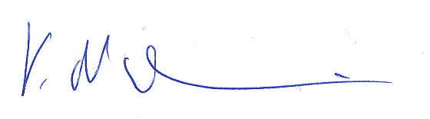

Prof. Dr. Volker Naulin

Head of Section Plasma Physics and Fusion Energy

Technical University of Denmark/Department of Physics

[vona@fysik.dtu.dk](mailto:vona@fysik.dtu.dk) +45 25374538