# readme for vel_SA_all.csv

This file contains information of how to read the columns from vel_SA_all.csv

vel_SA_all.csv is a dataset containing summary statistics for climate change velocities taken within each study area from the BioShifts database. Bellow is a screen shot of the dataset:

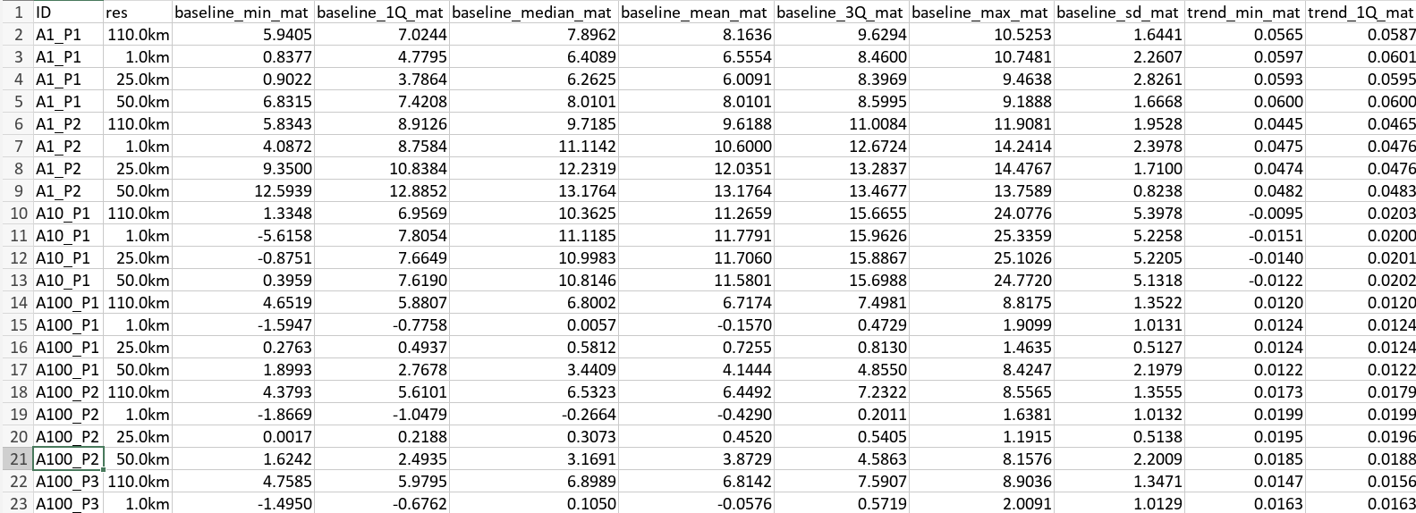

The first two columns of the dataset represent the study ID (column ID) and resolution of the environmental data used for calculating climate velocities (column res). Possible resolutions are: 1km, 25km, 50km, and 110km. For marine studies, we did not calculate statistics at 1km as climate variables are unavailable at this resolution.

The following columns are structured to represent a combination of attributes, named “variable”, “statistic” and “exposure”, such that each column name represents [variable]_[statistic]_[exposure].

Possible variables are:

|  |  |
| --- | --- |
| **Variable** | **Description** |
| baseline | Values of the exposure variable |
| trend | Slope of the exposure variable over time considering the duration of the range shift estimate within the study area |
| Vel | Climate change velocity |
| VelLat | Climate change velocity across latitude |
| VelEle | Climate change velocity across elevation |

Possible statistic are:

|  |  |
| --- | --- |
| **Statistic** | **Description** |
| min | Minimum value |
| 1Q | 1st quantile |
| median | Median value |
| mean | Mean value |
| 3Q | 3rd quantile |
| max | Maximum value |
| sd | Standard deviation |

Possible exposure are:

|  |  |
| --- | --- |
| **Exposure** | **Description** |
| mat | Mean annual temperature |
| map | Mean annual precipitation |
| sst | Seat surface temperature |

For example, the column “baseline_min_mat” indicates the minimum value of mean annual temperature across the study area, whereas the “trend_1Q_mat” indicate the value of the first quantile of trend in mean annual temperature.

## Important:

As in BioShifts there are studies conducted in land and ocean, we used realm-specific exposure variables. For instance, on land we used “mat” and “map”, whereas “sst” is only available for marine studies.

Also, metrics of “VelEle” were only calculated at the resolution of “1km”, as coarser resolutions would be less appropriate to represent elevation gradients.