

Sediment Trap Setup and Specifications

## Field Setup:

At each vertical hyporheic flux (VHF) probe location, two pairs of sediment trap types were deployed within 10 cm upstream and downstream of the probe center (Figure 1), with a total of 28 traps in the study reach. Each pair was installed in the same cross-section to ensure exposure to similar channel flow characteristics. The trap types consisted of (1) a solid PVC cylinder (6.5 cm diameter, 15 cm length) with an open bottom, allowing both upwelling and downwelling vertical flux exchange, and (2) the same PVC cylinder with a sealed bottom to eliminate the effects of VHF. Both trap types had solid walls as we focused solely on the impact of vertical fluxes on sediment deposition.

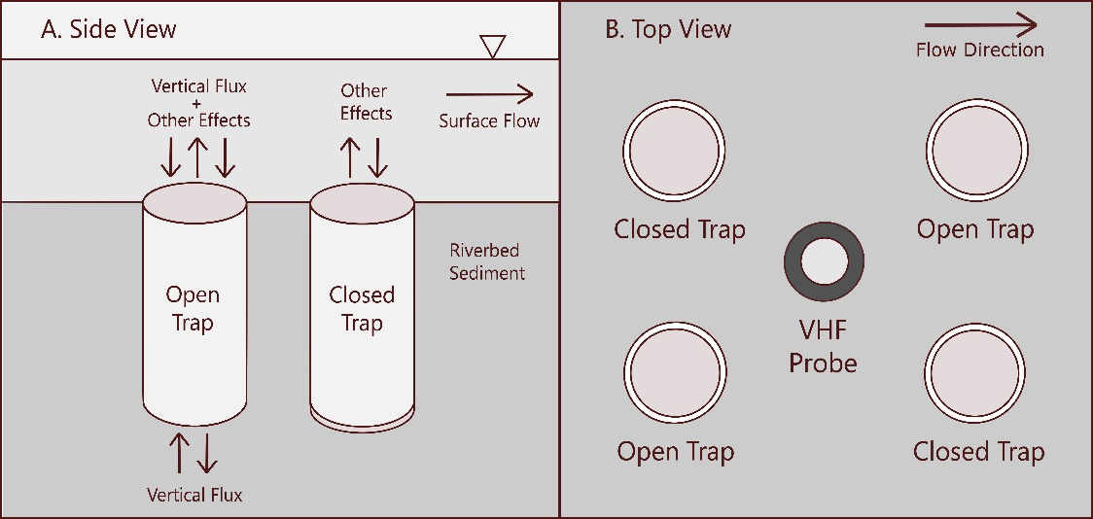

Figure 1. Conceptual diagram of sediment traps and stream setup

All PVC cylinders were filled with prewashed gravel with diameters greater than 10 mm enclosed in open 20-um mesh bags to capture and minimize the loss of fine sediment (Figure 2). Gravel was collected from the same stream in which the traps were installed to maintain consistency in sediment properties. At the end of each seasonal sampling period, the bags were removed, stored in plastic bags for laboratory processing, and replaced with new bags containing prewashed gravel for the next sampling period.

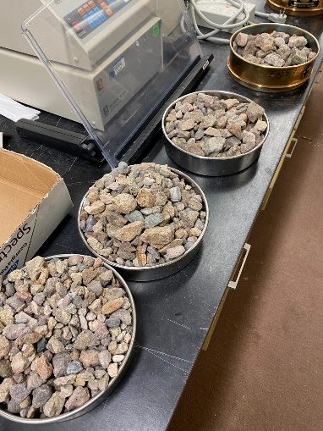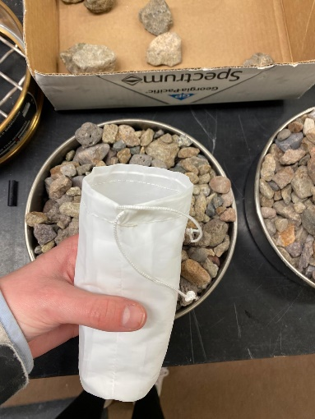 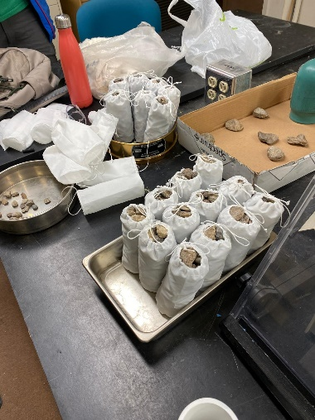

Figure 2. Pre-washed gravel and fine-mesh bag setup before field installation

To install the traps in the riverbed, we used a metal sleeve and a post driver to create holes matching the diameter and height of the PVC trap casings. Once the hole was large enough, we inserted each PVC casing flush with the streambed and repeated this process for all traps. The PVC casings were then filled with prewashed gravel and left in place for the duration of the sampling period. At the end of the period, the gravel and mesh bags were thoroughly rinsed to recover all deposited fine sediment.

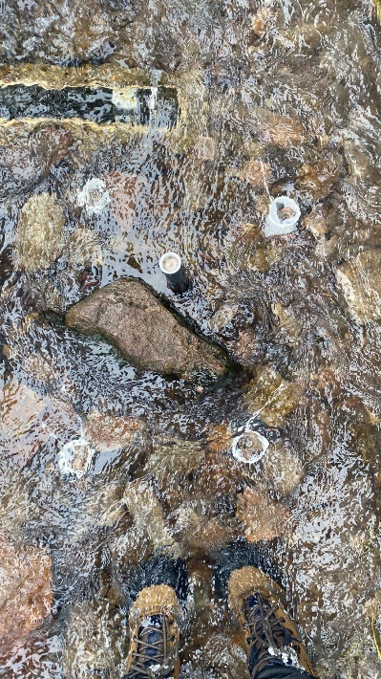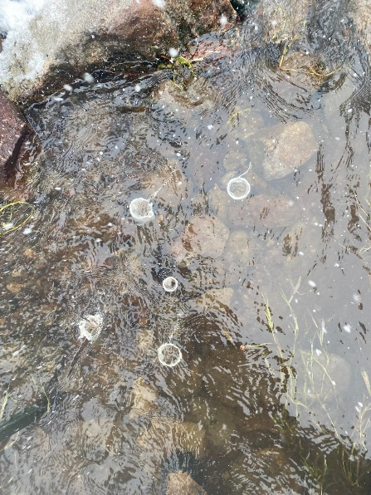 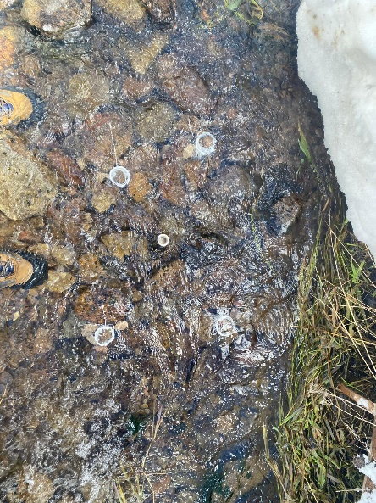

Figure 3. Field photos of installed sediment traps with respect to VHF probes

## Materials and design specifications:

* **Fine-mesh bags:** These were made from a moisture-resistant polyester mesh, sourced from [McMaster-Carr](https://www.mcmaster.com/products/mesh/mesh-size~371-371/). The mesh was sewn using nylon thread, following the pattern in Figure 4.

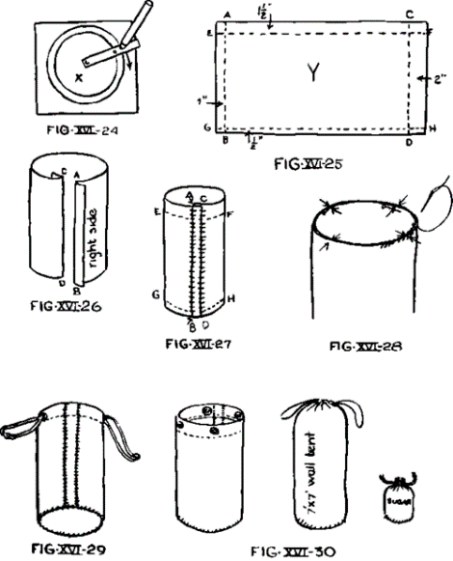

Figure 4. Sewing pattern for the fine-mesh bags

* **PVC trap casings:** Open-bottom traps were made by cutting 2.56″ (6.5 cm) PVC pipe into 15 cm sections. For the closed-bottom traps, clear acrylic sheets (3/32″ thick) were cut into circles matching the PVC pipe diameter and attached using waterproof epoxy putty.