Masteller Iteration Tests and Calibration Parameters
This is a summary document of how I calibrated the parameters using Masteller et al., 2025 predictive model for critical shear stress during temporal τ* data gaps.

Assuming τ*c re-initializes for data gaps
For this, I assume that whenever there is a data gap, τ*c values are NaN, and τ*c evolution will start again from a new known value of τ*c.

First parameter calibration:
Data ranges:
K₁ | 10⁻⁶ – 10⁻² | n=40
K₂ | 10⁻⁶ – 10⁻² | n=40
ε | 1-10 | n=10
Min and max from Masteller 2025: 0.0343 – 0.3435 (from La Jara Slope)
Best fit:
K₁ | 4.12 * 10⁻⁶
K₂ | 2.29 * 10⁻⁴
ε | 1
MAE= 0.03039
Due to the min and max ranges, the weakening was too strong and the τ*/ τ*c did not allow for the equation to continue strengthening
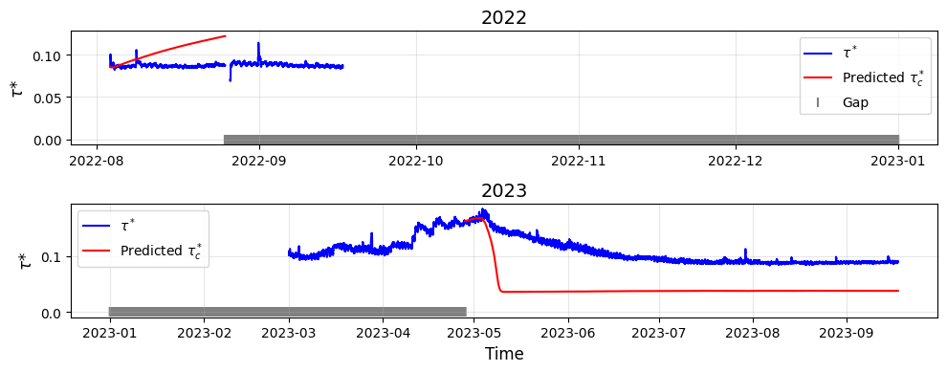

Second parameter calibration:
Data ranges:
K₁ | 10⁻⁶ – 10⁻² | n=40
K₂ | 10⁻⁶ – 10⁻² | n=40
ε | 1-10 | n=10
Min and max from Masteller 2025: 0.08 – 0.2 (from La Jara τ*c measurements)
Best fit:
K₁ | 1 * 10⁻⁶
K₂ | 5.54 * 10⁻⁵
ε | 1
MAE = 0.01255
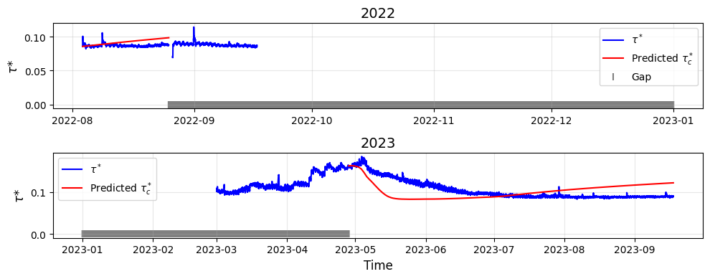

Third parameter calibration:
Data ranges:
K₁ | 10⁻⁶ – 10⁻⁴ | n=40
K₂ | 10⁻⁵ – 10⁻³ | n=40
ε | 1-10 | n=10
Min and max from Masteller 2025: 0.08 – 0.2 (from La Jara τ*c measurements)
Best fit:
K₁ | 1 * 10⁻⁶
K₂ | 4.64 * 10⁻⁵
ε | 1
MAE = 0.01202
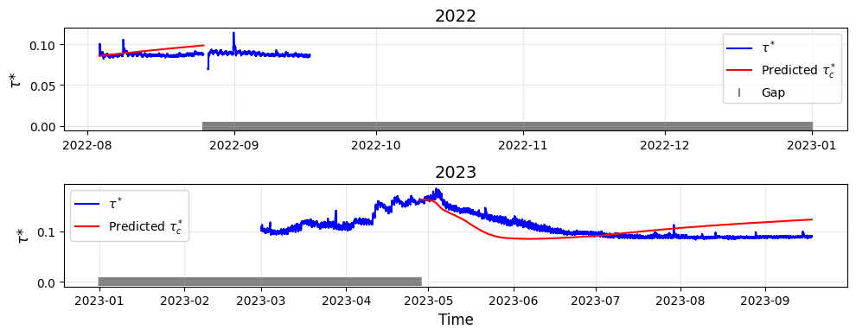

Fourth parameter calibration:
Data ranges:
K₁ | 10⁻⁶ – 10⁻² | n=40
K₂ | 10⁻⁶ – 10⁻² | n=40
ε | 0-2 | n=20
Min and max from Masteller 2025: 0.08 – 0.2 (from La Jara τ*c measurements)
Best fit:
K₁ | 1 * 10⁻⁶
K₂ | 3.07 * 10⁻⁴
ε | 1.789
MAE = 0.0118

Analysis and Conclusion:
K₁ is well constrained, whereas K₂ and ε, similar to the findings of Masteller (2025), the weakening parameters are harder to constrain because we have very few exceedance observations, which cause “equifinality” (different parameters cause the same result).
However, when comparing the predicted τ*c to our measured values, using this equation still outperforms the assumption of a constant river τ*c over the full observation period. MAE is 44% (lower) when using the model vs assuming constant τ*c.
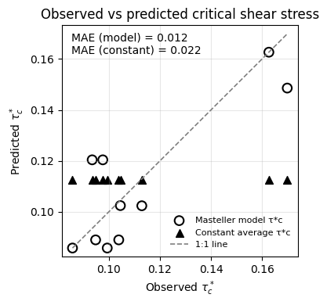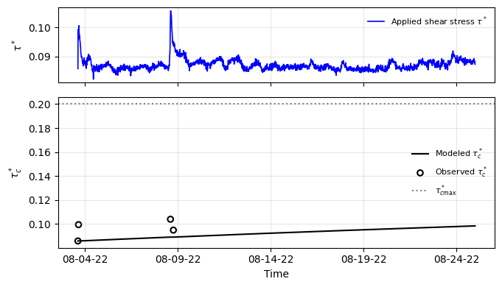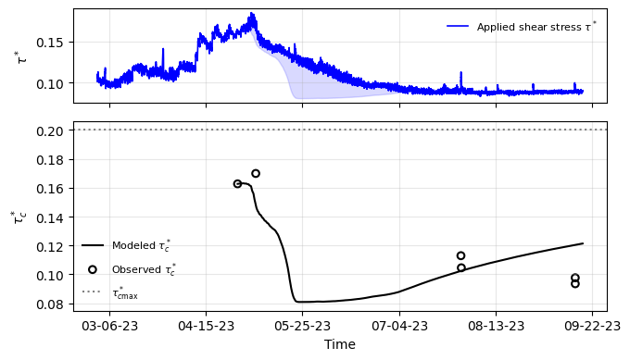
Plots above correspond to the fourth iteration of calibrated equation parameters to predict τ*c

Assuming τ*c continuous for data gaps
Instead of assuming NaN values and re-initialization of τ*c, we assume that it will remain as the same value during data gaps, and will continue to evolve when τ* record starts again
Data ranges:
K₁ | 10⁻⁶ – 10⁻² | n=40
K₂ | 10⁻⁶ – 10⁻² | n=40
ε | 1-10 | n=10
Min and max from Masteller 2025: 0.08 – 0.2 (from La Jara τ*c measurements)
Best fit:
K₁ | 1 * 10⁻⁶
K₂ | 3.8 * 10⁻³
ε | 6
MAE = 0.019
Doing this is slightly worse than re-initializing τ*c and increases ε significantly. We can also note that the strengthening is overpredicting during small flow magnitudes but underpredicting during high flow spring snowmelt. This means that the effect of τ* magnitude should be more explicitly influencing the rate of increase at each time step.
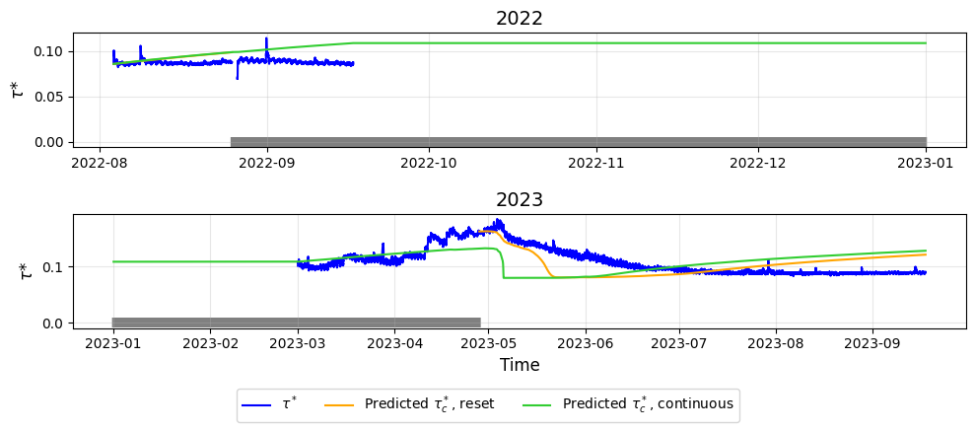
Lastly, if we compare re-initializing τ*c to assuming a continuous value during data gaps, the MAE is 40.6% better when re-initializing.

Assuming τ*c minimum for data gaps
We assume that it will reset to the minimum τ*c during data gaps and will continue to evolve when τ* record starts again.
Data ranges:
K₁ | 10⁻⁶ – 10⁻² | n=40
K₂ | 10⁻⁶ – 10⁻² | n=40
ε | 1-10 | n=10
Min and max from Masteller 2025: 0.08 – 0.2 (from La Jara τ*c measurements)
Best fit:
K₁ | 1 * 10⁻⁶
K₂ | 7.44 * 10⁻⁴
ε | 7
MAE = 0.0241
This is the worst MAE so far, and it is because the effect of strengthening discussed in (2) are even more present in this case. MAE using the re-initialized τ*c is 51% better than assuming a minimum reset.
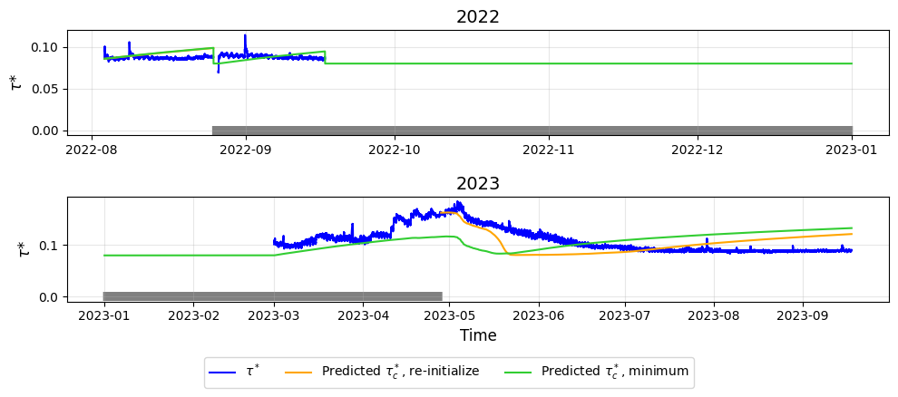

Not considering falling limb samples

