EPI590R R Lab 2
Nicole Luisi
10-01-2026

Over the last couple of weeks, you learned how to manipulate data and create Epi Curves with Microsoft Excel. In this lab, we will use the same dataset to produce similar visualizations with R.
First, make sure you have the necessary packages installed and loaded.
readxl to read Excel files
dplyr and tidyr to manipulate data
lubridate to work with dates
purrr and skimr to explore data
stringr to work with strings
ggplot2 to create data visualizations
knitr to help with our images in the document
RColorBrewer for colors
sf for spatial work
tigris for shapefiles
gt for tables
openxlsx for exporting tables to Excel
gtsummary for tables
glue for working with text strings
flextable for tables
ggpattern for plot patterns

Step 1 - Import the data (EPI590R_dataset_2026.xlsx).

data <- read_excel("data/EPI590R_dataset_2026.xlsx")

Step 2 - Explore the data.

The dplyr::glimpse() function will show us the number of rows and columns, list the variables and variable types, and give us an idea of the data values. We could also use str() for this. The head() function will print just a few rows of the dataset, here n=10 rows is specified. The skimr::skim() function also gives us a good overview. We can also use some features in the purrr package to run a function that asks R to return the most appropriate type of output based on variable type. Numeric variables will use summary(), factor and character variables with use table(), and datetime variables will also use summary().
Note that we are using results=‘hide’ in the code chunk to suppress all of this output from the knitted Word doc..

head(data, n=10)
dplyr::glimpse(data)
skimr::skim(data)
purrr::imap(data, \(x, var) {
if (var == "ID") return(NULL)
if (is.numeric(x)) return(summary(x))
if (inherits(x, "Date")) return(summary(x))
if (is.factor(x)) return(table(x, useNA = "always"))
if (is.character(x)) return(table(x, useNA = "always"))
if (is.logical(x)) return(table(x, useNA = "always"))
if (inherits(x, "POSIXct") || inherits(x, "POSIXt")) return(summary(x))
})

Step 3 - Clean and prepare data for analysis.

Based on the previous Excel lab, we will be using pos_test_date for our cases, and we may want to do some grouping by race (race) and age (DOB) later on, so we will start by cleaning those variables up a bit.

Here we are creating 3 new variables:
The age variable is calculated by subtracting the date of birth (DOB) from the positive test date (pos_test_date) and converting that to years; this will give us the age at the time of diagnosis.
From there, the age_group factor variable is created by using the continuous age values to make 10 year age groups, with the exception of the last group which will have all values >=70 years.
Next, a race_cat factor variable is created - we are combining the NAs with the Unknowns, but can use this approach to collapse other groups as needed.
We will also check for missing values in the pos_test_date variable so we can remove them before we make our plots.

data <- data %>%
mutate(age = as.numeric(difftime(pos_test_date, DOB, units = "days")) %/% 365.25,
age_group = as.factor(cut(age,
breaks = c(seq(0, 70, by = 10), Inf),
right = FALSE,
labels = c(paste(seq(0, 60, by = 10), seq(9, 69, by = 10), sep = "-"), "70+"),
include.lowest = TRUE)),
race_cat = as.factor(case_when(
race == "American Indian/Alaska Native" ~ "American Indian/Alaska Native",
race == "Asian" ~ "Asian",
race == "Black" ~ "Black",
race == "Native Hawaiian/Other Pacific Islander" ~ "Native Hawaiian/Other Pacific Islander",
race == "White" ~ "White",
race == "Multiple Races" ~ "Multiple Races",
TRUE ~ "Unknown")))
# Check age variables
check <- data %>% select(pos_test_date, DOB, age, age_group)
head(check, n=10)
## # A tibble: 10 × 4
## pos_test_date DOB age age_group
## <dttm> <dttm> <dbl> <fct>
## 1 2023-08-03 00:00:00 1997-04-02 00:00:00 26 20-29
## 2 2022-01-02 00:00:00 1963-07-16 00:00:00 58 50-59
## 3 2023-11-05 00:00:00 1992-09-17 00:00:00 31 30-39
## 4 2022-11-26 00:00:00 1986-10-10 00:00:00 36 30-39
## 5 2022-10-10 00:00:00 1988-08-18 00:00:00 34 30-39
## 6 2023-11-14 00:00:00 1971-12-08 00:00:00 51 50-59
## 7 2023-12-08 00:00:00 1997-05-10 00:00:00 26 20-29
## 8 2023-08-20 00:00:00 1974-11-13 00:00:00 48 40-49
## 9 2023-11-07 00:00:00 2006-05-16 00:00:00 17 10-19
## 10 2023-01-01 00:00:00 1937-10-29 00:00:00 85 70+
# Check race variable
data %>% count(race, race_cat) %>%
tidyr::pivot_wider(names_from = race_cat, values_from = n, values_fill = list(n = 0))
## # A tibble: 8 × 8
## race American Indian/Alas…¹ Asian Black `Multiple Races`
## <chr> <int> <int> <int> <int>
## 1 American Indian/Alaska Na… 28 0 0 0
## 2 Asian 0 371 0 0
## 3 Black 0 0 1013 0
## 4 Multiple Races 0 0 0 336
## 5 Native Hawaiian/Other Pac… 0 0 0 0
## 6 Unknown 0 0 0 0
## 7 White 0 0 0 0
## 8 <NA> 0 0 0 0
## # ℹ abbreviated name: ¹​`American Indian/Alaska Native`
## # ℹ 3 more variables: `Native Hawaiian/Other Pacific Islander` <int>,
## # Unknown <int>, White <int>
# Check for any missing pos_test_date value
data %>% summarise(num_NA = sum(is.na(pos_test_date)))
## # A tibble: 1 × 1
## num_NA
## <int>
## 1 0

Step 4 - Plot the case counts by day.

First, we will use summarise() to count the number of cases by day. Our pos_test_date variable is already by day (exact dates) so we will use this as the grouping variable.

data_cases_per_day <- data %>%
group_by(pos_test_date) %>%
summarise(cases = n()) %>%
mutate(pos_test_date=as.Date(pos_test_date))
# Check results
head(data_cases_per_day, n=10)
## # A tibble: 10 × 2
## pos_test_date cases
## <date> <int>
## 1 2022-01-01 10
## 2 2022-01-02 8
## 3 2022-01-03 5
## 4 2022-01-04 7
## 5 2022-01-05 4
## 6 2022-01-06 2
## 7 2022-01-07 1
## 8 2022-01-08 3
## 9 2022-01-09 3
## 10 2022-01-10 8

Before we try to plot anything, let’s take a look at the date range for pos_test_date. We will double check to make sure there are no NAs (there shouldn’t be), and then use range(). We are including na.rm=T so that this step works even if there are NAs, but again we should not have any.
It looks like our date range is Jan 1, 2022 to December 31, 2023.
We can also get a range of values for the case counts to inform how we set up our plot axis.
It looks like we have daily counts from 1 to 13.

# Check to make sure there are no NAs
table(is.na(data_cases_per_day$pos_test_date))
##
## FALSE
## 706
# Now to get the date range
range(data_cases_per_day$pos_test_date, na.rm = TRUE)
## [1] "2022-01-01" "2023-12-31"
# And range of values for the cases
range(data_cases_per_day$cases)
## [1] 1 13

Okay, now let’s get to work on a daily case plot.

First, we are going to use our date range to make a start and end point. We want to make sure our plot is uniform, so we will use the list of dates to enforce consistent 1 day increments, even if we don’t have any cases on some days (we will merge this list of dates with our own data and set the case count for any days without cases to zero).
We will also go ahead and create a variable to store the cumulative sum of cases (cumulative_case_count) using the cumsum() function.

# Dataset of all dates in the range we have
all_dates <- data.frame(daterange = seq(as.Date("2022-01-01"), as.Date("2023-12-31"), by = "day"))
# Merge with our data and insert 0's if no cases
data_cases_per_day_rev <- merge(x=all_dates,
y=data_cases_per_day,
by.x = "daterange",
by.y="pos_test_date",
all.x=T) %>%
mutate(cases = replace_na(cases, 0)) %>%
mutate(cumulative_case_count = cumsum(cases))
# Check result
head(data_cases_per_day_rev, n=10)
## daterange cases cumulative_case_count
## 1 2022-01-01 10 10
## 2 2022-01-02 8 18
## 3 2022-01-03 5 23
## 4 2022-01-04 7 30
## 5 2022-01-05 4 34
## 6 2022-01-06 2 36
## 7 2022-01-07 1 37
## 8 2022-01-08 3 40
## 9 2022-01-09 3 43
## 10 2022-01-10 8 51

Next, let’s make a plot of the cases by day using ggplot.

Note that the new date variable in the merged file is called daterange and the case count variable is called cases; these will become our x and y for the plot.
geom_col(fill = "#002060") is setting the color for our columns. You can swap that out for any hex code or color name in the quotes.
labs() allows us to set a main title for the plot (title=), as well as titles for the x (x=) and y (y=) axis. You can edit those labels as needed.
scale_x_date() is used to change the format of the date labels on the x axis. The %b gives an abbreviated month name (i.e., Jan, Feb, Mar), %d gives a 2-digit day, and %Y gives a 4-digit year. You can try using other date formats here as well. The breaks argument is specifying 2 week intervals for the dates between the start and end value we set.
scale_y_continuous() is creating some specifications for the values on the y axis based on our maximum daily case counts.
theme_light() and theme() elements are just customizing the look a bit more. For the x axis text, we are making sure those dates are vertical (angle=90) so they don’t overlap, similar to the way they look in Excel.
Note that we are storing the whole plot in an object called fig1a so we can easily save it as an image file. We are using theme_light() here because this looks best in the png file.

# Provide start and end dates to force plot boundaries
start_date <- as.Date("2022-01-01")
end_date <- as.Date("2023-12-31")
# Daily plot
fig1a <- ggplot(data_cases_per_day_rev, aes(x = daterange, y = cases)) +
geom_col(fill = "#002060") +
labs(title = "Figure 1 V1. Number of Confirmed Cases of Disease X in County Y, 2022-2023",
x = "Date of Positive Test",
y = "Daily Case Count") +
scale_x_date(date_labels = "%b %d, %Y",
breaks = seq(start_date, end_date, by="2 weeks")) +
scale_y_continuous(
limits = c(0, 12),
breaks = seq(0, 12, by = 2)) +
theme_light() +
theme(axis.text.x = element_text(angle = 90, hjust = 1, vjust = 0.5))
# Save plot as png image
ggsave("output/Figure 1 V1.png", plot = fig1a, width = 10, height = 8, dpi = 500)
## Warning: Removed 1 row containing missing values or values outside the scale range
## (`geom_col()`).
# Print image here
knitr::include_graphics("output/Figure 1 V1.png")
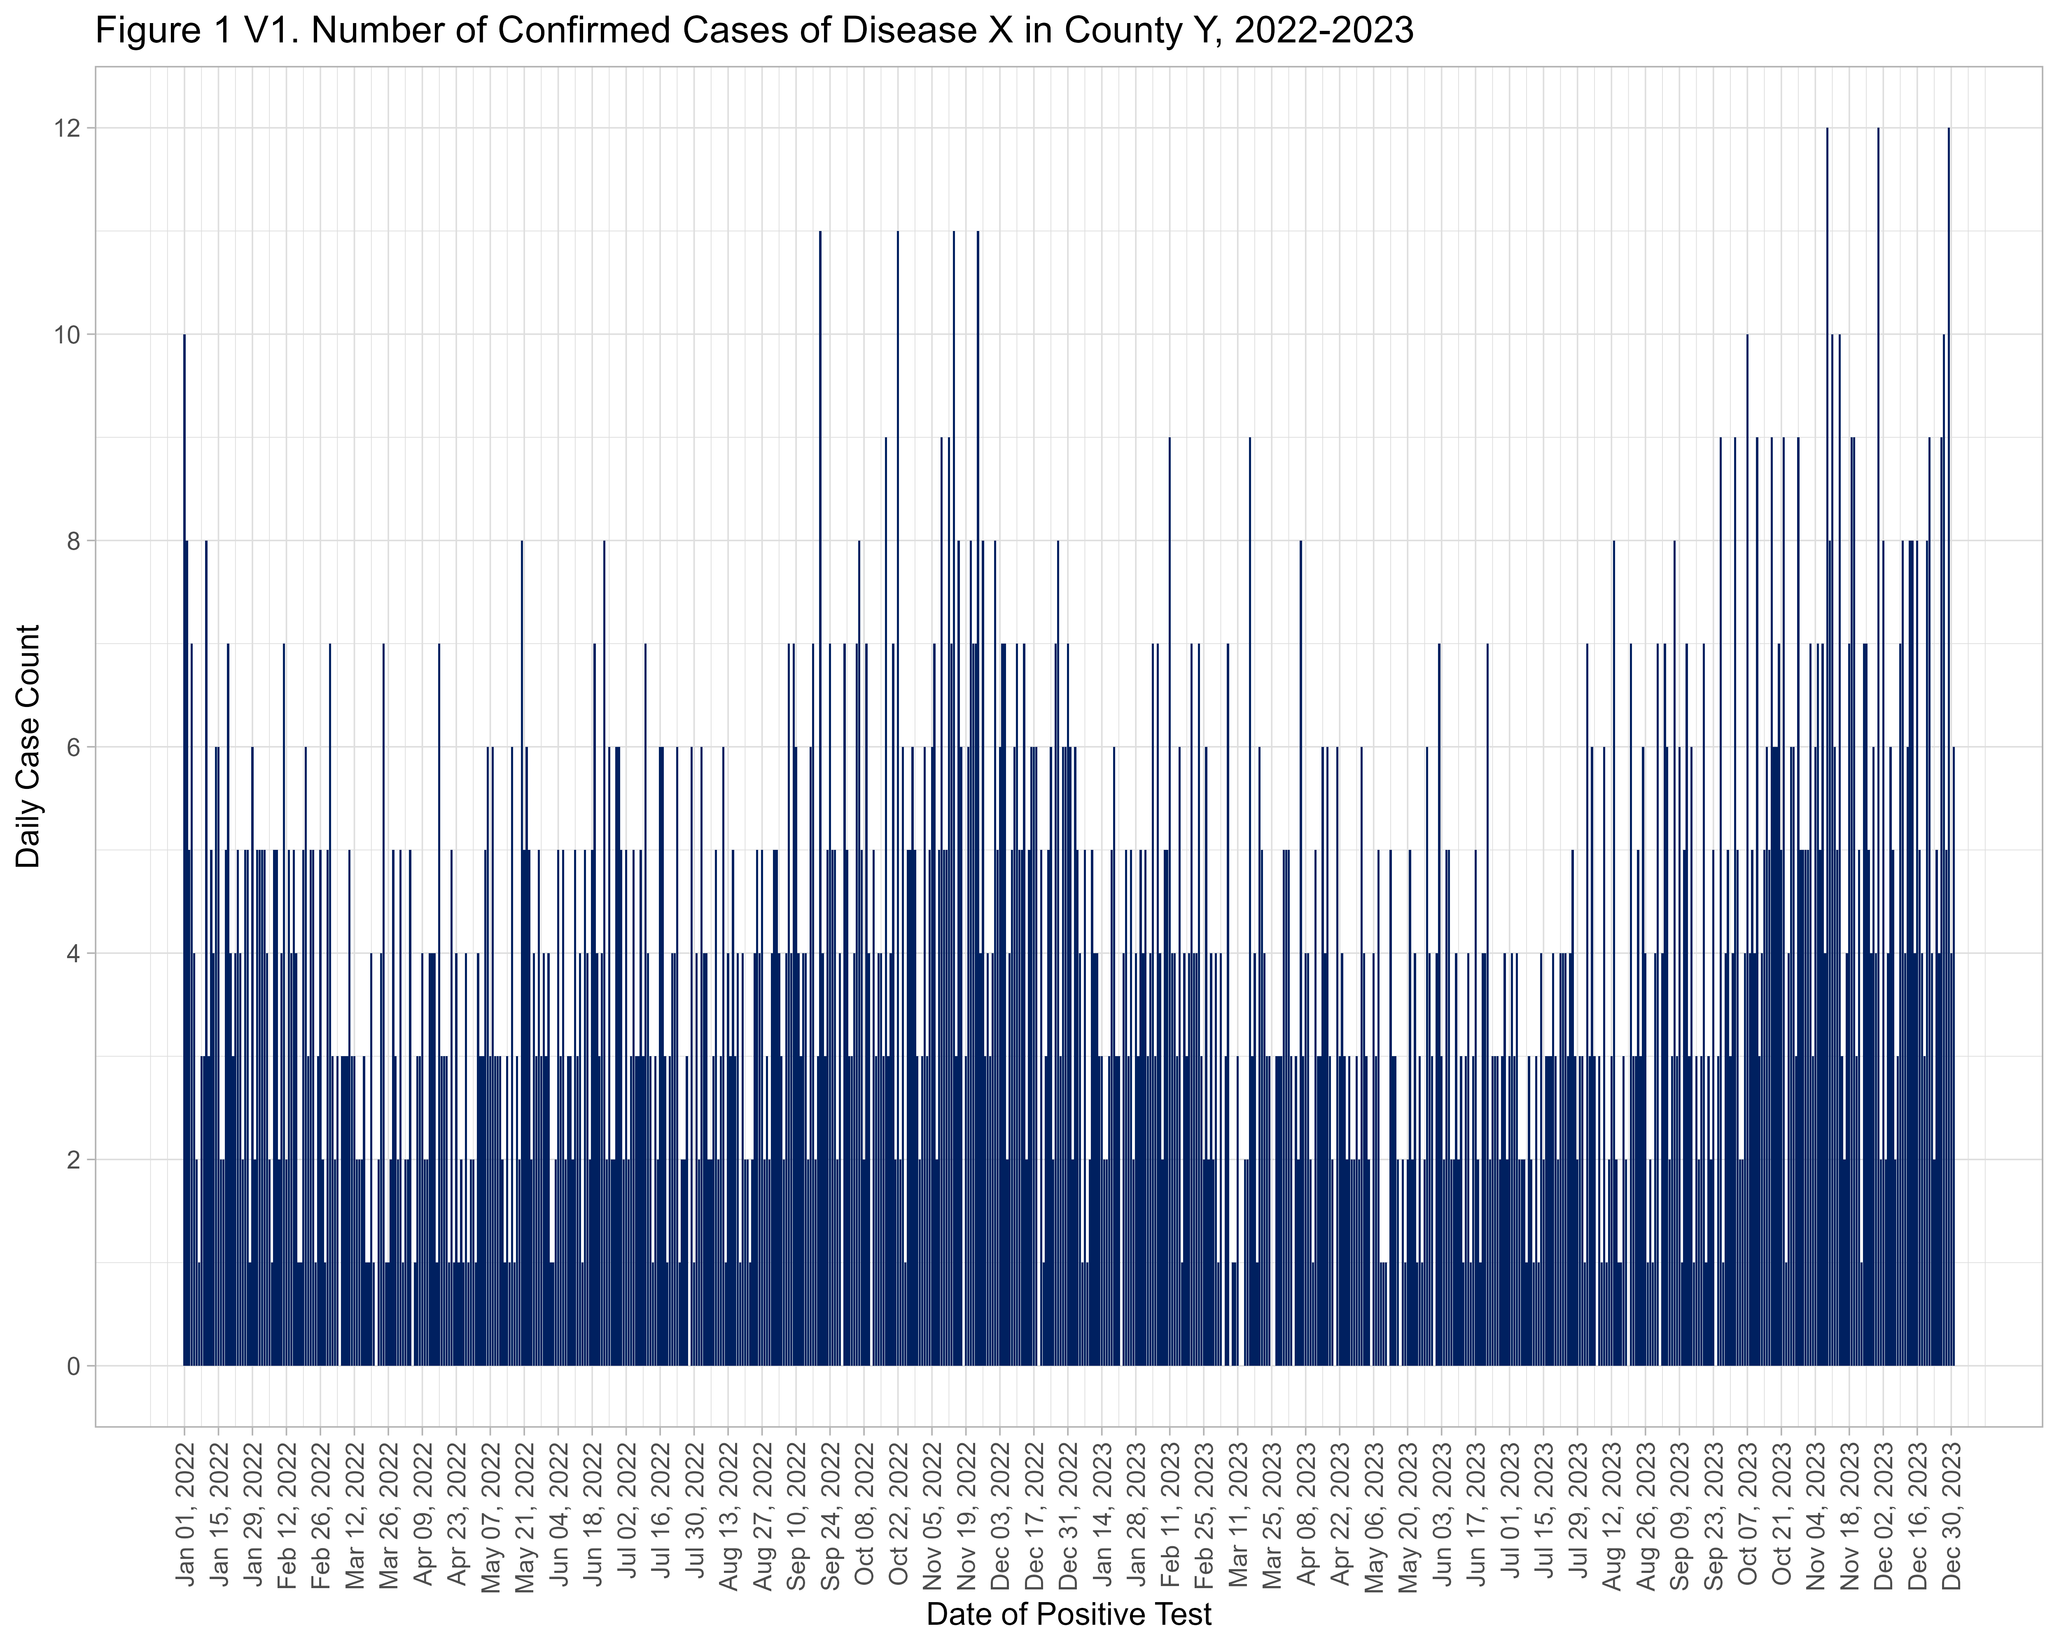
Do you see any issues? I do!

What is the issue and how can we modify the code above to fix this? In the space below this, describe the issue and the change you would suggest for the code. Then try modifying the code above and run the plot again.
# Warning: Removed 1 row containing missing values or values outside the scale range (`geom_col()`).
# Looks like cases goes up to 14 but we set the limit to 12 so it's cut off
# Fix: scale_y_continuous(limits = c(0, 14), breaks = seq(0, 14, by = 2)) - this is updated in next plot below

Now let’s fancy this up a bit more like you did in Excel. Here we will copy and paste the same basic plot and add some additional features.

geom_line() is used to overlay a line with our cumulative case count (cumulative_case_count). Here we are using 12/3000 to rescale the cumulative case count to match the scale we have for daily cases.
sec.axis() in scale_y_continuous() allows us to have a secondary axis on the right side of the plot for the cumulative case count while keeping the scale we have for daily case count on the left. We will use increments of 500 for this one. By reworking the aes settings in this version we can use scale_fill_manual and scale_color_manual to set colors for the daily case count columns and the cumulative case total line. Again, feel free to adjust these color hex codes - check out Color Brewer for guidance.
In the theme() section we will specify some info for the legend so we can get a key at the bottom with the colors for our columns and line.

# Plot
fig1b <- ggplot(data_cases_per_day_rev, aes(x = daterange)) +
geom_col(aes(y=cases, fill = "Daily Cases"), show.legend = TRUE) +
geom_line(aes(y = cumulative_case_count * (14/3000), color = "Cumulative Cases"), linewidth = 1) +
labs(title = "Figure 1 V2. Number of Confirmed Cases of Disease X in County Y, 2022-2023",
x = "Date of Positive Test",
y = "Daily Case Count") +
scale_x_date(date_labels = "%b %d, %Y",
breaks = seq(start_date, end_date, by="2 weeks")) +
scale_y_continuous(
limits = c(0, 14),
breaks = seq(0, 14, by = 2),
sec.axis = sec_axis(~ .*(3000/14), name = "Cumulative Case Count", breaks = seq(0, 3000, by = 500))) +
scale_fill_manual(values = "#002060", labels = "Daily Cases") +
scale_color_manual(values = "#00AC45", labels = "Cumulative Cases") +
theme_light() +
theme(axis.text.x = element_text(angle = 90, hjust = 1, vjust = 0.5),
legend.position = "bottom",
legend.title = element_blank()) +
guides(color = guide_legend(override.aes = list(fill = NA, shape = NA)),
fill = guide_legend(override.aes = list(color = NA)))
# Save plot as png image
ggsave("output/Figure 1 V2.png", plot = fig1b, width = 10, height = 8, dpi = 500)
# Print image here
knitr::include_graphics("output/Figure 1 V2.png")
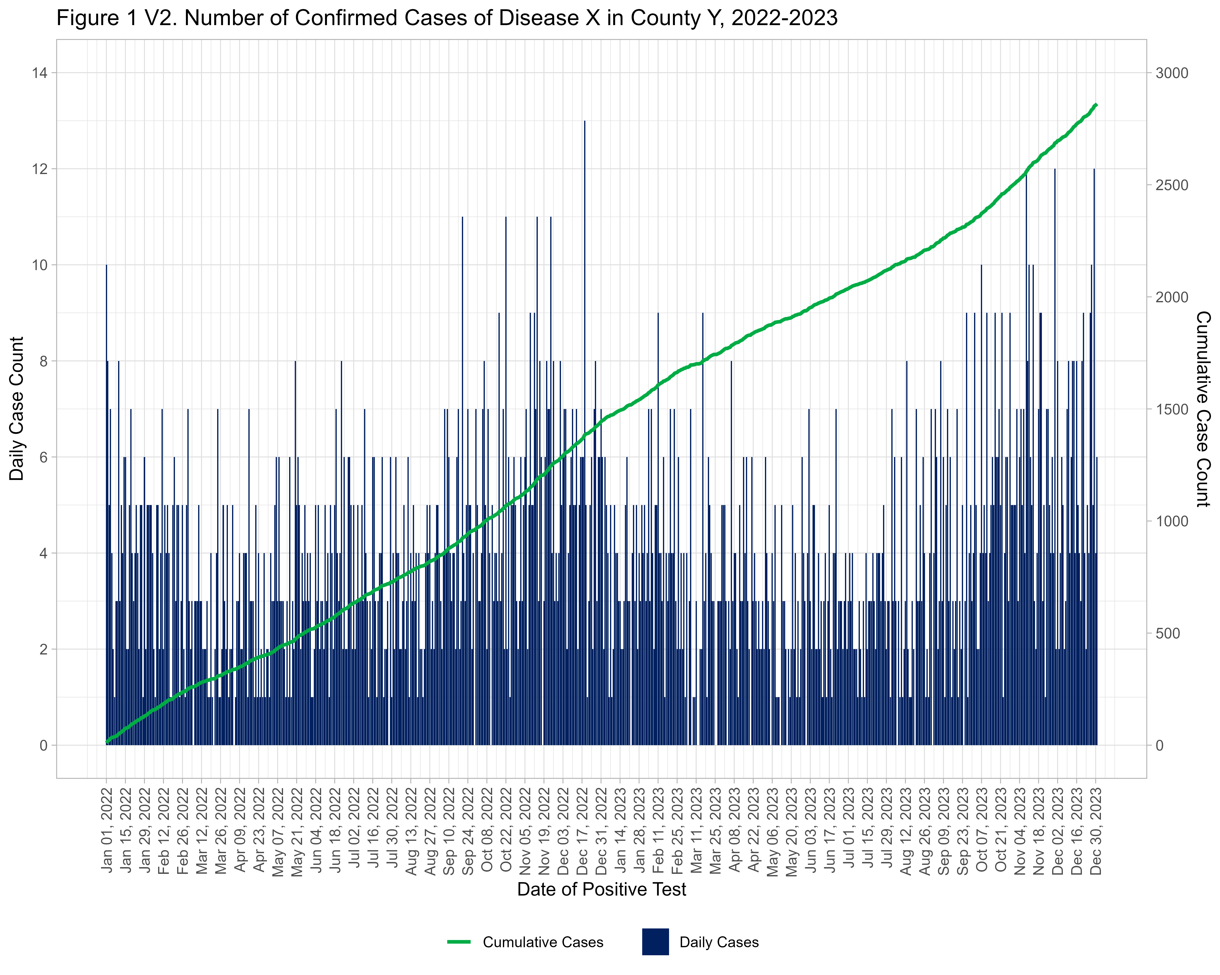

Step 5 - Plot the case counts by month.

First, we will use summarise() to count the number of cases by month. Here, as.Date(cut(pos_test_date, "month")) will group the counts by unique values for month.

data_cases_per_month <- data %>%
mutate(month = as.Date(cut(pos_test_date, "month"))) %>%
group_by(month) %>%
summarise(cases = n())
# Check results
head(data_cases_per_month, n=10)
## # A tibble: 10 × 2
## month cases
## <date> <int>
## 1 2022-01-01 137
## 2 2022-02-01 103
## 3 2022-03-01 88
## 4 2022-04-01 78
## 5 2022-05-01 111
## 6 2022-06-01 111
## 7 2022-07-01 103
## 8 2022-08-01 100
## 9 2022-09-01 135
## 10 2022-10-01 138

Again, before we try to plot anything, let’s take a look at the date range for month. We will double check to make sure there are no NAs (no months without any cases).
It looks like our date range is Jan 2022 to December 2023.
We can also get a range of values for the case counts to inform how we set up our plot axis.
It looks like we have monthly counts from 78 to 183.

# Check to make sure there are no NAs
table(is.na(data_cases_per_month$month))
##
## FALSE
## 24
# Now to get the date range
range(data_cases_per_month$month, na.rm = TRUE)
## [1] "2022-01-01" "2023-12-01"
# And range of values for the cases
range(data_cases_per_month$cases)
## [1] 78 183

Now let’s make the monthly plot.
Note that the new date variable is called month and the case count variable is called cases; these will become our x and y for the plot.
The elements of the monthly plot are similar to the daily plot above, but we have done a few extra things.
For the monthly plot, the scale_x_date() breaks are 1-month intervals.
The custom_labels function is allowing us to plot the month abbreviations on the x axis but only including the year value with the month when the year changes, otherwise the axis is really busy and repetitive.
We are also using geom_text() to insert a label with the number of cases inside each column; you can adjust the placement, size, and color of these labels as needed.

# Function to help with some custom labels for our x axis
custom_labels <- function(dates) {
months <- format(dates, "%b")
years <- format(dates, "%Y")
labels <- ifelse(duplicated(years), months, paste(months, years, sep = "\n"))
return(labels)
}
# Plot
fig2 <- ggplot(data_cases_per_month, aes(x = month, y = cases)) +
geom_col(fill = "#002060") +
geom_text(aes(label = cases), vjust = 1.5, color = "white", size=2.5, fontface="bold") +
labs(title = "Figure 2. Monthly Confirmed Cases of Disease X in County Y, 2022-2023",
x = "Date of Positive Test",
y = "Confirmed Cases") +
scale_x_date(labels = custom_labels, breaks = seq(start_date, end_date, by = "1 month")) +
theme_light()
# Save plot as png image
ggsave("output/Figure 2.png", plot = fig2, width = 10, height = 8, dpi = 500)
# Print image here
knitr::include_graphics("output/Figure 2.png")
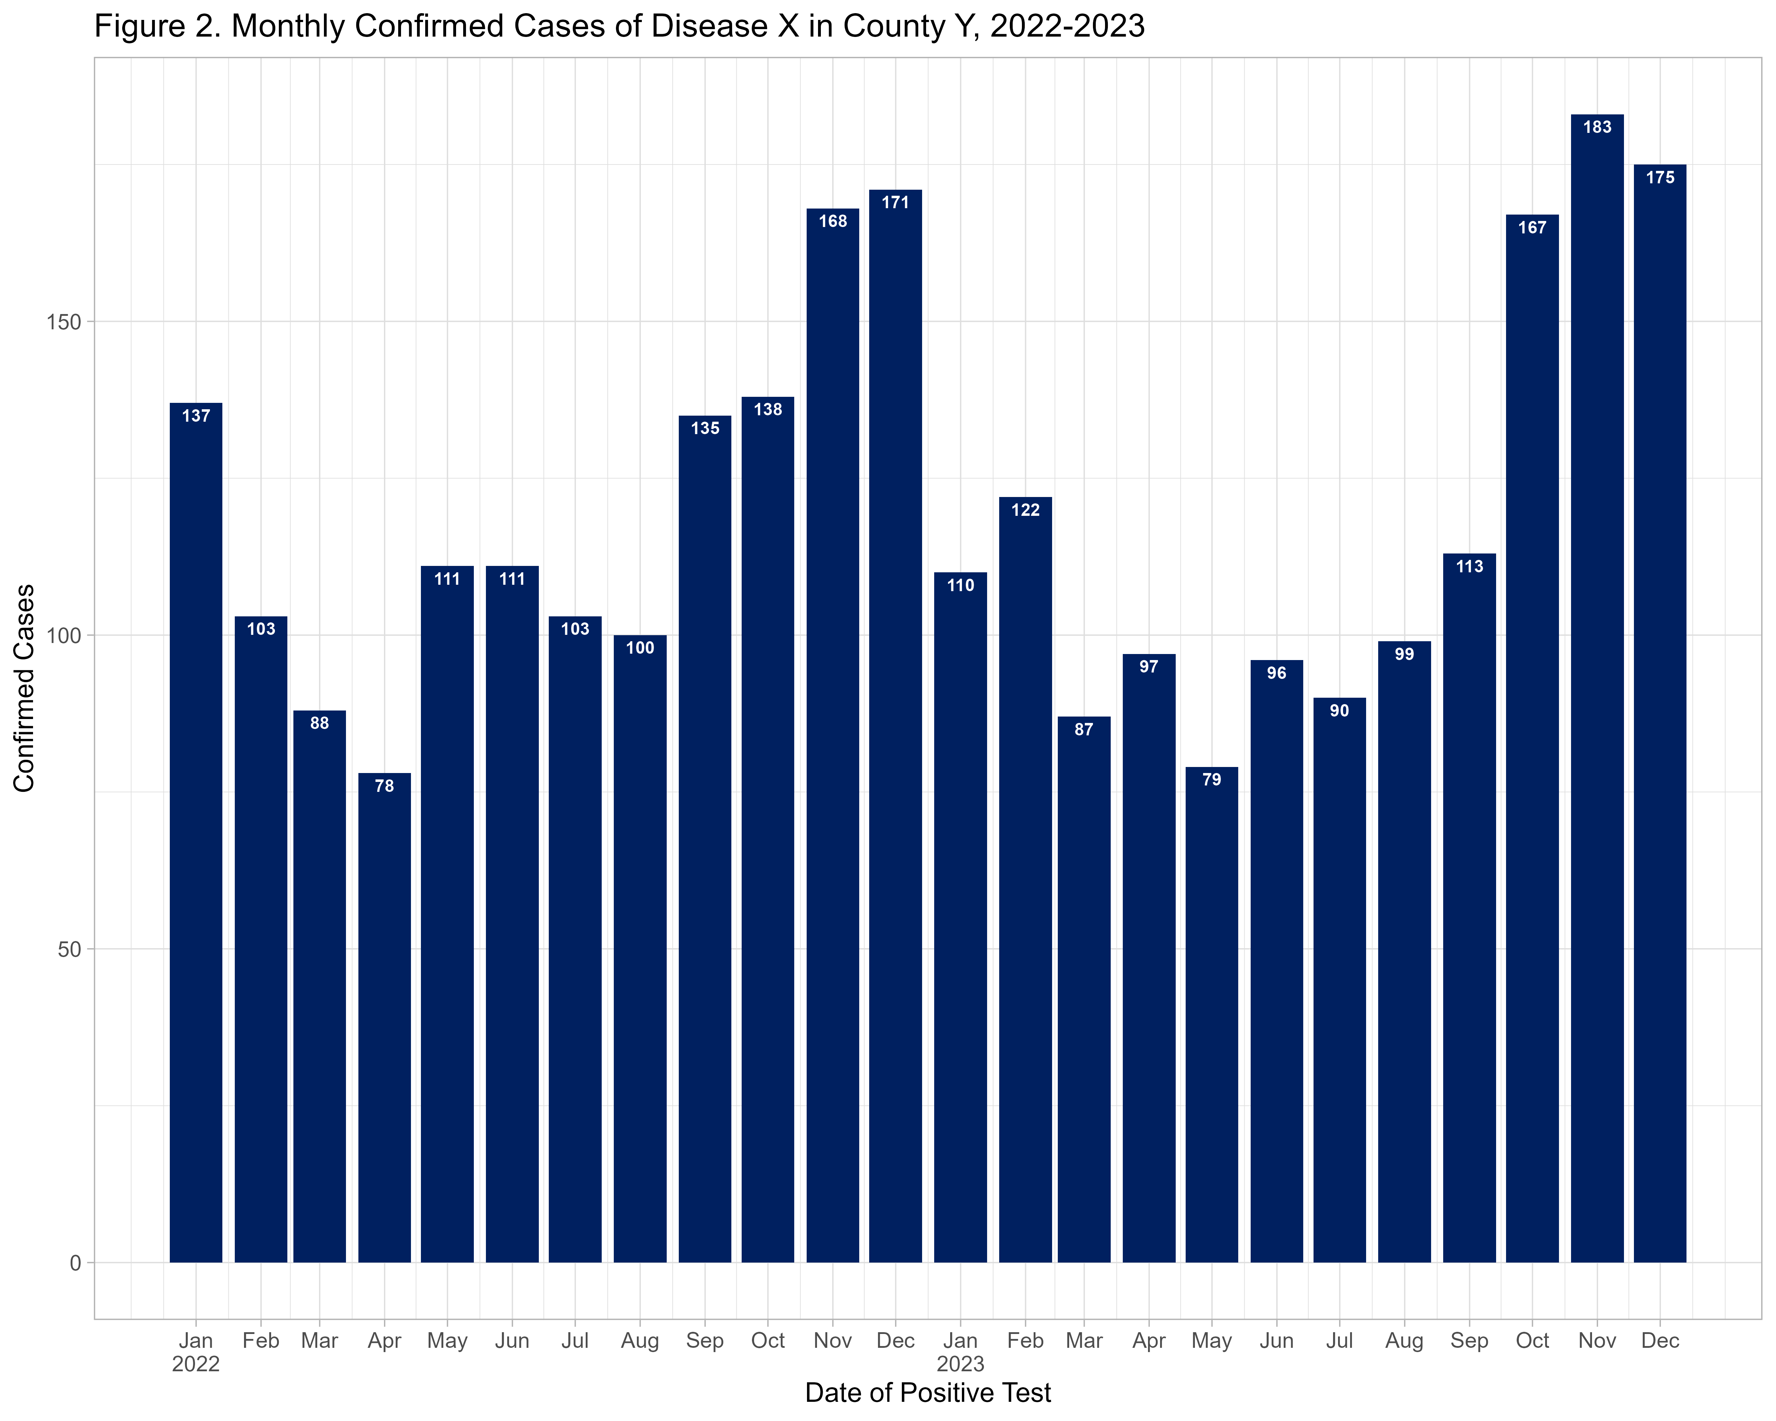
Step 6 - Make some stratified weekly plots.

First, let’s make a weekly plot stratified by race. We will go back to using the original file here so we have all of our other grouping variables.

Note that our race categories are alphabetical here, we would have to reorder our factor variable to put these in a different order. You can use forcats::fct_relevel for that.

# Create breaks by week
breaks_by_week <- seq.Date(
from = floor_date(min(as.Date(data$pos_test_date, na.rm=T)), "week", week_start = 1),
to = ceiling_date(max(as.Date(data$pos_test_date, na.rm=T)), "week", week_start = 1),
by = "week")
# Plot
fig3 <- ggplot(data) +
geom_histogram(
mapping = aes(
x = as.Date(pos_test_date),
group = race_cat,
fill = race_cat),
color = "black",
breaks = breaks_by_week,
closed = "left") +
scale_x_date(
expand = c(0,0),
date_breaks = "2 months",
date_minor_breaks = "1 month",
label = scales::label_date_short()) +
scale_y_continuous(expand = c(0,0)) +
scale_fill_brewer(palette = "Paired", name = "Race") +
theme_light() +
theme(plot.caption = element_text(face = "italic", hjust = 0),
axis.title = element_text(face = "bold"),
legend.position = "bottom",
strip.text = element_text(face = "bold", size = 10),
strip.background = element_rect(fill = "grey")) +
labs(title = "Figure 3. Number of Confirmed Cases of Disease X in County Y by Race, 2022-2023",
subtitle = "Weekly cases by race",
fill = "Race",
x = "Week of diagnosis",
y = "Weekly cases reported",
caption = stringr::str_glue("n = {nrow(data)} Cases from {format(min(data$pos_test_date, na.rm=T), format = '%a %d %b %Y')} to {format(max(data$pos_test_date, na.rm=T), format = '%a %d %b %Y')}\n{nrow(data %>% filter(is.na(pos_test_date)))} cases missing diagnosis date"))
# Save plot as png image
ggsave("output/Figure 3.png", plot = fig3, width = 10, height = 8, dpi = 500)
# Print image here
knitr::include_graphics("output/Figure 3.png")
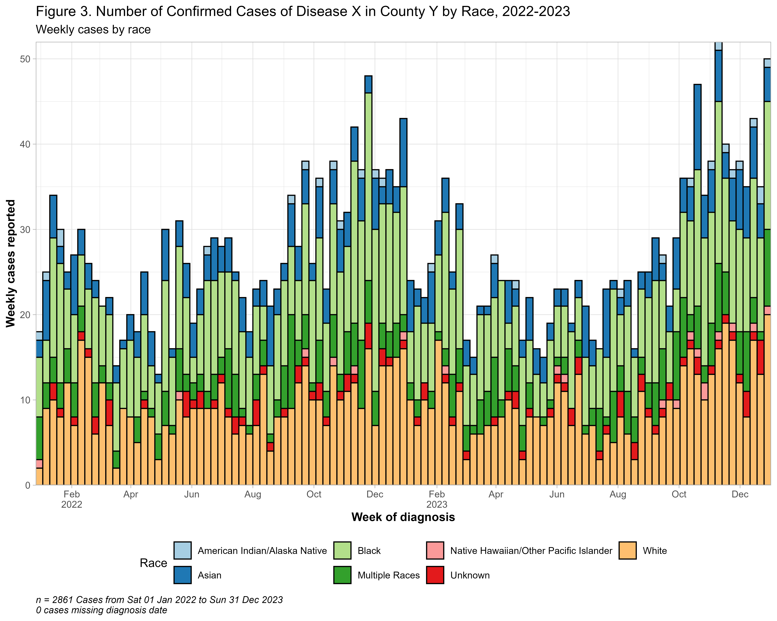
YOU TRY!

After presenting the previous figure to your team, you were asked to redo the weekly case counts by race figure, but in this version they would like to make a combo of race and ethnicity with 4 categories (Hispanic/Latino, non-Hispanic Black, non-Hispanic White, non-Hispanic Other/Multi) and they would like you to exclude anyone that is missing race or ethnicity. Create a new version of the race variable for this (don’t overwrite the previous one) and recreate the fig3 plot.

# Several ways to do this, but here is one example
# Create new race_eth variable as a factor so we can control the order in the plot
data <- data %>%
mutate(race_eth = case_when(
ethnicity == "Hispanic or Latino" ~ "Hispanic/Latino",
ethnicity == "Not Hispanic or Latino" & race_cat == "Black" ~ "non-Hispanic Black",
ethnicity == "Not Hispanic or Latino" & race_cat == "White" ~ "non-Hispanic White",
ethnicity == "Not Hispanic or Latino" ~ "non-Hispanic Other/Multi",
TRUE ~ NA_character_),
race_eth = factor(race_eth,
levels = c("Hispanic/Latino","non-Hispanic Black", "non-Hispanic White",
"non-Hispanic Other/Multi")))
fig3_rev <- ggplot(data) +
geom_histogram(
mapping = aes(
x = as.Date(pos_test_date),
group = race_eth, fill = race_eth),
color = "black",
breaks = breaks_by_week,
closed = "left") +
scale_x_date(
expand = c(0,0),
date_breaks = "2 months",
date_minor_breaks = "1 month",
label = scales::label_date_short()) +
scale_y_continuous(expand = c(0,0)) +
scale_fill_brewer(palette = "Paired", name = "Race") +
theme_light() +
theme(plot.caption = element_text(face = "italic", hjust = 0),
axis.title = element_text(face = "bold"),
legend.position = "bottom",
strip.text = element_text(face = "bold", size = 10),
strip.background = element_rect(fill = "grey")) +
labs(title = "Figure 3B. Number of Confirmed Cases of Disease X in County Y by Race/Ethnicity, 2022-2023",
subtitle = "Weekly cases by race/ethnicity",
fill = "Race/Ethnicity",
x = "Week of diagnosis",
y = "Weekly cases reported",
caption = stringr::str_glue("n = {nrow(data)} Cases from {format(min(data$pos_test_date, na.rm=T), format = '%a %d %b %Y')} to {format(max(data$pos_test_date, na.rm=T), format = '%a %d %b %Y')}\n{nrow(data %>% filter(is.na(pos_test_date)))} cases missing diagnosis date"))
# Save plot as png image
ggsave("output/Figure 3B.png", plot = fig3_rev, width = 10, height = 8, dpi = 500)
# Print image here
knitr::include_graphics("output/Figure 3B.png")
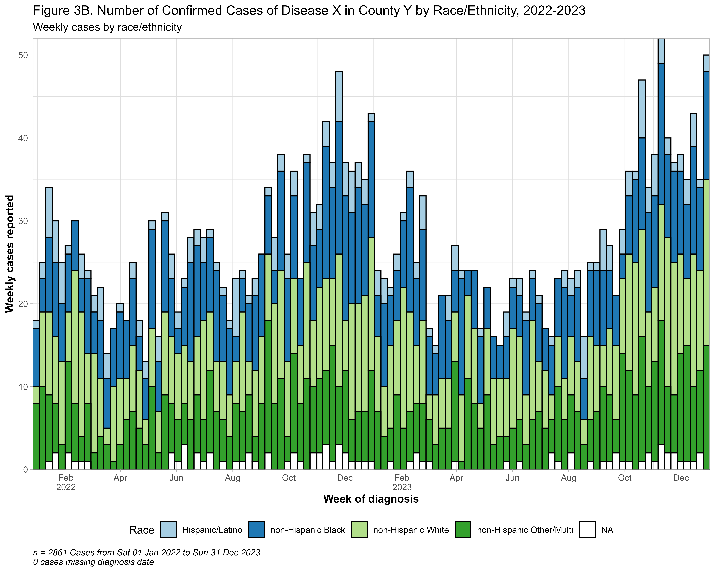

Now let’s make one more stratified by age group. We will use facets for this to get mini plots for each age group.

Here just to make the facets simpler, we will exclude the records with NA values for age.
The gghighlight::gghighlight() option is commented out, but this will put an outline of the full epidemic in the background behind the age group plots. You may need to rescale your image if you want to use this.

# Get rid of records without age
data_rev <- data %>% filter(!is.na(age_group))
# Labels for facets
my_labels <- as_labeller(c(
"0-9" = "Ages 0-9",
"10-19" = "Ages 10-19",
"20-29" = "Ages 20-29",
"30-39" = "Ages 35-39",
"40-49" = "Ages 40-49",
"50-59" = "Ages 50-59",
"60-69" = "Ages 60-69",
"70+" = "Age 70+"))
# Create breaks by week
breaks_by_week <- seq.Date(
from = floor_date(min(as.Date(data_rev$pos_test_date, na.rm=T)), "week", week_start = 1),
to = ceiling_date(max(as.Date(data_rev$pos_test_date, na.rm=T)), "week", week_start = 1),
by = "week")
# Plot
fig4 <- ggplot(data_rev) +
geom_histogram(
mapping = aes(
x = as.Date(pos_test_date),
group = age_group,
fill = age_group),
color = "black",
breaks = breaks_by_week,
closed = "left") +
#gghighlight::gghighlight() +
scale_x_date(
expand = c(0, 0),
breaks = seq(as.Date("2022-01-01"), as.Date("2023-12-01"),
by = "2 months"),
minor_breaks = seq(as.Date("2022-02-01"), as.Date("2023-12-01"),
by = "1 month"),
labels = scales::label_date_short()) +
scale_y_continuous(expand = c(0,0)) +
scale_fill_brewer(palette = "Paired", name = "age_group") +
theme_light() +
theme(plot.caption = element_text(face = "italic", hjust = 0),
axis.title = element_text(face = "bold"),
legend.position = "none",
strip.text = element_text(face = "bold", size = 10),
strip.background = element_rect(fill = "darkgray")) +
facet_wrap(~age_group,
ncol = 4,
strip.position = "top",
labeller = my_labels) +
labs(title = "Figure 4. Number of Confirmed Cases of Disease X in County Y, 2022-2023",
subtitle = "Weekly cases by age group",
fill = "Age Group",
x = "Week of diagnosis",
y = "Weekly cases reported")
# Save plot as png image
ggsave("output/Figure 4.png", plot = fig4, width = 14, height = 10, dpi = 500)
# Print image here
knitr::include_graphics("output/Figure 4.png")
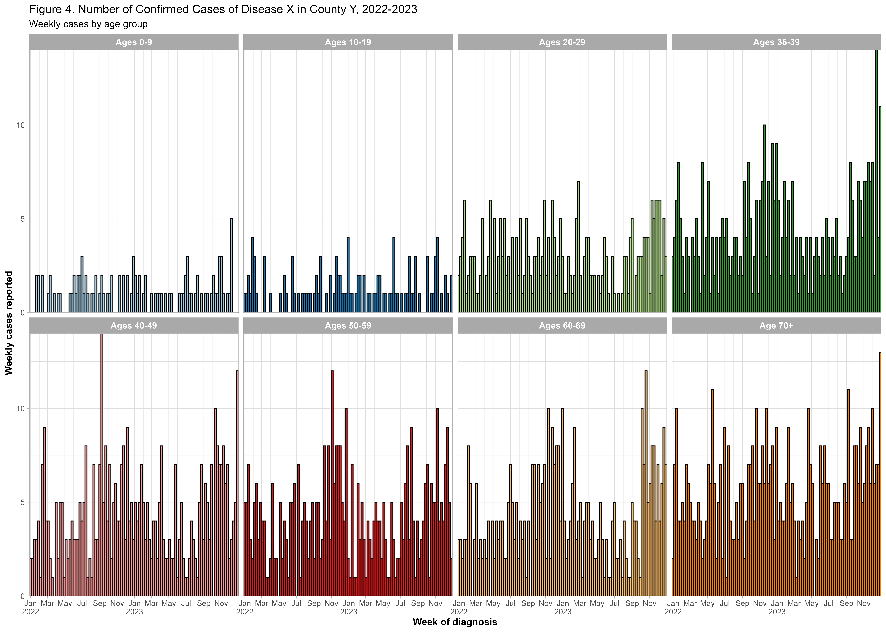

Step 7 - Make a density map of the case counts by zip code.

First, we will fix up the zip codes that don’t have a match to a ZCTA in the shapefile. Then we will use the tigris package to attach some geometry to our case counts so we can map it!

Disclaimer: This is not the best use case as we only have a few zip codes represented (and some do not correspond to ZCTAs in the most recent census shapefile) but it is still a useful exercise to think through!

# You will need to have these 2 packages installed
# install.packages(c("sf", "tigris"))
# Fix zips that don't have a match by assigning them another home
data_rev2 <- data %>%
mutate(zip = sprintf("%05d", case_zip)) %>%
mutate(zip_adj = case_when(
zip == "30320" ~ "30310",
zip %in% c("30321", "30323") ~ "30314",
TRUE ~ zip))
# Get all unique zips represented by our data
data_zips <- data_rev2 %>%
distinct(zip_adj) %>%
pull(zip_adj)
# Use tigris to get geometry of zips (shapefile)
tigris_zips <- tigris::zctas(cb = TRUE, year = 2020) %>%
filter(ZCTA5CE20 %in% data_zips) %>%
select(ZCTA5CE20, geometry)
## ZCTAs can take several minutes to download. To cache the data and avoid re-downloading in future R sessions, set `options(tigris_use_cache = TRUE)`
# Because we have only a few zips, a state map of GA would look odd
# Create a 10km buffer around study ZIP codes
study_area <- sf::st_buffer(sf::st_union(tigris_zips), 10000)
# Grab some surrounding ZCTAs so we can do a zoomed in map of the area
options(tigris_use_cache = TRUE) # cache
nearby_zips <- tigris::zctas(cb = TRUE, year = 2020) %>%
filter(sf::st_intersects(geometry, study_area, sparse = FALSE)[, 1])
# Put everything together and count the cases by zip
zip_cases_for_map <- nearby_zips %>%
left_join(data_rev2 %>%
count(zip_adj, name = "cases"),
by = c("ZCTA5CE20" = "zip_adj")) %>%
mutate(cases = replace_na(cases, 0))
# Make the map
fig5 <- ggplot(zip_cases_for_map) +
geom_sf(data = filter(zip_cases_for_map, cases == 0),
fill = "grey95", color = "black", linewidth = 0.2) +
geom_sf(data = filter(zip_cases_for_map, cases > 0),
aes(fill = cases), color = "black", linewidth = 0.2) +
scale_fill_gradient(low = "#deebf7", high = "#08519c", name = "Cases") +
labs(title = "Figure 5. Case Counts by ZIP Code",
subtitle = "Total # Cases, 2022–2023",
x = NULL, y = NULL) +
theme_classic() +
theme(axis.text = element_blank(), axis.ticks = element_blank(),
axis.title = element_blank())
# Save plot as png image
ggsave("output/Figure 5.png", plot = fig5, width = 10, height = 8, dpi = 500)
# Print image here
knitr::include_graphics("output/Figure 5.png")
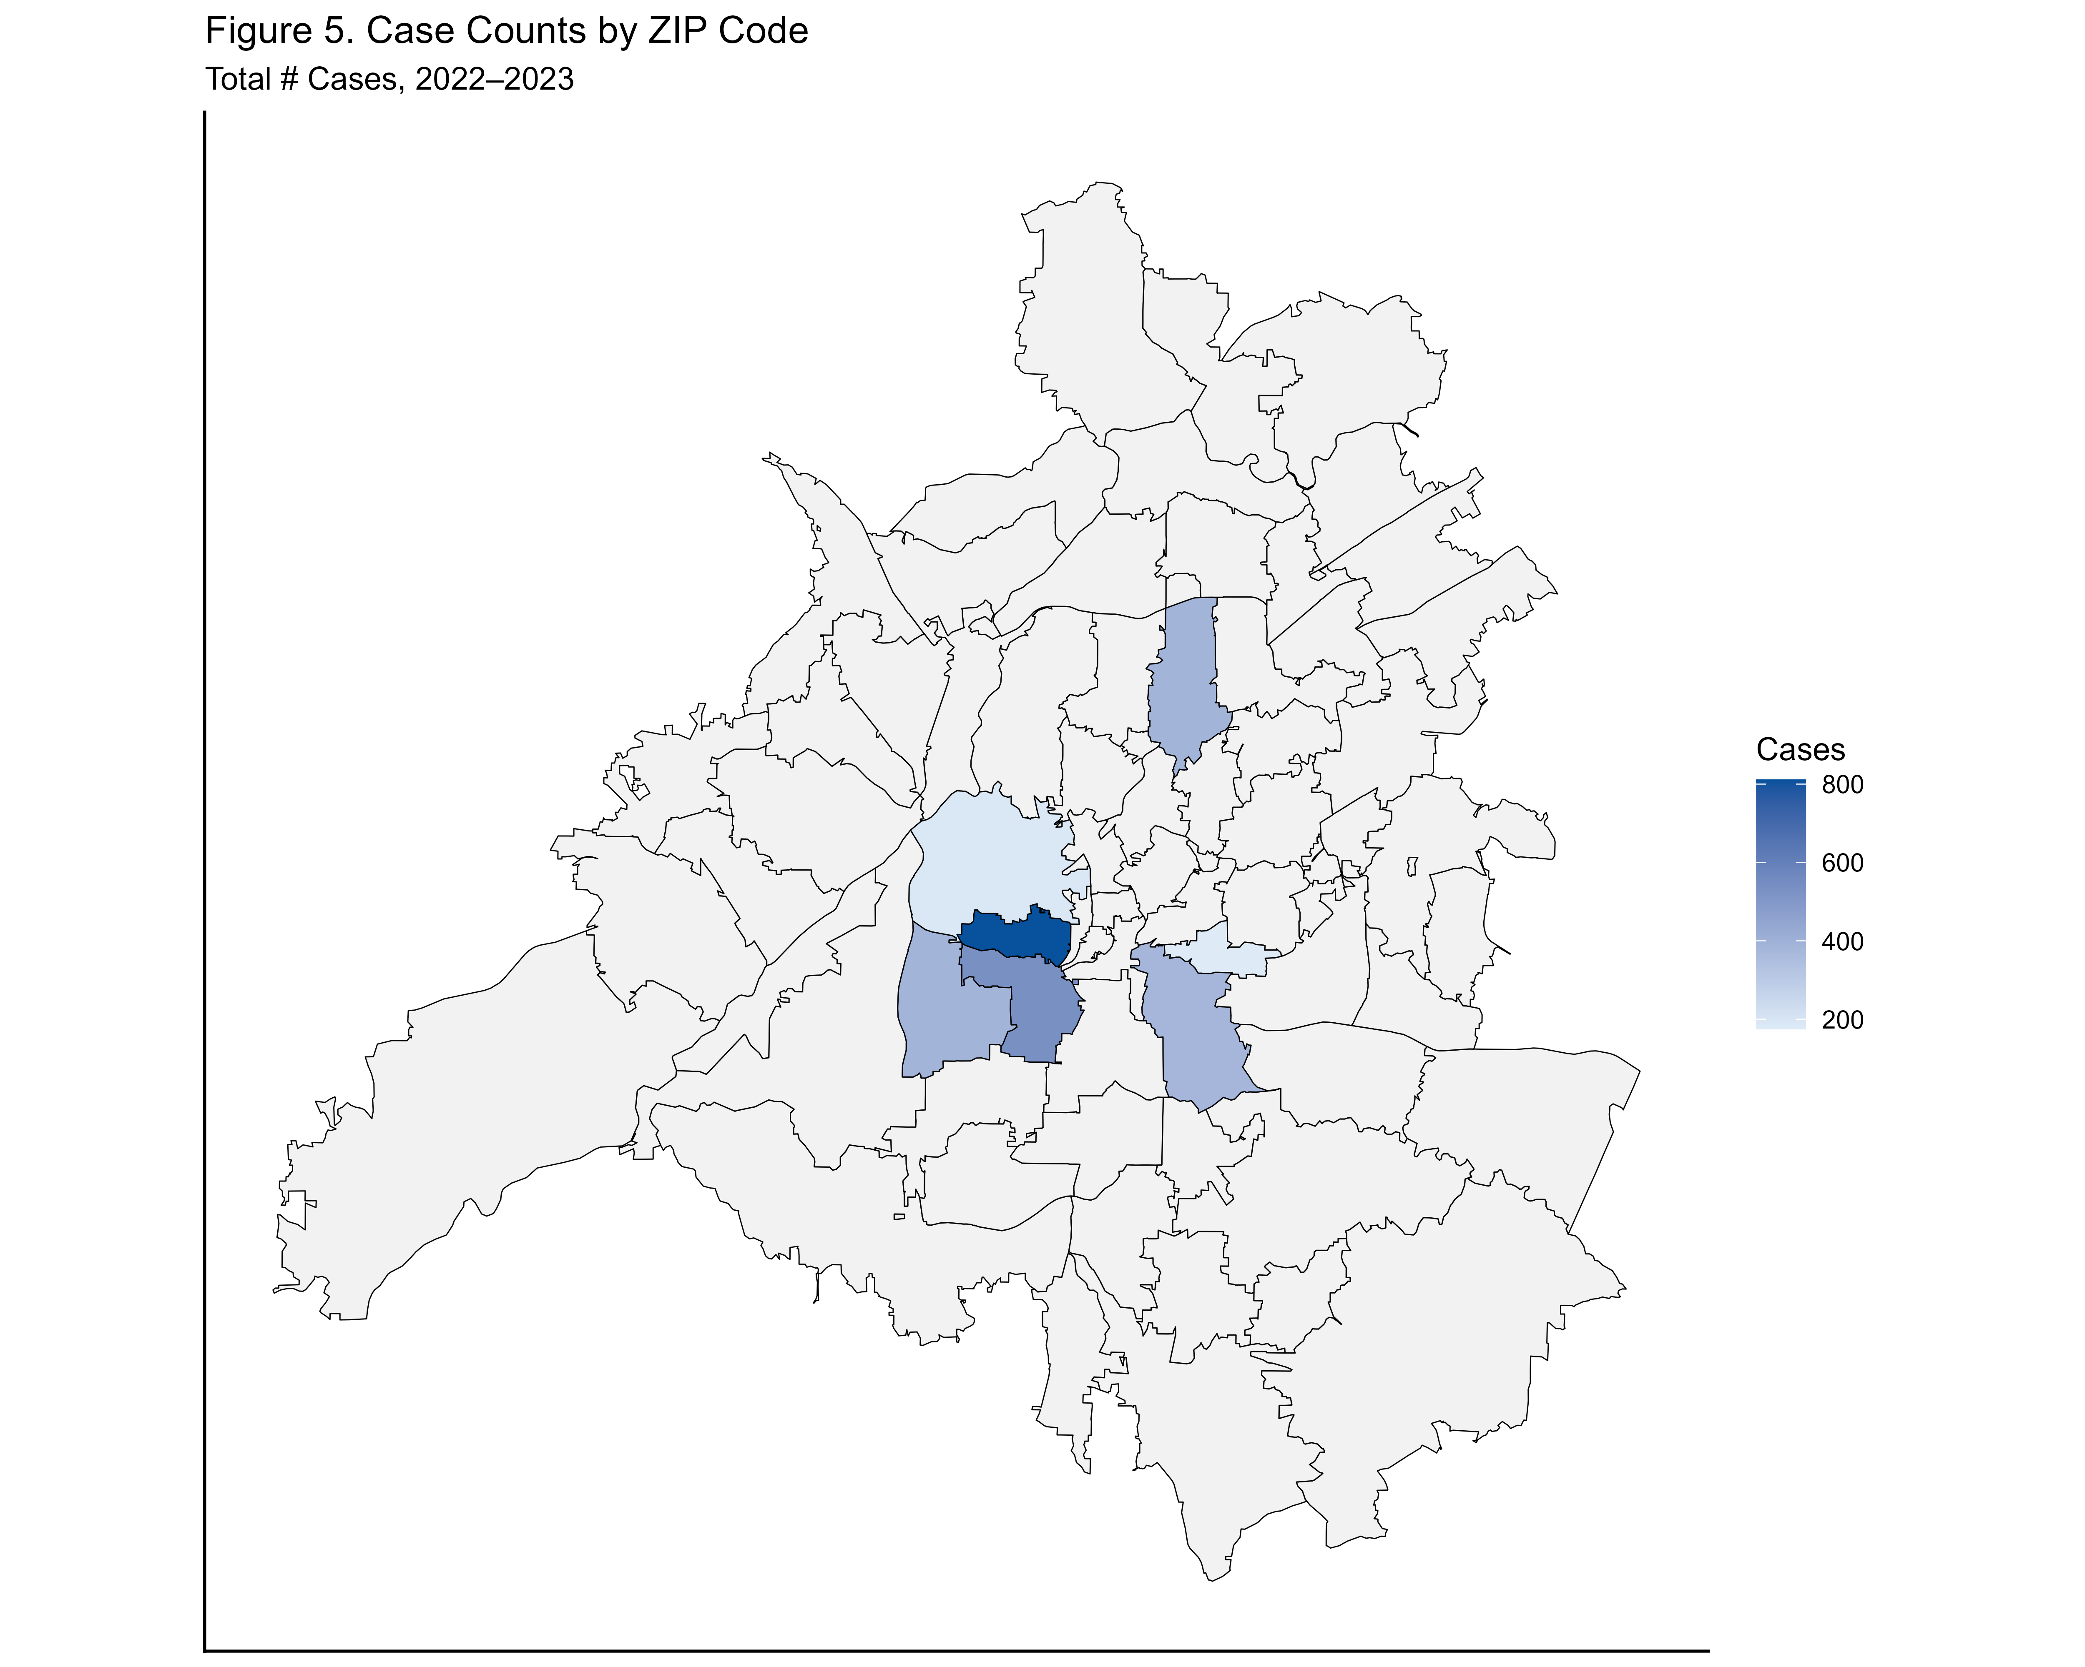
YOU TRY!

What if we wanted to do something similar but show side by side maps based on another field such as hospitalization?
Hint: Modify the counts we did by zip to create counts by both zip AND hospitalization. You might want to get rid of the unknown hospitalization status folks and focus on the no vs yes values for this. If you want to be a little fancy, try incorporating facet_wrap to make the map panels in a single figure rather then creating separate ones (facet_wrap(~hospitalized)). Note that you don’t need to redo the zip prep steps above, just create your new case counts and update the map.

# Yours may look a little different but here is mine
zip_cases_for_map_byhosp <- nearby_zips %>%
left_join(data_rev2 %>%
count(zip_adj, hospitalized, name = "cases"),
by = c("ZCTA5CE20" = "zip_adj")) %>%
filter(!is.na(hospitalized) & hospitalized != "Unk") %>%
mutate(cases = replace_na(cases, 0))
fig5_rev <- ggplot(zip_cases_for_map_byhosp) +
geom_sf(data = nearby_zips,
fill = "grey95", color = "black", linewidth = 0.2) +
geom_sf(data = filter(zip_cases_for_map_byhosp, cases > 0),
aes(fill = cases),
color = "black", linewidth = 0.2) +
scale_fill_gradient(low = "#deebf7", high = "#08519c", name = "Cases") +
facet_wrap(~hospitalized,
labeller = as_labeller(c(
No = "Not Hospitalized", Yes = "Hospitalized"))) +
labs(title = "Figure 5B. Case Counts by ZIP Code and Hospitalization Status",
subtitle = "Total # Cases, 2022–2023",
x = NULL, y = NULL) +
theme_classic() +
theme(strip.text = element_text(face = "bold", size = 11),
axis.text = element_blank(),
axis.ticks = element_blank(),
axis.title = element_blank())
# Save plot as png image
ggsave("output/Figure 5B.png", plot = fig5_rev, width = 10, height = 8, dpi = 500)
# Print image here
knitr::include_graphics("output/Figure 5B.png")
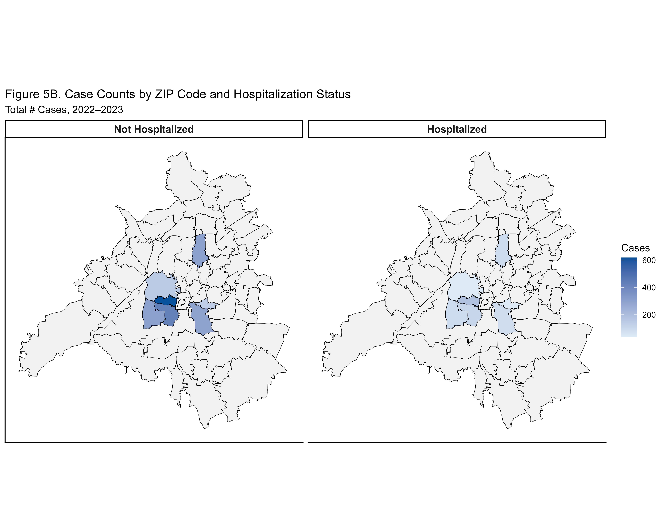

This is the end of R Lab 1. R Lab 2 will pick up from here and work on some tables and additional figures.

— New code for Lab 2 starts here. —

Step 8 - Make some tables!

There are many different approaches to dealing with tables. Here, we will introduce a few packages that are helpful for tables, but what is best really depends on your goal - sometimes you may just want to generate values for tables you are creating manually, other times you will want to generate the whole table with R and in that case some are better than others for different formats (markdown, html, word, excel).
In this example, we will generate our own table values and put them in a table format that works pretty well for word docs knitted from a markdown file like this one.
First, we will use group_by and summarise to create counts and percentages by race. In this example we will also use bind_rows to add on an extra overall total row for our table.
Next, we will use gt() to create a table of results. This one looks pretty good in both R and the knitted Word doc. In the table step, we can control the number of decimals displayed with our percentages, header labels, and we can bold our total row as well.

# Freqs by race
freq_table_byrace <- data %>%
group_by(race_cat) %>%
summarise(
# Count n rows/obs
count = n(),
# Calculate %
percentage = (n() / nrow(data)) * 100) %>%
# Logical trick to keep unknown last but use ascending sort by race_cat
# (Alternative is to rework the factor levels)
arrange(race_cat == "Unknown", race_cat) %>%
# Add overall total row
bind_rows(
summarise(data,
race_cat = "Total",
count = n(),
percentage = 100))
# Table with race
final_table_byrace <- freq_table_byrace %>%
gt() %>%
tab_header(title = "Disease X Confirmed Case Count and Percentage of Cases in County Y by Race, 2022-2023") %>%
fmt_number(columns = c(percentage), decimals = 1) %>%
cols_label(
race_cat = "Race",
count = "Case Count",
percentage = "Percentage of Cases") %>%
tab_style(style = list(cell_text(weight = "bold")),
locations = cells_body(rows = race_cat == "Total"))
final_table_byrace
Table 1: Disease X Confirmed Case Count and Percentage of Cases in County Y by Race, 2022-2023
Race | Case Count | Percentage of Cases
American Indian/Alaska Native | 28 | 1.0
Asian | 371 | 13.0
Black | 1013 | 35.4
Multiple Races | 336 | 11.7
Native Hawaiian/Other Pacific Islander | 19 | 0.7
White | 995 | 34.8
Unknown | 99 | 3.5
Total | 2861 | 100.0

YOU TRY! Let’s make a new version of this table that also includes sex and age group.

We already have a data frame with the race info we need. Let’s calculate our totals for sex and age group as we did for race, then combine all 3 of these to create a table. Note that we could do all the frequency calculations in one step as well but it would require converting the data to long format.
In the combined table, we will add some header rows without data and rename things to be consistent.
NOTE: To run this code chunk you will first need to fill in some of the info where you see placeholder text ?????.

# Freqs by sex
freq_table_bysex <- data %>%
# Change NA to Unknown (sex is character)
mutate(sex = ifelse(is.na(sex), "Unknown", sex)) %>%
group_by(sex) %>%
summarise(
count = n(),
percentage = (n() / nrow(data)) * 100) %>%
arrange(sex) %>%
bind_rows(
summarise(data,
sex = "Total",
count = n(),
percentage = 100))
# Freqs by age group
freq_table_byage <- data %>%
# Age group is a factor
mutate(age_group = forcats::fct_na_value_to_level(age_group, level = "Unknown")) %>%
group_by(age_group) %>%
summarise(
count = n(),
percentage = (n() / nrow(data)) * 100) %>%
arrange(age_group) %>%
bind_rows(
summarise(
data,
age_group = "Total",
count = n(),
percentage = 100))
# Combo table
combo_table <- bind_rows(
data.frame(category = "Sex", count = NA, percentage = NA),
freq_table_bysex %>% select(sex, count, percentage) %>% rename(category = sex),
data.frame(category = "Race", count = NA, percentage = NA),
freq_table_byrace %>% select(race_cat, count, percentage) %>% rename(category = race_cat),
data.frame(category = "Age Group", count = NA, percentage = NA),
freq_table_byage %>% select(age_group, count, percentage) %>% rename(category = age_group))
final_combo_table <- combo_table %>%
gt() %>%
tab_header(title = "Disease X Confirmed Case Count and Percentage of Cases in County Y, 2022-2023") %>%
fmt_number(columns = c(percentage), decimals = 1) %>%
sub_missing(columns = everything(), missing_text = "") %>%
cols_label(
category = "Category",
count = "Case Count",
percentage = "Percentage of Cases") %>%
# Bold section headings (Sex, Race, Age Group)
tab_style(style = list(cell_text(weight = "bold")),
locations = cells_body(rows = category %in% c("Sex", "Race", "Age Group"))) %>%
# Bold Total row
tab_style(style = list(cell_text(weight = "bold")),
locations = cells_body(rows = category == "Total")) %>%
# Bold column headers
tab_style(style = cell_text(weight = "bold"),
locations = cells_column_labels()) %>%
# Indent category values under each section heading
tab_style(style = cell_text(indent = px(20)),
locations = cells_body(columns = category, rows = !category %in% c("Sex", "Race", "Age Group", "Total")))
final_combo_table
Table 2: Disease X Confirmed Case Count and Percentage of Cases in County Y, 2022-2023
Category | Case Count | Percentage of Cases
Sex
Female | 1365 | 47.7
Male | 1492 | 52.1
Unknown | 4 | 0.1
Total | 2861 | 100.0
Race
American Indian/Alaska Native | 28 | 1.0
Asian | 371 | 13.0
Black | 1013 | 35.4
Multiple Races | 336 | 11.7
Native Hawaiian/Other Pacific Islander | 19 | 0.7
White | 995 | 34.8
Unknown | 99 | 3.5
Total | 2861 | 100.0
Age Group
0-9 | 101 | 3.5
10-19 | 113 | 3.9
20-29 | 294 | 10.3
30-39 | 446 | 15.6
40-49 | 448 | 15.7
50-59 | 436 | 15.2
60-69 | 440 | 15.4
70+ | 579 | 20.2
Unknown | 4 | 0.1
Total | 2861 | 100.0

These tables look decent in Word as is, but you may want to do more customization manually. Sometimes exporting tables to Excel can be really handy for that.

# Shortcut to put this in Excel for more formatting options
#openxlsx::write.xlsx(combo_table, file="output/final_combo_table.xlsx")
# Version with combined n(%) cells
combo_table2 <- combo_table %>%
mutate(n_pct_combo = if_else(
is.na(count) | is.na(percentage), NA_character_,
glue("{count} ({round(percentage, 1)}%)")) )
openxlsx::write.xlsx(combo_table2, file="output/final_combo_table2.xlsx")

Here is another table example using gtsummary that can be handy if you have a large number of variables. Any continuous variables will have mean and standard deviation, while categorical will have n and percent values. These tables don’t look as nice in markdown off the shelf, but you can export from the viewer or work on reformatting as a gt table.
NOTE: To run this code chunk you will first need to fill in some of the info where you see placeholder text ?????. Choose a grouping variable and a few others for the table - use a mix of continuous and categorical variables.

another_table <- data %>%
# Include grouping var and all others for the table in select
select(age, age_group, sex) %>%
tbl_summary(by = sex,
# default % here is column %, uncomment below to make it row %
# percent = "row",
statistic = list(all_categorical() ~ "{n} ({p}%)",
all_continuous() ~ "{mean} ({sd})"),
digits = all_continuous() ~ 1,
# var ~ "label for var", comma separated
label = list(age ~ "Age (years)",
age_group ~ "Age Group"),
missing = "ifany") %>%
add_overall(last = FALSE) %>%
add_p(test = list(
all_continuous() ~ "t.test",
all_categorical() ~ "chisq.test")) %>%
# Choose p value cutoff for bold
bold_p(t = 0.05)
## 4 missing rows in the "sex" column have been removed.
# Include grouping var and all others for the table in selectanother_table
# Again we could also stick this in Excel for more editing
# Currently this is a list so make the data frame
table_for_excel <- another_table %>% as_tibble()
openxlsx::write.xlsx(table_for_excel,
file = "output/gtsummary_to_excel.xlsx",
sheetName = "Table X",
overwrite = TRUE)

The flextable package is also great for tables, but it is a little more involved and we won’t also have time to get into all of the details of building one of these from scratch in this lab. However, we can convert our gtsummary table to a flextable to play around with the formatting and see another output option to Word.
#library(flextable)
another_table_flex <- another_table %>% as_flex_table()
# Add highlight to p < 0.05
another_table_flex2 <- another_table_flex %>%
flextable::bg(j = 5, i = ~ p.value < 0.6, part = "body", bg = "lightblue")
# Save to Word
flextable::save_as_docx(another_table_flex2, path = "output/sex_age_flextable.docx")
# Again, you can create a flextable directly - here is a very simple example
library(flextable)
data %>%
group_by(race_cat) %>%
summarise(N = n(),
mean_age = round(mean(age, na.rm = T), 1),
sd_age = round(sd(age, na.rm = T), 1)) %>%
flextable() %>%
set_header_labels(
race_cat = "Race",
N = "N",
mean_age = "Mean Age",
sd_age = "SD Age") %>%
bold(part = "header") %>%
autofit()
Race | N | Mean Age | SD Age
American Indian/Alaska Native | 28 | 54.9 | 19.3
Asian | 371 | 49.0 | 21.0
Black | 1,013 | 51.7 | 21.2
Multiple Races | 336 | 51.2 | 21.4
Native Hawaiian/Other Pacific Islander | 19 | 46.3 | 23.2
Unknown | 99 | 36.2 | 18.0
White | 995 | 50.3 | 21.8

Step 9 - Make an age distribution chart.

To recreate the stacked horizontal bar chart you made in Excel, we will adjust the groups slightly and make a bar plot. This one will be presented in order from the smallest to largest percentages but you could rework it to be in order by group as well. We will also use geom_text to add some data labels and a custom note using x and y values to place the note in a specific place.

# Reorder the age groups based on the values
freq_table_byage2 <- freq_table_byage %>%
# Exclude the total row
filter(age_group != "Total") %>%
arrange(desc(percentage)) %>%
mutate(age_group = factor(age_group, levels = age_group))
fig6 <- ggplot(freq_table_byage2, aes(x = "", y = percentage, fill = age_group)) +
geom_bar(stat = "identity", width = 0.5) +
coord_flip() + # Horizontal bar
labs(title = "Fig X. Age Distribution of Confirmed Cases of Disease X in County Y, 2022-2023 ",
x = "",
y = "Percentage of Cases") +
scale_y_continuous(labels = scales::percent_format(scale = 1)) +
scale_fill_manual(values = c("#f7fcf0", "#e0f3db", "#ccebc5", "#a8ddb5", "#7bccc4", "#4eb3d3",
"#2b8cbe", "#0868ac", "#084081"),
breaks = c("0-9", "10-19", "20-29", "30-39", "40-49", "50-59", "60-69",
"70+", "Unknown"),
labels = c("0-9", "10-19", "20-29", "30-39", "40-49", "50-59", "60-69",
"70+", "Unknown")) +
theme_light() +
theme(legend.title = element_blank(),
axis.ticks.y = element_blank(),
axis.text.y = element_blank(),
panel.grid.major.y = element_blank(),
legend.position = "bottom") +
geom_text(aes(label = paste0(round(percentage, 1), "%")),
position = position_stack(vjust = 0.5), size = 2.5, color = "black") +
geom_text(aes(label = "----------30-59 year olds account for just under half of all cases----------"),
y = 50,
vjust = -12,
size = 3,
color = "black")
# Save plot as png image
ggsave("output/Figure 6.png", plot = fig6, width = 8, height = 6, dpi = 300)
# Print image here
knitr::include_graphics("output/Figure 6.png")
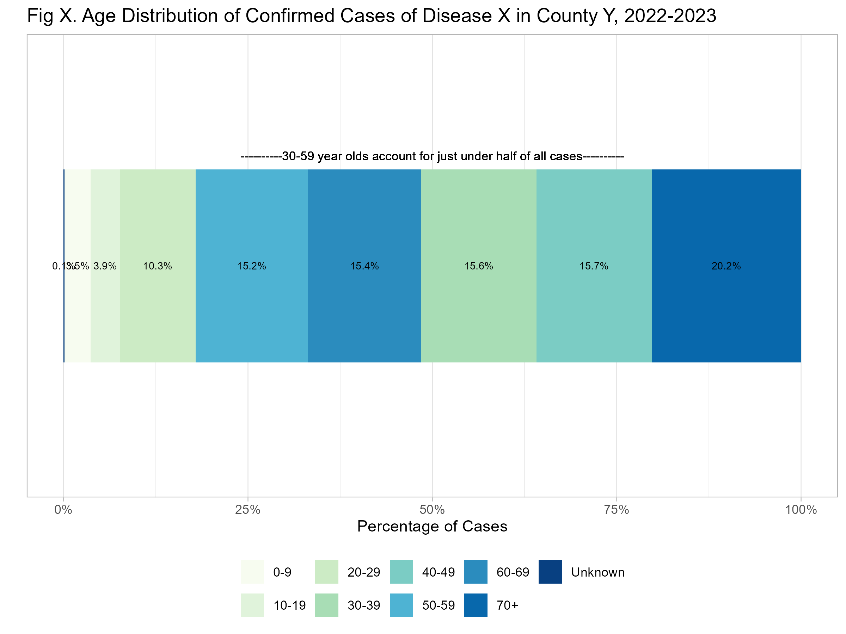

Step 10 - Make a pie chart to highlight some specific age results.

Let’s say you would like to highlight some results for a specific age group. Here we will re-categorize age as 70+ vs <70 years and make a pie chart to show this comparison.

# Make new age category variable and summarize cases for these groups
freq_table_byage3 <- freq_table_byage %>%
filter(age_group != "Total") %>%
# Use ifelse() to create age_group2 var as factor with levels for 70+ and <70
mutate(age_group2=factor(ifelse(age_group=="70+", 0, 1),
levels=0:1, labels=c("70+ years", "<70 years"))) %>%
group_by(age_group2) %>%
summarise(percentage = sum(percentage), count = sum(count))
fig7 <- ggplot(freq_table_byage3, aes(x = "", y = percentage, fill = age_group2)) +
geom_bar(stat = "identity", width = 1) +
coord_polar("y") +
labs(title = "The majority of new cases were among those <70 years old.",
fill = "Age Group") +
geom_text(aes(label = paste0(round(percentage, 1), "%")),
position = position_stack(vjust = 0.5),
color = "white", fontface = "bold") +
theme_light() +
theme(axis.text = element_blank(),
axis.ticks = element_blank(),
axis.title = element_blank()) +
scale_fill_manual(values = c("#a8ddb5", "#0868ac"))
# Save plot as png image
ggsave("output/Figure 7.png", plot = fig7, width = 8, height = 6, dpi = 500)
# Print image here
knitr::include_graphics("output/Figure 7.png")
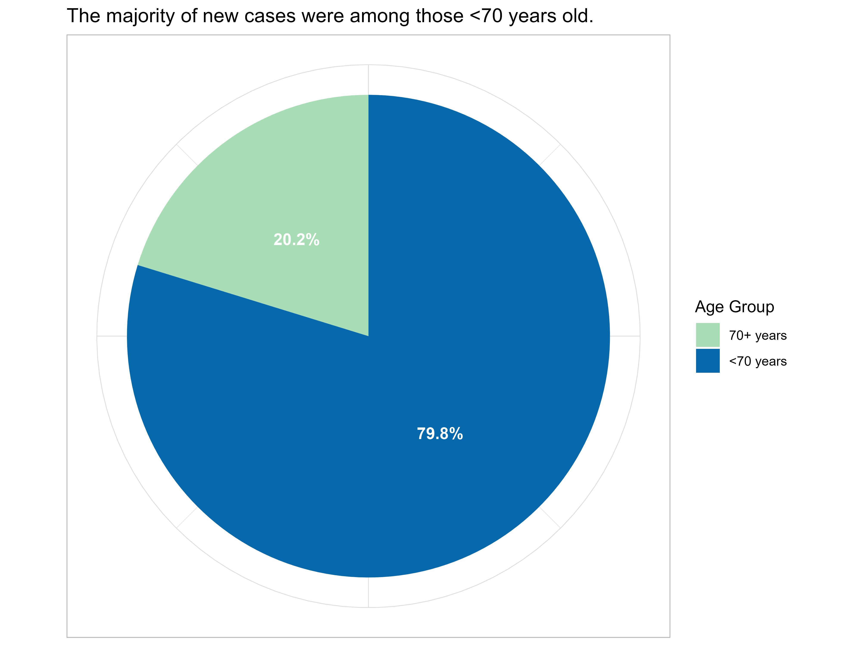
Step 11 - Summarize case counts by symptoms reported.

Let’s say we want to summarize case counts for these age groups by some other variables such as symptoms reported. We will use summarise() to sum the cases by each symptom variable and then generate a long version of these totals with pivot_longer. Next we will create a clustered bar chart that displays these totals by symptom next to the overall total cases for each age group.

# Using sym_fever, sym_nausea, sym_diarrhea and calculating total cases for anyone with a "Yes"
freq_table_byage4 <- data %>%
group_by(age_group) %>%
summarise(
count = n(),
percentage = (n() / nrow(data)) * 100,
# Create sum for each symptom var of interest
# Format should be new_tot_var = sum(sym_var == "value_of_sym_var", na.rm = TRUE)
tot_fever = sum(sym_fever == "Yes", na.rm = TRUE),
tot_nausea = sum(sym_nausea == "Yes", na.rm = TRUE),
tot_diarrhea = sum(sym_diarrhea == "Yes", na.rm = TRUE)) %>%
arrange(age_group)
# Reformat data
long_data <- freq_table_byage4 %>%
select(age_group, count, tot_fever, tot_nausea, tot_diarrhea) %>%
pivot_longer(cols = c(count, tot_fever, tot_nausea, tot_diarrhea),
names_to = "category",
values_to = "count")
fig8 <- ggplot(long_data, aes(x = age_group, y = count, fill = category)) +
geom_col(position = "dodge") +
labs(title = "Case Counts by Symptoms and Age Group",
x = "Age Group", y = "Count", fill = "") +
scale_fill_manual(values = c(
"count" = "lightgray",
"tot_fever" = "darkred",
"tot_nausea" = "blue",
"tot_diarrhea" = "gold"),
labels = c(
"count" = "Total Cases",
"tot_fever" = "Fever",
"tot_nausea" = "Nausea",
"tot_diarrhea" = "Diarrhea")) +
theme_light() +
theme(axis.text.x = element_text(angle = 45, hjust = 1))
# Save plot as png image
ggsave("output/Figure 8.png", plot = fig8, width = 8, height = 6, dpi = 500)
# Print image here
knitr::include_graphics("output/Figure 8.png")
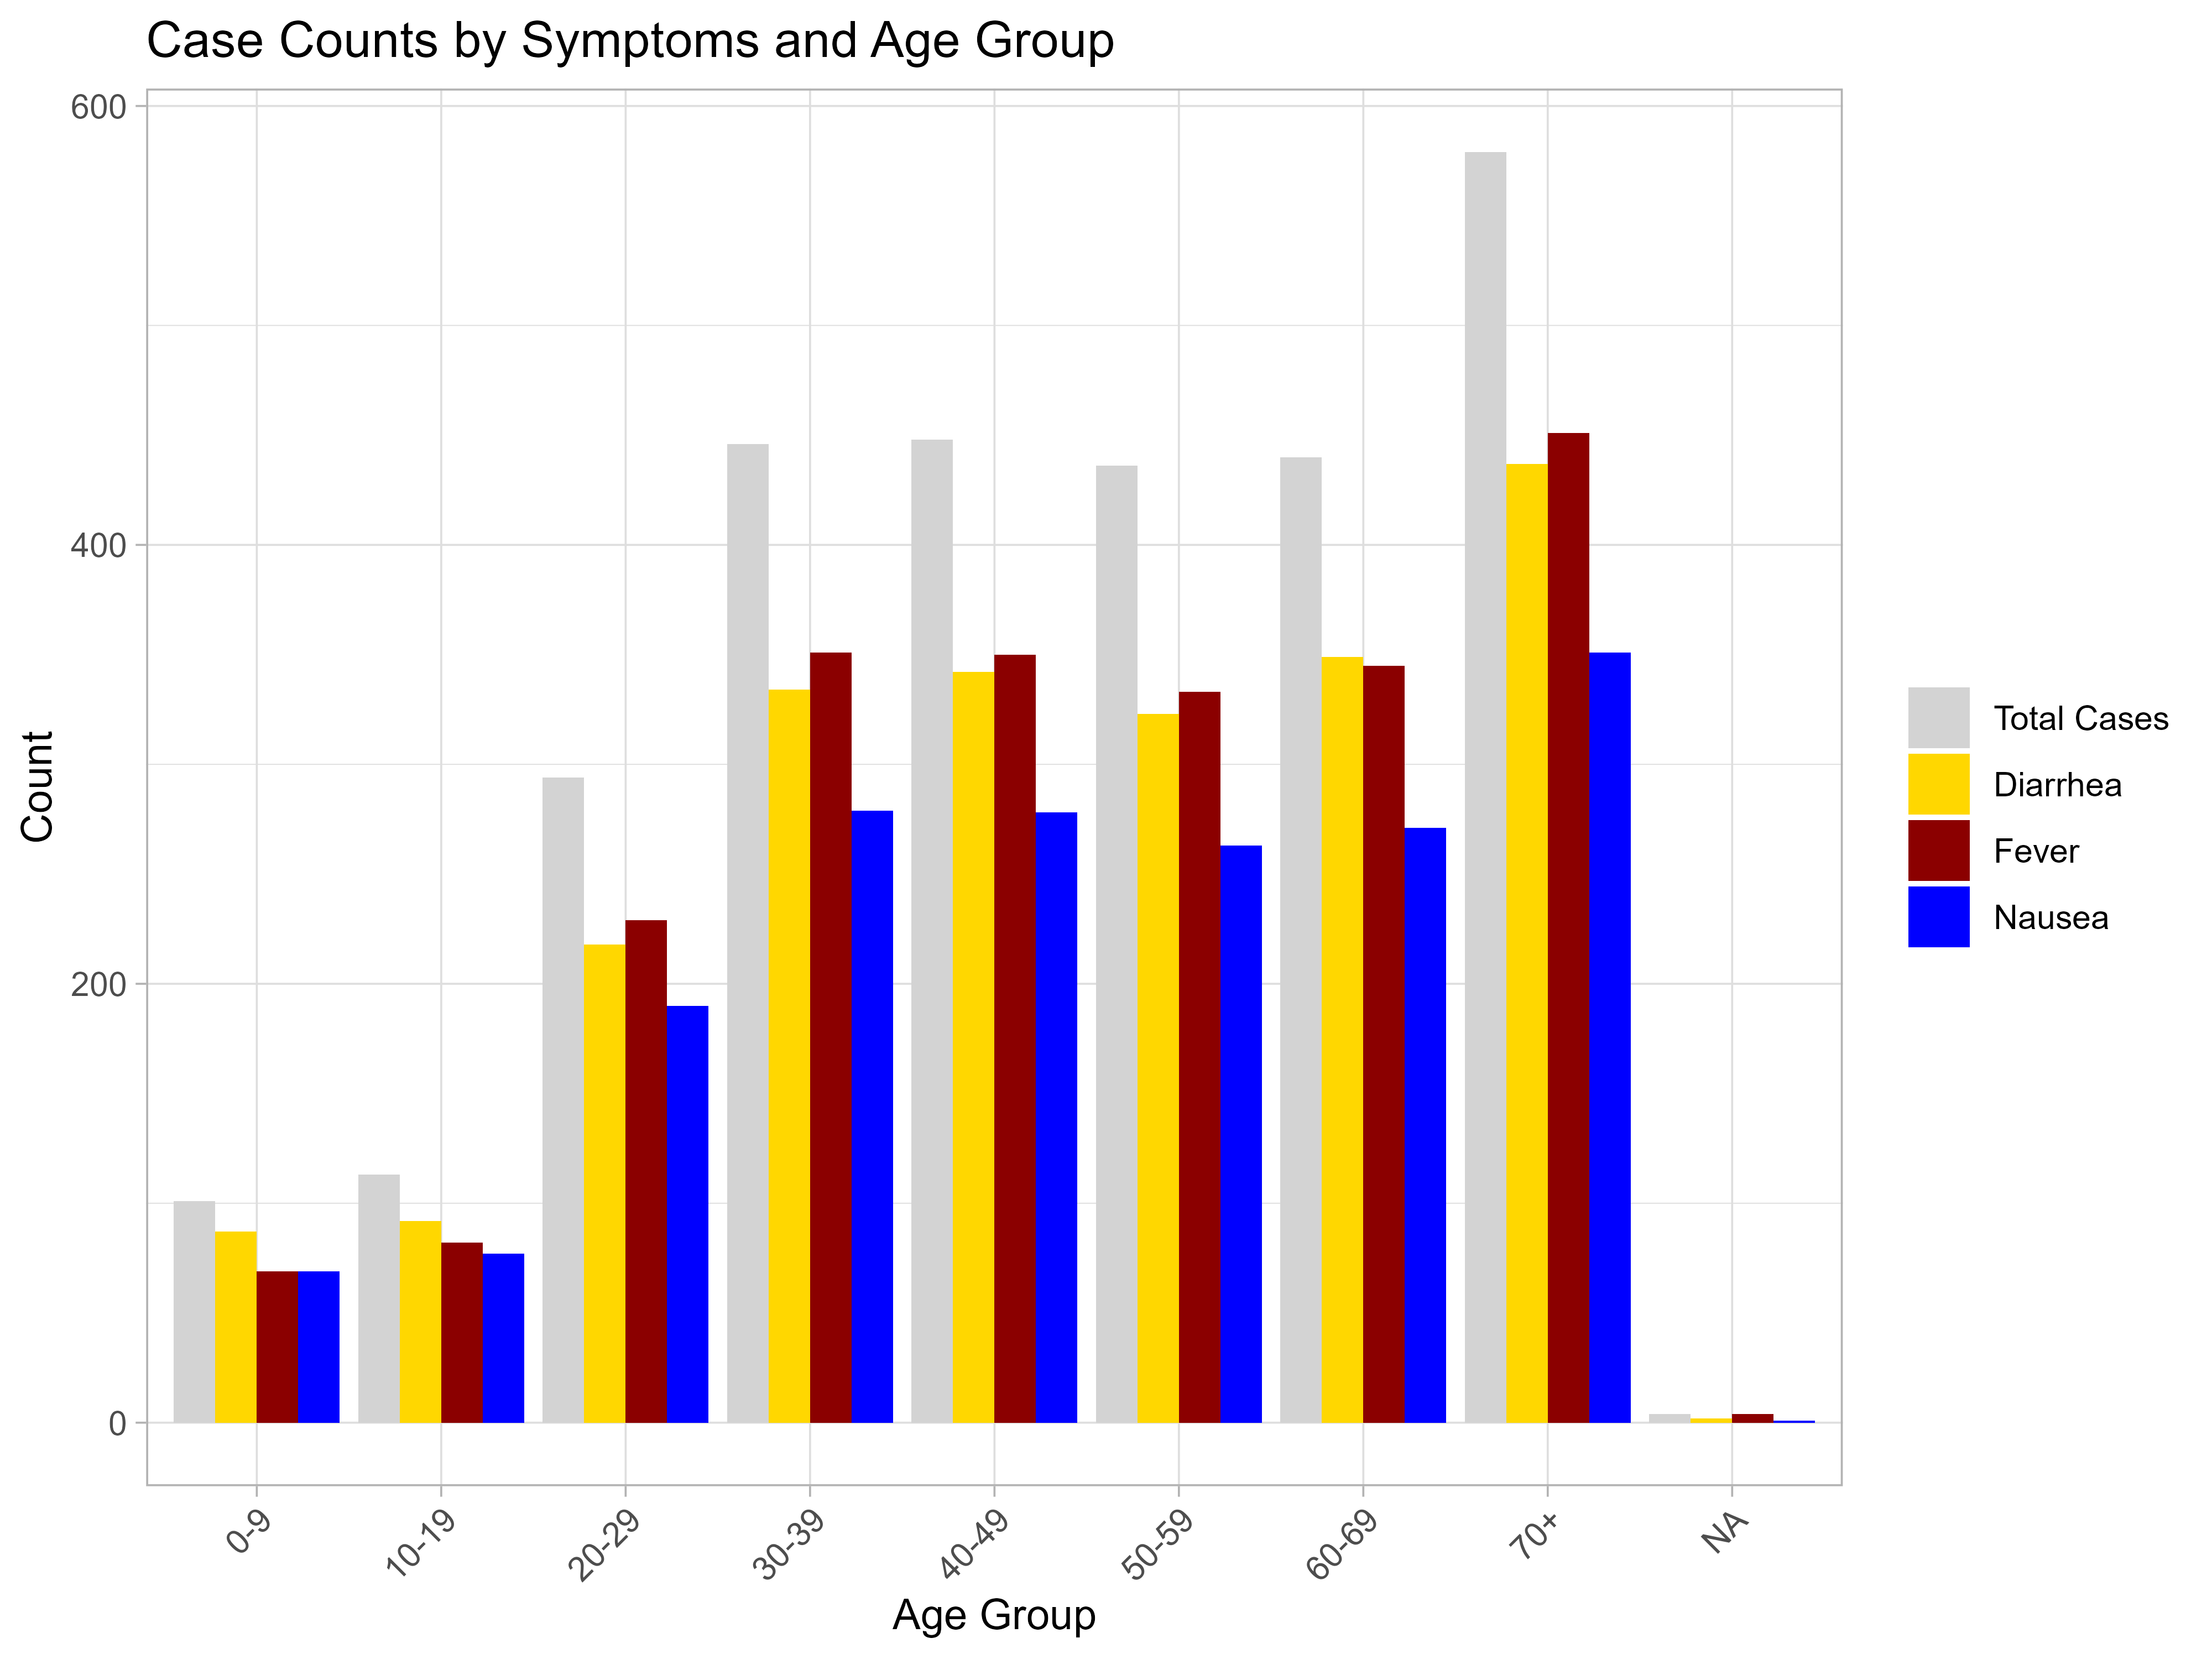

PRACTICE

YOU TRY

Use gtsummary to create a table that shows race_cat, age (continuous), and total number of symptoms by ethnicity. In the table, use row percents (we want to know the % of each category that is Hispanic or non-Hispanic, etc.) and label everything.
To save you some time, here is a great method to create sums for each row that count only when the symptoms listed are equal to “Yes”. Note that because we only have a few unique values for the counts, gtsummary will treat this one as categorical in the table rather than continuous.
rowwise() %>% mutate(total_symptoms = sum(c_across(c(LIST VARIABLES HERE WITH A COMMA AFTER EACH ONE)) == “Yes”, na.rm = TRUE)) %>% ungroup()

#
#Insert code here
#
data <- data %>%
rowwise() %>%
mutate(total_symptoms = sum(c_across(c(sym_fever, sym_diarrhea, sym_nausea,
sym_vomit, sym_bloodyvomit)) == "Yes", na.rm = TRUE)) %>%
ungroup()
another_table2 <- data %>%
select(race_cat, age, total_symptoms, ethnicity) %>%
tbl_summary(by = ethnicity,
percent = "row",
statistic = list(all_categorical() ~ "{n} ({p}%)",
all_continuous() ~ "{mean} ({sd})"),
label = list(
race_cat ~ "Race",
age ~ "Age",
total_symptoms ~ "Total # Symptoms"))
## 33 missing rows in the "ethnicity" column have been removed.
another_table2
Characteristic | Hispanic or Latino N = 222¹ | Not Hispanic or Latino N = 2,554¹ | Unknown N = 52¹
Race
American Indian/Alaska Native | 1 (3.6%) | 27 (96%) | 0 (0%)
Asian | 9 (2.4%) | 354 (96%) | 6 (1.6%)
Black | 132 (13%) | 870 (87%) | 3 (0.3%)
Multiple Races | 32 (9.6%) | 300 (90%) | 1 (0.3%)
Native Hawaiian/Other Pacific Islander | 0 (0%) | 19 (100%) | 0 (0%)
Unknown | 8 (9.0%) | 43 (48%) | 38 (43%)
White | 40 (4.1%) | 941 (96%) | 4 (0.4%)
Age | 48 (21) | 51 (21) | 35 (18)
Unknown | 0 | 4 | 0
Total # Symptoms
0 | 3 (6.7%) | 36 (80%) | 6 (13%)
1 | 14 (5.3%) | 246 (94%) | 2 (0.8%)
2 | 48 (7.6%) | 575 (91%) | 9 (1.4%)
3 | 54 (7.5%) | 645 (90%) | 18 (2.5%)
4 | 47 (9.7%) | 432 (89%) | 8 (1.6%)
5 | 56 (8.2%) | 620 (91%) | 9 (1.3%)
¹n (%); Mean (SD)

Step 12 - Summarize case counts by some other categorical variable in a grouped bar chart.

Let’s say you would like to highlight some results for food service workers by zip code and sex. This example will introduce ggpattern as another option to distinguish between categories.

# Grouped Bar Chart
library(ggpattern)
# Quick calculation for food service by zip and sex
tots_for_barchart <- data %>%
filter(!is.na(case_zip), !is.na(sex), !is.na(food_handler)) %>%
group_by(case_zip, sex) %>%
summarise(pct_foodhnd = mean(food_handler == "Yes") * 100, .groups = "drop")
# Bar chart
fig9 <- ggplot(tots_for_barchart,
aes(x = as.factor(case_zip), y = pct_foodhnd, fill = sex, pattern = sex)) +
geom_col_pattern(
# position = "dodge" out bars side-by-side rather than stacking
position = "dodge",
color = "#000000", # bar outline
pattern_fill = "#ffffff",
pattern_color = "#000000",
pattern_density = 0.3,
pattern_spacing = 0.05,
pattern_size = 0.2) +
labs(title = "Food Service Work Among Cases",
subtitle = "By zip code and sex",
x = "Zip code",
y = "% Cases Working in Food Service",
fill = "sex") +
scale_fill_manual(name = "Sex",
values = c("Male" = "#3B528BFF", "Female" = "#ffffff"),
labels = c("Male" = "Male", "Female" = "Female"),
# Fiddling with the guide here to combine info on color and pattern
guide = guide_legend( override.aes = list(pattern = c("stripe", "none")))) +
scale_pattern_manual(values = c("Male" = "none", "Female" = "stripe"), guide = "none") +
theme_minimal()
# Save as png image
ggsave("output/Figure 9.png", plot = fig9, width = 8, height = 6, dpi = 500)
# Print image here
knitr::include_graphics("output/Figure 9.png")
