Nicole Caicedo

December 8, 2016

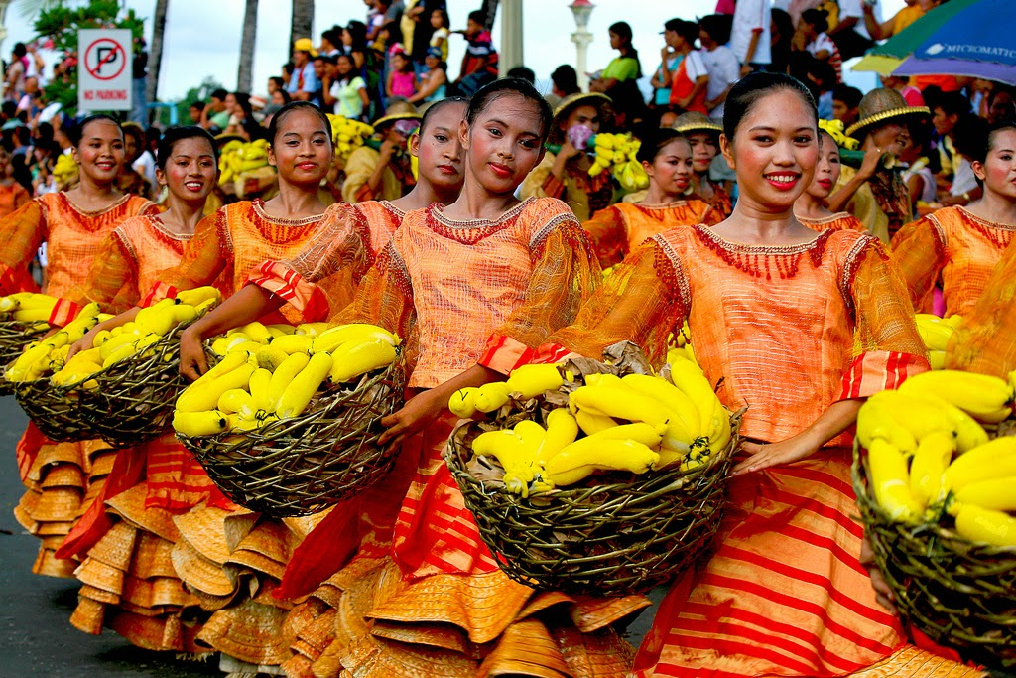

Filipino culture is not spoken of too often. The Filipino culture blends in with many other different cultures. The Philippines was colonized by the Spanish at first and then by the American after the Spanish-American War. They have customs very similar to those here in America. There is one thing that distinguishes them very much. That is the cuisine in the Philippines. They have different ways of eating and they also have their special dishes that are served on special occasions

One very important dish in the Filipino cuisine is rice. There are other cultures that also consider rice as an important dish. "Three crops a year are harvested to provide enough rice for the population" (Barringer 1771). One food that is served everyday is fish and shellfish, they are served either fresh or salted (Barringer 1771). The people in the Philippines cook their food on gas burners or wood or charcoal fires and then allow their food to cool before eating. The rice is usually cooked first because it takes the longest to prepare. The rice is the first thing to be placed on the table while the rest of the food is prepared. "Table knives are not used when they are eating. Forks and spoons are used for dining" (Barringer 1771). A tradition in the Philippines is placing the food on a banana leaf and eating with hands. It is also acceptable to use your hands to eat in restaurants.

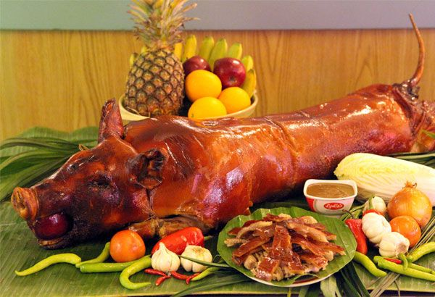Breakfast is usually served early in the morning and it consists of leftovers from the night before. Eggs and sausage are served for breakfast only on special occasions (Barringer 1771). In the afternoon the people eat what is called merienda which is a light snack. It consist of sweet foods, coffee and other things. Then lunch is a light meal with rice and then on another dish some fish or meat stew (Barringer 1772). Lastly, for dinner fish, pork, or chicken is served with a soup that is made of lentils or vegetables.

On a ceremonial occasion a special dish called Lechon is usually served. Lechon is a pig that has been roasted until the skin forms a hard brown crust, and the insides are very fatty. The importance of the host and the occasion are measured by the lechon. The blood that was drained from the pig is used to make dinuguan. Dinuguan is a stew of meat. Then sticky rice is prepared with coconut milk and sugar cane syrup. This is all wrapped in a banana leaf. Glutinous rice is grown specifically to use in this traditional dessert (Barringer 1772). One last traditional food is balut. Balut is a duck egg with an embryo.

Fruit are abundant all year, like several types of bananas and mangoes which are the national fruit. Ube, is a bland bright purple potato used as a colorful ingredient in cakes and ice cream. There is also Halo-halo which is a mixture that consists of layers of corn kernels, ice cream, small gelatin pieces, corn flakes, and shaved ice. It is a very popular dessert in the Philippines.

Every country has their own traditional dishes that are used for different occasions. The Philippines, which is not a country that is very spoken about has its own traditions. Some of the traditional platters in the Philippines can also be found in Hispanic countries just prepared differently. That does not necessarily mean that it is not original. Each country has its own way of preparing their food and what they use their food for.