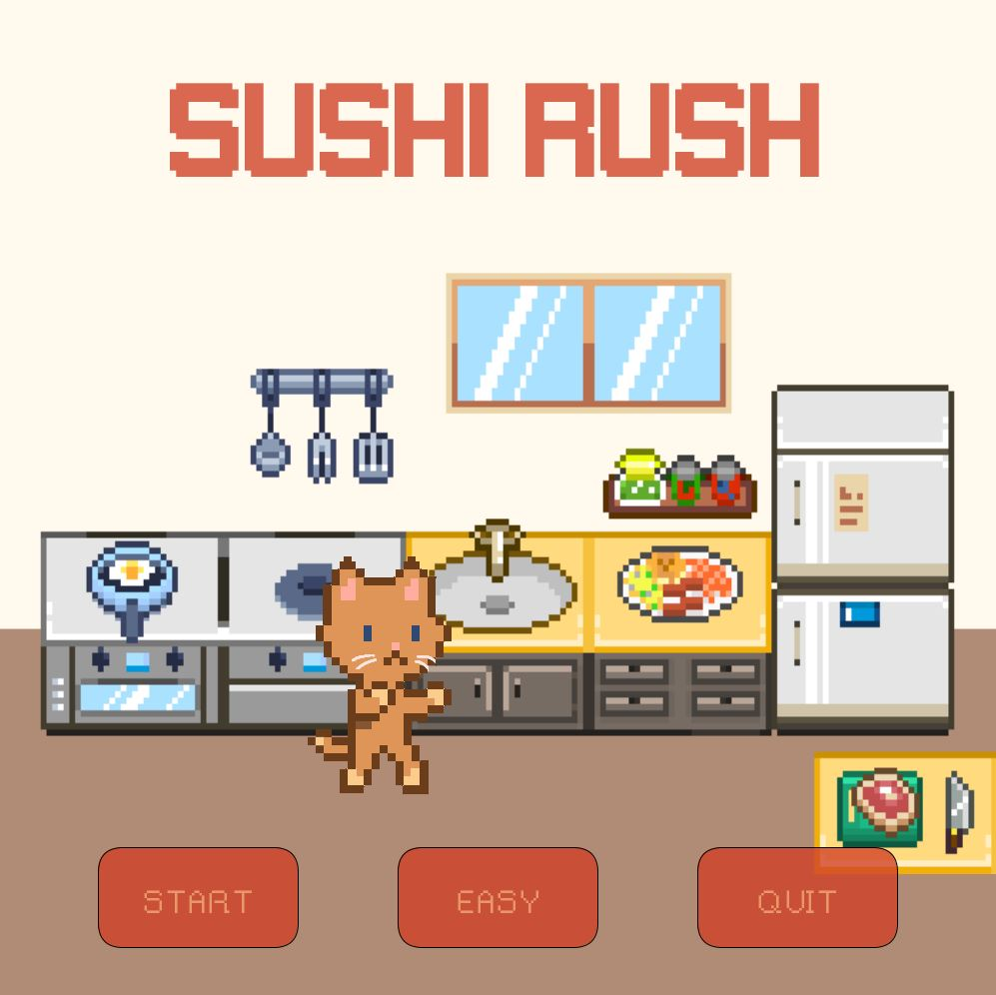

Sushi Rush

Nicole Ajoy

Version: 1.0

# Note from the Creator

## TO-DO

Hello! Thank you for downloading my game, *Sushi Rush*! This game currently runs on Processing version 3.5.4 (library imports should work on any Processing 3.X versions). There are still some things that must be implemented, but that will be ready for the next deadline!

## Library Imports

Before running the game, please make sure to download the libraries listed as they are imported into my program! They are necessary to properly run the game and to visualize everything. Please let me know if something does not work (I will gladly rewrite the code to work without such libraries) and/or if you need further explanation.

|  |  |
| --- | --- |
| Library | Website |
| GifAnimation | https://github.com/akiljohnson1/GifAnimation  Download and unzip the “gifAnimation.zip” folder > put the extracted folder in the following directory:  **<PathToProcessingSketchFolder>/libraries** |
| Minim | http://www.cs.cmu.edu/~jar/cn21.pdf  Download from Processing > Sketch > Add Library > search “Minim” |

# Game Description

## Overview

The genre of *Sushi Rush* is arcade/strategy game that follows the general game mechanics of the popular game, *Fruit Ninja*.

## Objective

The objective is to slice down as many pieces of sushi as possible, collecting enough points while avoiding bombs, to eventually beat the high score!

## UI/Controls & Gameplay

**TITLE SCREEN** There is currently one level implemented that can be set to an EASY or HARD difficulty from the title screen. By default, the level is set to EASY. The word that is displayed in the middle button on the title screen is the current difficulty. Once the user is satisfied with the difficulty setting, they can select the START button to start the game. Once the user is done playing, the user can exit the game from clicking on the QUIT button on the title screen. Likewise, the program can be terminated at any point by pressing the ESC key.

**GAMEPLAY SCREEN** In the gameplay screen, there is an X button on the upper left corner for when the user wishes to return to the title screen. The main UI is located on the top of the screen, including the timer, current score, highest score, and lives remaining. Both sushi and bombs will be thrown up, allowing the player to chop (or avoid) them. Bombs must obviously be avoided and are worth -5 points (deduct from current score and remove one life). Sushi pieces are each worth 10 points (add to the current score).

**EASY/HARD MODE** The difference between the EASY and HARD difficulties is that in the EASY mode, there are no power ups. However, in the HARD mode, the spawn rate of sushi/bombs increases, and powerups are made available.

**HOW-TO-PLAY** The player must click, hold, and drag their mouse across the screen. Any objects between the original mouse click position to where the mouse is released is what will be counted for collision. If a sushi collision is detected, points are added to the current score, and the piece is cut in half, falling down to the bottom of the screen. If a bomb collision is detected, the screen temporarily goes white, slowly fades back, points are deducted, and a life is lost. But the game continues. The game goes on until one of the following:

1. Player has one or more lives and the timer reaches 0
2. Player loses their last life
3. The X button is clicked

**GAMEOVER SCREEN** This screen is obtained only when all lives are lost before the timer runs out. The player is not stuck here though! Simply click the X button in the upper right corner to return to the title screen and try again.

# Resources

## Assets

|  |  |
| --- | --- |
| File (main/data folder) | Website |
| AUDIO | |
| audio_bg.mp3 | https://opengameart.org/content/chiptune-loops-0 |
| audio_chop.mp3 | https://www.fesliyanstudios.com/play-mp3/1215 |
| FONTS | |
| font_gameplay.tff | https://www.dafont.com/gameplay.font |
| font_rainyhearts.tff | https://www.dafont.com/rainyhearts.font |
| IMAGES | |
| bg_end.png | http://i.imgur.com/V35BBN0.png |
| bg_level.png | https://www.redbubble.com/people/stevenfholmes/works/27901396-pixel-art-wood-planks |
| bg_title.png | https://twitter.com/woostarspixels/status/902548037226172416 |
| Image_bomb.gif | http://pixelartmaker.com/art/cf8800006625ade |
| image_cat.gif | (made by me) |
| Image_paw.png | (made by me) |
| Image_sushi.png (all the sushi images) | https://www.deviantart.com/theskywaker/art/Sushi-Pixel-Art-630909109 |

## Other

|  |  |
| --- | --- |
| Resources | Website |
| Collision Detection (circle/line, rectangle/line) | http://www.jeffreythompson.org/collision-detection/table_of_contents.php |