

Ramon Magsaysay Memorial Colleges
College of Information Technology Education
Pioneer Avenue, General Santos City

Kopikuys Cashiering System

In Partial Fulfillment of the Requirement in
Systems Integration and Architecture I

Presented by:
Bayani, Nicole B.
Castillo, John Michael
Marquez, Jerica
Policarpio, Ruslie
Bolando, John Lawrence

Adviser:
Mr. Kenneth Alicer
Approval Sheet
Role | Name | Signature / Date
Adviser | [Adviser Name]
Panel Member 1 | [Name]
Panel Member 2 | [Name]
Department Head | [Name]
Acknowledgment
We would like to thank our adviser for guiding us in this project. We are also grateful to the KopiKuys staff and management who shared their time and ideas with us. Lastly, we thank our families and friends for their support and encouragement during this study.
Abstract / Executive Summary
The KopiKuys Cashiering System was developed to improve the process of handling sales transactions in a coffee shop. Manual recording of sales often leads to delays, calculation errors, and difficulty in generating accurate sales reports. This system aims to make cashiering faster, more accurate, and more organized.
The project followed a step-by-step development process, starting with gathering requirements through interviews, followed by system design and development using PHP for the backend, MySQL for the database, and HTML, CSS, and JavaScript for the user interface. A REST API was used to connect the components of the system.
The system includes essential cashiering features such as recording customer purchases, processing payments, managing staff accounts, and generating daily sales reports. With this system, KopiKuys can perform transactions efficiently, reduce human errors, and simplify sales monitoring. The expected result is a smoother cashiering process and better overall management of daily operations.

Table of Contents
[Auto-generate in Word: Insert -> Table of Contents or manually fill headings and page numbers after finalizing document.]
List of Figures
[Figure 1: ...]

List of Tables
[Table 1: ...]
1. Introduction
1.1 Background of the Study
Cashiering systems play an important role in businesses because they record and process sales efficiently. Many small coffee shops still rely on manual methods, which can lead to slow transactions, errors in computation, and difficulty in tracking daily sales. To address these issues, the KopiKuys Cashiering System was developed to automate the cashiering process. This system aims to make sales transactions faster, more accurate, and more convenient for both staff and customers. It also supports GCash payment to provide a cashless and hassle-free transaction option.
1.2 Problem Statement
KopiKuys experiences problems in handling manual sales transactions. The current process often causes delays, inaccurate calculations, and difficulties in generating daily reports. In addition, customers have limited payment options since cash is the only accepted method. These issues affect service speed and overall customer satisfaction.
1.3 Objectives
General Objective:
To develop a cashiering system that helps KopiKuys record, process, and monitor sales transactions efficiently, including GCash payments.
Specific Objectives:
- To record customer purchases and generate official receipts.
- To process sales transactions through cash and GCash payments.
- To generate daily and summary sales reports.
- To create user logins with different roles such as cashier and admin.
1.4 Scope and Limitations
Scope:
The system focuses on cashiering operations. It includes features for recording sales transactions, processing payments through cash and GCash, managing user accounts, and generating sales reports. It aims to improve the accuracy and speed of the cashiering process.
Limitations:
The system does not include inventory management, other online payment options such as PayPal or credit cards, or payroll functions. It is specifically designed for KopiKuys and may require modifications for other businesses.
1.5 Significance of the Study
This system will help KopiKuys improve the accuracy, speed, and convenience of its cashiering process. Cashiers can process both cash and GCash payments efficiently, while management can easily generate and review sales reports. Customers will also experience faster service with more payment options. The study demonstrates how small businesses can benefit from a simple but effective cashiering system with integrated online payment support.
2. Review of Related Literature and Systems
Past studies show that cashiering systems with real-time features can make businesses faster and more efficient. Santos [1] explained that real-time tracking helps reduce delays and errors in recording sales and inventory. Cruz and Lee [2] studied multi-branch businesses and found that centralized systems give owners better control and help them make decisions more quickly.
Some existing systems, such as Square POS [3] and Lightspeed Retail [4], already provide multi-branch cashiering and inventory features. However, these systems are often too expensive for small businesses to afford. Because of this, many local businesses prefer simpler and cheaper systems that still meet their needs. This project aims to give KopiKuys a practical solution by creating a custom multi-branch cashiering system that is cost-effective and user-friendly.
References (IEEE)
[1] R. Santos, "Real-time cashiering systems and their impact on efficiency in retail businesses," International Journal of Information Management, vol. 12, no. 3, pp. 101–110, 2020.
[2] J. Cruz and M. Lee, "Centralized systems for multi-branch businesses: Improving decision-making and control," Journal of Business Information Systems, vol. 15, no. 2, pp. 45–56, 2021.
[3] Square, Inc., "Square Point of Sale," 2023. [Online]. Available: https://squareup.com
[4] Lightspeed Commerce, "Lightspeed Retail POS system," 2023. [Online]. Available: https://www.lightspeedhq.com
3. Theoretical and Conceptual Framework
This project is based on the Management Information System (MIS) theory, which says that businesses need correct and timely information to make good decisions. It also uses Systems Theory, which explains that combining parts of a business into one system makes the whole process more effective.
4. Methodology
4.1 Project Development Approach
For this project, the Agile Development Approach was chosen because it works well for a small-scale system like the Coffee Shop Cashiering System. Agile allows features to be built, tested, and improved quickly, making it easier to meet the needs of the client.
1. Requirements change frequently
During development, new features may be requested, such as adding GCash, modifying the receipt layout, or changing the user interface. Agile allows the team to make these changes easily without starting the project over. This makes the system more flexible and able to meet the client’s evolving needs.
2. The system benefits from fast feedback
With Agile, each module—like order creation, payment processing, and receipt printing—can be tested as soon as it is developed. This helps find and fix errors early. It also allows the system to improve quickly based on real feedback from the shop owner or cashier.
3. The project is small and modular
The system can be divided into smaller parts, such as the Login module, Order module, Payment module, Receipt module, and Reports module. Each part can be completed in short development cycles, called sprints. This makes it easier to manage the project and deliver working features quickly.
4. Continuous improvement is required
Cashiering systems often need updates, like changing the UI layout, adjusting prices, adding product categories, or modifying receipt formatting. Agile supports making these improvements continuously, even after the first version of the system is released.
5. Faster delivery of usable features
Agile allows the team to deliver working parts of the system early. For example, the first sprint can focus on order encoding and display, the second on payment computation, the third on receipt generation, and the fourth on admin management. This way, the shop can already start using the system while development continues.
Conclusion
The Agile methodology was chosen because it provides flexibility, fast development, continuous feedback, and better adaptation to changes. Using Agile ensures the Coffee Shop Cashiering System becomes accurate, user-friendly, and closely aligned with the real operations of a cashier.

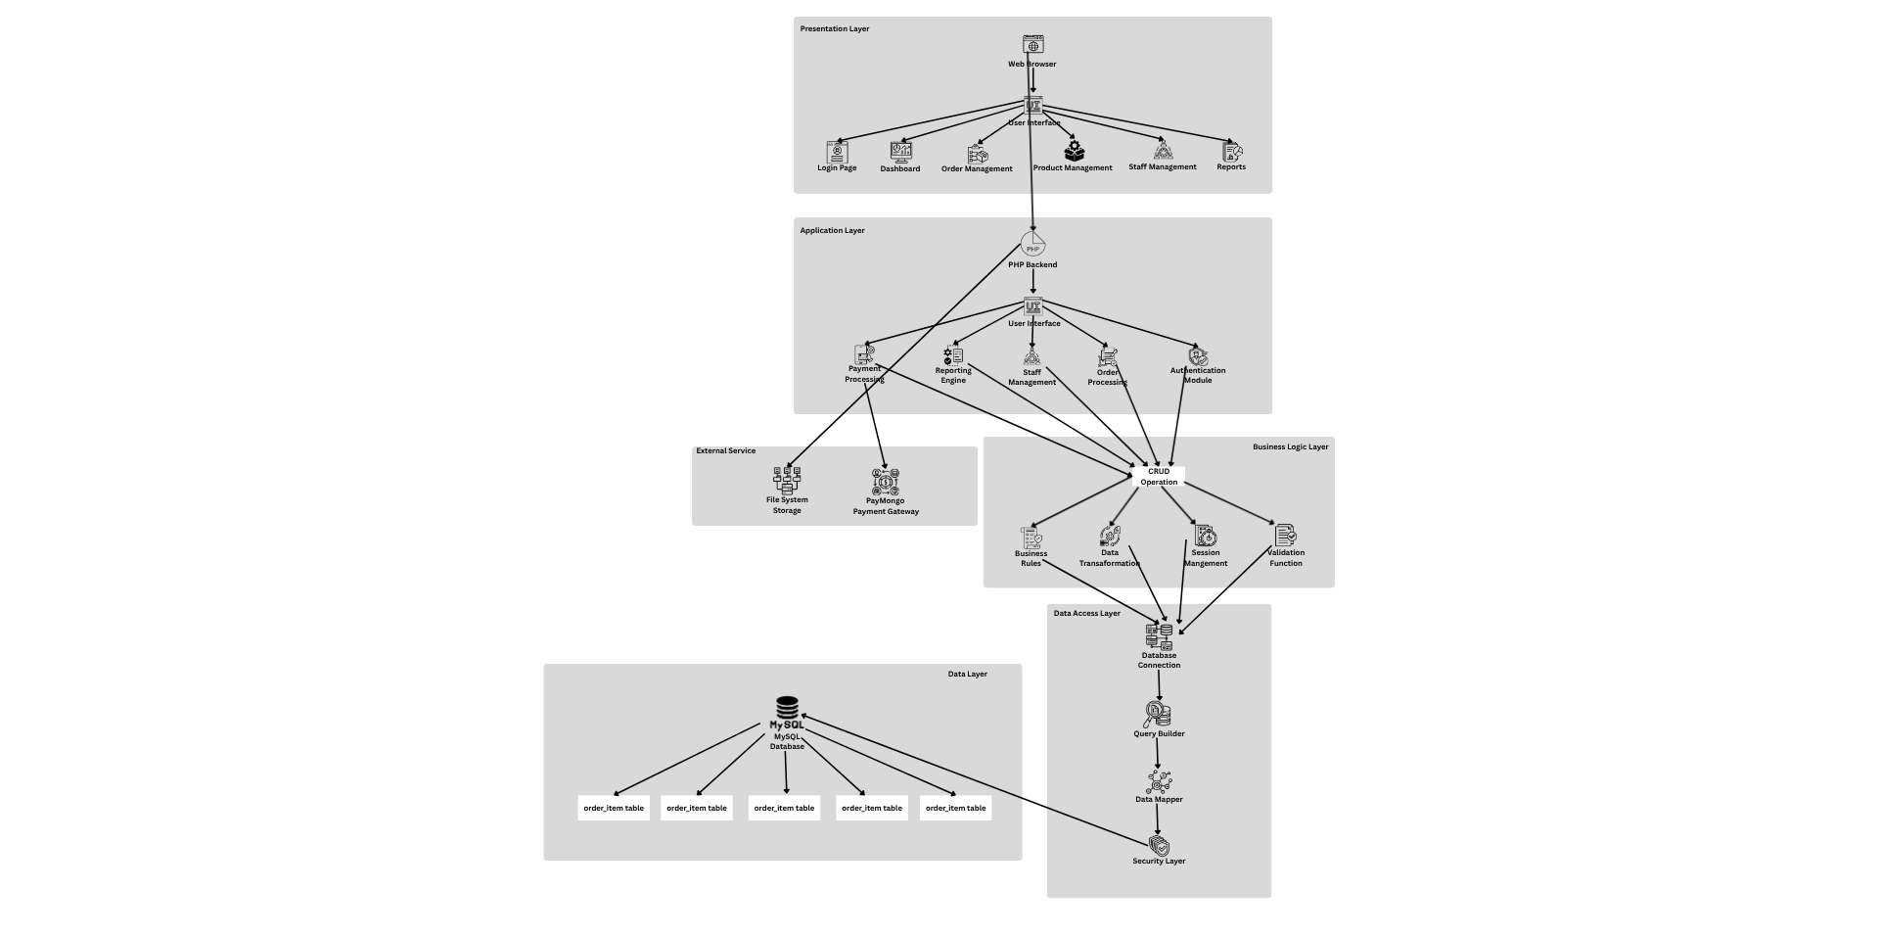
4.2 System Architecture

Presentation Layer
User interface components, including login, dashboard, order management, product management, staff management, and reports.
Application Layer
PHP backend modules handling authentication, order processing, management, staff management, reporting, and payment processing.
Business Logic Layer
Core business operations, including CRUD functions, validation session management, data transformation, and business rules.
Data Access Layer
Database interaction components, including connection management, query building, data mapping, and security measures.
External Services
Third-party integrations, including PayMongo payment gateway and file system storage for product images.
Data Layer
MySQL database with tables for cashier staff, products, categories, orders, and order items.

4.3 Hardware and Software Requirements
[List required hardware, OS, software, libraries, and versions.

4.4 Modules and Functionalities
The Kopikuys Cashiering System is designed to streamline the sales process by allowing the cashier to handle orders, manage customers, and process payments efficiently. It focuses only on cashiering operations — without inventory or stock management. The main modules and their functionalities are described below.
1. Login Module
Description:
This module provides secure access to the system. Only authorized staff can log in using their credentials. It ensures that only the cashier or admin can operate the system.
Functions:
- Authenticate user credentials (username and password).
- Redirect the user to the dashboard upon successful login.
- Display an error message for invalid credentials.
- Allow logout functionality.

2. Dashboard Module
Description:
The dashboard serves as the central control panel of the cashier. It provides quick navigation to other modules and displays useful sales information.
Functions:
- Display total sales for the day.
- Provide quick access buttons for taking orders and viewing transactions.
- Show user (cashier) information and system date/time.
3. Customer Module
Description:
This module manages customer information for order tracking and record purposes. It helps in identifying returning customers and linking them with their purchases.
Functions:
- Add new customer details (name, address, contact number).
- Update or delete customer records.
- Display customer list for selection during order placement.

4. Order Module
Description:
The heart of the system, this module handles order creation and management. The cashier can select products, calculate totals, and manage the payment process easily.
Functions:
- Select coffee and other menu items for the customer.
- Automatically calculate subtotals, taxes, and total price.
- Allow editing or removing items before confirming the order.
- Store each transaction for future reporting.
5. Payment Module
Description:
This module is responsible for processing payments and ensuring accurate billing. It supports both cash and GCash payments (for online testing or simulation).
Functions:
- Input customer payment amount and compute change.
- Validate if the payment is sufficient before finalizing the transaction.
- Record payment details (mode of payment, date, and time).
- Integrate with GCash test API for simulated transactions.
6. Receipt Module
Description:
After a successful payment, this module generates a printable receipt summarizing the transaction details.
Functions:
- Generate and display receipt with all order details.
- Include cashier name, date/time, and payment type.
- Provide print button for hard copy receipts.
7. Reports Module
Description:
This module allows viewing past transactions for sales monitoring and auditing purposes.
Functions:
- Display list of all completed transactions.
- Filter reports by date, cashier, or payment type.
- Generate daily sales summary.

8. Logout Module
Description:
Allows the user to securely exit the system.
Functions:
- Terminate the current session.
- Redirect back to the login page.
4.5 Data Flow and UML Diagrams
DFD Level 1
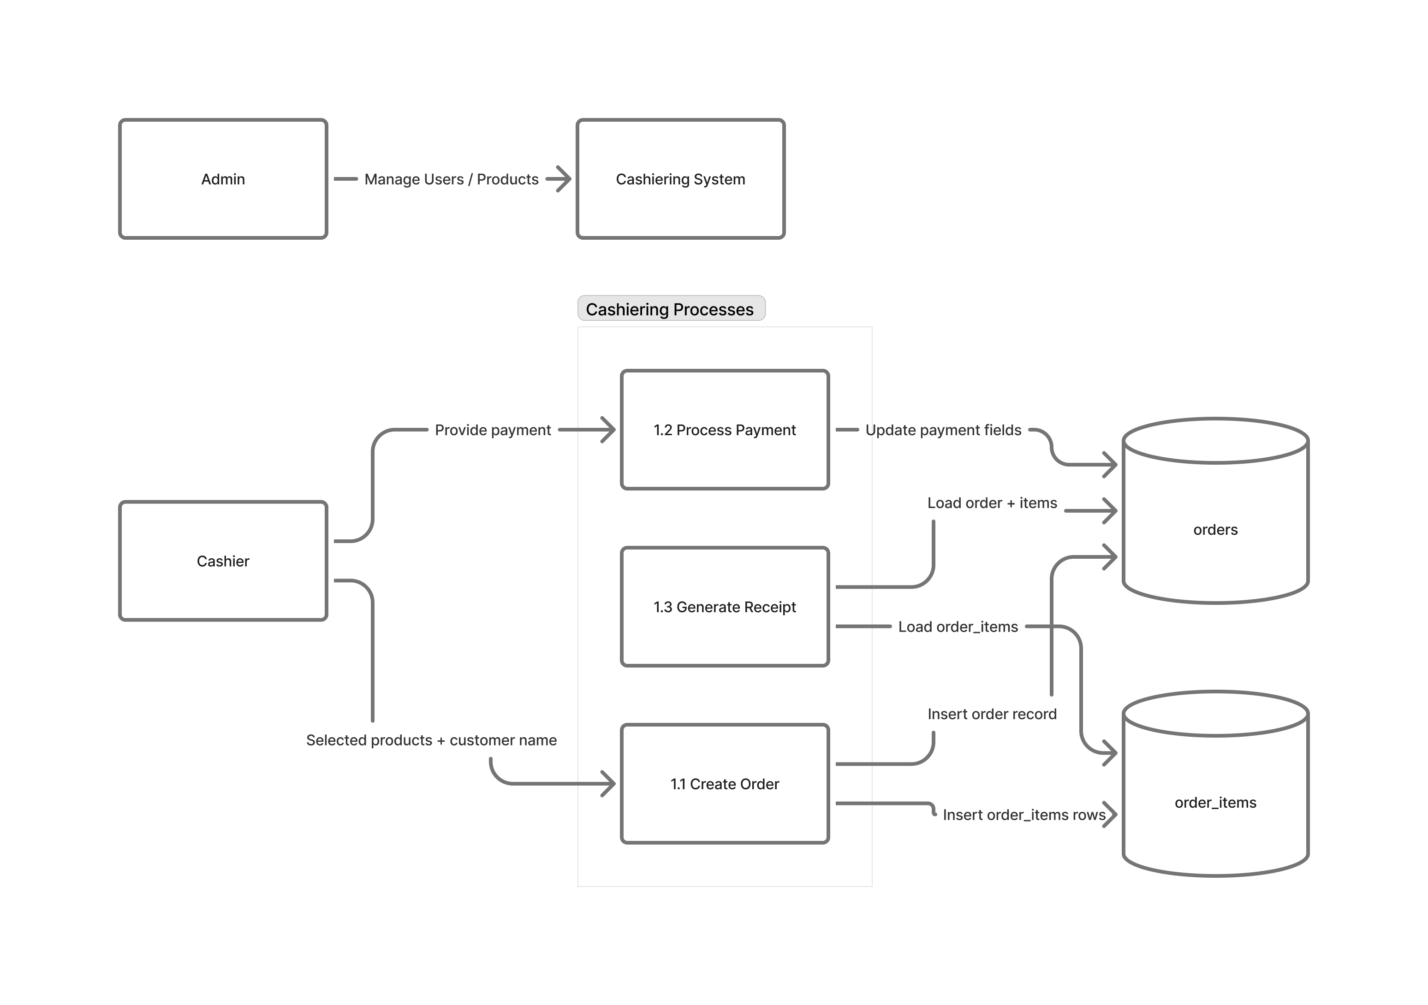

DFD Level 2
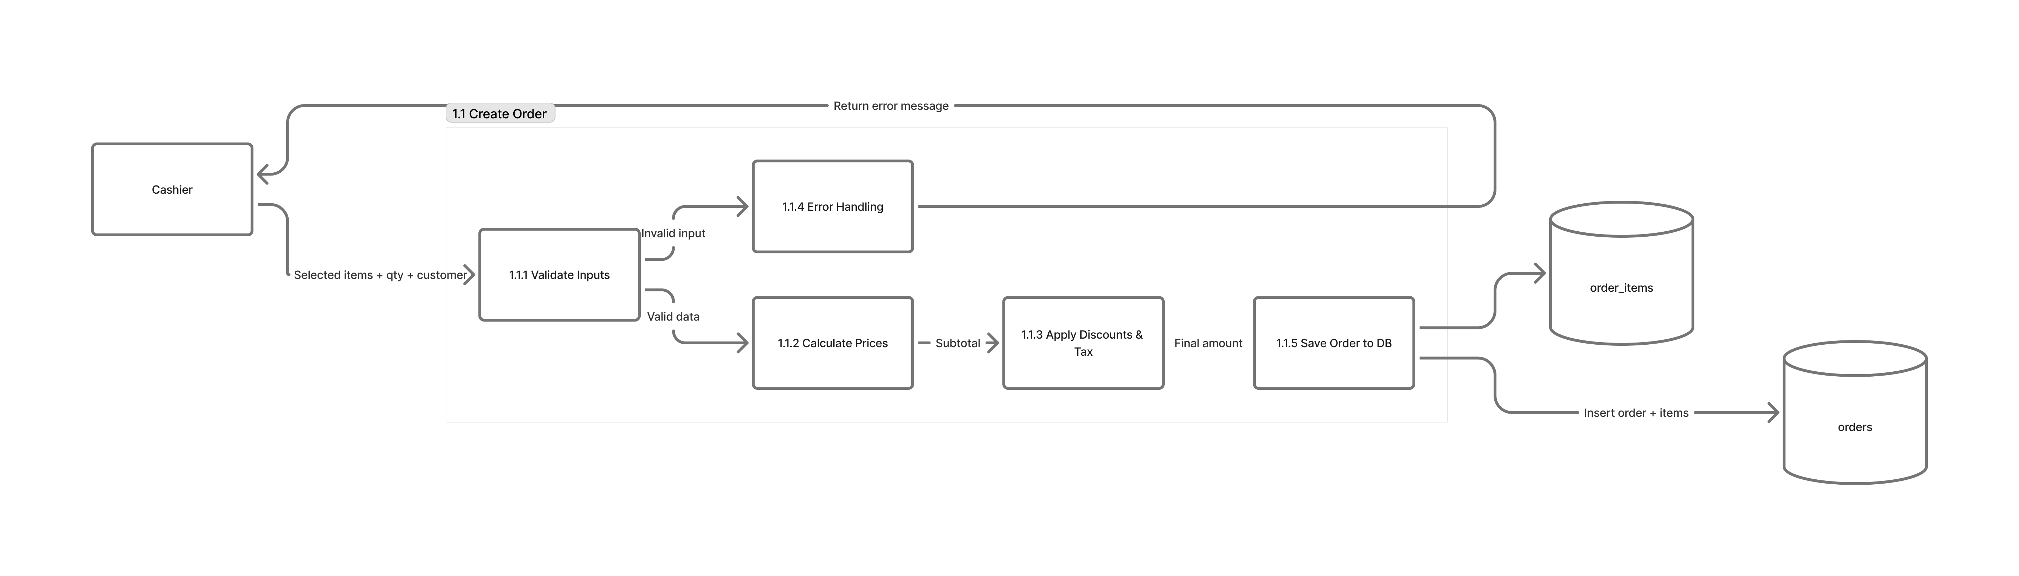
Context Diagram
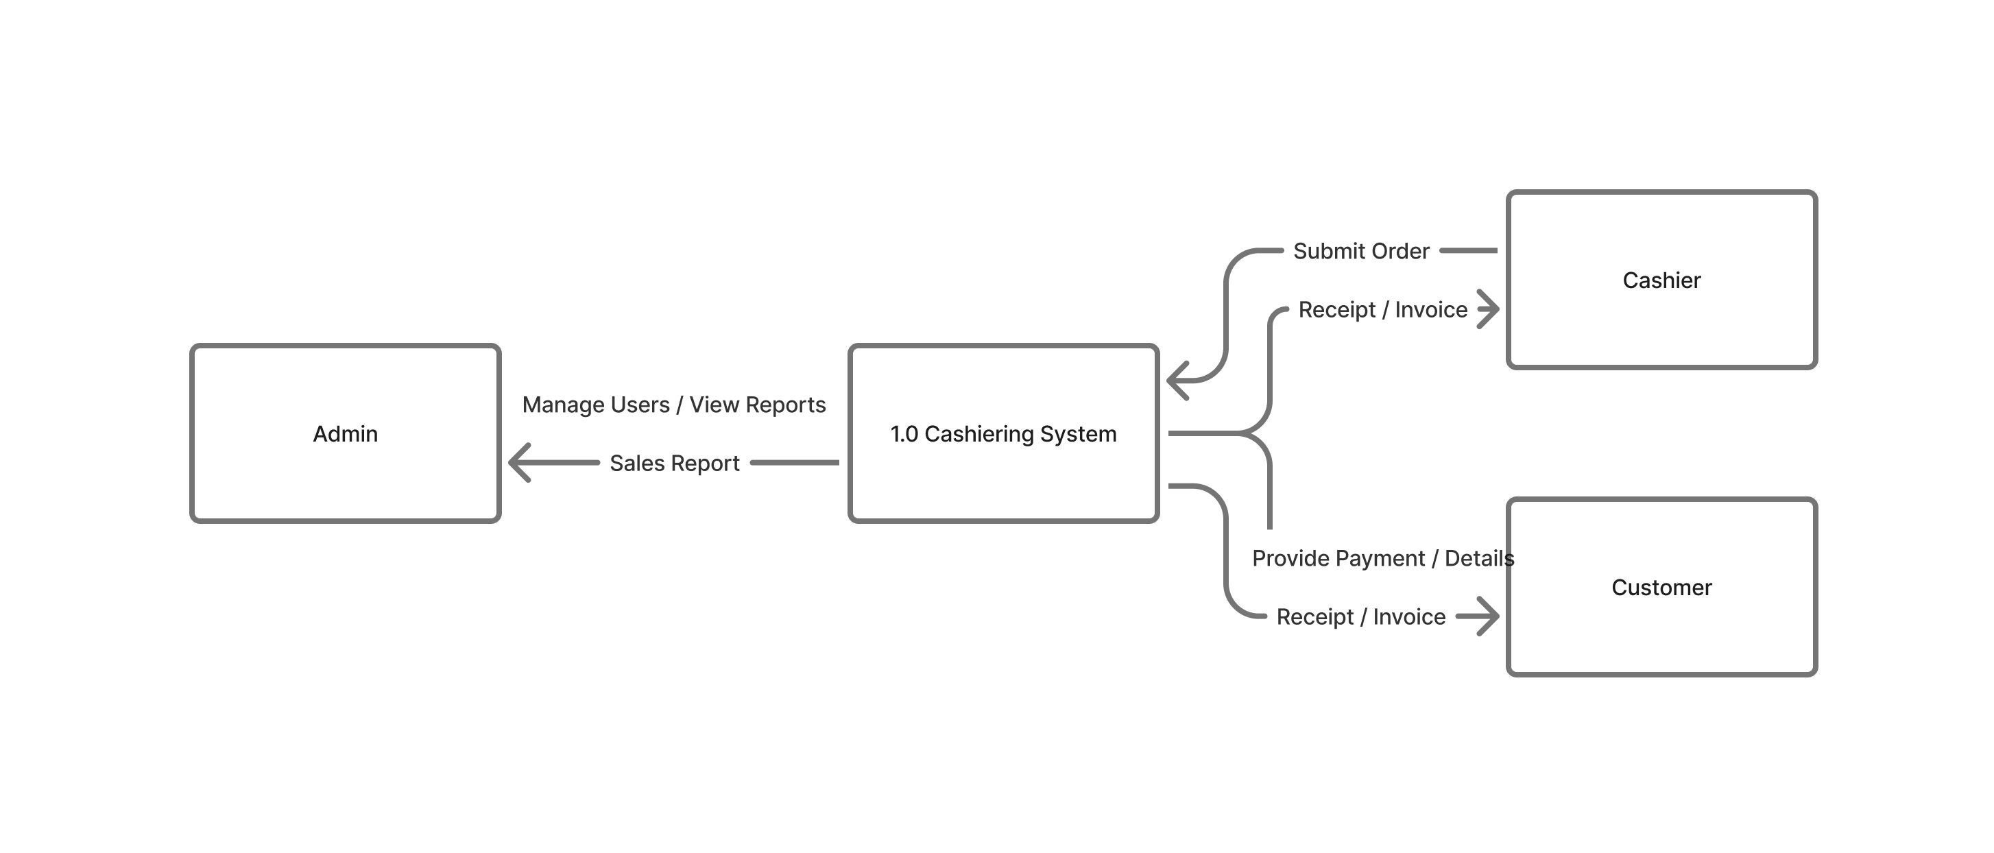
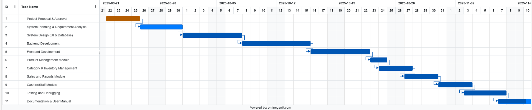
4.6 Project Timeline (Gantt Chart)

5. System Design and Implementation
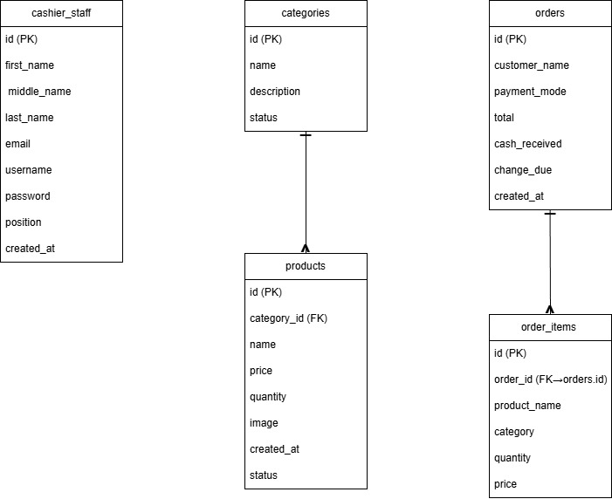
5.1 Database Design

cashier_staff
The cashier_staff table stores all employee accounts that are allowed to access the system. Each record includes the employee’s full name, email, username, password, and position, along with the date the account was created. This table currently does not have a relationship with the orders table because there is no cashier_id or similar field to identify who processed a specific order. An improvement for future versions of the system would be to add a processed_by field inside the orders table to track which cashier handled each transaction.
categories
The categories table groups drinks according to their type, such as Coffee Series, Non-Coffee Series, Choco-Ey Series, and Rookie Series. Each category contains a name, a description, and a status field that indicates whether the category is available or not. This table has a one-to-many relationship with the products table, meaning each category can have multiple products under it.
products
The products table contains the list of items available for sale in the shop. Every product is linked to a category through the category_id field. The table stores important details such as the product name, price, stock quantity, and image. These products appear in the point-of-sale interface and are used when customers place orders. The system also updates the product quantity based on sales.
orders
The orders table represents each customer purchase made in the system. It stores the customer’s name, payment mode, total amount, cash received, and the computed change. It also records the date and time when the order was created. Each order can have multiple order items connected to it, forming a one-to-many relationship with the order_items table.
order_items
The order_items table holds the detailed list of all products included in a specific order. Each entry stores the order it belongs to, the product name, the category, the quantity ordered, and the price per item. Although the product details are stored here, they are saved as plain text instead of linking to the actual products table. This design choice allows the system to keep a historical record even if a product is edited or deleted later, but it also means the data is not fully normalized.

5.2 User Interface Design
[Wireframes, mockups, screenshots]

5.3 Backend / API Design
[API endpoints, authentication, data models]

5.4 Integration Points and Workflows
[Describe how components interface with each other and external services]
6. Testing and Evaluation
6.1 Test Plan
[Define testing strategy and scope]

6.2 Test Cases and Results
[Provide tables of test cases, expected vs actual results]

6.3 User Acceptance Testing (UAT)
[Describe UAT process and results]
7. Results and Discussion
[Present outputs, screenshots, performance data, and interpret results in relation to objectives]
8. Summary, Conclusions, and Recommendations
[Summarize key findings, draw conclusions, and propose recommendations for future work]
References
[List all sources cited in APA or IEEE format]
Appendices
Appendix A: User Manual
[Include step-by-step user instructions]
Appendix B: Code Snippets
[Optional: include important code or link to repository]
Appendix C: Survey Instruments / Raw Data
[Include consent forms if applicable]

