**SharePoint App**

This is an overview about the proof of concept of the SharePoint Application.

Repository name: NMBL_SharePointAPI

Branch: develop

The solution contains just one an MVC project. (It is not a .NET Web API)

What could you do with the application?

1. Upload a file in a specified location.
2. Search files using a tag name as a parameter. As a result you will see a grid with pagination.
3. Open the file that you have searched.

Before you start:

Make sure you have completed the AccountUsername and AccountPassword keys in Web.config file with the correct information.

Also in this configuration file, you could change the path of the server in the ServerPath key.

**Workflow:**

Current SharePoint path is configured in web.config file and its value is: “https://nimblesoft.sharepoint.com/sites/dev”.

In that site the files have a custom column named “CustomerName”.

When you start the application the first screen is:

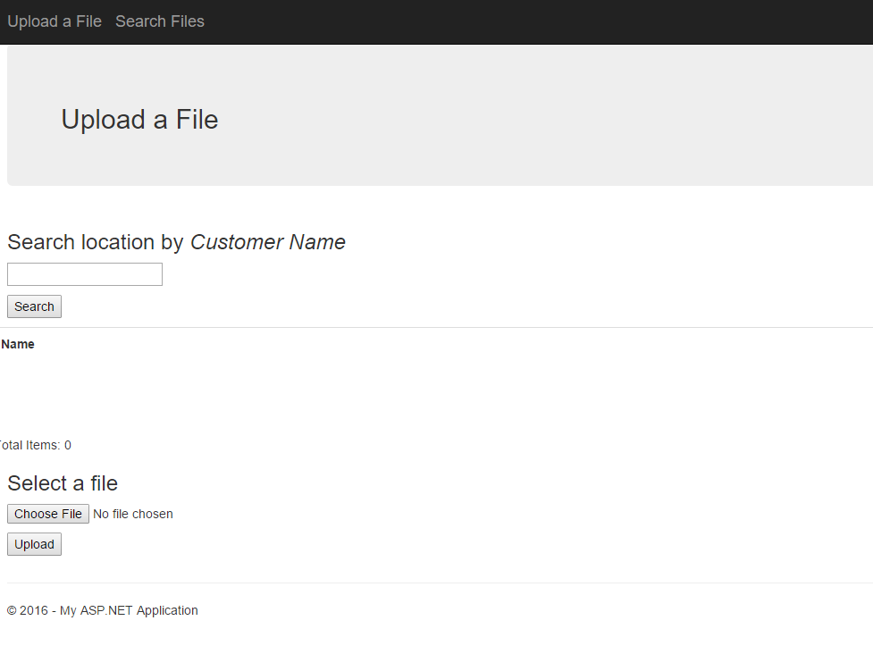

There you could search a location using a Customer Name, i.e. “Nico Leg”

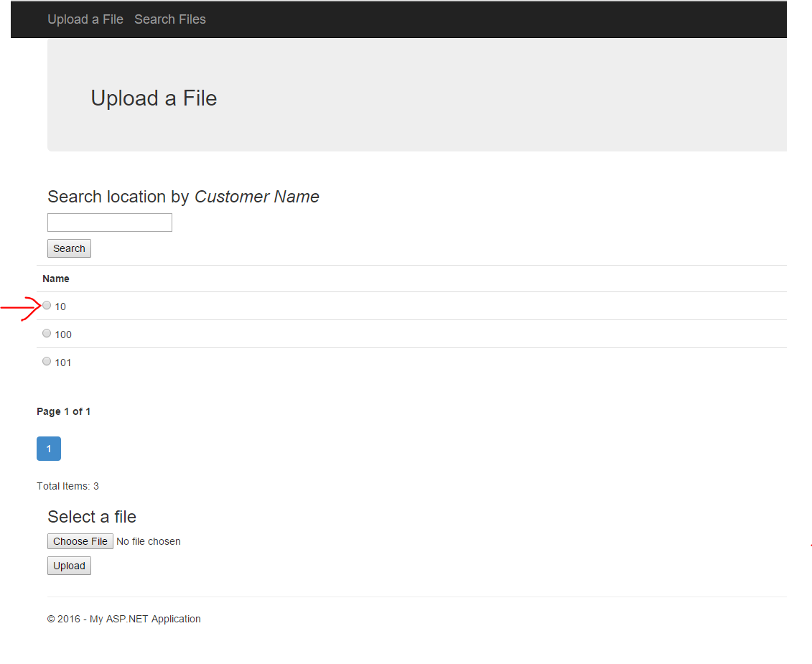

Then, select one location. i.e. “10”, choose a file and click on upload (see the below image).

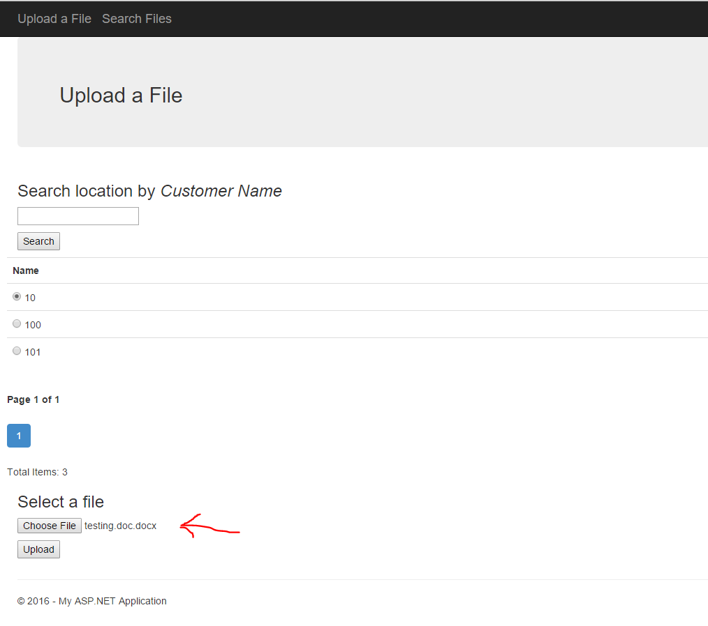

Once the file is uploaded, we could click on “Search Files” link in the menu.

Now we are in the second screen where we will be able to search for files.

Type a Customer Name to search files that belong to that customer and click on “Search” button.

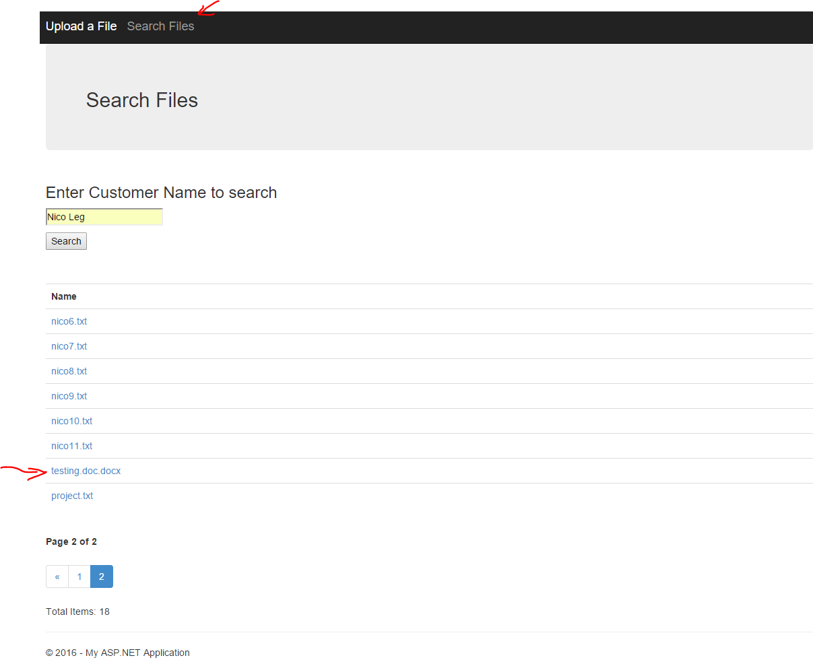

You should see the file you have added before and all the files that belong to that customer.

If you click in the file link it should be opened in SharePoint or downloaded.