COS10031 – Computer Technology

Assignment 3: ARMLite Mastermind Game

8:30am Tuesday, 10:30am Wednesday with Dr. Sourabh Dani

Nicole Reichert (100589839)

Marcus Mifsud (105875038)

Vandy Aum (105715697)

Luke Byrnes (7194587)

Due: 18 May 2025

Diploma IT - Swinburne College

Contents

Mastermind Assembly Game 3

Program Overview 3

Key Functions 3

Stage 1 (stage1.txt) 3

Stage 2 (stage2.txt) 4

Stage 3 (stage3.txt) 7

Stage 4 (stage4.txt) 8

Stage 5a (stage5a.txt) 11

Stage 5b (stage5b.txt) 14

Assumptions 17

No restrictions for user submitted Guess Limit 17

No Duplicate Guess controls 17

Appendix - Full Code Stack 18

# Mastermind Assembly Game

## Program Overview

This program replicates gameplay of the Mastermind boardgame in Assembly using the ARMLite assembly utility.

## Key Functions

### Stage 1 (stage1.txt)

- Luke Byrnes & Nicole Reichert

Stage 1 request’s the players to enter their names and define the maximum number of guesses using the following functions.

**File: stage1.txt**

56: // Display whoIsCodeMaker Query prompt:

57: whoIsCodeMakerMsg: .ASCIZ "Codemaker is: "

58: // Store **block** of memory of 128 **bytes** to store the **string**

59: codeMaker: .**BLOCK** 128

60: // Display whoIsCodeMaker Query prompt:

61: whoIsCodeBreakerMsg: .ASCIZ "\nCodebreaker is: "

62: // Store **block** of memory of 128 **bytes** to store the **string**

63: codeBreaker: .**BLOCK** 128

64: // Display guessLimit Query prompt:

65: whatIsGuessLimitMsg: .ASCIZ "\nGuess Limit: "

66: // Store the guesslimit as a label, 0 as default

67: guessLimit: .WORD 0

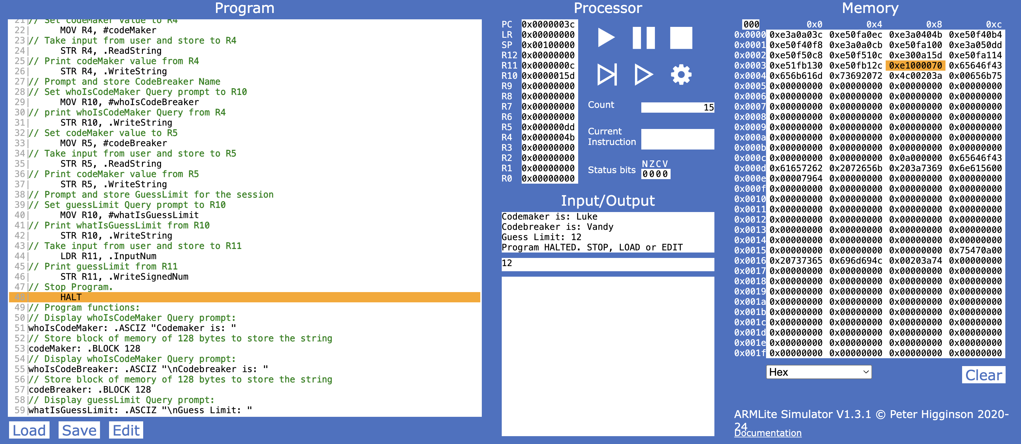

Stage 1: Functional Screenshot

### Stage 2 (stage2.txt)

- Vandy Aum & Marcus Mifsud

In stage 2 a function getcode was created to receive input of a code and validate that it follows the rules of the game. After receiving input, the value of each character is extracted from the string using LDRB before branching to validateChar where it is checked against all valid characters. The fifth character of the string is then checked and returns an error if it has any value.

**File: stage2.txt**

080: getcode:

081: // store **address** of where the function was called from

082: **MOV** R8, LR

083: // **branch** here if the code entered is invalid

084: getcodeNested:

085: // Read input of code

086: **MOV** R12, #tempcode

087: **STR** R12, .ReadString

088: // Validate Secret Code

089: // First Character

090: // Store the **address** of the first **byte** of R12 content

(secret code) in R9

091: **LDRB** R9, [R12]

092: **BL** validateChar

093: // Second Character

094: // Store the **address** of the second **byte** of R12 content

(secret code) in R9

095: //one character is one **byte** so when **adding** one **byte** to R12

**it** will **be** the **address** of the next character

096: **LDRB** R9, [R12, #1]

097: **BL** validateChar

098: // Third Character

099: // Store the **address** of the third **byte** of R12 content

(secret code) in R9

100: **LDRB** R9, [R12, #2]

101: **BL** validateChar

102: // Fourth Character

103: // Store the **address** of the fourth **byte** of R12 content

(secret code) in R9

104: **LDRB** R9, [R12, #3]

105: **BL** validateChar

106: // Fifth Character

107: // Store the **address** of the fifth **byte** of R12 content

(secret code) in R9

108: **LDRB** R9, [R12, #4]

109: **CMP** R9, #0 //check if a character was not entered

110: **BNE** overLimit //if a character was entered **branch** to

’overLimit’

111: //if a fifth character was not entered **and** all prior checks

passed, input is valid, return to code

112: // return **address** the function was called from to LR

113: **MOV** LR, R8

114: **B** Return

115:

116: invalidChar:

117: **MOV** R10, #errorMsg1

118: **STR** R10, .WriteString

119: **b** getcodeNested

120: tooFewChar:

121: **MOV** R10, #errorMsg2

122: **STR** R10, .WriteString

123: **b** getcodeNested

124: overLimit:

125: **MOV** R10, #errorMsg3

126: **STR** R10, .WriteString

127: **b** getcodeNested

128:

129: // VALIDATE CHARACTER FUNCTION

130: validateChar:

131: **CMP** R9, #0 //check if a character was not entered

132: **BEQ** tooFewChar

133: **CMP** R9, #0x72 //check if the character is r(red)

134: **BEQ** Return

135: **CMP** R9, #0x67 //check if the character is g(green)

136: **BEQ** Return

137: **CMP** R9, #0x62 //check if the character is **b(blue)**

138: **BEQ** Return

139: **CMP** R9, #0x79 //check if the character is y(yellow)

140: **BEQ** Return

141: **CMP** R9, #0x70 //check if the character is p(purple)

142: **BEQ** Return

143: **CMP** R9, #0x63 //check if the character is c(cyan)

144: **BEQ** Return

145: **b** invalidChar //**branch** to 'invalidChar' if the character was not

matched **by** any of the above checks

146:

147: // Function to return from function

148: Return: RET

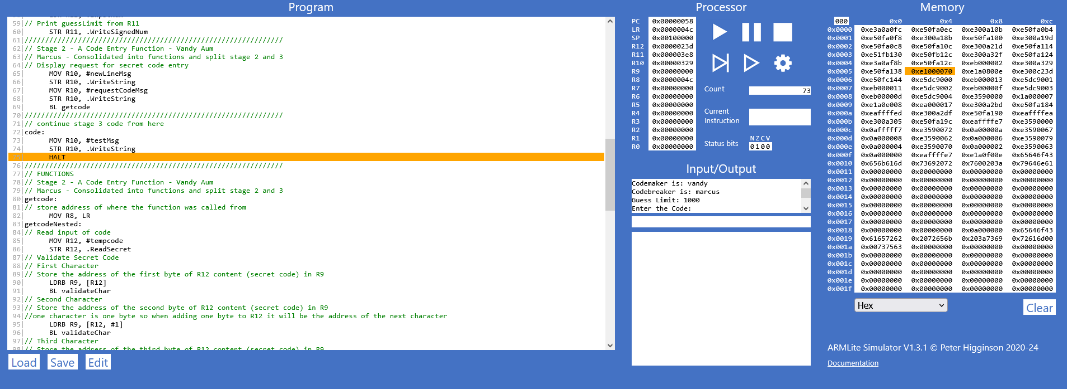

Stage 2: Functional Screenshot

### Stage 3 (stage3.txt)

- Marcus Mifsud & Vandy Aum

In stage 3 the ‘codeToArray’ function was created to convert the string ‘tempcode’ into an array. The getcode function was also modified to utilize .ReadSecret the first time it runs (always the code maker’s turn) to hide the entered code from the code breaker.

**File: stage3.txt – code to array function**

170: // Store code to array function

171: // R12 - **Address** to tempcode is stored here

172: // R9 - Current Character

173: // R6 - Memory **address** of the array to fill

174: // R7 - Array index

175: secretCodeToArray:

176: // load the **address** of the secret code into R6

177: **MOV** R6, #secretcode

178: **B** codeToArray

179: codeToArray:

180: // initialize the array position to 0

181: **MOV** R7, #0

182: fillArrayLoop:

183: // divide R7 (index) **by** 4

184: **LSR** R7, R7, #2

185: // load character into R9

186: **LDRB** R9, [R12 + R7]

187: // **multiply** R7 (index) **by** 4

188: **LSL** R7, R7, #2

189:

190: // store character into array element

191: **STR** R9, [R6 + R7]

192:

193: // increment index counter **by** 4

194: **ADD** R7, R7, #4

195:

196: **CMP** R7, #codeArraySize // repeat until 4 elements of the array have **been** filled

197: **BLT** fillArrayLoop

198: **B** Return

**File: stage3.txt – exert from updated *getcode* function**

088: getcodeNested:

089: // Read input of code

090: **MOV** R12, #tempcode

091: // Initialize R6

092: **MOV** R6, #0

093: **MOV** R6, #secretcode

094: **MOV** R9, #0

095: **LDRB** R9, [R6]

096: **CMP** R9, #0

097: **BEQ** secretcodeentry

098: **BNE** querycodeentry

099: // If codemaker's turn

100: secretcodeentry:

101: STR R12, .ReadSecret

102: B validateCharLoop

103: // If codebreaker's turn

104: querycodeentry:

105: **STR** R12, .ReadString

106: **B** validateCharLoop

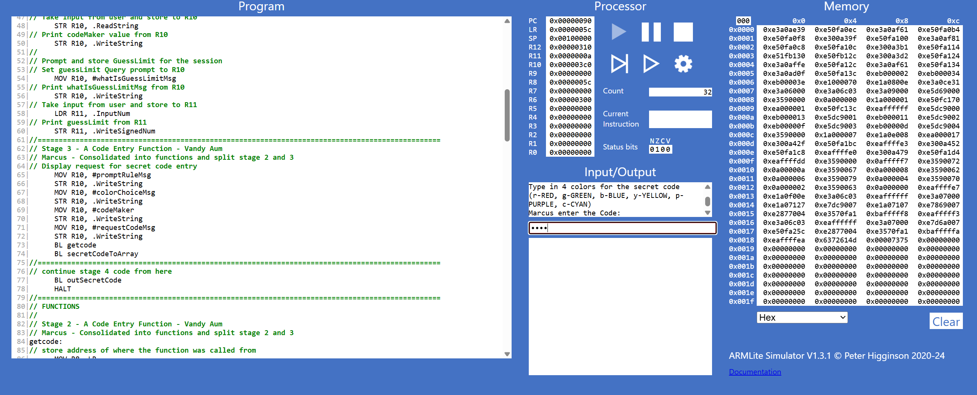

Stage 3: Screenshot showing code maker code entry

### Stage 4 (stage4.txt)

- Nicole Reichert & Marcus Mifsud

In stage 4 the queryloop function was created which increments the guess counter before checking if the code breaker has exceeded the guess limit. If not, the code breaker is requested to enter their guess using the *getcode* function. The code then branches back to the start of *queryloop* and continues looping until the guess limit is met.

**File: stage4.txt – *queryloop* function**

080: queryloop:

081: // Initialize to currentGuessCount

082: **MOV** R3, #0

083: **LDRB** R3, currentGuessCount

084: // Increment guess count **by** 1

085: **ADD** R3, R3, #1

086: **STRB** R3, currentGuessCount

087: // Check if we are at guess limit

088: **CMP** R3, R11

089: **BGT break**

090: // reset R3

091: **MOV** R3, #0

092: //

093: // Continue to guess now that we've checked guess count

094: // Print 'What is your guess'

095: MOV R10, #requestGuessMsg

096: STR R10, .WriteString

097: // Print codebreaker name

098: MOV R10, #codeBreaker

099: STR R10, .WriteString

100: // Print question mark

101: MOV R10, #questionMarkMsg

102: STR R10, .WriteString

103: // End line

104: MOV R10, #newLineMsg

105: STR R10, .WriteString

106: //

107: // Print 'This is guess number: '

108: MOV R10, #guessNumberCountMsg

109: STR R10, .WriteString

110: // Print guess number

111: LDRB R10, currentGuessCount

112: STR R10, .WriteUnsignedNum

113: // End line

114: MOV R10, #newLineMsg

115: STR R10, .WriteString

116: //

117: // Get codebreaker's guess

118: **BL** getcode

119: **BL** queryCodeToArray

120:

121: **B** query

122: // out of guesses

123: **break:**

124: HALT

125: //===========================================================================

126: // Continue stage 5 here

127: query:

128:

129: **B** queryloop

Stage 4: Functional Screenshot

### Stage 5a (stage5a.txt)

- Nicole Reichert & Marcus Mifsud

In stage 5a we check the query code against the secret code. To achieve this we use a nested loop, where the outer loop iterates for each peg of the query code, that peg is checked against the secret code peg of the same position, and if they did not match, the inner loop iterates for each character of the secret code other than the current query code character, checking for a colour match in a different position.

Because this doesn't check for any prior Case 1 states (as we have not completed a state machine here), this gives back ALL Case 1 and Case 2 instances, even if Case 1 and Case 2 might collide (in example of double colours in a secret code).

**File: stage5.txt – *comparecodes* function**

128: comparecodes:

129: // Initializing registers

130: **MOV** R0, #0 // Case 1 Counter

131: **MOV** R1, #0 // Case 2 Counter

132: **MOV** R3, #0

133: **LDRB** R3, arraySize // Array Size

134: **MOV** R9, #0 // Query character

135: **MOV** R4, #0 // Secret character

136: **MOV** R5, #querycode // Query array **address**

137: **MOV** R6, #secretcode // Secret array **address**

138: **MOV** R7, #0 // array index / loop counter

139: // R2 - Inner index

140:

141: // Case 1

142: case1start:

143: // initialize R2 (inner index)

144: **MOV** R2, #0

145: // Load a char from query code into R9

146: **LDRB** R9, [R5 + R7]

147: //

148: // Load a char from secret code into R4

149: **LDRB** R4, [R6 + R7]

150: //

151: // Compare for Case 1 (**BEQ)**

152: **CMP** R4, R9

153: // If case 1 is true

154: **BEQ** case1true

155: // If case 1 is false

156: **B** case2start

157:

158: // Case 2

159: case2start:

160: // if main index = inner index, skip case2 check

161: **CMP** R2, R7

162: **BEQ** case2loopback

163: // load secret char

164: **LDRB** R4, [R6 + R2]

165: // Compare secret char to query char

166: **CMP** R4, R9

167: // if case 2 is true

168: **BEQ** case2true

169: //

170: // **branch** here to skip comparison of chars already done in case 1

171: case2loopback:

172: // increment inner index

173: **ADD** R2, R2, #4

174:

175: // loop until full array checked

176: **CMP** R2, R3

177: **BLT** case2start

178: **B** charQueryEnd

179:

180: ///////////////////////////////////////////////////////////

181: // Case 1 success

182: // Query char matches secret char in same position

183: case1true:

184: // **Add** 1 to case1 counter

185: **ADD** R0, R0, #1

186: **B** case2start

187:

188:

189: // Case 2 success

190: // Query char matches a secret char in a different position

191: case2true:

192: // **Add** 1 to case2 counter

193: **ADD** R1, R1, #1

194: // go **back** to case 2 start

195: **B** case2loopback

196:

197: // Loop **back** to main

198: charQueryEnd:

199: // **Add** 4 to main index

200: **ADD** R7, R7, #4

201: // Have we hit end of loop?

202: **CMP** R7, R3

203: // if not, loop **back** to start of char checks

204: **BLT** case1start

205: // if loop complete, display char check info

206: **B** guessfeedback

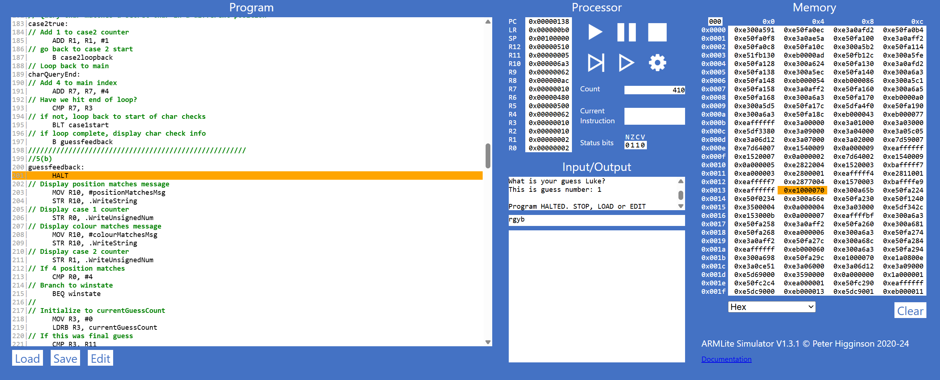

Stage 5a: Screenshot showing 2 exact matches and 2 colour matches (stored in R0 & R1)

### Stage 5b (stage5b.txt)

- Nicole Reichert & Marcus Mifsud

In stage 5 the *guessfeedback* function was created which displays the result of *comparecodes*. If the result of case 1 is 4 (the codes fully match) the code branches to *winstate* which displays a win message and then branches to *gameover* which ends the game. The logic for incrementing the current guess count and checking the guess limit was also moved here from the start of *queryloop*, and branches to *losestate* if the guess limit has been exceeded without a full code match. If the code breaker neither wins or loses at this point, the code loops back to the start of *queryloop* to allow another guess.

**File: stage5.txt**

209: guessfeedback:

210: // Display position matches message

211: **MOV** R10, #positionMatchesMsg

212: **STR** R10, .WriteString

213: // Display case 1 counter

214: **STR** R0, .WriteUnsignedNum

215: // Display colour matches message

216: **MOV** R10, #colourMatchesMsg

217: **STR** R10, .WriteString

218: // Display case 2 counter

219: **STR** R1, .WriteUnsignedNum

220: // If 4 position matches

221: **CMP** R0, #4

222: // **Branch** to winstate

223: **BEQ** winstate

224: //

225: // Initialize to currentGuessCount

226: **MOV** R3, #0

227: **LDRB** R3, currentGuessCount

228: // If this was final guess

229: **CMP** R3, R11

230: **BEQ** losestate

231: // Else, loop **back** for another guess

232: **B** queryloop

233:

234: winstate:

235: **MOV** R10, #newLineMsg

236: **STR** R10, .WriteString

237: **MOV** R10, #winStateMsg1

238: **STR** R10, .WriteString

239: **MOV** R10, #codeBreaker

240: **STR** R10, .WriteString

241: **MOV** R10, #winStateMsg2

242: **STR** R10, .WriteString

243: **B** gameover

244:

245: losestate:

246: **MOV** R10, #newLineMsg

247: **STR** R10, .WriteString

248: **MOV** R10, #loseStateMsg1

249: **STR** R10, .WriteString

250: **MOV** R10, #codeBreaker

251: **STR** R10, .WriteString

252: **MOV** R10, #loseStateMsg2

253: **STR** R10, .WriteString

254: **B** gameover

255:

256: gameover:

257: // clean our words if we wish to re-run

258: **BL** clean

259: **MOV** R10, #newLineMsg

260: **STR** R10, .WriteString

261: **MOV** R10, #gameOverMsg

262: **STR** R10, .WriteString

263: HALT

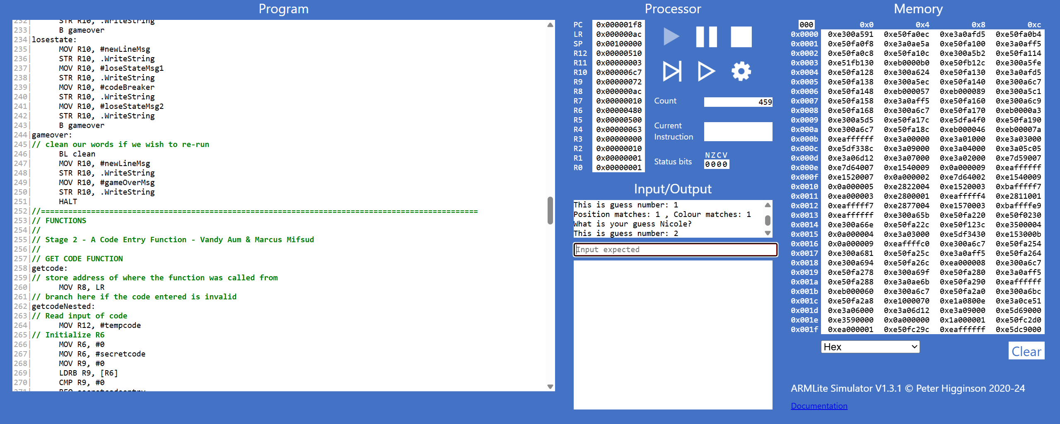

Stage 5b: Screenshot showing feedback for a guess

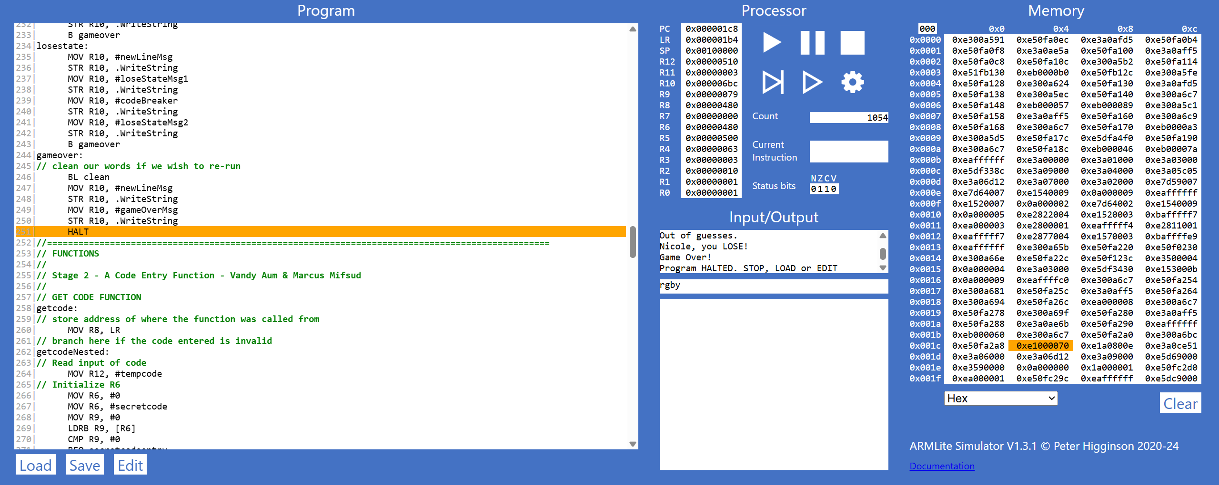

Stage 5b: Screenshot showing lose state

## Assumptions

### No restrictions for user submitted Guess Limit

Reasonable number of guesses will be submitted as input for the user without controls. The application does not constrict the user-entry value of the number of guesses to either a numerical entry limit, nor a theoretical mathematical limit of guesses needed to get the right answer. For example, as per the rules of Mastermind, the total sequences available to guess from is expressed by:

### No Duplicate Guess controls

There are no validation checks for duplicate sequence submissions made by the user. This means that the user is burning an opportunity to guess within the specified limit, but also means that they have increased the number of guesses that could potentially be needed to obtain the correct outcome if there was no limit specified. That is, for each duplicate guess , the number of total sequences increases by 1.

## 

## Appendix - Full Code Stack

File: mastermind.asm

001: //======================================================================

002: // COS10031 - Computer Technology | Assessment 3

003: // Vandy Aum, Marcus Mifsud, Nicole Reichert, Luke Byrnes

004: // **___ ___ _ _** _

005: // **| \/ | | | (_) | |**

006: // **| . . | __ _ ___| |_ ___ _ __ _ __ ___ _ _ __ __| |**

007: // **| |\/| |/ _` / __| __/ _ \ '__| '_ ` _ \| | '_ \ / _` |**

008: // **| | | | (_| \__ \ || __/ | | | | | | | | | | | (_| |**

009: // **\_| |_/\__,_|___/\__\___|_| |_| |_| |_|_|_| |_|\__,_|**

010: //

011: // Register Assignations

012: // R0 (Compare Code of Correct Pos/Col)

013: // R1 (Compare Code of (Correct Pos, Incorrect Col))

014: // R2

015: // R3

016: // R4

017: // R5

018: // R6

019: // R7

020: // R8 Function Return (stores LR to return after a function is used within a

function)

021: // R9 Code character address

022: // R10 String Handling

023: // R11 Guess Limit

024: // R12 Address to temp code

025: //======================================================================

026: // Stage 1 - Game Setup - Luke Byrnes & Nicole Reichert

027: //

028: // Prompt and store Codemaker Name

029: // Set whoIsCodeMakerMsg Query prompt to R10

030: MOV R10, #whoIsCodeMakerMsg

031: // print whoIsCodeMakerMsg Query from R10

032: STR R10, .WriteString

033: // Move codeMaker address to R10

034: MOV R10, #codeMaker

035: // Take input from user and store to R10

036: STR R10, .ReadString

037: // Print codeMaker value from R10

038: STR R10, .WriteString

039: //

040: // Prompt and store CodeBreaker Name

041: // Set whoIsCodeMakerMsg Query prompt to R10

042: MOV R10, #whoIsCodeBreakerMsg

043: // print whoIsCodeMakerMsg Query from R10

044: STR R10, .WriteString

045: // Move codeBreaker address to R10

046: MOV R10, #codeBreaker

047: // Take input from user and store to R10

048: STR R10, .ReadString

049: // Print codeMaker value from R10

050: STR R10, .WriteString

051: //

052: // Prompt and store GuessLimit for the session

053: guesslimitprompt:

054: // Set guessLimit Query prompt to R10

055: MOV R10, #whatIsGuessLimitMsg

056: // Print whatIsGuessLimitMsg from R10

057: STR R10, .WriteString

058: // Take input from user and store to R11

059: LDR R11, .InputNum

060: // BL to check we have a value between 1 and 100

061: BL guesslimitcheck

062: // Print guessLimit from R11

063: STR R11, .WriteUnsignedNum

064: //======================================================================

065: // Stage 3 - A Code Entry Function - Marcus Mifsud & Vandy Aum

066: // Marcus - Consolidated into functions and split stage 2 and 3

067: // Display request for secret code entry

068: MOV R10, #promptRuleMsg

069: STR R10, .WriteString

070: MOV R10, #colorChoiceMsg

071: STR R10, .WriteString

072: MOV R10, #codeMaker

073: STR R10, .WriteString

074: MOV R10, #requestCodeMsg

075: STR R10, .WriteString

076: MOV R10, #newLineMsg

077: STR R10, .WriteString

078: BL getcode

079: BL secretCodeToArray

080: //======================================================================

081: // Stage 4 - Query Code Entry - Nicole Reichert & Marcus Mifsud

082: // Marcus - Consolidated Nicole's work into main code **base**

083: queryloop:

084: // Initialize to currentGuessCount

085: //**MOV** R3, #0

086: //**LDRB** R3, currentGuessCount

087: // Increment guess count **by** 1

088: //**ADD** R3, R3, #1

089: //**STRB** R3, currentGuessCount

090: // reset R3

091: //**MOV** R3, #0

092: //

093: // Continue to guess now that we've checked guess count

094: // Print 'What is your guess'

095: MOV R10, #requestGuessMsg

096: STR R10, .WriteString

097: // Print codebreaker name

098: MOV R10, #codeBreaker

099: STR R10, .WriteString

100: // Print question mark

101: MOV R10, #questionMarkMsg

102: STR R10, .WriteString

103: // End line

104: MOV R10, #newLineMsg

105: STR R10, .WriteString

106: //

107: // Perform guessCount check now

108: BL guesscountcheck

109: // Print 'This is guess number: '

110: MOV R10, #guessNumberCountMsg

111: STR R10, .WriteString

112: // Print guess number

113: LDRB R10, currentGuessCount

114: STR R10, .WriteUnsignedNum

115: // End line

116: MOV R10, #newLineMsg

117: STR R10, .WriteString

118: //

119: // Get codebreaker's guess

120: **BL** getcode

121: **BL** queryCodeToArray

122:

123:

124: **B** comparecodes

125: //======================================================================

126: // Stage 5 - Query Code Evaluation - Nicole Reichert

127: // 5(a)

128: comparecodes:

129: // Initializing registers

130: **MOV** R0, #0 // Case 1 Counter

131: **MOV** R1, #0 // Case 2 Counter

132: **MOV** R3, #0

133: **LDRB** R3, arraySize // Array Size

134: **MOV** R9, #0 // Query character

135: **MOV** R4, #0 // Secret character

136: **MOV** R5, #querycode // Query array **address**

137: **MOV** R6, #secretcode // Secret array **address**

138: **MOV** R7, #0 // array index / loop counter

139: // R2 - Inner index

140:

141: // Case 1

142: case1start:

143: // initialize R2 (inner index)

144: **MOV** R2, #0

145: // Load a char from query code into R9

146: **LDRB** R9, [R5 + R7]

147: //

148: // Load a char from secret code into R4

149: **LDRB** R4, [R6 + R7]

150: //

151: // Compare for Case 1 (**BEQ)**

152: **CMP** R4, R9

153: // If case 1 is true

154: **BEQ** case1true

155: // If case 1 is false

156: **B** case2start

157:

158: // Case 2

159: case2start:

160: // if main index = inner index, skip case2 check

161: **CMP** R2, R7

162: **BEQ** case2loopback

163: // load secret char

164: **LDRB** R4, [R6 + R2]

165: // Compare secret char to query char

166: **CMP** R4, R9

167: // if case 2 is true

168: **BEQ** case2true

169: //

170: // **branch** here to skip comparison of chars already done in case1

171: case2loopback:

172: // increment inner index

173: **ADD** R2, R2, #4

174:

175: // loop until full array checked

176: **CMP** R2, R3

177: **BLT** case2start

178: **B** charQueryEnd

179:

180: ///////////////////////////////////////////////////////////

181: // Case 1 success

182: // Query char matches secret char in same position

183: case1true:

184: // **Add** 1 to case1 counter

185: **ADD** R0, R0, #1

186: **B** case2start

187:

188:

189: // Case 2 success

190: // Query char matches a secret char in a different position

191: case2true:

192: // **Add** 1 to case2 counter

193: **ADD** R1, R1, #1

194: // go **back** to case 2 start

195: **B** case2loopback

196:

197: // Loop **back** to main

198: charQueryEnd:

199: // **Add** 4 to main index

200: **ADD** R7, R7, #4

201: // Have we hit end of loop?

202: **CMP** R7, R3

203: // if not, loop **back** to start of char checks

204: **BLT** case1start

205: // if loop complete, display char check info

206: **B** guessfeedback

207: //////////////////////////////////////////////////////

208: //5(**b)**

209: guessfeedback:

210: // Display position matches message

211: **MOV** R10, #positionMatchesMsg

212: **STR** R10, .WriteString

213: // Display case 1 counter

214: **STR** R0, .WriteUnsignedNum

215: // Display colour matches message

216: **MOV** R10, #colourMatchesMsg

217: **STR** R10, .WriteString

218: // Display case 2 counter

219: **STR** R1, .WriteUnsignedNum

220: // If 4 position matches

221: **CMP** R0, #4

222: // **Branch** to winstate

223: **BEQ** winstate

224: //

225: // Initialize to currentGuessCount

226: **MOV** R3, #0

227: **LDRB** R3, currentGuessCount

228: // If this was final guess

229: **CMP** R3, R11

230: **BEQ** losestate

231: // Else, loop **back** for another guess

232: **B** queryloop

233:

234: winstate:

235: **MOV** R10, #newLineMsg

236: **STR** R10, .WriteString

237: **MOV** R10, #winStateMsg1

238: **STR** R10, .WriteString

239: **MOV** R10, #codeBreaker

240: **STR** R10, .WriteString

241: **MOV** R10, #winStateMsg2

242: **STR** R10, .WriteString

243: **B** gameover

244:

245: losestate:

246: **MOV** R10, #newLineMsg

247: **STR** R10, .WriteString

248: **MOV** R10, #loseStateMsg1

249: **STR** R10, .WriteString

250: **MOV** R10, #codeBreaker

251: **STR** R10, .WriteString

252: **MOV** R10, #loseStateMsg2

253: **STR** R10, .WriteString

254: **B** gameover

255:

256: gameover:

257: // clean our words if we wish to re-run

258: **BL** clean

259: **MOV** R10, #newLineMsg

260: **STR** R10, .WriteString

261: **MOV** R10, #gameOverMsg

262: **STR** R10, .WriteString

263: HALT

264:

265: //======================================================================

266: // FUNCTIONS

267: //

268: // Stage 2 - A Code Entry Function - Vandy Aum & **Marcus** Mifsud

269: //

270: // GET CODE FUNCTION

271: getcode:

272: // store **address** of where the function was called from

273: **MOV** R8, LR

274: // **branch** here if the code entered is invalid

275: getcodeNested:

276: // Read input of code

277: **MOV** R12, #tempcode

278: // Initialize R6

279: **MOV** R6, #0

280: **MOV** R6, #secretcode

281: **MOV** R9, #0

282: **LDRB** R9, [R6]

283: **CMP** R9, #0

284: **BEQ** secretcodeentry

285: **BNE** querycodeentry

286: // If codemaker's turn

287: secretcodeentry:

288: STR R12, .ReadSecret

289: B validateCharLoop

290: // If codebreaker's turn

291: querycodeentry:

292: **STR** R12, .ReadString

293: **B** validateCharLoop

294: // Validate Secret Code

295: validateCharLoop:

296: // First Character

297: // Store the **address** of the first **byte** of R12 content (temp

code) in R9

298: **LDRB** R9, [R12]

299: **BL** validateChar

300: // Second Character

301: // Store the **address** of the second **byte** of R12 content (temp

code) in R9

302: //one character is one **byte** so when **adding** one **byte** to R12

**it** will **be** the **address** of the next character

303: **LDRB** R9, [R12, #1]

304: **BL** validateChar

305: // Third Character

306: // Store the **address** of the third **byte** of R12 content (temp

code) in R9

307: **LDRB** R9, [R12, #2]

308: **BL** validateChar

309: // Fourth Character

310: // Store the **address** of the fourth **byte** of R12 content (temp

code) in R9

311: **LDRB** R9, [R12, #3]

312: **BL** validateChar

313: // Fifth Character

314: // Store the **address** of the fifth **byte** of R12 content (temp

code) in R9

315: **LDRB** R9, [R12, #4]

316: **CMP** R9, #0 //check if a character was not entered

317: **BNE** overLimit //if a character was entered **branch** to

‘overLimit’

318: //if a fifth character was not entered **and** all prior checks

passed, input is valid, return to code

319: // return **address** the function was called from to LR

320: **MOV** LR, R8

321: **B** Return

322:

323: invalidChar:

324: **MOV** R10, #errorMsg1

325: **STR** R10, .WriteString

326: **b** getcodeNested

327: tooFewChar:

328: **MOV** R10, #errorMsg2

329: **STR** R10, .WriteString

330: **b** getcodeNested

331: overLimit:

332: **MOV** R10, #errorMsg3

333: **STR** R10, .WriteString

334: **b** getcodeNested

335:

336: // VALIDATE CHARACTER FUNCTION

337: validateChar:

338: **CMP** R9, #0 //check if a character was not entered

339: **BEQ** tooFewChar

340: **CMP** R9, #0x72 //check if the character is r(red)

341: **BEQ** Return

342: **CMP** R9, #0x67 //check if the character is g(green)

343: **BEQ** Return

344: **CMP** R9, #0x62 //check if the character is **b(blue)**

345: **BEQ** Return

346: **CMP** R9, #0x79 //check if the character is y(yellow)

347: **BEQ** Return

348: **CMP** R9, #0x70 //check if the character is p(purple)

349: **BEQ** Return

350: **CMP** R9, #0x63 //check if the character is c(cyan)

351: **BEQ** Return

352: **b** invalidChar //**branch** to 'invalidChar' if the character was not

matched **by** any of the above checks

353:

354: // Function to return from function

355: Return: RET

356:

357: // STORE CODE TO ARRAY FUNCTION

358: // R12 - **Address** to tempcode is stored here

359: // R9 - Current Character

360: // R6 - Memory **address** of the array to fill

361: // R7 - Array index

362: // R3 - Array Size

363: secretCodeToArray:

364: // load the **address** of the secret code into R6

365: **MOV** R6, #secretcode

366: **B** codeToArray

367: queryCodeToArray:

368: **MOV** R6, #querycode

369: **B** codeToArray

370: codeToArray:

371: // initialize the array position to 0

372: **MOV** R7, #0

373: // initialize array size

374: **LDRB** R3, arraySize

375: fillArrayLoop:

376: // divide R7 (index) **by** 4

377: **LSR** R7, R7, #2

378: // load character into R9

379: **LDRB** R9, [R12 + R7]

380: // **multiply** R7 (index) **by** 4

381: **LSL** R7, R7, #2

382:

383: // store character into array element

384: **STR** R9, [R6 + R7]

385:

386: // increment index counter **by** 4

387: **ADD** R7, R7, #4

388:

389: **CMP** R7, R3 // repeat until 4 elements of the array have **been**

filled

390: **BLT** fillArrayLoop

391: **B** Return

392:

393: // OUTPUT ARRAY FUNCTION (only used for testing)

394: // output secret code

395: outSecretCode:

396: **MOV** R6, #secretcode

397: **B** outCodeArray

398: // output query code

399: outQueryCode:

400: **MOV** R6, #querycode

401: **B** outCodeArray

402: outCodeArray:

403: // intialize index counter

404: **MOV** R7, #0

405: // initialize array size

406: **LDRB** R3, arraySize

407: // output the 4 digit code from an array

408: outCodeArrayLoop:

409: **LDRB** R10, [R6 + R7]

410: **STR** R10, .WriteChar

411:

412: // increment index

413: **ADD** R7, R7, #4

414:

415: // loop until 4 elements have **been** output

416: **CMP** R7, R3

417: **BLT** outCodeArrayLoop

418: **B** Return

419:

420: //==========

421: //=HELPER FUNCTIONS - Nicole Reichert

422: // Checking **bounds** of functions - we could **be** inputting something over a

word or over a hard limit of 1-255.

423: guesslimitcheck:

424: **CMP** R11, #0xFF

425: **BGT** exceedlimit

426: **CMP** R11, #0x1

427: **BLT** exceedlimit

428: RET

429:

430: exceedlimit:

431: **MOV** R10, #errorMsg4

432: **STR** R10, .WriteString

433: **MOV** R11, #0

434: **B** guesslimitprompt

435:

436: guesscountcheck:

437: // Initialize to currentGuessCount

438: **MOV** R3, #0

439: **LDRB** R3, currentGuessCount

440: // Increment guess count **by** 1

441: **ADD** R3, R3, #1

442: **STRB** R3, currentGuessCount

443: // reset R3

444: **MOV** R3, #0

445: RET

446: clean:

447: // wipe currentguesscount

448: **LDRB** R8, currentGuessCount

449: **MOV** R8, #0

450: **STRB** R8, currentGuessCount

451: **MOV** R8, #secretcode

452: **MOV** R7, #0

453: **STR** R7, [R8]

454:

455: RET

456:

457: //======================================================================

458: // STORAGE =========================================================

459: // Store **block** of memory of 128 **bytes** to store the codemaker's name

460: codeMaker: .BLOCK 128

461: // Store block of memory of 128 bytes to store the codebreaker's name

462: codeBreaker: .**BLOCK** 128

463: // Array Size

464: arraySize: .**BYTE** 16 // 4 elements * 4 **bytes**

465: // secret code array

466: .ALIGN 128

467: secretcode: .**BYTE**  0

468: 0

469: 0

470: 0

471: //

472: // query code array

473: .ALIGN 128

474: querycode: .**BYTE**  0

475: 0

476: 0

477: 0

478: //

479: // temp code **string**

480: tempcode: .**BLOCK** 128

481: //

482: currentGuessCount: .**BYTE** 0

483: //

484: // MESSAGES =========================================================

485: // Display whoIsCodeMakerMsg Query prompt:

486: whoIsCodeMakerMsg: .ASCIZ "Codemaker is: "

487: // Display whoIsCodeBreakerMsg Query prompt:

488: whoIsCodeBreakerMsg: .ASCIZ "\nCodebreaker is: "

489: // Display guessLimit Query prompt:

490: whatIsGuessLimitMsg: .ASCIZ "\nGuess Limit: "

491: requestGuessMsg: .ASCIZ "What is your guess "

492: guessNumberCountMsg: .ASCIZ "This is guess number: "

493: //Display the prompt for user to input the secret code

494: requestCodeMsg: .ASCIZ " enter the Code: "

495: promptRuleMsg: .ASCIZ "\nType in 4 colors for the secret code"

496: colorChoiceMsg: .ASCIZ "\n(r-RED, g-GREEN, b-BLUE, y-YELLOW, p-PURPLE,

c-CYAN)\n"

497: // Outcome of guess messages

498: positionMatchesMsg: .ASCIZ "Position matches: "

499: colourMatchesMsg: .ASCIZ ", Colour matches: "

500: // Win/Lose States/GameOver

501: winStateMsg1: .ASCIZ "Exact code match.\n"

502: winStateMsg2: .ASCIZ ", you WIN!"

503: loseStateMsg1: .ASCIZ "Out of guesses.\n"

504: loseStateMsg2: .ASCIZ ", you LOSE!"

505: gameOverMsg: .ASCIZ "Game Over!"

506: // General use Messages

507: newLineMsg: .ASCIZ "\n"

508: questionMarkMsg: .ASCIZ "?"

509: // Error Messages

510: errorMsg1: .ASCIZ "\nError: Invalid character entered!\n"

511: errorMsg2: .ASCIZ "\nError: Not enough characters entered!\n"

512: errorMsg3: .ASCIZ "\nError: Too many characters entered!\n"

513: errorMsg4: .ASCIZ "\n--Please enter a value from 1 to 255!--\n"

514: // Test Message

515: testMsg: .ASCIZ "\nTEST\n"