**Bug 1**: UI Elements illegible at certain view widths. Consider view constrains or text ellipses. ­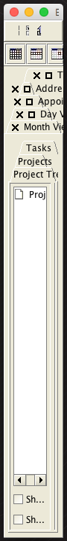

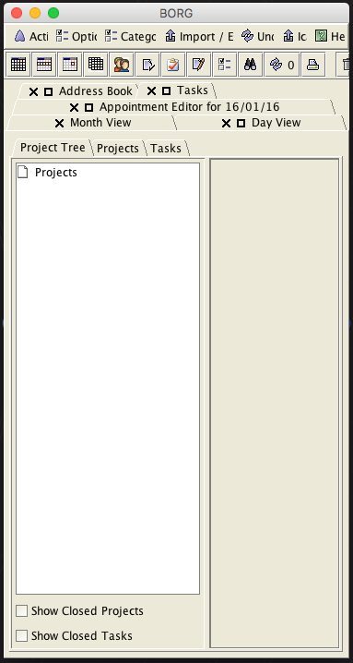

Trash can gets lost a certain size.

**Bug 2**: Will not import google calendar ical

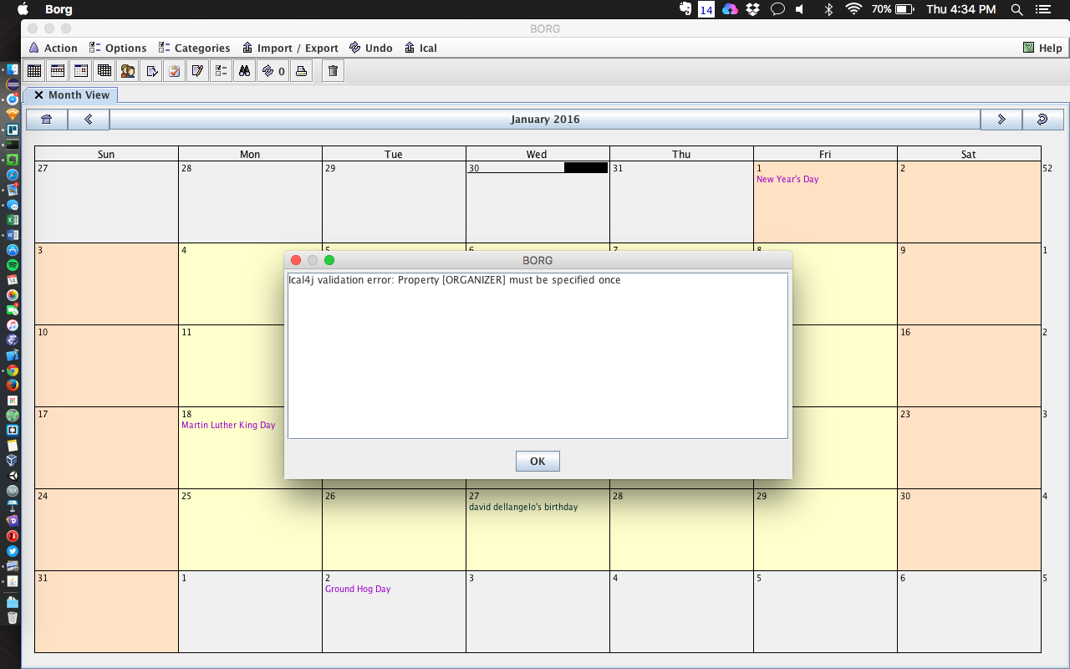

Wont import google Calendar

**Bug 3**: Shows things without category “work”

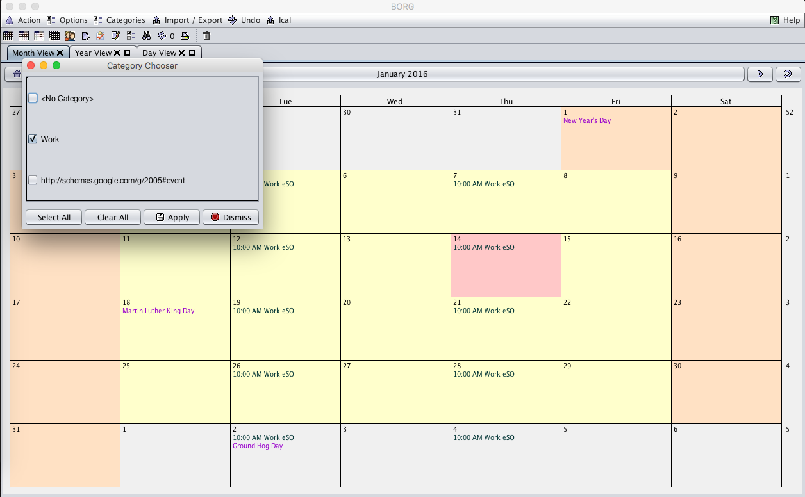

**Bug 4**: No way to re-attach views

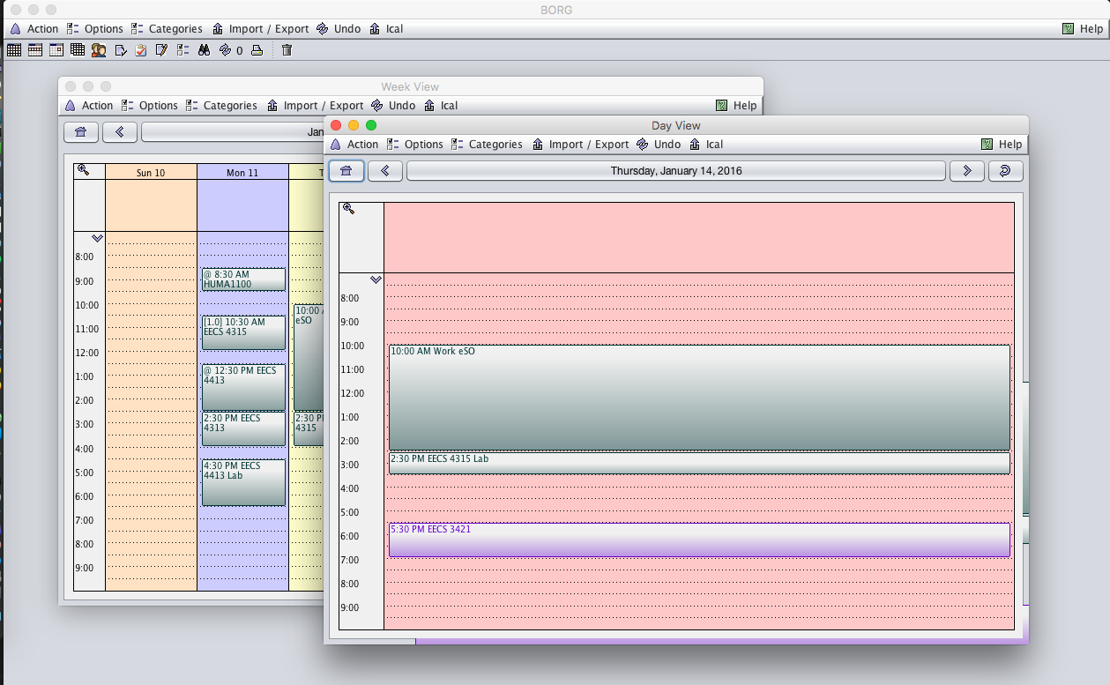

**Bug 5**: BORG does not notify user if database port is already in use, does not reset itself if the port becomes free.

* Set port in borg to that port
* Start something on port
* Relaunch borg

Error stack

Jan 25, 2016 3:33:42 PM net.sf.borg.control.Borg init

FINE: Debug logging turned on

Jan 25, 2016 3:33:42 PM net.sf.borg.common.SocketClient sendMsg

INFO: Connection closed by server.

**Bug 6**: JDBC for mysql does not work

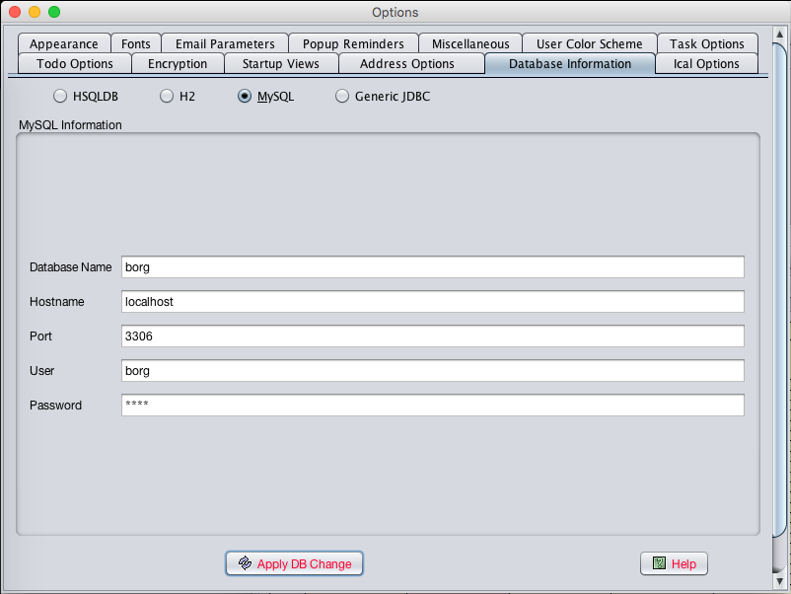

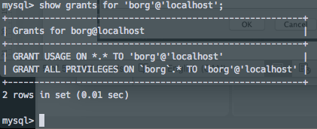

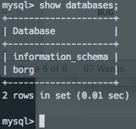

Error

