**Terps Ocean:**

**Smith MSIS Alumni Contact Information Database Project**



**Design Phase Documentation**

**11/07/2018**

**Business Overview**

Terps Ocean is a professional IT consulting firm focusing on providing information systems consulting service and well-designed business solutions to various kinds of business organizations. In Terps Ocean, everything is customized for our clients, we are trying our best to provide a terrific client experience and high product performance at the same time. Terps Ocean was established in College Park, 2018.

The database is required to keep track of the Smith alumni, their job role, company worked in, applied skills and certification. Every alumni has a unique alumni identification (alumniId) and is required to store his or her name, graduation year, graduation term, employment status (intern, full-time, part-time), email address, LinkedIn URL, office phone number and mobile phone number. Alumni work in different companies, each has a unique identifier, name, specific industry, headquarters and the number of alumni working in. Each company has a location, specified with city, state and postal code. Each alumni has a certain job role with description and working years. Certifications (name and date acquired) that alumni owns should be recorded. Besides, skills should also be recorded and updated yearly. 

**Company Brand**

**Project Roles:**

|  |  |
| --- | --- |
| **Team lead** | Yuheng Zhong |
| **Information System analyst** | Guiran Niu |
| **Database Designer** | Tianxing Liang |
| **Database Developer** | Nai Jieh Wang |
| **Application Developer** | Yiwen Wei |

**Database Design:**

**1. Database analysis**

**ER schema:**

**1.1 Database entities, attribute, and primary key:**

1. Alumni (**alumniID**, alName(fName, mName, lName), graduationYear, graduationTerm, employmentStatus, email, linkdInURL, officeNum, mobileNum)
2. Company (**companyID**, companyName, industry, companyCapital, alumniAtwork)
3. Job Role (**jobID,** JobTitle, workYears, jobDescription)
4. Skill (**skillId**, skillName, skillType)
5. Location (**locationID**, city, state, postalCode)

**1.2 relationship definition:**

**Alumni--Skill relationship:**

Own(certificationName, certificationDate)**:** many-to-many binary

1 Skill to 1 or more Alumni

1 Alumni to 1 or more Skill

**Alumni--Company relationship:**

WorksFor: Binary

1 Alumni to 0 or 1 Company

1 Company to 1 or more Alumni

**Alumni--Job Position relationship:**

WorkAs: Binary

1 Alumni can work as 1 Job position

1 Job position can be owned by 1 or many Alumni

**Alumni-Working Location relationship:**

WorksAt: Binary

1 Alumni to 1 Location

1 Location to 1 or more Alumni

**Company---Location relationship:**

LocatedIn: Binary

1 company can locate in 1 or more locations

1 location can have multiple companies

**2. ER diagram design:**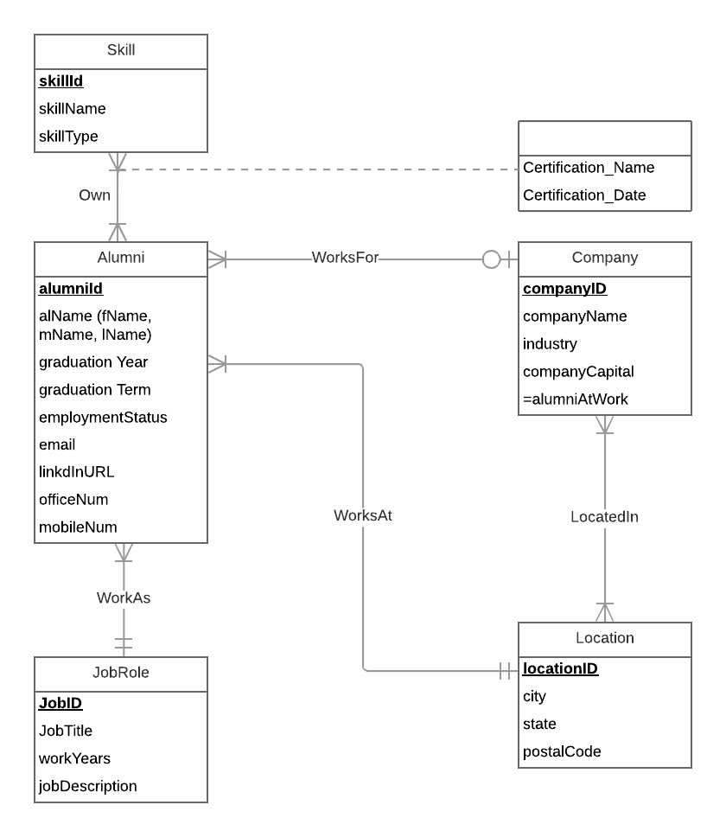

**(Initial ERD)**