**Terps Ocean:**

**Smith MSIS Alumni Contact Information Database Project**

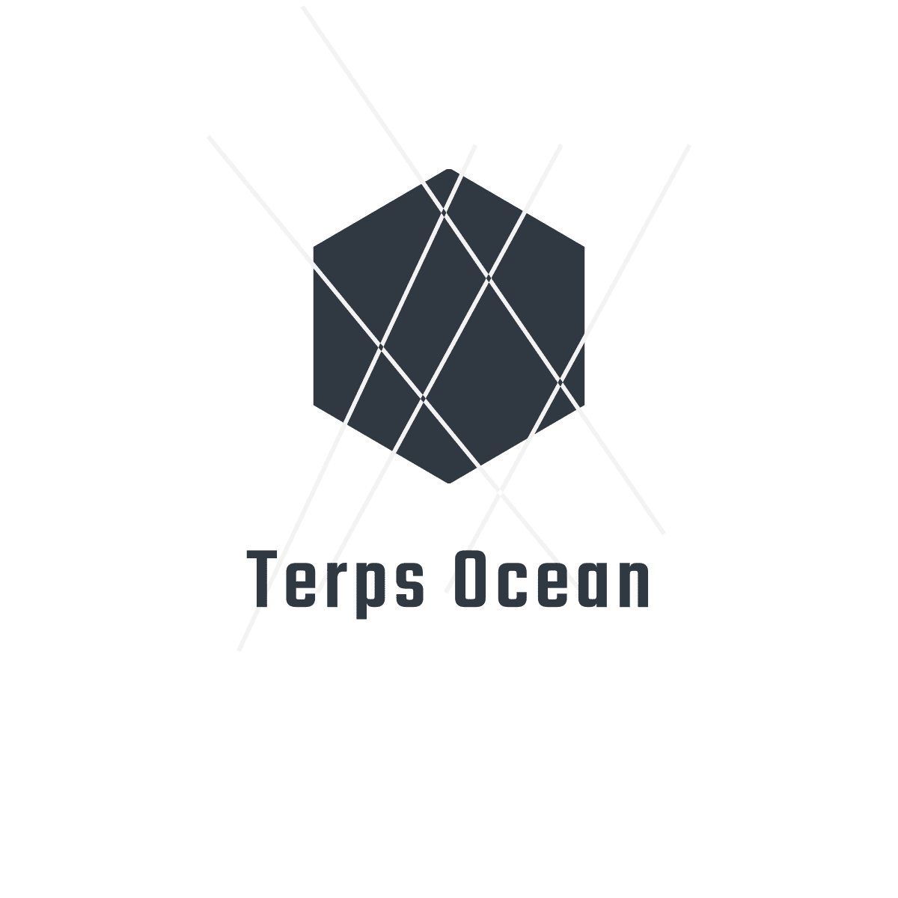

**Application Output Documentation**

**12/03/2018**

**Output Screenshot of Terps Ocean Application**

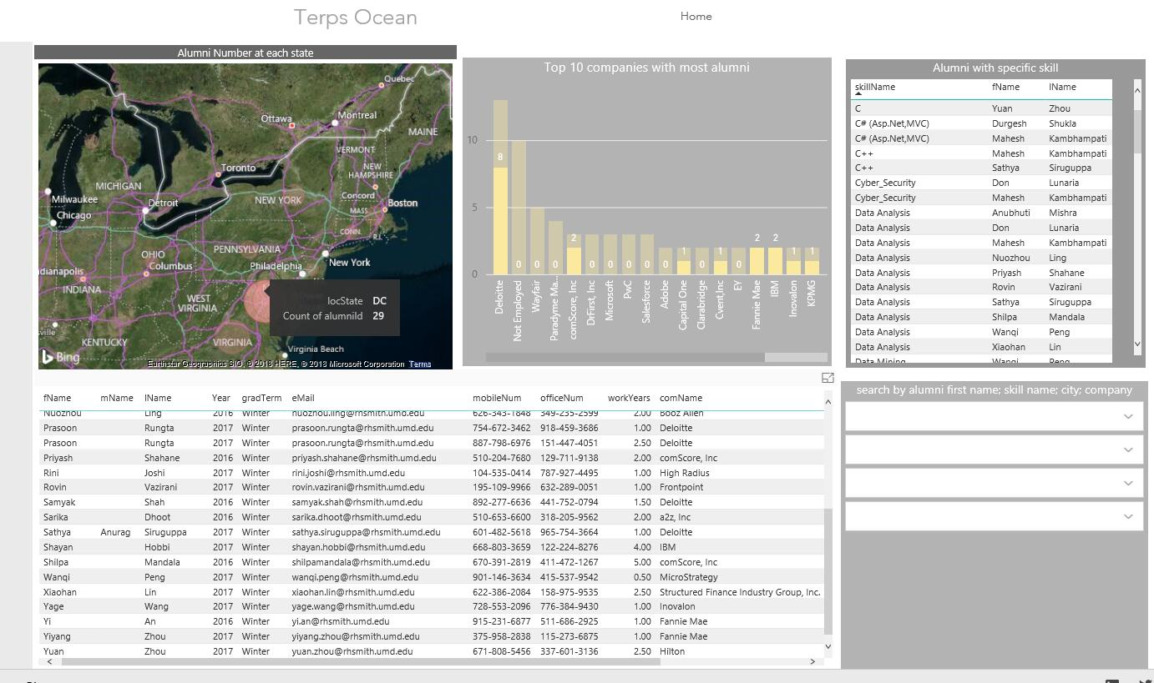**1, User story :** which state has the most alumni live in, so that we can hold an alumni event in this city

(Look at the heat map and find the circle with the biggest. Click it and you got which state has the most alumni live in, as well as a personal information table with all alumni in Washington)

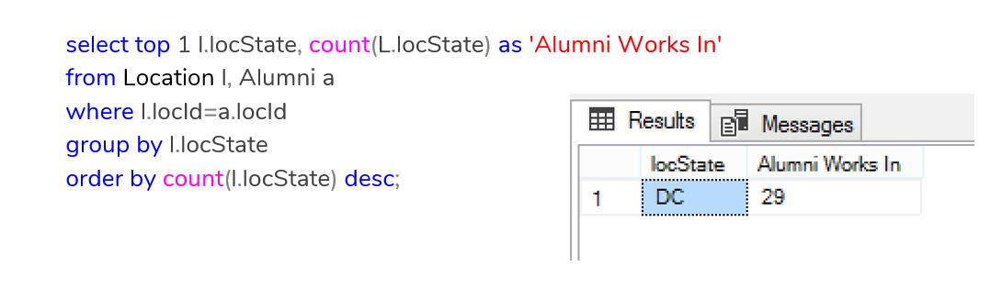

(Same result with SQL)

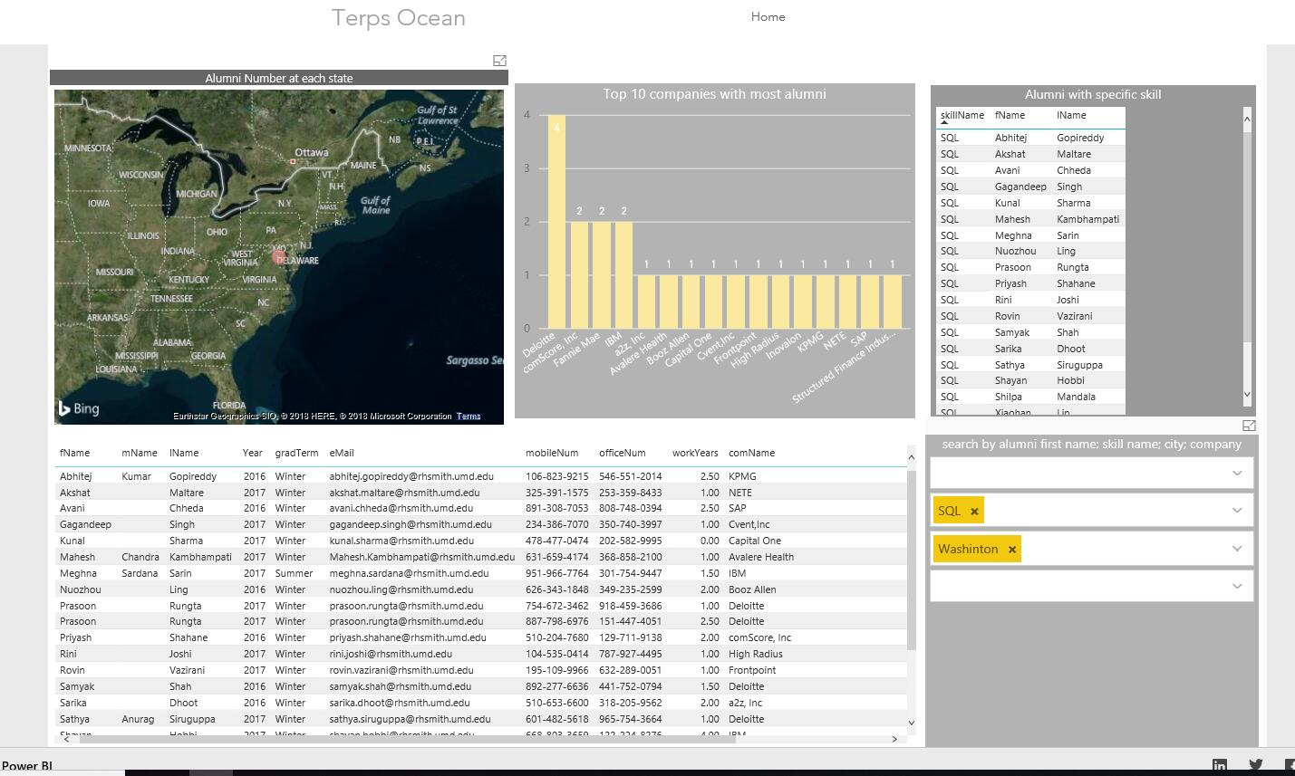**2, User story :** Who has SQL skill in Washington DC, as well as their detailed information, so that we can invite them come to on-campus SQL workshop to share their experience.

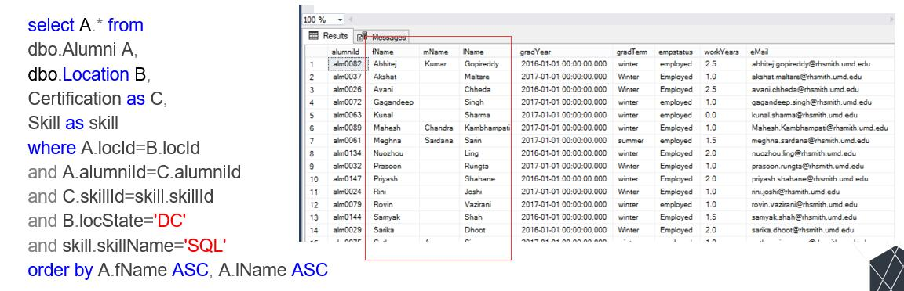

(Same Result with SQL)

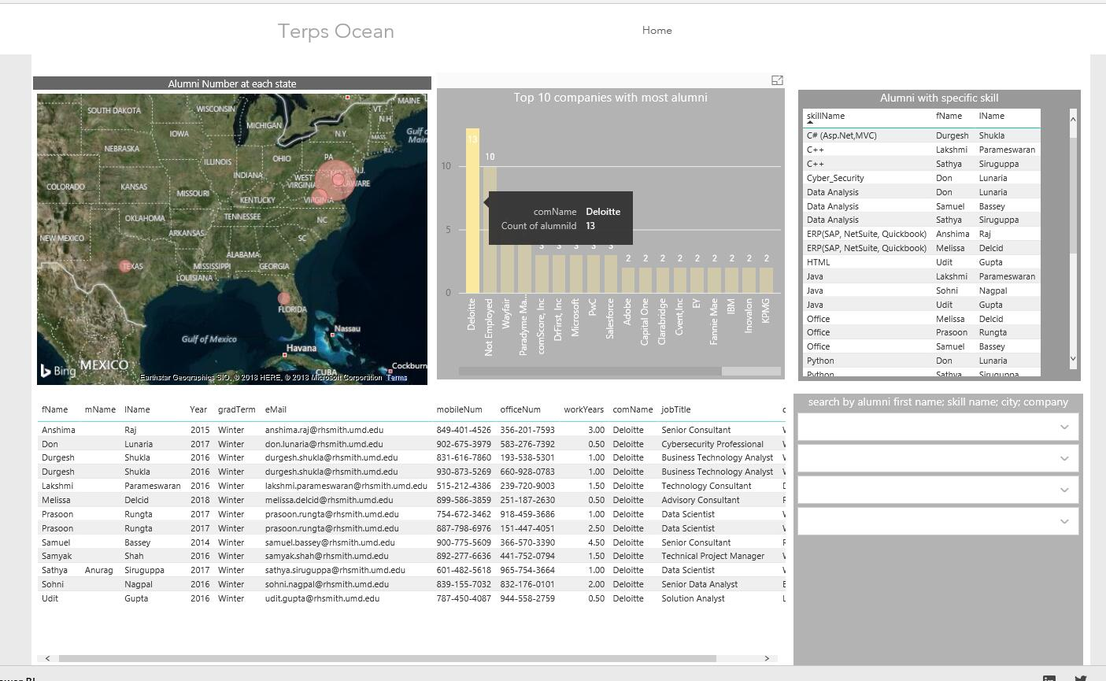**3, User story:** Which company has the most alumni work in, so that we can recommend students to intern there.

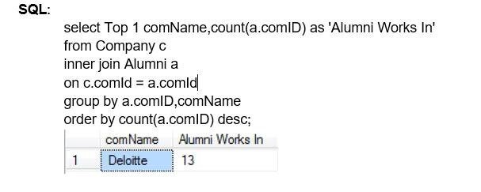

(Same Result with SQL)

**HTML code for portal file:**

<head>

<meta http-equiv="refresh" content="0;url=https://826001623.wixsite.com/terps-ocean">

<head>

**Power BI dashboard source code:**

<https://app.powerbi.com/view?r=eyJrIjoiMjc4Y2UwNjItZmFkMy00YmUyLWJiYTktODY5N2RkNjcyNDI4IiwidCI6ImM2YmEzMzM4LTNkY2YtNGQ3OC04Y2I1LWU5M2UxMjU3ZDNkYSIsImMiOjN9>

**Power BI HTML embed code:**

<iframe width="1024" height="786" src="https://app.powerbi.com/view?r=eyJrIjoiMjc4Y2UwNjItZmFkMy00YmUyLWJiYTktODY5N2RkNjcyNDI4IiwidCI6ImM2YmEzMzM4LTNkY2YtNGQ3OC04Y2I1LWU5M2UxMjU3ZDNkYSIsImMiOjN9" frameborder="0" allowFullScreen="true"></iframe>