**Terps Ocean:**

**Smith MSIS Alumni Contact Information Database Project**



**Proposal Phase Documentation**

**11/12/2018**

**1.Mission statements**

The purpose of Terp Ocean’s database is to provide a well-organized cataloging system that accounts for the contact information of all the MS Information Systems alumni of University of Maryland Robert. H. Smith School of Business and meet various customer needs based on accurate and adequate data.

**2.Mission objectives**

The objectives of this project for clients are as followed:

* Collect alumni’s current working place statistics to help clients organizing alumni events in each city.
* Analyze alumni’s skill sets to identify current trend and invite potential alumni to share experience to current students.
* Analyze employment statistics to identify companies that have most alumni to help create potential job opportunities by inviting companies to various information sessions.

Deliverables of this project are as followed:

* A finalized ERD file.
* A well-designed backend database meet client’s requirement.
* A well-designed frontend data visualization application.
* A set of finalized SQL script file(s) for client to query.
* Team presentation
* Final project package

**3.Final ER diagram**

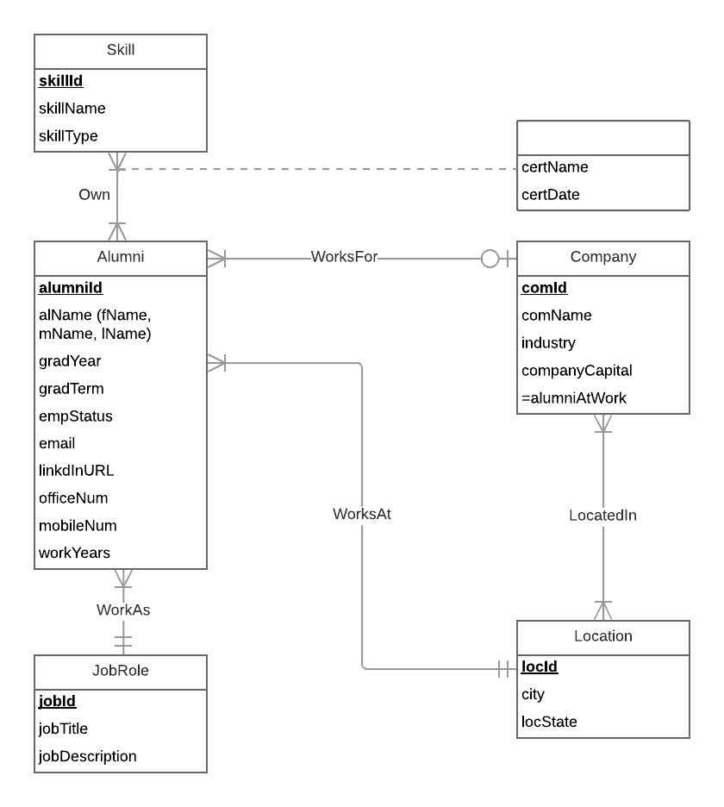

**4.Relational schema**

Alumni **(alumniId,** fName, mName, lName, gradYear, gradTerm, workYears, email, linkedinURL, officeNum, mobileNum, *comId, locId, jobId***)**

Company (**comId**, comName, industry, comCapital)

Location (**locId**, city, locState)

Locatedin (***comId, locId***)

JobRole (**jobId**, jobTitle, jobDescription)

Skill (**skillId,** skillName, skillType)

Certification (***alumniId, skillId,*** certName, certDate)

**5.Functional dependencies and 3NF**

**5.1 Functional dependencies**

AlumiId → fName, mName, lName, gradYear, empstatus, workYears, email, LinkedInURL

comId → comName, industry, comCapital

locId → city, locState

*comId, locId* →

jobId → jobTitle, jobDecription

skillId → skillName, skillType

alumniId, skillId → certName, certDate

**5.2 3NF**

Alumni **(alumniId,** fName, mName, lName, gradYear, gradTerm, workYears, email, linkedinURL, officeNum, mobileNum, *comId, locId, jobId***)** = 3NF

Company (**comId**, comName, industry, comCapital) = 3NF

Location (**locId**, city, locState) = 3NF

Locatedin (***comId, locId***) = 3NF

JobRole (**jobId**, jobTitle, jobDescription) = 3NF

Skill (**skillId,** skillName, skillType) = 3NF

Certification (***alumniId, skillId,*** certName, certDate) = 3NF

**6.Business rules and referential integrity actions**

**6.1 Business rules**

[R1.] When a company is deleted from the database, the corresponding information in alumni should be set to null

[R2.] When the information of a company is changed in database, the corresponding information of alumni should be changed accordingly

[R3.] When a location is deleted from the database, the corresponding information in alumni should be set to null

[R4.] When the information of a location is changed in database, the corresponding information in alumni should be changed accordingly

[R5.] When a job role is deleted from the database, the corresponding information in alumni should be set to null

[R6.] When the information of a job role is changed in database, the corresponding information of alumni should be changed accordingly

[R7.] When a company is located in a location, the company information and location information cannot be deleted or changed in the database

[R8.] When there is a certification of a skill is owned by alumni in database, the alumni and the skill information cannot be deleted or changed in the database

**6.2 Referential integrity :**

|  |  |  |  |  |  |  |  |
| --- | --- | --- | --- | --- | --- | --- | --- |
| Relation | Foreign | Base Relation | Primary  Key | Business Rule | Constraint: ON DELETE | Business  Rule | Constraint: ON UPDATE |
| Alumni | comId | Company | comId | R1 | SET NULL | R2 | CASCADE |
| Alumni | locId | location | locId | R3 | SET NULL | R4 | CASCADE |
| Alumni | jobId | JobRole | jobId | R5 | SET NULL | R6 | CASCADE |
| Locatedin | comId | Company | comId | R7 | NO ACTION | R7 | NO ACTION |
| Locatedin | locId | Location | locId | R7 | NO ACTION | R7 | NO ACTION |
| Certification | alumniId | Alumni | alumniId | R8 | NO ACTION | R8 | NO ACTION |
| Certification | skillId | Skill | skillId | R8 | NO ACTION | R8 | NO ACTION |

**7.Sample data**

**Alumni:**

**alumniId** (CHAR(7) NOT NULL **primary key**): alm0001

fName (VARCHAR(20)): Xin

mName (VARCHAR(20)): NULL

lName (VARCHAR(20)):Yu

gradYear (DATE): 2017

gradTerm (VARCHAR(10)): Winter

empstatus (VARCHAR(30)): Employed

workYears (NUMERIC(2,1)): 2

eMail (VARCHAR(100)): [xin.yu@rhsmith.umd.edu](mailto:xin.yu@rhsmith.umd.edu)

linkedinURL(VARCHAR(100)): <https://www.linkedin.com/in/ariel-yu/>

officeNum(CHAR(10)): NULL

mobileNum(CHAR(10)): NULL

*comId*(CHAR(6) *foreign key*) com001

*locId*(CHAR(6) *foreign key*): loc001

*jobId*(CHAR(6) *foreign key*):  *job001*

**Company:**

**comId**(CHAR(6) NOT NULL **primary key**): com001

comName(VARCHAR(50)): Paradyme Management, Inc.

industry(VARCHAR(50)): Technical

comCapital(NUMERIC(10,1)): NULL

**Location:**

**locId**(CHAR(6) NOT NULL **primary key**): loc001

city(VARCHAR(20)): Greenbelt

locState(VARCHAR(7)): MD

**Locatedin:**

***comId*** (CHAR(6) NOT NULL **primary key** *foreign key*): com001

***locId*** (CHAR(6) NOT NULL **primary key** *foreign key*): loc001

**JobRole**:

**jobId**(CHAR(6) NOT NULL **primary key**): job001

jobTitle(VARCHAR(50)): Technical Analyst

jobDescription(VARCHAR(MAX)): NULL

**Skill:**

**skillId**(CHAR(8) NOT NULL **primary key**): skill001

skillName(VARCHAR(30)): SQL

skillType(VARCHAR(30)): Technical

**Certification:**

***alumniId*** (CHAR(7) NOT NULL **primary key** *foreign key* ): .alm0001

***skillId***(CHAR(8) NOT NULL **primary key** *foreign key*): skill001

certName(VARCHAR(50)): NULL

certDate(DATE): NULL