**Assignment**

**Aim**: To create SAS data sets and generate various reports using Base SAS constructs.

**Prerequisite:**

1. Understanding of programming constructs of Base SAS

**Outcome:** After successful completion of this experiment students will be able to

1. To create SAS data sets
2. To generate various reports for a given the scenario.

(TO BE COMPLETED BY STUDENTS)

|  |  |
| --- | --- |
| Roll No. A020 | Name: Nicole Michelle DSouza |
| Class: B.Tech IT | Batch: A1 |
| Date of Practical: | Date of Submission: |
| Grade: |  |

1. Use the data set AU_SALESFORCE and generate the report shown below. (Hint: Subsetting variable: job_title, first_name)

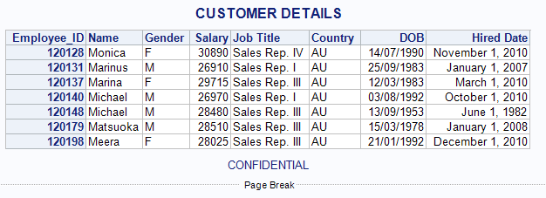

LIBNAME orion "D:\\PA_2021_22\Data_Sets";

title "CUSTOMER DETAILS";

footnote"CONFIDENTIAL";

**data** work.aussie;

set orion.au_salesforce;

where First_Name like "M%" and Job_Title contains "Sales Rep.";

**run**;

**proc** **print** data=work.aussie noobs label;

format Birth_Date ddmmyy10. Hire_Date worddate. ;

id Employee_ID;

label Birth_Date = "DOB"

First_Name = "Name"

Hire_Date = "Hired Date"

Job_Title = "Job Title";

var First_Name Gender Salary Job_Title Country Birth_Date Hire_Date;

**run**;

1. Create a data set named employees_info from employees and generate the report shown below. (Note: Subsetting variables/records, labelling and formatting not to be done in PROC step.) . Month hired is the calculated column by applying month function on Hire_date. (Hint: Subsetting variable month hired <6 and job title). The new data set to contain only the variables listed in the report shown.

LIBNAME orion "D:\\PA_2021_22\Data_Sets";

**data** work.employees_info ;

set orion.employees;

Month_Hired = Month(Hire_Date);

if Month_Hired < **6** ;

where Job_Title like "%III";

label Marital_Status= "Married/Unmarried";

format Marital_Status mar. Salary dollar12.2;

keep Employee_ID Job_Title Gender Salary Marital_Status Month_Hired;

**run**;

**proc** **format**;

value $mar 'M' ="Married"

'O'="Unknown"

'S'="Sinlge";

**run**;

**proc** **print** data=work.employees_info noobs label;

id Employee_ID;

**run**;

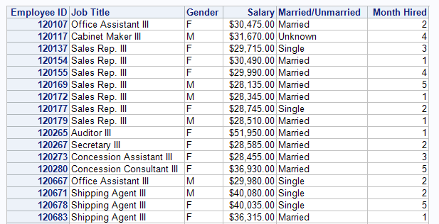

1. Create a temporary sorted data set named Employee_sorted by using employees and generate the below report. (Hint: Subsetting variable: job_title, gender)

LIBNAME orion "D:\\PA_2021_22\Data_Sets";

**data** work.Employee_sorted ;

set orion.employees;

format Marital_Status mar.;

where Job_Title like "Se%" and Gender contains"F";

**run**;

**proc** **format**;

value $mar 'M' ="Married"

'O'="Unknown"

'S'="Single";

**run**;

**proc** **sort** data= work.employee_sorted;

by Marital_Status descending Employee_ID;

**run**;

**proc** **print** data=work.Employee_sorted noobs split=" ";

id Employee_ID;

format Salary DOLLAR12.2 Hire_date WORDDATE.;

by Marital_Status;

LABEL Job_Title = "Position"

Hire_date = "Date Hired";

VAR Name Job_Title Department Gender Salary Hire_date;

**run**;

