**Practical No. 15**

**Aim**: To read raw data files using formatted input method and understand iterative data processing and usage of Arrays in Base SAS.

**Prerequisite:**

1. Understanding of fundamental programming constructs of Base SAS

**Outcome:** After successful completion of this experiment students will be able to

1. Read raw data sets using formatted input method
2. Use DO loops to eliminate redundant code and repetitive calculations.
3. Use SAS Arrays to perform repetitive calculations.

|  |  |
| --- | --- |
| Roll No.: A020 | Name: Nicole Michelle Dsouza |
| Class: BTech IT Sem VII | Batch: A1 |
| Date of Practical: 21/09/2022 | Date of Submission: 21/09/2022 |
| Grade: |  |

**Assignment 1:**

The record layout of the data file sales1.dat is shown below.

|  |  |  |  |
| --- | --- | --- | --- |
| Field description | Starting column | Length of field | Data type |
| **Employee id** | **1** | **6** | **Numeric** |
| First name | 8 | 12 | Character |
| **Last name** | **21** | **18** | **Character** |
| Gender | 40 | 1 | Character |
| **Job title** | **43** | **20** | **Character** |
| **Salary** | **64** | **8** | **Numeric $100,000** |
| **Country** | **73** | **2** | **Character ‘AU’ or ‘US’** |
| Birth date | 76 | 10 | Numeric mm/dd/yyyy |
| **Hire date** | **87** | **10** | **Numeric mm/dd/yyyy** |

* Create 2 SAS data sets US_trainees and AU_trainees from the raw data file. (A trainee is anyone who has a job title of sales rep. I)
* Each data set should contain the fields indicated by **bold letters** in the layout table.
* Write only U.S trainees to the US_trainees data set and only Australian trainees to the AU_trainees data set. Do not keep the country variable in the output data sets.
* Print both the data sets.

**Code of the program:**

libname orion "d:\\pa_2021_22\data_sets";

data work.us_trainees work.au_trainees;

infile 'd:\\pa_2021_22\data_sets\sales1.dat';

input @43 Job_title $15.

@1 Employee_ID 6.

@21 Last_Name $10.

@64 Salary DOLLAR8.

@87 Hire_Date mmddyy10.

@73 Country $2.;

if Job_Title = 'Sales Rep. I';

drop Country;

if Country = 'AU' then

output work.au_trainees;

else if Country = 'US' then

output work.us_trainees;

run;

title 'US Trainees';

proc print data=work.us_trainees noobs;

id Employee_ID;

format Salary dollar10. Hire_Date date9.;

run;

title 'AU Trainees';

proc print data=work.au_trainees noobs;

id Employee_ID;

format Salary dollar10. Hire_Date date9.;

run;

title;

**Output of the Program:**

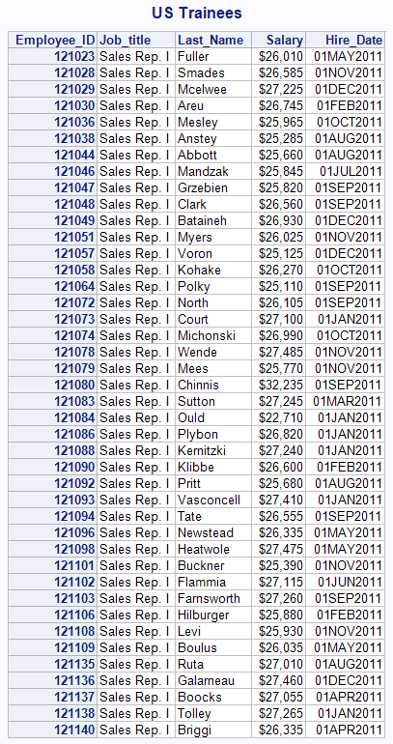

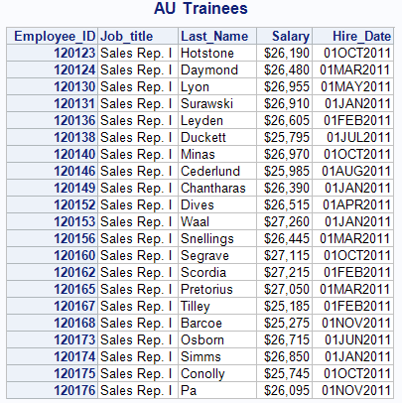

**Assignment 2:**

Use the data set orion.orders_midyear.

* Create a data set discount_sales to reflect the 5% discount.
  + Create an array Mon to access Month1 through Month6.
  + Use a DO loop to adjust each customers monthly data. Apply the 5% discount.
* Print the resulting data set and verify your results.
  + Use DOLLAR 10.2 format for the monthly sales amount.

**Code of the program:**

data work.discount_sales;

set orion.orders_midyear;

keep Customer_ID Month1-Month6;

array mon{6} Month1-Month6;

do i=1 to 6;

mon{i} = mon{i}*0.95;

end;

run;

proc print data=work.discount_sales noobs;

id Customer_ID;

format Month1-Month6 dollar10.2;

run;

**Output of the Program:**

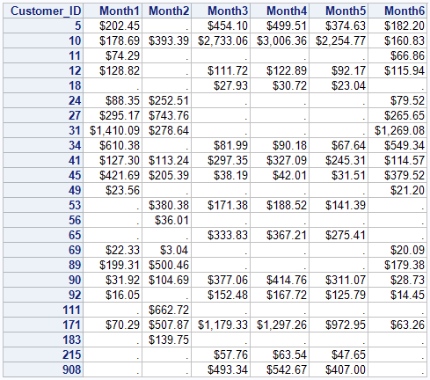

**Assignment 3:**

Orions income last year was $50,000,000 and expenses totaled $38,750,000. Income is projected to increase at 1% per year and expenses are expected to increase at 2% per year.

* Create a SAS data set named work.expenses that contain each years projected income and expenses.
  + Use a iterative DO loop with a conditional clause that stops when expenses exceed income or after 30 years, whichever occurs first
* Print the data set and generate the report shown below.

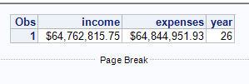

**Code of the program:**

data work.expenses;

income = 50000000;

expenses = 38750000;

year = 0;

do i=1 to 30 while (income>expenses);

income = income*1.01;

expenses = expenses*1.02;

year = year+1;

if year=26 then output;

end;

drop i;

run;

proc print data=work.expenses;

format expenses dollar15.2 income dollar15.2;

run;

**Output of the Program:**



**\*\*\*\*\*\*\*\*\*\*\*\*\*\*\*\*\*\*\*\*\*\***