# **Practical No. 7**

**Aim**: To create a SAS data set by reading data from a raw data file.

**Prerequisite:**

1. Understanding of fundamental programming constructs of Base SAS

**Outcome:** After successful completion of this experiment students will be able to

1. Use INFILE and INPUT statements to read raw data file.
2. Use LENGTH statement to define type and length of a variable.

(TO BE COMPLETED BY STUDENTS)

| Roll No. A020 | Name: Nicole Michelle DSouza |
| --- | --- |
| Class: B.TECH IT SEM VII | Batch: A1 |
| Date of Practical: 12-08-2022 | Date of Submission: 12-08-2022 |
| Grade: |  |

**Assignment 1:**

For the following program

**data** work.canada_customers;

**run**;

**proc** **print** data=work.canada_customers;

**run**;

* Add appropriate LENGTH, INFILE and INPUT statements to read the comma-delimited raw data file named as “customer_canada.csv”
* Read the following fields:

| Name | Type | Length |
| --- | --- | --- |
| First | Character | 20 |
| Last | Character | 20 |
| ID | Numeric | 8 |
| Gender | Character | 1 |
| Age | Numeric | 8 |
| AgeGroup | Character | 12 |

* Create a report as shown

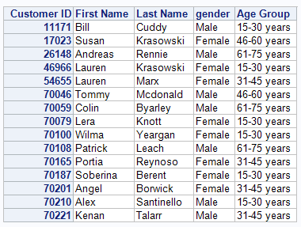

* Display the descriptor portion of the new data set and observe the result by writing a VARNUM statement in the PROC CONTENTS.

**Code of the program:**

**data** work.canada_customers;

infile "D:\PA_2021_22\Data_Sets\customer_canada.csv" dlm=',' dsd missover;

length First_Name $**20** Last_Name $**20** Customer_ID **8** Gender $**1** Age **8** Age_Group $**12**;

input First_Name Last_Name Customer_ID Gender Age Age_Group;

**run**;

**proc** **format**;

value $Gender

'M' = 'Male'

'F' = 'Female';

**run**;

**proc** **print** data = work.canada_customers noobs label;

id Customer_ID;

var First_Name Last_Name Gender Age_Group;

label Customer_ID = "Customer ID";

label First_Name = "First Name";

label Last_Name = "Last Name";

label Gender = "gender";

label Age_Group = "Age Group";

format gender $Gender.;

**run**;

**proc** **contents** data=work.canada_customers varnum;

**run**;

**Output of the Program:**

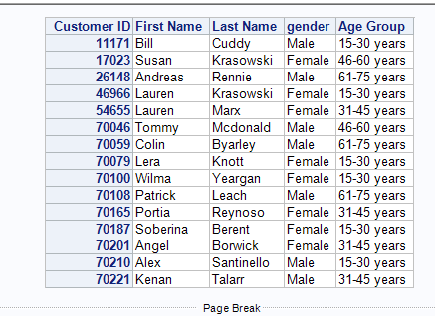

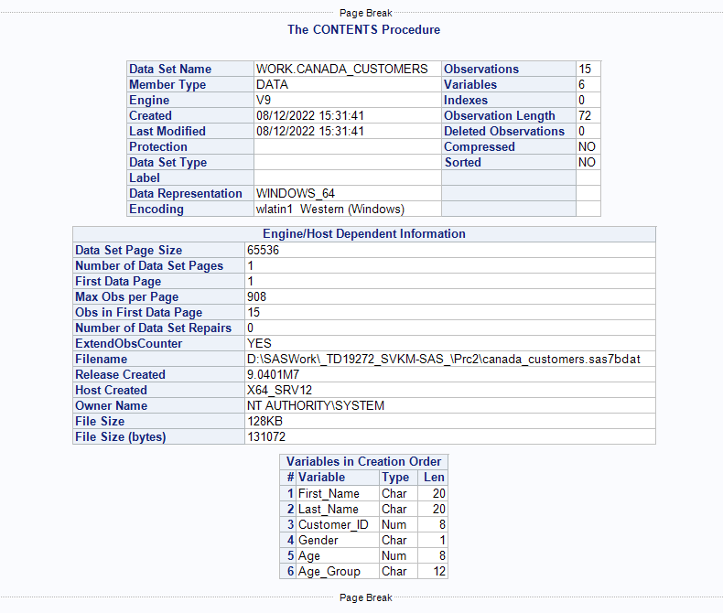

**Assignment 2:**

Create a temporary data set named Managers2 by reading Managersdata.dat file. Use the tab as the delimiter (dlm='09'x)

* Read the following fields from the raw data file.

| Name | Type |
| --- | --- |
| ID | Character |
| First | Character |
| Last | Character |
| Gender | Character |
| Salary | Numeric |
| Title | Character |

* Use appropriate length values for columns that are truncated in the report.
* The new data set should contain only First, Last and Title.

**Code of the program:**

**data** work.Managers2;

infile "D:\PA_2021_22\Data_Sets\Managersdata.dat" dlm='09'x dsd missover;

length ID **8** First_Name $**20** Last_Name $**20** Gender $**1** Salary **8** Title $**20**;

input ID First_Name Last_Name Gender Salary Title;

**run**;

**proc** **print** data = work.Managers2 noobs;

var First_Name Last_Name Title;

**run**;

**Output of the Program:**



