**Practical No. 10**

**Aim**: To merge and concatenate SAS data sets.

**Prerequisite:**

1. Understanding of fundamental programming constructs of Base SAS

**Outcome:** After successful completion of this experiment students will be able to

1. Use SET statement in a data step & RENAME= data set option.
2. Merge one to one, one to many based on a common variable.
3. Merge data sets with non matches using the IN= data set option.

(TO BE COMPLETED BY STUDENTS)

|  |  |
| --- | --- |
| Roll No. A020 | Name: Nicole Michelle DSouza |
| Class:B.Tech IT | Batch:A1 |
| Date of Practical: | Date of Submission: |
| Grade: |  |

**Assignment 1:**

* Write a DATA step to concatenate orion.sales and orion.nonsales to create a new data set, work.allemployees.
* The new data set should include only employee_id,first_name,last_name, job_title and salary.
* Add a PROC PRINT step to display the report as shown below.

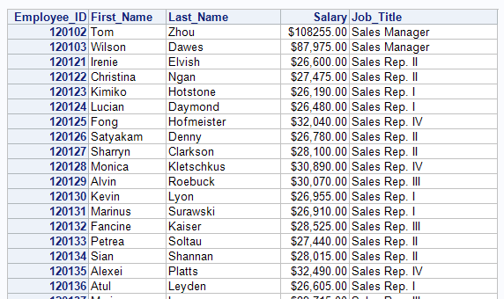

**Code of the program:**

libname orion "d://PA_2021_22/Data_Sets";

**data** work.allemployees;

merge orion.sales orion.nonsales(rename=(First = First_Name));

where Job_Title contains "Sales";

keep employee_id first_name last_name job_title salary;

**run**;

**proc** **print** data=work.allemployees noobs;

id Employee_ID;

format salary dollar12.2;

**run**;

/*

proc print data=orion.nonsales;

run;*/

**Output of the Program:**

**Assignment 2:**

Create a new data set listlevel by merging orion.product_dim_n with orion.product_list_n. The new data set should include only product_id, product_name,and product_level and only those observations with product level equal to 3.

Create the report shown below.

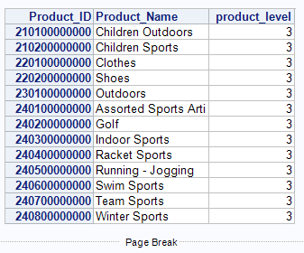

**Code of the program:**

libname orion "d://PA_2021_22/Data_Sets";

**proc** **sort** data= orion.product_dim_n

out=work.prod;

by Product_id;

**run**;

**proc** **sort** data= orion.product_list_n

out=work.lisr;

by Product_id;

**run**;

**data** work.listlevel;

merge work.prod work.lisr;

by Product_id;

if product_level =**3**;

keep product_id product_name product_level ;

**run**;

**proc** **print** data=work.listlevel noobs;

id Product_ID;

**run**;

**Output of the Program:**

**Assignment 3:**

* Write a PROC SORT step to sort orion.customer by country to create a new data set work.customer.
* Write a DATA step to merge the resulting data set with the orion.country_n by country to create a new data set work.allcustomer.
* Include only variables customer_id,country,customer_name and country_name in work.allcustomer.
* Modify the DATA step to store only those observations that contain both customer information and country information (use a subsetting IF and IN= variables)

**Code of the program:**

libname orion "d://PA_2021_22/Data_Sets";

**proc** **sort** data= orion.customer

out=work.customer;

by Country;

**run**;

**proc** **sort** data= orion.country_n;

by Country;

**run**;

**data** work.allcustomer;

merge work.customer(in=cust) orion.country_n(in=coun);

if cust=**1** and coun =**1**;

keep customer_id country customer_name country_name ;

**run**;

**proc** **print** data=work.allcustomer noobs;

id Customer_ID;

**run**;

**Output of the Program:**



