**Practical No. 11**

**Aim**: To produce Frequency tables and create files with ODS statements

**Prerequisite:**

1. Understanding of fundamental programming constructs of Base SAS

**Outcome:** After successful completion of this experiment students will be able to

1. Use PROC FREQ to validate data in a SAS data set.
2. Use MEANS procedure to calculate summary statistics.
3. Create files that can be viewed in Microsoft excel.

(TO BE COMPLETED BY STUDENTS)

|  |  |
| --- | --- |
| Roll No. A020 | Name: Nicole Michelle Dsouza |
| Class:B.Tech IT | Batch:A1 |
| Date of Practical: | Date of Submission: |
| Grade: |  |

**Assignment 1:**

For the data set orion.orders, apply the Freq procedure to,

* Display the number of distinct levels of customer_id and employee_id.
* Use a WHERE statement to limit the report to retail sales (order_type=1).
* Do not display the frequency count tables and the percentage.
* Display the title Unique customers and salespersons for retail sales.
* Display the number of distinct levels for customer_id for catalog and internet orders.
  + Limit the report to catalog and internet sales by selecting obervations with order_type other than 1.
  + Specify an option to display results in decreasing frequency order.
  + Specify an option to suppress the cumulative statistics.
  + Display the title “catalog and internet customers”

**Code of the program part A:**

LIBNAME orion "d://PA_2021_22/Data_Sets";

title"Unique customers and salespersons for retail sales";

**proc** **freq** data= orion.orderss nlevels;

tables Employee_ID Customer_ID / noprint nopercent;

where Order_Type = **1**;

**run**;

**Code of the program part B:**

LIBNAME orion "d://PA_2021_22/Data_Sets";

title"catalog and internet customers";

**proc** **freq** data= orion.ordersss nlevels order=freq;

tables Customer_ID / nocum;

where Order_Type ~= **1**;

**run**;

/*

proc print data= orion.ordersss;

run;*/

**Output of the Program part A:**

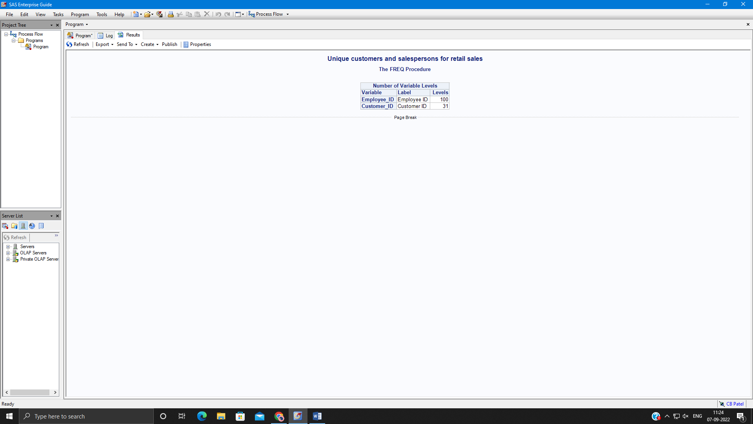

**Output of the Program part B:**

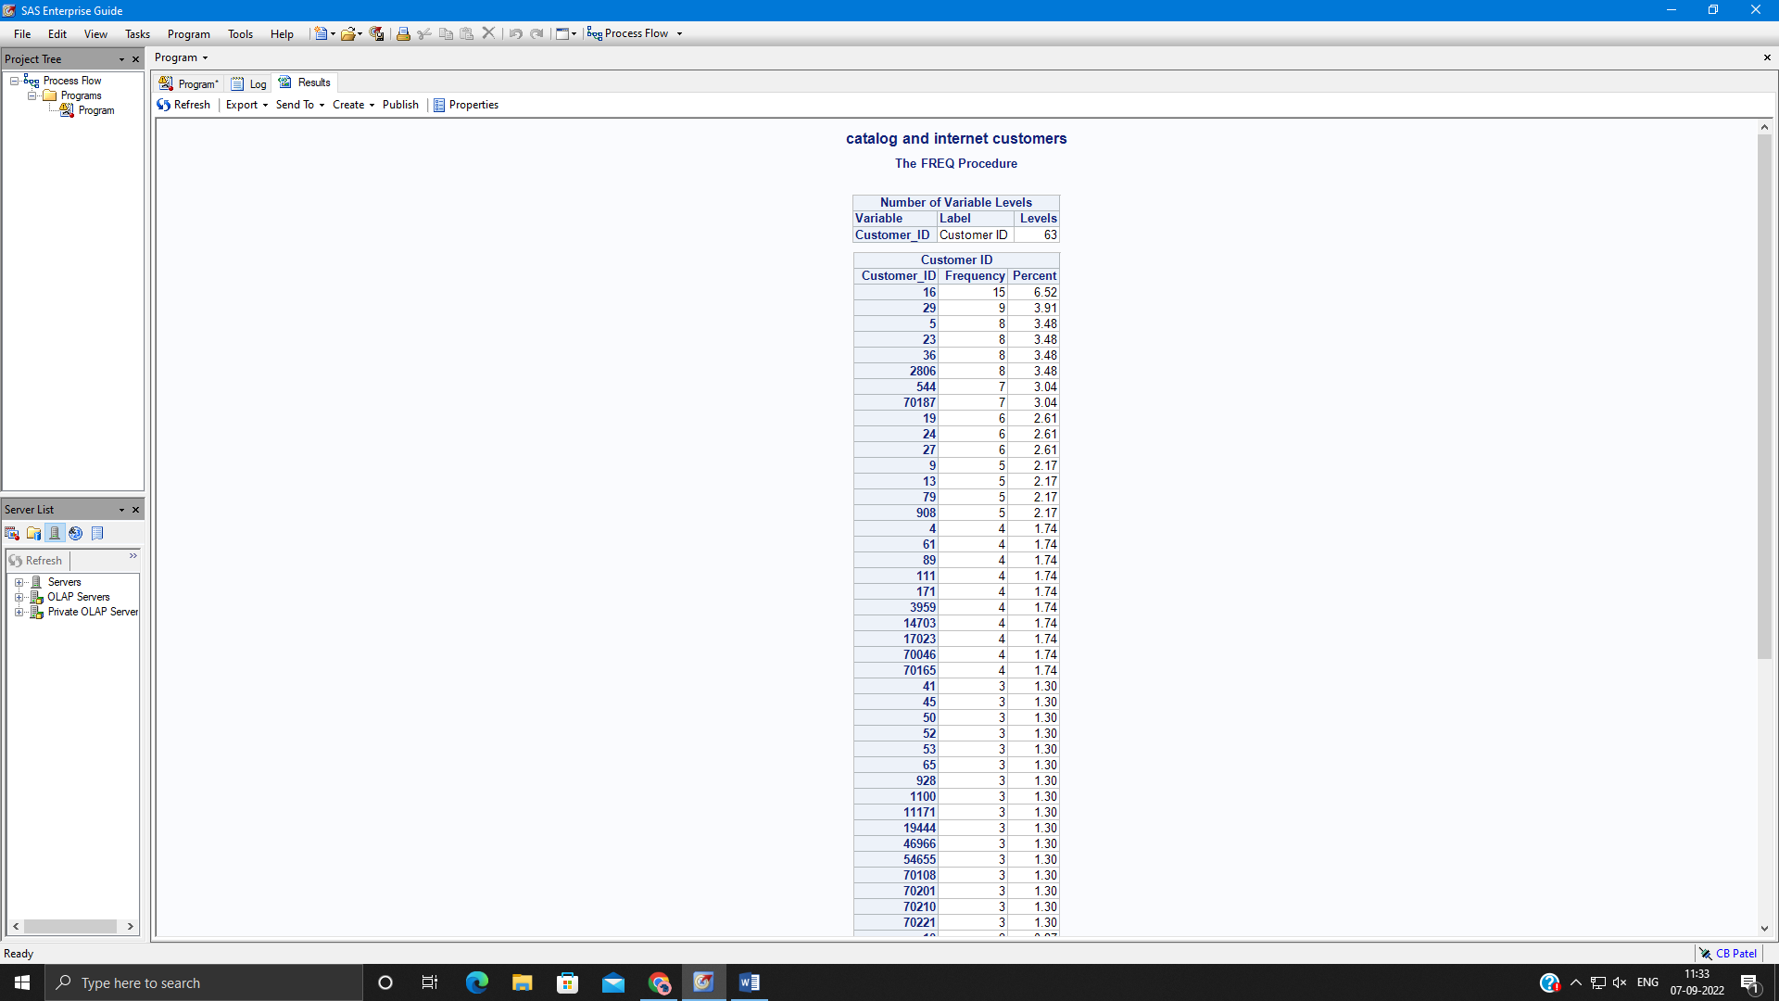

**Assignment 2:**

For the following program.

**proc** **format**;

value ordertypes

**1**='Retail'

**2**='Catalog'

**3**='Internet';

**run**;

title 'Revenue from All Orders';

**proc** **means** data=orion.order_fact;

**run**;

title;

* Display only the SUM statistic for the total_retail_price variable.
* Add a class statement to display separate statistics for the combination of order_date and order_type.
* Apply the ordertypes format so that the order types are displayed as text description. Apply the year4. Format so that the order dates are displayed as years.

**Code of the program:**

LIBNAME orion "d://PA_2021_22/Data_Sets";

**proc** **format**;

value ordertypes

**1**='Retail'

**2**='Catalog'

**3**='Internet';

**run**;

title 'Revenue from All Orders';

**proc** **means** data=orion.order_fact sum nonobs;

class Order_Date Order_Type;

format Order_Type ordertypes. Order_Date year4.;

var Total_Retail_Price;

**run**;

title;

**Output of the Program:**

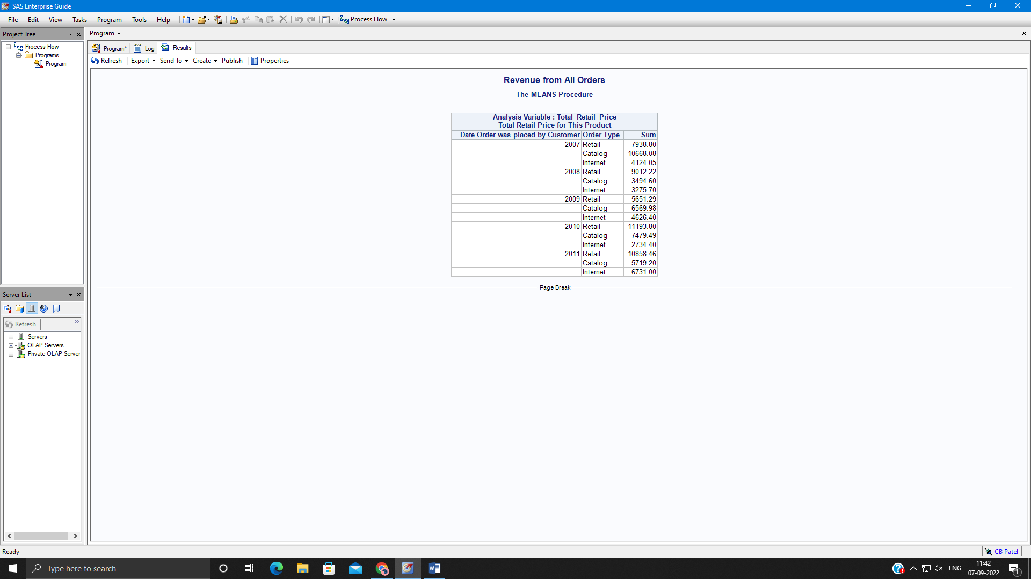

**Assignment 3:**

For the following program:

title 'Customer Information’;

**proc** **print** data=orion.customer;

**run**;

* Add ODS statement to create a pdf file with the following naming convention:

“&path\filename.pdf”

* Add a STYLE= option to the ODS PDF statement to use the curve style template.
* Submit the program and view the output in adobe reader.

**Code of the program:**

LIBNAME orion "d://PA_2021_22/Data_Sets";

ods pdf file="d:/filename.pdf" style=CURVE;

title 'Customer Information';

**proc** **print** data=orion.customer;

**run**;

ods pdf;

**Output of the Program:**



