**Practical No. 12**

**Aim**: To explicitly control the output of multiple observations to a SAS data set and create multiple SAS data sets using conditional processing.

**Prerequisite:**

1. Understanding of fundamental programming constructs of Base SAS

**Outcome:** After successful completion of this experiment students will be able to

1. Use explicit OUTPUT statement to write PDV contents to a data set.
2. Use conditional processing to control the data set to which an observation is written.
3. Use OBS= and FIRSTOBS= option to control the observations being processed.

(TO BE COMPLETED BY STUDENTS)

|  |  |
| --- | --- |
| Roll No. A020 | Name: Nicole Michelle DSouza |
| Class:B.Tech IT | Batch: A1 |
| Date of Practical: | Date of Submission: |
| Grade: |  |

**Assignment 1:**

For the following program.

**proc** **print** data=orion.prices;

**run**;

* Write a data step to create a new data set work.price_increase that forecasts unit prices for the next 3 years. Use explicit OUTPUT statements to forecast Unit_price for the next 3 years using Factor as the annual rate of increase.
* Print the new data set to include only product_id, unit_price and year.

**Code of the program:**

LIBNAME orion "D://PA_2021_22/Data_Sets";

**data** work.price_increase;

set orion.prices;

year = **1**;

Unit_Price= Unit_Price*(**1**+Factor);

output;

year=**2**;

Unit_Price = Unit_Price*(**1**+Factor);

output;

year=**3**;

Unit_Price = Unit_Price*(**1**+Factor);

output;

keep Product_ID Unit_Price year;

**run**;

**proc** **print** data=work.price_increase;

**run**;

**Output of the Program:**

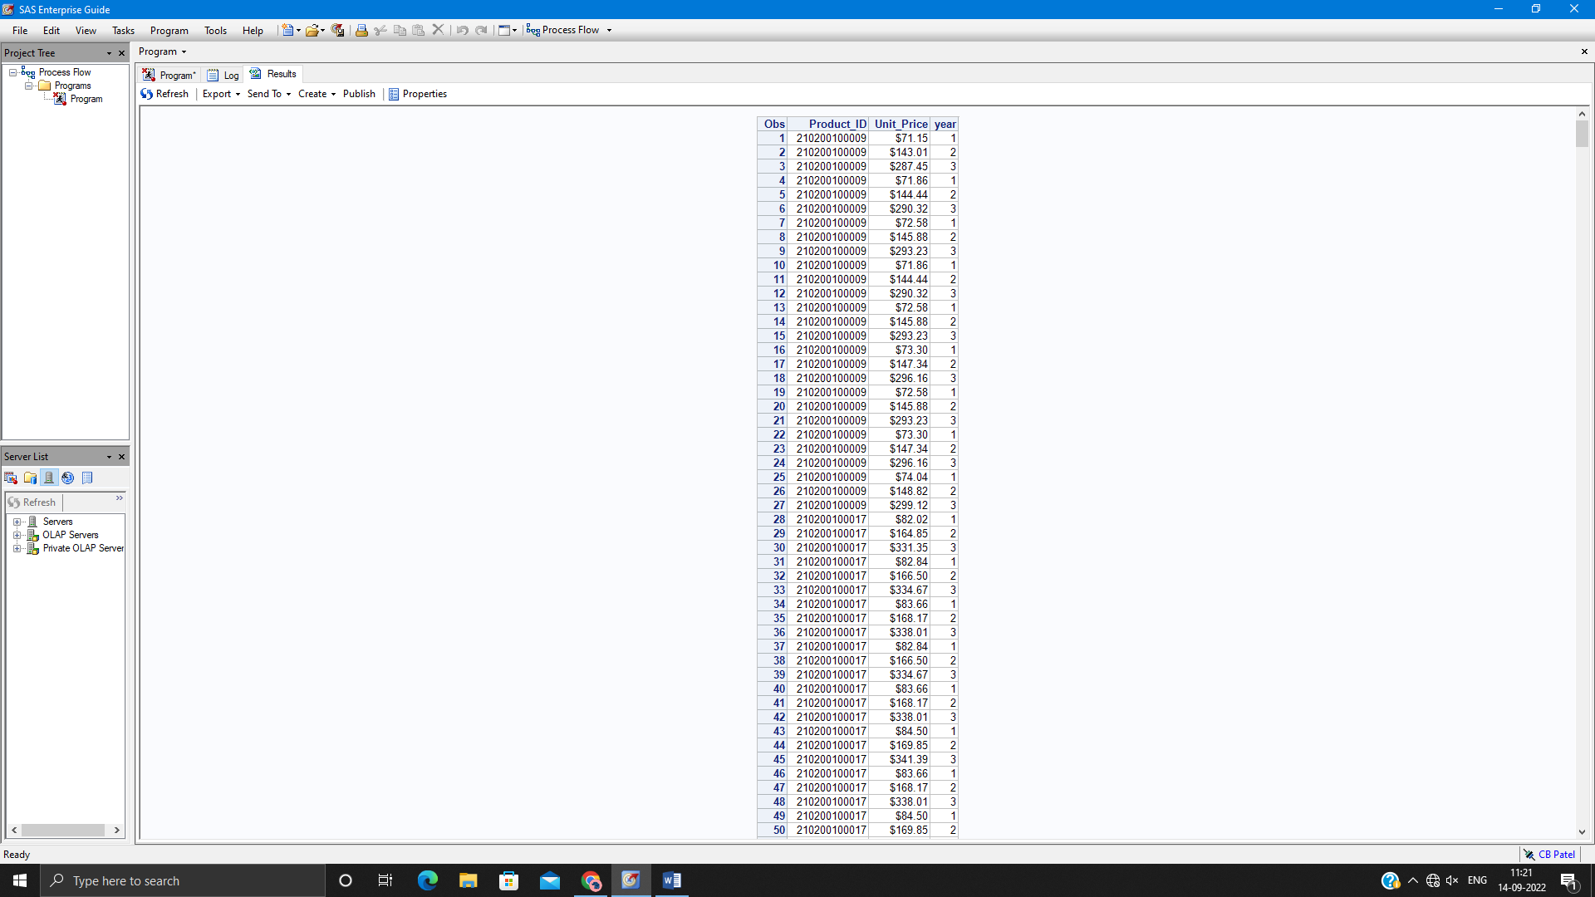

**Assignment 2:**

Read the data set orion.orders.

* Create 3 data sets named work.fast, work.slow and work.veryslow.
* Write a WHERE statement to read only the observations with order_type =2 or 3.
* Create a variable named Shipdays that is the number of days between when the order is placed and when is it delivered.
* Handle the outputs as follows.
  + Output to work.fast when value of Shipdays is less than 3.
  + Output to work.slow when value of Shipdays is 5 to 7.
  + Output to work.veryslow when value of Shipdays is greater than 7.
  + Do not output an observation when value of Shipdays is 3 or 4
* Drop the variable employee_id
* Print the result of all 3 new data sets created with appropriate title.

**Code of the program:**

LIBNAME orion "D://PA_2021_22/Data_Sets";

**data** work.fast work.slow work.veryslow;

set orion.orders;

where Order_Type = **2** or Order_Type = **3**;

Shipdays = Delivery_Date - Order_Date;

if Shipdays lt **3** then output work.fast;

else if Shipdays >= **5** and Shipdays <=**7** then output work.slow;

else if Shipdays gt **7** then output work.veryslow;

drop Employee_ID;

**run**;

title1"Fast Work";

**proc** **print** data=work.fast;

**run**;

title1;

title2"Slow Work";

**proc** **print** data=work.slow;

**run**;

title2;

title3"Extremely Slow Work";

**proc** **print** data=work.veryslow;

**run**;

**Output of the Program:**

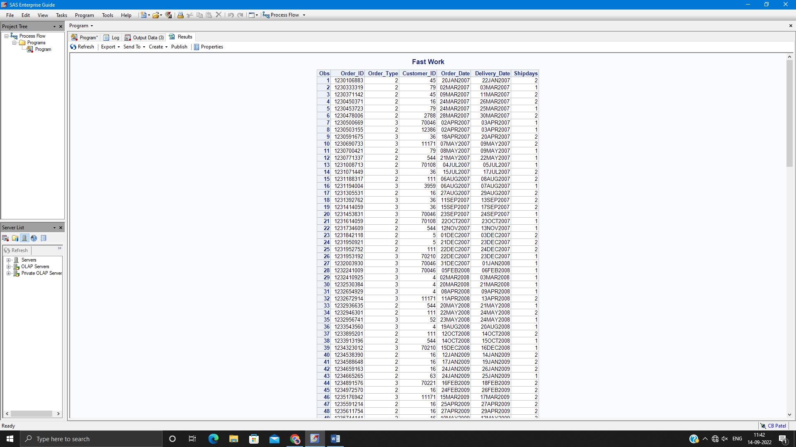

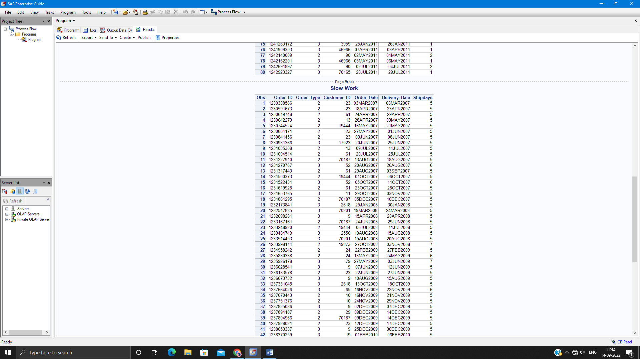

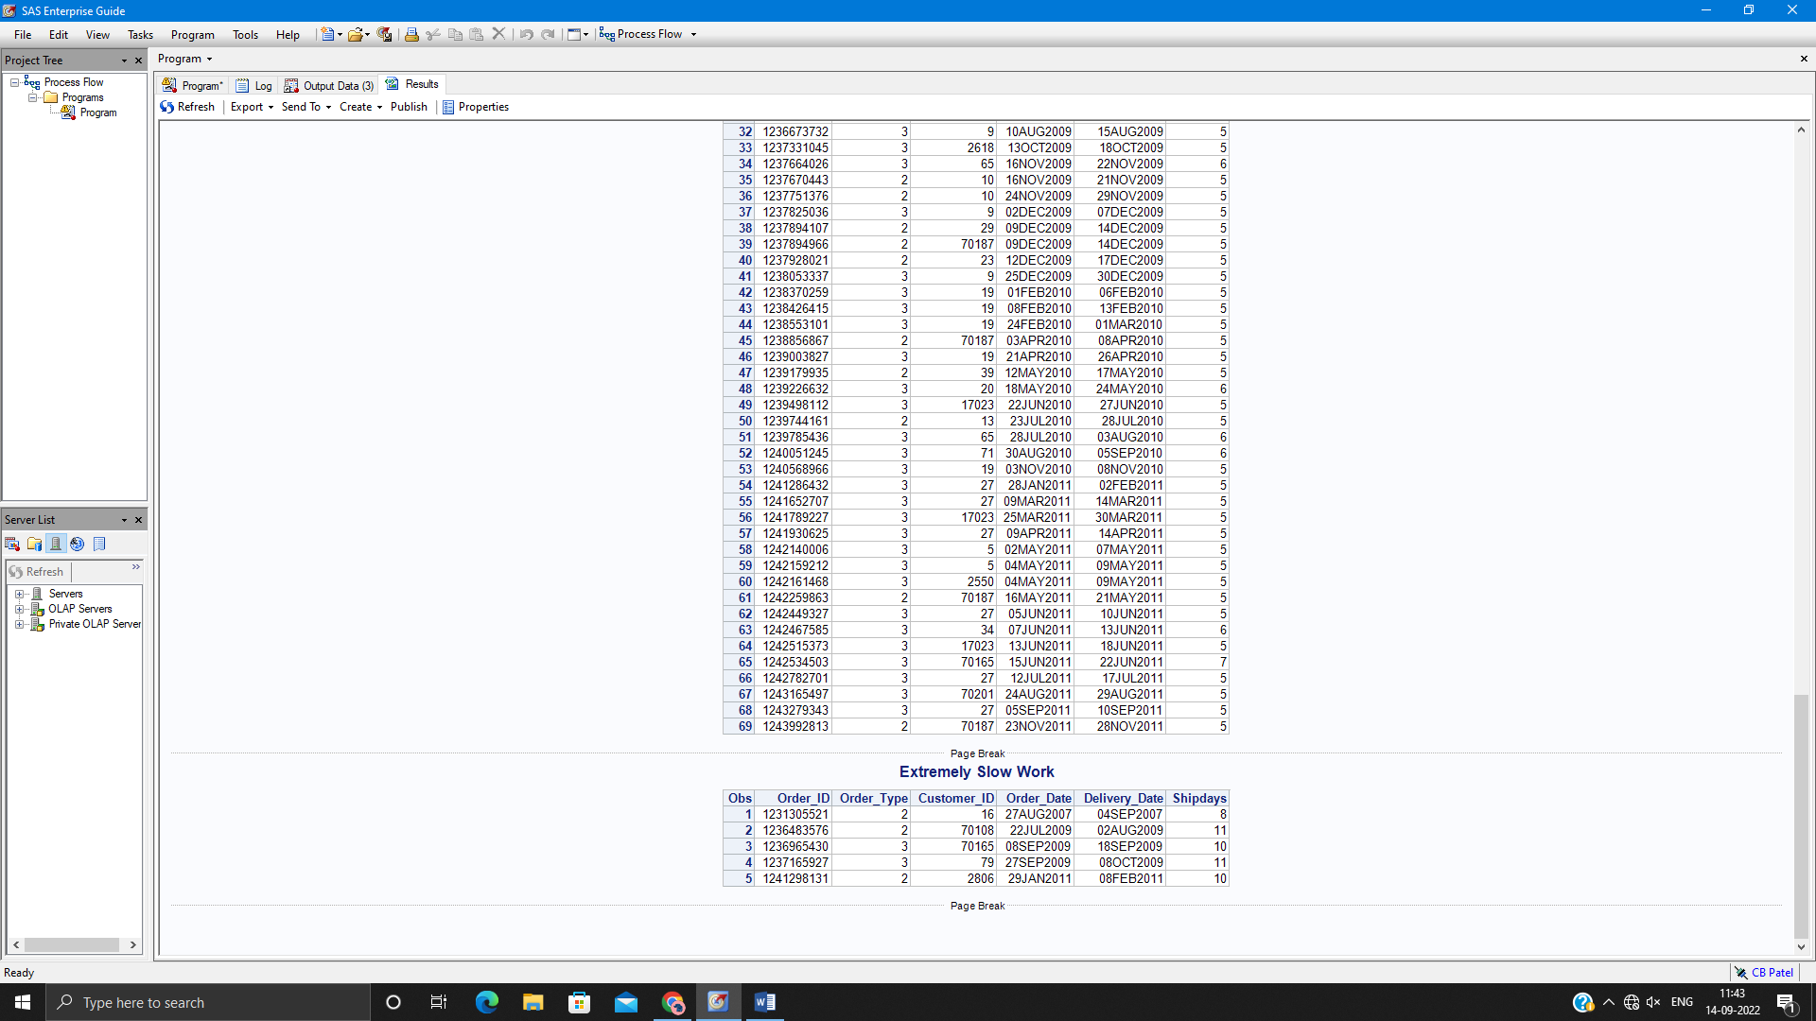

**Assignment 3:**

* Read the data set product_dim_n.
* Create 2 data sets named work.children and work.clothes.
* Output to these data sets depending on whether the value of product_line is ‘Children’ or ‘Clothes & Shoes’.
* Work.children should contain only product_id, product_category and supplier_country.
* Work.clothes should contain only product_id and supplier_id.
* Print only the first 6 observations from work.children.
* Print the selected observation – 2 and 3 from work.clothes.

**Code of the program:**

LIBNAME orion "D://PA_2021_22/Data_Sets";

**data** work.children(keep= product_id product_category supplier_country) work.clothes(keep=product_id supplier_id );

set orion.product_dim_n;

select(Product_Line);

when("Children") output work.children;

when ("Clothes & Shoes") output work.clothes;

otherwise;

end;

**run**;

**proc** **print** data= work.children (obs=**6**);

**run**;

**proc** **print** data=WORK.CLOTHES(firstobs=**2** obs=**3**);

**run**;

**Output of the Program:**

**\*\*\*\*\*\*\*\*\*\*\*\*\*\*\*\*\*\*\*\*\*\*\*\*\*\*\*\*\*\***