**Practical No. 13**

**Aim**: To summarize data by creating an accumulating total variable for a group of data and read raw data files with formatted Input.

**Prerequisite:**

1. Understanding of fundamental programming constructs of Base SAS

**Outcome:** After successful completion of this experiment students will be able to

1. Use RETAIN statement to retain the value of a variable in the PDV across iterations of the DATA step.
2. Use First and Last variables for each variable listed in the BY statement.
3. Use multiple INPUT statements to read a raw data file with multiple records per observation.

(TO BE COMPLETED BY STUDENTS)

|  |  |
| --- | --- |
| Roll No. A020 | Name: Nicole Michelle DSouza |
| Class: | Batch: |
| Date of Practical: | Date of Submission: |
| Grade: |  |

**Assignment 1:**

For the following program.

**data** work.mid_q4;

set orion.order_fact;

where **'01nov2008'd** <= Order_Date <= **'14dec2008'd**;

**run**;

* Modify the program to create an accumulating total Sales2Dte, to display the sales-to-date total (add Sales2Dte and Total_Retail_Price)
* Also create an accumulating variable, Num_Orders, indicating how many orders to date that total represents. Each observation counts as one order.
* Display only the columns Order_ID, Order_Date ,Total_Retail_Price , num_orders and Sales2Dte with a DOLLAR10.2 format.
* Add a title 'Orders from 01Nov2008 through 14Dec2008'

**Code of the program:**

LIBNAME orion "D://PA_2021_22/Data_sets";

**data** work.mid_q4;

set orion.order_fact;

retain Sales2Dte **0**;

Sales2Dte =sum(Sales2Dte,Total_Retail_Price);

retain num_orders **0**;

num_orders = sum(num_orders,**1**);

where **'01nov2008'd** <= Order_Date <= **'14dec2008'd**;

format Sales2Dte DOLLAR10.2;

keep Order_ID Order_Date Total_Retail_Price num_orders Sales2Dte;

**run**;

**proc** **print** data= work.mid_q4;

**run**;

**Output of the Program:**

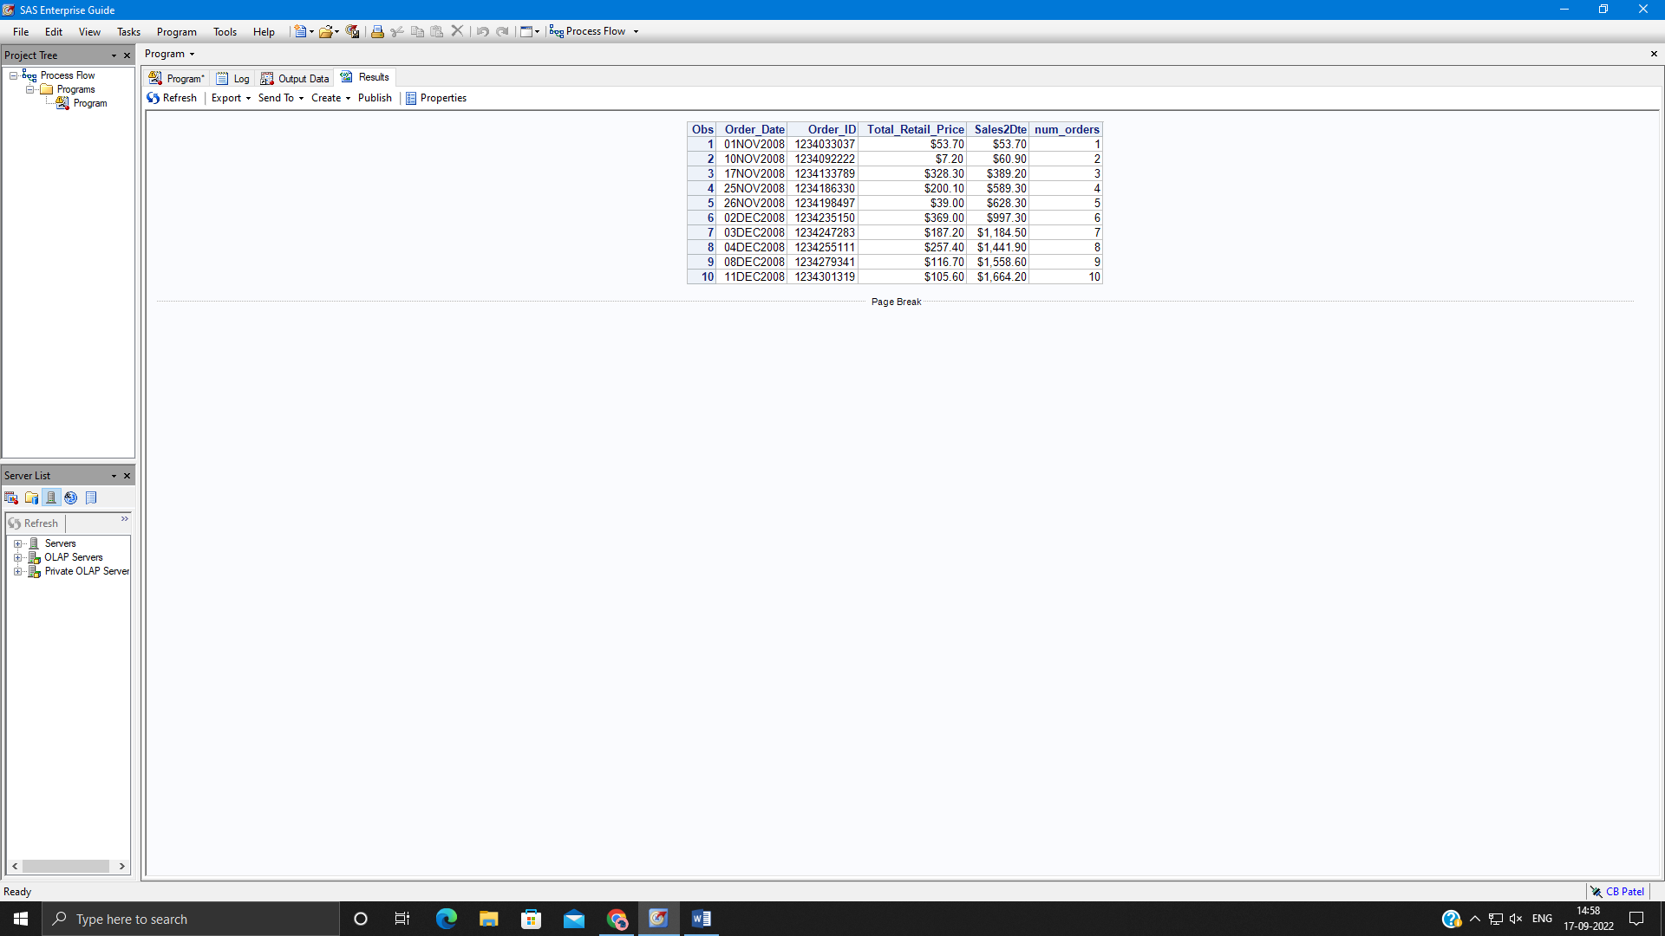

**Assignment 2:**

* Sort the input data set orion.order_summary by customer_id. and store the sorted data into work.sumsort.
* Create a new data set work.customers which will have a new variable total_sales. This variable contains the total of sales across all months for each customer (add total_sales and Sale_Amt). The new data set should have only the columns customer_id, Sale_amt and total_sales.
* Print the work.customers data set using DOLLAR11.2 format for the variable total_sales.

**Code of the program:**

**proc sort data= orion.order_summary out =work.sumsort;**

**by customer_id;**

**run;**

**data work.customers;**

**set work.sumsort;**

**by customer_id;**

**if first.customer_id then total_sales =0;**

**total_Sales+sale_amt;**

**if last.customer_id;**

**keep customer_id Sale_amt total_Sales;**

**format total_sales dollar12.2;**

**run;**

**proc print data=work.customers;**

**run;**

**Output of the Program:**



