**Practical No. 14**

**Aim**: To manipulate character values, truncate and compute descriptive statistics of numeric values using various SAS functions.

**Prerequisite:**

1. Understanding of fundamental programming constructs of Base SAS

**Outcome:** After successful completion of this experiment students will be able to

1. Use SAS functions to extract, edit and search character values.
2. Use SAS numeric functions like ROUND, CEIL, FLOOR and INT and many other descriptive statistics SAS functions like SUM, MEAN, MAX etc.

(TO BE COMPLETED BY STUDENTS)

|  |  |
| --- | --- |
| Roll No. A020 | Name:Nicole Michelle Dsouza |
| Class: B.Tech IT | Batch: A1 |
| Date of Practical: | Date of Submission: |
| Grade: |  |

**Assignment 1:**

Use the data set orion.newcompetitors.

* Create a data set named work.small.
* Create 2 new variables named Country, and Store_Code as given below.
  + Country: contains the first two characters of ID.
  + Store_Code: Contains the other characters from the value ID.

The first character in the value of Store_code indicates the size of the store, and 1 is the code for a small retail store. Write a program to output only the small retail store observations.

The city values should appear with proper case in the report.

* Generate the report shown below.

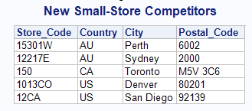

**Code of the program:**

LIBNAME orion "D:\\PA_2021_22\Data_Sets";

title"New Small Store Competitors";

**data** work.small;

set orion.newcompetitors;

ID = compress(ID);

Country = substr(ID,**1**,**2**);

Store_Code= substr(ID,**3**,**8**);

City = propcase(City);

if substr(Store_Code,**1**,**1**)=**1**;

drop id;

**run**;

**proc** **print** data= WORK.SMALL noobs;

**run**;

**Output of the Program:**

**Assignment 2:**

Use the data set orion.customers_ex5 and create a new data set named work.names.

* The new data set should contain only three variables: New_name, name and Gender as given below.
  + New_name: The name column contains the names in the format: lastname, firstname which should be changed to Firstname Lastname.
  + The new variable should also have the customer name preceded by Ms., if gender is female or preceded by Mr. if gender is male.

**Code of the program:**

LIBNAME orion "D:\\PA_2021_22\Data_Sets";

title"New Small Store Competitors";

**data** work.names;

set orion.customers_ex5;

New_name = propcase(Name,",");

if Gender = 'M' then New_name = catx("","Mr.",New_name);

else New_name = catx("","Ms.",New_name);

keep New_name name Gender;

**run**;

**proc** **print** data=work.names noobs;

**run**;

**Output of the Program:**

**Assignment 3:**

Use the data set orion.orders_midyear.

* Create a data set named work.sale_stats with 3 new variables for all months in which the customer placed an order.
  + The variable MonthAvg should contain the average of month variable. Round MonthAvg to the nearest integer.
  + The variable MonthMax should contain the max of month values.
  + The variable MonthSum should contain the sum of month values.
* Print the variables customer_id, Month_Avg, MonthMax and MonthSum using appropriate formats and generate the report shown.

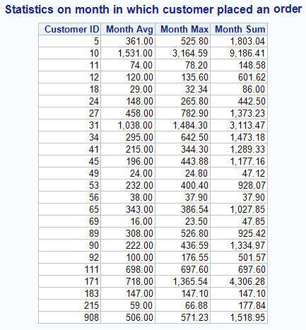

**Code of the program:**

LIBNAME orion "D:\\PA_2021_22\Data_Sets";

**data** work.sale_stats;

set orion.orders_midyear;

MonthAvg = mean(of Month1-Month6 );

MonthMax=max(of Month1--Month6);

MonthSum= sum(of Month:);

**run**;

**proc** **print** data= work.sale_stats;

var MonthAvg MonthMax MonthSum;

**run**;

**Output of the Program:**

**\*\*\*\*\*\*\*\*\*\*\*\*\*\*\*\*\*\*\*\*\*\*\*\*\*\*\*\*\*\***