**Practical No. 1**

**Aim**: To examine SAS Data sets.

**Prerequisite:**

1. Understanding of fundamental programming constructs of Base SAS

**Outcome:** After successful completion of this experiment students will be able to

1. Define components of a SAS data set.
2. Use the PRINT and CONTENTS procedure to browse the data and descriptor portion of a SAS Data set.

(TO BE COMPLETED BY STUDENTS)

|  |  |
| --- | --- |
| Roll No. | Name: |
| Class: | Batch: |
| Date of Practical: | Date of Submission: |
| Grade: |  |

Assignment 1:

Read a SAS Data set from the library SASHELP and print its descriptor and also the data portion.

**Code of the program:**

**proc** **print** data= sashelp.cars;

**run**;

**proc** **contents** data = sashelp.cars;

**run**;

**Output of the Program:**

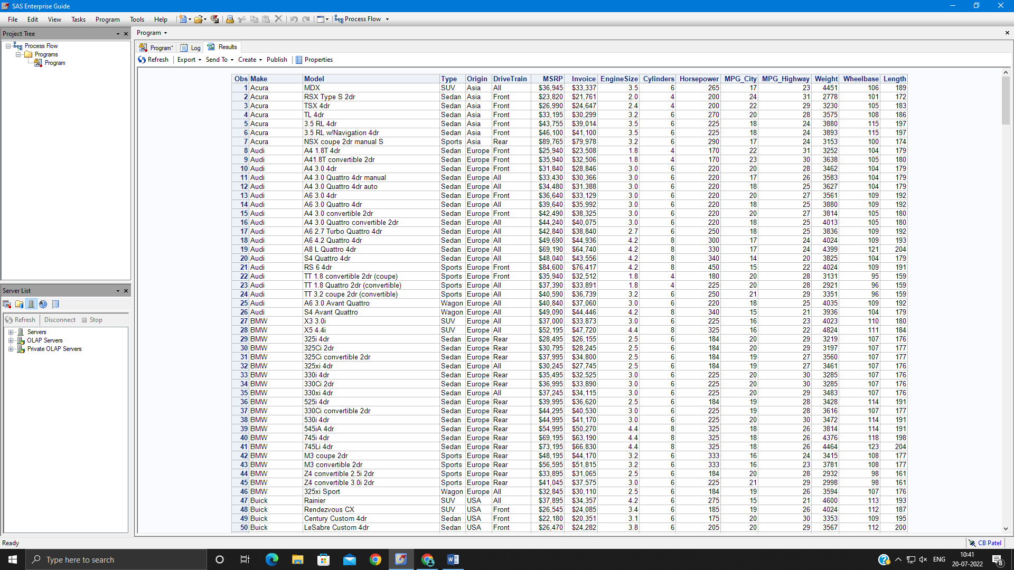

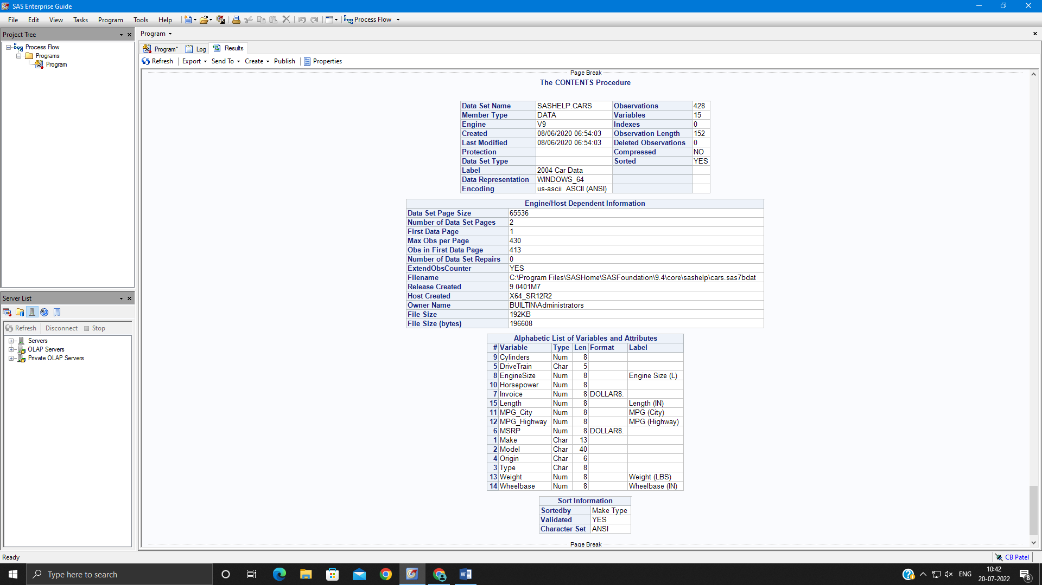

Assignment 2:

For the program below, after the DATA step, add a PROC CONTENTS step to display the descriptor portion of work.newpacks.

**data** work.newpacks;

input Supplier_Name $ **1**-**20** Supplier_Country $ **23**-**24**

Product_Name $ **28**-**70**;

datalines;

Top Sports DK Black/Black

Top Sports DK X-Large Bottlegreen/Black

Top Sports DK Comanche Women's 6000 Q Backpack. Bark

Miller Trading Inc US Expedition Camp Duffle Medium Backpack

Toto Outdoor Gear AU Feelgood 55-75 Litre Black Women's Backpack

Toto Outdoor Gear AU Jaguar 50-75 Liter Blue Women's Backpack

Top Sports DK Medium Black/Bark Backpack

Top Sports DK Medium Gold Black/Gold Backpack

Top Sports DK Medium Olive Olive/Black Backpack

Toto Outdoor Gear AU Trekker 65 Royal Men's Backpack

Top Sports DK Victor Grey/Olive Women's Backpack

Luna sastreria S.A. ES Hammock Sports Bag

Miller Trading Inc US Sioux Men's Backpack 26 Litre.

;

**run**;

How many observations are in the data set? -13

How many variables are in the data set?-3

What is the length of the variable Product_name? - 43

After the PROC CONTENTS step, add a PROC PRINT to display the data portion of work.newpacks.

**Code of the program:**

**data** work.newpacks;

input Supplier_Name $ **1**-**20** Supplier_Country $ **23**-**24**

Product_Name $ **28**-**70**;

datalines;

Top Sports DK Black/Black

Top Sports DK X-Large Bottlegreen/Black

Top Sports DK Comanche Women's 6000 Q Backpack. Bark

Miller Trading Inc US Expedition Camp Duffle Medium Backpack

Toto Outdoor Gear AU Feelgood 55-75 Litre Black Women's Backpack

Toto Outdoor Gear AU Jaguar 50-75 Liter Blue Women's Backpack

Top Sports DK Medium Black/Bark Backpack

Top Sports DK Medium Gold Black/Gold Backpack

Top Sports DK Medium Olive Olive/Black Backpack

Toto Outdoor Gear AU Trekker 65 Royal Men's Backpack

Top Sports DK Victor Grey/Olive Women's Backpack

Luna sastreria S.A. ES Hammock Sports Bag

Miller Trading Inc US Sioux Men's Backpack 26 Litre.

;

**run**;

**proc** **contents** data= work.newpacks;

**run**;

**proc** **print** data= work.newpacks;

**run**;

**Output of the Program:**



