**Practical No. 2**

**Aim**: To subset Report Data.

**Prerequisite:**

1. Understanding of fundamental programming constructs of Base SAS

**Outcome:** After successful completion of this experiment students will be able to

1. Use VAR statement to select variables.
2. Use the SUM, WHERE and ID statement to calculate total, select/identify observations.

(TO BE COMPLETED BY STUDENTS)

|  |  |
| --- | --- |
| Roll No. A020 | Name:Nicole Michelle DSouza |
| Class: B.Tech IT | Batch:A1 |
| Date of Practical: | Date of Submission: |
| Grade: |  |

Assignment 1:

Use the program below.

**proc** **print** data=orion.order_fact;

**run**;

Add a WHERE statement to select only the observations with total_retail_price more than 500 and Order date to be more than 12th Dec 2009.

Add an option to suppress the Obs column.

Add an ID statement to use customer_id as the identifying variable and an VAR statement to display customer_id, order_id, order_type,quantity and total_retail_price.

**Code of the program:**

LIBNAME orion "d://PA_2021_22/Data_sets";

**proc** **print** data=orion.order_fact NOOBS;

where total_retail_price > **500** and Order_Date > **'12DEC2009'D**;

ID Customer_ID;

VAR order_id order_type quantity total_retail_price;

**run**;

**Output of the Program:**

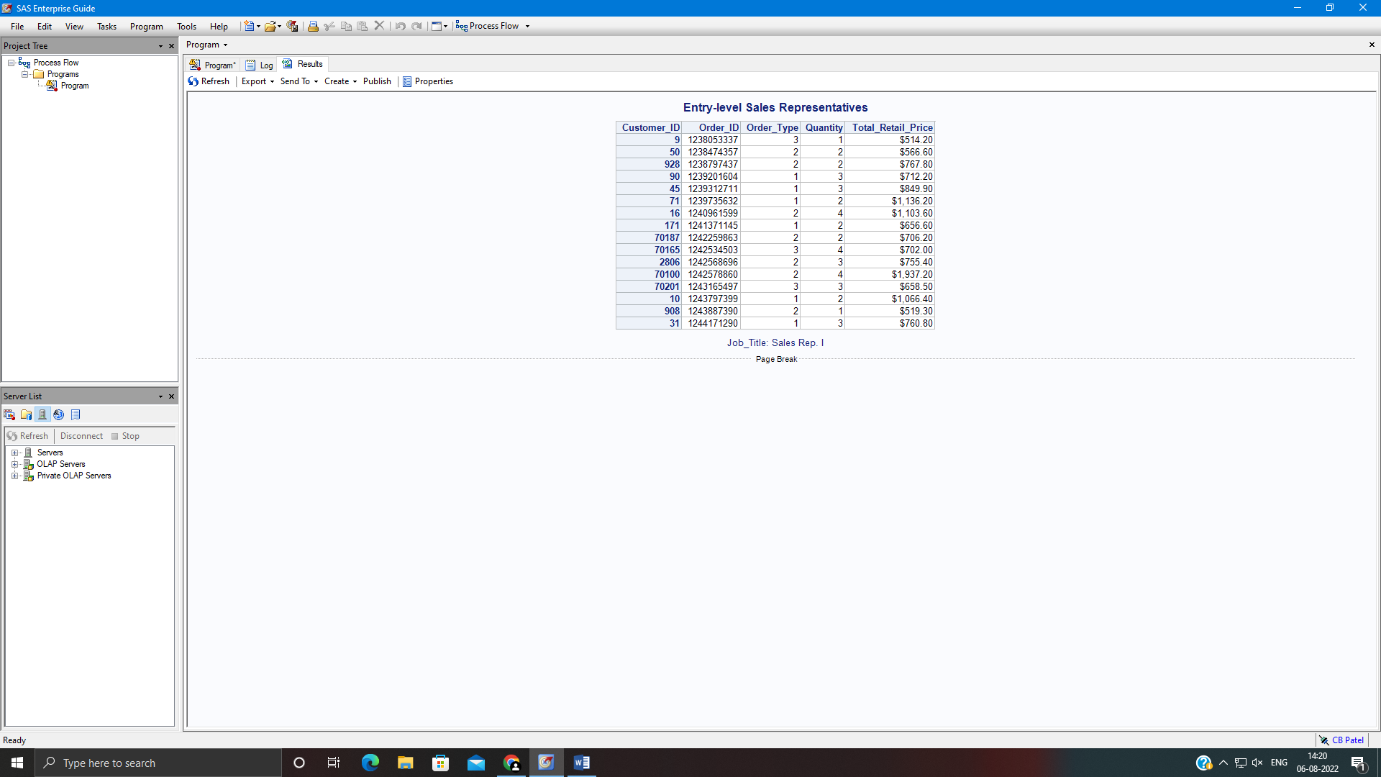

Assignment 2:

Write a PRINT step to display orion.customer_dim. Modify the program to display a subset of orion.customer_dim by selecting only the observations for customers between the ages of 30 and 40 also gender being male (Hint: use WHERE SAME operator). Also suppress the Obs column. Add a statement to use customer_id instead of Obs as the identifying column.

**Code of the program:**

LIBNAME orion "d://PA_2021_22/Data_sets";

**proc** **print** data=orion.customer_dim noobs;

where Customer_Age>**30** and Customer_Age<**40**;

where same and Customer_Gender='M';

id Customer_ID;

**run**;

**Output of the Program:**



