**Practical No. 3**

**Aim**: To Sort/Group Report data and Enhance Reports.

**Prerequisite:**

1. Understanding of fundamental programming constructs of Base SAS

**Outcome:** After successful completion of this experiment students will be able to

1. Use SORT commands to sort the SAS data sets.
2. Use TITLE, FOOTNOTE and LABEL statements to enhance reports.

(TO BE COMPLETED BY STUDENTS)

|  |  |
| --- | --- |
| Roll No. A020 | Name:Nicole Dsouza |
| Class: B.Tech IT | Batch: A1 |
| Date of Practical: | Date of Submission: |
| Grade: |  |

Assignment 1:

For the following program

**proc** **print** data=orion.employee_payroll;

**run**;

Add a PROC SORT step before the PROC PRINT step to sort orion.employee_payroll by Salary. Place the result into a temporary data set named sort_salary.

**Code of the program:**

LIBNAME orion "d://PA_2021_22/Data_sets";

**proc** **sort** data = orion.employee_payroll

out=work.sort_salary ;

by Salary;

**run**;

**proc** **print** data=orion.employee_payroll;

**run**;

**Output of the Program:**

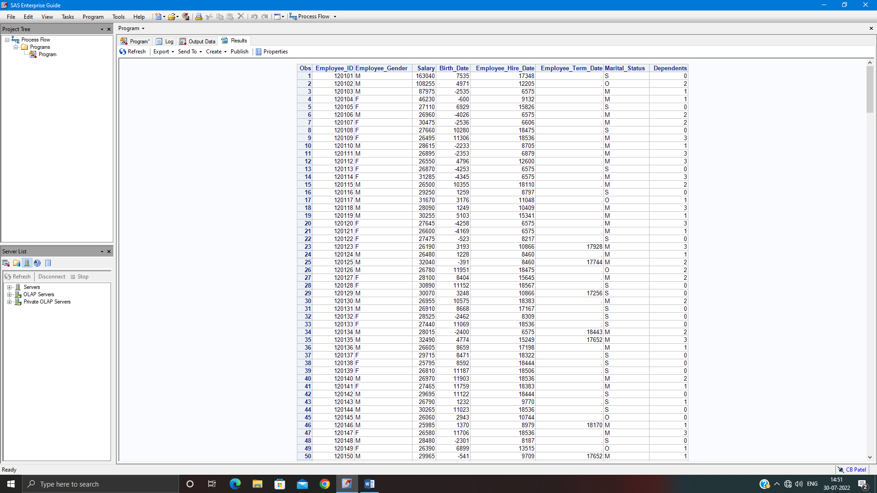

Assignment 2:

Sort orion.employee_payroll by Employee_gender and by descending Salary within gender. Place the result in a temporary data set named sort_sal.

Print a subset of the sort_sal data set. Select only those observations who earn more than $65,000. Group the report by employee_gender and include a total and subtotals for salary. Suppress the Obs column. Display only employee_id,salary and Martial status.

**Code of the program:**

LIBNAME orion "d://PA_2021_22/Data_sets";

**proc** **sort** data = orion.employee_payroll

out=work.sort_salary ;

by Employee_Gender DESCENDING Salary;

**run**;

**proc** **print** data=orion.sort_sal noobs;

WHERE Salary>= **65000**;

by Employee_Gender;

sum Salary;

var Employee_ID Salary Marital_Status;

**run**;

**Output of the Program:**

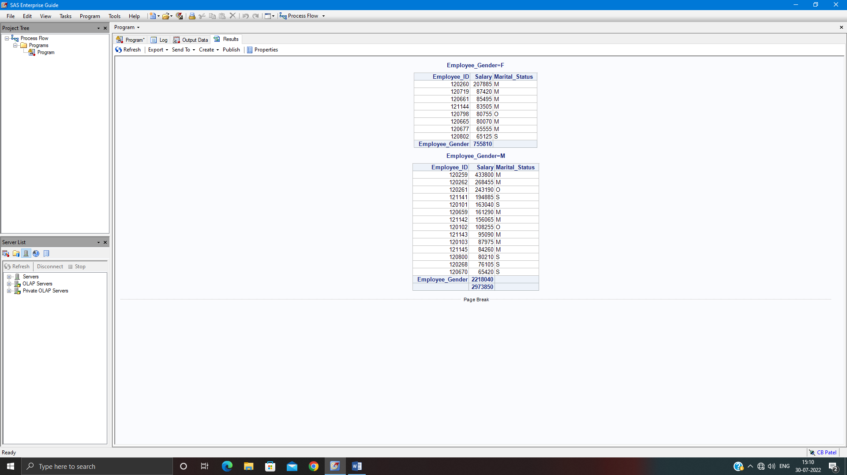

Assignment 3:

For the following program,

**proc** **print** data=orion.sales noobs;

where Country='US' and Job_Title='Sales Rep. I';

var Employee_ID First_Name Last_Name Gender Salary;

**run**;

Add a title – “Entry-level Sales Representatives” and a footnote – “Job_Title: Sales Rep. I”

Use labels for variables as shown below.

Employee_id – employee ID

First_name - First Name

Last_Name – Last Name

Salary – Annual Salary

Modify the program to use a blank space as the split = character to generate two-line column headings.

**Code of the program:**

LIBNAME orion "d://PA_2021_22/Data_sets";

title1 'Entry-level Sales Representatives';

footnote 'Job_Title: Sales Rep. I';

**proc** **print** data=orion.sales split=" ";

where Country='US' and Job_Title='Sales Rep. I';

var Employee_ID First_Name Last_Name Gender Salary;

label Employee_ID = "employee ID"

First_name = 'First Name'

Last_Name = 'Last Name'

Salary = 'Annual Salary';

**run**;

**run**;

**Output of the Program:**



