**Practical No. 4**

**Aim**: To create user defined formats and apply the SAS defined and user defined formats on the SAS data sets.

**Prerequisite:**

1. Understanding of fundamental programming constructs of Base SAS

**Outcome:** After successful completion of this experiment students will be able to

1. Use a DATA step to create SAS data set from existing SAS data set.
2. Apply SAS formats with the Format statement.

(TO BE COMPLETED BY STUDENTS)

|  |  |
| --- | --- |
| Roll No. A020 | Name: Nicole Michelle DSouza |
| Class: B.TECH IT | Batch: A1 |
| Date of Practical: | Date of Submission: |
| Grade: |  |

**Assignment 1:**

For the following program

**Proc print** data=orion.employee_payroll;

**run**;

* Add a PROC PRINT step to display only Employee_id, Salary,Birth-date and Employee_Hire_Date.
* Add a FORMAT statement to display Salary in a DOLLAR format(dollar12.2), Birth_Date in the 01/31/2012 date style (mmddyy10) and Employee_Hire_Date in 01JAN2012 date style (date9).

**Code of the program:**

libname orion "d:\PA_2021_22\Data_Sets";

**proc** **print** data=orion.employee_payroll;

var Employee_ID Salary Birth_Date Employee_Hire_Date;

format Salary dollar12.2

Birth_Date mmddyy10.

Employee_Hire_Date date9.;

**run**;

**Output of the Program:**

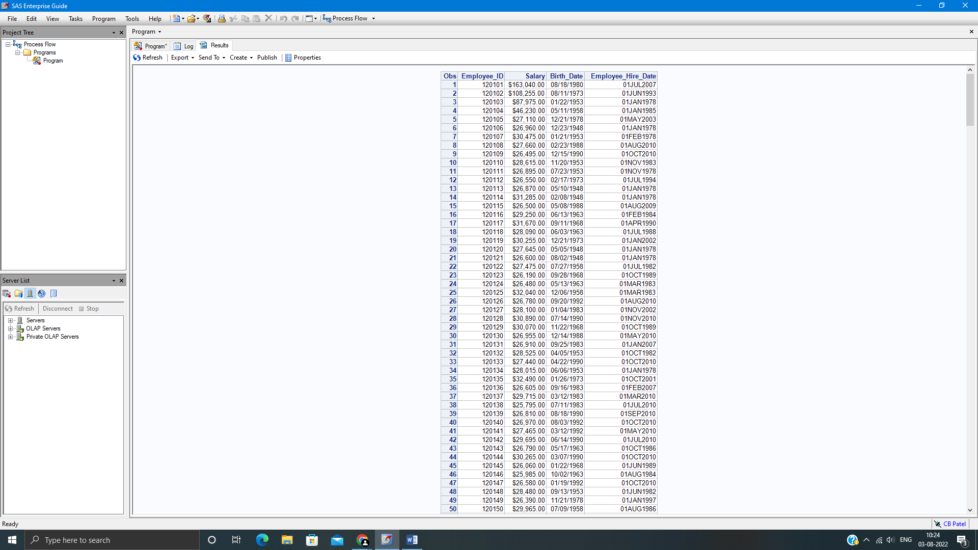

**Assignment 2:**

For the following program

* Add a PROC FORMAT step following the data step to create a character format named $GENDER that displays gender codes as follows.

F --- Female

M ------- Male

* In the same PROC FORMAT step, create a numeric format named MNAME that displays month numbers as follows

1--- January

2 ---- February

3 ---- March

* Add a PROC PRINT step to display the Q1Birthdays data set. Apply the 2 user defined formats to Employee_Gender and Birth_Month variables respectively. Include the title “ Ëmployees with Birthdays in Q1” and clear the title at the end of the program.

**Code of the program:**

libname orion "d:\PA_2021_22\Data_Sets";

**data** Q1Birthdays;

set orion.employee_payroll;

BirthMonth=month(Birth_Date);

If BirthMonth le **3**;

**run**;

**proc** **format**;

value $gender 'F' ='FEMALE'

'M'='MALE';

**RUN**;

**PROC** **FORMAT**;

VALUE MNAME **1**= 'January'

**2** ='February'

**3**='March';

**run**;

title 'Ëmployees with Birthdays in Q1';

**proc** **print** data = Q1Birthdays;

format Employee_Gender $gender.

BirthMonth MNAME.;

title;

**run**;

**Output of the Program:**



